ITU WRS-10 Sync Application
The ITU WRS-10 Sync Application allows you to synchronize WRS-10 documents* from the ITU servers to your local drive. It has been configured to access ITU Servers and synchronize on demand to the latest published documents.
*WRS-10 published documents include: Contributions (C), Presentations (SP) and Information Documents (INF).

Step 1: Downloading and installing the ITU WRS-10 Sync Application

The ITU WRS-10 application can be downloaded from the current Web page (see below).
It will also be available (for faster installation), along with the initial set of documentation, on the USB key you receive at Seminar Registration.
For installing the ITU WRS-10 Sync Application, you can either use:
1. WRS10-setup.exe (recommended option). This is a PC setup program that installs WRS-10 Menu and Sync program to C:\ITU WRS-10\. It creates an ITU WRS-10 program group and shortcut to desktop.
- Download WRS10-setup.exe (xx MB) (Document restricted to TIES users [ITU-R])
- To install, run WRS10-setup.exe and follow the instructions.
2. Or WRS10-unzip.exe. This is an alternative PC program in case you do not have the right to install applications on your laptop. It unzips the files to your C: drive, or a drive of your choice, and must be kept on the root folder. It does not create a program group nor shortcut to desktop.
- Download WRS10-unzip.exe (xx MB) (Document restricted to TIES users [ITU-R])
- To install, run WRS10-unzip.exe. Select drive to unzip (C:\ drive by default) and then click Unzip button. To start the program, execute "C:\ITU WRS-10\WRS10.exe".
Back to top

Step 2: Synchronizing (copying) WRS-10 documents

Starting up ITU WRS-10 Menu
- Click Start>All Programs>ITU World Radiocommunication Seminar 2010>Launch ITU WRS-10 Menu.
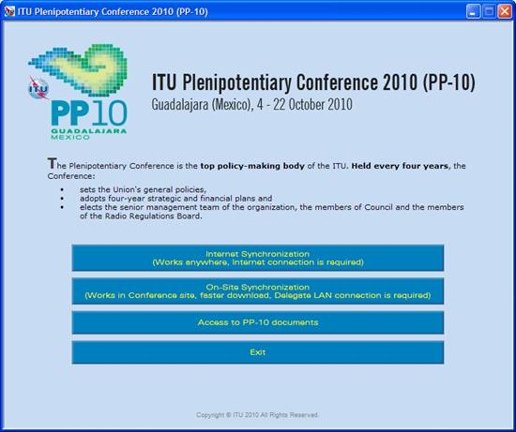

Synchronizing WRS-10 documents
1. Synchronization
Select "Synchronize Documents" to download or update the WRS-10 collection of documents on your PC.

2. Select the language(s) of your choice.
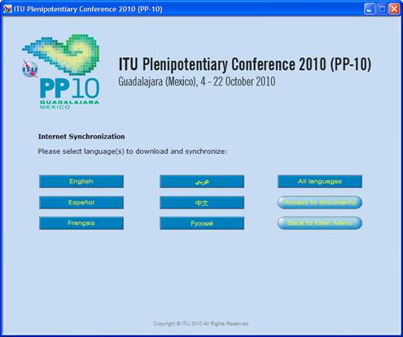

3. Once the language(s) have been selected, synchronization will begin.
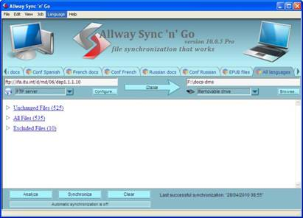
Notes:
- The first time you use it, it may take a few moments to synchronize all the documents posted.
- Installing from the USB key provided at registration, provides you with the initial set of documentation and so, decreases the time necessary for the first synchronization operation.
- Synchronization is set to run on demand; you may launch it at any time from the menu by clicking on the synchronize button, see step 2.
- The application Allway Sync' n' Go will be loaded after selecting a language. After a successful synchronization, it will disappear but if there is a problem, it will remain open and user needs to fix the problem by contacting the ITU Support team.

Back to top

Step 3: Accessing ITU WRS-10 documents

1. Click on “Access to WRS-10 documents” to show Documents page. This menu will give you access to the documents even if you are not connected to the internet.
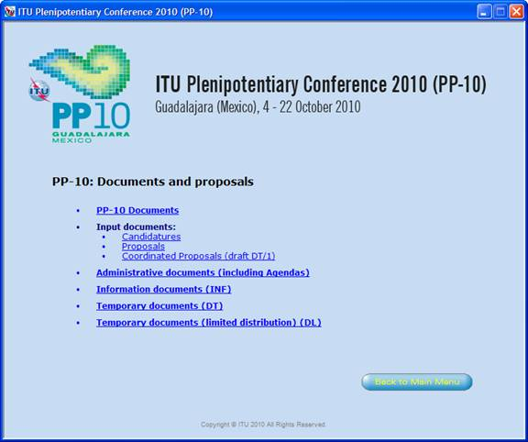

2. When you select any option above, it will load the corresponding html page.
Note: A warning such as "To help protect your security, Internet Explorer has restricted from running the scripts or ActiveX controls that could access your computer.", click on it and select "Allow Blocked Content...".

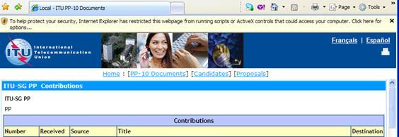

If you experience problems in accessing or synchronizing documents, please contact our IT assistance and support service by calling the Helpdesk service.

