|  |  |  |  |
| --- | --- | --- | --- |
| Telecommunication Development Sector | |  | |
| Regional Preparatory Meeting for the Americas Region (RPM-AMS) for WTDC-14 | | |  | |
| Montevideo, Uruguay, 19 - 21 August 2013 | | |  | |
|  | |  | |
|  | | Document RPM-AMS13/3-E | |
| 3 June 2013 | |
| Original: English | |
|  | | | |
| SOURCE: | Director, Telecommunication Development Bureau | | |
| TITLE: | ICT Trends in the Americas Region | | |
|  |  | | |

Contents

1. Overview of global ICT developments, policies and regulatory trends 3

1.1 Global ICT policies and regulatory trends 3

1.2 ICT regulatory trends in the Americas region at a glance 12

2. Overview of ICT developments in the Americas 18

3. The ICT Development Index (IDI) in the Americas 30

4. The ICT Price Basket (IPB) in the Americas 36

5. Conclusions 44

References 45

## Overview of global ICT developments, policies and regulatory trends

New information and communication technologies (ICTs) continue to penetrate countries in all regions of the world, as more and more people are getting connected. More and more countries are reaching critical mass in terms of ICT access and use, which accelerates ICT diffusion and further boosts demand, driven by the spread of mobile Internet.

ITU estimates that in 2013, there are almost as many mobile-cellular subscriptions (6.8 billion) as people in the world (7.1 billion), with mobile-cellular penetration reaching 96 per cent, globally, and 89 per cent in developing countries.

The uptake of both, fixed (wired)-broadband and mobile-broadband services has continued to grow worldwide. By 2013, the number of fixed-broadband subscriptions has climbed to almost 700 million, corresponding to a global penetration rate of 9.8 per cent. At the same time, the number of active mobile-broadband subscriptions has grown by over 30 per cent annually over the last two years, to almost 2.1 billion by 2013. This means that there are three times as many mobile-broadband as fixed-broadband subscriptions. Indeed, mobile-broadband is the ICT service displaying the sharpest growth rates, globally, and contributing to changes in ICT use and uptake, as well as to the type of services that the industry is providing.

### 1.1 Global ICT policies and regulatory trends

The ICT industry is facing many changes in today’s digital world from the transition in technologies, to the emergence of new players, the displacement of revenues, and changes in business models. For users—both individuals and businesses—there is an ever-expanding variety of services and applications to serve their information, communication and entertainment needs. The predicted phenomenal growth in data traffic, led by changing consumer and business behaviours, continues to put pressure on traditional telecommunications operators to review, adapt and diversify their business practices.

The rapid take-up of IP-based messaging (mainly over smartphones), such as WhatsApp and Viber, and free-call application providers, is disruptive to the business of traditional telecom operators. Video streaming and downloads are putting a further strain on network operators.

Broadband networks are increasingly used for the delivery of long-form video provided by over-the-top (OTT) services such as ‘LOVEFiLM Instant’ and ‘NetFlix’[1], rather than short-form Internet video such as video clips on YouTube.[2] Double-digit growth in global IP consumer traffic is expected to continue over the coming years driven by the diversification of pay-TV and video streaming services, and other media-rich content.

Furthermore, communications is no longer solely the privilege of human beings – indeed, the Internet of Things is fast becoming reality, with machine to machine (M2M) communications expected to grow significantly in the near future adding to the strain on networks. Cisco predicts that by 2016 TVs, tablets, smartphones, and business Internet machine-to-machine (M2M) modules will show a growth rate of 42 percent, 116 percent, 119 percent, and 86 percent, respectively. Traffic from wireless devices will exceed traffic from wired devices by 2014**[3].** Triggered by the growing number of Internet connections over mobile and fixed platforms, monthly Internet protocol (IP) traffic has skyrocketed from the modest 1 petabyte two decades ago, to an estimated 44’000 petabytes in 2012[4]. And the sky does not seem to be the limit for future IP traffic growth. These tremendous volumes are driven by growth in the number of connected people and devices, and the growing availability of abundant, diversified, and in most cases free, online content.

**Chart 1.1**: **Growth in IP traffic, Internet users and apps downloads (1994-2013)**



Source: ITU, based on data from ITU, Cisco VNI, Andrew Odlyzko, RHK, Telegeography, IDC, ABI Research, and Chetan Sharma Consulting.  
Note: 1) “b” equals billion. 2) Numbers for IP traffic and application downloads for 2010 and later as well as 2013 numbers on individuals using the Internet are estimates

The impressive growth of mobile services, whether cellular or mobile broadband, coupled with the advent of Internet, have revolutionized the way we communicate in little more than a decade. While it took 125 years to accumulate 1 billion fixed lines, it took 21 years to reach 1 billion mobile cellular subscriptions, nine years to reach an additional 5 billion, and only nine years to reach the first billion of mobile broadband subscriptions. Looking at the Internet, it took five years to achieve the milestone of the first billion of users. When looking at the number of downloaded applications, one can no longer count in terms of years, but in months – the first billion applications downloaded from Apple’s App store was reached in only nine months, while it now takes 7 days to accumulate 1 billion tweets.[5]

The advent of next-generation mobile cellular technologies and the wider adoption of increasingly sophisticated broadband-enabled mobile devices have made access to the digital society more ubiquitous and universal. Smartphones and tablets are fast becoming primary mobile access devices, as they marry functionality with convenience. Some analysts predict that the total number of smartphones reached 1.1 billion by end of 2012, and that this number will triple to reach a total of 3.3 billion in 2018[6]. Smartphones can also create new usage patterns for users out of reach of fixed connectivity. From the developing countries’ perspective, smartphones provide a great opportunity for Internet to take root where wired broadband infrastructure is still lacking. In that sense, besides being a primary mobile device, smartphones can easily become primary Internet access devices, in particular in some developing countries.

As a result of the growth in users, traffic and applications, revenues in the ICT sector overall are expected to continue to rise, but new industry participants seem poised to take an increasing share. Total revenues from traditional telecommunications operators are likely to grow, even though they may lose up to 6.9 per cent in cumulative voice revenues (representing USD 479 billion) to OTT VoIP services by 2020.[7] In another closely related area, the cloud computing market was worth USD 18 billion in 2011 and is estimated to reach USD 32 billion by 2013,[8], driven by big data stored in the cloud now accounting for two thirds of data center traffic worldwide.[9]

*Adapting to change*

In such an era of transition, policy-makers and regulators need to consider carefully whether their legal and regulatory frameworks will be able to effectively address the changing ICT landscape and ensure non-discriminatory practices and transparency of information from network and service providers.

The past two decades have confirmed the power of the regulatory reform trinity: separate regulators, competition and privatization (see Chart 1.x). By following, adapting and often reinventing any of these three, countries around the world have revitalized their telecommunication and information technology markets, kicking off the irreversible transformation into digital economies. While the number of regulators continues to grow slowly but surely, privatizations have slowed considerably over the past five years, likely due to the global financial crisis and the new dynamics of the ICT sector, which generally now provide multiple opportunities for market entry through simplified licensing regimes.

**Chart 1.2 Liberalization and reform trends over the last decade**

Source: ITU Telecommunications/ICT Regulatory Database.

Adopting the appropriate regulatory tools to respond to new market behaviours and the growing need for consumer protection is becoming increasingly complex for regulators in today’s converged environment. While there is a good case to be made for competition and market-based approaches to broadband, policy-makers and regulators must balance market forces with the need to prevent market failures. They further need to assess at each level whether *ex ante* regulation is necessary or should be left to *ex post* regulation. Adding to the complexity, multiple players are now operating in the same markets but under different regimes, for example in the provision of voice services, traditional telecom operators are not only competing with players in adjacent markets, such as ISPs and cable operators but with players in the above layers such as content and application providers such as OTTs.

Continuous efforts have been made by countries to liberalize the telecommunications/ICT markets. Not surprisingly, competition is now the norm in most ICT markets throughout the world. However, ensuring consumers can actually benefit from greater choices and effectively switch operators/providers remains an issue in many liberalized markets, thus affecting the competitiveness of these markets. Consumers are often challenged by the difficulty in evaluating and choosing among the various packages and price offers available, and refrain from switching likely due to the lack of clarity and uncertainty. This may also be the case when number portability is required, as it is respectively in 37 per cent of the countries worldwide for mobile and 25 per cent for fixed[10], in instances where consumers are further charged for porting the service.

Nevertheless, fierce competition among the different mobile broadband technologies is pressurizing mobile operators to diversify their service offers and innovate in terms of service packages and pricing. The increasingly crowded and competitive market for mobile broadband (92 percent of the markets worldwide are open to some form of competition) is resulting in booming demand for bandwidth, squeezed margins for operators and enhanced virtual experiences for consumers.

The growth of broadband services over wireless networks is putting enormous pressure on radio spectrum. A growing number of regulators are introducing market-based mechanisms such as in-band migration, spectrum sharing and spectrum trading. Market-driven approaches to making more spectrum available for mobile broadband services are today considered best practice, enabling inter-platform competition and spurring innovation.[11] These measures are put in place to distribute spectrum access in an effort to mitigate the demand for fresh spectrum bands both for 3G and 4G services quickly and efficiently. In many countries, however, there is no longer any available spectrum that can easily be re-farmed for IMT-Advanced (4G) broadband services, such as LTE-Advanced and WiMax-Advanced. Regulators have complex decision to make to determine which other industries and legacy services – including government services– should be relocated or forced to share spectrum in order to make way for the extensive bandwidth that 4G services require. In addition, regulators may have to move progressively away from granting licenses for exclusive rights to certain spectrum bands. Some regulators have allocated spectrum bands for license-exempt use, effectively allowing more freedom for market players to manage spectrum among themselves.

*Changing mandate*

The nature of ICT as cross-sectoral and pervasive infrastructure means that telecom/ICT regulators are today forced to go beyond traditional models for regulation, which have historically consisted mainly of regulating access to networks and services, ensuring fair competition, protecting the interests of consumers and advancing universal access. Regulators are now confronted with issues in new areas to address the challenges of living in a digital world, while nurturing the opportunities of the networked society. Over the past years, a growing number of the 161 established telecom/ICT regulators have seen their mandate expand to include information technology and broadcasting. More recently, electronic content, cybersecurity, data protection, privacy and environmental issues have entered into the purview of regulators. As indicated earlier, the increased use of online applications and services to communicate and do business (such as social media, cloud services, e-payment and other m-banking services) bring a host of new regulatory issues to the fore.

**Chart 1.3: Selected regulatory functions, world, 2012**

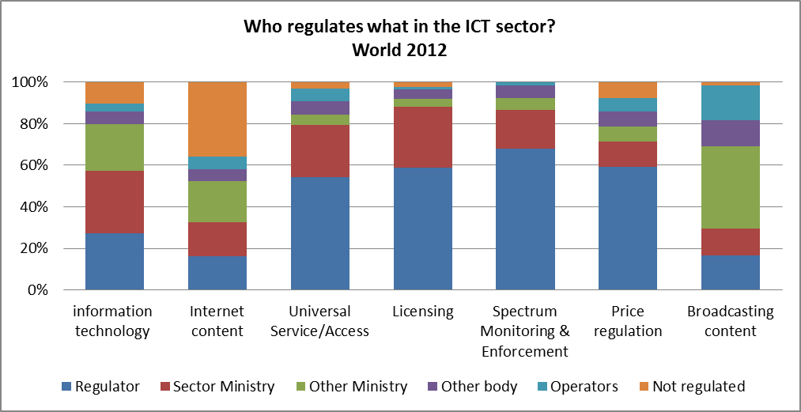

Source: ITU Telecommunications/ICT Regulatory Database.

To adapt to the changing ICT environment, some governments have continued the move towards reform of their institutional and organizational structure by merging multiple separate regulatory authorities over different areas of telecommunication and broadcasting into a single converged Communications/ICT authority. Conversely, other countries (mainly in Africa, the Americas and Europe) have established multi-sectoral agencies - either when sector reforms were initiated or more recently, after reaching a certain level of maturity of their markets (for example, in Germany, Denmark, the Netherlands and Spain).

*Changing policies*

In this highly dynamic digital environment, however, some key questions need to be addressed to assess the readiness of countries’ legal and regulatory frameworks to push forward their digital agendas and secure the infrastructure investment needed. In particular, regulators need to consider whether they are sufficiently equipped to ensure non-discriminatory practices and transparency of information from network and service providers. They also need to identify if additional measures should be adopted to help ensure a level playing field among operators. In addition, where public funds are requested, clear policies should be adopted with regards to how these should be used, in a manner consistent with principles for open access. In setting national broadband policies and plans, governments need to consider the need for spectrum practices to be reviewed. With respect to consumer protection, policy makers and regulators are increasingly called upon to address multiple issues, such as protection from cyber-hazards, securing privacy and data protection in a cloud environment, and user awareness on the appropriate use and impact of shared content. As the character of the services carried over those networks is genuinely transnational, strengthening cross-border, regional and international cooperation in particular in those areas will remain key in ensuring that all citizens of the world can benefit from affordable, secure and safe access anytime anywhere. Furthermore, enforcing a sound policy and regulatory framework calls upon a clear vision and strategy at the highest level for moving forward toward the establishment of the information society countries aspire to since the World Summit on the Information Society (WSIS).

Reviewing existing ICT policy and regulatory frameworks to adapt to the fast-changing digital environment is an ongoing process that requires coordination with multiple stakeholders to develop forward-looking approaches to attract and secure the huge and sustained investments in networks that is still needed. The policy and regulatory measures governing broadband have implications for other sectors of the economy, as well as society as a whole, given broadband’s role as critical information infrastructure underpinning other key sectors (including power networks, transport, health and financial services). Mindful of this critical role ICTs play, over 145 governments have today adopted or are planning to adopt a national policy, strategy or plan to promote broadband. Many of these broadband policies and plans focus on building nationwide broadband infrastructure, stimulating demand through the adoption of online services and applications such as e-education, e-health/telemedicine, e-government, e-business, and extending connectivity to provide universal access (See Chart 1.4).

**Chart 1.4: Goals of the national broadband plan, 2012**

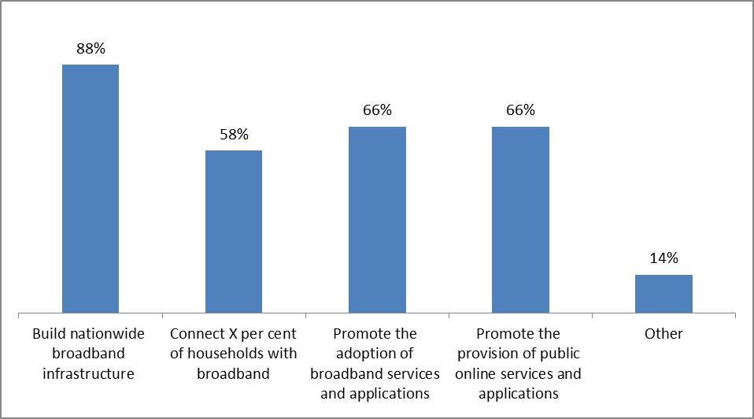

Source: ITU Telecommunications/ICT Regulatory Database.

Finding innovative ways to fund the policies and plans, and where private investment may be limited, some countries have opted for investing public funds directly in the construction and operation of the network, at least for a limited period – for example in Australia, Malaysia and Singapore. Alternatively, others have established public private partnerships (PPP) to drive the development of universal access projects, as has happened in France, Thailand and Kenya. Some governments have also provided direct financial subsidies through the adoption of stimulus packages, as happened in the European Union and the United States.[12] Others have also established dedicated broadband funds.

The global community of regulators has further recognized various options for policy-makers and regulators to create incentives for the private sector to invest in ICTs, such as adopting enabling policies, simplifying licensing regimes, making available more spectrum, reducing regulatory obligations and offering tax incentives. [13] In addition, for a thriving broadband environment, regulatory frameworks need to achieve a balance between the promotion of competition in services, as opposed to infrastructure in order to address the challenges associated with access to broadband networks and services”.[14]

### ICT regulatory trends in the Americas region at a glance[15]

Governments worldwide find themselves at a challenging juncture. Data traffic is growing exponentially, consumers call for anytime and anywhere secured access to innovative ICT applications and services, thus putting pressure on network operators who are in turn facing massive investment requirements to deploy the needed broadband infrastructure, in a time of economic uncertainty and slow recovery. In this context, funding alternatives are required to meet connectivity and access demands and goals, in addition to reducing and sharing costs strategies. Governmental intervention is therefore needed at various levels to address the emerging economic and social imperatives of a digital world. In this environment, whether in the Americas region or in any other region of the world, targeted policies and effective regulation remain key *t*o ensure that investment continues to drive growth and innovation in ICTs. This following section will examine how countries in the Americas region have embarked on reforming their ICT sector to adapt and anticipate the changes taking place in a vibrant and dynamic digital ecosystem.

Countries in the Americas region, such as Brazil, the United States and Canada, were among the early adopters of sector reforms to boost access to telecommunications and then ICTs by setting the legal and regulatory conditions for an enabling environment to develop. The pace of reforms in the region accelerated over the last decade and has followed similar paths as in other parts of the world. Liberalization efforts were undertaken in all countries to open up most ICT markets to competition and foreign investments. Nearly 80 percent of the incumbent operators in the Americas region are partially or totally privately-owned and 70 per cent of the countries have no restrictions on foreign ownership. The Americas region performs well in terms of competition in its ICT markets, reaching levels above world’s average in all broadband related markets as shown in Chart 1.5. The delivery of VoIP services is legal in 93 per cent of the countries in the region just after Europe VOIP is legal in all countries and the Asia and Pacific region where the service is legal in 95 per cent of countries. More efforts may be required in 20 per cent of countries where basic and DSL services still remain under monopoly provision. Ensuring consumers can benefit from greater competitiveness may be achieved by requiring number portability from fixed and mobile operators. Currently, number portability is required from fixed line operators in 35 per cent of the countries in the region but is available to 38 per cent of fixed line users. While for mobile operators, number portability is required in 52 per cent of the countries of the region, it is available in only 44 per cent of countries. This is a fairly low percentage compared to Europe, the Arab States and Asia and the Pacific regions (see Chart .1.5).

**Chart 1.5 Competitiveness of the Americas region, selected market segments, 2012**

***Competition in selected market segments, Americas region and the world, 2012***

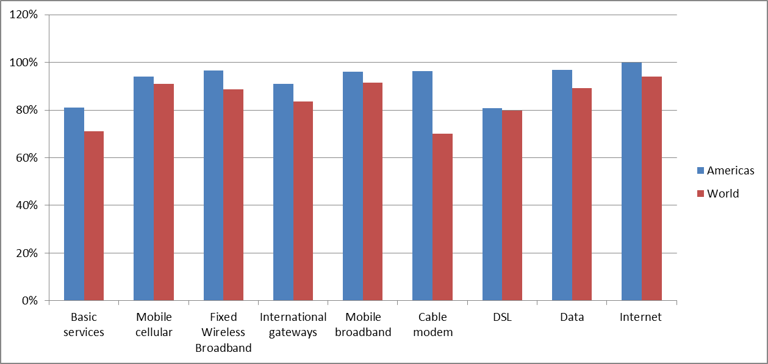

***Number portability, by region, 2012***

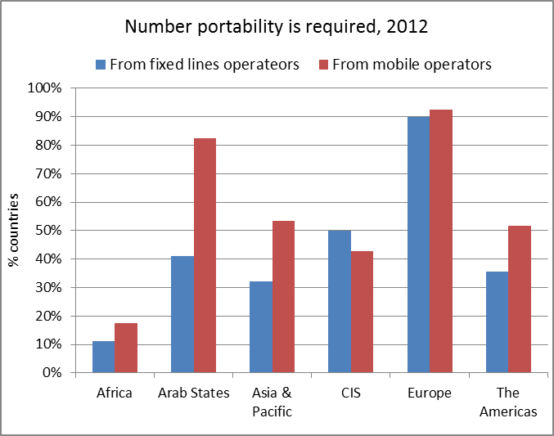 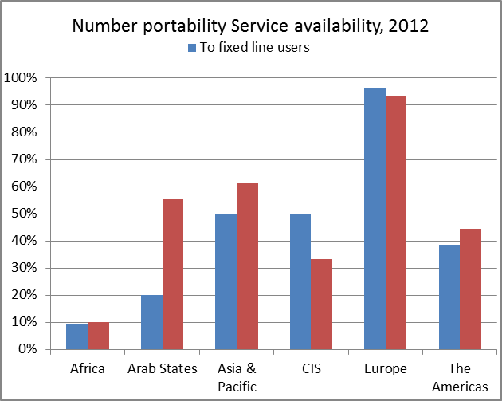

Source: ITU Telecommunications/ICT Regulatory Database.

The adoption of simplified licensing regime and the establishment of a separate telecom/ICT regulators are further regulatory and institutional measures undertaken by governments to reform the sector. Countries such as Argentina, the Bahamas, Colombia and Peru have eased their market entry processes by adopting simplified licensing regime. Service-specific individual licences remains however the norm in many countries in the Americas region. The region saw the creation of the first telecom regulator in 1934, when the United States established the Federal Communications Commission (FCC) followed by the Canadian Radio-television and Telecommunications Commission (CRTC) in Canada, in 1968. Over the last two decades, most countries in the region followed the US and Canadian examples. By end of 2012, 94 per cent of the countries in the region had established a separate telecom/ICT regulator, and the Americas region now represents the region with the highest level of percentage of separate regulators (see Chart 1.6).

**Chart 1.6 Separate regulators by region, 2012**

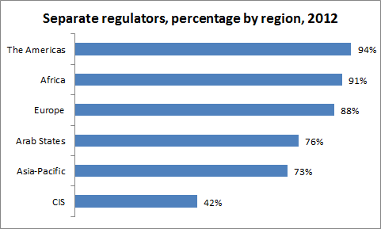

Source: ITU Telecommunications/ICT Regulatory Database.

**Chart 1.7 Selected regulatory functions, the Americas region, 2012**

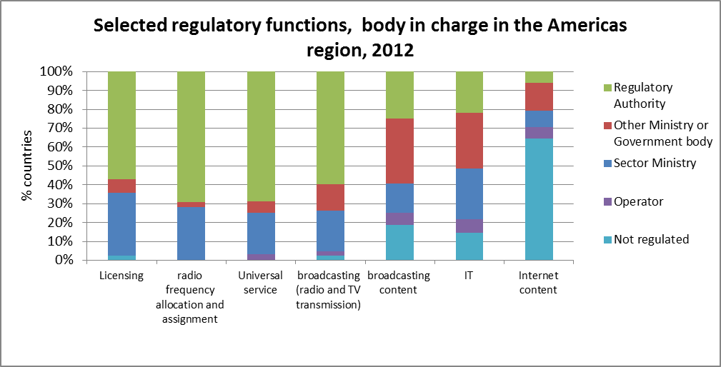

Source: ITU Telecommunications/ICT Regulatory Database.

Adapting to the changes taking place in the sector, some countries have further reformed their regulatory institutions by moving from sector specific regulators to establishing a single converged regulator. In other countries, the move has been to establish a multi-sector regulator, as in countries in Central America and the Caribbean, having a single entity to oversee ICT markets as well as other utilities such as electricity, water, posts, gas, etc. In Barbados and the Bahamas, the Fair Trade Commission and the Utilities Regulation and Competition Authority (URCA) are responsible for responsible for utility regulation, fair competition and consumer protection. The mandate of the converged regulator such as the FCC in the United States, CRTC in Canada, ANATEL in Brazil and INDOTEL in the Dominican Republic may cover telecommunications, spectrum matters, Information technologies, broadcasting and in some instances, electronic content. Internet content is largely unregulated in the region. Regulators in Colombia, Costa Rica and Panama have further seen their mandate expanded to include cybersecurity matters.

In 2000, the region also saw the creation of the first joint telecommunications regulatory body, the Eastern Caribbean Telecommunications Authority (ECTEL) to serve its five Caribbean Member States[16].

In an effort to bring the cost of network deployment down and to capitalize on the investments made, 59 per cent of the countries in the Americas region have mandated passive infrastructure sharing and 70 per cent colocation, respectively in line and above world average level of regulation in these areas. In 88 per cent of countries, mobile virtual network operators are allowed to operate as infrastructure sharing for those operators is permitted.

**Chart 1.8 Infrastructure sharing, by region, 2012**

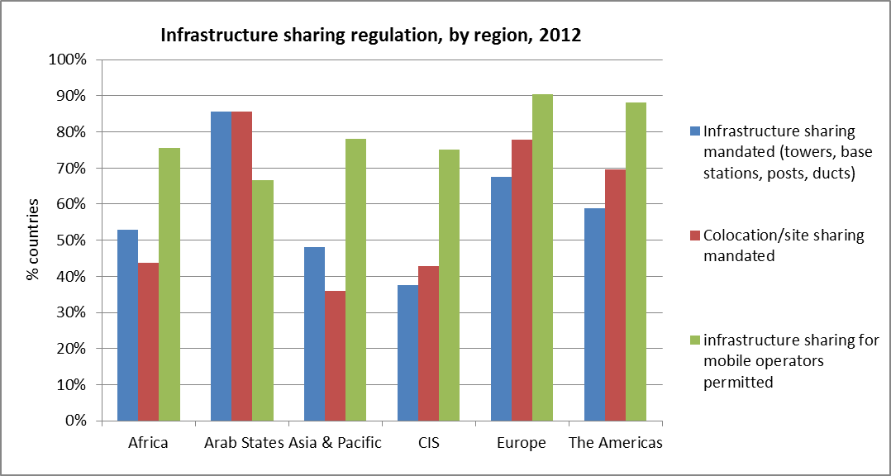

Source: ITU Telecommunications/ICT Regulatory Database.

To respond to the growing demand for spectrum, 75 per cent of the countries in the Americas region have adopted some form of market based mechanisms by allowing in-band migration. This makes the Americas the region with the highest percentage of countries that have adopted market based mechanisms, followed by Europe. At least 21 per cent of the countries, including Chile, Guatemala, El Salvador and Uruguay have gone further and authorize spectrum trading. Whereas operators were assigned spectrum for WiMax services in 80 per cent of the countries in the region, the service was commercially available in 66 per cent of them. Spectrum for LTE services was assigned in at least eight countries and service made commercially available in five of them, including Antigua and Barbuda, Nicaragua and Saint Lucia. To ensure consumers in the region benefit from mobile wireless access to broadband services, more technology neutral spectrum licenses need to be granted (auctioned) and services made commercially available.

Acknowledging the key role broadband plays in today’s digital economy, 27 countries in the region have adopted or are planning to adopt a national policy, strategy or plan to promote broadband. Recognizing the importance of demand stimulation, adoption of online services and applications ranks high as a goal within these plans, along with nationwide broadband infrastructure build-out. Five countries that don’t have a plan yet but that are planning to adopt such a policy instrument have nevertheless included broadband in their universal service definition. The Americas region was the first region in which Universal service funds were set up, focusing at that time on access to voice and in particular fixed voice services. Some countries like Peru and the Dominican Republic introduced broadband services as part of their US objectives, already in 2007, and have leveraged USF to finance broadband projects as part of their broadband strategy. 21 countries in the region now have an operational Universal Service Fund (USF), but only five of these funds are either partly or wholly used to finance the national broadband band plan. In addition to public-private partnerships, government direct financial subsidies have been identified as of the main means of financing these plans. In Brazil, the government has opted for direct public funding of the construction and operation of the network based on an open access principle to ensure competitive access in the provision of services.

As highlighted in the following sections, further sector reforms in the region could increase penetration levels, in particular in terms of fixed and mobile broadband.

**Chart 1.9: Broadband plans, by region, 2012**

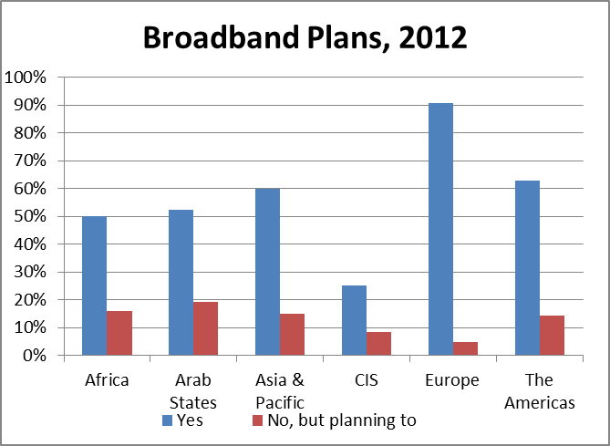

Source: ITU World Telecommunication/ICT Regulatory Database.

## Overview of ICT developments in the Americas

In line with global trends, the Americas region[17] has experienced steady ICT infrastructure development and service uptake since 2008. An increasing number of the almost 950 million people in the region are getting connected and joining the information society.

Apart from the number of fixed-telephone subscriptions, which has been on the decline since 2008, the Americas region shows persistent increases in all key ICT services and penetration rates are above the global average. In particular, the fixed (wired)- broadband penetration rate of 17.1 per cent stands out as close to twice the global average of 9.8 per cent and the percentage of Internet users at 60.8 per cent as almost twice the developing country average of 30.7 by end 2013. Mobile-cellular penetration surpassed the number of inhabitants in 2011 and ITU estimates that by end 2013 regional penetration will have reached 109.4 per cent. The proportion of households with Internet access at home, estimated at 60.8 per cent by end 2013, is remarkable as well and only exceeded by the European region. ITU estimates that by end 2013, mobile-broadband penetration will have reached 48 per cent (see Chart 2.1).

The United States and Canada, the only two developed countries in the region, represent 37 per cent of the region’s total population. High ICT levels in both countries have a strong influence on regional averages and are not always in line with ICT developments in many of the region’s developing countries. The sub-region of Latin America and the Caribbean –which excludes the United States, Canada and Bermuda - has achieved much higher penetration rates than the (larger) Americas region in terms of mobile cellular. In other areas – fixed- and mobile-broadband, and Internet uptake – the sub-region Latin America and the Caribbean lies behind the Americas.

**Chart 2.1: ICT developments in the Americas, 2008-2013\***

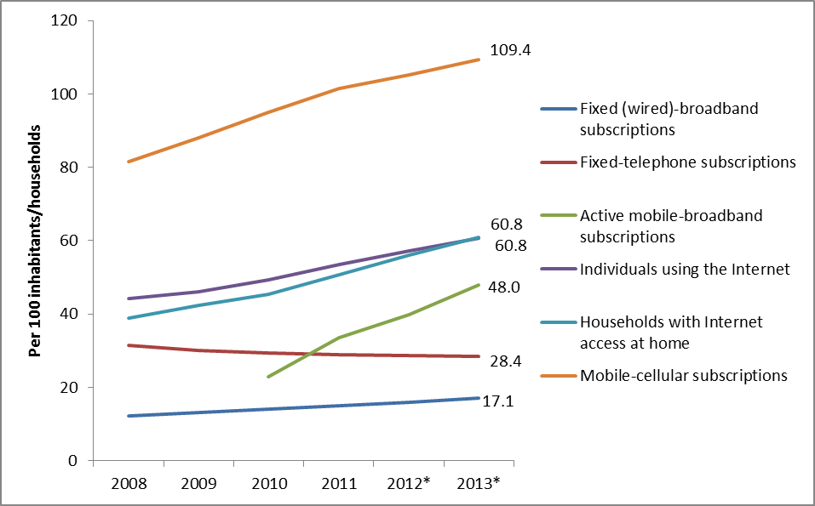

Source: ITU World Telecommunication/ICT Indicators database.

Note: *Estimates.

**Box 1: ITU’s work on statistics**

The data presented in this report are primarily based on ITU’s World Telecommunication/ICT Indicators (WTI) Database. The WTI Database includes more than 100 statistical indicators from over 200 economies worldwide and covers over 50 years. They include three sets of data: (i) telecommunication/ICT infrastructure and access data; (ii) price data for key ICT services; and (iii) data on access to and use of ICTs by households and individuals. As a United Nations Agency, ITU is the official source for global ICT statistics. Data are collected annually from national ICT ministries, telecommunication regulatory authorities and national statistical offices (see [http://www.itu.int/ITU-D/ict/datacollection/](http://www.itu.int/ITU-D/ict/datacollection)).

ITU revises and defines new indicators through its Expert Groups which are open to the ITU membership and experts in the field of ICT statistics. The Expert Group on Telecommunication/ICT Indicators (EGTI) and the Expert Group on ICT Household Indicators (EGH) work through online discussion forums and report back to the World Telecommunication/ICT Indicators Symposium (WTIS). WTIS is the key global forum to discuss ICT measurement issues. The Symposium takes place annually and is targeted to those responsible for ICT statistics in relevant Ministries, regulatory agencies, national statistical offices, telecommunication operating companies and experts in the subject of information society measurements. WTIS 2013 will be held in Mexico City from 4 to 6 December 2013.

For more information and for joining one of the Expert Groups, see: <http://www.itu.int/en/ITU-D/Statistics/Pages/default.aspx>.

The Americas region has seen a consistent increase in ICT penetration from 2008 to 2013, even though the regional 2008-2013 growth rate of key ICT services lags behind the global average. This can be explained by the fact that already in 2008 penetration rates of all key ICT services were considerably above the global average. The strongest growth took place with regards to mobile-broadband services with a compound annual growth rate of close to 30 per cent between 2010 and 2013. The number of households with Internet access registered an important increase as well. From 2010 to 2012 the annual growth rate reached double digits, but is slowing down in 2013 according to ITU estimates. In line with the global trend, growth in the number of mobile-cellular subscriptions has slowed down since 2011, as saturation levels have been reached in most countries (Chart 2.2).

**Chart 2.2: ICT developments in the Americas, annual change, 2008-2013\***

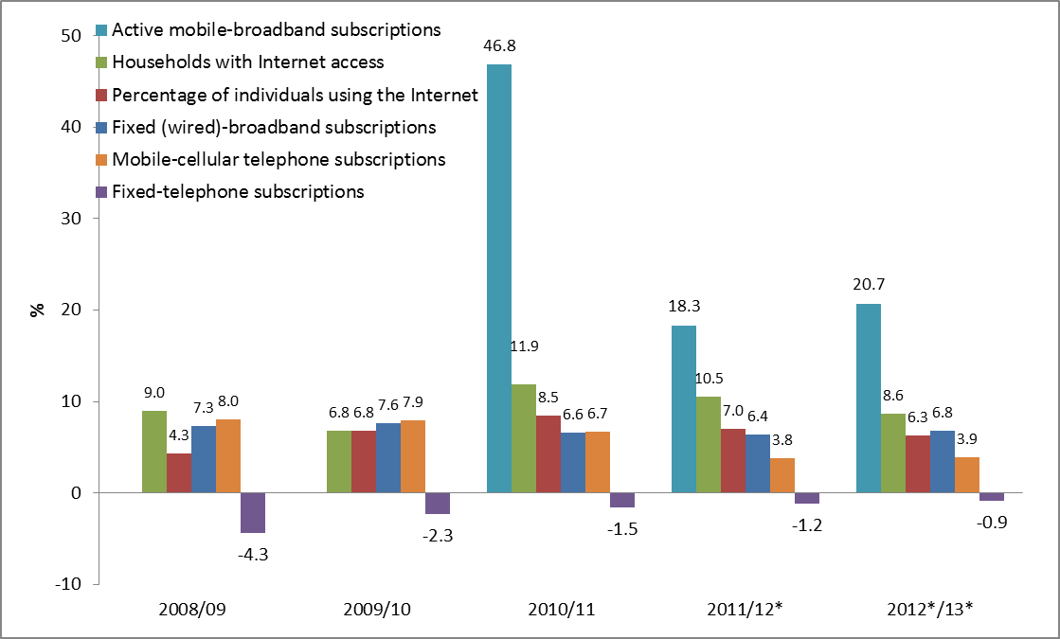

Source: ITU World Telecommunication/ICT Indicators database.

Note: * Estimates.

Mobile-cellular telephone penetration in the Americas is estimated to be at 109.4 per cent by end 2013 and thus above the global (96.2%) and developing country average (89.4%). By end 2012, a total of 21 countries out of the region’s 35 countries had reached penetration levels of 100 per cent and above. This includes economies such as Argentina (142.5%), Brazil (125.2%) and Colombia (103.2%). On the other hand, the United States and Canada had below average mobile-cellular penetration rates of 98.2 and 75.7 per cent in 2012, respectively. Due to relatively lower penetration rates in those two North American countries, the Latin America and Caribbean sub-region’s average (119.5%) is considerably higher than the America region’s overall average (109.4%). Cuba has one of the lowest penetration rates worldwide at 14.9 per cent in 2012. Other countries with lower mobile-cellular penetration include the low and lower-middle income countries[18] Belize (50.6%), Haiti (59.4%) and Guyana (72.2%). Penetration also remains below the developing country average in the Bahamas with 72.3 per cent in 2012 (Chart 2.3).

**Chart 2.3: Mobile-cellular subscriptions in the Americas, 2012 (top), and by region and level of development, 2013*(bottom)**

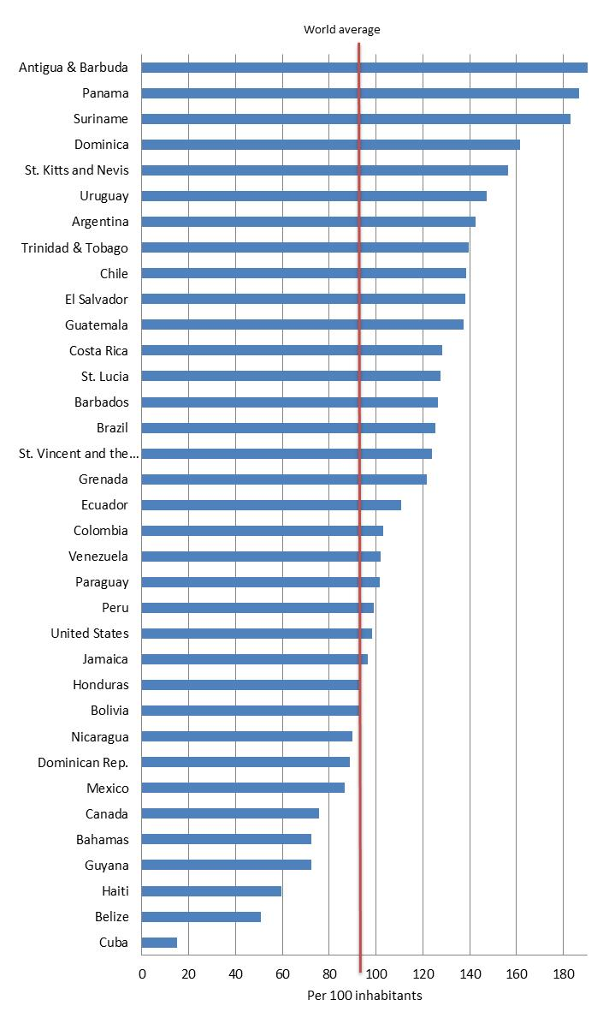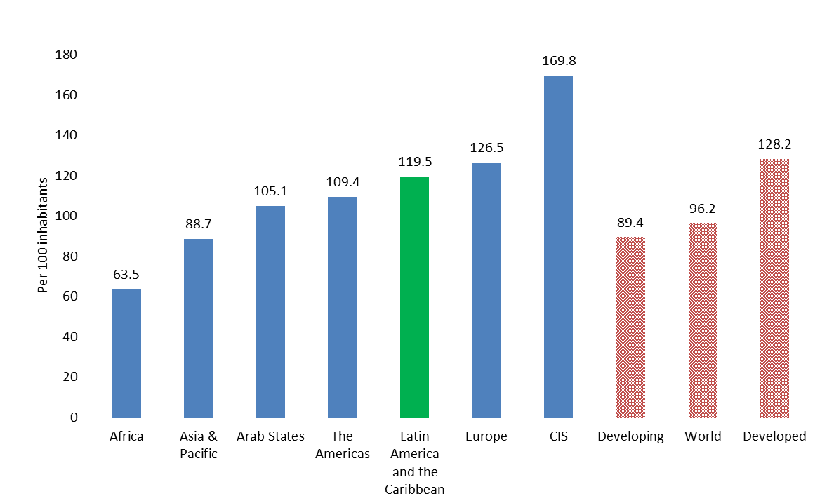

Source: ITU World Telecommunication/ICT Indicators database.

Note: *Estimates. The red line in the left-hand-side chart shows the 2012 world average.

ITU estimates that the Americas region will have a total of 460 million mobile-broadband subscriptions by end 2013, over 80 million more than the year before. At 48 per cent, regional mobile-broadband penetration is estimated to be higher than the global average (29.5%) and second highest of all regions - only topped by Europe with a penetration rate of 67.5 per cent by end 2013. The sub-regional average mobile-broadband penetration for Latin America and the Caribbean (26.2%) is much lower, suggesting that there is an important divide between the North and the rest of the Americas region. Indeed, penetration is highest in the high-income North American countries of the United States (74.7%) and Canada (50%). The regional average is strongly influenced by the United States, the region’s most populous country, as well as Brazil, which also has a huge market in terms of population and a relatively high mobile-broadband penetration of 36.6 per cent in 2012. With this, Brazil’s mobile-broadband penetration stands above the 2012 world average. On the other hand, in seven out of 35 countries included in the region, 3G networks had not been launched by 2012 and a number of countries had very low penetration rates of below 5 per cent (Chart 2.4).

**Chart 2.4: Active mobile-broadband subscriptions in the Americas 2012 (top), and by region and level of development, 2013* (bottom)**

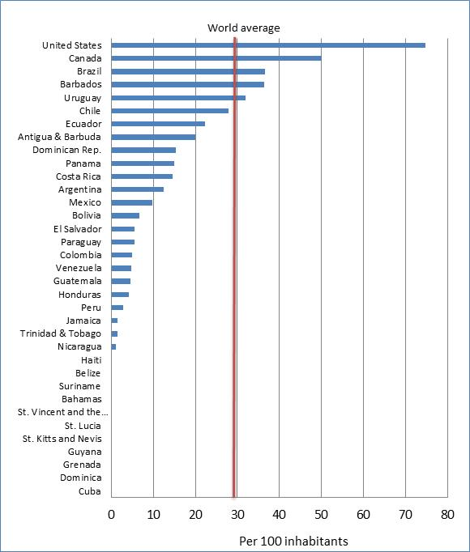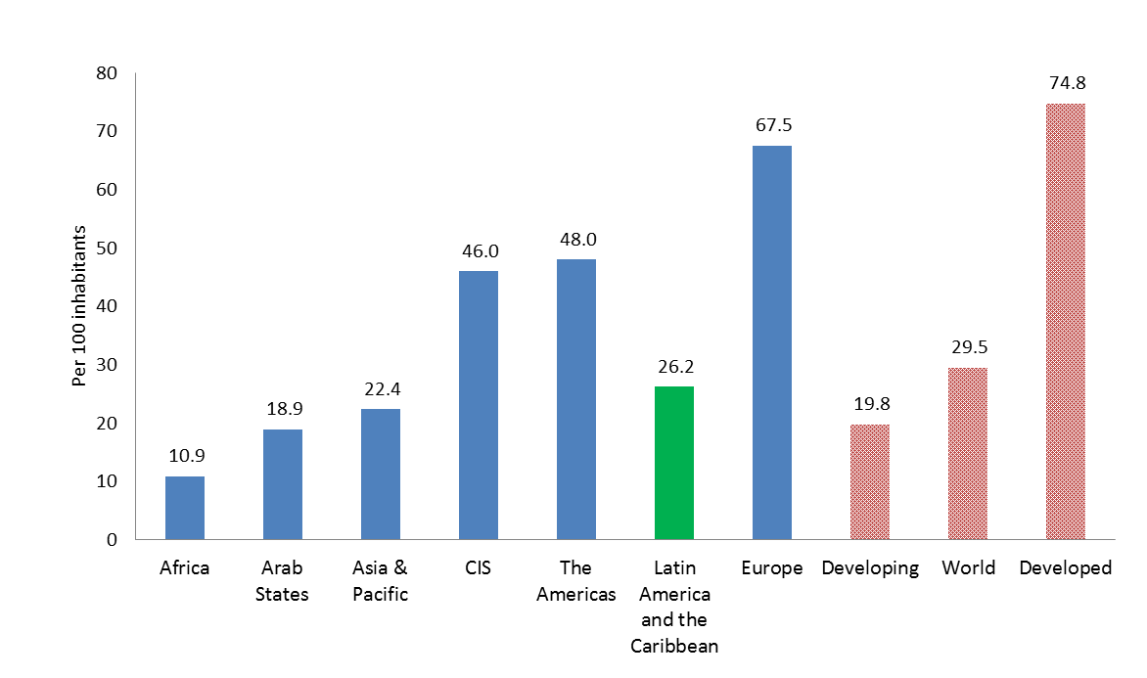

Source: ITU World Telecommunication/ICT Indicators database.

Note: *Estimates. The red line in the top chart shows the 2012 world average.

Fixed (wired)-broadband penetration in the Americas region is relatively high at 17.1 per cent by end 2013, above the global average of 9.8 per cent, almost three times the developing country average, and more than twice that of the Asia and the Pacific region. The Latin America and the Caribbean sub-regional average of 9.9 per cent, however, is just slightly above the global average. The highest penetration rates can be found outside the sub-region, in the region’s two developed countries Canada (32.9% in 2012) and the United States (28% in 2012). Uruguay’s fixed (wired)-broadband penetration of 16.6 per cent in 2012 also stands above the global and developing country averages. In a number of countries that have launched 3G services, fixed (wired)- broadband access continues to dominate. Peru, Columbia and Venezuela all have relatively low mobile-broadband penetration rates, but higher fixed (wired)- broadband penetration numbers. In Mexico, fixed (wired)- and mobile-broadband penetration levels are similar, at around 10 per cent in 2012 (Chart 2.5).

**Chart 2.5: Fixed (wired)-broadband subscriptions in the Americas, 2012 (top) and by region and level of development, 2013* (bottom)**

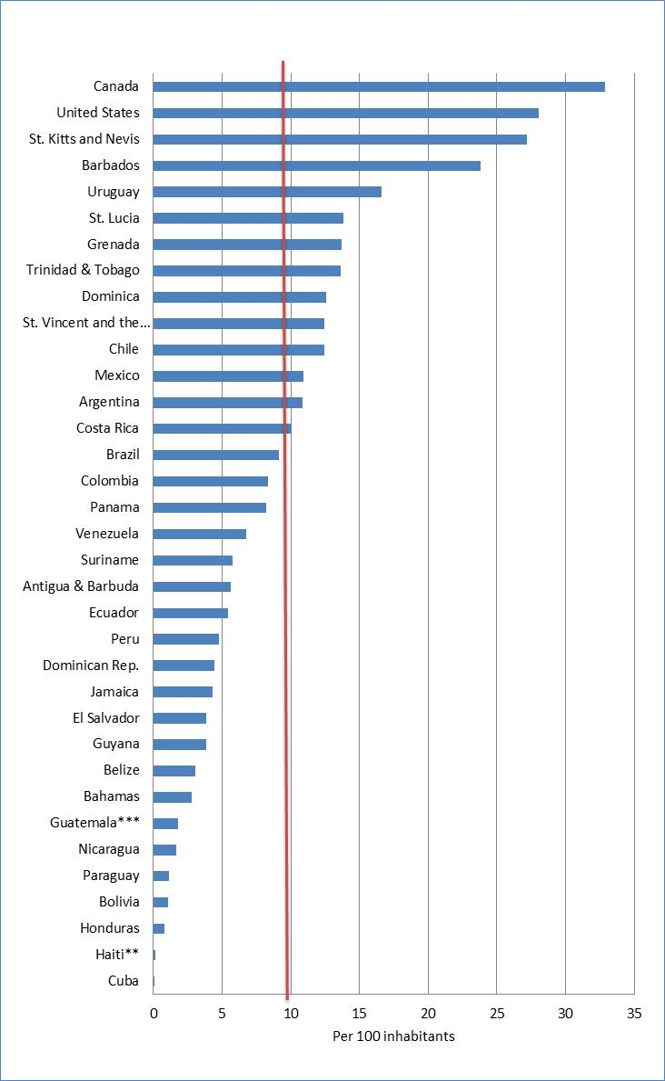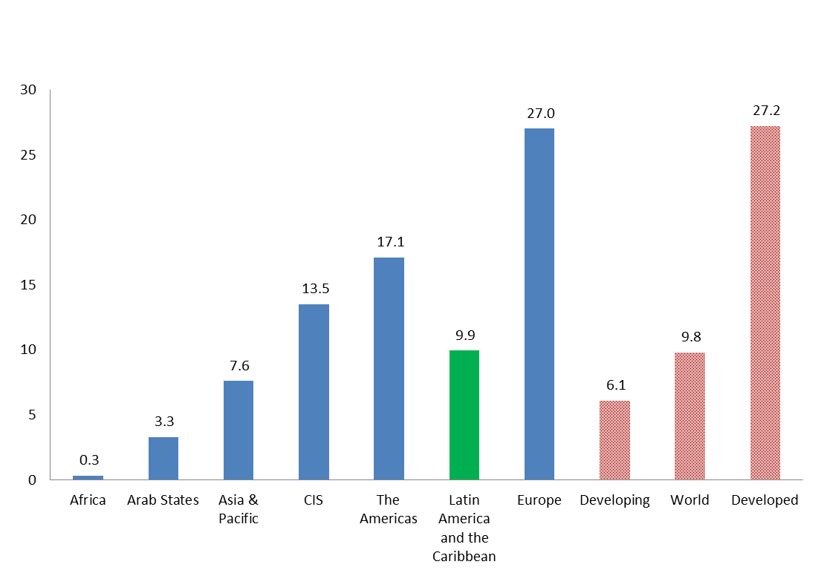

Source: ITU World Telecommunication/ICT Indicators database.

Note: *Estimates. ** Refers to 2011 *** Refers to 2010. The red line in the top chart shows the 2012 world average.

More than 60 per cent of the population of the Americas region - a total of 582 million people - will be online by end 2013. The regional average is twice that of the developing country average of 30.7 per cent and only Europe is home to a higher proportion of Internet users. In the Latin America and the Caribbean sub-region, close to half the population (46.8%) is using the Internet in 2013, considerably more than in the developing countries (30.7%) and more than globally (38.8%). Internet user penetration in the Americas region varies from over 80 per cent in the USA and Canada, to below 20 per cent in Honduras, Guatemala, Nicaragua and Haiti (Chart 2.6).

**Chart 2.6: Percentage of individuals using the Internet, in the Americas, 2012 (top) and by region and level of development, 2013* (bottom)**

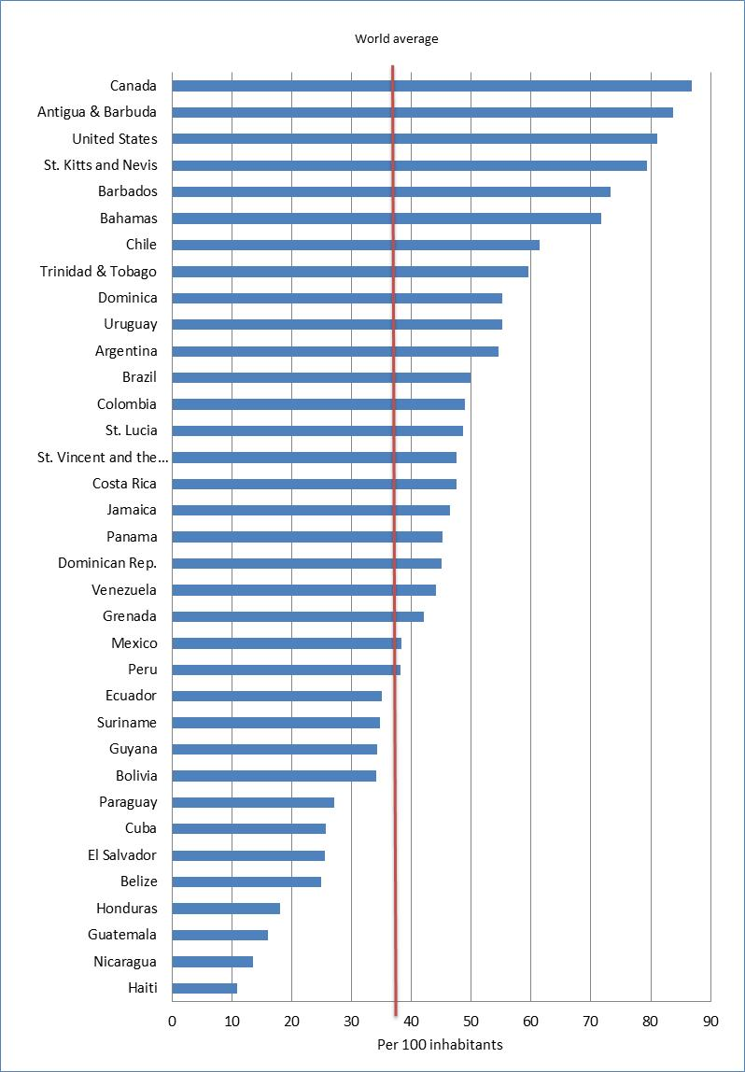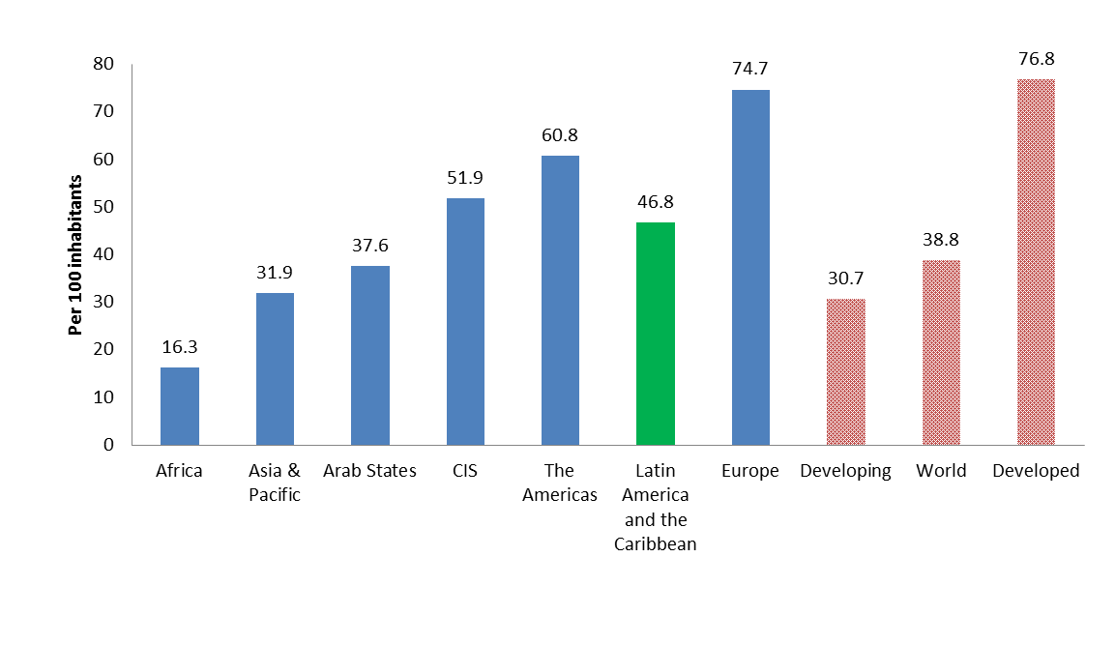

Source: ITU World Telecommunication/ICT Indicators database.

Note: *Estimates. The red line in the top chart shows the 2012 world average.

Young people are much more likely to be online in the Americas region, similar to what is happening in other regions. In most of the developing countries shown in Chart 2.7, penetration rates among the 15-24 year olds are more than twice as high as among those 25-74 years old. In Ecuador, for example, 60 per cent of people aged 15-24 were online in 2011 compared to only 22 per cent of 25-74 year olds. In Ecuador Internet penetration is almost three times as high amongst the younger population group. The difference is less pronounced in the region’s developed economies that have reached high penetration rates. In Canada, virtually all 15-24 year olds were online in 2010, compared to 82 per cent of people aged 25-74 years (Chart 2.7).

**Chart 2.7: Proportion of individuals using the Internet in selected countries in the Americas, by age, latest available year**

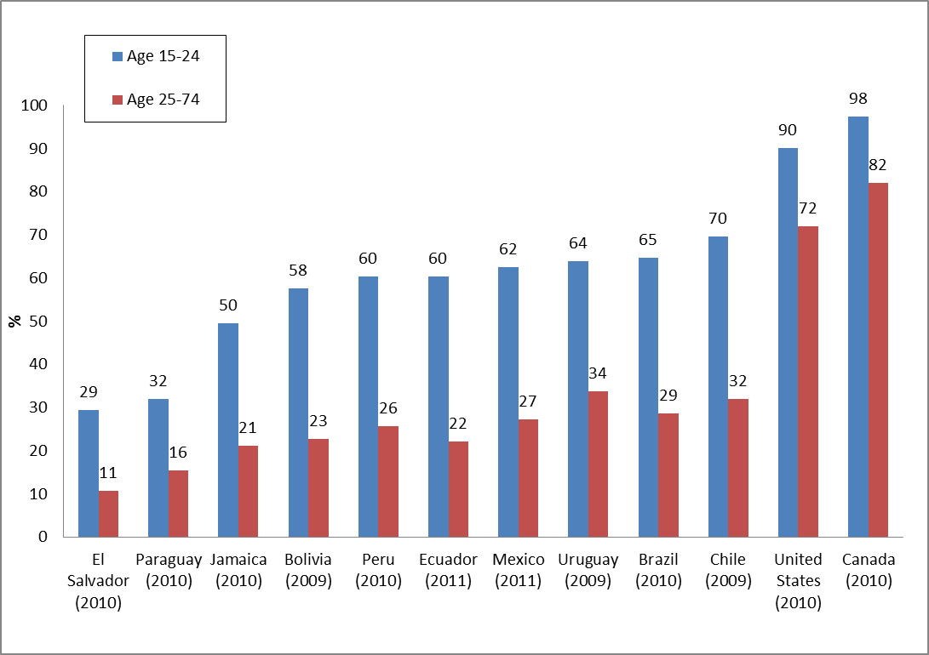

Source: ITU World Telecommunication/ICT Indicators database.

By end 2013, ITU estimates that the proportion of households with Internet access in the Americas, at 60.8 per cent, will be above the global (41.3 %) and twice as high as the developing country average (28.0 %). There is, however, still room for improvement in the region’s developing countries, as the much lower average number of households with Internet access (39.8%) in the Latin America and the Caribbean sub-region underlines. In the region’s two developed countries Canada and the United States, the percentage of households with Internet access in 2012 reaches top levels at 83 per cent and 75 per cent, respectively. In six out of the region’s 33 developing countries the proportion of households with Internet access lies below ten per cent. High penetration numbers are reached in a number of the region’s developing countries: in 2012, the number of households with Internet access exceeded the global average in Barbados, St. Vincent and the Grenadines, Uruguay, Antigua and Barbuda, Argentina, Costa Rica, Brazil, Chile and Trinidad and Tobago (Chart 2.8).

**Chart 2.8: Households with Internet access in the Americas, 2012 (top) and by region and level of development, 2013* (bottom)**

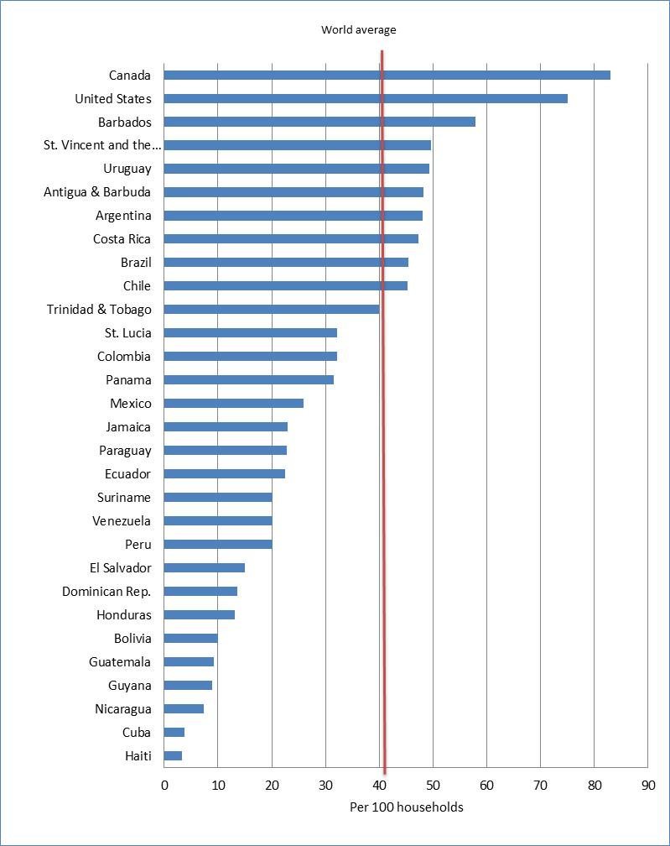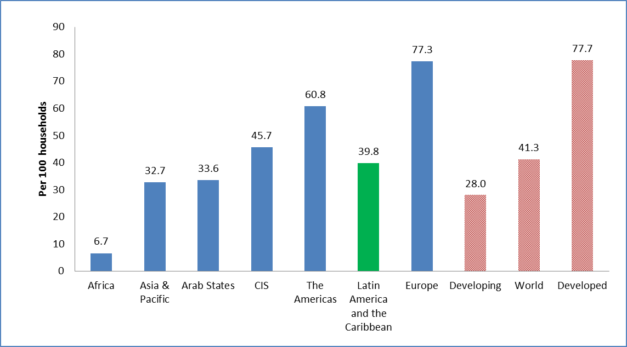

Source: ITU World Telecommunication/ICT Indicators database.

Note: *Estimates. Data for Bahamas, Belize, Dominica, Grenada and St. Kitts and Nevis are not available. The red line in the top chart shows the 2012 world average.

The next two sections feature a regional analysis of the ITU ICT Development Index (IDI) and the ICT Price Basket (IPB), two ICT benchmarking tools published by ITU in 2012 (ITU, 2012).

## The ICT Development Index (IDI) in the Americas[19]

The ICT Development Index (IDI) is a composite index combining 11 indicators into one benchmark measure that serves to monitor and compare developments in information and communication technology (ICT) across countries. The IDI is divided into the following three sub-indices and is measured on a scale from a minimum/low of 0 to a maximum/high of 10:

* *Access sub-index*: This sub-index captures ICT readiness, and includes five infrastructure and access indicators (fixed-telephone subscriptions, mobile-cellular telephone subscriptions, international Internet bandwidth per Internet user, percentage of households with a computer, and percentage of households with Internet access).
* *Use sub-index*: This sub-index captures ICT intensity, and includes three ICT intensity and usage indicators (percentage of Internet users, fixed (wired)-broadband subscriptions, and active mobile-broadband subscriptions[20]).
* *Skills sub-index*: This sub-index captures ICT capability or skills as indispensable input indicators. It includes three proxy indicators (adult literacy, gross secondary enrolment and gross tertiary enrolment), and therefore is given less weight in the computation of the IDI compared with the other two sub-indices.[21]

An analysis of the IDI highlights differences in ICT developments globally, and regionally. By looking at the regional level, it is possible to highlight trends and identify reasons why some countries are doing better than others, or lagging behind. Among the six regions, the Americas[22] ranks third in the IDI, with an average 2011 IDI value of 4.26, behind Europe and CIS but ahead of the Asia and the Pacific region, the Arab States and Africa. The America’s average IDI value is slightly above the world average IDI value of 4.15 (Chart 3.1).

**Chart 3.1: IDI by region, ranges and averages, 2011**

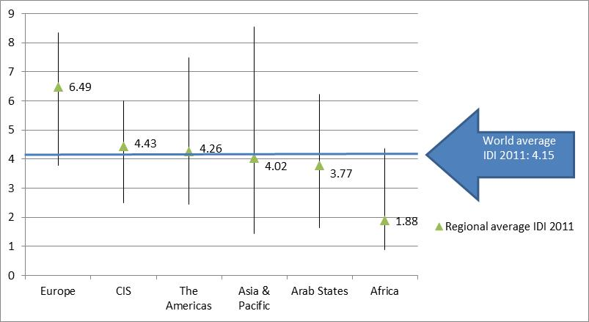

Source: ITU World Telecommunication/ICT Indicators database.

Note: Simple averages.

An analysis of regional IDI ranges – calculated by deducting the lowest value from the highest value – and coefficients of variation provide additional insights into differences in ICT level within each region (Table 3.1). The Americas has a coefficient of variation value of 30.05, which is higher than in Europe and the CIS, but somewhat lower than in regions where differences in ICT development are very distinct such as the Asia and the Pacific region. Still, the range of IDI values is quite high (at 5.04) indicating that countries in the region are at very different stages in terms of ICT development.

**Table 3.1: IDI by region, 2010 and 2011**

Source: ITU.

Note: StDev= Standard deviation; CV= Coefficient of variation

The regional IDI ranking is headed by the North American developed countries United States and Canada. Both achieved an IDI of above seven. The IDI scores for all other countries from the Americas region remain below seven, El Salvador, Cuba, Honduras and Nicaragua ranking last with an IDI of below three (see Table 3.2). The Americas region has the second highest range in IDI values (after the Asia and the Pacific region). This reflects the diversity of the region which comprises, at one end of the scale, the two rich, developed countries (United States and Canada), which are very advanced in terms of ICT development, and, at the other end of the scale, lower-income developing countries. Nevertheless, the region has a relatively strong centre with most countries attaining IDI values of between three to five, and the regional average IDI of 4.26 is above the global average of 4.15 (see Chart 3.1).

**Table 3.2: IDI-The Americas**

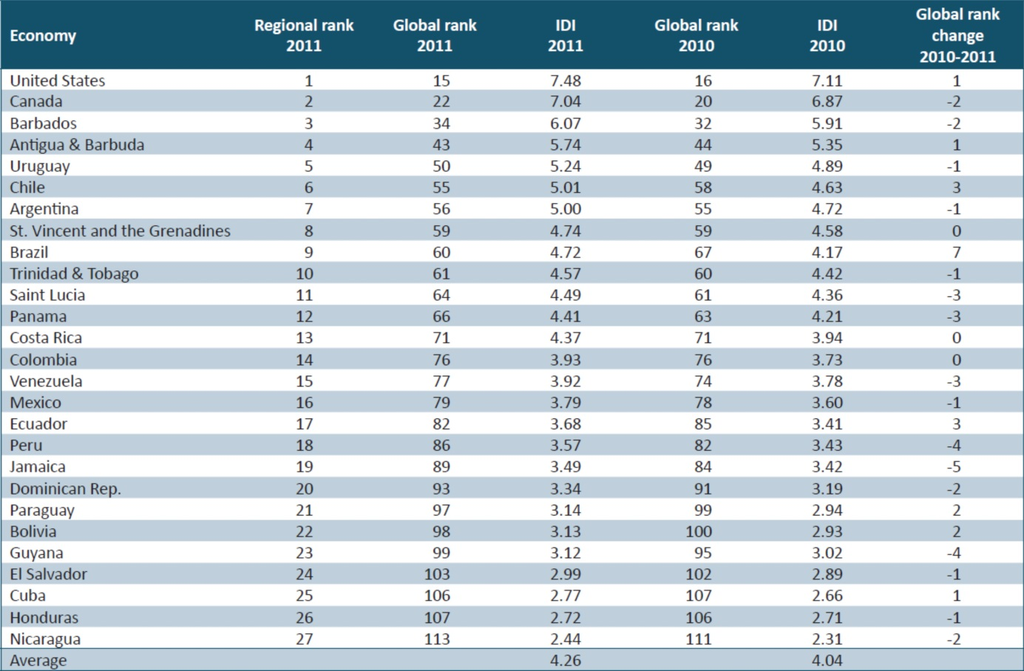

Source: ITU.

Two countries from the Americas region, Brazil and Costa Rica, are among those that made most progress in the IDI from 2010 to 2011 (Box 3.1). Both countries likewise feature among the most dynamic countries in terms of the access sub-index, which also include Ecuador and Uruguay. All four countries made impressive strides in connecting more households to the Internet, especially Brazil, where the proportion of households with Internet access shot up from 27 per cent in 2010 to 38 per cent in 2011. Mobile-cellular penetration also increased, in particular in Costa Rica, where the mobile market was liberalized in 2011. The majority of countries in the region now exceed 100 per cent mobile-cellular penetration. The United States was one of the last developed countries to pass this threshold, penetration having increased to 106 per cent in 2011. A number of Caribbean island states, which are small in terms of population and thus total number of Internet users, have very high international Internet bandwidth per Internet user. For example, St. Vincent and the Grenadines boasts the second highest ratio worldwide, after Hong Kong (China). Antigua and Barbuda, Barbados and Costa Rica likewise have very high bandwidth per Internet user.

**Box 3.1: Brazil and Costa Rica are the most dynamic IDI countries from the Americas region**

Brazil and Costa Rica were the most dynamic countries in the Americas in terms of changes in IDI ranking, as well as absolute and relative IDI value changes. The spider charts (Figure Box 3.1) illustrate these countries’ normalized values, and changes between 2010 and 2011, for each of the 11 indicators included in the IDI and highlights achievements that have led to improvements in the IDI:

**Brazil** moved up seven places in the IDI between 2010 and 2011, to 60th, with an increase in IDI of 0.54. Mobile-cellular penetration showed impressive gains, and the percentage of households with a computer and with Internet access increased by more than 10 percentage points, to 45 and 38 per cent, respectively. The growth in household Internet access is a first result of Brazil’s national broadband plan – *Programa Nacional* *de Banda Larga* (PNBL) – which has been implemented with effect from May 2010. The goal of the plan is to bring fast (at least 1 Mbit/s) and affordable broadband access to 40 million Brazilian households by 2014 (CGPID, 2010). Rural areas are targeted in particular, in order to deliver government and health services as well as e-education. Agreements have been concluded with a number of Brazilian operators to extend broadband access to communities and cap monthly subscription prices at USD 30 to 35 for connections offering speeds of 1 Mbit/s.[23] In the IDI use sub-index, improvements were made in the number of Internet users, which stands at 45 per cent in 2011, and in mobile-broadband penetration. The latter almost doubled, from 11 per cent in 2010 to 21 per cent in 2011, which is the highest penetration in Latin America, and the third highest in the Americas region, after the United States and Canada. Many customers are switching from 2G to 3G services. The share of GSM (2G)-enabled subscriptions peaked in November 2009 (at 90%) and has since been on the decline, while the share of 3G-enabled subscriptions is growing.[24]

**Costa Rica** ranks 71st in the 2011 IDI, with an increase of 0.43 in its IDI, one of the largest absolute increases and more than twice the global average change. The access sub-index grew most, mainly thanks to a steep increase in the percentage of households with Internet access. Most remarkable is the increase in the country’s mobile-cellular penetration, from 65 per cent in 2010 to 92 per cent in 2011. For a long time, Costa Rica had been lagging behind other Latin American countries in terms of mobile-cellular uptake, but it has now caught up. In 2011, the country experienced major alterations in its telecommunication landscape: in the run-up to the liberalization of the telecommunication market in late 2011, incumbent ICE introduced prepaid mobile cellular offers in 2010[25] and two new mobile operators[26] started business in November 2011. These developments could herald future increases in the index. In 2011, mobile-broadband penetration remains minimal, at around 2 per cent, but new entrants are expected to accelerate 3G roll-out.

**Figure Box 3.1: Spider charts, IDI changes in Brazil (left) and Costa Rica (right), 2010 to 2011**

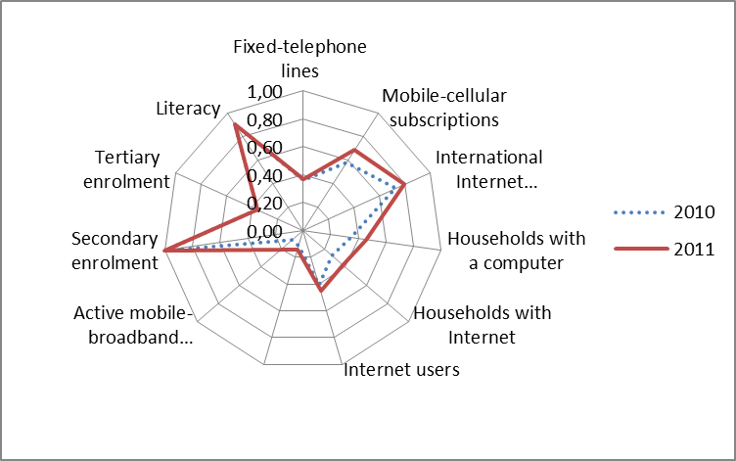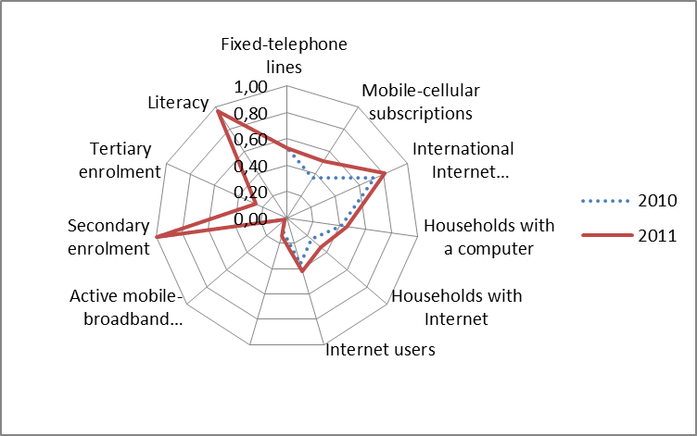

Source: ITU.

In the use sub-index of the IDI, by far the largest increases in the region were in mobile-broadband penetration. For example, mobile-broadband penetration more than doubled in Brazil and Chile, to 17 and 21 per cent, respectively, by end 2011. Following the launch of 3G in Antigua and Barbuda in 2011, the country reached an impressive 20 per cent penetration by the end of the year. Five countries from the Americas included in the IDI – Cuba, Barbados, Guyana, St. Vincent and the Grenadines and Saint Lucia – remain without mobile-broadband services in 2011[27]. In the latter three, however, fixed (wired) broadband is important, and reaches a relatively high penetration level in Barbados (22%). The United States is one of the countries with the highest broadband penetration levels worldwide, recording a mobile-broadband penetration of 65 per cent and a fixed (wired)-broadband penetration of 29 per cent in 2011. Canada does equally well in global comparison, with penetration rates of around 32 per cent for both indicators.

While the United States and Canada are among the highest ranked countries on all three indicators making up the use sub-index, most other countries in the region still display relatively low use sub-index values. A number of countries have seen their global ranking fall from 2010 to 2011, mostly because of lack of growth in the use sub-index. In particular, this includes countries where 3G services have not yet been launched (such as Guyana and Saint Lucia), as well as countries where penetration is low and growth rates are marginal (such as Peru and Venezuela). It is noteworthy that, in a number of countries, the IDI use sub-index lags behind the potential suggested by a relatively high access sub-index. Panama and Costa Rica, for instance, have above-average access sub-index values of 5.16 and 5.28, but their use sub-index scores of 2.34 and 1.95, respectively, remain below the global average. The same holds true for Saint Lucia and St. Vincent and the Grenadines. All of these countries harbor considerable potential for increasing ICT usage, but have yet to make full use of their relatively well developed ICT infrastructure. In Costa Rica, Saint Lucia and St. Vincent and the Grenadines, the skills sub-index value is below the global average, which may help to explain why ICT usage is low despite relatively widespread ICT access.

## The ICT Price Basket (IPB) in the Americas[28]

The ITU ICT Price Basket (IPB) is a global benchmarking tool that provides insightful information on the cost and affordability of ICT services. The IPB is composed of three distinct prices – for fixed-telephone, mobile-cellular and fixed-broadband services – and computed as a percentage of countries’ average gross national income (GNI) per capita. This puts prices into perspective, and makes it possible to monitor the affordability of ICT services. Prices are also presented in United States dollars (USD) and in purchasing power parity (PPP) terms, but countries are ranked on the basis of the relative cost (or affordability) of ICT services within the country, i.e. as a percentage of GNI per capita.

A regional comparison of the IPB between 2008 and 2011 shows that while over this four-year period the price of ICT services fell in all regions of the world, services remain much more affordable in some regions than in others. With an average 2011 IPB value of 5.5, ICT services in the Americas are more expensive than in Europe and the CIS, but less than in the Arab States, Asia and the Pacific and Africa. The Americas region showed a relatively moderate price decrease in the period from 2008 to 2011 (around 10% on average). However, the Americas is the only region where prices fell more between 2010 and 2011 than between 2009 and 2010, and the region actually witnessed the highest IPB value drop of 11.9 per cent that year, just ahead of the Arab States (11.6%) (Chart 4.1).

**Chart 4.1: ICT Price Basket by region, 2008-2011**

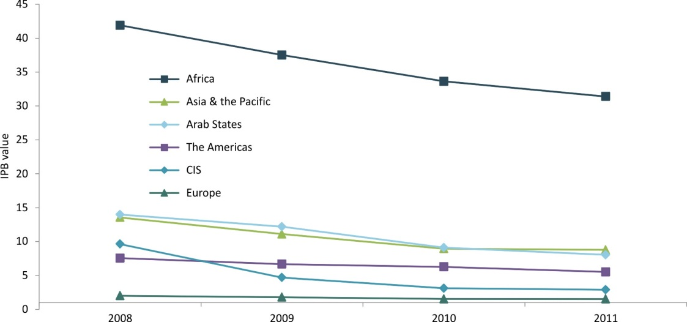

Source: ITU.

Note: Simple averages. The regional averages in this chart are based on prices for the 144 countries for which prices are available for 2008, 2009, 2010 and 2011.

The 2011 ICT Price Basket values in the Americas range from 0.6 in the United States, which ranks tenth globally, to 36 in Cuba, ranked 142nd out of the 161 economies included in the IPB. Only the United States and Canada – the region’s sole developed economies that stand out for their relatively high GNI per capita levels compared to other countries in the region – have an IPB value of below 1 per cent. The IPB represents less than 2 per cent of average monthly GNI per capita in Trinidad and Tobago, Bahamas, Costa Rica and Venezuela. In a total of 20 out of 34 countries in the region, the IPB represents less than 4 per cent of GNI p.c. (Table 4.1).

**Table 4.1: IPB and sub-baskets (USD, PPP$ and as a percentage of GNI per capita), 2011, the Americas**

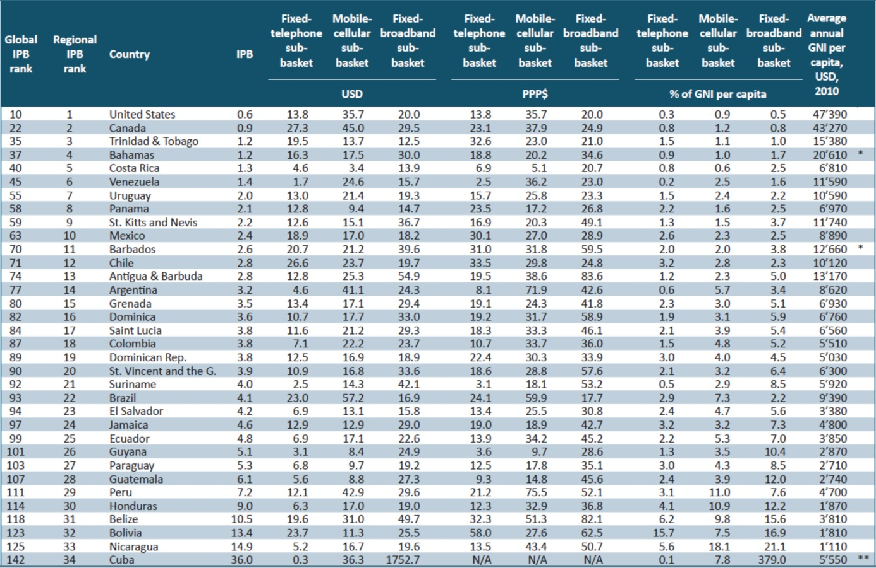

Source: ITU. GNI and PPP$ values are based on World Bank data.

Note: N/A – Not available. *2009. **2008.

While higher income economies tend to have relatively lower ICT prices, a number of countries in the region offer relatively affordable ICT services in relation to what their average GNI per capita level would predict. Costa Rica, for example, but also Panama and Mexico, have annual GNI per capita levels of below USD 10’000 but rank in the top ten economies with the most affordable ICT prices in the region.

Chart 4.2 provides a comparison of prices in terms of purchasing power parity (which takes into account the national buying power of a local currency), and highlights differences between countries in terms of their mobile-cellular and fixed-broadband services.

**Chart 4.2: Purchasing power adjusted ICT prices in the Americas, 2011**

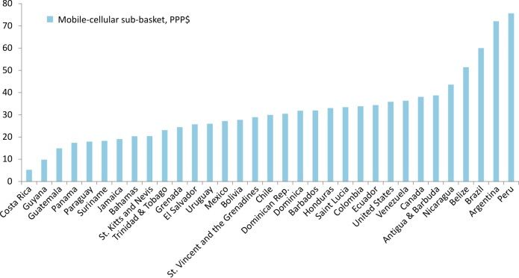

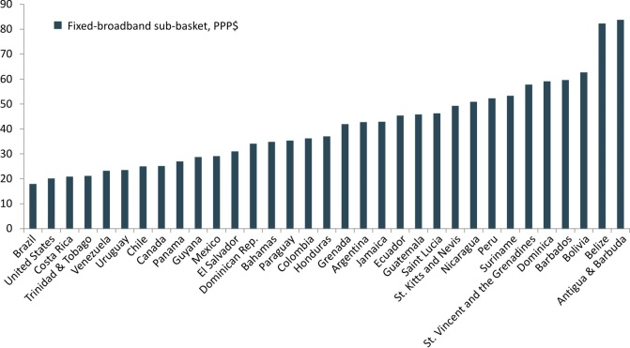

Source: ITU. PPP$ values are based on World Bank data.

Note: Cuba is not included, since PPP$ values are not available.

Within the region, both the United States and Canada, where ICT prices are very affordable and which rank high in terms of the overall IPB and the three sub-baskets, show relatively low PPP-adjusted fixed-broadband basket values, yet relatively high PPP$ values for the mobile-cellular sub-basket. One explanation is that the mobile-cellular sub-basket is likely to overestimate the cost of mobile-cellular services (and the price per minute) because in both the United States and Canada the low-user basket is not representative. Indeed, the United States Wireless Association (CTIA) has repeatedly highlighted that on average US-Americans make a much higher number of calls from mobile phones than other countries, and that the price per minute of low-user packages is not representative, and is high, compared to the packages to which most US citizens subscribe.[29] A review of OECD mobile-cellular packages and rankings similarly showed that Canada ranks low (showing relatively high prices) in low-volume packages, but high (showing relatively low prices) in high-volume packages. In the OECD 30-calls basket (which is the one on which ITU’s mobile-cellular sub-basket is based), Canada ranks second last, but it comes in at rank five on the OECD (high-volume) 900-minutes basket (Nordicity, 2011).

A number of countries, including Costa Rica, Panama and Trinidad and Tobago, have low PPP-adjusted prices for both mobile-cellular and fixed-broadband services. At PPP$ 5.1, Costa Rica’s 2011 mobile-cellular sub-basket was the cheapest in the region, and the country’s PPP$- adjusted fixed-broadband sub-basket, at PPP$ 20.7, is also relatively low. Even though until 2011 Costa Rica had one of the last remaining state telecommunication monopolies in Latin America (and, indeed, in the world), prices for ICT services have been relatively reasonable. Thus, the lack of liberalization does not seem to have had a negative impact on prices. On the other hand, penetration rates in Costa Rica have remained below average. Mobile-cellular penetration, for example, stood at only 65 per cent in 2010 and 92 per cent in 2011, as compared with the Latin American average of 95 and 103 per cent in 2010 and 2011, respectively. According to some analysts, this is due to a low level of network and customer service, as well as a lack of mobile-cellular prepaid services, which were only introduced in 2011.[30] While competition in the mobile-cellular market may not necessarily drive down prices, it could improve quality of service, and increase penetration rates in the years to come.

Both Brazil and Venezuela have relatively high PPP$ mobile-cellular sub-baskets but at the same time offer relatively cheap fixed-broadband services. A growing number of countries are paying special attention to the spread and uptake of broadband networks and services, and have introduced national broadband plans, which are often linked to efforts to bring down prices and make broadband more affordable. Latin America is no exception. In Brazil and Venezuela, as well as in Costa Rica and Uruguay, there have been increasing government efforts to develop access to broadband networks, not only by introducing more entry-level broadband offers, but also by lowering prices. Government initiatives in Venezuela, Costa Rica and Uruguay are carried out through public operators, whereas in Brazil they are achieved through agreements with the private sector and targeted government policies, including by increasing competition in the wholesale market to reduce end user prices (Galperin 2012, ITU 2011).

Regulatory mechanisms, such as the introduction of mobile virtual network operators (MVNO) and the reduction of mobile termination rates (MTR), have been used across the region to boost competition, reduce some operators’ market dominance and thereby bring down mobile-cellular prices. In Mexico, Cofetel was able to drastically reduce mobile termination rates at the end of 2011, which quickly resulted in lower retail prices and all operators announcing call price cuts.[31] This will exert a further positive impact on mobile-cellular prices in Mexico. Another market development which has started to spread in the region is the increasing introduction of MVNOs, an area where Latin America has traditionally lagged behind other regions. While in 2010 the Latin American market was home to about 15 per cent of the world’s mobile-cellular subscriptions, it represented less than one per cent of the global MVNO subscriber base.[32] In early 2010, Chile was the only country in the region with an approved MVNO-specific regulation, although some MVNOs were operating in Brazil, Colombia, Ecuador and Mexico.[33] Since then, more countries have started to regulate MVNOs and are encouraging the entrance of alternative operators, which is likely to further enhance competition.[34]

**Mobile Broadband prices in the Americas**

In view of their growth rates and their potential for connecting more and more people to the Internet, the price and affordability of mobile-broadband services is becoming an important issue. With this in mind, in 2011, ITU conducted a pilot mobile-broadband price data collection exercise covering 127 countries, with the aim of understanding the methodological constraints and difficulties involved and of gaining insights into the affordability of mobile-broadband services. These mobile-broadband prices are not included in the IPB but were collected and analyzed separately (ITU, 2012).

The price of mobile-broadband services in the Americas stays below the world and developing country averages with a cost of 4.9 per cent of GNI p.c. for postpaid computer-based services and 10.9 per cent of GNI p.c. for prepaid handset-based offers in 2011.Postpaid computer-based services in particular are relatively affordable and below 5 per cent of monthly GNI per capita, a target set by the Broadband Commission for Digital Development for entry-level broadband services. Mobile-broadband services are most affordable in high-income countries. A number of lower-middle-income and upper-middle-income countries in the region, however, stand out for their competitive offers. Prices for prepaid handset-based and postpaid computer-based mobile broadband in upper-middle-income countries such as Costa Rica, Panama and Venezuela are below 3 per cent of GNI per capita. In the Americas, broadband services were priced below the 5 per cent of GNI per capita threshold set by the Broadband Commission in 16 out of 34 countries for fixed-broadband and in 7 out of 22 countries for prepaid and postpaid mobile-broadband. In four countries postpaid computer-based services were below the 5 per cent of GNI per capita threshold (Table 4.2). Both postpaid and prepaid mobile broadband are cheaper on average than fixed broadband services in the region.

**Table 4.2: Mobile-broadband prices in USD and as a percentage of GNI per capita, 2011, the Americas**

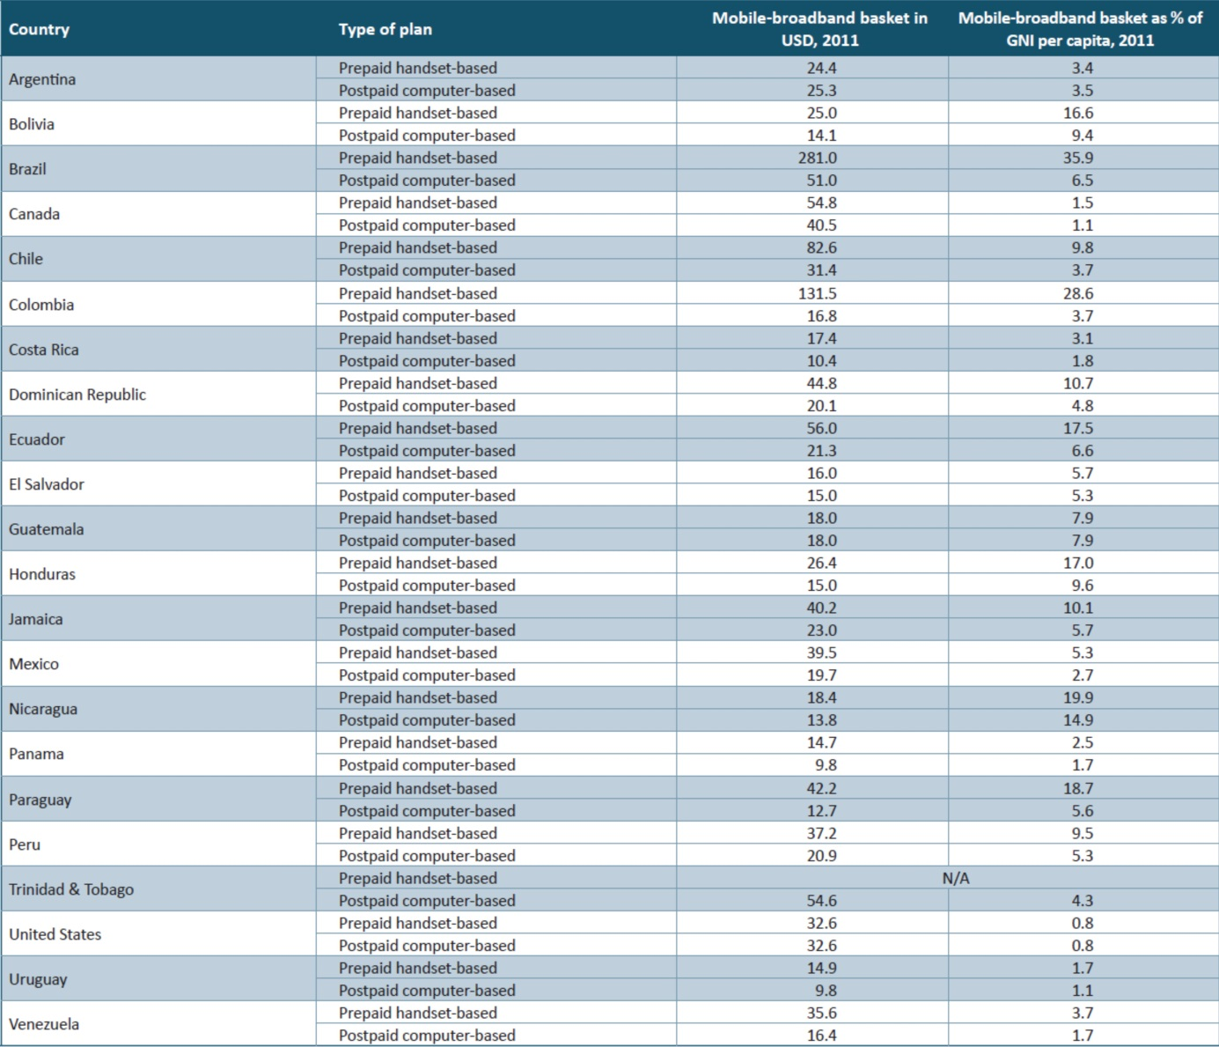

Source: ITU.

Note: N/A – Not available.

## Conclusions

ICT penetration in the Americas stands above the global average for all key services. The region is relatively diverse in terms of income and ICT levels and regional penetration rates are driven up by the United States, the Americas’ most populous country and Canada. In Brazil, the region’s developing country with the largest population, penetration levels are above the global average for all key ICT services. In the region’s lower-income countries, ICT use and uptake are limited and services largely unaffordable. The region also shows a pronounced mobile-broadband divide and the uptake of mobile-broadband services remains limited in a large number of countries.

Most economies in the region have comparatively high mobile-cellular penetration rates and mobile markets are reaching saturation levels. A number of policies could help to incentivize sustainable competition in the mobile markets. As Universal Service Funds were established and are operational in a number of countries in the region, these funds could be used to a greater extent to foster broadband infrastructure deployment and stimulate demand up take.

Affordable fixed- and mobile-broadband services will help bring a greater number of people in the Americas online. Thus, the further spread of affordable broadband is the major challenge in the years ahead, in particular in countries with a huge landmass, such as Brazil and Argentina or very low level of development, such as Haiti. Countries can leverage on the existing mobile-cellular networks and sustain the development of mobile markets by expanding mobile-broadband growth. Policy-makers and regulators can play a major role in accelerating the transition from traditional mobile-cellular services to mobile-broadband services. This includes providing a regulatory environment and licensing regulation in particular, spectrum licensing, that is conducive to investment in 3G and advanced wireless-broadband networks, such as LTE.

## References

Galperin, H. (2012), *Broadband tariffs in Latin America and the Caribbean: Benchmarking and trends*, Policy Brief, Dialogo Regional sobre Sociedad de la Informacion (DIRSI), University of San Andres, Argentina, 2012. Available at:

http://www.dirsi.net/sites/default/files/Hern%C3%A1n%20Galper%C3%ADn%20-%20policy_brief_english.pdf.

ITU (2013), *Trends in Telecommunication Reform: Transnational aspects of regulation in a networked society*. Available at: <http://www.itu.int/en/ITU-D/Regulatory-Market/Pages/Regulatory-Publications.aspx>

ITU (2012), *Trends in telecommunication Reform: Smart regulation in a broadband world*. Available at:  <http://www.itu.int/pub/D-REG-TTR.13-2012>

ITU (2012), *Measuring the Information Society 2012*. Available at:

<http://www.itu.int/ITU-D/ict/publications/idi/material/2012/MIS2012_without_Annex_4.pdf>.

ITU (2012) Study for the Connect Americas Summit 2012 *on Regulatory Impact*

*of Convergence and Broadband for the Americas.* Available at: <http://www.itu.int/net/ITU-D/CDS/gq/generic/asp-reference/gq_file_download.aspx?FileID=1544>

ITU (2011), *Measuring the Information Society 2011*. Available at:

<http://www.itu.int/ITU-D/ict/publications/idi/material/2011/MIS_2011_without_annex_5.pdf>.

Nordicity (2011), *International wireless market comparison - Review of the OECD wireless rankings,* prepared for Telus, June 2011. Available at:

http://www.nordicity.com/reports/International%20Wireless%20Comparisons%20v%20June%208%20EN.pdf.

OECD (2011), *Communications outlook 2011*. Available at:

http://www.oecd.org/document/44/0,3746,en_2649_34225_43435308_1_1_1_1,00.html.

____________________

1. According to Sandvine (2011), “*Netflix accounts for 29.7% of peak period downstream traffic*” across Americas fixed access networks.
2. On Monday 9th Jan 2012, Amazon’s LOVEFiLM announced having reached two million subscribers, “*driven by a record number of sign-ups in the fourth quarter of 2011. The Amazon-owned service added hundreds of thousands of new customers that now* have *access to* [*LOVEFiLM Instant*](http://www.lovefilm.com/browse/film/watch-online/)*, which provides a unique offering of instantly streamed film and TV series, combined with the vast selection of DVD, Blu-ray and Video Game rentals. This is the fastest customer growth rate LOVEFiLM has experienced since 2009*” when it was first introduced. See <http://corporate.blog.lovefilm.com/a-press-releases/amazon%E2%80%99s-lovefilm-hits-2-million-members.html#more-1403>
3. Cisco Visual Networking Index: Forecast and Methodology, 2011-2016, <http://www.cisco.com/en/US/solutions/collateral/ns341/ns525/ns537/ns705/ns827/white_paper_c11-481360_ns827_Networking_Solutions_White_Paper.html>
4. Telegeography 2012
5. http://visual.ly/twitter-statistics-2011
6. Ericsson Mobility Report 2012
7. http://ovum.com/press_releases/ovum-reveals-death-of-telephone-is-exaggerated-as-ott-voip-predicted-to-cost-telcos-479bn-by-2020/
8. The power of Cloud: Driving business model innovation, IBM Global Business Services by Saul Berman, Lynn Kesterson-Townes, Anthony Marshall and Robini Srivathsa.
9. ITU and CISCO VNI.
10. ITU World Telecommunication Regulatory database.
11. ITU GSR11 Best Practice Guidelines, [www.itu.int/bestpractices](http://www.itu.int/bestpractices)
12. See ITU, Trends in Telecommunication Reform 2013, Trends in Telecommunication Reform 2012, Smart Regulation for a Broadband World, chapters on open access regulation and Strategies for financing universal broadband access for further discussion on this matter. See : <http://www.itu.int/trends12>
13. GSR11 Best practice guidelines on regulators approaches to advance the deployment of broadband, encourage innovation and enable digital inclusion of all, at: www.itu.int/ bestpractices
14. GSR10 best practice guidelines for Enabling Open Access, at: ww.itu.int/ bestpractices
15. Based on responses from national administrations to the ITU annual telecommunications/ICT regulatory survey and stored in the ITU’ ICT Eye at: [www.itu.int/icteye](http://www.itu.int/icteye)
16. http://www.ectel.int/aboutectel.htm
17. The list of countries included in the Americas region is based on the country grouping of ITU BDT regions, see: <http://www.itu.int/ITU-D/ict/definitions/regions/index.html>.
18. References to income levels are based on the World Bank classification, see: http://data.worldbank.org/about/country-classifications/country-andlending-groups.
19. This section is based on data and analysis from ITU (2012).
20. The ITU indicator “active mobile-broadband subscriptions” (see ITU, 2011a) is referred to in this publication as “mobile-broadband subscriptions”.
21. Data on the indicators included in the skills sub-index are sourced from the UNESCO Institute for Statistics (UIS). See Annex 1 of (ITU, 2012) for more details on the definition of the indicators.
22. The 2011 IDI includes 27 countries from the Americas region for which data were available.
23. See http://www.mc.gov.br/acoes-e-programas/programa-nacional-de-banda-larga-pnbl/252-temas/programa-nacional-de-banda-largapnbl/23723-termos-de-compromisso.
24. See http://www.teleco.com.br/ncel.asp.
25. See http://www.telecomsinsight.com/file/92741/costa-rica-telecoms-ready-to-reach-potential.html.
26. Claro (AmericaMovil) and Movistar (Telefonica) launched services in the country in 2011, see http://www.americamovil.com/amx/cm/reports/Q/1Q12EN.pdf.
27. Barbados launched 3G mobile-broadband services in 2012.
28. This section is based on data and analysis from ITU (2012). The analysis is based on 34 countries from the Americas region for which 2011 IPB data were available.
29. According to the CTIA semi-annual survey, the average US-American citizen makes about 400 minutes of calls per month and sends some 200 sms. Operators have adapted by offering a large number of high-volume or unlimited packages, based on which the actual cost per minute and per call is much cheaper than the one on which the IPB is based. For example: “Tracfone offers its “Straight Talk” plan of unlimited minutes and text,

    nationwide, any time, for USD 45 a month, and Boost has a USD 50 a month plan that offers users unlimited talk, text, web and walkie-talkie service”. See http://telecoms.cytalk.com/2011/05/us-canada-and-spain-win-the-battle-for-most-expensive-cellphone-bills/. Similarly, in its 2011 Communications Outlook, OECD confirms that “Users in the United States tended to make far larger average use of mobile telephony than in other

    countries, because of the more widespread use of unlimited voice services or large buckets of minutes”, see OECD (2011).
30. See http://www.ft.com/cms/s/0/74e1a934-0914-11df-ba88-00144feabdc0.html#axzz1sU0BzEbd.
31. “In March [2011] Cofetel ordered that interconnection fees be reduced from 0.95 pesos ($0.08) to 0.39 pesos, taking Mexico from a relatively high rate to one of the lowest in the OECD. Retail prices have already fallen: Telcel cut the price of its off-net calls by two-thirds, and Telefonica by half. Telmex lowered the price of calls to mobiles (thereby probably reducing the national inflation rate). The cuts may not end there: Cofetel is considering applying “asymmetric regulation” to America Movil, which could force it to charge less to its rivals than they charge it.” See: http://www.economist.com/node/21546028. See also: OECD (2012).
32. See http://www.pyramidresearch.com/pr_prlist/PR111610_INSLA2.8.htm.
33. See http://www.fiercetelecom.com/story/finding-niche-mvnos-latin-america/2010-06-01.
34. See http://wirelessfederation.com/news/90633-virgin-mobile-to-launch-mvno-services-in-chile-in-2012-latin-america.