COUNCIL WORKING GROUP ON
CHILD ONLINE PROTECTION (COP)
13th meeting, Geneva, 2 February 2017
INTERNATIONAL TELECOMMUNICATION UNION
Document CWG – COP XXXX
2 February 2017
Original: Spanish
ARGENTINE REPUBLIC

Contribution “Update on the status of the

#TodosSomosÚnicos (We are all unique) Campaign”.

During the past 12th meeting of the Council Working Group, the #TodosSomosÚnicos campaign was presented within the context of ITU.
In that occasion, it was indicated that in April 2016 and with the purpose of creating awareness about the dangers posed by bullying and cyberbullying for boys, girls and teenagers in social media, the National Communication Agency (ENACOM) and the pontifical foundation Scholas Occurrentes subscribed a cooperation framework agreement in order to carry out joint activities aimed at contributing to children’s development, stressing the importance of education and harnessing the key role that information and communication technologies (ICT) play as an inclusion and communication tool.
In the framework of this agreement, both institutions launched the #TodosSomosÚnicos (We are all unique) campaign, announced during the VI Scholas Occurrentes World Congress held at the Vatican in the presence of his Holiness.
“Bullying hides a profound cruelty”, Pope Francis
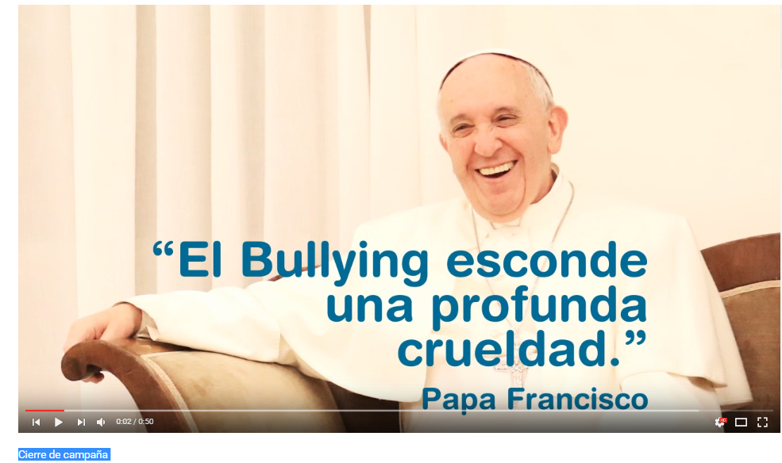
The modality chosen for this campaign is that of a viral campaign in social media, based on flyers and animation. People from ENACOM devised a series of characters according to the different age groups with a soundtrack specially composed for the campaign so that the target audience could identify with the leading characters.
Scholas distributes the pieces through its channels, accompanied by ENACOM, with the intention to reach a large audience, in pursuit to add the support and participation of different stakeholders in the ICT sector so that the initiative can be disseminated both nationally and globally
Regarding the material for the campaign, it should be pointed out that from the time of the above presentation at ITU until the end of the school year in Argentina (December 2016), as it was scheduled, new pieces were posted. Also, as from January 2017 and until the beginning of the new school year (March 2017) those pieces continue to be replicated as campaign reinforcement.
Below you can find the material currently being disseminated:
About the most recent pieces, it can be said that they are intended to create empathy with the victims and to urge boys, girls and young people to reflect and not to be part of the bully’s group, assuming an active and responsible attitude with respect to these acts.
1. Empathy (1) https://www.youtube.com/watch?v=JSJh1yNJ9Ow&index=9&list=PL-rhLmHfBsunTvG_nU7h4Rnk9_cHQqaEV
2. Empathy (2) https://www.youtube.com/watch?v=mAvQKTrESm0&index=10&list=PL-rhLmHfBsunTvG_nU7h4Rnk9_cHQqaEV
3. Empathy Bridge https://www.youtube.com/watch?v=qUDawsrHhw4&index=11&list=PL-rhLmHfBsunTvG_nU7h4Rnk9_cHQqaEV
4. Campaign Closing https://www.youtube.com/watch?v=dGe3WYYtbs8&list=PL-rhLmHfBsunTvG_nU7h4Rnk9_cHQqaEV&index=12

Also, the playlist of all Campaign pieces can be found at:
https://www.youtube.com/playlist?list=PL-rhLmHfBsunTvG_nU7h4Rnk9_cHQqaEV
The campaign has been very successful, with good repercussion in the social media. The annex contains all the data and measurements on each piece for better understanding.
Additionally, regarding the presentation of the campaign at regional level, it was presented to the Inter-American Telecommunication Commission (CITEL), an agency specialized in the subject, part of the ORGANIZATION OF AMERICAN STATES (OAS) with a very positive reaction. The 32º MEETING OF PERMANENT EXECUTIVE COMMITTEE OF CITEL (COM/CITEL), held from 29 November to 1 December 2016, in the Dominican Republic, took note of Document: COM/CITEL/doc. 76/16.
Moreover, another activity planned for the future in the framework of the abovementioned Agreement is a Seminar called “Awareness of the dangers and responsible use of the web”. It will be held in Argentina, more precisely in the city of Buenos Aires, during the first four-month period of the year 2017, due to which progress is being made in working actively on the preparations.
The aim of the Seminar is to invite attendees to reflect, to make it serve as a contribution to pontifical foundation Scholas Occurrentes to raise awareness among boys and girls, young people, parents and educators about bullying and cyberbullying, and to warn about the risks posed by Internet and the associated consequences, and to advise on ways to prevent them. The meeting proposes to compromise on good practices and conscientious use of new technologies, to avoid acts of violence enhanced through virtual communications, stressing ICT’s importance and key role as an inclusion and communication tool.
Finally, it should be pointed out that a formal invitation will be sent to ITU in due time for them to participate in the Seminar, taking into account their great expertise in the field.

----
ANNEX

Measurement and monitoring of the Bullying CyberBullying Campaign ENACOM-SCHOLAS #TodosSomosÚnicos:

The campaign pieces were published in the Facebook, Instagram and Twitter accounts of Scholas Occurrentes and were shared by the Enacom accounts.
The publications were made according to a schedule that considered the times when the target audience was more prone to be on the social media.
The campaign used the hashtag #TodosSomosÚnicos (We are all unique) to classify and sort all the information and reactions around the campaign. Having a personalized hashtag allows also the identification of campaigns that relate to more than one institution, as was this case.
On Facebook, publications added a total reach of 40 415 users. This represents the total number of people that saw the publications in their wall. The piece with highest reach was the one named “Hug” with a total of 14 707 people.
Twitter had the same publications as Facebook with a total of 17 554 impressions. The piece called “Bridges” was the one with the best performance with 7 231 impressions.
In the case of Instagram, the campaign had a total of more than 1 900 impressions and the piece “Unique” was the one with best performance.
Scholas’ social media have more than 300 000 fans on Facebook, 6 000 Twitter and Instagram, whie Enacom has 29 000 on Facebook, 14 000 on Twitter and 500 on Instagram.
To leverage the reach of the campaign #TodosSomosÚnicos and to have a greater impact on the target audience joint actions were performed with the so-called “influencers”. For the campaign in Argentina, youtuber Lucas Castel took part. He has more than 2 million followers in his channel.
Below you will find the performance results for each piece, both for Facebook and Twitter.

Facebook:

Children’s segment: Bows
Date: 3 October
Type of piece: video.

Reach
5414 people reached
781 video reproductions
76 comments, reactions and times it was shared

Summary
48 | Likes | 44 | In the publication | 4 | In the shared content
7 | Loves | 6 | In the publication | 1 | In the shared content
1 | Comments | 0 | In the publication | 1 | In the shared content
20 | Times shared | 20 | In the publication | 0 | In the shared content

112 |  | Clicks in publications
32 | Clicks to reproduce |  | 0 | Clicks on the link |  | 80 | Other clicks

Negative comments
2 | Hide publication | 0 | Hide all publications
0 | Report as spam | 0 | No longer like this publication

Performance of the video in this publication:
Minutes reproduced | 607
Single users | 2.193
Video reproductions | 2.260
10-second reproductions | 733
Average video reproduction time | 0:04

Public reached:
People reached | 5 570
Interaction with the publication | 81
Most active audience | Women 45/54
Location with the greatest interaction | Province of Buenos Aires

Piece: Unique
Date: 26/09
Type of Piece: GIF

Reach:
4 382 people reached
93 reactions, comments and times it was shared

Summary
4.328 | People reached
93 | Reactions, comments and times it was shared

68 | Likes | 54 | in the publication | 14 | in the shared content
4 | Loves | 2 | in the publication | 2 | in the shared content
2 | Comments | 0 | in the publication | 2 | in the shared content
19 | Times shared | 19 | in the publication | 0 | in the shared content

68 Clicks on publications
0 | Photo visualizations | 16 | Clicks on the link | 52 | Other clicks

Negative Comments
4 | Hide publication | 1 | Hide all publications
0 | Report as spam | 0 | No longer likes this publication

Teenage segment
Date: 29 August

Piece: Bridges
Type of Piece: video

Reach:
9766 people reached
1393 video reproductions
163 reactions, comments and times it was shared

Summary
91 | Likes | 69 | in the publication | 22 | in the shared content
16 | Loves | 11 | in the publication | 5 | in the shared content
1 | Wows | 1 | in the publication | 0 | in the shared content
3 | Comments | 3 | in the publication | 0 | in the shared content
52 | Times shared | 52 | in the publication | 0 | in the shared content

313 Clicks on publications
115 | Likes | 1 | Click on the link | 197 | Other Clicks

Negative Comments
2 | Hide publication | 1 | Hide all publications
0 | Report as spam | 0 | No longer like this publication

Video performance in this publication:
Minutes reproduced | 393
Single users | 1.357
Video reproductions | 1.393
10-second reproductions | 575
Average video reproduction time | 0:04

Audience reached:
Interaction with the publication | 163
Most active audience | Women 45/54
Location with the greatest interaction | Province of Buenos Aires

Piece: Hug

Date: September 30
Type of Piece: Video

Reach
14.707 people reached
2236 video reproductions
319 reactions, comments and times it was shared

Summary
209 | Likes | 114 | in the publication | 95 | in the shared content
7 | Loves | 2 | in the publication | 5 | in the shared content
2 | Sads | 0 | in the publication | 2 | in the shared content
0 | Comments | 0 | in the publication | 0 | in the shared content
101 | Times shared | 100 | in the publication | 1 | in the shared content

478 Clicks on publications
118 | Clicks to reproduce | 4 | Click on the link | 356 | Other clicks

Negative Comments
2 | Hide publication | 0 | Hide all publications
0 | Report as spam | 0 | No longer like this publication

Audience & interaction:
People reached | 14 707
Interaction of the publication | 319
Most active audience | Women 35-44
Location with greatest interaction | Province of Buenos Aires

Piece: Backpack
Date: September 19
Type of Piece: GIF

Reach:
4173 people reached
49 reactions, comments and times it was shared

Summary
36 | Likes | 35 | in the publication | 1 | in the shared content
1 | Loves | 1 | in the publication | 0 | in the shared content
1 | Wows | 1 | in the publication | 0 | in the shared content
0 | Comments | 0 | in the publication | 0 | in the shared content
11 | Times shared | 11 | in the publication | 0 | in the shared content

32 Clicks on publications
0 | Photo viewings | 10 | Click on the link | 22 | Other clicks

Negative Comments
3 | Hide publication | 0 | Hide all publications
0 | Report as spam | 0 | No longer like this page

Piece: Reader
Date: 05 September
Type of Piece: GIF

Reach:
6 146 people reached
86 reactions, comments and times it was shared

Summary
58 | Likes | 48 | in the publication | 10 | in the shared content
2 | Loves | 2 | in the publication | 0 | in the shared content
1 | Sads | 1 | in the publication | 0 | in the shared content
5 | Comments | 3 | in the publication | 2 | in the shared content
20 | Times shared | 20 | in the publication | 0 | in the shared content

85 Clicks on publications
0 | Photo viewings | 14 | Click on the link | 71 | Other clicks

Negative Comments
5 | Hide publication | 2 | Hide all publications
2 | Report as spam | 0 | No longer like this page

Twitter:

Children’s segment

Piece: BOW
Type of Piece: Video
Date: 03 September

Link: https://twitter.com/InfoScholas/status/782973505017090049/video/1

Reach:
Impressions | 2.442
Total interactions | 41
Interactions with the multimedia content | 16
Retweets | 8
Likes | 8
Open discussion | 5
Clicks on profiles | 2
Replies | 1
Followings | 1

Piece: Unique
Type of Piece: GIF
Date: 26 September
Link: https://twitter.com/InfoScholas/status/780422877942349825/photo/1

Reach:

Retweets: 5
Likes: 6

Impressions | 856
Total interactions | 36
Interactions with multimedia content | 16
Likes | 6
Open discussion | 6
Retweets | 5
Clicks on the hashtag | 2
Clicks on the profile | 1

Teenage Segment

Piece: BACKPACK
Type of Piece: GIF
Date: 19 September
Link: https://twitter.com/InfoScholas/status/777891556984557570/photo/1

Reach

Retweets: 17
Likes: 11

Impressions | 3 716
Total interactions | 71
Interactions with multimedia content | 22
Retweets | 17
Likes | 11
Open discussion | 10
Clicks on profile | 7
Replies | 1

Piece: HUG
Type of Piece: video
Date: 30 September
Link: https://twitter.com/InfoScholas/status/781884053196771328/video/1

Reach:

Retweets: 20
Likes: 21

Impressions | 2 690
Multimedia viewings | 1
Total interactions | 91
Interactions with multimedia content | 25
Likes | 21
Retweets | 20
Clicks on the hashtag | 2
Clicks on the profile | 2
Followings | 1

Piece: Umbrella
Type of Piece: GIF
Date: 30 May
Link: https://twitter.com/InfoScholas/status/737431379399610369

Reach:

Tweets: 2
Retweets: 6

Impressions | 613
Total interactions | 47
Interactions with multimedia content | 26
Open discussion | 7
Likes | 6
Clicks on profile | 5
Retweets | 2
Clicks on link | 1

Piece: Bridges
Type of Piece: Video
Date: 29 September

Reach:

Retweets: 17
Likes: 25

Impressions | 7 231
Total interactions | 113
Interactions with multimedia content | 39
Likes | 25
Retweets | 17
Open discussion | 17
Clicks on profile | 13
Replies | 1
Clicks on link | 1

Total results of campaign on Twitter

Total number of Retweets: 69
Total number of Likes: 77
Total number of impressions: 17554
Total number of interactions: 399

Instagram:

Piece: Unique
861 Impressions (times viewed)
628 users reached
49 interactions

Piece: Bridges
94 reproductions
662 Impressions
471 users reached
49 interactions

Piece: Bow
94 reproductions
670 Impressions
470 people reached
30 interactions

Influencers:

Users and Youtubers of different nationalities also joined us to disseminate the campaign.
mensaje. 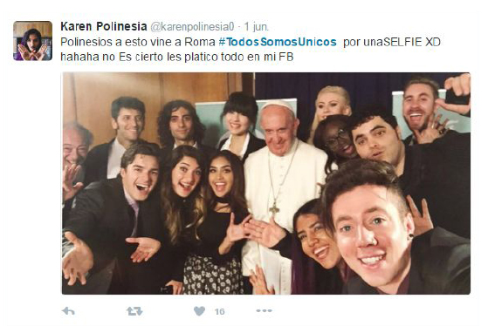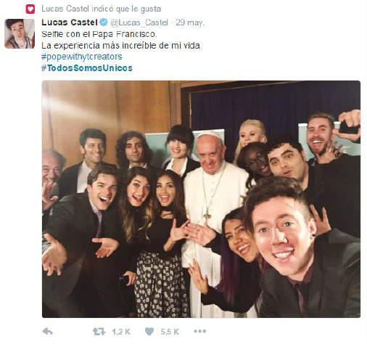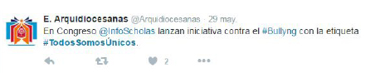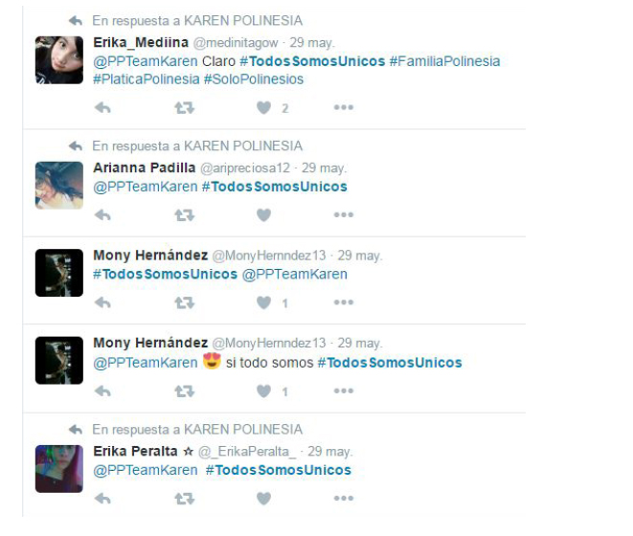
Thanks to the activity generated by @Lucas_Castel in Buenos Aires #TodosSomosÚnicos became trending topic on 29 May, according to Trendsmap BA.
