Council Working Group for
Strategic and Financial Plans 2020-2023
Third meeting – Geneva, 15-16 January 2018
Revision 1 to
Document CWG-SFP-3/5-E
19 January 2018
English only

ANNEX 1 to Resolution 71: ITU Strategic Plan 2020-2023

ITU Strategic Framework 2020-2023
RBM planning | Implementation | Vision & mission | Vision is the better world ITU wants to see.  Mission refers to the main overall purposes of the Union, as per the Basic Instruments of ITU. | Values: ITU's shared and common beliefs that drive its priorities and guide all decision-making processes
 |  | Strategic goals & targets | Strategic goals refer to the Union's high-level targets to which the objectives contribute, directly or indirectly. They relate to the whole of ITU.  Targets are the expected results during the period of the strategic plan; they provide an indication as to whether the goal is being achieved. Targets may not always be achieved, for reasons that may be beyond the control of the Union.
 |  | Objectives & outcomes | Objectives refer to the specific aims of the Sectoral and intersectoral activities in a given period.  Outcomes provide an indication as to whether the objective is being achieved. Outcomes are usually partly, but not entirely, within the organization's control.
 |  | Outputs | Outputs are the final tangible results, deliverables, products and services achieved by the Union in the implementation of the operational plans.
 |  | Activities | Activities are various actions/services for transforming resources (inputs) into outputs. Activities may be grouped into processes.

Vision
“An information society, empowered by the interconnected world, where telecommunication/information and communication technologies enable and accelerate social, economic and environmentally sustainable growth and development for everyone”

Mission
“To promote, facilitate and foster affordable and universal access to telecommunication/information and communication technology networks, services and applications and their use for social, economic and environmentally sustainable growth and development”

Values
The Union recognizes that achieving its mission requires that it builds and maintains trust among its membership and inspires the confidence of the public at-large. This applies to both what the Union does and how it is done.
The Union is committed to continuously building and safeguarding that trust by ensuring that its actions are guided by the following values:
[ Excellence: focusing on core strengths, make decisions on evidence and preferably by consensus, taking effective action and monitoring outputs, avoiding internal ITU duplication;
Transparency: Transparency allows accountability for decisions, actions and results. Embracing transparency, ITU communicates and demonstrates progress towards the achievement of its goals;
Openness: Being aware of and responsive to the needs of all its membership, as well as the activities and expectations of intergovernmental organizations, the private sector, civil society, technical community and academia;
Universality and neutrality: As a United Nations specialized agency, ITU reaches, covers and represents all parts of the world. Within the remit of the Basic Instruments of the Union, its operations and activities reflect the express will of its membership. ITU also recognizes the overarching pre-eminence of human rights, including the right to freedom of opinion and expression, which includes the freedom to seek, receive and impart information and ideas through any media and regardless of frontiers, and the right to not be subjected to arbitrary interference with privacy; ]
[ People-centred, service-oriented and results-based: Being people-centred, ITU is focused on people in order to deliver results that matter to each and every individual. Being service-oriented, ITU is committed to further delivering high-quality services and maximizing satisfaction of beneficiaries and stakeholders. Being results-based, ITU aims for tangible results and to maximize the impact of its work. ]
The Union expects all of its staff to faithfully adhere to the Standards of Conduct for the International Civil Service and the ITU Code of Ethics. ITU also expects that any partner will uphold the highest standards of ethical behavior.

Strategic Goals
The strategic goals of the Union are listed hereafter and are consistent with supporting the fulfilment of the WSIS Action Lines and the 2030 Agenda for Sustainable Development.
Goal 1 – Growth: Enable and foster access to and increased use of telecommunication/ICT in support of the digital economy and society
Recognizing the role of telecommunications/ICTs as a key enabler for social, economic and environmentally sustainable development, ITU will work to enable and foster access to, and increase the use of, telecommunications/ICTs. Growth in the use of telecommunications/ICTs has a positive impact on short- and long-term socio-economic development, as well as on the growth of the digital economy, towards building an inclusive digital society.

Goal 2 – Inclusiveness: Bridge the digital divide and provide broadband access ‘leaving no one behind’
Being committed to ensuring that everyone without exception benefits from telecommunications/ICTs, ITU will work to bridge the digital divides for an inclusive digital society and enable the provision of broadband access for all, leaving no one behind. Bridging the digital divide focuses on global telecommunication/ICT inclusiveness, fostering telecommunication/ICT access, accessibility, affordability and use in all countries and regions and for all peoples, including marginal and vulnerable populations, such as women and girls, youth, people with different income levels, indigenous peoples, older persons and persons with disabilities.

Goal 3 – Sustainability: Manage emerging risks, challenges and opportunities resulting from the rapid growth of telecommunication/ICT
To promote the beneficial use of telecommunications/ICTs, ITU recognizes the need to manage emerging risks, challenges and opportunities from the rapid growth of telecommunications/ICTs. The Union focuses on enhancing the quality, reliability, sustainability, resilience of networks and systems [ as well as safety and security ] in the use of telecommunications/ICTs. Accordingly, the Union will work towards minimizing the negative impact of undesired collaterals, such as cybersecurity threats, including potential harm to the most vulnerable parts of society, in particular children, and negative effects on the environment, including e-waste.

Goal 4 – Innovation: Enable innovation in telecommunication/ICT in support of the digital transformation of society
The Union recognizes the crucial role of telecommunications/ICT in the digital transformation of society. The Union seeks to contribute to the development of an environment that is conducive to innovation, where advances in new technologies become a key driver for the implementation of the WSIS Action Lines and the 2030 Agenda for Sustainable Development.

Goal 5 – Partnership: Strengthen cooperation among ITU membership and all other stakeholders in support of the ITU strategic goals
In order to facilitate the achievement of the above strategic goals, the Union recognizes the need to foster engagement and cooperation among governments, private sector, civil society, intergovernmental and international organizations, and the academic and technical communities. The Union also recognizes the need to contribute to the global partnership to strengthen the role of telecommunication/ICTs as means of implementation of the WSIS Action Lines and the 2030 Agenda for Sustainable Development.

Targets
Targets represent the effect and long-term impact of ITU’s work and provide an indication of progress towards achievement of the strategic goals. The Union will work collaboratively with the full range of other organizations and entities around the world committed to advancing the use of telecommunications/ICTs. The purpose of such targets is to provide the direction where the Union should focus its attention and to materialize the ITU vision for an interconnected world for the four-year period of the strategic plan.
Table 1. Targets
Target | Data source
Goal 1: Growth
Target 1.1: by 2023, 65% of households worldwide should have access to the Internet | ITU
Target 1.2: by 2023, 70% of individuals worldwide should have access to the Internet | ITU
Target 1.3: by 2023, internet access should be 25% more affordable (baseline year 2017) | ITU
Target 1.4: by 2023, all countries should adopt a digital agenda/strategy [proposed target] | ITU
Target 1.5: by 2023: 80% of SMEs should be selling products or services online [proposed target] | UNCTAD
Target 1.6: by 2023, increase by 50% the number of fixed broadband subscriptions [proposed target] | ITU
Target 1.7: by 2023, 40% of countries to have more than half of the fixed broadband subscriptions more than 10 Mbit [proposed target] | ITU
Target 1.8: by 2023, 40% of population should be interacting with government services online [proposed target] | ITU
Target 1.9: by 2023, 30% of population should be using using digital financial services [proposed target] | World Bank
Goal 2: Inclusiveness
Target 2.1: by 2023, in the developing world, 60% of households should have access to the Internet | ITU
Target 2.2: by 2023, in the least developed countries, 30% of households should have access to the Internet | ITU
Target 2.3: by 2023, in the developing world, 60% of individuals should be using the Internet | ITU
Target 2.4: by 2023, in the least developed countries, 30% of individuals should be using the Internet | ITU
Target 2.5: by 2023, the affordability gap between developed and developing countries should be reduced by 25% (baseline year 2017) | ITU
Target 2.6: by 2023, broadband services should cost no more than 3% of average monthly income in developing countries | ITU
Target 2.7: by 2023, 96% of world population covered by broadband services | ITU
Target 2.8: by 2023, gender equality in broadband access should be achieved | ITU
Target 2.9: by 2023, enabling environments ensuring accessible telecommunications/ICTs for persons with disabilities should be established in all countries | ITU
Target 2.10: by 2023, improve by 40% the proportion of youth/adults with telecommunication/ICT skills [proposed target] | ITU
Goal 3: Sustainability
Target 3.1: by 2023, improve cybersecurity preparedness of countries, with key capabilities: presence of strategy, national computer incident/emergency response teams and legislation | ITU
Target 3.2: by 2023, increase the global e-waste recycling rate to 50% | ITU & UNU
Target 3.3: by 2023, raise the number of countries with an e-waste legislation to 50% [proposed target] | ITU & UNU
Target 3.4: by 2023, net telecommunication/ICT-enabled Greenhouse Gas abatement should have increased by 30% compared to the 2015 baseline [proposed target] | IPCC
Target 3.5: by 2023, all countries should have a National Emergency Telecommunication Plan as part of their national and local disaster risk reduction strategies [proposed target] | ITU
Goal 4: Innovation
Target 4.1: by 2023, all countries should have a policy/strategy fostering telecommunication/ICT-centric innovation [proposed target] | ITU
Goal 5: Partnership
Target 5.1: by 2023, increased telecommunication/ICT-related funding/development programmes, projects and initiatives [proposed target] | ITU

Strategic Risk Management
Bearing in mind the prevailing challenges, evolutions and transformations that have the most potential to impact on ITU activities during the period of the strategic plan, the list of top-level strategic risks presented in Table below has been identified, analysed and evaluated. These risks have been considered when planning the strategy for 2020-2023, and the corresponding mitigation measures have been identified as necessary. It should be emphasized that the strategic risks are not meant to represent deficiencies of ITU's operations. They represent forward-looking uncertainties that may affect efforts to fulfil the mission of the Union during the period of the strategic plan.
ITU has identified, analysed and assessed these strategic risks. Apart from the strategic planning processes, setting the overall framework on how to mitigate these risks, operational mitigation measures will be defined and implemented through the operational planning process of the Union.
Table 2. Strategic risks and mitigation strategies
Risk | Mitigation strategy
- Diminishing relevance and ability to demonstrate clear added value  - Risk of duplication of efforts and inconsistencies inside the organization that affects our ability to demonstrate added value  - Risk of conflicting efforts, inconsistencies and competition with other relevant organizations and bodies that leads to misperception of ITU’s mandate, mission and role | - Risk avoidance: by clear mandates of each structure and role in the Union;  - Risk limitation: improve the cooperation framework;  - Risk avoidance: identify and concentrate on areas with clear added value;  - Risk transfer: by establishing long term partnerships;  - Risk limitation: by an appropriate and consistent communication strategy (internal and external).
- Spreading too thin  - Risk of mission dilution and losing sight of the organization core mandate | - Risk avoidance: by focusing and building on the strengths of the Union;  - Risk limitation: by ensuring consistency of ITU activities / working outside of silos.
- Failure to respond quickly to emerging needs and innovate sufficiently while still providing high quality deliverables  - Risk of unresponsiveness, leading to disengagement of membership and other stakeholders  - Risk of being left behind | - Risk avoidance: plan for the future while being agile, responsive and innovative;  - Risk limitation: define, promote and implement a fit-for-purpose organizational culture;  - Risk transfer: proactively engage stakeholders.
- Concerns regarding trust and confidence  - Risk of rising concerns related to trust by membership and stakeholders  - Risk of rising concerns on confidence within membership | - Risk avoidance: adopt and implement common values – all actions guided by the adopted values;  - Risk limitation: engage with membership and other stakeholders, improve communication, commit to the values, and promote ownership of strategic initiatives.
- Inadequate internal structures, tools, methodology and processes  - Risk of structures, methods and tools becoming inadequate, failing to be effective | - Risk limitation: Optimize internal structures, improve tools, methodologies and processes;  - Risk transfer: Initiate processes for quality certification;  - Risk limitation: Improve internal and external communication.
- Insufficient funding  - Risk of reduced financial contributions and sources of revenue | - Risk limitation: identify and explore new markets and players;  - Risk limitation: ensure effective financial planning;  - Risk limitation: membership engagement strategies;  - Risk transfer: increase relevance of ITU activities.

ITU results framework
ITU will implement the strategic goals of the Union for 2020-2023 through a number of objectives to be attained in this period. Each Sector will contribute to the overarching goals of the Union in the context of its specific remit, through implementation of the Sector-specific objectives and the overarching intersectoral objectives. The Council will ensure efficient coordination and oversight of this work.
The Enablers support the overall objectives and strategic goals of the Union. The activities and support services of the General Secretariat and the Bureaux provide these Enablers to the work of the Sectors and the whole Union.
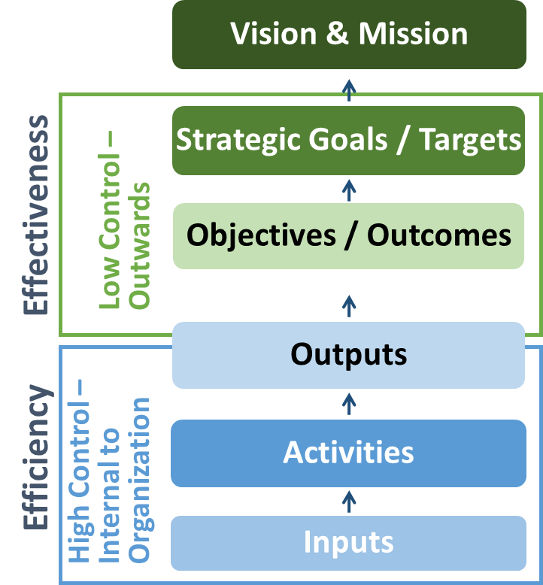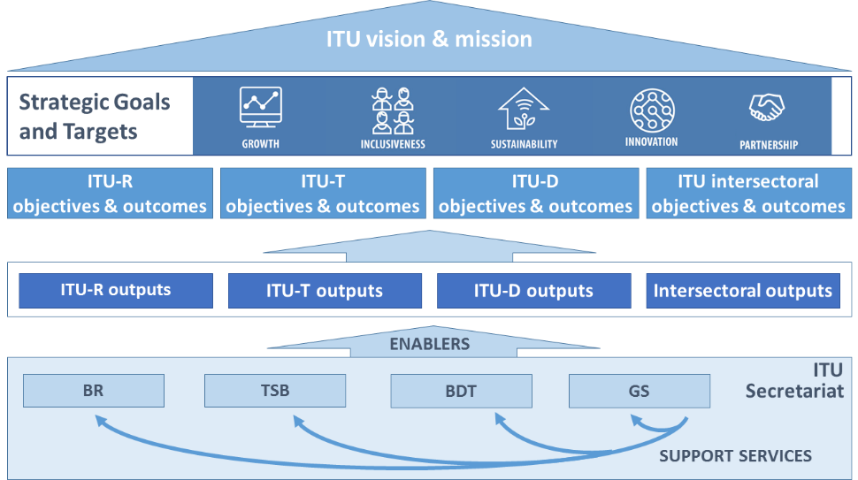

ITU-R Objectives:
- R.1 (Spectrum regulations): Meet, in a rational, equitable, efficient, economical and timely way, the ITU membership’s requirements for radio-frequency spectrum and satellite-orbit resources, while avoiding harmful interference
- R.2 (Radiocommunication standards): Provide for worldwide connectivity and interoperability, improved performance, quality, affordability and timeliness of service and overall system economy in radiocommunications, including through the development of international standards
- R.3 (Disseminate information): Foster the acquisition and sharing of knowledge and know-how on radiocommunications
ITU-T Objectives:
- T.1 (Development of standards): Develop [non-discriminatory] international standards (ITU-T recommendations), in a timely manner, and foster interoperability and improved performance of equipment, networks, services and applications
- T.2 (Bridging the standards gap): Promote the active participation of the membership, in particular developing countries, in the definition and adoption of [non-discriminatory] international standards (ITU-T recommendations) with a view to bridging the standardization gap
- T.3 (Telecommunication resources): Ensure effective allocation and management of international telecommunication numbering, naming, addressing and identification resources in accordance with ITU-T recommendations and procedures
- T.4 (Knowledge sharing): Foster the acquisition and sharing of knowledge and know-how on the standardization activities of ITU-T
- T.5 (Cooperation with standardization bodies) Extend and facilitate cooperation with international, regional and national standardization bodies and regional telecommunication organizations
ITU-D Objectives:
- D.1 (Coordination): Foster international cooperation and agreement on telecommunication/ICT development issues
- D.2 (Modern and secure telecommunication/ICT infrastructure): Foster the development of infrastructure and services, including building confidence and security in the use of telecommunications/ICTs
- D.3 (Enabling environment): Foster an enabling policy and regulatory environment conducive to sustainable telecommunication/ICT development
- D.4 (Inclusive digital society): Foster the development and use of telecommunications/ICTs and applications to empower people and societies for sustainable development
Inter-Sectoral Objectives:
- I.1 (Collaboration) Foster closer collaboration among all stakeholders in the telecommunication/ICT ecosystem
- I.2 (Emerging telecommunication/ICT trends) Enhance identification, awareness and analysis of emerging trends in the telecommunication/ICT environment
- I.3 (Telecommunication/ICT accessibility) Enhance telecommunications/ICTs accessibility for persons with disabilities and specific needs
- I.4 (Gender equality [and equity]) Enhance the use of telecommunication/ICTs for gender equality and empowerment of women and girls
- I.5. (Environmental sustainability) Leverage telecommunication/ICTs to reduce environmental footprint
- I.6 (Reducing overlaps) Reduce the areas of overlap and foster closer and more transparent coordination among General Secretariat and ITU Sectors, taking into account the Union’s budgetary provisions

Table 3. Linkage of ITU objectives with the Strategic Goals:
 |  | Goal 1: Growth | Goal 2: Inclusiveness | Goal 3: Sustainability | Goal 4: Innovation | Goal 5: Partnership
Objectives | ITU-R objectives
 | R.1. Spectrum regulations
 | R.2. Radiocommunication standards
 | R.3. Disseminate information
 | ITU-T objectives
 | T.1. Development of standards
 | T.2. Bridging the standards gap
 | T.3. Telecommunication resources
 | T.4. Knowledge sharing
 | T.5. Cooperation with standardization bodies
 | ITU-D objectives
 | D.1. Coordination
 | D.2. Modern and secure telecommunication/ICT infrastructure
 | D.3. Enabling environment
 | D.4. Inclusive digital society
 | Inter-Sectoral objectives
 | I.1. Collaboration
 | I.2. Emerging telecommunication/ICT trends
 | I.3. Telecommunication/ICT accessibility
 | I.4. Gender equality [and equity]
 | I.5. Environmental sustainability
 | I.6. Reducing overlaps

Objectives, Outcomes and Outputs / Enablers
Table 4: ITU-R Objectives, Outcomes and Outputs
R.1 (Spectrum regulations) Meet, in a rational, equitable, efficient, economical and timely way, the ITU membership’s requirements for radio-frequency spectrum and satellite-orbit resources, while avoiding harmful interference
Outcomes | Outputs
R.1-a: Increased number of countries having satellite networks and earth stations recorded in the Master International Frequency Register (MIFR)  R.1-b: Increased number of countries having terrestrial frequency assignments recorded in the MIFR  R.1-c: Increased percentage of assignments recorded in the MIFR with a favourable finding  R.1-d: Increased percentage of countries which have completed the transition to digital terrestrial television broadcasting  R.1-e: Increased percentage of spectrum assigned to satellite networks which is free from harmful interference  R.1-f: Increased percentage of assignments to terrestrial services recorded in the MIFR which are free from harmful interference | R.1-1: Final acts of world radiocommunication conferences, updated Radio Regulations  R.1-2: Final acts of regional radiocommunication conferences, regional agreements  R.1-3: Rules of Procedure and other decisions of the Radio Regulations Board (RRB)  R.1-4: Publication of space notices and other related activities  R.1-5: Publication of terrestrial notices and other related activities
R.2 (Radiocommunication standards) Provide for worldwide connectivity and interoperability, improved performance, quality, affordability and timeliness of service and overall system economy in radiocommunications, including through the development of international standards
Outcomes | Outputs
R.2-a: Increased mobile-broadband access, including in frequency bands identified for international mobile telecommunications (IMT)  R.2-b: Reduced mobile-broadband price basket, as a percentage of gross national income (GNI) per capita  R.2-c: Increased number of fixed links and increased amount of traffic handled by the fixed service (Tbit/s)  R.2-d: Increased number of households with digital terrestrial television reception  R.2-e: Increased number of satellite transponders (equivalent 36 MHz) on communication satellites in operation and corresponding capacity (Tbit/s); Number of VSAT terminals; Number of households with satellite television reception  R.2-f: Increased number of devices with radionavigation-satellite reception  R.2-g: Increased number of satellites having Earth exploration payloads in operation, corresponding quantity and resolution of transmitted images and data volume downloaded (Tbytes) | R.2-1: Decisions of the Radiocommunication Assembly, ITU-R resolutions  R.2-2: ITU-R recommendations, reports (including the CPM report) and handbooks  R.2-3: Advice from the Radiocommunication Advisory Group
R.3 (Disseminate information) Foster the acquisition and sharing of knowledge and know-how on radiocommunications
Outcomes | Outputs
R.3-a: Increased knowledge and know-how on the Radio Regulations, Rules of Procedure, regional agreements, recommendations and best practices on spectrum use  R.3-b: Increased participation in ITU-R activities (including through remote participation), in particular by developing countries | R.3-1: ITU-R publications  R.3-2: Assistance to members, in particular developing countries and LDCs  R.3-3: Liaison/support to development activities  R.3-4: Seminars, workshops and other events

Table 5. Enablers for ITU-R
Supported Objective(s) | BR activities | Contribution to the Outcomes of the Sector | Results
R.1 | Efficient processing of frequency assignment notices | Increased certainty for planning new radiocommunication networks | Reduced processing time for publication of notices, within regulatory limits
R.1, R.2, R.3 | Development, maintenance and improvement of ITU-R software, databases and online tools  Technical, regulatory, administrative, outreach and logistical activities in support of ITU-R objectives | Increased reliability, efficiency and transparency in the application of the Radio Regulations. | New and improved ITU-R software, databases and online tools  Efficient and timely delivery of ITU-R outputs and support to ITU-R objectives  BR contributions to ITU-R meetings, conferences and events

Table 6. ITU-T Objectives, Outcomes and Outputs
T.1 (Development of standards) Develop [non-discriminatory] international telecommunication/ICT standards (ITU-T recommendations), in a timely manner, and foster interoperability and improved performance of equipment, networks, services and applications
Outcomes | Outputs
T.1-a: Increased utilization of ITU-T recommendations  T.1-b: Improved conformance to ITU-T recommendations  T.1-c: Enhanced standards in new technologies and services | T.1-1: Resolutions, recommendations and opinions of the World Telecommunication Standardization Assembly (WTSA)  T.1-2: WTSA regional consultation sessions  T.1-3: Advice and decisions of the Telecommunication Standardization Advisory Group (TSAG)  T.1-4: ITU-T recommendations and related results of ITU-T study groups  T.1-5: ITU-T general assistance and cooperation  T.1-6: Conformity database  T.1-7: Test centres and interoperability events  T.1-8: Development of test suites
T.2 (Bridging the standards gap) Promote the active participation of the membership, in particular developing countries, in the definition and adoption of [non-discriminatory] international telecommunication/ICT standards (ITU-T recommendations) with a view to bridging the standardization gap
Outcomes | Outputs
T.2-a: Increased participation in the ITU-T standardization process, including attendance of meetings, submission of contributions, taking leadership positions and hosting of meetings/workshops, especially from developing countries  T.2-b: Increase of the ITU-T membership, including Sector Members, Associates and Academia | T.2-1: Bridging the standardization gap (e.g. remote participation, fellowships, establishment of regional study groups)  T.2-2: Workshops and seminars, including offline and online training activities, complementing the capacity-building work on bridging the standardization gap  T.2-3: Outreach and promotion
T.3 (Telecommunication resources) Ensure effective allocation and management of international telecommunication numbering, naming, addressing and identification resources in accordance with ITU-T recommendations and procedures
Outcomes | Outputs
T.3-a: Timely and accurate allocation of international telecommunication numbering, naming, addressing and identification resources, as specified in the relevant recommendations | T.3-1: Relevant TSB databases  T.3-2: Allocation and management of international telecommunication numbering, naming, addressing and identification resources in accordance with ITU-T recommendations and procedures
T.4 (Knowledge sharing) Foster the acquisition and sharing of knowledge and know-how on the standardization activities of ITU-T
Outcomes | Outputs
T.4-a: Increased knowledge on ITU-T standards and on best practices in their implementation of ITU-T standards  T.4-b: Increased participation in ITU-T's standardization activities and increased awareness of the relevance of ITU-T standards  T.4-c: Increased Sector visibility | T.4-1: ITU-T publications  T.4-2: Database publications  T.4-3: Outreach and promotion  T.4-4: ITU Operational Bulletin
T.5 (Cooperation with standardization bodies) Extend and facilitate cooperation with international, regional and national standardization bodies and regional telecommunication organizations
Outcomes | Outputs
T.5-a: Increased communications with other standards organizations  T.5-b: Decreased number of conflicting standards  T.5-c: Increased number of memoranda of understanding/collaboration agreements with other organizations  T.5-d: Increased number of ITU-T A.4, A.5 and A.6 qualified organizations  T.5-e: Increased number of workshops/events organized jointly with other organizations | T.5-1: Memoranda of understanding (MoUs) and collaboration agreements  T.5-2: ITU-T A.4/A.5/A.6 qualifications  T.5-3: Jointly organized workshops/events

Table 7. Enablers for ITU-T
Supported ITU-T Objective(s) | TSB activities | Contribution to the Outcomes of the Sector | Results
T.1 | - Timely and efficient provisioning of documents (WTSA Resolutions, Recs, Opinions, ITU-T Recs, SGs related documents, reports)  - Secretariat support and organization and logistical support for meetings  - Advisory services  - TSB EWM services and information services  - Operation and maintenance of C&I DBs; logistical support for interop/testing events, testbeds | - Increased quality of ITU-T recommendations | - Timely up-to-date information for delegates and standards community about ITU-T’s products and services
T.2 | - Organization of BSG hands-on training sessions; fellowship financial support; logistical support of regional groups  - Organization of workshops  - Announcements (ITU newsblog, promotional activities)  - Account management of ITU-T memberships, retention of current members and proactive acquisition of new members | - Increased ITU-T membership and participation in the standardization process | - Active participation of delegates and organizations that have so far only participated passively in ITU-T activities, or not at all
T.3 | - Processing and publication of numbering, addressing, naming and identification applications / resources | - Timeliness and accuracy in the allocation of the resources | - Timely availability of numbering information facilitates management of networks
T.4 | - ITU-T publication services  - Development and maintenance of ITU-T databases  - Outreach and promotion service (ITU newsblog, social media, web)  - Organization of workshops, CTO group meetings, Kaleidoscope, sessions at ITU Telecom, WSIS etc | - Increased knowledge and awareness on ITU-T standards, increased participation in ITU-T activities and increased Sector visibility | - Timely availability of publications (documents; databases) and easy to use services enhances the delegate experience
T.5 | - Maintenance and management of MoUs; establishment of new MoUs  - Maintenance and management of A.4/A.5/A.6 DB  - Logistical support for jointly organized WSs and events  - Support services for various collaboration activities (WSC, GSC, CITS, FIGI, WSIS, U4SSC …) | - Increased cooperation with other organizations | - Collaboration activities may avoid duplication of work

Table 8. ITU-D Objectives, Outcomes and Outputs
D.1 (Coordination) Foster international cooperation and agreement on telecommunication/ICT development issues
Outcomes | Outputs
D.1-a: Enhanced review and increased level of agreement on the draft ITU-D contribution to the draft ITU strategic plan, the World Telecommunication Development Conference (WTDC) Declaration, and the WTDC Action Plan  D.1-b: Assessment of the implementation of the Action Plan and of the WSIS Plan of Action  D.1-c: Enhanced knowledge-sharing, dialogue and partnership among the ITU membership on telecommunication/ICT issues  D.1-d: Enhanced process and implementation of telecommunication/ICT development projects and regional initiatives  D.1.e: Facilitation of agreement to cooperate on telecommunication/ICT development programmes between Member States, and between Member States and other stakeholders in the ICT ecosystem, based on requests from ITU Member States involved | D.1-1 World Telecommunication Development Conference (WTDC) and WTDC Final Report  D.1-2 Regional preparatory meetings (RPMs) and final reports of the RPMs  D.1-3 Telecommunication Development Advisory Group (TDAG) and reports of TDAG for the Director of BDT and for WTDC  D.1-4 Study groups and guidelines, recommendations and reports of study groups  D.1-5 Platforms for regional coordination, including regional development forums (RDFs)  D.1-6: Implemented telecommunication/ICT development projects and services related to regional initiatives.
D.2 (Modern and secure telecommunication/ICT Infrastructure) Foster the development of infrastructure and services, including building confidence and security in the use of telecommunications/ICTs
Outcomes | Outputs
D.2-a: Enhanced capacity of the ITU membership to make available resilient telecommunication/ICT infrastructure and services.  D.2-b: Strengthened capacity of Member States to effectively share information, find solutions, and respond to threats to cybersecurity, and to develop and implement national strategies and capabilities, including capacity building, encourage national, regional and international cooperation towards enhanced engagement among Member States and relevant players.  D.2-c: Strengthened capacity of Member States to use telecommunications/ICTs for disaster risk reduction and management, to ensure availability of emergency telecommunications, and support cooperation in this area. | D.2-1 Products and services on telecommunication/ICT infrastructure and services, wireless and fixed broadband, connecting rural and remote areas, improving international connectivity, bridging the digital standardization gap, conformance and interoperability, spectrum management and monitoring, the effective and efficient management and proper use of telecommunication resources within the mandate of ITU, and the transition to digital broadcasting, such as assessment studies, publications, workshops, guidelines, and best practices.  D.2-2 Products and services in building confidence and security in the use of telecommunications/ICTs, such as reports and publications, and to contribute to the implementation of national and global initiatives.  D.2-3 Products and services on disaster risk reduction and management, and emergency telecommunications, including assistance to enable Member States to address all phases of disaster management, such as early warning, response, relief, and restoration of telecommunication networks.
D.3 (Enabling Environment) Foster an enabling policy and regulatory environment conducive to sustainable telecommunication/ICT development
Outcomes | Outputs
D.3-a: Strengthened capacity of Member States to enhance their policy, legal and regulatory frameworks conducive to development of telecommunications/ICTs.  D.3-b: Strengthened capacity of Member States to produce high-quality, internationally comparable telecommunication/ICT statistics which reflect developments and trends in telecommunications/ICTs, based on agreed standards and methodologies.  D.3-c: Improved human and institutional capacity of the ITU membership to tap into the full potential of telecommunications/ICTs.  D.3-d: Strengthened capacity of the ITU membership to integrate telecommunication/ICT innovation in national development agendas and to develop strategies to promote innovation initiatives, including through public, private, and public-private partnerships. | D.3-1 Products and services on telecommunication/ICT policy and regulation for better international coordination and coherence, such as assessment studies and other publications, and other platforms to exchange information.  D.3-2 Products and services on telecommunication/ICT statistics and data analysis, such as research reports, collection, harmonization and dissemination of high-quality, internationally comparable statistical data, and forums of discussion.  D.3-3 Products and services on capacity building and human skills development, including those on international Internet governance, such as online platforms, distance and face-to-face training programmes to enhance practical skills and shared material, taking into account partnerships with telecommunication/ICT education stakeholders.  D.3-4 Products and services on telecommunication/ICT innovation, such as knowledge-sharing and assistance, upon request, on developing a national innovation agenda; mechanisms for partnerships; development of projects, studies and telecommunication/ICT innovation policies.
D.4 (Inclusive Digital Society) Foster the development and use of telecommunications/ICTs and applications to empower people and societies for socio-economic development and environmental protection
Outcomes | Outputs
D-4-a: Improved access to and use of telecommunication/ICT in least developed countries (LDCs), small island developing states (SIDS) and landlocked developing countries (LLDCs), and countries with economies in transition.  D.4-b: Improved capacity of the ITU membership to accelerate economic and social development by leveraging and using new technologies and telecommunication/ICT services and applications.  D.4-c: Strengthened capacity of the ITU membership to develop strategies, policies and practices for digital inclusion, in particular for the empowerment of women and girls, persons with disabilities and other persons with specific needs.  D.4-d: Enhanced capacity of the ITU membership to develop telecommunication/ICT strategies and solutions on climate-change adaptation and mitigation and the use of green/renewable energy. | D.4-1 Products and services on concentrated assistance to LDCs, SIDS and LLDCs and countries with economies in transition, to foster availability and affordability of telecommunications/ICTs.  D.4-2 Products and services on telecommunication/ICT policies supporting the development of the digital economy, ICT applications and new technologies, such as information sharing and support for their deployment, assessment studies, and toolkits.  D.4-3 Products and services on digital inclusion for girls and women and people with specific needs (elderly, youth, children and indigenous people, among others), such as awareness-raising on digital inclusion strategies, policies and practices, development of digital skills, toolkits and guidelines and forums of discussion to share practices and strategies.  D.4-4 Products and services on ICT climate-change adaptation and mitigation, such as promotion of strategies and dissemination of best practices on mapping vulnerable areas and developing information systems, metrics, and e-waste management.

Table 9. Enablers for ITU-D
Supported Objective(s) | BDT activities | Contribution to the Outcomes of the Sector | Results
D.1, D.2, D.3, D.4 | 1. Development and implementation of efficient strategies in telecommunication/ICT development towards achieving WSIS Action Lines and Sustainable Development Goals (SDGs), including communication and promotion activities | - Increased understanding and sharing of the ITU-D objectives and outputs  - Increased guidance for ITU-D activities  - Increased clarity of the programme of activities | - Measurable progress towards achieving WSIS Action Lines and SDGs  - Increased level of international cooperation in the area of telecommunication/ICT development  - Increased level of satisfaction by Member States with services and products provided by BDT
 | 2. Efficient administration of and support to telecommunication/ICT development activities through coordination of and collaboration among services, finance and budget administration, event organization support and IT support. | - Clear and coordinated scheduling of events  - Provision of necessary financial, IT and manpower support within available resource limits  - Provision of reliable support to events | - Enhanced coordination and collaboration in organizing events and implementing activities  - Efficient use of financial resources  - Timely and efficient organization of events  - Increased quality and coordination of BDT’s reporting to Member States
 | 3. Efficient organization of and support to activities on telecommunication/ICT infrastructure, ICT applications and cybersecurity. | - Identification of priorities and needs of Member States  - Development of relevant products and services and their timely delivery to end users  - Effective involvement of all relevant stakeholders in the development and delivery of products and services to Member States | - Increased quality and enhanced accessibility of products, services, and expertise developed and delivered by BDT in the areas of telecommunication/ICT infrastructure, ICT applications, and cybersecurity  - Increased level of satisfaction by Member States  - Tangible improvements in ITU’s Member States as a result of BDT’s activities in areas of telecommunication/ICT infrastructure, ICT applications, and cybersecurity  - Enhanced role of telecommunications/ICTs in the social and economic development of Member States
 | 4. Efficient organization of and support to activities on projects and knowledge management through capacity building, project support, ICT data and statistics, and emergency telecommunication support. | - Identification of priorities and needs of Member States  - Development of relevant products and services and their timely delivery to end users  - Effective involvement of all relevant stakeholders in the development and delivery of products and services to Member States | - Increased quality and enhanced accessibility of products, services, and expertise developed and delivered by BDT in the areas of projects and knowledge management  - Increased level of satisfaction by Member States  - Tangible improvements in ITU’s Member States as a result of BDT’s activities in the areas of projects and knowledge management  - Successful mitigation of emergency telecommunication risks
 | 5. Efficient organization of and support to innovation and partnership activities through partnership building, innovation, and study group coordination services. | - Identification of priorities and needs of Member States  - Development of relevant products and services and their timely delivery to end users  - Effective involvement of all relevant stakeholders in the development and delivery of products and services to Member States | - Increased quality and enhanced accessibility of products, services, and expertise developed and delivered by BDT in the areas of partnership building and innovation  - Increased level of satisfaction by Member States  - Wider participation of stakeholders and partners in the development of telecommunications/ICTs in developing countries  - Increased level of resources from donors for the benefit of Member States’ efforts to develop their telecommunication/ICTs
 | 6. Efficient delivery and coordination of activities in telecommunication/ICT development through regional and area office activities | - Increased ITU outreach in various regions and areas of the world | - Effective and efficient delivery of products, services, information, and expertise of BDT and ITU to Member States  - Increased level of satisfaction by Member States with services and products provided by BDT

Table 10. Inter-Sectoral Objectives, Outcomes and Outputs
I.1 (Collaboration) Foster closer collaboration among all stakeholders in the telecommunication/ICT ecosystem
Outcomes | Outputs
I.1-a: Increased collaboration among relevant stakeholders  I.1-b: Increased synergies from partnerships  I.1-c: Increased recognition of telecommunications/ICTs as a cross-cutting enabler for the WSIS Action Lines and the 2030 Agenda for Sustainable Development  I.1-d: Enhanced support to tech SMEs developing and delivering ICT products and services | I.1-1: Inter-Sectoral world conferences, forums, events and platforms for high-level debate (such as WCIT, WTPF, WSIS, WTISD, ITU TELECOM, Kaleidoscope)  I.1-2: Knowledge-sharing, networking and partnerships  I.1-3: Memoranda of understanding (MoUs)  I.1-4: Reports and other inputs to UN inter-agency, multilateral and intergovernmental processes  I.1-5: Establishment of support services for tech SMEs in ITU activities and events
I.2 (Emerging telecommunication/ICT trends) Enhance identification, awareness and analysis of emerging trends in the telecommunication/ICT environment
Outcomes | Outputs
I.2-a: Timely identification, awareness and analysis of emerging trends in telecommunications/ICTs | I.2-1: Intersectoral initiatives and reports on relevant emerging telecommunication/ICT trends and other similar initiatives  I.2-2: ITU News  I.2-3 Platforms to promote new trends
I.3 (Telecommunication/ICT accessibility) Enhance telecommunications/ICTs accessibility for persons with disabilities and specific needs
Outcomes | Outputs
I.3-a: Increased availability and compliance of telecommunication/ICT equipment, services and applications with universal design principles  I.3-b: Increased engagement of organizations of persons with disabilities and specific needs in the work of the Union  I.3-c: Increased awareness, including multilateral and intergovernmental recognition, of the need to enhance access to telecommunications/ICTs for persons with disabilities and specific needs | I.3-1: Reports, guidelines, standards and checklists relating to accessibility of telecommunications/ICTs  I.3-2: Mobilization of resources and technical expertise, for example, through promoting greater participation in international and regional meetings by persons with disabilities and specific needs  I.3-3: Further development and implementation of the ITU Accessibility Policy and related plans  I.3-4: Advocacy, both at UN level and at regional and national levels
I.4 (Gender equality [and equity]) Enhance the use of telecommunication/ICTs for gender equality [and equity,] and empowerment of women and girls
Outcomes | Outputs
I.4-a: Enhanced access to and use of telecommunication/ICTs to promote the empowerment of women  I.4-b: Enhanced participation of women at all level of decision making in the work of the Union and the telecommunication/ICT sector  I.4-c: Increased engagement with other UN organizations and stakeholders involved in using telecommunication/ICTs to promote the empowerment of women  [ I.4-d: Full implementation of UN system-wide strategy on gender parity within ITU’s remit ] | I.4-1: Toolkits, assessment tools and guidelines for policy development and skills development and other practices for implementation  I.4-2: Networks, collaboration, initiatives and partnerships  I.4-3: Advocacy, both at UN level and at regional and national levels  I.4-4: Support the Equals partnership
I.5 (Environmental sustainability) Leverage telecommunication/ICTs to reduce environmental footprint
Outcomes | Outputs
I.5-a: Improved efficiency of environmental policies and standards  I.5-b: Reduced energy consumption from telecommunication/ICT applications  I.5-c: Increasing number of recycled e-waste  I.5-d: Improved solutions for Smart Sustainable Cities | I.5-1: Energy efficiency policies and standards  I.5-2: Safety and environmental performance of ICT equipment and facilities (e-waste management)  I.5-3: Global platform for Smart Sustainable Cities, including development of KPIs
I.6 (Reducing overlaps) Reduce the areas of overlap and foster closer and more transparent coordination among General Secretariat and ITU Sectors, taking into account the Union’s budgetary provisions
Outcomes | Outputs
I.6-a: Closer and more transparent collaboration among the ITU Sectors, the General Secretariat and the 3 Bureaux  I.6-b: Reducing the areas of overlap among the ITU Sectors and the work of the General Secretariat and the 3 Bureaux  I.6-c: Realise savings through avoidance of areas of overlap | I.6-1: Process to identify and eliminate all forms and instances of duplication of functions and activities between all ITU structural bodies, optimizing, inter alia, management methods, logistics, coordination and support by the Secretariat  I.6-2: Implement the concept of “One ITU”, harmonizing, to the extent feasible, procedures across Sectors and regional offices/regional presence in the implementation of goals and objectives of the ITU and Sectors

Table 11. General Secretariat Enablers / Support Services
Supported Objective(s) | GS activities | Contribution to the Outcomes | Results
All | Management of the Union | - Effective and efficient governance of the organization  - Effective coordination among the Sectors of the Union | - Improved internal coordination  - Management of the strategic risks of the organization  - Decisions of the governing bodies being implemented  - Development, implementation and monitoring of the Strategic and Operational Plans  - Level of implementation of accepted Recommendations  - Application of efficiency measures  - Overall quality of support services provided
All | Event management services (including translation and interpretation) | - Efficient and accessible ITU conferences, meetings, events and workshops | - High quality of services provided for ITU events (availability of documents, courtesy and professionalism of ITU’s conference service staff, quality of interpretation, quality of documents, quality of conference premises and facilities)  - Improved financial efficiency
All | Publication services | - Ensuring the quality, availability, and cost effectiveness of the ITU publications | - High quality of ITU publications  - Expeditious publishing process  - Improved financial efficiency
All | ICT services | - Reliable, efficient and accessible information and communication technology infrastructures and services | - Users satisfied with the ICT services provided by ITU  - Availability and functionality of ICT services (high-availability, IT safety and security, library and archive services, delivery of promised services on a timely basis, help provided in using technology effectively, introduction of new and innovative ICT services, ICT services valuable to ITU staff and delegates)-  - Increased number of platforms/systems facilitating the digital transformation of the organization  - Business continuity and disaster recovery in place
All | Safety and security services | - Ensuring a safe and secure working environment for ITU staff and delegates | - Overall safety and security of organization’s premises and assets worldwide  - Reduced work related injuries or incidents  - Staff preparedness for missions
All | Human resources management services (including payroll, staff administration, staff well-being, organization design and recruitment, planning and development) | - Ensuring efficient use of human resources, in a work-conducive environment | - Develop and implement the HR framework fostering sustainable and satisfied workforce, including the elements of career development and training  - Workforce adapted to the evolving environment and the evolving needs of the organization  - Expeditious recruitment processes  - Gender parity among ITU employees / gender parity in ITU statutory committees
All | Financial resources management services (including budget and financial analysis, accounts, procurement, travel) | - Ensuring efficient planning and use of financial and capital resources | - IPSAS compliance and unqualified Annual audit of Accounts  - Procurement and Travel Services: ITU guidelines and UN good practices in place  - No overspend in budget implementation  - Cost savings from efficiency measures implemented
All | Legal services | - Provision of legal advice  - Ensuring adherence to rules and procedures | - Interests, integrity and reputation of the Union protected  - Rules and regulations applied
All | Internal audit | - Ensuring efficient and effective governance and management controls | - Internal audit recommendations being implemented
All | Ethics office | - Promoting highest standards of ethical behaviour | - Adherence to the Standards of Conduct for the International Civil Service and the ITU Code of Ethics
All | Engagement with the membership / Membership support services | - Ensuring efficient membership-related services | - Increased number of members  - Increased membership satisfaction  - Increased revenue from Sector Members, Associates and Academia
All | Communication services | - Ensuring effective communication services | - Increased regular engagement of key stakeholders on ITU digital platforms  - Improved media coverage of ITU  - Improved perception of the work of ITU  - Improved traffic on ITU multimedia channels (Flickr, YouTube, etc.)  - Increase in ITU News traffic and engagement  - Increase in Social Media engagement and referrals
All | Protocol services | - Ensuring efficient management of protocol services | - Increased satisfaction of delegates and visitors
All | Facilitation of the work of governing bodies (PP, Council, CWGs) | - Supporting and facilitating the decision-making processes of the governing bodies | - Improved efficiency of the governing bodies meetings
All | Facilities management services | - Ensuring efficient management of ITU premises | - Efficient management of the process of developing the new ITU building  - Cost savings in managing ITU facilities  - ITU to remain a Carbon Neutral organization
All | Content development and management services / Corporate strategic management and planning | - Ensuring efficient planning  - Strategic advisory to senior management | - Approval of the ITU planning instruments by membership  - Support to the development of strategic initiatives
Inter-sectoral Objectives I.1, I.2 | Coordination and cooperation in promoting telecommunication/ICTs for the SDGs | - Increased synergies, collaboration and internal communication on the partnerships developed and the activities undertaken on international cooperation for the promotion of ICT for SDGs  - Better coordination of organization of ITU events and meetings  - Increased consistency for planning the participation in conferences and fora | - New and improved measures and mechanisms with a view to increase the efficiency and effectiveness of the organization  - Coordinated ITU work and contribution to the WSIS Action Lines and the 2030 Agenda for Sustainable Development
Inter-sectoral Objectives I.3, I.4, I.5, I.6 | Coordination and cooperation in areas of mutual interest (including accessibility, gender, environmental sustainability) | - Coordinated work in the areas of mutual interest, promoting synergies and introducing efficiencies and savings in the use of the ITU resources  - Increased consistency for planning the participation in conferences and fora  - Increased internal communication on the activities undertaken on all thematic areas.  - Better coordination of organization of ITU events and meetings | - Implementation of the consolidated Annual Work Plan per thematic area  - New and improved measures and mechanisms, with a view to increase the efficiency and effectiveness of the organization

Linkage with the WSIS Action Lines and the 2030 Agenda for Sustainable Development
Linkage with the WSIS Action Lines
ITU has a leading role in the WSIS process, where as a lead facilitator, along with UNESCO and UNDP, coordinates the multi-stakeholder implementation of the Geneva Plan of Action. Notably, ITU is the sole facilitator on three different WSIS Action Lines; C2 (Information and communication infrastructure), C5 (Building confidence and security in the use of ICTs) and C6 (Enabling environment).
Mapping ITU outputs and key activities to WSIS Action Lines (based on information from the ITU SDG Mapping Tool)
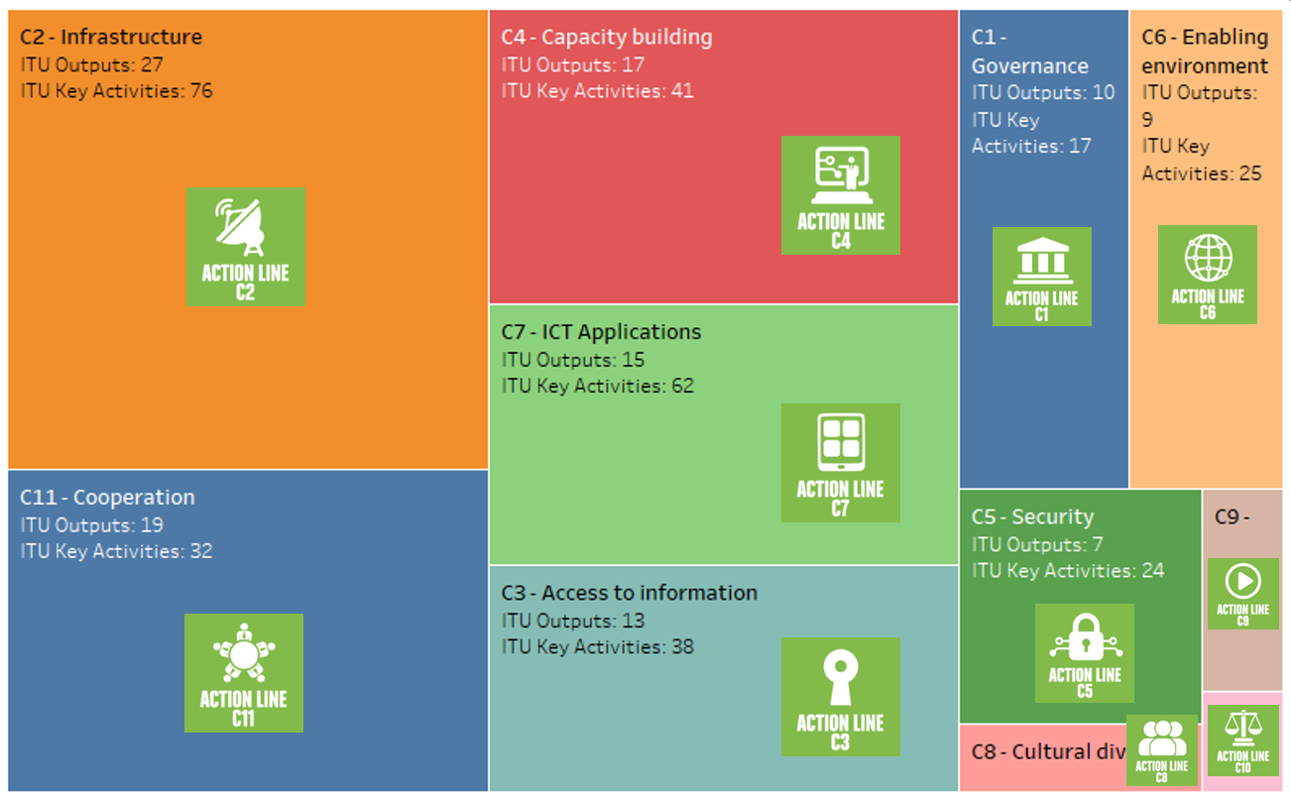

Linkage with the Sustainable Development Goals
With the adoption of the UNGA Resolution “Transforming our world: the 2030 Agenda for Sustainable Development” ITU, along with the rest of the UN family, needs to support Member States and contribute to the worldwide efforts to achieve the SDGs. The associated 17 SDGs and 169 related targets offer a holistic vision for the UN system.
The role of Information Communication Technologies (ICTs) as essential catalysts to fast-forward the achievement of the SDGs is clearly highlighted in the 2030 Agenda: “the spread of information and communications technology and global interconnectedness has great potential to accelerate human progress, to bridge the digital divide, and to develop knowledge societies”. ITU, as the UN’s specialized agency for ICTs and global connectivity, has a key role to play in promoting prosperity in our digital world.
In order to maximise ITU’s contribution to the 2030 Agenda, ITU’s primary focus is in addressing SDG 9 (Industry, Innovation and Infrastructure) and Target 9.c aiming to significantly increase access to ICTs and provide universal and affordable access to the Internet. Indeed, the infrastructure that powers our world and forms the backbone of the new digital economy is vital. It is essential to so many of the technological applications and potential solutions to the SDGs and is crucial for them to be both global and scalable.
As SDG17 (Partnership for the Goals) highlights ICTs as a means of implementation, with crosscutting transformative potential, it is imperative that ITU leverages this broad impact. Notable SDGs where ITU has a particularly strong impact include SDG 11 (Sustainable Cities and Communities), SDG 10 (Reduced Inequalities), SDG 8 (Decent Work and Economic Growth), SDG 1 (No Poverty), SDG 3 (Good-Health and Well-Being), SDG 4 (Quality Education) and SDG 5 (Gender Equality).
It is, therefore, through infrastructure and connectivity and in partnership with all stakeholders that ITU will contribute the most towards achieving the remaining SDGs.
Mapping ITU outputs and key activities to SDGs (as per the ITU SDG Mapping Tool)
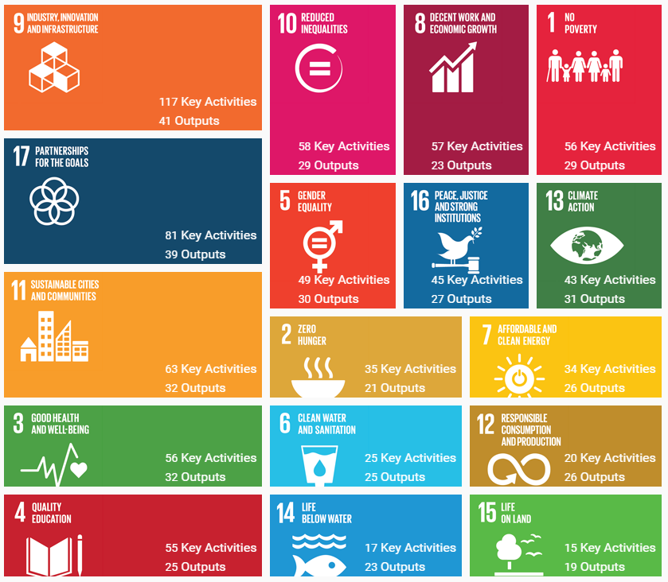
ITU is also the custodian of five SDG indicators (4.4.1, 5.b.1, 9.c.1, 17.6.2 and 17.8.1) contributing to the UNSTATS monitoring of the SDGs.

Linking ITU Strategic Goals to SDG targets
Goal 1 – Growth
SDG Target (indicator(s)): 1.4 (1.4.1), 2.4 (2.4.1), 4.1 (4.1.1), 4.2 (4.2.2), 4.3 (4.3.1), 4.4 (4.4.1), 4.A (4.A.1), 5.5 (5.5.1, 5.5.2), 5.B (5.B.1), 6.1, 6.4 (6.4.1), 7.3 (7.3.1), 8.2 (8.2.1), 8.10 (8.10.2), 9.1, 9.2, 9.3 (9.3.1, 9.3.2), 9.4 (9.4.1), 9.5, 9.C (9.C.1), 11.3 (11.3.2), 11.5 (11.5.2), 11.B (11.B.1, 11.B.2), 13.1 (13.1.2), 13.3 (13.3.2), 17.6 (17.6.1, 17.6.2)
Goal 2 – Inclusiveness
SDG Targets (indicator(s)): 1.4 (1.4.1), 1.5 (1.5.3), 2.C (2.C.1), 3.D (3.D.1), 4.1 (4.1.1), 4.2 (4.2.2), 4.3 (4.3.1), 4.4 (4.4.1), 4.5 (4.5.1), 4.6 (4.6.1), 4.7 (4.7.1), 4.A (4.A.1), 4.B (4.B.1), 4.C (4.C.1), 5.1 , 5.2 (5.2.1, 5.2.2), 5.3, 5.5 (5.5.1, 5.5.2), 5.6 (5.6.1, 5.6.2), 5.A (5.A.1, 5.A.2), 5.B (5.B.1), 5.C, 6.1, 6.4 (6.4.1), 7.1 (7.1.1, 7.1.2), 7.B (7.B.1), 8.3 (8.3.1), 8.4 (8.4.2), 8.5 (8.5.1), 8.10 (8.10.2), 9.1, 9.2, 9.3 (9.3.1, 9.3.2), 9.4 (9.4.1), 9.5, 9.A (9.A.1), 9.B (9.B.1), 9.C (9.C.1), 10.2 (10.2.1), 10.6, 10.7 (10.7.1), 10.B (10.B.1), 10.C (10.C.1), 11.1 (11.1.1), 11.2, 11.3 (11.3.2), 11.5 (11.5.2), 11.A, 11.B (11.B.1, 11.B.2), 12.1 (12.1.1), 12.A (12.A.1), 13.1 (13.1.2), 13.3 (13.3.2), 13.A(13.A.1), 13.B (13.B.1), 14.A (14.A.1), 16.2 (16.2.2), 16.8 (16.8.1), 17.3 (17.3.2), 17.6 (17.6.1, 17.6.2), 17.7, 17.8 (17.8.1), 17.9 (17.9.1), 17.18
Goal 3 – Sustainability
SDG Targets (indicator(s)): 1.5 (1.5.3), 2.4 (2.4.1), 8.4 (8.4.2), 8.5 (8.5.1), 8.10 (8.10.2), 9.1, 9.2, 9.4 (9.4.1), 9.5, 9.A (9.A.1), 11.6 (11.6.1, 11.6.2), 11.A, 11.B (11.B.1, 11.B.2), 12.1 (12.1.1), 12.2 (12.2.1, 12.2.2), 12.4 (12.4.1, 12.4.2), 12.5 (12.5.1), 12.6 (12.6.1), 12.7 (12.7.1), 12.8 (12.8.1), 12.A (12.A.1), 16.2 (16.2.2), 16.4, 17.7
Goal 4 – Innovation
SDG Targets (indicator(s)): 2.4 (2.4.1), 2.C (2.C.1), 3.6 (3.6.1), 3.D (3.D.1), 4.3 (4.3.1), 4.4 (4.4.1), 4.5 (4.5.1), 4.6 (4.6.1), 4.7 (4.7.1), 4.A (4.A.1), 4.B (4.B.1), 5.A (5.A.1, 5.A.2), 6.1, 6.4 (6.4.1), 7.1 (7.1.1, 7.1.2), 7.2 (7.2.1), 7.3 (7.3.1), 8.2 (8.2.1), 8.3 (8.3.1), 8.10 (8.10.2), 9.1, 9.2, 9.3 (9.3.1, 9.3.2), 9.4 (9.4.1), 9.5, 9.A (9.A.1), 9.B (9.B.1), 9.C (9.C.1), 10.5 (10.5.1), 10.C (10.C.1), 11.2, 11.3 (11.3.2), 11.4, 11.5 (11.5.2), 11.6 (11.6.1, 11.6.2), 11.B (11.B.1, 11.B.2), 12.3, 12.5 (12.5.1), 12.A (12.A.1), 12.B (12.B.1), 13.1 (13.1.2), 14.4 (14.4.1), 14.A (14.A.1), 16.3, 16.4, 16.10 (16.10.2), 17.7
Goal 5 – Partnership
SDG Targets (indicator(s)): 3.D (3.D.1), 4.4 (4.4.1), 4.7 (4.7.1), 4.A (4.A.1), 4.B (4.B.1), 4.C (4.C.1), 5.1, 5.2 (5.2.1, 5.2.2), 5.3, 5.5 (5.5.1, 5.5.2), 5.6 (5.6.1, 5.6.2), 5.A (5.A.1, 5.A.2), 5.B (5.B.1), 5.C, 7.B (7.B.1), 8.3 (8.3.1), 8.4 (8.4.2), 9.1, 9.2, 9.3 (9.3.1, 9.3.2), 9.4 (9.4.1), 9.5, 9.A (9.A.1), 9.B (9.B.1), 9.C (9.C.1), 10.5 (10.5.1), 10.6, 10.B (10.B.1), 10.C (10.C.1), 11.1 (11.1.1), 11.2, 11.3 (11.3.2), 11.5 (11.5.2), 11.B (11.B.1, 11.B.2), 12.3, 12.6 (12.6.1), 12.7 (12.7.1), 12.8 (12.8.1), 12.A (12.A.1), 12.B (12.B.1), 13.1 (13.1.2), 13.3 (13.3.2), 16.2 (16.2.2), 16.3, 16.4, 16.8 (16.8.1), 16.10, (16.10.2), 17.6 (17.6.1, 17.6.2), 17.7, 17.8 (17.8.1), 17.9 (17.9.1), 17.18

Implementation and evaluation of the Strategic Plan
The strong and coherent linkage between the Union’s strategic, operational and financial planning is ensured by implementing the ITU results-based management (RBM) framework in accordance with Resolutions 71, 72 and 151 (Rev. Busan, 2014) of the Plenipotentiary Conference.
Results will be the main focus of strategy, planning and budgeting in the ITU RBM framework. Performance monitoring and evaluation, together with risk management, will ensure that the strategic, operational and financial planning processes are based on informed decision-making and appropriate resource allocation.
The ITU performance monitoring and evaluation framework will be further developed according to the strategic framework outlined in the strategic plan for 2020-2023, to measure progress towards achievement of the ITU objectives and outcomes, strategic goals and targets set out therein, evaluating performance and detecting issues that need to be addressed.
The ITU risk-management framework will be further developed, to ensure an integrated approach to the ITU RBM framework set in the strategic plan for the Union for 2020-2023.

Appendix A. Allocation of resources (linkage with the financial plan)
(to be updated according to the Financial Plan for 2020-2023)

In accordance with the Preamble of the 2030 Agenda for Sustainable Development (UNGA A/RES/70/1)
Referring to PP-14 Res.64
Boxes and ticks demonstrate primary and secondary links to goals
[ Clarification to be added regarding the work in ITU-T and ITU-D ]
Within the context of the Outputs of the ITU-D contribution to the ITU strategic plan, “products and services” refers to activities within the mandate of ITU-D as defined by Article 21 of the ITU Constitution, including, among others, capacity building and dissemination of ITU expertise and knowledge
ITU SDG Mapping Tool: https://www.itu.int/sdgmappingtool
SDG indicators with a reference to ICTs are highlighted in bold.

