# Guidelines for the preparation of Proposals for WTSA-16

Contents

Guidelines for the preparation of Proposals for WTSA-16 1

1 Introduction 2

2 Getting started 2

2.1 Baseline texts for Proposals 2

2.2 Proposal types 2

2.3 Conference Proposals Interface (CPI) 3

2.4 Use of Microsoft Word 3

2.4.1 Microsoft Word versions 3

2.4.2 Use of track changes (revision marks) 4

2.5 WTSA-16 meeting documents 4

3 Guidelines for the presentation of Proposals 4

3.1 Organization/structuring of Proposals 4

3.2 Summary/introduction 4

3.3 Numbering of Proposals 5

4 Proposal workflow 5

4.1 Submitting Proposals 5

4.2 Proposal tracking 5

Annex A: Presentation/formatting of WTSA-16 documents 7

Annex B: Settings for "track changes" 10

# 1 Introduction

These guidelines have been prepared by the WTSA-16 Secretariat to assist in the preparation and submission of Proposals to the forthcoming World Telecommunication Standardization Assembly 2016 (WTSA-16).

Delegations are invited to submit Contributions to WTSA-16 at least four weeks before the Assembly (Monday, 26 September 2016), noting the firm submission deadline of Monday, 10 October 2016. Early availability of Contributions ensures sufficient time for translation and consideration before the Assembly.

NOTE - In accordance with the Plenipotentiary Conference (Busan, 2014), all documents to WTSA-16 will be made publicly available unless the submitter of the document advises the ITU Secretariat otherwise: <http://www.itu.int/md/S14-PP-C-0175/en>

For any inquiries regarding these guidelines, please contact [tsbwtsa-doc@itu.int](mailto:tsbwtsa-doc@itu.int).

# 2 Getting started

## 2.1 Baseline texts for Proposals

Proposals should be prepared and submitted using the [Conferences Proposals Interface](https://www.itu.int/net4/Proposals/CPI/WTSA16) (CPI, see clause 2.3); this will ensure that the latest versions of in-force Provisions are used as the baseline for any changes, and that your documents are correctly formatted.

Note that some Provisions have been updated or introduced since WTSA-12, including Resolution 2, Recommendations ITU-T A.5, A.7, A.23 (Annex A), A.25, A-Supp.4 and A-Supp.5.

## 2.2 Proposal types

Each individual Proposal should be presented using one of the following "Actions":

* **MOD (modify)**: Proposal to modify existing provision(s) (*use* "track changes").  
  E.g., addition, deletion or replacement of words or figures.
* **ADD (add)**: Proposal to add a new provision, i.e., a draft new WTSA Resolution, A-series Recommendation or Opinion (do *not* use "track changes").  
  Note that adding text to an existing provision should be done as a MOD.
* **SUP (suppress)**: Proposal to delete an existing Resolution, Recommendation or Opinion (do *not* use "track changes").  
  Reasons/rationale for deletion should be given.
* **NOC (no change)**: Proposal to maintain provision(s) without change (do *not* use "track changes").  
  Reasons/rationale for maintaining the text should be given.
* **OTHER:** Proposal on general matters not included above.

Examples of the presentation of MODs, ADDs, SUPs and NOCs can be found in Annex A.

## 2.3 Conference Proposals Interface (CPI)

The [Conference Proposals Interface](https://www.itu.int/net4/proposals/CPI/Main?EventId=13483) (CPI) is an electronic tool developed by the ITU to facilitate the preparation and submission of Proposals to WTSA-16. Figure 2-1 illustrates the three-stage process, and step-by-step Guidelines are available at:  
<https://www.itu.int/en/ITU-T/wtsa16/Documents/CPI/WTSA-16_CPI-UserGuide.docx>.

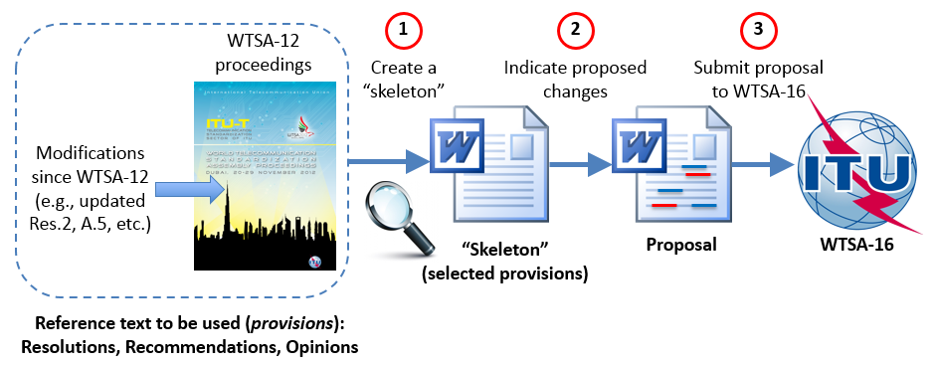

**Figure 2-1 – Preparing and submitting Proposals using CPI**

## 2.4 Use of Microsoft Word

All Proposals submitted to WTSA-16 should be prepared using CPI; however, other Contributions may be submitted to [tsbwtsa-doc@itu.int](mailto:tsbwtsa-doc@itu.int) using the official MS Word templates:  
[English](http://www.itu.int/en/ITU-T/wtsa16/Documents/Templates/WTSA16E.docx) | [Arabic](http://www.itu.int/en/ITU-T/wtsa16/Documents/Templates/WTSA16A.docx) | [Chinese](http://www.itu.int/en/ITU-T/wtsa16/Documents/Templates/WTSA16C.docx) | [Spanish](http://www.itu.int/en/ITU-T/wtsa16/Documents/Templates/WTSA16S.docx) | [French](http://www.itu.int/en/ITU-T/wtsa16/Documents/Templates/WTSA16F.docx) | [Russian](http://www.itu.int/en/ITU-T/wtsa16/Documents/Templates/WTSA16R.docx)

The use of CPI ensures compliance with the official WTSA-16 MS Word templates. When preparing Proposals, the format and styles of the text must not be changed.

NOTE – CPI introduces each proposed change with a code (see Figure 2-2). These codes contain hidden text that is used by ITU's internal systems to track a document's history. Please take care not to modify these codes in any way.

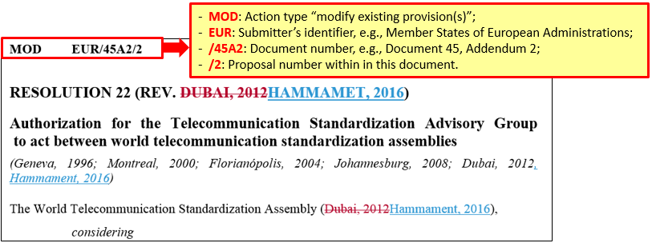

**Figure 2-2 – Proposal codes**

### 2.4.1 Microsoft Word versions

Since mid-2014, the ITU has been migrating to the MS Office 2013 Suite, including MS Word 2013, which is used for the processing and publishing of WTSA-16 documentation, including Proposals for the work of the Assembly.

### 2.4.2 Use of track changes (revision marks)

Proposals of type "MOD" (modify) should be prepared ensuring that MS Word track changes options are set as described in Annex B. All other Proposals should not use track changes.

## 2.5 WTSA-16 meeting documents

The following five types of meeting document may be used during the Assembly:

* **Document**: Plenary documents are published in the “Contributions” series, and include Proposals, committee reports and general information of interest to plenary sessions.
* **Temporary Document (TD / DT)**: Committee documents, equivalent to study-group TDs, and may include draft revised Resolutions, A-series Recommendations and Opinions, and working group meeting reports.
* **ADMIN (ADM)**: Meeting agendas.
* **Information (INF)**: General information (rarely used).
* **Working Document**: Informal documents used by committees and working groups. In order to accelerate the work, these are typically not translated.

Once available, these documents can be accessed from the WTSA-16 documents webpage:  
<http://www.itu.int/en/ITU-T/wtsa16/Pages/documents.aspx>

# 3 Guidelines for the presentation of Proposals

The following standards of presentation should be adhered to as far as possible.

## 3.1 Organization/structuring of Proposals

More than one Proposal may be included in a single Document, e.g., when there are a small number of Proposals or when they are closely related. In some cases, e.g., where many Proposals addressing different issues are being prepared, submitters may group them into a series of addenda to the main Document, for example:

* Document xx, "[Member]'s Proposals for the work of the Assembly"
  + Document xx Addendum 1: Proposals relating to BSG
  + Document xx Addendum 2: Establishment of a region group on [topic]
  + Document xx Addendum 3: Etc…

In the case of common Proposals submitted on behalf of more than one Member, the main Proposal document could contain a table indicating which Proposals were supported by which supporting entities. In such cases, all of the co-signatories should be mentioned in the source of the document.

## 3.2 Summary/introduction

All Contributions to the Assembly should include an abstract (maximum 250 words) outlining the background or content of the document(s). Proposals may then briefly outline the proposed views or positions on the subject.

Each individual Proposal to suppress or retain an existing Provision (i.e., SUP or NOC) should be followed by the reasons or rationale for the proposed action (see Figure A.3 in Annex A).

## 3.3 Numbering of Proposals

In accordance with the provisions of No. 42 of the General Rules of Conferences, Assemblies and Meetings of the Union, the Secretariat will annotate the individual Proposals with index numbers (codes) composed as follows:

**Action ABC/25A6/3**

Where:

* **Action** is one of: MOD, ADD, SUP, NOC;
* **ABC** is the identifier of the Member(s) submitting the Proposal or common Proposal;
* **25** is the number assigned by the Secretariat to the document, **A6** is the addendum number in which the Proposal is published; and
* **3** is the serial number of the Proposal within that document.

When using CPI, this numbering process is automated – please do not modify these index numbers (codes) in any way. Examples can be found in Figures A.2 and A.3 in Annex A.

# 4 Proposal workflow

## 4.1 Submitting Proposals

Proposals should be prepared and submitted according to the internal rules and procedures of the submitting entity(s). Once ready, Proposals should be submitted using the Conference Proposals Interface (CPI) or by email to [tsbwtsa-doc@itu.int](mailto:tsbwtsa-doc@itu.int).

Please submit Proposals at least four weeks before the Assembly (Monday, 26 September 2016), noting the firm submission deadline of Monday, 10 October 2016.

## 4.2 Proposal tracking

Figure 4-1 provides a simplified workflow from submission to Approval of Proposals.

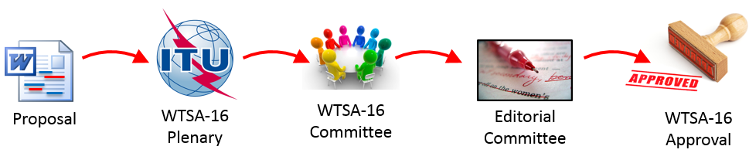

**Figure 4-1 - WTSA-16: Proposal workflow**

Each individual Proposal is traceable to ensure transparency, and can be monitored on the publicly available Proposals Management System website (see Figure 4-1) at:  
<http://www.itu.int/net4/proposals/WTSA16>

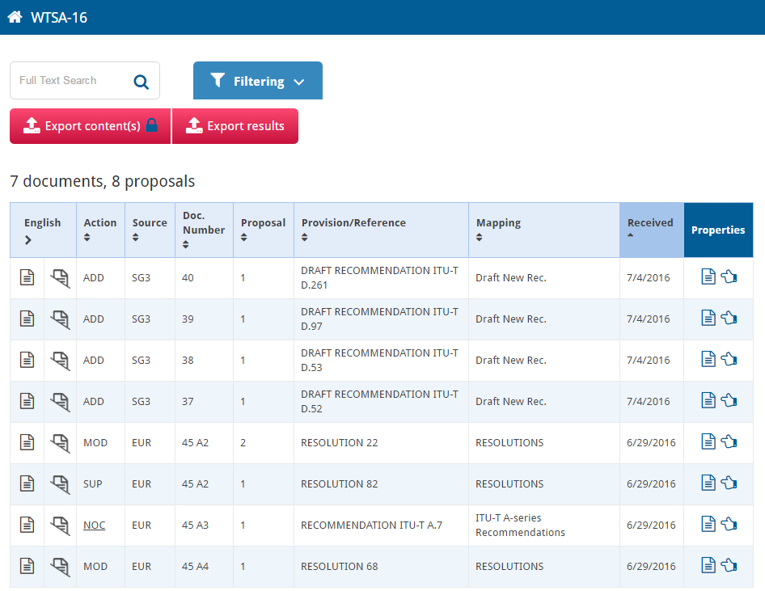

**Figure 4-2 – Proposals Management System web view**

# Annex A: Presentation/formatting of WTSA-16 documents

Figures A.1 – A.6 give examples of presentation and formatting of WTSA-16 documents.

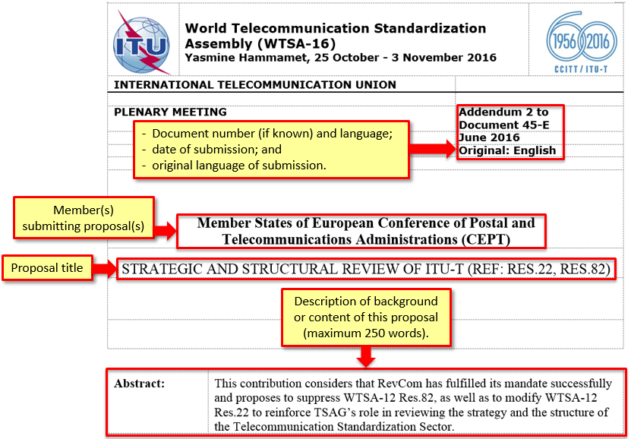

**Figure A.1 – Anatomy of a Proposal – cover page**

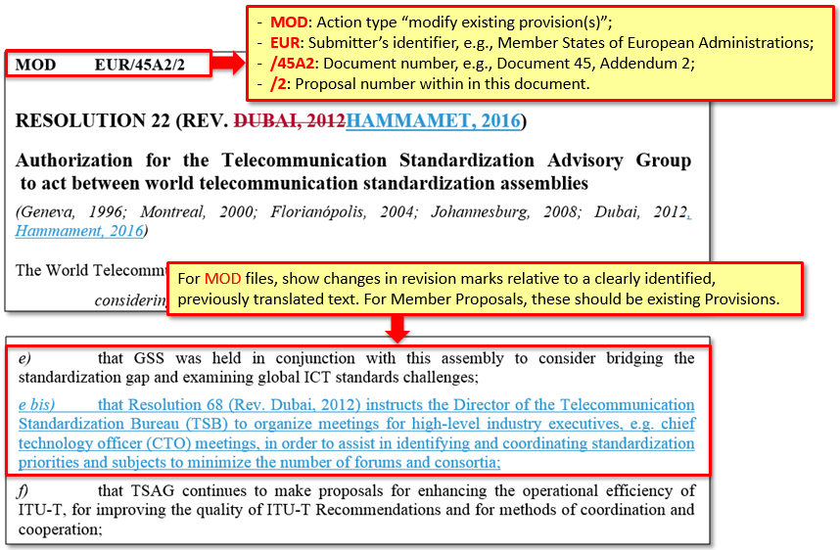

**Figure A.2 – Presentation of "MOD" Proposals**

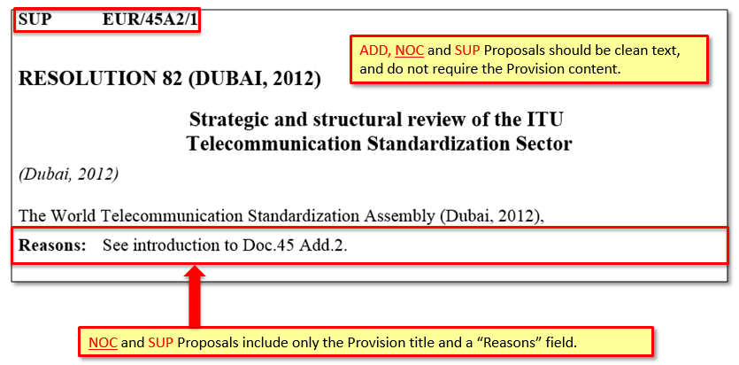

**Figure A.3 – Presentation of "NOC" and "SUP" Proposals**

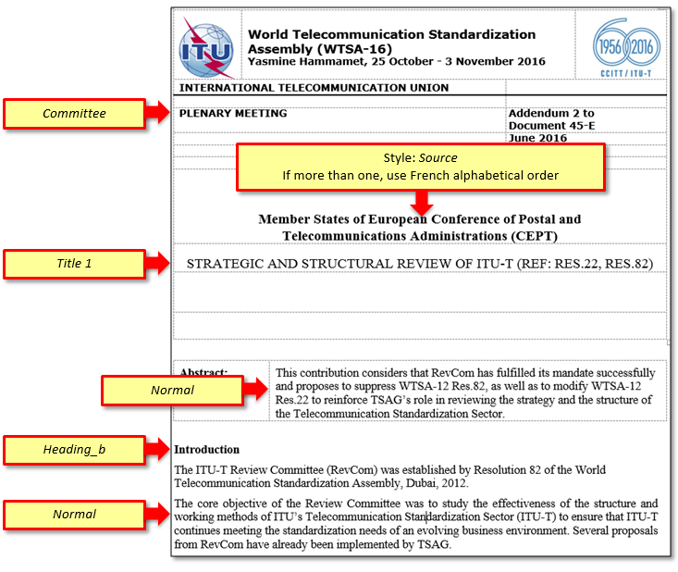

**Figure A.4 – Cover page styles**

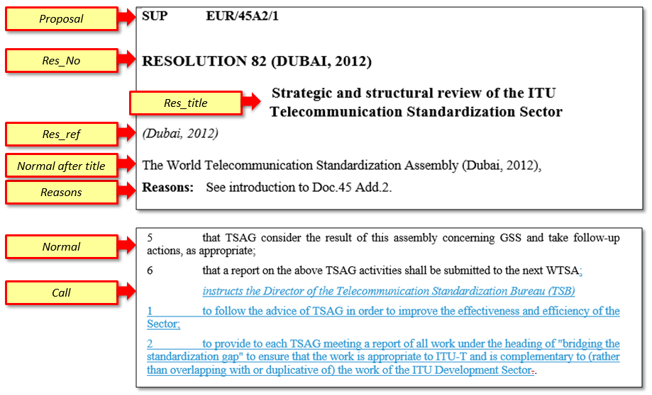

**Figure A.5 – Resolution styles**

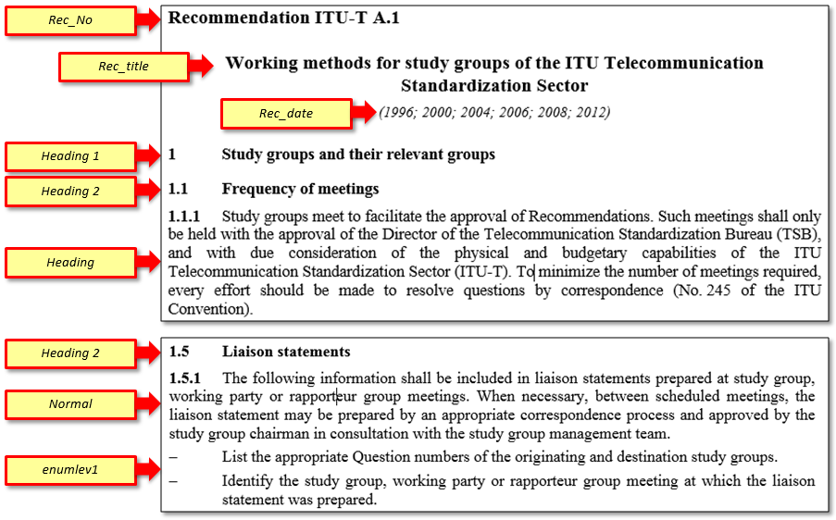

**Figure A.6 – Recommendation styles**

# Annex B: Settings for "track changes"

| **Word 2010 options** | **Word 2013 options** |
| --- | --- |
| Under the **Review** tab:   * the Display for Review = **Final: Show Markup**     Click on the small arrow beside **Track Changes** and click on **Change Tracking Options**:    and apply the following options:   * Insertions = Underline (blue) * Deletions = Strikethrough (red) * Track moves: Moved from = Double strikethrough (green) * Track moves: Moved to = Double underline (green) * Balloons - Use Balloons = Never | Under the **Review** tab:   * the Display for Review = **All Markup**     Click on the small arrow beside **Tracking** which opens the **Track Changes Options**:    and apply the following options:   * Balloons in All Markup view show = Nothing   Then click on the **Advanced Options**:   * Insertions = Underline (blue) * Deletions = Strikethrough (red) * Track moves: Moved from = Double strikethrough (green) * Track moves: Moved to = Double underline (green) |

_______________________