Conference Proposals Interface (CPI)
User Guide
Contents
Conference Proposals Interface (CPI) User Guide 1
1 CPI overview 2
2 Logging on 3
3 Languages 3
4 Searching the authoritative texts 3
5 Preparing a baseline document ("skeleton") 4
5.1 Proposal types 4
5.2 Creating a skeleton 5
5.3 Removing a proposal 6
5.4 Re-ordering provisions/proposals 6
6 Saving your skeleton/producing a baseline Word file 7
6.1 Selecting sources 7
6.2 Example of the resulting Word document for a skeleton created in CPI 8
6.3 Example email notification received after the saving of a skeleton created in CPI 9
7 Loading a previously saved skeleton 9
8 Finalizing your MS Word document 10
9 Submitting proposals to ITU 10
9.1 Submitting proposals using CPI 10
9.2 Example of a confirmation of submission email 11

1 CPI overview
The work of the World Telecommunication Standardization Assembly 2016 (WTSA-16) is driven by proposals from ITU Member States, regional organizations and ITU-T Sector Members, supplemented by proposals from the ITU-T study groups and TSAG. A significant number of proposals are changes to in-force Resolutions, Recommendations or Opinions, or addition of draft new provisions.
The Conference Proposals Interface (CPI) is a web-based tool that assists in the preparation of proposals by creating a clean baseline document (a "skeleton") upon which proposed modifications can be indicated. CPI will be familiar to those who have submitted proposals to other recent major ITU events, such as the ITU Plenipotentiary Conference 2014 (PP-14) or the World Radiocommunication Conference 2015 (WRC-15).
Key terms:
- Authoritative texts: Currently in-force ITU-T Resolutions, A-series Recommendations and Opinions (i.e., the WTSA-12 proceedings plus all changes subsequently Approved by TSAG).
- Skeleton: Those provisions from the authoritative texts that have been selected by a submitter as a baseline for proposed modifications. Once a skeleton has been created using CPI, the system generates a corresponding Word file in the correct format.
- Proposal: A Contribution to WTSA-16 suggesting changes to the currently in-force Resolutions, Recommendations and Opinions. Proposals should be based on the Word file created by CPI, updated to indicate the desired modifications (using "track changes" where needed – see clause 5.1 below).
Useful addresses and contact details:
- CPI: https://www.itu.int/net4/Proposals/CPI/WTSA16
- Guidelines and presentations: https://www.itu.int/en/ITU-T/wtsa16/Pages/cpi.aspx
- WTSA-16 Secretariat: wtsa-doc@itu.int
Below is a description of how to prepare and submit proposals to WTSA-16 using CPI.

2 Logging on
To log on, navigate to https://www.itu.int/net4/Proposals/CPI/WTSA16, and enter your TIES username and password, then click "Sign in".

3 Languages
By default, your default TIES language is used. To change it, select your preferred language from the list at the top of the screen.
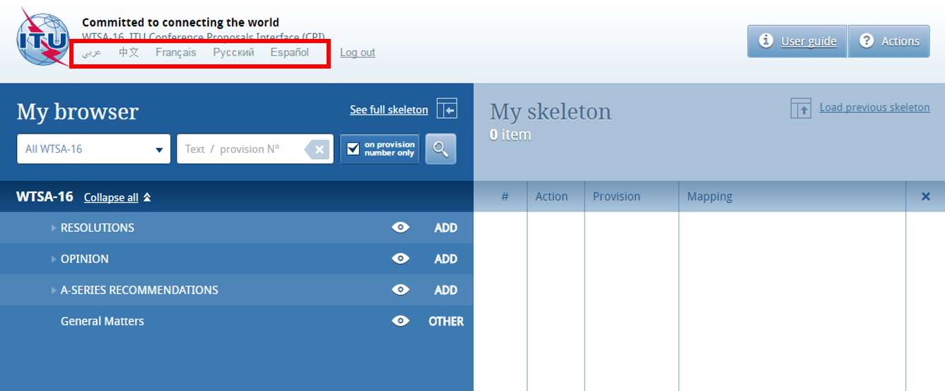

4 Searching the authoritative texts
You may search for key words/terms using "My browser". Searches can be performed on the entire collection of texts or on a selected volume (i.e., Resolutions, Opinions, Recommendations, etc.). Additionally, you may search within the document content or only within the titles of provisions (in which case, click "On provision number only").
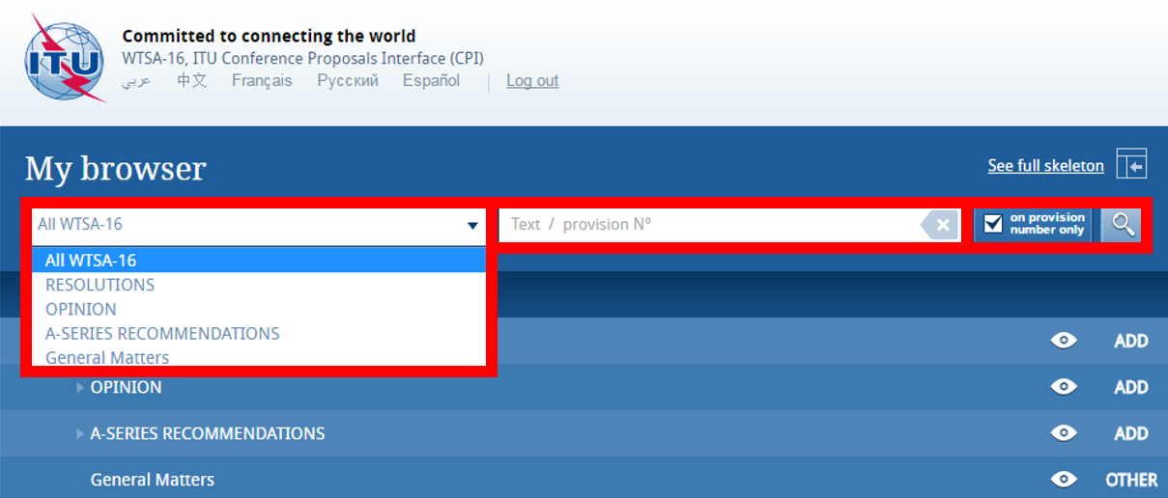
You may inspect the content of provisions by clicking on the "eye" icon. Note that you may create a Word file from any provisions that you inspect.
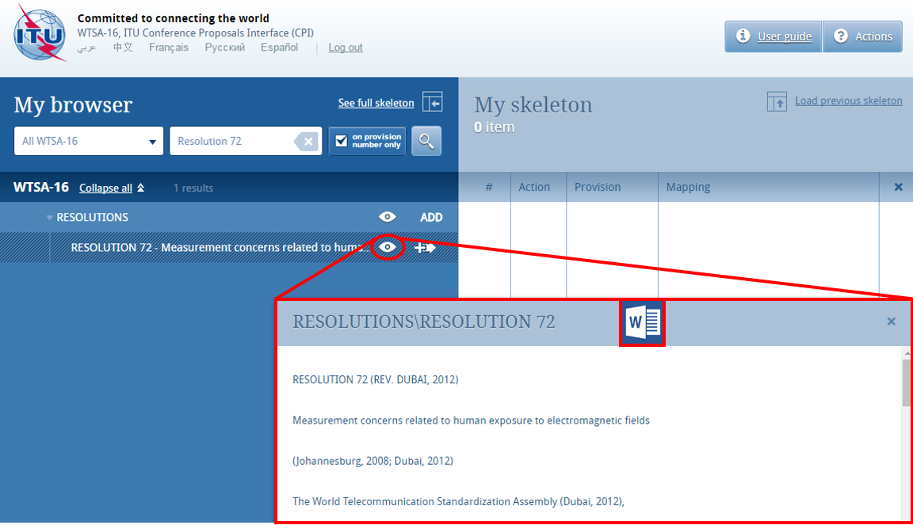

5 Preparing a baseline document ("skeleton")

5.1 Proposal types
Each individual proposal will use one of the following "Actions":
- MOD (modify): Proposal to modify existing provision(s) (use "track changes").
E.g., addition, deletion or replacement of words or figures.
- ADD (add): Proposal to add a new provision, i.e., a draft new WTSA Resolution, A-series Recommendation or Opinion (do not use "track changes").
Note that adding text to an existing provision should be done as a MOD.
- SUP (suppress): Proposal to delete an existing Resolution, Recommendation or Opinion (do not use "track changes").
Reasons/rationale for deletion need to be given.
- NOC (no change): Proposal to maintain provision(s) without change (do not use "track changes").
Reasons/rationale for maintaining the text need to be given.
- OTHER: Proposal on general matters no included above.

5.2 Creating a skeleton
To create a skeleton, identify the first provision that you wish to modify, then click on the icon to select it and apply the associated Action to make a proposal. Note that you may "ADD" only at the level of Resolutions, Recommendations or Opinions; and you may "MOD", "SUP" or "NOC" at the level of individual provisions.
Click on the “Actions” button in the top right-hand corner to see a description of each Action type.
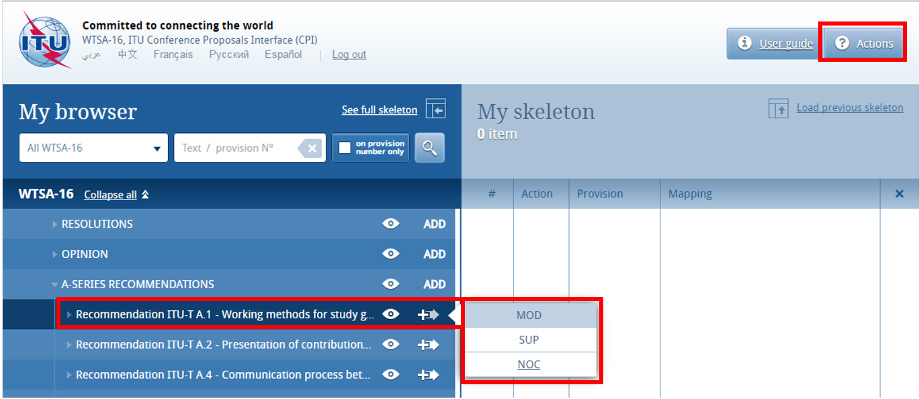
The selected provision and the associated Action will then appear under “My skeleton”. Repeat this process until all provisions have been added to your skeleton.
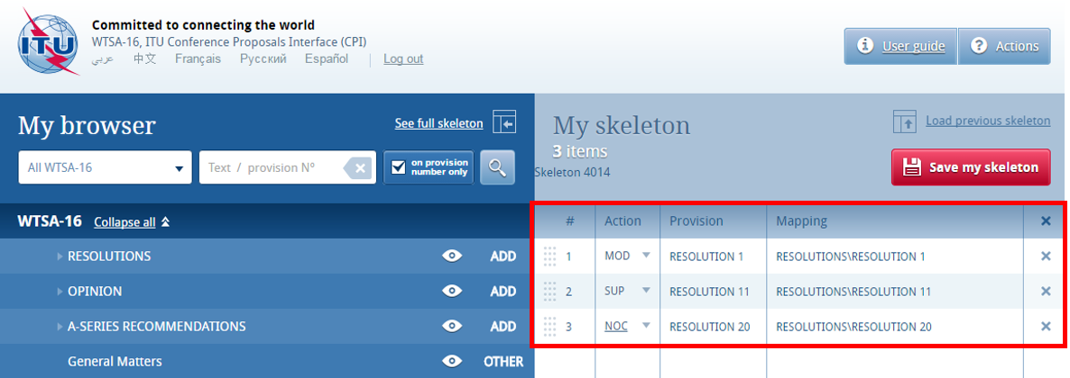
By default, a "Reasons" clause will be added automatically immediately after each proposal. To remove the "Reasons" clause, click on see full skeleton and unclick “Display reasons”.
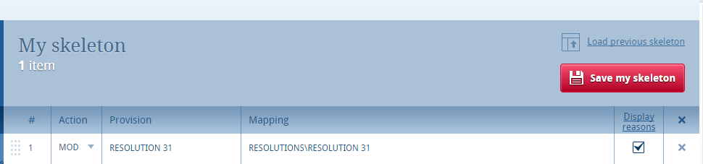
Your skeleton can be downloaded in any of the six official languages.

5.3 Removing a proposal
To remove a proposal from your skeleton, click on the icon located on the same row as the proposal to be removed; to remove all proposals from your skeleton, click on the icon in the header of the table.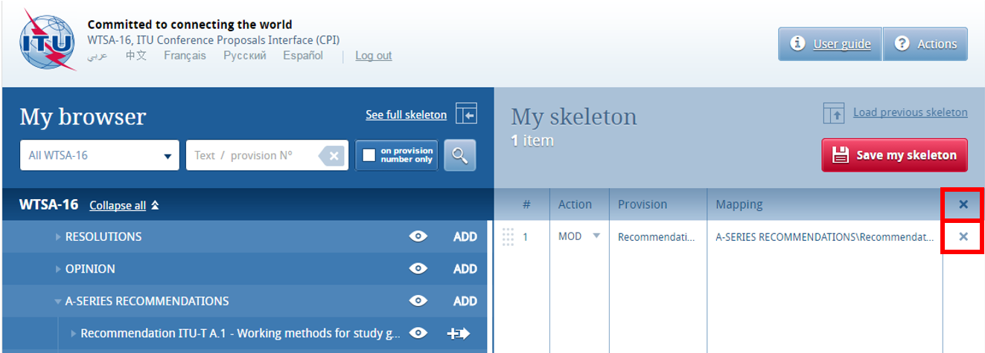

5.4 Re-ordering provisions/proposals
Should you wish to re-order selected provision(s), click on the grey squares and drag-and-drop selected provisions.
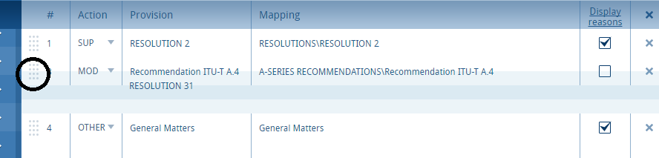

6 Saving your skeleton/producing a baseline Word file
Since CPI is a web interface, do not forget to save your skeleton before leaving the application if you wish to retrieve it later.
The act of saving will generate a baseline Word file in any one of the six official UN languages. The system will also email a copy of this file to your TIES email or your TIES forwarding address. In order to check or update your TIES email forwarding address, go to: http://www.itu.int/TIES/ and click on "Edit my account", then review the information highlighted below.
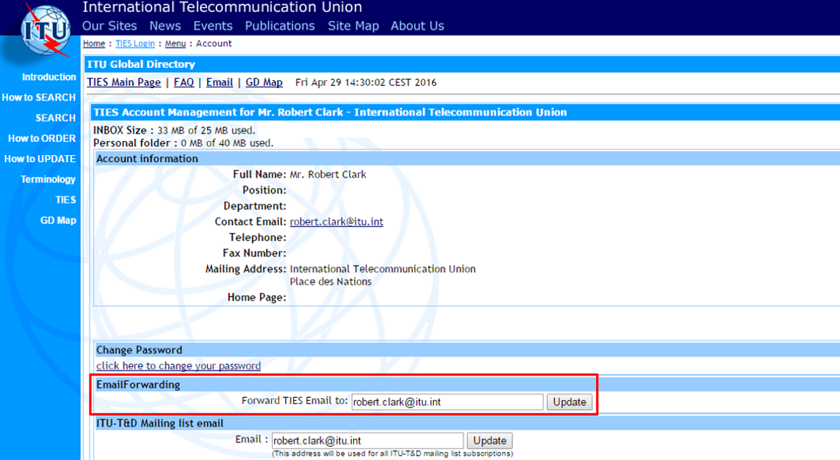

6.1 Selecting sources
Upon saving your skeleton, select the source(s) of the proposal. A combination of the following may be selected:
- the Member State associated to your TIES account;
- the Regional Group to which your Member State is associated, to create common proposals (only shown if you have been designated as coordinator for a regional group);
- Co-Signatories: select multiple Member States from the drop-down menu;
- Sector Member.
Click again on the “Save my skeleton” button at the bottom of the dialogue box to save this metadata and create a MS Word file, which will open on your computer as well as being emailed to you (see below). CPI will assign a provisional number for your proposal(s). It will also assign a unique ticket number that can be found in the email notification.
The output Word file should be used as the basis of your proposals.

6.2 Example of the resulting Word document for a skeleton created in CPI
The Word file includes a header containing information about the event and the submitter. The content is based on the latest version of provisions, and is correctly formatted in order to be translated into all official UN languages and submitted to WTSA-16.
Before submitting the Word file to the WTSA-16 secretariat, insert any introductory text as you wish, and indicate using "track changes" your proposed modifications to the content.
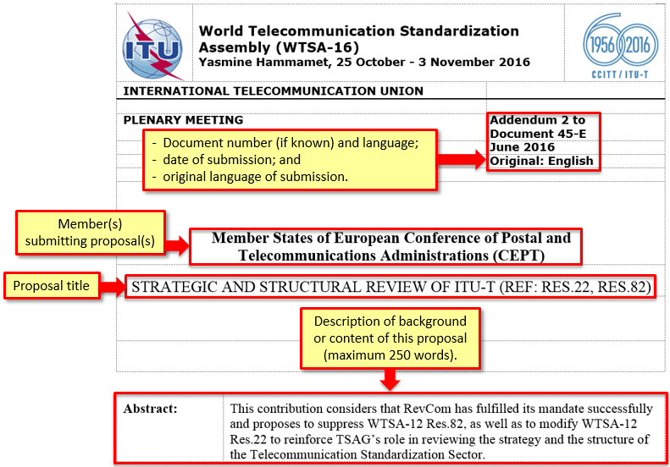
NOTE – CPI introduces each proposed change with a code (Figure 2-2). These codes contain hidden text that is used by ITU's internal systems to track a document's history. Please take care not to modify these codes in any way.
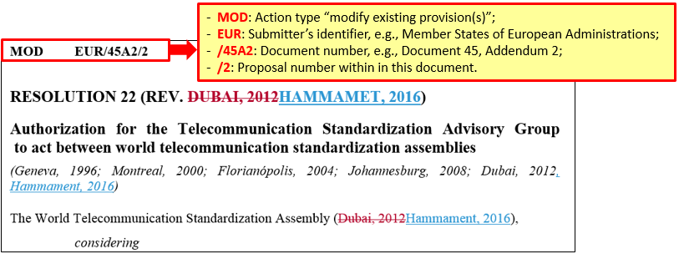

6.3 Example email notification received after the saving of a skeleton created in CPI
The email notification includes a copy of the skeleton Word file and hyperlinks to CPI in order to modify your skeleton, submit your proposal etc.
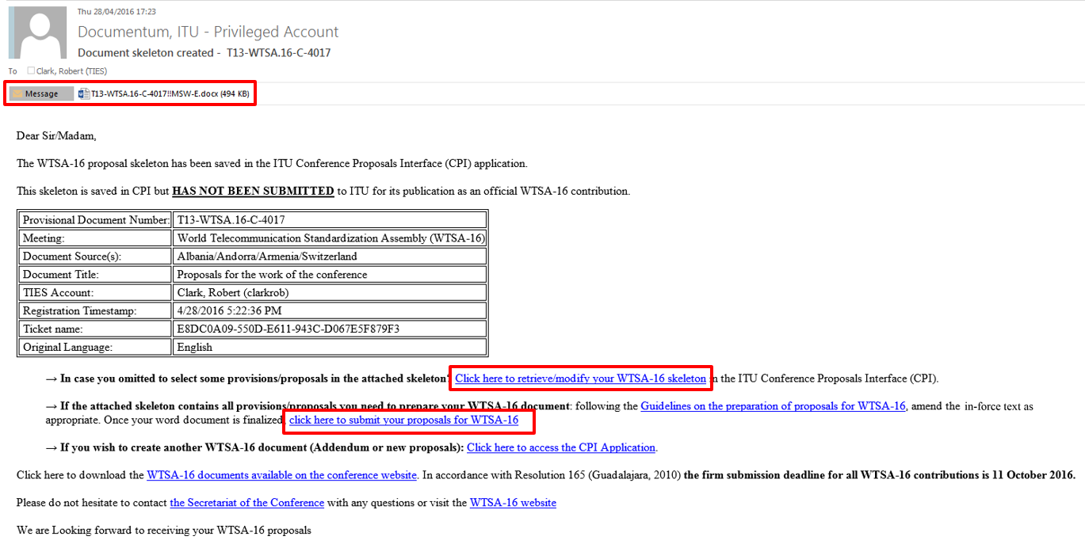

7 Loading a previously saved skeleton
If you wish to change the baseline text for your proposal(s), you may load and then modify skeletons previously saved in CPI before creating a new Word file.
To load a previously saved skeleton, either click the link in the email (see above), or click the "Load previous skeleton" button in the CPI interface. You may then select or delete any of the skeletons that you previously created.
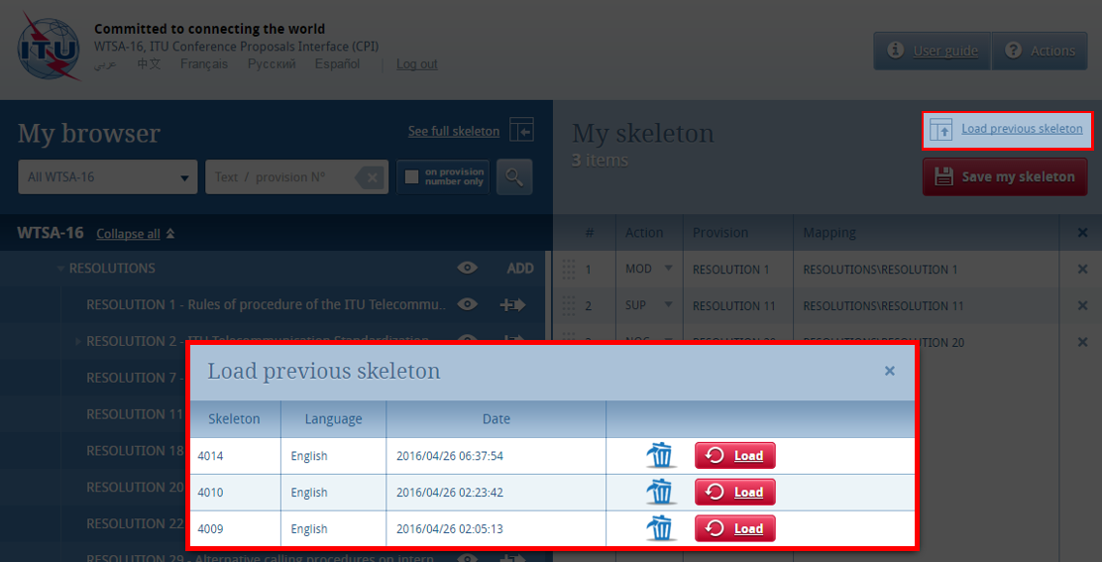
Once a skeleton has been created, a Word file can be produced in any of the six official UN languages. Click on the desired language, then click "Save my skeleton", and follow the process described above.

8 Finalizing your MS Word document
Once your Word document has been created, you may modify it as you wish before submitting it to the WTSA-16 Secretariat for posting.
NOTE - "MOD" proposals should be made with track changes switched on: new text added should then appear as underlined (underlined); existing text deleted should appear as crossed out (crossed out). Members should refer to the Guidelines on the Preparation of Proposals available on the CPI website for further instructions.
Should you wish to add, remove or reorder some proposals included in your document, you can retrieve your skeleton in CPI using the “Load previous skeleton” (see above) or on the link provided in the email you received when you saved your skeleton.

9 Submitting proposals to ITU
While anyone with a TIES account can prepare the text of a proposal, only users officially accredited or designated for the official submission of proposals to WTSA-16 can submit documents using CPI. Their name(s) and TIES username(s) should be provided to the WTSA-16 Secretariat:
wtsa-doc@itu.int.

9.1 Submitting proposals using CPI
To submit your proposal(s) to the WTSA-16 Secretariat, return to the email you received when successfully creating your skeleton and click on the link “click here to submit your proposals for WTSA-16”. You will be redirected to the CPI on-line application and the associated ticket name will automatically be displayed. Select the MS Word file containing your proposal(s) by clicking on the icon to upload your document. If required, you can add a suffix (addendum number), remarks, or additional contact emails (a copy of the confirmation of submission email will be sent to these additional contact emails).
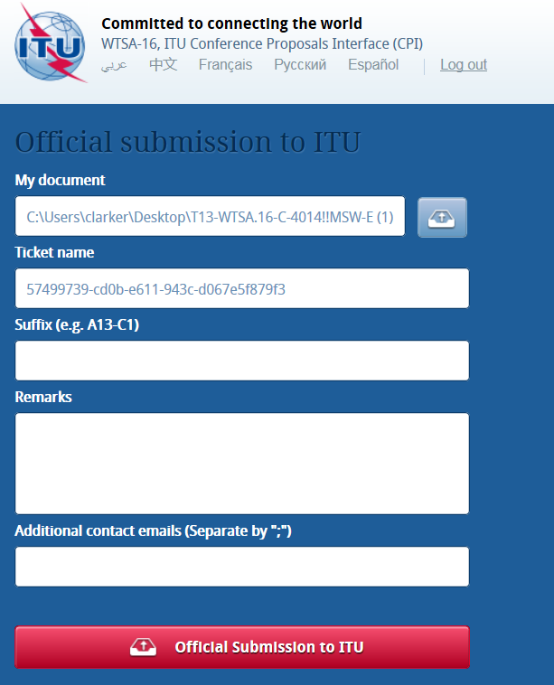

9.2 Example of a confirmation of submission email




