Logging In The Room:
- Open your browser and enter the name of the meeting room:
http://itu.adobeconnect.com/itu-t_tutorial/
- Enter your login details that have been sent to you.
Inside Adobe Connect:
There are two options to join this meeting:

Option 1: Listen through computer speakers (listen mode only)
Option 2: Dial-In or dial-out to yourself over the phone.

Option 1:

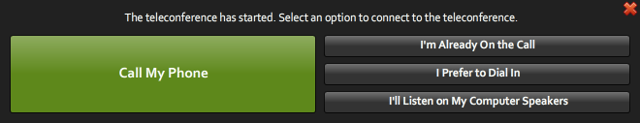
By choosing this option, you can only listen to the conference. You won’t be able to speak.
A chat box is available if you wish to make some comments.

Option 2:

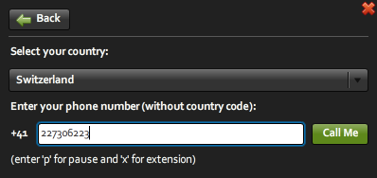

- Click on “Call My Phone”
- Select the country
- Type in your number

The system will then call you on the specified number. To mute/unmute yourself, press *6.

Please note that Skype is strongly discouraged as it can provide very bad audio quality and bring some noise in the call depending on your internet connection.

