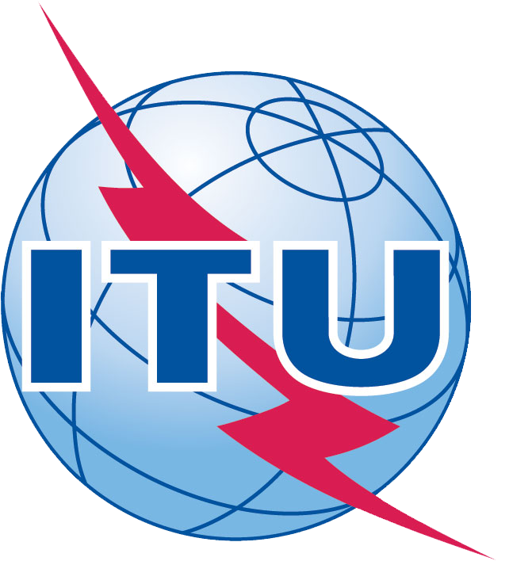
FOURTH MEETING OF CTO GROUP

Sunday, 18 November 2012
Dubai World Trade Center
Dubai, United Arab Emirates
14:00-18:00

FINAL LIST OF PARTICIPANTS

- Cisco Mrs Monique Morrow, SP CTO, Asia Paficic
(Mr. Chip Sharp)
- Ericsson Mr. Jan Ellsberger, Director, Technology Strategies and Industry
(Dr. Asok Chatterjee)
- Etisalat Mr. Nasser Bin Obbod Al Falasi, Chief Government Relations & Communications Officer
and Chair of 2012 ITU Global Standards Symposium
- Fujitsu Mr. Kazuhiko Ogawa, Corporate Vice President, Executive Vice President, Network Business Group
(Mr. Naoshi Sato)
- Huawei Mr. Xuemin Wang, Vice President for Industry
(Mr. Wei Feng)
- KDDI Dr. Yutaka Yasuda, Chairman of KDDI R&D Labs.
(Mr. Masao Kojima)
7. NEC Mr. Hidenobu Harasaki, CTO for Standardization
(Mr. Kaoru Kenyoshi)
8. NSN Mr. Ulrich Dropmann, Head of Industry Environment
(Dr. Helmut Schink)
9. NTT Mr. Naohide Nagatsu, General Manager, R&D European Representative Office
10. Orange FT Group Mr. Philippe Lucas, VP International Standardization & Industrial Relationships
(Mr. Dominique Wurges)
11. RIM Ms. Veena Rawat, VP and Ambassador to ITU
12. Telecom Italia Mr. Luigi Licciardi, EVP Head of Tilab and Global Consulting
13. Telkom South Africa Dr. Richard Majoor, Head of Technical Regulations, Regulatory Affairs & Public Policy
14. Verizon Mr. Leslie Martinkovics, Director, International Public Policy & Regulatory Affairs

ITU Mr. Malcolm Johnson, Director, TSB
Mr. Reinhard Scholl, Deputy Director,TSB
Mr. Bilel Jamoussi, AG Secretary, TSB
Mr. Alexander Ntoko, TSB
Mr. Colin Langtry, BR
Mr. Mario Maniewicz, BDT
Mr. Richard Hill, TSB
Mr. Toby Johnson, TSB
Mr. Martin Adolph, TSB Ms. Sabrina Camp, TSB
Ms. Honora Daily, TSB

