Home Network Transport

Standards Overview and Work Plan

October 2025 SG15 meeting

Contact persons for project updates:

Study Group 15 Advisor:  Mr. Hiroshi Ota  International Telecommunication  Union (ITU)  Place des Nations  1211 Geneva 20  Switzerland  Tel.: +41 22 730 6356  E-mail: hiroshi.ota@itu.int | Study Group 15 Chairman  Mr. Glenn Parsons  Ericsson  349 Terry Fox Drive  Ottawa - ON K2K 2V6  Canada  Tel: +1 514 379 9037  E-mail:  glenn.parsons@ericsson.com | Q3/15 Associate Rapporteur  Mr. Tony Zeng  Huawei  H1, Xiliubeipo Village  Dongguan, Guangdong China  Tel: +86 13689576518  E-mail:  Tony.zengyan@huawei.com

Home Network Transport is an ITU-T Project dealing with studies and Recommendations on the Home Network. The present Home Network Transport (HNT) Standards Overview and Work Plan is part of ITU-T SG15 Lead Study Group activities on coordination of Home Network Transport standards.

Home Network Transport Standards Overview and Work Plan
Issue 18, October 2025

Revision Status Report: Major Updates of Version 18, October 2025
In this version 18, following changes, additions and updates have been made:
1) The web-based HNT Standards Overview has been updated with following new or revised Standards, Recommendations, Amendments and Corrigenda, Supplements, Technical Reports and other technical documents from ITU-T SG15, other ITU Study Groups and other SDOs that have been approved and published since the last ITU-T SG15 March 2025 plenary meeting.
2) Section 2 Overview of Home Networks applications has been updated.
3) Work programmes and ongoing standardization activities in Section 4.1 have been updated with the latest Q3/15 activities resulting from October 2025 ITU-T SG15 - WP1 plenary meeting and latest Q5/15 and Q7/15 activities resulting from ITU-T SG15 - WP2 October 2025 plenary meeting.
4) Work programmes and ongoing standardization activities in Sections 4.2 and 4.3 have been updated with the incoming liaisons from other ITU SGs and SDOs and reports from liaison Rapporteurs of ITU-T SG15.

Home Network Transport Standards Overview and Work Plan

General… 6
Introduction 6
1. Home Network Transport technologies 7
2. Overview of Home Networks applications 9
3. Web presentation of the HNT Standards Landscape……………………………………12
3.1 Web-based HNT Standards Overview 12
3.2 Taxononmy of the web-based HNT Standards Overview 13
3.3 HNT Topics and related Groups (ITU Study Groups and SDOs)…………………20
4. Ongoing standardization activities in the area of Home Network Transport 24
4.1 Ongoing standardization activities in the area of Home Network Transport
within ITU-T SG15……………………………………………….. 24
4.2. Ongoing standardization activities in the area of Home Network Transport in
other ITU Study Groups 29
[ITU-T SG5; SG9; SG13; SG16; SG17; SG20] [ITU-R SG1; SG5; SG6]
[ITU-D SG1]
4.3. Ongoing standardization activities in the area of Home Network Transport
in other Standards Development Organizations 40
[Broadband Forum; Bluetooth SIG; ETSI; HomeGrid Forum, CENELEC;
IEC; IEEE 802.3; IEEE 802.11; Wi-Fi Alliance®; IEEE 802.15;
IEEE 1901; IEEE 1905; ISO/IEC; MoCA®; TIA; TTC; Thread Group;
CSA (ex. Zigbee Alliance);
Z-Wave Alliance]
5. List of Contacts 59
6. Lead Study Group activities related to the HNT Standards Overview and Work Plan 65
Annex 1 - Guide on the use of the web-based HNT Standards Overview 66

HOME NETWORK TRANSPORT STANDARDS OVERVIEW AND WORK PLAN
Issue 18, OCTOBER 2024

General
As home networks become more sophisticated, and as their interactions with the access network become more complex, coordination between access network standards and home network standards becomes of increasing importance. WTSA-20 reaffirmed Study Group 15 as Lead Study Group on Home Network Transport (HNT) within ITU-T and Study Group 15 entrusted Working Party 1/15 (Transport aspects of access, home and smart grid networks), under Question 1/15, with the task to manage and carry out the Lead Study Group activities on Home Network Transport.
Using a process similar to the access network transport (ANT) standards coordination, a Home Network Transport (HNT) Standards Overview and Work Plan has been developed.
The HNT Standards Overview and Work Plan is a living document. The current version is available at https://www.itu.int/en/ITU-T/studygroups/Pages/sg15-hnt.aspx.

Introduction
The continuing customer demand for ever higher bit rate data services, high-speed Internet access and other innovative services, and the ongoing needs of network operators to leverage in-premises connectivity for distributing within the home IPTV and other services and applications, require the development of new Recommendations and enhancements to existing Recommendations covering all aspects of in-premises networking transceivers. These studies include, but are not limited to, the transport of higher layer protocols, the management and test of the in-premises systems, spectral management aspects and energy saving techniques.
Given the interdisciplinary nature of Home Network applications, it is expected that a high degree of cooperation with other ITU Sectors (ITU-R, ITU-D), ITU-T Study Groups, Questions, Focus Groups (FGs), Joint Coordination Activities (JCAs), Global Strategic Initiatives (GSIs), as well as other international standards bodies will be required.
Within the ITU-T, the study and development of Recommendations related to transport in the Home Network is being carried out in Study Group 15 - see in Section 2 below, and in several other Study Groups - e.g. SGs 5, 9, 13, 16, 17, 20 as well as in ITU-R - see in Section 3 below. Other standards bodies, forums and consortia are also active in this area - see in Section 4 below for the lists of such activities.
Recognizing that without a strong coordination effort there is the danger of duplication of work as well as the development of incompatible and non-interoperable standards, the ITU-T designated Study Group 15 as the Lead Study Group on Home Network.
A web-based HNT Standards Overview has been created to classify the existing HNT standards and to represent the multitude of home networking technologies and services offered to the customer. This web presentation of the existing HNT standards is part of the present document and is available in the web-based ITU-T Standards Landscape – Topic/Root “Home Network Transport Standards“ at ITU-T landscape for ICT standards - HNT on the ITU-T SG15 website.

The description and taxonomy of the web-based HNT Standards Overview are provided in the Sections 3.1, 3.2 and 3.3 of the present document.
The list of HNT-Relevant Standards can be downloaded using the topics and related groups (ITU Study Groups and SDOs) of the web-based HNT Standards Overview represented in Section 3.3.
A guide on the use of the web-based HNT Standards Overview is provided in Annex 1.
A critical part of the HNT standardization work is the network of contacts for the development of relevant standards and the tracking of correspondence, usually in the form of liaisons, to guide the work. The list of contacts in Section 5 provides an overview of the other relevant Study Groups in the ITU and other Standardization Groups corresponding through liaisons with Study Group 15 about matters related to the HNT Standards Overview and Work Plan.

- Home Network Transport technologies
- Wireline home networking
  - Over phoneline
    - HomePNA transceivers [ITU-T G.995x-series]
    - Phoneline Enhanced HomePNA transceivers [ITU-T G.9954]
    - Phoneline G.hn unified transceivers [ITU-T G.996x-series]
  - Over powerline - Power Line Communications (PLC)
    - Narrowband PLC transceivers [ITU-T G.990x-series];
[IEEE COM/PLC: IEEE Std 1901.2 and 2a]
    - Broadband PLC transceivers [IEEE COM/PLC: IEEE Std 1901and 1901.1]; [ISO/IEC 12139-1]; [TIA-1113]
    - Powerline G.hn unified transceivers [ITU-T G.996x-series]
  - Over coaxial cable
    - Multimedia over Coax Alliance (MoCA) [MoCA Home 2.0/2.0 Bonded, 2.5, 3.0 and MoCA Link]
    - Coax Enhanced HomePNA transceivers [ITU-T G.9954]
    - Coax G.hn unified transceivers [ITU-T G.996x-series]
    - HiNoC - High performance network over Coax [ITU-T J.195.x-series, J.196.x-series, J.198.1]
  - Over Ethernet twisted-pair cable
    - IEEE 802.3 transceivers over Catx cable [IEEE Std 802.3]
    - Catx G.hn unified transceivers [ITU-T G.996x-series]
  - Over plastic optical fibre (POF)
    - ETSI POF based home networking [ETSI TS 105 175-1.x-series]
    - IEEE 802.3 transceivers over POF [IEEE Std 802.3]
    - POF G.hn unified transceivers [ITU-T G.996x-series]
  - Over glass optical fibre
    - FTTR [ITU-T G.9930, G.9940 and G.994x series]
- Wireless home networking
  - IEEE 802.11 Wireless LAN / Wi-Fi [IEEE Std 802.11: 802.11n (Wi-Fi 4), 802.11ac (Wi-Fi 5), 802.11ax (Wi-Fi 6 and 6E), 802.11bn (Wi-Fi 7)]
  - IEEE 802.11 Wireless Gigabit (WiGig) [IEEE Std 802.11: 802.11ad, 802.11aj, 802.11ay]
  - IEEE 802.11 Wake-Up Radio [IEEE Std 802.11: 802.11ba]
  - Sub 1 GHz Wireless LAN [IEEE Std 802.11: 802.11ah]; [ITU-T G.9959]
  - ETSI HiperLAN Type 2 [ETSI TR 101 683, TS 101 475, TS 101 493-1, TS 101 761-1]
  - ETSI DECT (Digital Enhanced Cordless Telecommunications)
    - Classic DECT [ETSI EN 300 175-x-series]
    - DECT Ultra Low Energy (ULE) [ETSI TS 102 939-x-series]
    - DECT-2020 New Radio (NR) [ETSI TS 103 636-x-series]
  - IEEE 802.15.4 based low-rate wireless networks [IEEE Std 802.15.4];
[Thread Group]; [Connectivity Standards Alliance (CSA) – ex Zigbee Alliance]
  - Bluetooth technology [Bluetooth SIG: Bluetooth Classic and Bluetooth Low Energy]
  - Optical wireless communications
    - Visible Light Communication / Li-Fi [ITU-T G.9991 and G.9992];
[IEEE 802.11bb (draft)]; [IEEE Std 802.15.7 and 802.15.13]
  - Sub 1 GHz wireless / Z-Wave transceiver [ITU-T G.9959]; [Z-Wave Alliance]

- Overview of Home Networks applications
Table 1 – Examples of Home Network applications and related Home Network technologies

Technology | Standards | Internet connectivity | In-home Access Points connectivity  (Note 1) | Personal and close proximity connectivity  (Note 2) | IoT /  Domotics applications (Note 3) | Smart Grid /  Energy  Management
Wireline home networking
HomePNA (Phoneline) | G.9951  G.9952  G.9953  G.9954 | X
G.hn  (Phoneline) | G.9960  G.9961  G.9962  G.9963  G.9964 | X | X |  | X
Narrowband  PLC  (Powerline) | G.9901  G.9902  G.9903  G.9904  G.9905 |  |  |  | X | X
Narrowband  PLC  (Powerline) | IEEE 1901.1  IEEE 1901.2  (inactive)  IEEE 1901.2a  (inactive) |  |  |  |  | X
G.hn  Broadband  PLC  (Powerline) | G.9960  G.9961  G.9962  G.9963  G.9964 | X | X |  | X | X
Other  Broadband  PLC  (Powerline) | IEEE 1901  IEEE 1901b  IEEE 1901c | X | X |  | X | X
MoCA (Coax) | MoCA Alliance | X | X
HiNoC (Coax) | J.195 series  J.196 series  J.198.1 | X | X
HomePNA  (Coax) | G.9954 | X | X
G.hn  (Coax) | G.9960  G.9961  G.9962  G.9963  G.9964 | X | X |  | X
IEEE 802.3  Ethernet  (Catx) | 1000BASE-T  2.5GBASE-T  5GBASE-T  10GBASE-T | X | X
IEEE 802.3  Ethernet  (Catx) | 10BASE-T1L  10BASE-T1S |  |  |  | X
G.hn  (Catx) | G.9960  G.9961  G.9962  G.9963  G.9964 | X | X |  | X
ETSI (PoF) |  | X | X
IEEE 802.3 (PoF) | 1000BASE-RHA | X | X
G.hn  (PoF) | G.9960  G.9961  G.9962  G.9963  G.9964 | X | X |  | X
Over glass optical fibre | G.9930  G.9940  G.9941  G.9942  G.9943  G.9949 | X | X |  | X
Wireless home networking
IEEE 802.11 | Wi-Fi 4, 5, 6, 6E, 7 | X | X |  | X
IEEE 802.11 | WiGig  mmWave Wi-Fi |  |  | X
IEEE 802.11  Low power  Wi-Fi | Sub-1 GHz  IEEE 802.11ah  Wake-Up Radio  IEEE 802.11ba |  |  |  | X
IEEE 802.15.4  based Low-Rate Wireless Networks | IEEE 802.15.4  Thread |  |  |  | X
IEEE 802.15.4  based Low-Rate Wireless Networks | Zigbee |  |  |  | X | X
Bluetooth | Bluetooth Classic Bluetooth Low Energy (LE) |  |  | X | X
ITU-T G.9959  Sub-1 GHz  based Wireless Networks | G.9959  Z-Wave |  |  |  | X | X
DECT | DECT ULE |  |  |  | X
DECT | Classic DECT DECT-2020 NR |  |  | X | X
LiFi | G.9991  IEEE 802.11bb  IEEE 802.15.7  IEEE 802.15.13 |  |  | X | X
CENELEC “HBES” and ISO/IEC JTC 1/SC 25 “Home Electronic System”
HBES and HES |  |  |  |  | X | X
Note 1: Access Point connectivity to provide e.g. in-home Wi-Fi backhauling.
Note 2: Personal connectivity for Personal Area Network (PAN) and close proximity connectivity e.g. cordless communication and multiple gigabit links typically at ranges of around 10 m for in-room use.
Note 3: Connectivity to IoT and domotics applications e.g. to support Smart Home.

- Web presentation of the HNT Standards Landscape
3.1 Web-based HNT Standard Overview
A web-based HNT Standards Overview was developed to classify the existing HNT standards using inputs and published standards lists from ITU-T Study Group 15 and other ITU Study Groups, as well as from other standards development organizations (SDOs), Forums & consortia.

The web-based HNT Standards Overview is part of the web-based ITU-T Standards Landscape
- Topic/Root “Home Network Transport Standards” and is available on the ITU-T SG15 website at ITU-T landscape for ICT standards - HNT

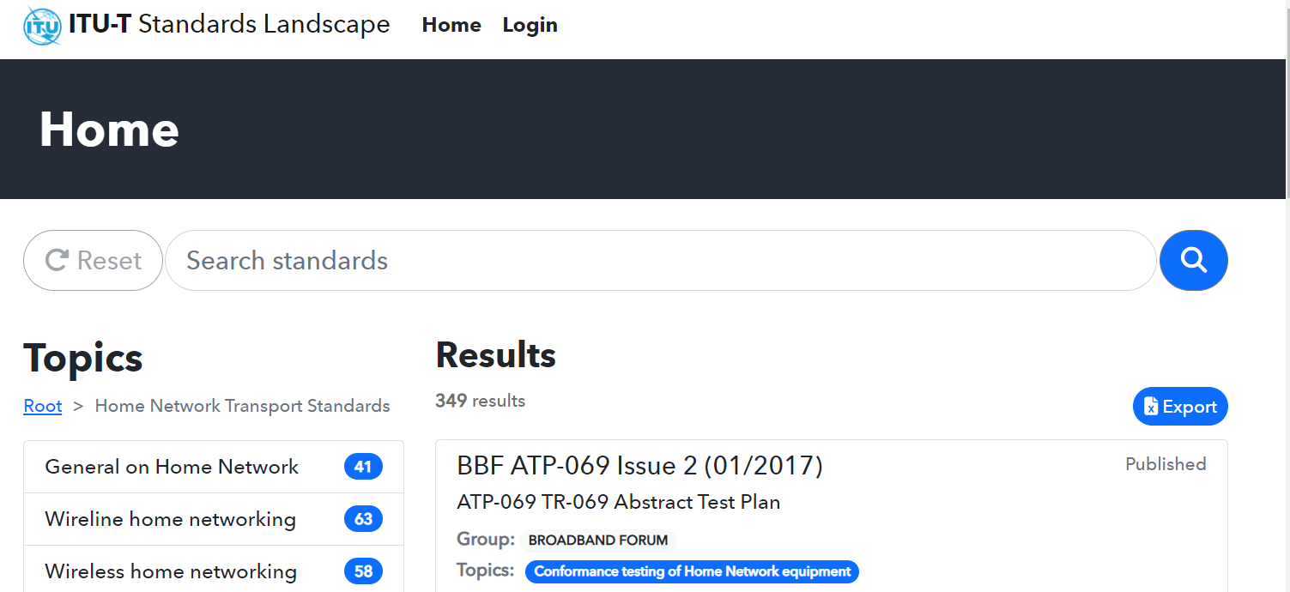

The web-based HNT Standards overview is organized by topics representing the home network technologies, the various systems generations of each technology and related technical matters as well as their applications in the home. It enables an easy identification and download of the publicly available Standards, Recommendations, Technical Specifications and other technical documents related to each topic. The web-based HNT Standards Overview focuses on the most relevant published and updated documents related to Home Network Transport.
The items listed within each topic represent Standards, Recommendations, Technical Specifications or other technical documents and are identified by their responsible ITU Study Group or SDO, their individual reference number, as well as their publication date and title. The items are also searchable on number, title and description and are alphanumerically listed within each topic; this is inherent in the data base system.
Lists of Standards, Recommendations, Technical Specifications and other documents (items) can be generated from the web-based HNT Standards Overview as needed for each topic or groups of topics and responsible Group (ITU Sector or ITU-T SGs or SDOs) and exported on an excel table.
The taxonomy used for the web-based HNT Standards Overview is described in the Section 1.2 below and a guide on how to use the web presentation is provided in Annex 1.

3.2 Taxonomy of the web-based HNT Standards Overview
Topics of “Home Network Transport Standards” representing the home networking technologies and applications
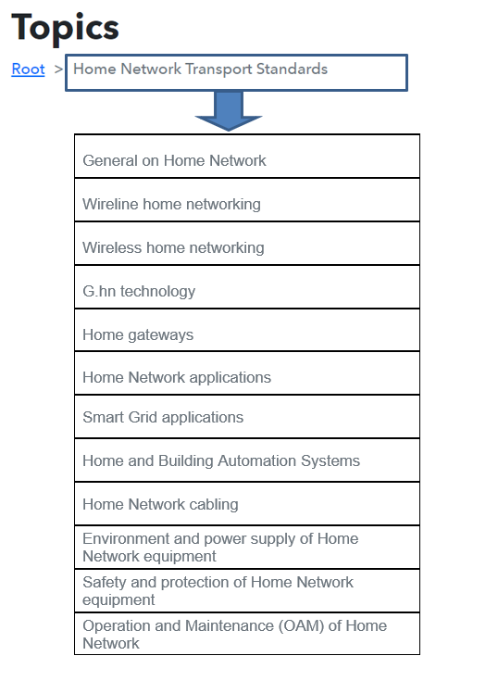

Each of the above topics is further described on the next pages.

Topics of “General on Home Network” providing general information on home network architecture and function as well as on the security aspects.
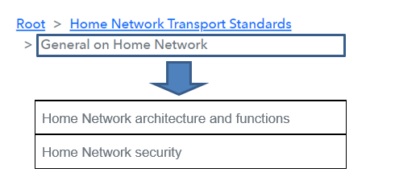

Topics of the “Wireline home networking” representing the various wire based home networking systems and transceiver generations.
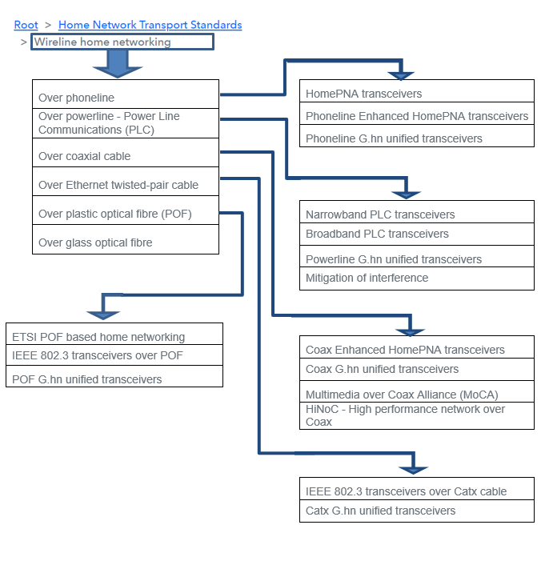

Topics of the “Wireless home neworking” representing the various wireless based home networking systems and transceiver generations.
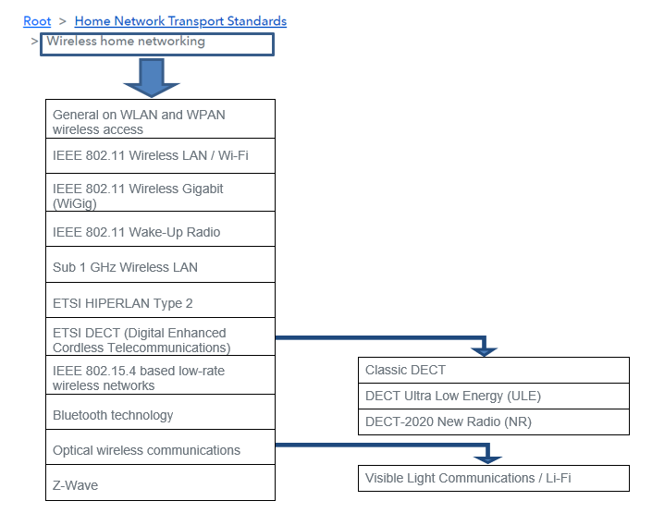
Topic “G.hn technology” providing the G.hn transceiver specifications and information on G.hn applications.
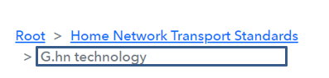

Topic “Home gateways” providing the specifications of various home gateways.


Topics of “Home Network applications” representing the various types of connectivities in the home and related home networking transceivers.
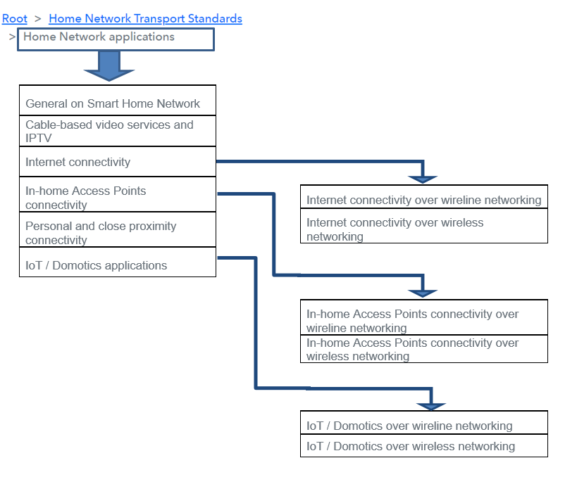

Topic “Smart Grid applications” representing the related home transceivers and technical matters.


Topics of “Home and Building Automation Systems” representing HBES (CENELEC) and HES (ISO/IEC) general requirements, terminology, architecture and applications as well as other related technical matters.
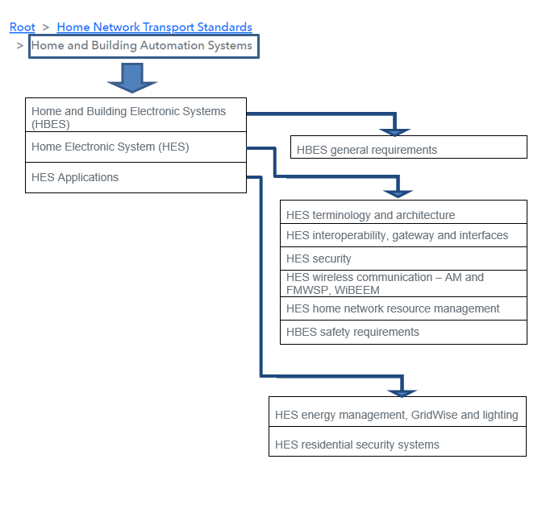

Topic “Home Network cabling” providing the standards related to home cabling.



Topic “Environment and power supply of Home Network equipment” providing standards related to power supply of customer premises equipment.
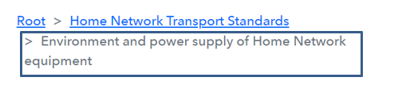

Topic “Safety and protection of Home Network equipment” providing standards related the safety aspects of customer premises equipment.


Topics of “Operation and maintenance (OAM) of Home Network” providing standards related to management and testing of customer premises equipment.
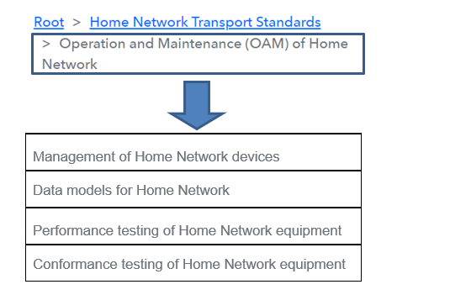

3.3 HNT Topics and related Groups (ITU Study Groups and SDOs)
Some of the listed documents in the web-based ANT Standards Overview may not be publicly available. Interested people may contact the responsible standardization group in the list of contacts in Section 5.
HNT Topics related to Transmission Medium, Transceivers Technologies and Applications
TOPICS | GROUPS: ITU Study Groups and SDOs
General on Home Network
> Home Network architecture and functions | Broadband Forum, ETSI ISG F5G,  IEC TC100 TA18, IEEE 1905,  ITU-T SG15, SG16 and SG20
> Home Network security | ISO/IEC JTC1/SC25, ETSI IGS F5G,  ITU-T SG15 and SG17
> Intelligent Home Network | Broadband Forum Service Requirement WA, ETSI IGS F5G
Wireline home networking
> Over phoneline
>>> HomePNA transceivers | ITU-T SG15
>>> Phoneline Enhanced HomePNA transceivers | ITU-T SG15
>>> Phoneline G.hn unified transceivers | ITU-T SG15
> Over powerline - Power Line Communications (PLC)
>>> Narrowband PLC transceivers | IEEE COM/PLC, ITU-T SG15
>>> Broadband PLC transceivers | IEEE COM/PLC, ISO/IEC JTC1/SC6, TIA
>>> Powerline G.hn unified transceivers | ITU-T SG15
>>> Mitigation of interference | ITU-T SG15
> Over coaxial cable
>>> Coax Enhanced HomePNA transceivers | ITU-T SG15
>>> Coax G.hn unified transceivers | ITU-T SG15
>>> Multimedia over Coax Alliance (MoCA) | MoCA
>>> HiNoC - High performance network over Coax | ITU-T SG9
> Over Ethernet twisted-pair cable
>>> IEEE 802.3 transceivers over Catx cable | IEEE 802.3
>>> Catx G.hn unified transceivers | ITU-T SG15
> Over plastic optical fibre (POF)
>>> ETSI POF based home networking | ETSI TC ATTM
>>> IEEE 802.3 transceivers over POF | IEEE 802.3
>>> POF G.hn unified transceivers | ITU-T SG15
> Over glass optical fibre | ETSI TC ATTM, ITU-T SG15
Wireless home networking
> General on WLAN and WPAN wireless access | ETSI TC BRAN and TC ERM,  ITU-R SG1 and SG5, ITU-T SG13
> IEEE 802.11 Wireless LAN / Wi-Fi | IEEE 802.11
> IEEE 802.11 Wireless Gigabit (WiGig) | IEEE 802.11
> IEEE 802.11 Wake-Up Radio | IEEE 802.11
> Sub 1 GHz Wireless LAN | IEEE 802.11, ITU-T SG15
> ETSI HIPERLAN Type 2 | ETSI TC BRAN
> ETSI DECT (Digital Enhanced Cordless Telecommunications)
>>> Classic DECT | ETSI TC DECT, ITU-R SG5
>>> DECT Ultra Low Energy (ULE) | ETSI TC DECT
>>> DECT-2020 New Radio (NR) | ETSI TC DECT
> IEEE 802.15.4 based low-rate wireless networks | IEEE 802.15,  Connectivity Standards Alliance (CSA), Thread Group
> Bluetooth technology | Bluetooth SIG
> Optical wireless communications
>>> Visible Light Communications / Li-Fi | IEEE 802.11, IEEE 802.15, ITU-R SG1,  ITU-T SG15
> Z-Wave | Z-Wave Alliance, ITU-T SG15
G.hn technology | ITU-T SG15
Home gateways | Broadband Forum, IEC TC 100 TA18, ISO/IEC JTC1/SC25, ITU-T SG15, SG9 and SG16
Home Network applications
> General on Smart Home Network | ITU-T SG9, SG15 and SG20
> Cable-based video services and IPTV | Broadband Forum, ETSI TC Cable and TC ATTM, ITU-T SG9, SG15 and SG16
> Internet connectivity
>>> Internet connectivity over wireline networking | ETSI TC ATTM, IEEE COM/PLC,  IEEE 802.3, ITU-T SG9 and SG15, MoCA
>>> Internet connectivity over wireless networking | IEEE 802.11
> In-home Access Points connectivity
>>> In-home Access Points connectivity over wireline networking | ETSI TC ATTM, IEEE COM/PLC,  IEEE 802.3, ITU-T SG9 and SG15, MoCA
>>> In-home Access Points connectivity over wireless networking | IEEE 802.11
> Personal and close proximity connectivity | Bluetooth SIG, ETSI TC DECT, IEEE 802.11, IEEE 802.15, ITU-R SG1, ITU-T SG15
> IoT / Domotics applications
>>> IoT / Domotics over wireline networking | IEEE COM/PLC, IEEE 802.3, ITU-T SG15
>>> IoT / Domotics over wireless networking | Bluetooth SIG,  Connectivity Standards Alliance (CSA),  ETSI TC DECT, IEEE 802.11, IEEE 802.15, ITU-R SG1, ITU-T SG15 and SG20,  Thread Group, Z-Wave Alliance
Smart Grid applications | CENELEC TC 205,  Connectivity Standards Alliance (CSA),  ETSI TC ATTM, IEEE COM/PLC,  ISO/IEC JTC1/SC25, ITU-R SG1,  ITU-T SG15, SG17 and SG20,  Z-Wave Alliance
Home and Building Automation Systems
> Home and Building Electronic Systems (HBES)
>>> HBES general requirements | CENELEC TC 205
> Home Electronic System (HES)
>>> HES terminology and architecture | ISO/IEC JTC1/SC25
>>> HES interoperability, gateway and interfaces | ISO/IEC JTC1/SC25
>>> HES security | ISO/IEC JTC1/SC25
>>> HES wireless communication – AM and FMWSP, WiBEEM | ISO/IEC JTC1/SC25
>>> HES home network resource management | ISO/IEC JTC1/SC25
>>> HBES safety requirements | ISO/IEC JTC1/SC25
> HES Applications
>>> HES energy management, GridWise and lighting | ISO/IEC JTC1/SC25
>>> HES residential security systems | ISO/IEC JTC1/SC25

ANT Topics related to Home Cabling Infrastructure incl. Operation and Maintenance
TOPICS | GROUPS: ITU Study Groups and SDOs
Home Network cabling | CENELEC TC 86BXA and TC 215,  ETSI TC ATTM, IEC TC 86 SC 86A,  IEC TC 46 SC 46C, ISO/IEC JTC1/SC25,  ITU-T SG5 and SG15
Environment and power supply of Home Network equipment | ETSI TC EE, ITU-T SG5 and SG9
Safety and protection of Home Network equipment | IEC TC 76, ISO/IEC JTC1/SC25,  ITU-R SG1, ITU-T SG5 and SG15,
Operation and Maintenance (OAM) of Home Network
> Management of Home Network devices | Broadband Forum, IEEE 802.3,  ISO/IEC JTC1/SC25, ITU-T SG15
> Data models for Home Network | Broadband Forum, IEEE 802.3
> Performance testing of Home Network equipment | Broadband Forum, ETSI TC BRAN, ETSI ISG F5G
> Conformance testing of Home Network equipment | Broadband Forum, Home Grid Forum, TTC

4. Ongoing standardization activities in the area of Home Network Transport

4.1 Ongoing standardization activities in the area of Home Network Transport within ITU-T SG15
Question 3/15 of ITU-T SG15 – WP1/15 is responsible for the Home Network standardization activities. Q3/15 addresses “Technologies for in-premises networking and related access applications”.

Work item | Question | Status | Timing | Approval process | Subject / Title | Reference(s) | Editor(s)
G Suppl. CMAFP | Q3/15 | Agreed | 2025-10 | Agreement | Coordinated management of access and fibre in premises networks | SG15-TD189R1/PLEN (2025-10) | Ning WANG (China Mobile Communications Co. Ltd.), Xuming WU (Huawei Technologies Co., Ltd.), Hai DING(China Unicom)
G Suppl. CoexFIN | Q3/15 | Agreed | 2025-10 | Agreement | Coexistence between G.fin and G.Xfin systems | SG15-TD190R1/PLEN (2025-10) | Hai DING (China Unicom),  Qizheng LI (China Telecommunications Corporation)
G Suppl. FIP4SME | Q3/15 | Agreed | 2025-10 | Agreement | Use cases & Requirements of Fibre-in-premises for Small & Medium Enterprise Applications (FIP4SME) | SG15-TD191R1/PLEN (2025-10) | Qizheng LI (China Telecommunications Corporation),  Tony ZENG (Huawei Technologies Düsseldorf GmbH)
G Suppl. ISAC4FIP | Q3/15 | Under study | 2026 | Agreement | Use cases, requirements and technical vision of ISAC for in-premises networks | SG15-TD88/WP1 (2025-10) | Yue SUN (China Unicom),  Zhongyi WANG (ZTE),
G.9930 Amd. 2 | Q3/15 | Consented | 2025-10 | AAP | Point-to-point fibre in the premises | SG15-TD193R1/PLEN (2025-10) | Ronald HERON (Nokia Corporation)
G.9942 Amd. 1 | Q3/15 | Under study | 2026 | AAP | High speed fibre-based in-premises transceivers – data link layer | - | Hai DING(China Unicom),  Qizheng LI (China Telecommunications Corporation),
G.9943 (ex G.fin-NM) | Q3/15 | Approved 2025-10-24 | 2025-10 | AAP | High speed fibre-based in-premises transceivers - network management | SG15-TD125R1/PLEN (2025-10) | Yue SUN (China Unicom), Qiang CHENG (CAICT)
G.9943 Amd.1 | Q3/15 | Under study | 2026 | AAP | High speed fibre-based in-premises transceivers - network management | - | Yue SUN (China Unicom), Qiang CHENG (CAICT)
G.9949 (ex G.WMCI) | Q3/15 | Approved 2025-10-24 | 2025-10 | AAP | WLAN management control interface (WMCI) for in-premises network | SG15-TD126R1/PLEN (2025-10) | Qiang CHENG (CAICT),  Hai DING (China Unicom)
G.9949 Amd.1 | Q3/15 | Consented 2025-10-24 | 2026-6 | AAP | WLAN management control interface (WMCI) for in-premises network - Amendment 1 | SG15-TD188R1/PLEN (2025-10) | Qiang CHENG (CAICT),  Hai DING (China Unicom)
G.9975 (ex G.uvs-XR) | Q3/15 | Approved 2025-10-24 | 2025-10 | AAP | Technical requirements of extended reality service over in-premises networks | SG15-TD127R1/PLEN (2025-10) | Wu JIA (China Unicom)
G.dop | Q3/15 | Under study | 2026-07 | AAP | Data Over Power - Vehicle Network. System, Management, PHY and DLL Specification | SG15-TD120/WP1 (2025-10) | Marcos MARTINEZ (Maxlinear Inc)
G.Sup.Edge4Home | Q3/15 | Under study | 2026 | Agreement | Enhanced on-premises networking with computing functions | SG15-TD96/WP1 (2025-10) | Wu JIA (China Unicom)
G.Sup.TwinHome | Q3/15 | Under study | 2026 | Agreement | Digital twin network on in-premises networking | SG15-TD97/WP1 (2025-10) | Wu JIA (China Unicom)
G.Xfin-PHY | Q3/15 | Under study | 2026 | AAP | High speed fibre-based in-premises transceivers - 10G Physical layer | SG15-TD119/WP1 (2025-10) | Junwei LI (China Mobile Communications Co. Ltd.),  Xuming WU (Huawei Technologies Co., Ltd.)
G.Xfin-DLL | Q3/15 | Under study | 2026 | AAP | High speed fibre-based in-premises transceivers - 10G data link layer | SG15-TD117/WP1 (2025-10) | Qizheng LI (China Telecommunications Corporation),Yi JIANG (ZTE Corporation),
GSTP-HNSG | Q3/15 | Under study | 2026 | Agreement | Technical paper on the use of G.hn technology for smart grid | SG15-TD63/WP1 (2025-03) | Cédric LAVENU (Enedis),
G.Sup. FIP4B10G | Q3/15 | Under study | 2027 | Agreement | Beyond 10Gbps fibre in-premises network: use cases, system requirements & technology options | - | Jose Vicente Galan Conejos (Maxlinear)  Yue Sun (China Unicom)
G.sup.ION-aiHome | Q3/15 | Under study | 2027 | Agreement | AI-enhanced home networking | - | Wu Jia (China Unicom), Tony Zeng (Huawei)

Work item: Short name identifying a (draft or approved) Recommendation or other text. It may be a provisional name or the final publication designation (e.g. H.264)
Question: Number of the Question responsible for the development of a work item
Status: Current Approval state of a work item
Timing: Best current estimate of the expected year and month of Determination (TAP), Consent (AAP), or Agreement (non-normative materials) of a work item
Approval process: One of: Traditional Approval Process (TAP); Alternative Approval Process (AAP); or Agreement
Subject / Title: Best current expectation of the full name of a work item
Base text(s): Previous published version of a work item and/or its latest draft. It may also include reference to A.5 justification documentation.
Editor(s): Person(s) responsible for coordinating development of a work item

Question 5/15 and Question 7/15 of ITU-T SG15 – WP2/15 are responsible for the standardization of components for the optical physical infrastructures (e.g., fibre and cable, optical node) of the Home Network. Q5/15 addresses “Characteristics and test methods of optical fibres and cables, and installation guidance” and Q7/15 the “Connectivity, operation and maintenance of optical physical infrastructures”.

The table below of Q5/15 and Q7/15 current work items related to Home Network infrastructures (e.g., fibre and cable, optical node) has been updated with the latest Q5/15 and Q7/15 activities resulting from ITU-T SG15 - WP2 July 2024 plenary meeting.

Work item | Question | Timing | Approval process | Version | Liaison relationship | Subject / Title | Priority | Reference(s) | Editor(s)
G.smmcf | Q5/15 | 2028 | AAP | New | IEC SC86A, IEC SC86B, IEEE 802.3 | Characteristics of a single-mode weakly-coupled multi-core optical fibre and cable | Medium | SG15-C435 (2025-10) | Takashi Matsui (NTT)
G.csmcf | Q5/15 | 2028 | AAP | New | IEC SC86A, IEC SC86B, IEEE 802.3 | Characteristics of a cut-off shifted single-mode weakly-coupled multi-core optical fibre and cable | Medium | SG15-C435 (2025-10) | Yoshinori Yamamoto (CLPAJ)
G.650.1 | Q5/15 | 2028 | AAP | Rev. | IEC SC86A, IEC SC86B | Definitions and test methods for linear, deterministic attributes of single-mode fibre and cable | Medium | SG15-C278 (2025-03) | Jing Li (YOFC)
G.650.2 | Q5/15 | 2028 | AAP | Rev. | IEC SC86A, IEC SC86B | Definitions and test methods for statistical and non-linear related attributes of single-mode fibre and cable | Medium | SG15-TD109/WP2 (2025-10) | Hiroyuki Kamata (CLPAJ)  Jing Li (YOFC)
G.652 | Q5/15 | 2027 | AAP | Rev. | IEC SC86A, IEC SC86B | Characteristics of a single-mode optical fibre and cable | Medium | G.652 (08.2024) | Jing Li (YOFC)
G.654 | Q5/15 | 2027 | AAP | Rev. | IEC SC86A, IEC SC86B | Characteristics of a cut-off shifted single-mode optical fibre and cable | Medium | G.654 (08.2024) | Yoshinori Yamamoto (CLPAJ)
G.657 | Q5/15 | 2027 | AAP | Rev. | IEC SC86A, IEC SC86B | Characteristics of a bending-loss insensitive single-mode optical fibre and cable | Medium | G.657 (08.2024) | Peter Louis Pondillo (Corning)
L.102/L.26 | Q5/15 | 2025-10 | AAP | Rev. | IEC SC86A, IEC SC86B | Optical fibre cables for aerial application | High | SG15-TD162R2/PLEN (2025-10) | Kazuhide Nakajima (NTT)
L.ocwp.1 | Q5/15 | 2027 | AAP | New | IEC SC86A | Aerial Optical fibre cables along electrical power lines applications with lower voltage | Medium | SG15-TD123/WP2 (2025-10) | Mudita Chandra (Ministry of Communications India)
L.ocwp.2 | Q5/15 | 2027 | AAP | New | IEC SC86A | Aerial optical fibre cables along electrical power lines applications with higher voltage | Medium | SG15-TD113/WP2 (2025-10) | Xing Zhihao (SGCC)
L.105 | Q5/15 | 2025-10 | AAP | Rev. | IEC SC86A, IEC SC86B | Optical fibre cables for drop applications | High | SG15-TD186R2/PLEN (2025-10) | David Kozischek (Corning)
L.107 | Q5/15 | 2025-10 | AAP | Rev. | IEC SC86A | Optical fibre cable for sewer duct applications | High | SG15-TD196R2/PLEN (2025-10) | Han Chao (CAICT)
L.108 | Q5/15 | 2026 | AAP | Rev. | IEC SC86A | Optical fibre cable elements for microduct blowing-installation application | High | SG15-TD112/WP2 (2025-10) | ZHOU Ziqiang (SGCC)
L.110 | Q5/15 | 2025-10 | AAP | Rev. | IEC SC86A, IEC SC86B | Optical fibre cables for direct surface application | High | SG15-TD161R3/PLEN (2025-10) | Kosuke Nakagawa (CLPAJ)
L.111 | Q5/15 | 2026 | AAP | Rev. | IEC SC86A, IEC SC86B | Optical fibre cables for in-home applications | High | SG15-TD130/WP2 (2025-10) | Yue Sun (China Unicom)
L.adssi | Q5/15 | 2028 | AAP | New | IEC SC86A, IEC SC86B | Installation of All-Dielectric Self-Supported (ADSS) cable along electrical power lines (L.adssi) | Medium | SG15-C570 (2025-10) | Qingqing Qi (CICT)
L.Sup.39 | Q5/15 | 2026 | Agreement | Rev. | - | Optical fibre cable Recommendations and standardization guideline | High | SG15-TD102R1/WP2 (2025-10) | Mudita Chandra (Ministry of Communications India)
L.Sup.ne | Q5/15 | 2026 | Agreement | New | - | National experiences with respect to ITU-T L.1xx-series optical fibre cables, installation methods, and test methods | High | SG15-TD129/WP2 (2025-10) | Xiong Zhuang (YOFC)

Work item | Question | Timing | Approval process | Version | Liaison relationship | Subject / Title | Priority | Reference(s) | Editor(s)
L.250 | Q7/15 | 2027 | AAP | Rev. | - | Topologies for optical access network | Medium | In-force L.250 (2024-01) | Yoshifumi Wakisaka (NTT)
L.302 | Q7/15 | 2027 | AAP | Rev. | - | Optical fibre outside plant maintenance support, monitoring and testing system | Medium | In-force L.302 (2000-10) | Yoshifumi Wakisaka (NTT)
L.361 | Q7/15 | 2026-7 | AAP | Rev. | - | ID tag requirements for network infrastructure management | High | SG15-TD117R1/WP2 (2025-10) | Chao HAN (CAICT)
L.391 | Q7/15 | 2025-10 | AAP | Rev. | - | Monitoring systems for outside plant facilities | Medium | SG15-TD197R1/PLEN (2025-10) | Junwei MA (State Grid Corporation of China)
L.mct | Q7/15 | 2027 | AAP | New | - | Maintenance of conduits for telecommunication | Medium | SG15-TD94R1/WP2 (2025-10) | Chihiro KITO (NTT)
L.nis | Q7/15 | 2027 | AAP | New | ITU-T SG3, ITU-D SG1 | Practical considerations for network infrastructures sharing | Medium | SG15-TD118R1/WP2 (2025-10) | Chao HAN (CAICT)
L.405 (ex. L.pcc) | Q7/15 | 2025-10 | AAP | New | IEC SC86A, IEC SC86B | Preconnectorised cabling components for FTTx infrastructures | High | SG15-TD182R1/PLEN (2025-10) | David KOZISCHEK (Corning)

ITU-T Q3/15 Project FTTR (Fibre to the room)
Question 3/15 of ITU-T SG15 organised a first Joint ETSI ISG F5G (European Telecommunications Standards Institute – Industry Specification Group - Fifth Generation Fixed Network), BBF (Broadband Forum), CCSA TC6 (China Communications Standards Association – Technical Committee 6) and ITU-T SG15 Workshop on “FTTR” (Fibre to the room) on 14 June 2021.
For more information see workshop programme and presentations at
Joint ETSI ISG F5G, BBF, CCSA TC6 and ITU-T SG15 Workshop on "FTTR" (Fibre to the room)
Question 3/15 of ITU-T SG15 organised a second Joint ETSI ISG F5G, BBF, CCSA TC6 and ITU-T SG15 Workshop on “FTTR” (Fibre to the room) on 28 June 2022.
For more information see workshop programme and presentations at
Second Joint ETSI ISG F5G, BBF, CCSA TC6 and ITU-T SG15 Workshop on "FTTR" (Fibre to the room)
Question 3/15 of ITU-T SG15 organized a third Joint ETSI ISG F5G, BBF, CCSA TC6 and ITU-T SG15 Workshop on “FTTR” (Fibre to the room) on 23 June 2023.
For more information see workshop programme and presentations at
Third Joint ETSI ISG F5G, BBF, CCSA TC6 and ITU-T SG15 Workshop on "FTTR" (Fibre to the room)
Question 3/15 of ITU-T SG15 organized a fourth Joint ETSI ISG F5G, BBF, CCSA TC6 and ITU-T SG15 Workshop on “FTTR” (Fibre to the room) on 13 July 2024.
For more information see workshop programme and presentations at
Fourth Joint ETSI ISG F5G, BBF, CCSA TC6 and ITU-T SG15 Workshop on "FTTR" (Fibre to the room)

Question 3/15 of ITU-T SG15 organized a fifth Joint ETSI ISG F5G, BBF, CCSA TC6 and ITU-T SG15 Workshop on “FTTR” (Fibre to the room) on 22 October 2025.
For more information see workshop programme and presentations at
Fourth Joint ETSI ISG F5G, BBF, CCSA TC6 and ITU-T SG15 Workshop on "FTTR" (Fibre to the room)

Work Programme of ITU-T SG15 can be found at https://www.itu.int/ITU-T/workprog/wp_search.aspx?sg=15
More information about ITU-T SG15 can be found at https://www.itu.int/en/ITU-T/studygroups/2022-2024/15/Pages/default.aspx

4.2. Ongoing standardization activities in the area of Home Network Transport in other ITU Study Groups
This following list is intended to improve understanding and communication of the on-going work related to Home Network in other Study Groups of the ITU-T, ITU-R and ITU-D Sectors and may help identify possible gaps or overlaps.
The list gives an updated overview of such activities.
ITU-T SGs | SGs activities related to Home Network and other information
ITU-T SG2 | ITU-T SG2: Operational aspects of telecommunications and ICTs  SG15 TD108/GEN - February 2025  WTSA-24 has assigned the Lead SG role for Telecommunication Management to SG2. In that context, Q5/2 is responsible for maintaining the Telecommunications Management and OAM Project Plan, to monitor and manage all these activities and issues for the ITU-T. Internal to the ITU-T, this leadership involves providing a kind of framework for Telecommunications Management and OAM activities that can be used to identify and resolve appropriate issues across Study Groups.  Q5/2 would again like to draw your attention to the document and would appreciate any suggestions and comments concerning keeping this document current.  Action taken by Q3/15: Provide input on the O&M for the recent publication of the projects in Q3/15 of G.hn (G.9963) and G.fin (G.9943) for Q5/2.
ITU-T SG5  continuation of ITU-T SG5 | ITU-T SG5: Electromagnetic fields (EMF), environment, climate action, sustainable digitalization, and circular economy  WP1/5 - EMC, lightning protection, EMF  WP2/5 - Environmental efficiency, e-waste, circularity and sustainable ICT networks  ITU-T SG5 work programme update related to Home Network  SG15 TD253 WP1 - July 2024  ITU-T Study Group 5 would like to inform ITU-T Study Group 15 that, with respect to the information sent in 2023,  under Q2/5, there is updated information on protection of single twisted pair Ethernet (SPE).  The standardization of single twisted pair power over Ethernet (SPoE) has been continuing by the IEEE 802.3 to supply up  to 50 W to network powered devices (NPD), such as video cameras with pan and tilt. Industrially, there is an SPE variant  with a design reach of 1 km.  ITU-T SG5 is monitoring this SPE evolution for stability before revising any existing Recommendations or creating any new Recommendations.  Regarding the work covering environmental aspects, ITU-T SG5 provides below the list of their current work items:  Topic: Home Network Transport Standards / Environment and power supply of Home Network equipment  Work Group: ITU-T SG5  Source: https://www.itu.int/net4/ITU-T/landscape#?topic=0.132.9&workgroup=1&searchValue=&page=1&sort=Revelance  Work programme of ITU-T SG5 can be found at following URL  https://www.itu.int/ITU-T/workprog/wp_search.aspx?sg=5  More information about ITU-T SG5 can be found at following URL  https://www.itu.int/en/ITU-T/studygroups/2022-2024/05/Pages/default.aspx
  Name | Responsible group | Status | Subject | Topics
  L.1071  (ex. L.D4PI) | ITU-T SG5 | Consented | A model for digital product passport information on sustainability and circularity | Information, parameters required for the DPP
  L.UFCS | ITU-T SG5 | Under study | Universal Fast Charging Solution for mobile terminal | Specifications for universal fast charging solution
  L.UPCSW | ITU-T SG5 | Under study | Universal power adapter for smart watches and smart bands | Specifications for a standardized charger and charging adaptors and ports for all smartwatches and smart bands
  L.SimplifiedLCA | ITU-T SG5 | Under study | Guidance on simplified life cycle assessments of Information and Communication Technologies | Simplified method to assess the lifecycle of an ICT good
  L.1070 | ITU-T SG5 | Approved | Global digital sustainable product passport opportunities to achieve a circular economy | Definition of a digital passport of ICT equipment covering sustainable related parameters
  L.1023 | ITU-T SG5 | Approved | Assessment method for circularity performance scoring | Update of the standard to clarify the application of some criteria
  K.147 | ITU-T SG5 | Under study (a revision) | Protection of digital ports connected to balanced pairs of conductors | Update of considerations on protection so as to reflect the specifications, practice, and experience in IEEE 802.3
  K.Suppl.25 | ITU-T SG5 | Under study | Long reach single twisted-pair Ethernet resistibility testing | Update of considerations on protection so as to reflect the specifications, practice, and experience in IEEE 802.3
ITU-T SG9 | ITU-T SG9: Audiovisual content transmission and integrated broadband cable networks  WP1/9 - Cable transport and terminals, including video and data  ITU-T SG9 work programme update related to Home Network  SG15 TD 270 GEN - July 2024  ITU-T SG9 inform SG15 that during ITU-T SG9 meeting, 14-23 November 2023, Bogotá, Colombia, they started the approval process (AAP consent) for the work items ITU-T J.198.2 (ex J.HiNoC3-PHY) “Physical layer specification for third-generation HiNoC” and ITU-T J.198.3 (ex J.HiNoC3-MAC) “MAC layer specification for third-generation HiNoC”.  SG9 also inform that they agreed to publish the new Supplement ITU-T J.Suppl.12 (ex J.Sup-HiNoC) “Comparison between third-generation HiNoC and second-generation HiNoC”.  Work programme of ITU-T SG9 can be found at following URL  https://www.itu.int/ITU-T/workprog/wp_search.aspx?sg=9  More information about ITU-T SG9 can be found at following URL  https://www.itu.int/en/ITU-T/studygroups/2022-2024/09/Pages/default.aspx
ITU-T SG11 | ITU-T SG11: Signalling requirements, protocols, test specifications and combating counterfeit telecommunication/ICT devices  SG15 TD 223 WP1 - July 2024  ITU-T SG11 confirms that following consideration of SG15 inputs, according to the SG11 C&I Action plan, which was updated in May 2023 (see SG11-TD507/GEN), TSB was encouraged to proceed and update the reference table accordingly. The latest version of the reference table will be made available at: https://itu.int/go/reference-table.  ITU-T SG11 reminds that in order to avoid any further delays on updating the reference table, according to the SG11 C&I action plan, SGs are encouraged to provide their inputs related to the reference table directly to TSB secretariat via conformity@itu.int.  Work Programme of ITU-T SG11 can be found at following URL  https://www.itu.int/ITU-T/workprog/wp_search.aspx?sg=11  More information about ITU-T SG11 can be found at following URL  https://www.itu.int/en/ITU-T/studygroups/2022-2024/11/Pages/default.aspx
ITU-T SG13 | ITU-T SG13: Future networks and emerging network technologies  WP3/13 - Network Evolution, Trust and Quantum Enhanced Networking  Work Programme of ITU-T SG13 can be found at following URL  https://www.itu.int/ITU-T/workprog/wp_search.aspx?sg=13  More information about ITU-T SG13 can be found at following URL  https://www.itu.int/en/ITU-T/studygroups/2022-2024/13/Pages/default.aspx
ITU-T SG16 | ITU-T SG16: Multimedia and related digital technologies​  WP1/16 - Multimedia content delivery  Work programme of ITU-T SG16 can be found at following URL  https://www.itu.int/ITU-T/workprog/wp_search.aspx?sg=16  More information about ITU-T SG16 can be found at following URL  https://www.itu.int/en/ITU-T/studygroups/2022-2024/16/Pages/default.aspx
ITU-T SG17 | ITU-T SG17: Security  WP2/17 - 5G, IoT and ITS security  Work programme of ITU-T SG17 can be found at following URL  https://www.itu.int/ITU-T/workprog/wp_search.aspx?sg=17  More information about ITU-T SG17 can be found at following URL  https://www.itu.int/en/ITU-T/studygroups/2022-2024/17/Pages/default.aspx
ITU-T SG20 | ITU-T SG20: Internet of things (IoT) and smart cities and communities (SC&C)  WP1/20 - Interoperability, Applications and Digital Services  Work programme of ITU-T SG20 can be found at following URL  https://www.itu.int/ITU-T/workprog/wp_search.aspx?sg=20  More information about SG20 can be found at following URL  https://www.itu.int/en/ITU-T/studygroups/2022-2024/20/Pages/default.aspx

ITU-R SGs | SGs activities related to Home Network and other information
ITU-R  ITU-R SG1  continuation of ITU-R SG1 | ITU-R overall activities related to Home Network  ITU-R SG1: Spectrum Management  WP1A - Spectrum engineering techniques  SG15 TD 159 WP1 Nov – Dec 2023  Liaison statement from ITU-R Working Party 1A on the role of powerline communications in home-networking applications.  ITU-R WP1A provides following comments on the role of powerline communications in home-networking applications.  Concerning the information linked to the HNT projects referenced in the recent work plans of ITU-T SG15 WP1,  ITU-R WP1A has noted a continuing interest in the use of powerline connectivity for various applications in and related to  home-networking, including smart grids, smart metering, internet-of-things and visual light communications.  Considering the potential interference effects to radiocommunication services and the need for deconflicting the interactions  between several powerline systems operating in the same domain or in neighbouring domains sharing common powerlines,  ITU-R WP1A would appreciate if ITU-T SG15 could provide an estimation of the role, scope and scale of the deployment  still expected for powerline use in the current and anticipated home-networking projects.  ITU-R WP1A has noted the greater potential for interference when using the MIMO configuration for powerline  communications as a result of additional radiation from the protective earth wire.  ITU-R WP1A concludes with expressing its desire to continue the good cooperation established with ITU-T SG15 and in  trying to forestall interference problems from networking solutions using metallic conductors.  The next meeting of ITU-R WP1A is currently scheduled to be held during 12 to 19 June 2024. If information becomes  available before then, it may also be communicated to the ITU-R WP1A Correspondence Group on EMC Related Interference  and Coexistence of Wired Telecommunications systems with Radiocommunication Systems, in order to ensure timely  consideration of any potential co-existence issues.  More information about ITU-R WP1A can be found at following URL  https://www.itu.int/en/ITU-R/study-groups/rsg1/rwp1a/Pages/default.aspx  More information about ITU-R SG1 can be found at following URL  https://www.itu.int/en/ITU-R/study-groups/rsg1/Pages/default.aspx
  Contacts: Philippe Aubineau  Counsellor, ITU-R Study Group 1 | philippe.aubineau@itu.int
  John Shaw  Chairman of the Correspondence Group on EMC Related Interference and Coexistence of Wired Telecommunications systems with Radiocommunication Systems | shawzone@usa.net
ITU-R SG5 | ITU-R SG5: Terrestrial Services  WP5A - Land mobile service above 30 MHz (excluding IMT); wireless access in the fixed service; amateur and amateur-satellite services  - ITU-R SG5 Guide to the use of ITU-R texts: Overview of the ITU-R texts relating to the land mobile service, including wireless access in the fixe service (last update: 18 January 2024): see at https://www.itu.int/oth/R0A06000001/en  Radio Local Area Networks (RLANs) and Multiple Gigabit Wireless Systems (MGWS)  WP 5A conducts work on radio local area networks (RLANs) and Multiple Gigabit Wireless Systems (MGWS) under Question ITU-R 212-4/5 (Nomadic wireless access systems including radio local area networks).  LANs/MGWS could be used to implement a home network. For a description of this work refer to:  - section 8.2 “Nomadic Wireless Access” of the Guide to the use of ITU-R texts relating to the land mobile service, including wireless access in the fixed service, and in particular Recommendation ITU-R M.1450-5, which recommends characteristics of broadband radio local area networks,  - section 8.4 “Multiple Gigabit Wireless Systems” of the Guide to the use of ITU-R texts relating to the land mobile service, including wireless access in the fixed service, and in particular Recommendation ITU-R M.2003-2, which provides general characteristics and radio interface standards for MGWS in frequencies around 60 GHz and Report ITU-R M.2227-2 which describes applications, deployment scenarios and technical characteristics of MGWS.  - section 11: Cordless Telecommunication Systems of the Guide, and in particular Recommendation ITU-R M.1033-1 and Report ITU-R M.1025-1 which provides technical and operational characteristics of cordless telephones and cordless telecommunication systems.  More information about ITU-R WP5A can be found at following URL  https://www.itu.int/en/ITU-R/study-groups/rsg5/rwp5a/Pages/default.aspx  More information about ITU-R SG5 can be found at following URL  https://www.itu.int/en/ITU-R/study-groups/rsg5/Pages/default.aspx
ITU-R SG6  continuation of ITU-R SG6 | ITU-R SG6: Broadcasting Service  WP6A - Terrestrial broadcasting delivery  SG15 TD 151 GEN - September 2025  In its Liaison Statement ITU-R WP6A shared the information to addresses the liaison from SG15 on developments with low frequency powerline communications.  ITU-T WP6A has noted the information from ITU-T SG 5 (Doc. 6A/156–SG5-TD317-R1) concerning the interlinked work in ITU-T and CENELEC on standards covering MCE, which does, however, confirm concerns on the scope of monitoring needed for assessing the consistency of these various workstreams. In particular, WP 6A has considered at length the detailed information provided by CENELEC TC 219 regarding its progress on pr EN 50065-1 (Doc. 6A/161 – TC219_Sec0181_INF), and the relationship with similar work undertaken in TC 210 (EN 50561), ITU-T SG 5 (ITU-T K.PLC_emc), and ITU-T SG 15 (ITU-T G.9901). However, the wealth of information provided in the replies received makes it difficult to develop a full reply during the current meeting of WP 6A. As such, the subject has been referred to the WP 6A Rapporteur Group on electromagnetic compatibility (EMC) and RF Noise for further consideration.  More information about ITU-R WP6A can be found at following URL  https://www.itu.int/en/ITU-R/study-groups/rsg6/rwp6a/Pages/default.aspx  WP6B - Broadcast service assembly and access  SG15 TD 228 WP1 - July 2024  ITU-R WP 6B informs SG15 that it has no comments to make on either ANT or HNT Transport Standards Overviews and Work Plans at present but will continue to review the information.  ITU-R SG6 also informs ITU-T SG15 that two new Reports have been published:  - Report ITU-R BS/BT.2522 A framework for the future of broadcasting which explores the areas of user expectations, programme production and distribution.  - Report ITU-R BS/BT.2524 A framework for the future of broadcast production which expands the programme production section of Report ITU-R BS/BT.2522. This Report may be of interest to the HNT activities as it contains details of the use of image formats above 8K and the use of Advanced Immersive Media Systems  ITU-R WP 6B informs that new studies on “Broadcast Core Network” have begun and may be of interest to SG15. WP 6B will keep ITU-T SG15 informed of developments.  More information about ITU-R WP6B can be found at following URL  https://www.itu.int/en/ITU-R/study-groups/rsg6/rwp6b/Pages/default.aspx  More information about ITU-R SG6 can be found at following URL  https://www.itu.int/en/ITU-R/study-groups/rsg6/Pages/default.aspx
ITU-D SG1 | ITU-D SG1: Enabling environment for meaningful connectivity  Question 1/1: Strategies and policies for the deployment of broadband in developing countries  Question 5/1: Telecommunications/ICTs for rural and remote areas  SG15 TD 91 WP1 April 2023  ITU-D Q1/1 thanks ITU-T SG15 for the LS on the new versions of the HNT Standards overview and work plan and provides the link 1/REP/1 to its report of meeting 29 November 2022.  The date of next ITU-D Q1/1 meeting is 8-19 May 2023.  More information on the ITU-D Sector can be found at following URL  https://www.itu.int/en/ITU-D/Pages/default.aspx  More information about ITU-D SG1 can be found at following URL  https://www.itu.int/en/ITU-D/Pages/New-ITU-D-Study-Group-Questions.aspx

4.3. Ongoing standardization activities in the area of Home Network Transport in other Standards Development Organizations
This following list is intended to improve understanding and communication of the on-going work related to Home Network in other Standardization Developing Organizations and may help identify possible gaps or overlaps.
The list gives an updated overview of such activities.
SDOs | SDOs activities related to Home Network and other information
Broadband Forum | Broadband Forum  https://www.broadband-forum.org  Information about Broadband Forum Projects “Connected Home” can be found at following URL  https://www.broadband-forum.org/projects/connected-home  Broadband Forum Test Plans related to HNT can be found at following URL  https://www.broadband-forum.org/test-plans  Broadband Forum Work in Progress related to HNT can be found at following URL  https://www.broadband-forum.org/broadband-forum-resources/work-in-progress  SG15 TD-169 GEN October 2025 from Broadband Forum Liaison Rapporteur for ITU-T SG15  Liaison report for Broadband Forum from Broadband Forum Liaison Rapporteur  This document contains a report of activity in Broadband Forum since the March 2025 SG15 plenary, relevant to the ITU-T SG15 work.
Bluetooth SIG | Bluetooth® Technology  https://www.bluetooth.com/  Bluetooth® Classic  Bluetooth® Low Energy (LE)  More information on Bluetooth technology can be found au following URL  https://www.bluetooth.com/learn-about-bluetooth/tech-overview/  Information on Bluetooth Specifications can be found at following URL  https://www.bluetooth.com/specifications/specs/  Bluetooth is a IEEE 802.15.1 based wireless system.  More information about Bluetooth specifications in development can be found at following URL  https://www.bluetooth.com/specifications/in-development/
ETSI | ETSI  https://www.etsi.org/
ETSI TC ATTM | ETSI TC ATTM “Access, Terminals, Transmission and Multiplexing”  https://www.etsi.org/committee/1390-attm  More information about ETSI ATTM can be found at following URL  https://portal.etsi.org/TB-SiteMap/ATTM/ATTM-ToR  Work Programme of ETSI ATTM can be found at following URL  https://portal.etsi.org/tb.aspx?tbid=689&SubTB=689,693,851,706,694,695#/
ETSI TC  BRAN | ETSI TC BRAN “Broadband Radio Access Networks”  https://www.etsi.org/committee/1389-bran  More information about ETSI BRAN can be found at following URL  https://portal.etsi.org/TB-SiteMap/bran/bran-tor  Work Programme of ETSI BRAN can be found at following URL  https://portal.etsi.org/tb.aspx?tbid=287&SubTB=287#/
ETSI TC  DECT | ETSI TC DECT “Digital Enhanced Cordless Telecommunications”  https://www.etsi.org/committee/1394-dect  ETSI Classic DECT  ETSI DECT Ultra Low Energy (ULE)  ETSI DECT-2020 New Radio (NR)  DECT-2020 NR is a Radio Interface Technology (RIT) designed to provide a slim but powerful technology foundation for wireless applications deployed in various use cases and markets. This radio technology includes, but is not limited to Cordless Telephony, Audio Streaming Applications, Professional Audio Applications, consumer and industrial applications of Internet of Things (IoT) such as industry and building automation and monitoring, and in general solutions for local area deployments for Ultra-Reliable Low Latency Communication (URLLC) and massive Machine Type Communication (mMTC) as envisioned by ITU-R for IMT2020.  The roadmap of DECT can be seen in Technical Report TR 103 513 V1.1.1 (2019-11): Digital Enhanced Cordless Telecommunications (DECT); DECT Technology Roadmap  More information about ETSI DECT can be found at following URLs  https://portal.etsi.org/TB-SiteMap/dect/dect-tor and https://www.etsi.org/technologies/dect  Work Programme of ETSI DECT can be found at following URL  https://portal.etsi.org/tb.aspx?tbid=19&SubTB=19,894#/
ETSI TC  EE | ETSI TC EE “Environmental Engineering”  https://www.etsi.org/committee/1395-ee  More information about ETSI EE can be found at following URL  https://portal.etsi.org/TB-SiteMap/ee/ee-tor  Work Programme of ETSI EE can be found at following URL  https://portal.etsi.org/tb.aspx?tbid=28&SubTB=28,29,30,635,853#/
ETSI ISG F5G | ETSI ISG - Fifth Generation Fixed Network (F5G)  https://www.etsi.org/committee/1696-f5g  SG15 TD-163R1 GEN October 2025  Liaison Report from ETSI ISG F5G Liaison Rapporteur of ITU-T SG15 and ETSI ISG F5G Liaison Officer  This liaison report provides a summary of the liaisons, joint activity and status of ETSI F5G ISG since the March SG15 plenary 2025, including information about the F5G Advanced evolution and use cases as well as the roadmap and releases in ETSI ISG F5G.  Work Programme of ETSI F5G can be found at following URL  https://portal.etsi.org/tb.aspx?tbid=885&SubTB=885#/  More information about ETSI ISG F5G can be found at following URL  https://portal.etsi.org/Portals/0/TBpages/F5G/ISG_F5G_ToR_D-G_APPROVED_20191210.pdf  ​​
HomeGrid Forum | HomeGrid Forum  http://www.homegridforum.org/  HomeGrid Forum (HGF) is an industry alliance formed to support the development and deployment of a unified coaxial, phoneline, powerline, and plastic optical fiber home networking technology called G.hn (Gigabit Home Networking).  HomeGrid Forum G.hn Certification Testing  More information about G.hn Certification can be found at following URL  https://homegridforum.org/certification-overview/  SG15 TD 650 WP1 December 2021  In its liaison TD 650 WP1 from December 2021, HomeGrid Forum informs about the recent developments on the GiGAWire VB™ technology for broadband access applications, based on ITU-T G.hn family of Recommendations and provides details on the G.hn Access standardization profiles addressing broadband access network topologies, as well as the acceleration of the deployments with the GiGAWire VB™ open-source code program.  Additional information about GiGaWire can be found at following URL  https://homegridforum.org/giga-wire-access/
CENELEC | CENELEC  https://www.cencenelec.eu/
CENELEC  TC 86BXA | CENELEC TC 86BXA: Fibre optic interconnect, passive and connectorised components  SG15 TD-166 GEN October 2025  Liaison report from CENELEC TC 86BXA  This liaison reports summarises the progress of standardisation development in CENELEC TC 86BXA since the previous SG15 plenary  CENELEC TC 86BXA held a hybrid meeting in Brussels, Belgium 11-12 June 2025 at the CEN Meeting Centre.  There were 12 in-person delegates present and 9 remote attendees, who represented 9 national committees (Austria, Belgium, Czech Republic, France, Germany, Netherlands, Romania, Switzerland, and the United Kingdom). In addition, three invited guests attended.  The committee functions as a single working group with the following details:  WG3: Fibre optic connectors, passive components, fibre management systems and protective housings  Scope: To prepare and maintain European standards and specifications for fibre optic Interconnecting devices, passive and connectorised components, protective housings, fibre management systems, fusion splice protectors, mechanical splices, unprotected microducts and microduct connectors  Convenor: M. Gurreri (BE)  Mr. Daniel Daems (BE) has been elected as the new chair of TC 86BXA and presided over the plenary meeting. Liaison activities have been established with IEC SC 86A, IEC SC 86B, IEC SC 86A&B JWG8, and ITU-T SG15/WP2.  General information, structure, work programme and published Standards can be found at following URL  https://standards.cencenelec.eu/dyn/www/f?p=305:7:0:25:::FSP_ORG_ID,FSP_LANG_ID:1258371  Business Plan of TC 86BXA: see https://standards.cencenelec.eu/BPCLC/BP_TC_86BXA.pdf
CENELEC  TC 205 | CENELEC TC 205: Home and Building Electronic Systems (HBES)  General information, structure, work programme and published Standards can be found at following URL  https://standards.cencenelec.eu/dyn/www/f?p=305:7:0:25:::FSP_ORG_ID,FSP_LANG_ID:1258281  Business Plan of TC 205: see https://standards.cencenelec.eu/BPCLC/BP_TC_205.pdf
CENELEC  TC 215 | CENELEC TC 215: Electrotechnical aspects of telecommunication equipment  General information, structure, work programme and published Standards can be found at following URL  https://standards.cencenelec.eu/dyn/www/f?p=305:7:0:25:::FSP_ORG_ID,FSP_LANG_ID:1258297  Business Plan of TC 215: see https://standards.cencenelec.eu/BPCLC/BP_TC_215.pdf
IEC  CISPR | International special committee on radio interference - EMC requirements  https://www.iec.ch/emc/iec_emc/iec_emc_players_cispr.htm
IEC | IEC  https://iec.ch/homepage
IEC  TC 46/SC 46C | IEC TC 46/SC 46C: Wires and symmetric cables  Scope, structure, projects and publications can be found at following URL  https://www.iec.ch/dyn/www/f?p=103:7:::::FSP_ORG_ID:1366
IEC TC 76 | IEC TC 76: Optical radiation safety and laser equipment  Scope, structure, projects and publications can be found at following URL  https://www.iec.ch/dyn/www/f?p=103:7:::::FSP_ORG_ID:1264
IEC  TC 86/SC 86A  continuation of  IEC  TC 86/SC 86A | IEC TC 86/SC 86A: Fibres and cables  Scope, structure, projects and publications can be found at following URL  https://www.iec.ch/dyn/www/f?p=103:7:::::FSP_ORG_ID:1398  SG15 TD-153/GEN October 2025  Liaison report from IEC TC86 SC86A  This liaison report outlines some of the main topics discussed in the IEC SC86A WG1 (Fibres and associated measuring methods) and IEC SC86A WG3 (Cables) meetings held in April’2025 (Corning, USA) and in Sept’25 (New Delhi, India)  IEC SC86A WG3 (Cables)  SG15 TD 329 GEN July 2024 from Liaison Rapporteur  Following document from IEC SC86A WG3 that are relevant to the HNT is in ballot process (or in preparation for ballot) (CD, CDV, or FDIS) since the last ITU-T SG15 November 2023 meeting:  - IEC 60794-2-20 ED4: Optical fibre cables - Part 2-20: Indoor cables - Family specification for multi-fibre optical cables  IEC TC 86/SC 86CA: Fibre optic systems and active devices  SG15 TD-160/GEN October 2025 from Liaison Rapporteur  Liaison report from IEC TC86 SC86C  This liaison report outlines some of the main topics discussed in the IEC SC86C meetings held in Sep’2025, in New Delhi, India. IEC SC86C will conduct interim meetings in March 2026 followed by a plenary in November 2026 in Hamburg, Germany.
IEC  TC 100/TA 18 | IEC TC 100/TA 18: Multimedia home systems and applications for end-user networks  Scope, structure, projects and publications can be found at following URL  https://www.iec.ch/dyn/www/f?p=103:7:::::FSP_ORG_ID:22351
IEEE 802.3  continuation of  IEEE 802.3 | IEEE 802.3 Ethernet Working Group  https://www.ieee802.org/3/The current revision is IEEE Std 802.3-2022, Standard for Ethernet: https://standards.ieee.org/ieee/802.3/10422/  SG15 TD 140 GEN October 2025  IEEE 802.3 Working Group communicates following update since the last SG15 March 2025 meeting:  New documents approved/published (since last SG15 meeting)  IEEE Std. 802.3.2-2025, IEEE Standard for YANG Data Model Definitions, approved 8 September 2025 and waiting for publication.  The following are example HNT applicable technologies in IEEE Std 802.3-2022 (including its amendments):  - The 10BASE-T, 100BASE-TX and 1000BASE-T specifications for operation over various grades of twisted pair cabling have long been used as a home networking technology, and they continue to be applicable.  - 2.5GBASE-T, 5GBASE-T and 10GBASE-T provide a migration path for higher bandwidth home networks.  - Home gateways typically include both IEEE Std 802.11 specified capabilities and either 10/100 Mb/s, 10/100/1000 Mb/s, or 10/100/1000/2500 Mb/s Ethernet ports.  - IEEE Std 802.3-2022 includes new single-pair Ethernet PHYs, 10BASE-T1L and 10BASE-T1S, to serve building automation needs. These provide a migration path to wired Ethernet for a variety of operational technology needs, such as access control, heating, ventilation, air conditioning, and smart building sensors.  - 1000BASE-RHA is a plastic optical fiber port type targeted for home networks.  - Fiber optic Ethernet port types would be applicable to HNT especially in cases where a non-conductive medium is required. It is appropriate to note that BASE-T port types are not specified for outdoor cable installations.  - For access to the home, the approved standard includes various speeds of operation for Ethernet Passive Optical Networks.  - The standard also includes DTE Power via the MDI (also called Power over Ethernet) capabilities applicable to HNT (e.g., to provide power to security equipment). These specifications include multiple options for BASE-T cabling also providing options for amount of power provided to the Powered Device.  Other optional Ethernet capabilities have relevance to HNT including:  - Two additional standards provide SNMP and YANG management capabilities for Ethernet. Projects have been initiated to revise (update) the current standards. These projects are IEEE P802.3.1, Standard for Ethernet Structure of Management Information version 2 (SMIv2) Data Model Definitions, and IEEE P802.3.2, Standard for Ethernet - YANG Data Model Definitions. Both projects are currently in the IEEE 802.3 Working Group recirculation ballot. More information about these two projects can be found at the following URLs: https://www.ieee802.org/3/1/b and https://www.ieee802.org/3/2/a  The scope of the current IEEE P802.3da project includes improving time synchronization and power delivery with potential application in home networks. The latest draft is included in the Task Force private area at the URL: https://www.ieee802.org/3/da/comments/index.html  Approved amendments to IEEE Std 802.3-2022 and current projects enhance capabilities for many other Ethernet application areas.  The contact information for the chair of IEEE 802.3 in Section 5 is current.
IEEE 802.11  continuation of  IEEE 802.11 | IEEE 802.11 Working Group for Wireless Local Area Networks  http://www.ieee802.org/11/  The current revision is IEEE Std 802.11-2020: https://standards.ieee.org/ieee/802.11/7028/  Wireless LAN / Wi-Fi (branded as Wi-Fi 4, 5, 6 and 6E by Wi-Fi Alliance)  Wireless Gigabit / WiGig (mmWave Wi-Fi)  Wake-Up Radio (WUR)  Low-power Wi-Fi Sub 1GHz  Visible Light Communications / Li-Fi  New IEEE 802.11 standardization projects applicable to Home Network  IEEE P802.11be is a Task Group to work on a major amendment for next generation wireless LAN to Enable Extremely High Throughput (EHT) and Low Latency for Wi-Fi. The new amendment will define Extreme High Throughput (EHT) physical (PHY) and medium access control (MAC) layers capable of supporting a maximum throughput of at least 30 Gbps.  IEEE P802.11be – IEEE Draft Standard for Information technology--Telecommunications and information exchange between systems Local and metropolitan area networks--Specific requirements - Part 11: Wireless LAN Medium Access Control (MAC) and Physical Layer (PHY) Specifications Amendment: Enhancements for Extremely High Throughput (EHT)  Branded as future Wi-Fi 7 by the Wi-Fi Alliance  More information about IEEE P802.11be can be found at following URLs  https://standards.ieee.org/ieee/802.11be/7516/ and https://www.ieee802.org/11/Reports/tgbe_update.htm  See also https://standards.ieee.org/beyond-standards/the-evolution-of-wi-fi-technology-and-standards/  IEEE P802.11bf is a Task Group about WLAN sensing within the IEEE 802.11 working group.  IEEE P802.11bf - IEEE Draft Standard for Information Technology -- Telecommunications and Information Exchange Between Systems Local and Metropolitan Area Networks -- Specific Requirements - Part 11: Wireless LAN Medium Access Control (MAC) and Physical Layer (PHY) Specifications Amendment 2: Enhancements for Wireless LAN Sensing  More information about IEEE P802.11bf can be found at following URLs  https://standards.ieee.org/ieee/802.11bf/10365/ and https://www.ieee802.org/11/Reports/tgbf_update.htm  IEEE 802.11bb is a Task Group on Light Communications that is focused on introducing necessary changes to the base IEEE 802.11 Stds to enable communications in the light medium – access.  IEEE published on 10 November 2023 the IEEE 802.11bb -2023 - IEEE Standard for Information Technology--Telecommunications and Information Exchange between Systems Local and Metropolitan Area Networks--Specific Requirements Part 11: Wireless LAN Medium Access Control (MAC) and Physical Layer (PHY) Specifications Amendment 6: Light Communications  This amendment specifies modifications to existing physical layers (PHYs) and the medium access control layer (MAC) that enable transparent operation of IEEE 802.11 over the light in the 800 nm to 1000 nm band. This amendment specifies PHYs that provide bidirectional operations that achieve a minimum and maximum throughput of 10 Mb/s and 9.6 Gb/s, respectively, as measured at the MAC data service access point (SAP), and facilitate interoperability among solid-state light sources with different modulation bandwidths.  More information about IEEE 802.11bb can be found at following URLs  https://standards.ieee.org/ieee/802.11bb/10823/ and https://www.ieee802.org/11/Reports/tgbb_update.htm
Wi-Fi Alliance® | Wi-Fi Alliance®  https://www.wi-fi.org/  Information about the Wi-Fi generation names and user interface visuals can be found at following URL  Generational Wi-Fi User Guide  Information about Wi-Fi Alliance work areas can be found at following URL  https://www.wi-fi.org/who-we-are/current-work-areas  Information about Wi-Fi Certification can be found at following URL  https://www.wi-fi.org/certification
IEEE 802.15 | IEEE 802.15 Working Group for Wireless Specialty Networks (WSN)  http://www.ieee802.org/15/  Low-Rate Wireless Networks  https://standards.ieee.org/ieee/802.15.4/7029/  - IEEE Std 802.15.4-2020 - IEEE Standard for Low-Rate Wireless Networks  Short-Range Optical Wireless Communications  https://standards.ieee.org/ieee/802.15.7/6820/  - IEEE Std 802.15.7-2018 - IEEE Standard for Local and metropolitan area networks--Part 15.7: Short-Range Optical Wireless Communications  Multi-Gigabit/s Optical Wireless Communications  IEEE 802.15.13-2023 - IEEE Standard for Multi-Gigabit per Second Optical Wireless Communications (OWC), with Ranges up to 200 m, for Both Stationary and Mobile Devices  More information can be found at following URL https://standards.ieee.org/ieee/802.15.13/10269/  Note: 802.15.13 is mainly designed for industrial wireless network applications.
IEEE COM/PLC | IEEE Power Line Communications Standards Committee (PLC Committee)  https://sagroups.ieee.org/plcsc/  The scope of the Power Line Communications Standards Committee (PLCSC) is to develop and maintain:  - Standards in Communications and Networking over Power Lines including in access, in-home and enterprise, in-vehicle and vehicle-to-grid  - Standards related to Heterogeneous Networking involving Power Line Communication in various networking scenarios  - Standards relevant to PLC or other modes of communication that are designed for Power Grid, Smart Cities, IoT applications, and for embodiment in devices designed to be deployed in Power Utility Grid and Microgrid environments  - Standards related to applications for SmartGrid DER management, AMI, and management of HAN devices  The list of published standards of the Power Line Communications Standards Committee is available at following URL  https://sagroups.ieee.org/plcsc/published-standards/
IEEE COM/PLC  IEEE 1901 | IEEE 1901: Broadband Over Power Lines PHY/MAC Working Group  https://sagroups.ieee.org/1901/  The scope of the IEEE 1901 Working Group is to maintain and advance the IEEE 1901 standard “IEEE Standard for Broadband over Power Line Networks: Medium Access Control and Physical Layer Specifications” originally approved in 2010.  This has resulted in the publication of:  - IEEE 1901-2020 - IEEE Standard for Broadband over Power Line Networks: Medium Access Control and Physical Layer Specifications  More information about IEEE 1901 can be found at following URL: https://standards.ieee.org/ieee/1901/7598/  - IEEE 1901b-2021 - IEEE Standard for Broadband over Power Line Networks: Medium Access Control and Physical Layer Specifications Amendment 2: Enhancements for Authentication and Authorization.  More information about the IEEE 1901.b can be found at following URL: https://standards.ieee.org/ieee/1901b/10362/  and recently  - IEEE 1901c-2024 – Standard for Broadband over Power Line Networks: Medium Access Control and Physical Layer Specifications – Amendment 3: Enhanced Flexible Channel Wavelet (FCW) physical and media access control layers for use on any media  More information about P1901c can be found at following URL https://sagroups.ieee.org/1901/ and https://standards.ieee.org/ieee/1901c/10922/
IEEE COM/PLC  IEEE 1901.1  IEEE 1901.2  IEEE P1901.3 | Standard for Smart Grid Powerline Communication Working Group  - IEEE Std 1901.1-2018 - IEEE Standard for Medium Frequency (less than 12 MHz) Power Line Communications for Smart Grid Applications  https://standards.ieee.org/ieee/1901.1/6834/  - IEEE Std 1901.2-2013 - IEEE Standard for Low-Frequency (less than 500 kHz) Narrowband Power Line Communications for Smart Grid Applications (currently inactive – reserved)  https://standards.ieee.org/ieee/1901.2/4833/  - IEEE Std 1901.2a-2015 - IEEE Standard for Low-Frequency (less than 500 kHz) Narrowband Power Line Communications for Smart Grid Applications - Amendment 1 (currently inactive – reserved)  https://standards.ieee.org/ieee/1901.2a/6207/  - IEEE P1901.3: IEEE Standard for Medium Frequency (less than 12 MHz) Power Line Communications (PLC) with a Hybrid PLC/Radio Frequency Physical Layer (PHY)  https://standards.ieee.org/ieee/1901.3/11262/  Expected Date of submission of draft to the IEEE SA for Initial Standards Association Ballot: Dec 2024  Projected Completion Date for Submittal to RevCom: Dec 2025
IEEE COM/PLC  IEEE 1905.1 | IEEE Standard for a Convergent Digital Home Network for Heterogeneous Technologies  https://standards.ieee.org/ieee/1905.1/4995/  - IEEE Std 1905.1-2013 - IEEE Standard for a Convergent Digital Home Network for Heterogeneous Technologies  https://standards.ieee.org/ieee/1905.1/4995/  - IEEE Std 1905.1a-2014 - IEEE Standard for a Convergent Digital Home Network for Heterogeneous Technologies  Amendment 1: Support of New MAC/PHYs and Enhancements  https://standards.ieee.org/ieee/1905.1a/5820/
ISO/IEC  JTC 1 | ISO/IEC JTC 1 - Information technology  IEC - ISO/IEC JTC 1 Dashboard> Scope
ISO/IEC  JTC 1/SC 6 | ISO/IEC JTC 1/SC 6: Telecommunications and information exchange between systems  https://www.iso.org/committee/45072.html
ISO/IEC  JTC 1/SC 25 | ISO/IEC JTC 1/SC 25: Interconnection of Information Technology Equipment  https://www.iso.org/committee/45270.html  All information related to ISO/IEC JTC 1/SC 25 is available on the IEC web site  Scope of ISO/IEC JTC 1/SC 25  The scope of SC 25 is to provide technologies for interconnection of information technology equipment in Customer premises – see also ISO/IEC JTC 1/SC 25 Scope  ISO/IEC JTC 1/SC 25 Subcommittee(s) and/or Working Group(s) responsible for home networks:  - SC 25/WG 1 “Home Electronic System (HES)” develops IoT (Internet of Things) standards for the interconnection of electrical and electronic equipment and products for homes and small buildings.  - SC 25/WG 3 “Customer Premises Cabling” develops standards for customer premises cabling systems including test procedures, planning and installation guide.  SG15 TD 546 WP1 April 2021  In its liaison ISO/IEC JTC 1/SC 25 attaches a summary “Home Electronic System (HES) Overview” dated September 2020 prepared by Dr. Kenneth Wacks - Convener of ISO/IEC JTC 1/SC 25/WG 1 – see attached below.  This summary provides an overview of the more than 50 standards and technical reports published and under development originated in SC25/WG1. This document served as reference for the update of the “List of HES standards and technical reports” below as well as Part 6 of the “Web-Based Home Network Transport (HNT) Standards Overview” - see Section 3 - of the present document.
MoCA®  continuation of  MoCA®  continuation of  MoCA®  continuation of  MoCA® | MoCA® Multimedia over Coax Alliance  http://www.mocalliance.org/  SG15 TD 82 WP1 September 2022  MoCA provided a complete update of the section “MoCA home networking MAC/PHY specifications” as below.  The Multimedia over Coax Alliance, MoCA®, supports three versions of its MoCA home networking MAC/PHY specifications (MoCA Home™ 2.0/2.0 Bonded, MoCA Home™ 2.5 and MoCA Home™ 3.0).  MoCA 1.0 and 1.1 specifications are sunset and the Alliance no longer certifies products using these protocols.  MoCA Home™ 2.0/2.0 Bonded  - Up to 1 Gbps MAC data rate  - Deterministic (scheduled) media access with 3.6 ms average latency  - Two packet error modes: Very low Packet Error Rate (1e-8) and Nominal Packet Error Rate (1e-6)  - Single or dual 100 MHz channels operating in the frequency range of 400…1650MHz  - Power states: active, low power, standby and sleep mode  - Backward interoperable with MoCA 1.1  MoCA Home™ 2.5  - Up to 2.5 Gbps MAC data rate  - MoCA protected setup (MPS)  - Management Proxy  - Enhanced Privacy  - Network wide Beacon Power  - Bridge detection  - MoCA Home 2.5 is backward interoperable with MoCA Home 2.0/2.0 Bonded.  NOTE: MoCASec™ is a peer-to-peer security feature accessible for MoCA Home™ 2.0/2.0 Bonded and MoCA Home™ 2.5 via firmware download. Peer-to-peer security is embedded in MoCA Home™ 3.0.  MoCA Home™ 3.0  - Up to 10 Gbps MAC data rate with a channel bandwidth of up to 1600 MHz and 5 Gbps with a channel bandwidth of up to 800 MHz  - Less channel bandwidth required to achieve 2.5 Gbps of MAC data rate (300 MHz ~ 400 MHz)- Low latency (as low as 1.4 ms)  - Provides peer-to-peer security capability  - Strong security and privacy features (support for IEEE Std 802.1X, 128-bit AES-CTR)  - Up to four 400 MHz channels operating in the frequency range of 200…2075MHz  - Support for network-wide reduced power mode  - Support for remote password provisioning without user intervention  - MoCA Home 3.0 is backward interoperable with MoCA Home 2.0/2.0 Bonded and MoCA Home 2.5.  More details on MoCA Home™ networking technology can be found at: https://mocalliance.org/technology/index.php  MoCA Access™ 2.5 MAC/PHY Specification is a network access standard capable of 2.5 Gbps data rates over coaxial cable.  MoCA Access™ 2.5  - Fiber extension technology using in-building coaxial cabling.  - Based on MoCA 2.5 specification.  -Throughput is 2.5 Gbps downstream and 2 Gbps upstream.  - Latency is less than 5ms.  - Point-to-multipoint serving up to 16 modems (clients).  - Works over existing in-building coaxial wiring.  - Operating frequency range of 400MHz - 1675MHz.  - Co-exists with TV, and cellular (4G/5G) technologies.  - Supports standard traffic shaping and QoS up to eight (8) traffic classes.  - Strong security support.  - Three transmission power modes with 45dB, 55dB or 65dB link budgets and power saving modes.  - Included in TR-419 by Broadband Forum: Fiber to the extension point, Technical Report TR-419  Applications include:  - Fiber to the building (FTTB)  - MDUs, MTEs, Affordable Housing Units, Social and Affordable Housing  - Wired backhaul for 4G/5G  - Hotels, hospitals, restaurants, offices  MoCA Access supports standard traffic shaping and QoS up to eight (8) traffic classes. It also provides strong security, three transmission power modes with 45dB, 55dB or 65dB link budgets and power saving modes.  More details on MoCA Access can be found at following URL: http://www.mocalliance.org/access/index.htm  MoCA Link™ 2.5 MAC/PHY specification provides a multi-gigabit solution especially designed for sub-millisecond low-latency point to point links over coaxial cabling for fiber extension, satellite, and 5 G connectivity.  MoCA link™ 2.5 shares the physical characteristics of MoCA Home™ 2.5.  - Point to point connection for 5G, Fiber PON and Satellite  - Ultra-low latency of less than 1 millisecond  - Allows low-cost access termination on the street, roof, or outside wall of the premises  - Enables reverse power feed  - Based on MoCA Home™ 2.5 technology  - 2.5 Gbps, Multi-Gigabit speeds  - Will be extended to MoCA Link™ 3.0 (10 Gbps)  - Ease of deployment using existing coaxial cabling  - Ease of deployment reusing deployed coaxial cabling  - Operating frequency range of 400MHz - 1675MHz.  - Coexists with TV, DOCSIS and cellular (4G/5G) technologies.  - Supports standard traffic shaping and QoS up to four (4) queue in actual applications.  - Strong security support.  - Three transmission power modes with 45dB, 55dB or 65dB link budgets and power saving modes.  More details on MoCA Link™ can be found at following URL  https://mocalliance.org/mocalink/index.php  Note: MoCA emphasizes true and realized data rates and has conducted numerous field tests to verify MAC rates.
TIA | TIA (Telecommunications Industry Association)  http://standards.tiaonline.org/  -TIA-1113 - 2008 Edition, May 2008: Medium-Speed (up to 14 Mbps) Power Line Communications (PLC) Modems using Windowed OFDM
TTC | TTC (The Telecommunication Technology Committee)  https://www.ttc.or.jp/e  - TTC JJ-300.00 – Version 3.0 – May 25, 2017: Home-network Topology Identifying Protocol (HIP)
Thread Group | Thread Group  https://www.threadgroup.org/  Thread Specifications can be found at following URL  https://www.threadgroup.org/support#specifications  Thread is a IEEE 802.15.4 based wireless system. More information on Thread solution can be found at following URLs  https://www.threadgroup.org/What-is-Thread/Overview  https://www.threadgroup.org/What-is-Thread/Developers
CSA  (ex. Zigbee Alliance) | Connectivity Standards Alliance (CSA)  https://csa-iot.org/  In May 2021 Zigbee Alliance rebranded as Connectivity Standards Alliance.  Zigbee is a IEEE 802.15.4 based wireless system  Zigbee Specifications can be found at following URL  https://csa-iot.org/all-solutions/zigbee/  More information about the Zigbee solution and developer resources can be found at following URL  https://csa-iot.org/resources/developer-resources/
Z-Wave  Alliance | Z-Wave Alliance  https://z-wavealliance.org/  Z-Wave PHY and MAC layers are defined by ITU-T Recommendation G.9959 .  Z-Wave Specifications can be found at following URL  https://z-wavealliance.org/z-wave-specifications/  More information about Z-Wave technology can be found at following URL  https://z-wavealliance.org/about_z-wave_technology/  More information on Z-Wave Smart home control can be found at following URL  https://www.z-wave.com/

5. List of Contacts

Body | Contact person |  | Link to the Web-Site | Status of contact  Notes  Liaison Tracking
Broadband Forum | Lincoln Lavoie  Broadband Forum Technical Committee Chair  lylavoie@iol.unh.edu |  | www.broadband-forum.org/ | SG15 TD 359 GEN  July 2024  Liaison Rapporteur  Frank Van der Putten  frank.van_der_putten@nokia.com
CENELEC TC 86A  “Optical fibres and optical fibre cables”  CENELEC TC 86BXA  “Fibre optic interconnect, passive and connectorised components” |  |  | https://standards.cencenelec.eu/dyn/www/f?p=305:7:0:25:::FSP_ORG_ID,FSP_LANG_ID:1258369  https://standards.cencenelec.eu/dyn/www/f?p=305:7:0:25:::FSP_ORG_ID,FSP_LANG_ID:1258371 | SG15 TD 344 GEN  July 2024  Liaison Rapporteur  Mike Gurreri  Michael.Gurreri@commscope.com  SG15 TD 345 GEN  July 2024  Liaison Rapporteur  Mike Gurreri  Michael.Gurreri@commscope.com
CENELEC CLC/TC 205,  "Home and Building Electronic Systems (HBES)" |  |  | https://standards.cencenelec.eu/dyn/www/f?p=305:7:0:25:::FSP_ORG_ID,FSP_LANG_ID:1258281
CENELEC CLC/TC215,  "Electrotechnical aspects of telecommunication equipment” |  |  | https://standards.cencenelec.eu/dyn/www/f?p=305:7:0:25:::FSP_ORG_ID,FSP_LANG_ID:1258297
IEC TC 86 SC 86A  Fibres and cables |  |  | https://www.iec.ch/dyn/www/f?p=103:7:0::::FSP_ORG_ID:1398 | SG 15 TD 329 GEN  July 2024  Liaison Rapporteur  Sudipta Bhaumik  Sterlite Technologies Ltd, India  sudipta.bhaumik@stl.tech
ETSI TC ATTM  Access Terminals, Transmission and Multiplexing | Chairman: ATTM  Dominique Roche  eG4U  dominique.roche@eg4u.org  ATTM Technical Secretary  Pat O’Keeffe  eG4U  Pat.okeeffe@eg4u.ie  ATTM AT2  Olivier Bouffant  ATTM/AT2 Chairman  olivier.bouffant@orange.com |  | https://www.etsi.org/committee/1390-attm
ETSI TC DECT  Digital Enhanced Cordless Telecommunications |  |  | https://www.etsi.org/committee/1394-dect
ETSI ISG F5G  5th Generation Fixed Network |  | Marcus Brunner  marcus.brunner@huawei.com | https://www.etsi.org/committee/1696-f5g | SG15 TD 343 GEN  July 2024  Liaison Rapporteur  Tony Zeng  Huawei  China  tony.zengyan@huawei.com
ETSI TC EE  Environmental Engineering |  |  | https://www.etsi.org/committee/1395-ee
ETSI BRAN  Broadband Radio Access Networks |  |  | https://www.etsi.org/committee/1389-bran
IEEE 802.3 | David Law  Chair, IEEE 802.3 Ethernet Working Group  dlaw@hpe.com |  | http://www.ieee802.org/3/ | SG15 TD 255 WP1  July 2024  SG15 TD 333 GEN  July 2024  Liaison Rapporteur  Tom Huber  Nokia USA  tom.huber@nokia.com
IEEE 802.11 |  |  | https://www.ieee802.org/11/
IEEE 802.15 |  |  | http://www.ieee802.org/15/
IEEE 1901  Working Group on Power Line Communications (COM/PLC) | Chair,  Jean-Philippe Faure  jean-philippe.faure@progilon.com |  | https://sagroups.ieee.org/1901/ | SG15 TD 639 WP1  April 2021
MoCA®  Multimedia over Coax Alliance | Roberta Silverstein, Managing Director Multimedia over Coax Alliance, MoCA (R)  robertas@mocalliance.org |  | www.mocalliance.org  www.mocainyourhouse.com | SG15 TD 82 WP1  September 2022
HomeGrid Forum |  |  | http://www.homegridforum.org/ | SG15 TD 650 WP1  December 2021
ITU-R WP1A | John Shaw  Chairman, Correspondence Group on EMC Related Interference and  Coexistence of wired telecommunication systems with radiocommunication systems  shawzone@gmail.com  Philippe Aubineau  Counsellor  ITU-R Study Group 1  philippe.aubineau@itu.int |  | www.itu.int/en/ITU-R/study-groups/Pages/default.aspx | SG15 TD 159 WP1  Nov – Dec 2023
ITU-R WP5C |  |  | www.itu.int/en/ITU-R/study-groups/rsg5/rwp5c/Pages/default.aspx
ITU-R WP5D |  |  | www.itu.int/en/ITU-R/study-groups/rsg5/rwp5d/Pages/default.aspx
ITU-R WP6 | Yukihiro Nishida  Chairman ITU-R Study Group 6  nishida.y-fe@nhk.or.jp |  | https://www.itu.int/en/ITU-R/study-groups/rsg6/Pages/default.aspx | SG15 TD 12 GEN  September 2022
ITU-R WP6A | John Shaw  Rapporteur on Power Line Telecommunication (PLT) and general EMC-related potential  shawzone@gmail.com |  | http://www.itu.int/en/ITU-R/study-groups/rsg6/Pages/default.aspx | SG15 TD 226 WP1  July 2024
ITU-R WP6B | Paul Gardiner  Chairman, WP6B  paul.gardiner@eu.sony.com |  | https://www.itu.int/en/ITU-R/study-groups/rsg6/rwp6b/Pages/default.aspx | SG15 TD 228 WP1  July 2024
ITU-T SG5 | Dominique Würges  SG5 Chairman  dominique.wurges@orange.com  Fryderyk Lewicki  WP1/5 Chairman  Orange Polska  fryderyk.lewicki@orange.com  Paolo Gemma  WP2/5 Chairman  paolo.gemma@huawei.com  Qi Shuguang  WP3/5 Chairman  qishuguang@caict.ac.cn |  | http://www.itu.int/en/ITU-T/studygroups/2017-2020/05/Pages/default.aspx | SG15 TD253 WP1  July 2024
ITU-T SG9 | Satoshi Miyaji  Chairman SG9  KDDI Corporation, Japan  sa-miyaji@kddi.com  Cui Zhao  ABS, NRTA, China  zhaocui@abs.ac.cn  Kei Kawamura  Rapporteur for Q1/9  KDDI Corporation  ki-kawamura@kddi.com  Jingyi Xue  Rapporteur of Q10/9  ABP, NRTA  China  xuejingyi@abp2003.cn  TaeKyoon Kim  Rapporteur for Q7/9  ETRI  Broadcasting and Telecommunications Convergence Research Lab. Broadcasting System Research Dept./Digital CATV System Research Team  138 Gajeongno, Yuseong-gu, Daejeon  305-700  Korea (Rep. of)  tkkim@etri.re.kr |  | http://www.itu.int/en/ITU-T/studygroups/2017-2020/09/Pages/default.aspx | SG15 TD 270 GEN  July 2024
ITU-T SG11 | Ritu Ranjan Mittar  SG11 Chairman  rr.mittar@gov.in  Martin Brand  A1 Telekom Austria AG  martin.brand@a1.at |  | http://www.itu.int/en/ITU-T/studygroups/2017-2020/11/Pages/default.aspx | SG15 TD 223 WP1  July 2024
ITU-T SG13 |  |  | http://www.itu.int/en/ITU-T/studygroups/2017-2020/13/Pages/default.aspx
ITU-T SG16 | Sarra Rebhi  Office National de la télédiffusion  Tunisia  rebhi.sarra@telediffusion.net.tn |  | http://www.itu.int/en/ITU-T/studygroups/2017-2020/16/Pages/default.aspx | SG15 TD 4 WP1  September 2022
ITU-T SG17 | Jonghyun Baek  Rapporteur of Q6/17  jhbaek@kisa.or.kr |  | http://www.itu.int/en/ITU-T/studygroups/2017-2020/17/Pages/default.aspx | SG15 TD 483 WP1  September 2020
ITU-T SG20 |  |  | http://www.itu.int/en/ITU-T/studygroups/2017-2020/20/Pages/default.aspx
ITU-D SG1 | Ahmed Gad  Rapporteur for Question 1/1, Egypt  ahmed.abdelaziz.gad@gmail.com  Aminata Amadou  BDT Focal Point for Question 1/1  aminata.amadou-garba@itu.int |  | https://www.itu.int/en/ITU-D/Pages/New-ITU-D-Study-Group-Questions.aspx | SG15 TD 91 WP1  April 2023
ITU-D SG2 |  |  | https://www.itu.int/en/ITU-D/Pages/New-ITU-D-Study-Group-Questions.aspx
ISO/IEC JTC 1/SC 25 | Marco Peter  Secretary ISO/IEC JTC 1/SC 25  peter@zvei.org |  | https://www.iso.org/committee/45270.html | SG15 TD 546 WP1  April 2021
TIA = Telecommunication Industry Association  TR-41, TR-42 |  |  | https://standards.tiaonline.org/

6. Lead Study Group activities related to the HNT Standards Overview and Work Plan
This list of Lead Study Group activities should be used to identify work items, to show the current status and should be taken as a permanent living document that will accompany the work through the Study Period.
Status: July 2024
Work Item | Title | Meeting results | Work during interim period
1 | Maintain and update the HNT Standards Overview and Work Plan document together with other ITU-T Study Groups and in conjunction with ITU-R and other relevant standards organizations. | The web-based presentation of the HNT Standards, as well as the HNT Standards Work Plan have been both updated based on received liaison statements (LS) from other ITU-T and ITU-R Study Groups, other SDOs, new approved documents and work plan from ITU-T SG15 WP1 Q3, WP2 Q5 & Q7, LS from ITU-T SG15 liaison Rapporteurs and new published documents observed on the web-sites of other relevant SDOs. The HNT Standards Overview and Work Plan document details the taxonomy and features of the web-based HNT Standards Overview. These changes have been incorporated in the new version of the HNT Standards Overview and Work Plan document from July 2024. | Maintain existing correspondence relationships with appropriate groups
2 | Maintain and update the web-based HNT Standards Overview. | The web-based HNT Standards Overview has been accordingly updated: see at ITU-T landscape for ICT standards - HNT
3 | Identify "gaps, overlaps and conflicts" by observing on-going standardization activities. | ITU-T SG15 Q1/15 noted the activities of ETSI new group on 5th Generation Fixed Network (F5G) activities “shifting the paradigm from Fibre to the Home to Fibre to Everything Everywhere”. | To follow up ETSI F5G activities with Q2/15 and Q3/15.
4 | Communicate with other groups, inside and outside ITU-T as needed for coordination purposes and serve as focal point to provide ITU inter-Sector coordination with other ITU-R and ITU-D Study Groups. | The new version of the HNT Standards Overviews and Work Plan document has been provided via LS for action to ITU-T TSAG, ITU-T SG5, SG9, SG13, SG16, SG17, ITU-R SG1, SG5, SG6, ETSI TC ATTM, ISO/IEC JTC 1/SC 25, IEEE 802.3, Broadband Forum, MoCA and via LS for information to ITU-T SG20 as well as ITU-D SG1 and SG2. | Maintain existing correspondence relationships with the appropriate groups.
5 | Maintain and update a living list of the conformance and interoperability testing (CIT) activities in other organizations related to technologies based on ITU-T Recs. from WP1/15. | No updates received so CIT document not updated. | Maintain existing correspondence relationships with the appropriate groups

Annex 1

Guide on the use of the web-based HNT Standards Overview

Search of a list of standards using the Topics structure:
for example, search the list of all ITU-T SG15 Recommendations on “Wireline home networking over coaxial cable”.
Step 1 – starting from ITU-T landscape for ICT standards .
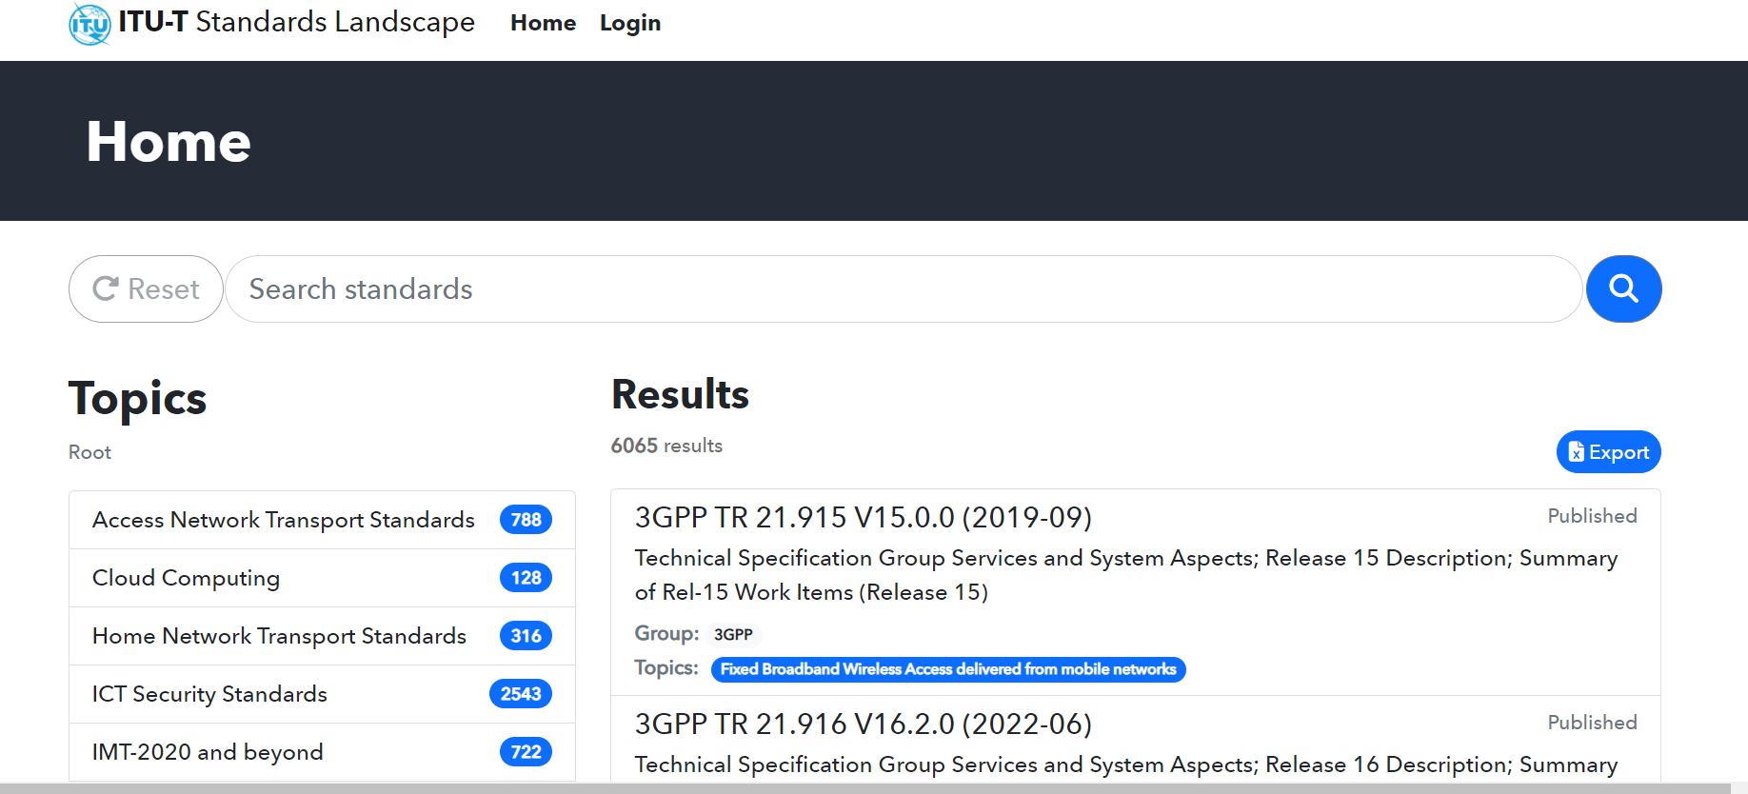
Click on
Step 2 – or starting from ITU-T landscape for ICT standards - HNT.
Click on
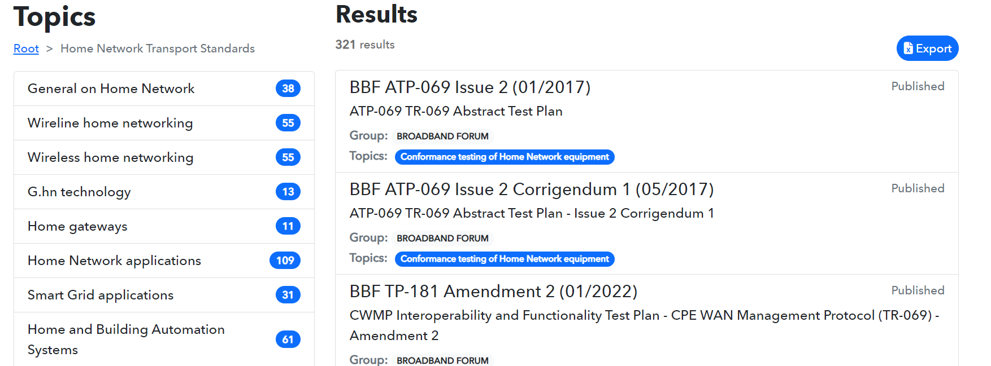
Step 3
Click on
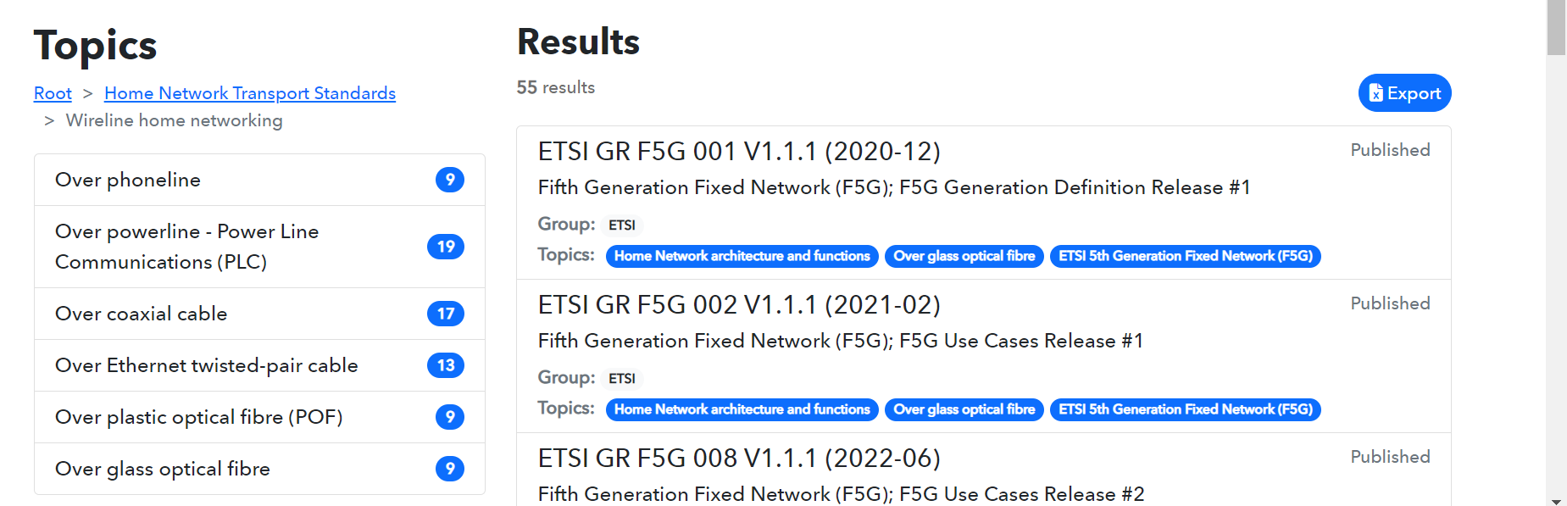

Step 4
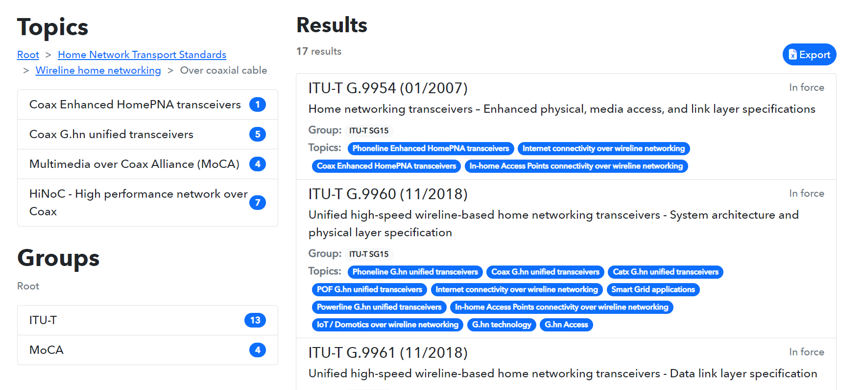
Click on

Step 5
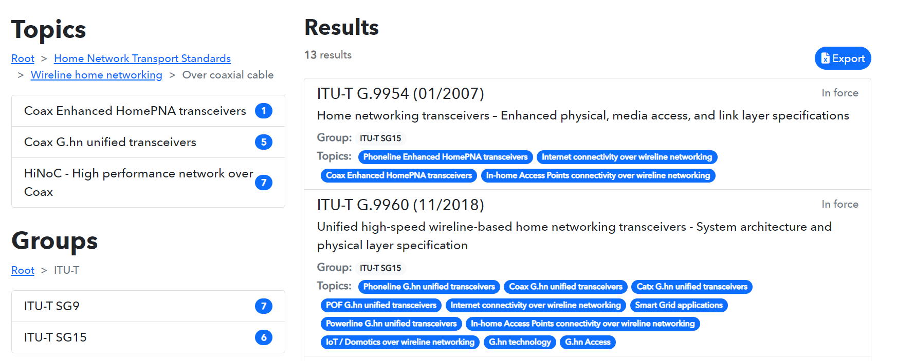
Click on

Step 6
The list of all ITU-T SG15 Recommendations, including Supplements related to “Wireline home networking over coaxial cable” is displayed. The list can be exported on an excel table.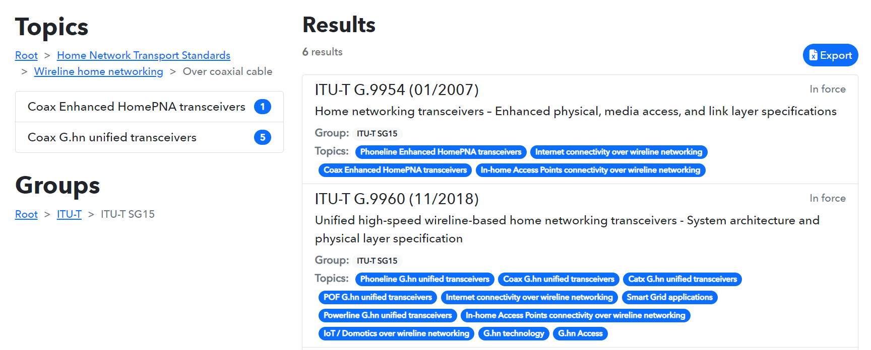
Click on

Step 7: “Documents Export xlsx” is ready for download, the list of all ITU-T SG15 Recommendations on “Wireline home networking over coaxial cable” can be displayed in excel.
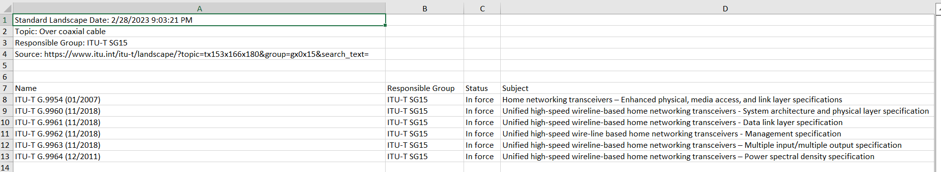

Search of a selected standard using the Topics structure:
for example, search Recommendation ITU-T G.9960.
Proceed with steps 1 to 5 as in above search example 1
Step 6: Click on item ITU-T G.9960.
Click on
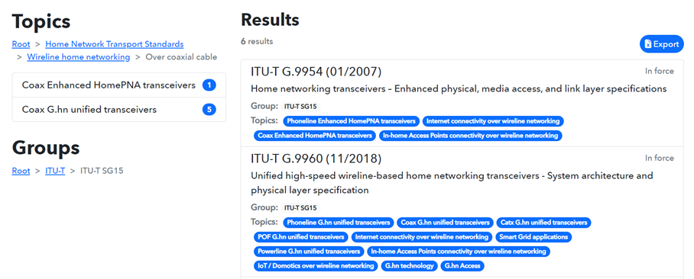

Step 7: See the displayed information on ITU-T G.9960 (11/2018) and click on the link to access to the ITU-T SG15 webpage of Recommendation G.9960.
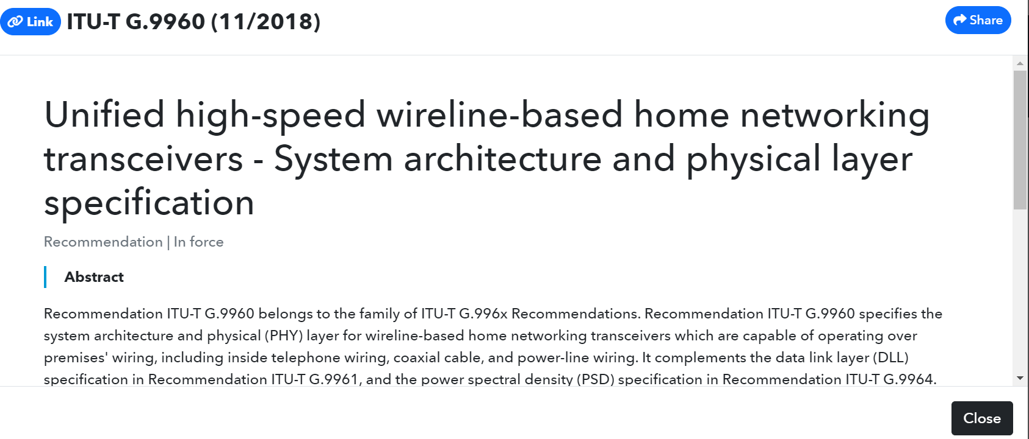
Click on Link

Step 8: The ITU-T SG15 webpage of Recommendation G.9960 (11/2018) including its
Amendments is displayed, and the searched document can be downloaded.
Click on “here” to download the document.
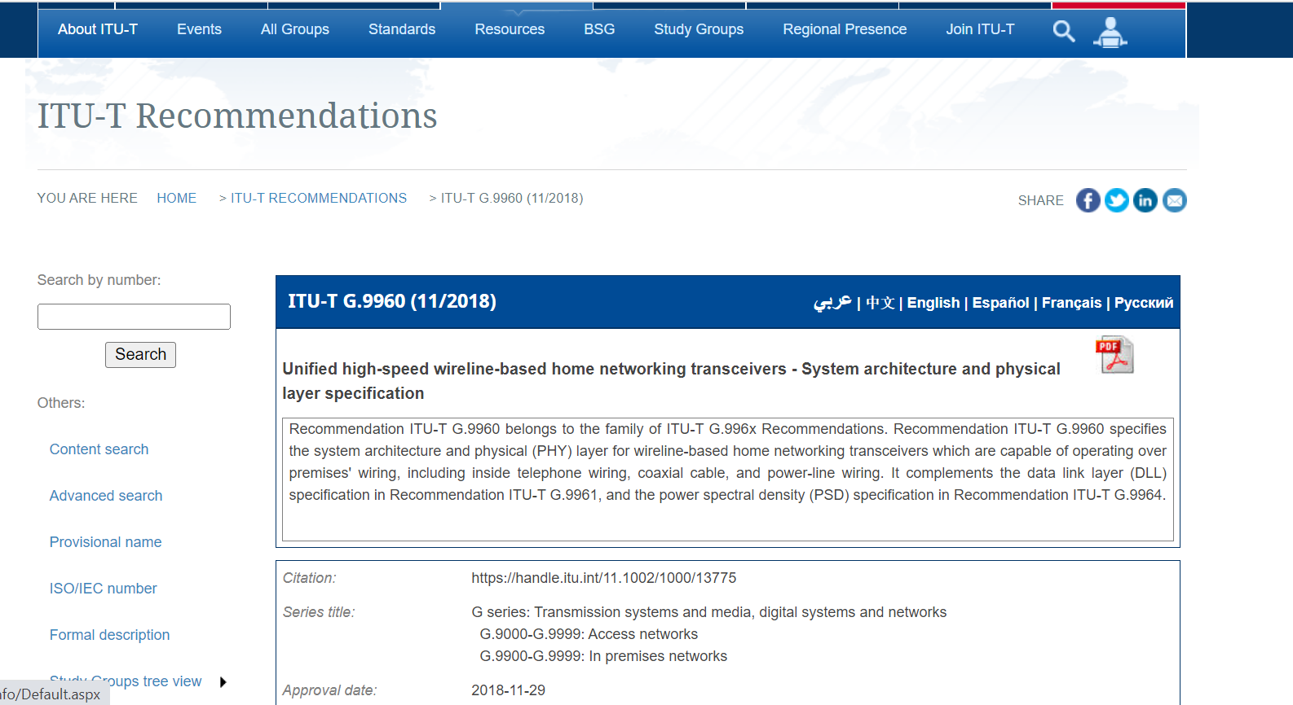
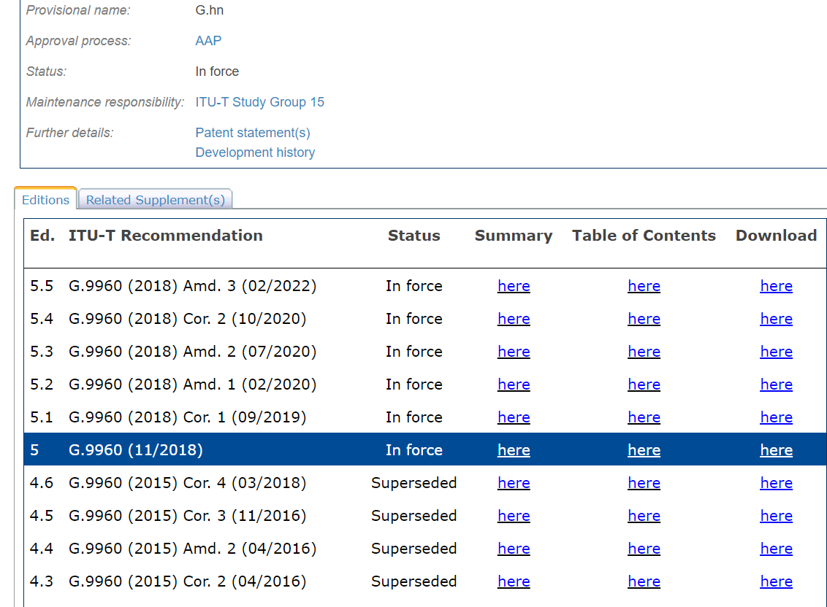
Click on here
to download the document

- Search of a standard using the search function of the ITU-T Standards Landscape:
for example, search Recommendation ITU-T G.9991.

Step 1: Enter G.9991 in the “Search standards” window of the ITU-T Standards Landscape
and launch the search. The items are also searchable on title or descriptive terms.
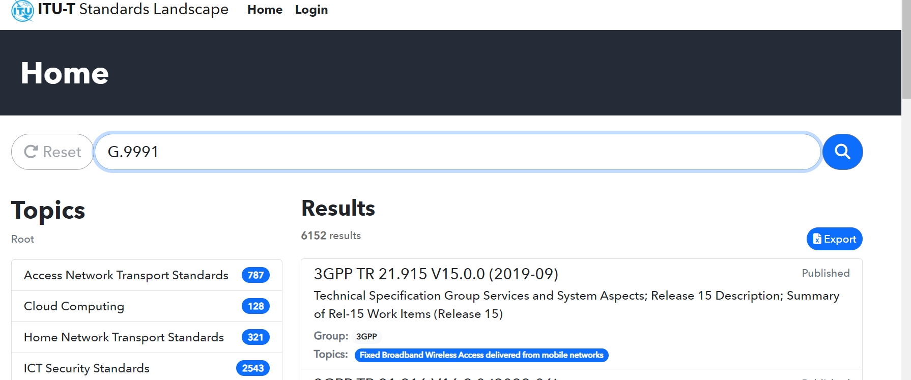

Step 2: See displayed Results and continue as for steps 6, 7 and 8 in above search example 2.
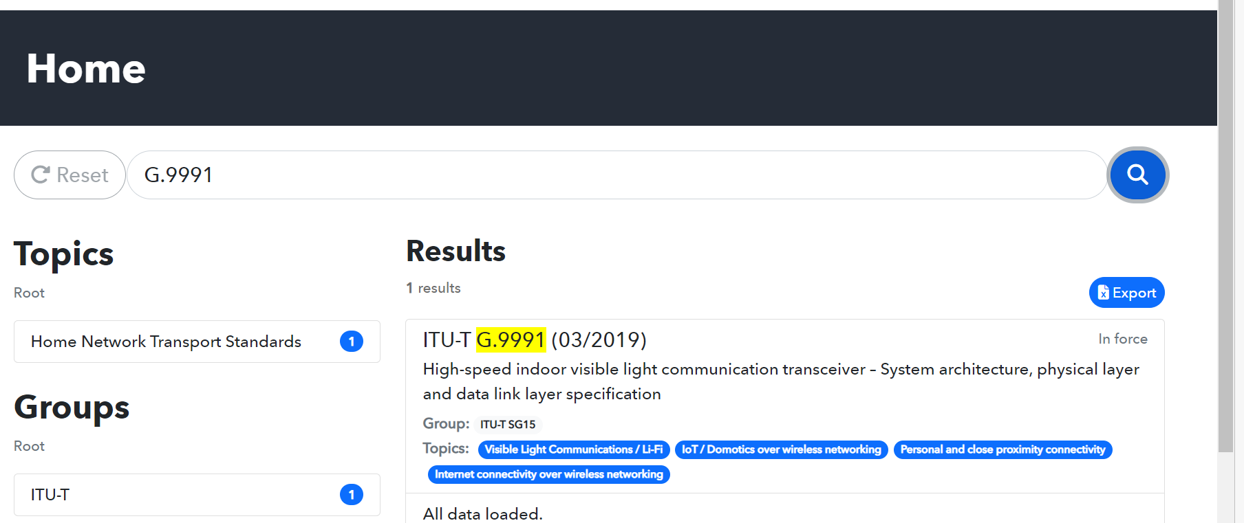
Click on

- Search of a list of standards using the Groups structure:
for example, search the list of all ITU-T SG15 Recommendations related to “Smart Grid applications”.
Proceed with step 1 as above in section 1
Step 2
Click on
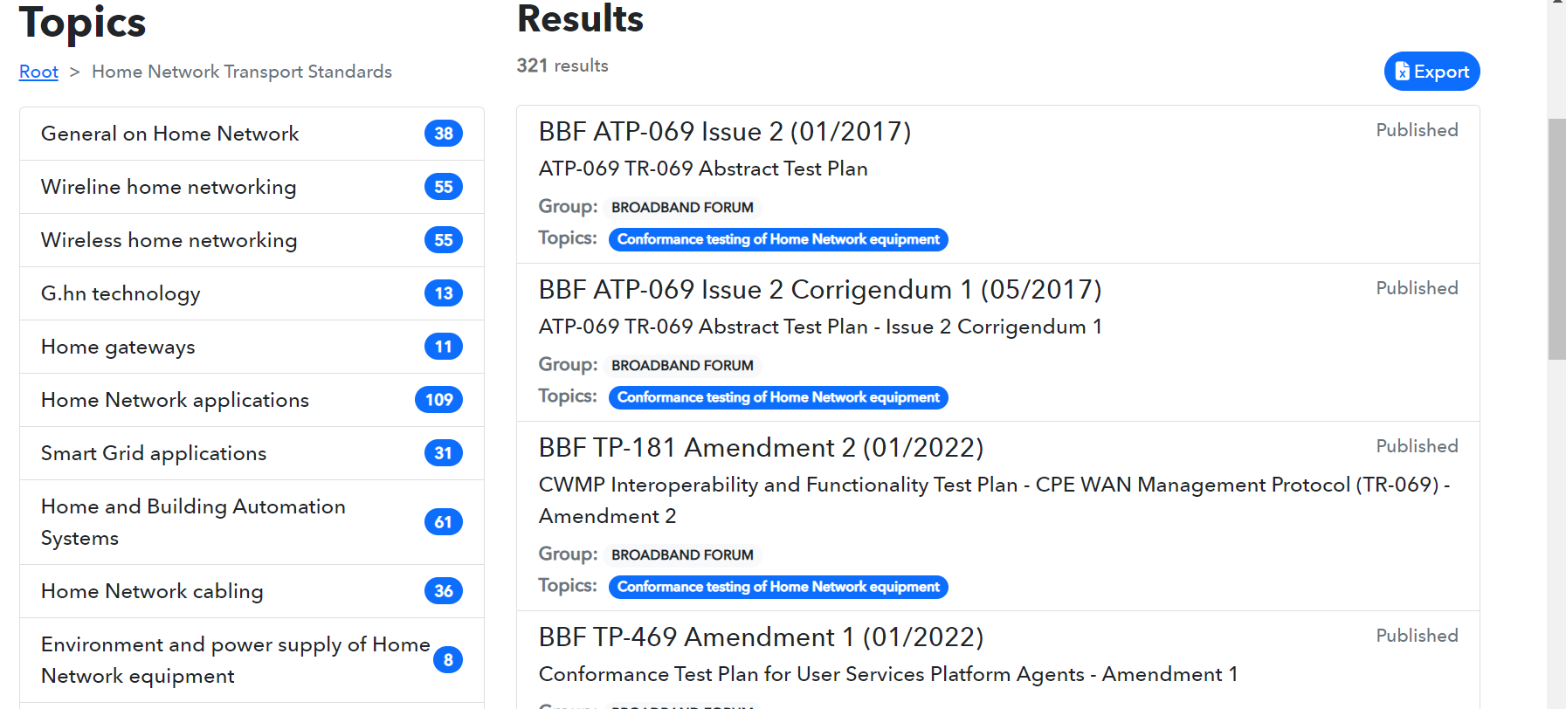
Step 3: click on the Groups ITU-T.
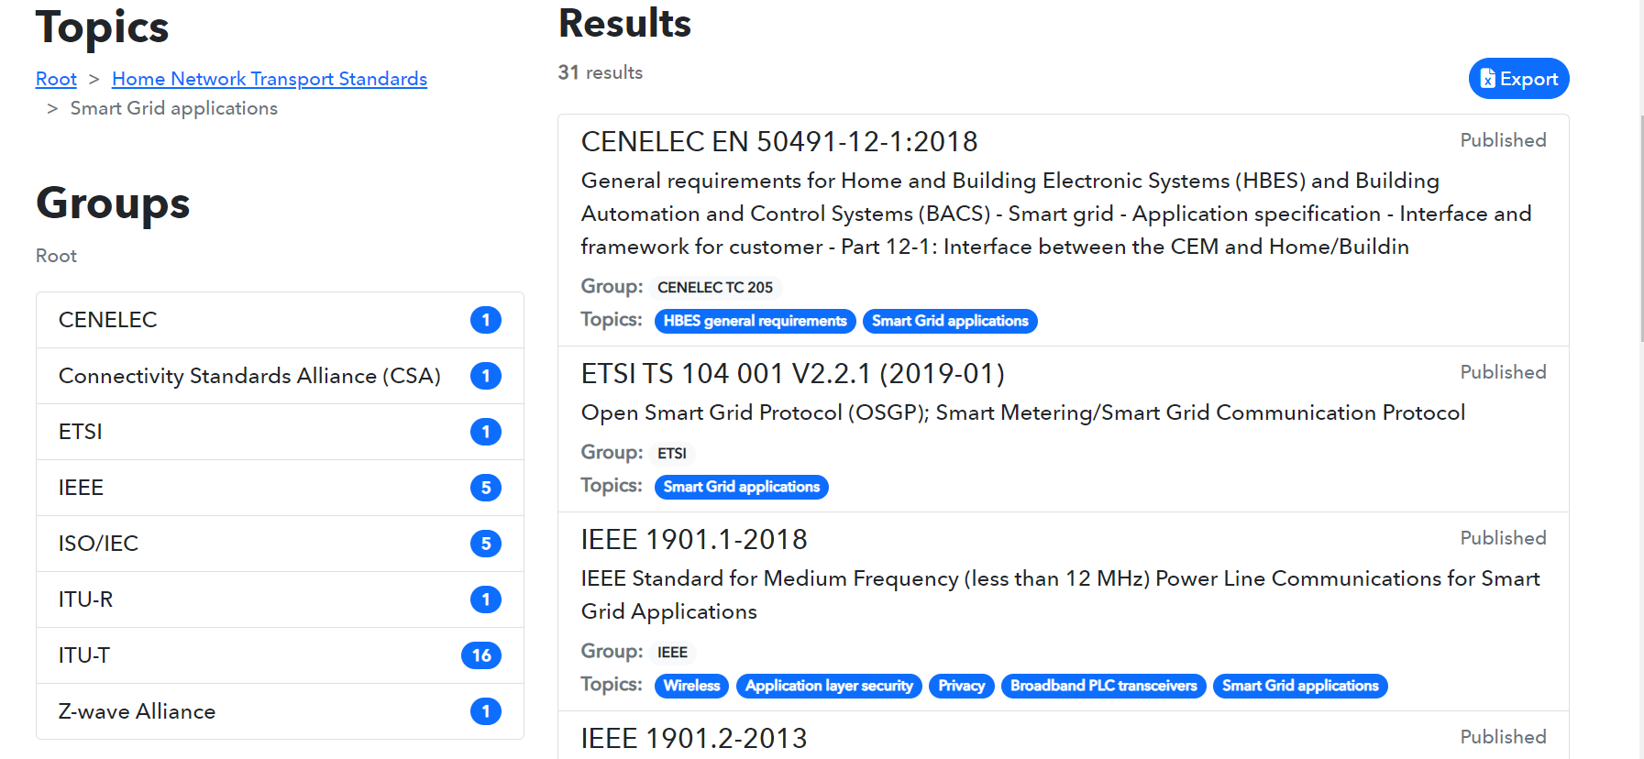
Click on
Step 4
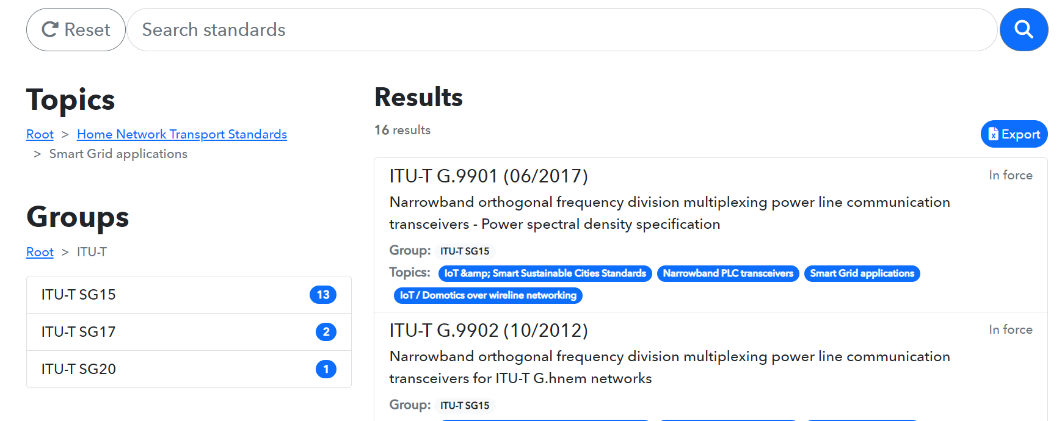
Click on

Step 5: The list of all ITU-T SG15 Recommendations related to “Smart Grid applications” is displayed. The list can be downloaded and exported on an excel table.
Proceed as for steps 6 and 7 in above search example 1 to download the list in excel.




