Access Network Transport

Standards Overview and Work Plan

July 2024 Q1/15 meeting

Contact persons for the project updating:

|  |  |  |
| --- | --- | --- |
| Study Group 15 Advisor:  Mr. Hiroshi Ota  International Telecommunication  Union (ITU)  Place des Nations  1211 Geneva 20  Switzerland  Tel.: +41 22 730 6356  E-mail: [hiroshi.ota@itu.int](mailto:hiroshi.ota@itu.int) | Study Group 15 Chairman  **Mr. Glenn Parsons**  **Ericsson 349 Terry Fox Drive Ottawa - ON K2K 2V6 Canada**  **Tel: +1 514 379 9037**  **E-mail:**  [**glenn.parsons@ericsson.com**](mailto:glenn.parsons@ericsson.com) | Question 1/15 Rapporteur  Mr. Jean-Marie Fromenteau  Corning Incorporated  Corning, NY 14831  USA  Tel: +49 9561 42 74 20  E-mail:  [fromentejm@corning.com](mailto:fromentejm@corning.com) |

Access Network Transport is an ITU-T Project dealing with studies and Recommendations on the Access Network. The present Access Network Transport (ANT) Standards Overview and Work Plan is part of ITU-T SG15 Lead Study Group activities on coordination of Access Network Transport standards.

Access Network Transport Standards Overview and Work Plan

Issue 40, July 2024

|  |
| --- |
| Revision Status Report: Major Updates of Version 40, July 2024 |
| In this version 40, following changes, additions and updates have been made: 1) The previous “ANT Standards Overview” and “ANT Standards Work Plan” documents have been both consolidated in this present single document. The part ANT Standards Work Plan is in Sections 10, 11 and 12 of this document.  2) The web-based ANT Standards Overview has been updated with the below listed new or revised Standards, Recommendations, Amendments and Corrigenda, Supplements, Technical Reports from ITU-T SG15, other ITU Study Groups and other SDOs that have been approved and published since the last ITU-T SG15 November 2023 plenary meeting:   * Access Network Architecture and Functions > General on Access Network Architecture and Functions: *no changes* > ETSI 5th Generation Fixed Network (F5G): ETSI GR F5G 021 V1.1.1 (2023-11) > Fixed Access Network Sharing: BBF TR-386 Issue 2 (06/2024) > FTTdp and FTTep: BBF TR-301 Issue 2 Amendment 2 (12/2023) > Wireline – Wireless Convergence: BBF TR-458 Corrigendum 1 (03/2024); ITU-T Y.3207 (04/2024)   > ITU-T and ITU-R technical papers, reports, guides and handbooks: ITU-R SG5 Guide to the use of ITU-R texts (01/2024); ITU-T FSTP-ACC-Rural (07/2023), L Suppl. 56 (10/2022), L Suppl. 59 (11/2023)   * Fibre Optic Broadband Access   > Point-to-Point (PtP): ITU-T G.9806 (2020) Amd. 3 (01/2024)*; BBF TR-383 Amd.7 (12/2023)  > Passive Optical Network (PON): ITU-T G.988 (2022) Amd. 1 (03/2024)*, G.9804.1 (2019) Amd. 2 (01/2024)*, G.9804.3 (2021) Amd. 2 (03/2024)*, G Suppl. 79 (12/2023); BBF TR-385 Issue 3 (04/2024), TR-383 Amd.7 (12/2023), TR-309 Issue 3 (06/2024)  > Hybrid Fibre Access Technologies : ITU-T G Suppl. 55 (12/2023), G Suppl. 71 (12/2023) ; SCTE 174 2018 (R2024)   * Metallic Conductor Broadband Access   > Digital Subscriber Lines (DSL) Technologies: BBF TR-383 Amd.7 (12/2023)  > G.hn Access: ITU-T G.9960 (2023) Amd. 1 (01/2024)*, G.9961 (12/2023), G.9961 (2023) Amd. 1 (01/2024)*, G.9964 (12/2023)   * Hybrid Fibre Coax (HFC) Broadband Access   > General on Cable Networks: ITU-T J.1 (01/2024), J.1631 (11/2021); SCTE 07 2018 (R2024)  > DOCSIS (Data Over Cable Service Interface Specification): ANSI/SCTE 23-1 2017 (R2022), ANSI/SCTE 23-2 2017 (R2022), ANSI/SCTE 23-3 2017 (R2022), SCTE 135-1 2018 (R2024), ANSI/SCTE 135-3 2023  > High Performance Networks over Coax (HiNoC): ITU-T J.195.1 (03/2024), J.195.2 (03/2024), J.195.3 (03/2024), J.196.2 (03/2024), J.196.3 (03/2024), J.198.2 (01/2024), J.198.3 (01/2024), J. Suppl.12  > Radio Frequency over Glass Fibre-to-the-Home (RFoG): SCTE 174 2018 (R2024)   * Broadband Access Network Infrastructure   > Guide on Standards and Recommendations: *no changes*  > Network infrastructure engineering: ITU-T ICT-2013-01 (12/2013), ITU-T FSTP-ACC-Rural (07/2023), ITU-T L.250 (01/2024), L Suppl. 58 (12/2023); ETSI TS 103 933 V1.1.1 (2024-04)  > Fibre optic infrastructure : ITU T G.650.1(01/2024), L.100 (01/2024), L.109 (01/2024) ; IEC 61300-1:2022+AMD1:2024 CSV, IEC 60875-1:2024 ; ISO/IEC 14763-3:2024  > Copper cables infrastructure: *no changes*  > Power supply and energy management: ETSI TS 103 531 V1.2.1 (2024-01); ITU-T ICT-2013-01 (12/2013)  > Safety and equipment protection: *no changes*  > Operation and maintenance: ITU-T L.312 (01/2024); BBF TR-383 Amd.7 (12/2023), TR-385 Issue 3 (04/2024), TR-309 Issue 3 (06/2024); IEC 61280-4-2:2024, IEC TR 61282-14:2024   * Broadband Power Line Communications (PLC): IEEE 1901c-2024 * Fixed Broadband Wireless Access > Basic requirements and general characteristics of FWA: ITU-R SG5 Guide to the use of ITU-R texts (01/2024)   > Fixed Broadband Wireless Access delivered from mobile networks: ITU-R M.2012-6 (12/2023), M.2150-2 (12/2023), M.2160-0 (11/2023) > Technical reports, technical papers, guides and handbooks on fixed wireless access: Guide to the use of ITU-R texts (01/2024); ITU-T L Suppl. 59 (11/2023)   * Technical reports, technical papers, guides and handbooks on access network:   ITU-R SG5 Guide to the use of ITU-R texts (01/2024); ITU-T FSTP-ACC-Rural (07/2023), L Suppl. 56 (10/2022), L Suppl. 59 (11/2023)  (*) Refer to the related main ITU-T Recommendation in the web-based overview to get access to the Amendment and/or Corrigendum.  3) Section 8 - Table of existing and under study Standards for Optical Access Networks has been updated.  4) Work programmes and ongoing standardization activities in Section 10.1 have been updated with the latest Q2/15 and Q4/15 activities resulting from July 2024 ITU-T SG15 - WP1 plenary meeting and latest Q5/15 and Q7/15 activities resulting from ITU-T SG15 - WP2 July 2024 plenary meeting.  5) Work programmes and ongoing standardization activities in Section 10.2 have been updated with the incoming liaisons from other ITU SGs and SDOs and reports from liaison Rapporteurs of ITU-T SG15.  6) Sections 11 and 12 have been updated. |

**Access Network Transport Standards Overview and Work Plan**

**Issue 40, July 2024**

Introduction 5

1. Scope 5

2. References 6

3. General Access Network architecture 6

4. Access Network functional groups 7

5. Reference configuration for ITU-T G.99x-series Recommendations 9

6. Access Network Transport interfaces 10

7. Access Network Transport technologies 13

8. Table of existing and under study Standards for Optical Access Networks 16

9. Web presentation of the ANT Standards Landscape 19

9.1 Web-based ANT Standards Overview 19

9.2 Taxonomy of the web-based ANT Standards Overview 20

9.3 ANT Topics and related Groups (ITU Study Groups and SDOs) 27

10. Ongoing standardization activities in the Area of Access Network Transport 33

10.1 Ongoing standardization activities in the area of Access Network Transport  
 within ITU-T SG15  33

10.2 Ongoing standardization activities in the area of Access Network Transport  
 in other groups within ITU and other Standards Development Organizations 39

11. List of Contacts 59  
  
12. Lead Study Group activities related to the ANT Standards Overview and Work  
 Plan 66

Annex 1 - Guide on the use of the web-based ANT Standards Overview 67

**ACCESS NETWORK TRANSPORT STANDARDS OVERVIEW AND WORK PLAN**

Issue 40, July 2024

# Introduction

In today’s global communications world the traditional boundaries in network access between Telecommunication Network Operators, Communication Services Providers, Satellite and Cable TV Networks, Mobile Networks and Information Technologies cease to exist.

Within the ITU-T, the study and development of Recommendations related to transport in the access network is being carried out in several different Study Groups, e.g., SG 9, 13, 15. Moreover, ITU-R and other standards bodies, forums and consortia are also active in this area.

Recognizing that without a strong coordination effort there is the danger of duplication of work as well as the development of incompatible and non-interoperable standards, the WTSC 96 designated Study Group 15 as **Lead Study Group** on **Access Network Transport (ANT) - reaffirmed at the WTSA-20 –** with the mandate to:

1. study the appropriate core Questions (Question 2/15 and Question 4/15),
2. define and maintain an overall (standards) framework, in collaboration with other SGs and standards bodies,
3. coordinate, assign and prioritize the studies done by the Study Groups (recognizing their mandates) to ensure the development of consistent, complete, and timely Recommendations.

Study Group 15 entrusted Working Party 1/15 (Transport aspects of access, home, and smart grid networks), under Question 1/15, with the task to manage and carry out the Lead Study Group activities on Access Network Transport.

# Scope

This document defines an ANT on the background of the Recs. G.902 and GII Y.100 series and provides an overview of the existing ANT related standards released and/or prepared by the ITU and other standardization bodies.

The main purpose ofthe **ANT Standards Overview** **and Work Plan** is to identify:

- Which standards exist,

- Lack of standards,

- Duplication and/or overlap,

- Market needs,

- Priorities.

The **existing ANT standards** are listed in the **web-based ANT Standards Overview**.This web presentation of the existing ANT standards is part of the present document and isavailable in the web-based ITU-T Standards Landscape – Topic/Root “Access Network Transport Standards“ at [ITU-T landscape for ICT standards - ANT](https://www.itu.int/itu-t/landscape/?topic=tx356&group=g&search_text=) on the ITU-T SG15 website. The description and taxonomy of the web-basedANT Standards Overvieware provided in **Sections 9.1, 9.2 and 9.3** of the present document.  
The list of **ANT-Relevant Standards** can be downloaded using the topics and related groups (ITU Study Groups and SDOs) of the web-based ANT Standards Overview represented in **Section 9.3**.  
A guide on the use of the web-based ANT Standards Overview is provided in **Annex 1.**

**ANT Standards Work Plan**: Ongoing standardization activities, Standards under study/development in the area of Access Network Transport are identified in the **Section 10.**  
  
The present ANT Standards Overview and Work Plan is a living document. The current version is available at <https://www.itu.int/en/ITU-T/studygroups/com15/Pages/ant.aspx>.

1. **References**

ITU-T Recommendation G.902 (11/1995): Framework Recommendation on functional access networks (AN) – Architecture and functions, access types, management and service node aspects  
  
ETSI EG 202 306 V1.2.1 (1998-05): Transmission and Multiplexing I; Access networks for residential customers  
  
ITU-T G Suppl. 50 (09/2011): Overview of digital subscriber line Recommendations  
  
ITU-T Recommendations Y.100 series on Global Information Infrastructure (GII)

1. **General Access Network architecture**

The basic documents for the following definitions are ITU-T G.902 and ETSI EG 202 306.

**Access Network Transport (ANT)**

Based on definitions specified in ITU-T Rec. G.902 the Access Network (AN) provides transport bearer capabilities for the provision of telecommunications services inside of the AN between a service node interface (SNI) providing customer access to a service node and each of the associated interfaces towards the Customer Premises Network(s) which are being grouped as user network interfaces (UNIs). An Access Network implementation comprises transmission media and access network element (NE) entities.  
An Access Network is delimited by its interfaces. Users are connected via a User Network Interface (UNI) to the network. The AN is connected to the Service Node (SN) via the Service Node Interface (SNI) and to the Telecommunication Management Network (TMN) via a Q3 interface.  
Figure 1 “General Access Network architecture and boundaries” shows the AN with the UNI, SNI and Q3 interface as the boundaries to other network entities.



Figure 1 “General Access Network architecture and boundaries” (from ITU-T G.902)

An Access Network element can be configured and managed through a Q3 interface that may be implemented at the Q reference point. This Q reference point is the access point for management information, configuration control, performance monitoring and maintenance as defined in ITU-T Rec. M.3010.

In principle there are no restrictions on the types and number of SNIs and UNIs that an Access Network may implement. The Access Network does not include Customer Premises Networks and/or terminal equipment respectively.

1. **Access Network functional groups**

The ANT functions as definitions specified in the ITU-T Rec. G.902 are divided into 5 groups:

1. User port functions
2. Service port functions
3. Core functions
4. Transport functions
5. AN-system management functions

Figure 2 gives an example of one AN functional architecture and how each of the functional groups are interconnected.  
  


Figure 2 “Example of functional architecture of an Access Network” (from ITU-T G.902)

Figure 3 shows an example of the layers that are processed in each functional group based on the example given in Figure 2.



Figure 3 “Layered structure of an Access Network based on G.902”  
 (from ITU-T I.414)

* **User port function (UPF):** This function adapts the specific UNI requirements into the core and system management functions.
* **Service port function (SPF):** This function adapts the specific SNI requirements into the core and system management functions.
* **Core function (CF):** This function adapts the individual User Port or Service Port bearer requirements into common transport bearers. The core function can be distributed in the AN.
* **Transport function (TF):** This function provides the network connections for the common bearers between different locations and the media adaptation.
* **AN system management function (AN-SMF):** AN System Management function coordinates operations and maintenance of the User Port function, Service Port function, Core function and Transport function within the AN. It coordinates time critical management and operation requirements for the allocated user ports with the Service Node via the SNI. It communicates with the TMN via the Q3 interface for the purpose of being monitored and/or controlled.

**Functions of Access Network Transport (ANT)**

The Transport Function (TF) provides the paths for the transport of common bearers between different locations in the Access Network (AN) and the media adaptation for the relevant transmission media used.

Examples of transport functions are:

1. multiplexing function,
2. cross connect function including grooming, on demand connection and configuration,
3. management functions,
4. physical media function.
5. **Reference configuration for ITU-T G.99x-series Recommendations**

As described in ITU-T G Suppl. 50, there are two generic reference configurations used to relate the ITU-T G.99x-series Recommendations for DSL systems. First reference configuration is based on the reference configuration used for the N-ISDN in ITU-T I.410 and described in figure 4 below. The other reference configuration is a protocol reference configuration to provide a view of the ITU-T G.99x-series Recommendations from the protocol architecture point of view.

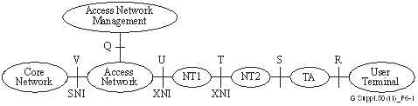

Figure 4 “A reference configuration for a generic ITU-T G.99x system”   
(from ITU-T G Suppl. 50)

This reference configuration identifies the reference points in the context of Access Network (AN). The generic reference configuration consists of seven elements:

1) Core network

2) Access network

3) Network termination 1 (NT1)

4) Network termination 2 (NT2)

5) Terminal adapter (TA)

6) User terminal

7) Access network management

Core network and access networks are separated at the V reference point – which serves as Service Node Interface (SNI). The access network and the access network management elements are separated at the Q reference point. The NT1 makes a physical connection to the access network at the U reference point and provides service presentation to a customer on a logical or physical interface at the T reference point. An NT2 connects to the network at the T reference point, may connect to multiple user terminals on S reference point interfaces. The NT2 may be integrated with an NT1 to form an NT1/2. The NT term is used for generic network termination for various services. For some services it could be part of the access network, and for others not. The U and T reference points serve as Access Network Interfaces (XNI). The Access Network Interface (XNI) is the interface between the access network and the user premises, and therefore also serves as User Network Interface (UNI).  
A TA adapts the transport protocol to the specific requirements of a user terminal.

Note: The NT term is used for generic Network Termination for various services. For some services/configurations, the NT might be property of the customer and therefore integrated in the CPN; nevertheless, it terminates the Access Network from a functional/physical point of view.

1. **Access Network Transport interfaces**

##### Examples of Service Node Interfaces (SNIs)

##### SNI is defined as the interface that includes the following conditions:

##### interconnection between the access network and the service node,

##### described by a well-known standard,

##### includes a physical layer aspect.

Example of SNIs, physical interfaces and services that can be supported by the physical interfaces are shown in Table 1-1.

| Table 1-1 – Examples of SNIs and services | | |
| --- | --- | --- |
| SNI | Physical interface | Service |
| 1GE/10GE/25GE/40GE/ 50GE/100GE/200GE/400GE [IEEE 802.3] | 1G/10G/25G/40G/50G/100G/200G/400G BASE | Ethernet, or Ethernet-based eCPRI |
| [ITU-T G.8261],  [ITU-T G.8262] | - | Synchronous Ethernet (SyncE) |
| [ITU-T G.964] and  [ITU-T G.965] | V5.1 and V5.2 | POTS, basic ISDN |
| [ITU-T G.967.1] and  [ITU-T G.967.2] | VB5.1 and VB5.2 | B- ISDN |
| [ITU-T G.703] | PDH, STM-1e | DS3, E1, E3, STM-1, DS1, DS0 |
| [ITU-T G.957] | STM-1,4,16,64 | E1, E3, DS1, DS3, GFP, E4,  STM-n, DS0 |
| [ATIS 0600107] | PDH | DS0, DS1, DS3 |
| SDH/SONET | SDH/SONET | OC3-OC192, STM1-STM64 |
| OTN [ITU-T G.872] and  [ITU-T G.709] | I1, I2, I3 | OTN |
| CPRI/OBSAI (Open Base Station Architecture Initiative) | Option2, Option3 Option7, Option8, Option10 | Wireless fronthaul |

##### Examples of User Network Interfaces (UNIs)

##### As defined in the ITU-T I.112, the User Network Interface (UNI) is the interface between the terminal equipment and a network termination at which interface the access protocols apply.

A UNI is defined as the interface that includes the following conditions:

* interconnection between the access network and the customer,
* described by a well-known standard,
* includes a physical layer aspect.

Examples of UNIs, physical interfaces and connectivity to be provided are shown in Table 1-2.

| Table 1-2 – Examples of UNI and connectivity service | | |
| --- | --- | --- |
| UNI | Physical interface | Connectivity service |
| 10Mbps/100Mbps/1Gbps/10Gbps/25Gbps Ethernet [IEEE 802.3] | 10/100/1000/10G/25G BASE | Ethernet, or Ethernet based eCPRI |
| MoCA Home™ 2.0/MoCA Home™ 2.5/ MoCA Home™ 3.0;  MoCA Link™ 2.5 | – | MoCA Home™ 2.0 MoCA Home™ 2.5 MoCA Home™ 3.0 MoCA Link™ 2.5 |
| MoCA Access™ 2.5, MoCA Link™ 2.5 | - | FTTB, FTTep |
| 1 Gbit/s fibre UNI | 1000BASE | Ethernet |
| 10 Gbit/s fibre UNI | 10GBASE | Ethernet |
| [ITU-T G.8261],  [ITU-T G.8262] | – | Synchronous Ethernet (SyncE) |
| [b‑ITU-T Q.552] | – | POTS |
| ISDN [ITU-T I.430] | – | ISDN |
| V.35 | – | – |
| G.hn [ITU-T G.9960] and [ITU-T 9961] | G.hn | G.hn, FTTB, FTTep |
| VDSL2 [ITU-T G.993.2], ADSL2+ [ITU‑T G.992.5] | xDSL | xDSL (e.g., FTTB, FTTC, FTTCab) |
| G.fast [ITU-T G.9700] and  [ITU-T G.9701] | G.fast | G.fast (FTTdp) |
| MGfast [ITU-T G.9710] and [ITU-T G.9711] | MGfast | MGfast (FTTdp, FTTep) |
| [ITU-T G.703] | DS3, E1, E3 | PDH |
| [b‑ATIS 0900102] and [b‑ATIS 0600107] | T1, DS0, DS1, DS3 | PDH |
| SDH/SONET | OC3 – OC192,  STM1- STM64 | SDH/SONET |
| OTN [ITU-T G.709],  [ITU-T G.872] | - | I1, I2 |
| CPRI/OBSAI (Open Base Station Architecture Initiative) | Option2, Option3 Option7, Option8, Option10 | Wireless fronthaul |
| WLAN | IEEE802.11x | Wireless LAN |
| 1PPS | 1PPS | Synchronizing interface |

##### Examples of Services

Services for residential subscribers, business customers, and mobile backhauling applications

| Service | |
| --- | --- |
| PSTN | VoIP |
| POTS |
| ISDN |
| TV (real-time) | IPTV |
| Digital TV broadcasting |
| Video | Digital video, video over IP |
| Leased line | T1, E1, E3, DS0, DS1, DS3 |
| High speed Internet access | Gigabit Ethernet [IEEE 802.3] |
| Ethernet data service | Ethernet service is mainly to transmit data such as IP, which includes VoIP, video streams coded by MPEG-2 or MPEG-4, and so on |
| L2 VPN services | Such as Ethernet services, with latest MEF Carrier Ethernet 2.0 extension, etc. |
| IP services | Such as L3 VPN and VoIP, etc. |
| Mobile backhaul | Accurate frequency/phase/time synchronization |
| Mobile fronthaul | Wireless fronthaul: Connectivity to wireless based stations (e.g., Wi-Fi Hotspots, 3G/4G/5G cell-sites) | |
| Business applications | Ethernet services such as point-to-point, multipoint-to-multipoint and rooted-multipoint Ethernet virtual connection (EVC) services (also called E-Line, E-LAN and E-Tree, respectively). |

1. **Access Network Transport technologies**

Today’s Access Network Transport technologies enable the telecom and internet service providers to offer multi-services and applications (e.g. voice telephony, data, video, etc.) – including both legacy and emerging services – to a wide range of markets and customers, e.g. residential subscribers in SFUs (single family units) and MDUs (multi-dwelling units), businesses, public organizations like schools, hospitals, etc.. They may also be connected to other network infrastructures like for example base stations of mobile networks, security and monitoring networks and they may support wholesale and retail.  
Access Network Transport types can be classified as below according to the transmission medium of the physical path and used technology:

1. Metallic Conductor Broadband Access
   1. Integrated services digital network (ISDN) [ITU-T I.432.x-series]
   2. Digital Subscriber Lines (DSL) Technologies [ITU-T G.99x-series] and [ITU-T G.97xx-series]
      * HDSL (High bit rate DSL) and SHDSL (Single-pair high-speed DSL) [ITU-T G.991.x-series]
      * ADSL (Asymmetric DSL), ADSL2 and ADSL2plus [ITU-T G.992.x-series]
      * VDSL (Very-high speed DSL), VDSL2 and VDSL2 Vectoring [ITU-T G.993.x-series]
      * G.fast (fast access to subscriber terminals) /FTTdp [ITU-T G.9701] and G.fastback (backhaul applications based on G.fast) [ITU-T G.9702]
      * MGfast (Multi-gigabit fast access to the subscriber terminals) [ITU-T G.9711]
   3. Ethernet over copper (EoC) [IEEE Std 802.3]
   4. G.hn Access [ITU-T G.996x-series]
2. Fibre Optic Broadband Access [ITU-T G.98x-series] and [ITU-T G.98xx-series]
   1. Point-to-Point (PtP) Ethernet (Bidirectional single fibre systems)
      * 100 Mbit/s [ITU-T G.985]; 1 Gbit/s [ITU-T G.986]; 10 Gbit/s, 25 Gbit/s,   
        50 Gbit/s and 100 Gbit/s [ITU-T G.9806]; 100 Mbit/s, 1 Gbit/s, 10 Gbit/s, 25 Gbit/s and 50 Gbit/s [IEEE Std 802.3]
   2. Passive Optical Network (PON)
      * Early PON Protocols: OAN [ITU-T G.982] and B-PON [ITU-T G.983.x-series]
      * Gigabit PON: G-PON [ITU-T G.984.x-series] and 1G-EPON [IEEE Std 802.3]
      * 10-Gibabit PON: XG-PON [ITU-T G.987.x-series]; XGS-PON [ITU-T G.9807.1] and 10G-EPON
      * 40-Gigabit PON: NG-PON2 (Nx10 Gbit/s per channel with N = min. 4 TWDM channels) [ITU-T G.989.x-series]
      * 25G and 50G-EPON (Nx25-EPON) [IEEE Std 802.3]
      * Higher-Speed PON (PONs that operate at speeds of 50 Gbit/s per channel for at least the downstream channels) [ITU-T G.9804.x-series]
      * Multiple-wavelength PON (MW-PON) [ITU-T G.9802.x-series]
      * Super-PON [IEEE Std 802.3]

**Section 8** “Table of existing and under study Standards for Optical Access Networks” provides an overview of the divers PtP Ethernet and PON systems developed by IEEE 802.3 and ITU-T SG15.  
  
Additional information on ITU-T PON and PtP optical fibre systems for the access network – including their maximum downstream/upstream bitrates – can be found on the ITU-T SG15 website at TECHNICAL FLYERS - [ITU-T SG15 Flyers](https://www.itu.int/en/ITU-T/studygroups/2022-2024/15/Pages/flyers.aspx).

* 1. Hybrid Fibre Access Technologies
     + Radio Frequency over Glass Fibre-to-the-Home (RfoG) [ANSI/SCTE 174]
     + Radio over Fibre (RoF) [ITU-T G.9803]
     + RF-Video Overlay [ITU-T J.185] and [ITU-T J.186]
     + Wireless – Fibre Access Networks (Wireless/Mobile xHaul) [G Suppl. 66] and [G Suppl. 75]

1. Hybrid Fibre Coax (HFC) Broadband Access
   1. DOCSIS (Data-Over-Cables Service Interface Specification) Network
      * DOCSIS 1.0 [ITU-T J.112] and [ITU-T J.125]; DOCSIS 1.1 [ITU-T J.112 Annex B] and [ITU-T J.125]
      * DOCSIS 2.0 [ITU-T J.112 Annex B] and [ITU-T J.122]
      * DOCSIS 3.0 [ITU-T J.222.x-series]
      * DOCSIS 3.1 [ITU-T J.225]
      * DOCSIS 4.0 [ITU-T J.224]
   2. High Performance Networks over Coax (HiNoC) connected with fibre to the building (FTTB)
      * 1st Generation HiNoc [ITU-T J.195.x-series]
      * 2nd Generation HiNoc [ITU-T J.196.x-series]
      * 3rd Generation HiNoc [ITU-T J.198.x-series]
   3. Multimedia over Coax Alliance (MoCA) access networking [ MoCA Access™ 2.5] and [MoCA Link™ 2.5]
   4. Ethernet Passive Optical Networks Protocol over Coax (Epoc) [IEEE Std 802.3]
   5. Radio Frequency over Glass Fibre-to-the-Home (RfoG) [ANSI/SCTE 174]
   6. Radio over IP transmission (RoIP) [ITU-T J.1106], [ITU-T J.1107] and [ITU-T J.1108]
2. Fixed Broadband Wireless Access
   1. ETSI HiperMAN
   2. Wireless MAN / WiMAX [IEEE Std 802.16]
   3. Wireless LAN / Wi-Fi Hotspots [IEEE Std 802.11]
   4. Fixed Broadband Wireless Access delivered from mobile networks (IMT-Advanced/4G [ITU-R M.2012]; IMT-2020/5G [ITU-R M.2150])
   5. Broadband Satellite and High-Altitude Platform Stations (HAPS)
3. Broadband Power Line Communications (PLC) [IEEE COM/PLC: IEEE Std 1901]

# Table of existing and under study Standards for Optical Access Networks

The matrix below provides an overview of the existing and under study standards for Optical Access Networks developed by IEEE 802.3 Ethernet Working Group and ITU-T Study Group 15. The matrix classifies the divers Point-to-Point (PtP) Ethernet and Passive Optical Network (PON) systems by bit-rate per channel and type of Optical Distribution Network (ODN).

The standards highlighted in grey are under study.  
The matrix below provides an overview of the currently existing and under study standards for Optical Access Networks developed by IEEE 802.3 Ethernet Working Group and ITU-T Study Group 15. The matrix classifies the divers Point-to-Point (PtP) Ethernet and Passive Optical Network (PON) systems by bit-rate per channel and type of Optical Distribution Network (ODN).   
The standards highlighted in grey are under study.

| Standards Development Organizations | 1 Gb/s  per channel | 2.5 Gb/s  per channel | 10 Gb/s  per channel | 25 Gb/s  per channel | 50 Gb/s  per channel | 100 Gb/s  per channel |
| --- | --- | --- | --- | --- | --- | --- |
| **PtP Bidirectional single fibre systems** | | | | | |  |
| ITU-T SG15 | G.986 |  | G.9806 | G.9806 | G.9806 | G.9806 |
| IEEE 802.3 | 802.3ah |  | 802.3cp | 802.3cp | 802.3cp | P802.3dk |
| **Splitter-based ODN Single channel TDMA systems** | | | | | | |
| ITU-T SG15 |  | **G-PON**  G.984.x series | **XG-PON (NG-PON1)** G.987.x series  **XGS-PON**  G.9807.1 |  | **50G-PON** G.9804.x series  G.9804.1: HSP Requirements  G.9804.2: HSP comTC G.9804.3: HSP 50Gpmd |  |
| IEEE 802.3 | **1G-EPON**  802.3ah |  | **10G-EPON** 802.3av | **25G-EPON** 802.3ca *Nx25G with N=1* |  |  |
| **Splitter-based ODN Multi-channel TWDM systems** | | | | | | |
| ITU-T SG15 |  |  | **NG-PON2** G.989.x series  *- Nx10G with N = up to 4 TWDM channels - optional extended up to 8 TWDM channels* |  | **Nx50G-PON** G.9804.x series  *- Nx50G with N to be defined*  G.9804.1: HSP Requirements G.9804.2: HSP comTC G.9804.4: HSP TWDMpmd |  |
| IEEE 802.3 |  |  |  | **50G-EPON** 802.3ca  *Nx25G with N=2* |  |  |
| **Splitter-based ODN Multi-channel WDM Overlay** | | | | | | |
| ITU-T SG15 | **NG-PON2** G.989.x series  *- Nx1G with N = up to 8 (12) PtP WDM channels as overlay to up to 8 (4) TWDM channels* | **NG-PON2** G.989.x series  *- Nx2.5G with N = up to 8 (12) PtP WDM channels as overlay to up to 8 (4) TWDM channels* | **NG-PON2** G.989.x series  *- Nx10G with N = up to 8 (12) PtP WDM channels as overlay to up to 8 (4) TWDM channels* |  |  |  |
| **Wavelength multiplexed ODN with logical point to point connections (a.k.a. WDM-PON)** | | | | | | |
| ITU-T SG15 |  |  |  | **25GMW-PON** G.9802.x series  *-* *Nx25G with N tbd - optional Nx10G or mix of 10G & 25G channels* G.9802: MW-PON G.9802.1: WDMPON.req G.9802.2: WDMPON.pmd&tc |  |  |
| **Wavelength multiplexed ODN with point to multipoint connections (a.k.a. SuperPON)** | | | | | | |
| IEEE 802.3 |  |  | **Super-PON** 802.3cs *- Nx10G with N = up to 16 channels following the 10G-EPON standard* |  |  |  |

1. **Web presentation of the ANT Standards Landscape**

# 9.1 Web-based ANT Standards Overview

A web-based ANT Standards Overview was developed to classify the existing ANT standards using inputs and published standards lists from ITU-T Study Group 15 and other ITU Study Groups, as well as from other standards development organizations (SDOs), Forums & consortia.  
  
The **web-based ANT Standards Overview** is part of the web-based ITU-T Standards Landscape  
- Topic/Root “Access Network Transport Standards” and is available on the ITU-T SG15 website at  
[ITU-T landscape for ICT standards - ANT](https://www.itu.int/itu-t/landscape/?topic=tx356&group=g&search_text=)

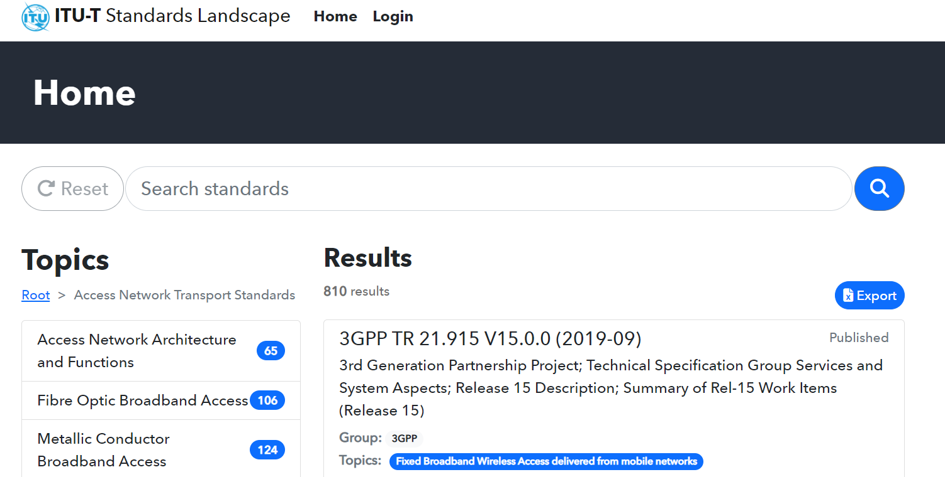

The web-based ANT Standards overview is organized by topics representing the broadband access network technologies, the various systems generations of each technology and related technical matters. It enables an easy identification and download of the publicly available Standards, Recommendations, Technical Specifications, and other technical documents related to each topic. The web-based ANT Standards Overview focuses on the most relevant published and updated documents related to Access Network Transport.

The items listed within each topic represent Standards, Recommendations, Technical Specifications or other technical documents and are identified by their responsible ITU Study Group or SDO, their individual document reference number, as well as their publication date and title. The items are also searchable on number, title and description and are alphanumerically listed within each topic; this is inherent in the data base system.

Lists of Standards, Recommendations, Technical Specifications and other documents (items) can be generated from the web-based ANT Standards Overview as needed per topic(s) and/or per responsible group(s) (ITU-T Study Groups or SDOs) and exported on an excel table.

The taxonomy used for the web-based ANT Standards Overview is described in the section below and a guide on how to use the web presentation is provided in Annex 1.

# 9.2 Taxonomy of the web-based ANT Standards Overview

**Topics of “Access Network Transport Standards”** representing the broadband access network technologies.

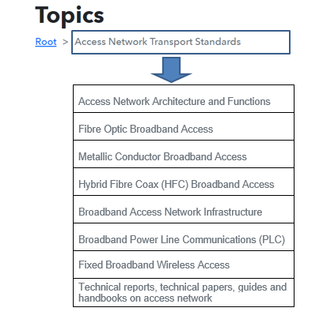

Each of the above topics is further described on the next pages.

**Topics of “Access Network Achitecture and Functions”** providing general information on related technical matters.

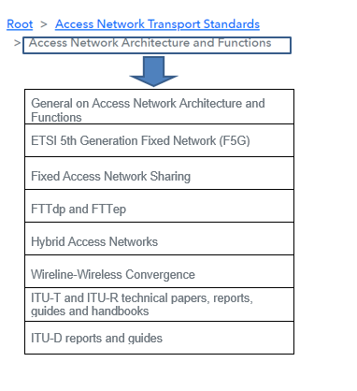

**Topics of the “Fibre Optic Broadband Access”** representing the various PtP and PON systems generations as well as other fibre based access technologies and related technical matters.

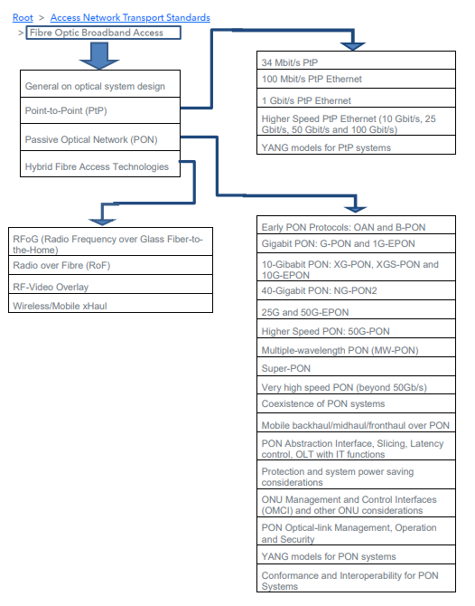

**Topics of the “Metallic Conductor Broadband Access”** representing the various DSL systems generations as well as other copper based access technologies and related technical matters.

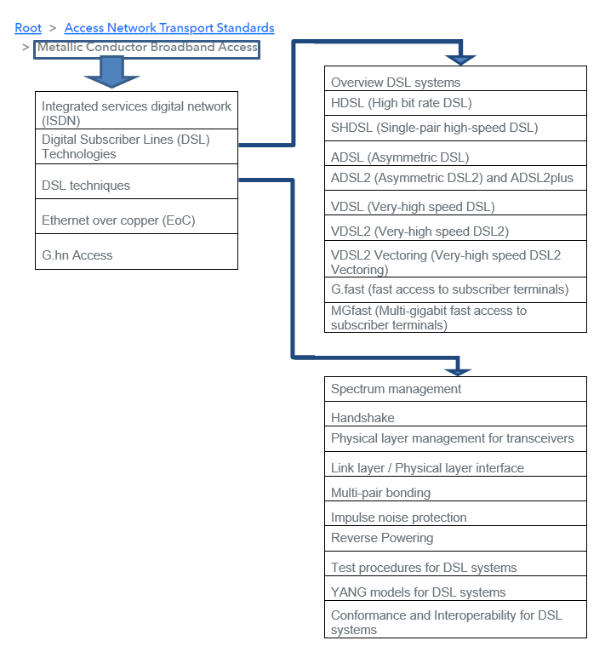

**Topics of the “Hybrid Fibre Coax (HCF) Broadband Access”** representing the various DOCSIS systems generations and cable modems as well as other cable TV access technologies and related technical matters.

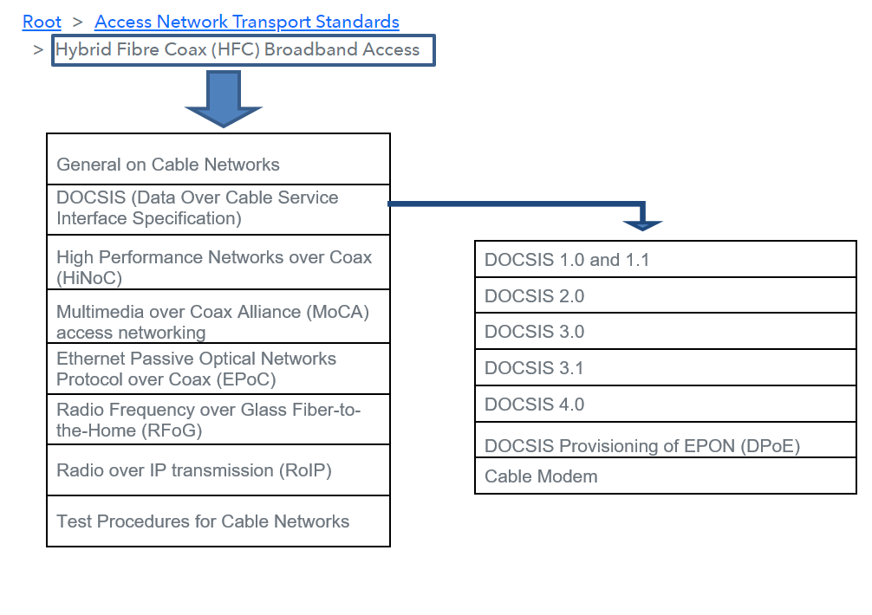

**Topics of the “Broadband Access Network Infrastructure”** representing the various technologies and components of the broadband network physical infrastructure and related technical matters.

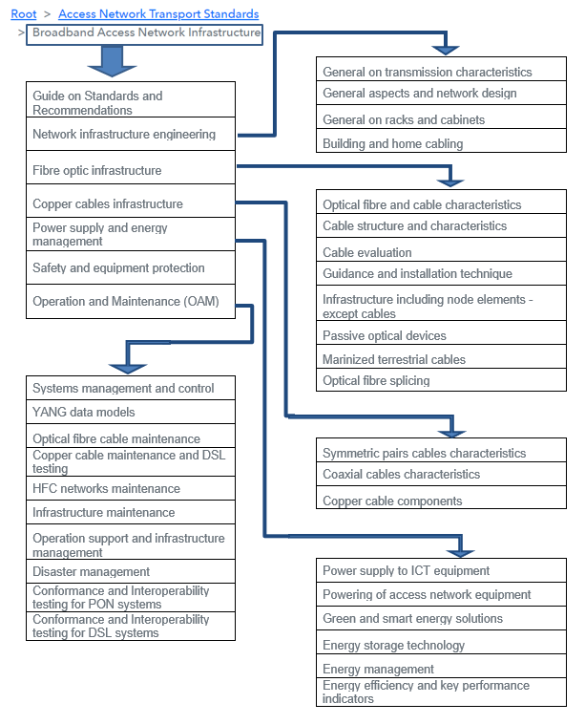

**Topic “Broadband Power Line Communications (PLC)”**

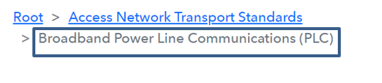

**Topics of the “Fixed Broadband Wireless Access”** representing the various broadband FWA solutions and related technical matters.

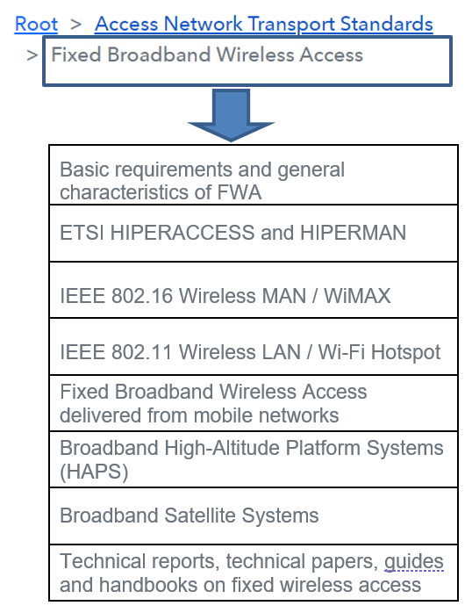

**Topic “Technical reports, technical papers, guides and handbooks on access networks”**

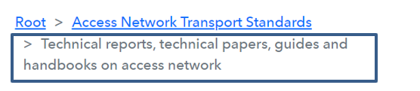

# 9.3 ANT Topics and related Groups (ITU Study Groups and SDOs)

Some of the listed documents in the web-based ANT Standards Overview may not be publicly available. Interested people may contact the responsible standardization group in the list of contacts in Section 4 of the ANT Standards Work Plan.  
 **ANT Topics related to Transmission Medium and Technologies**

|  |  |
| --- | --- |
| **TOPICS** | **GROUPS: ITU Study Groups and SDOs** |
| **Access Network Architecture and Functions** |  |
| > General on Access Network Architecture and Functions | Broadband Forum, ETSI TC ATTM, ITU-T SG13 and SG15 |
| > ETSI 5th Generation Fixed Network (F5G) | ETSI ISG F5G, ITU-T SG15 |
| > Fixed Access Network Sharing | Broadband Forum |
| > FTTdp and FTTep | Broadband Forum |
| > Hybrid Access Networks | Broadband Forum |
| > Wireline – Wireless Convergence | Broadband Forum, ITU-T SG13 |
| > ITU-T and ITU-R technical papers, reports, guides and handbooks | ITU-R SG5, ITU-T SG5, SG13 and SG15 |
| > ITU-D reports and guides | ITU-D SG1 |
| **Fibre Optic Broadband Access** |  |
| > General on optical system design | ITU-T SG15 |
| > Point-to-Point (PtP) |  |
| >>> 34 Mbit/s PtP | ITU-T SG15 |
| >>> 100 Mbit/s PtP Ethernet | IEEE 802.3, ITU-T SG15 |
| >>> 1 Gbit/s PtP Ethernet | IEEE 802.3, ITU-T SG15 |
| >>> Higher Speed PtP Ethernet (10 Gbit/s, 25 Gbit/s, 50 Gbit/s and 100 Gbit/s) | IEEE 802.3, ITU-T SG15 |
| >>> YANG models for PtP systems | Broadband Forum, IEEE 802.3, IETF |
| > Passive Optical Network (PON) |  |
| >>> Early PON Protocols: OAN and B-PON | ETSI TC ATTM, ITU-T SG15 |
| >>> Gigabit PON: G-PON and 1G-EPON | IEEE 802.3, ITU-T SG15 |
| >>> 10-Gigabit PON: XG-PON, XGS-PON and 10G-EPON | IEEE 802.3, ITU-T SG15 |
| >>> 40-Gigabit PON: NG-PON2 | Broadband Forum, ITU-T SG15 |
| >>> 25G and 50G-EPON | IEEE 802.3 |
| >>> Higher Speed PON: 50G-PON | ITU-T SG15 |
| >>> Multiple-wavelength PON (MW-PON) | ITU-T SG15 |
| >>> Super-PON | IEEE 802.3 |
| >>> Very high speed PON (beyond 50Gb/s) | ITU-T SG15 |
| >>> Coexistence of PON systems | ITU-T SG15 |
| >>> Mobile backhaul/midhaul/fronthaul over PON | Broadband Forum, ITU-T SG15 |
| >>>PON Abstraction Interface, Slicing, Latency control, OLT with IT functions | Broadband Forum, ITU-T SG15 |
| >>> Protection and system power saving considerations | ITU-T SG15 |
| >>> ONU Management and Control Interfaces (OMCI) and other ONU considerations | Broadband Forum, ITU-T SG15 |
| >>> PON Optical-link Management, Operation and Security | Broadband Forum, ITU-T SG15 |
| >>> YANG models for PON systems | Broadband Forum, IEEE 802.3, IETF, ETSI IGS F5G |
| >>> Conformance and Interoperability for PON systems | Broadband Forum, IEEE 1904, ITU-T SG15 |
| > Hybrid Fibre Access Technologies |  |
| >>> RFoG (Radio Frequency over Glass Fiber-to-the-Home) | SCTE |
| >>> Radio over Fibre (RoF) | ITU-R SG5, ITU-T SG15 |
| >>> RF-Video Overlay | ITU-T SG9 |
| >>> Wireless/Mobile xHaul | Broadband Forum, ITU-T SG15 |
| **Metallic Conductor Broadband Access** |  |
| > Integrated services digital network (ISDN) | ATIS, ITU-T SG13 and SG15 |
| > Digital Subscriber Lines (DSL) Technologies |  |
| >>> Overview DSL systems | ITU-T SG15 |
| >>> HDSL (High bit rate DSL) | ATIS, ETSI TC ATTM, ITU-T SG15 |
| >>> SHDSL (Single-pair high-speed DSL) | ATIS, ETSI TC ATTM, ITU-T SG15 |
| >>> ADSL (Asymmetric DSL) | ATIS, Broadband Forum, ETSI TC ATTM,  ITU-T SG15 |
| >>> ADSL2 (Asymmetric DSL2) and ADSL2plus | Broadband Forum, ETSI TC ATTM,  ITU-T SG15 |
| >>> VDSL (Very-high speed DSL) | ATIS, ETSI TC ATTM, ITU-T SG15 |
| >>> VDSL2 (Very-high speed DSL2) | ETSI TC ATTM, ITU-T SG15 |
| >>> VDSL2 Vectoring (Very-high speed DSL2 Vectoring) | Broadband Forum, ITU-T SG15 |
| >>> G.fast (fast access to subscriber terminals) | ITU-T SG15 |
| >>> MGfast (Multi-gigabit fast access to the subscriber terminals) | ITU-T SG15 |
| > DSL techniques |  |
| >>> Spectrum management | ATIS |
| >>> Handshake | ITU-T SG15 |
| >>> Physical layer management for transceivers | ITU-T SG15 |
| >>> Link layer / Physical layer interface | ITU-T SG15 |
| >>> Multi-pair bonding | ATIS, Broadband Forum, ITU-T SG15 |
| >>> Impulse noise protection | ITU-T SG15 |
| >>> Reverse Powering | Broadband Forum, ETSI TC ATTM |
| >>> Test procedures for DSL systems | Broadband Forum, ITU-T SG15 |
| >>> YANG models for DSL systems | Broadband Forum, IETF |
| >>> Conformance and Interoperability for DSL systems | Broadband Forum, ITU-T SG15 |
| > Ethernet over copper (EoC) | IEEE 802.3 |
| > G.hn Access | Broadband Forum, HomeGrid Forum,  ITU-T SG15 |
| **Hybrid Fibre Coax (HFC) Broadband Access** |  |
| > General on Cable Networks | ETSI JTC Broadcast, ETSI TC ATTM, SCTE, ITU-T SG9 |
| > DOCSIS (Data Over Cable Service Interface Specification) |  |
| >>> DOCSIS 1.0 and 1.1 | CableLabs, SCTE, ETSI TC ATTM, ITU-T SG9 |
| >>> DOCSIS 2.0 | CableLabs, SCTE, ETSI TC ATTM, ITU-T SG9 |
| >>> DOCSIS 3.0 | CableLabs, SCTE, ETSI TC ATTM and TC Cable, ITU-T SG9 |
| >>> DOCSIS 3.1 | CableLabs, SCTE, ETSI TC Cable, ITU-T SG9 |
| >>> DOCSIS 4.0 | CableLabs, SCTE, ETSI TC Cable, ITU-T SG9 |
| >>> DOCSIS Provisioning of EPON (DPoE) | ETSI TC ATTM |
| >>> Cable Modem | ETSI TC Cable, ITU-T SG9 |
| > High Performance Networks over Coax (HiNoC) | ITU-T SG9 |
| > Multimedia over Coax Alliance (MoCA) access networking | MoCA |
| > Ethernet Passive Optical Networks Protocol  over Coax (EPoC) | IEEE 802.3 |
| > Radio Frequency over Glass Fibre-to-the-Home (RFoG) | SCTE |
| > Radio over IP transmission (RoIP) | ITU-T SG9 |
| > Test Procedures for Cable Networks | CableLabs, SCTE |
| **Broadband Power Line Communications (PLC)** | IEEE COM/PLC, ISO/IEC JTC1/SC6, TIA |
| **Fixed Broadband Wireless Access** |  |
| > Basic requirements and general characteristics of FWA | ETSI TC BRAN, ITU-R SG1 and SG5,  ITU-T SG5, SG9 and SG13 |
| > ETSI HIPERACCESS and HIPERMAN | ETSI TC BRAN |
| > IEEE 802.16 Wireless MAN / WiMAX | IEEE 802.16 |
| > IEEE 802.11 Wireless LAN / Wi-Fi Hotspot | IEEE 802.11 |
| > Fixed Broadband Wireless Access delivered from mobile networks | 3GPP, ITU-R SG5,  ITU-T SG5, SG9 and SG13 |
| > Broadband High-Altitude Platform Systems (HAPS) | ETSI TC SES, ITU-R SG5 |
| > Broadband Satellite Systems | 3GPP, ETSI TC SES, ITU-R SG4 and SG5, ITU-T SG5 |
| > Technical reports, technical papers, guides  and handbooks on fixed wireless access | ITU-D SG1, ITU-R SG5, ITU-T SG13, |

**ANT Topics related to Components of the Physical Infrastructure incl. Operation and Maintenance**

|  |  |
| --- | --- |
| **TOPICS** | **GROUPS: ITU Study Groups and SDOs** |
| **Broadband Access Network Infrastructure** |  |
| > Guide on Standards and Recommendations | ETSI TC ATTM, ITU-T SG9 and SG15 |
| > Network infrastructure engineering |  |
| >>> General on transmission characteristics | ITU-T SG15 |
| >>> General aspects and network design | CENELEC TC 86A, ETSI TC ATTM,  ITU-T SG5 and SG15 |
| >>> General on racks and cabinets | ETSI TC EE, ETSI TC ATTM |
| >>> Building and home cabling | CENELEC TC 215, ETSI TC ATTM, ISO/IEC JTC1/SC25, ITU-T SG5 |
| > Fibre optic infrastructure |  |
| >>> Optical fibre and cable characteristics | IEC TC 86 SC 86A, ITU-T SG15 |
| >>> Cable structure and characteristics | IEC TC 46 SC 46C, IEC TC 86 SC 86A, ITU-T SG15 |
| >>> Cable evaluation | ITU-T SG15 |
| >>> Guidance and installation technique | ETSI TC ATTM, IEC TC 78 and TC 86 SC 86A, ITU-T SG5 and SG15 |
| >>> Infrastructure including node elements - except cables | IEC TC 86 SC 86B, ITU-T SG15 |
| >>> Passive optical devices | ETSI TC ATTM, IEC TC 86 SC 86B, ITU-T SG15 |
| >>> Marinized terrestrial cables | ITU-T SG15 |
| >>> Optical fibre splicing | ETSI TC ATTM, IEC TC 86 SC 86A and SC 86B, ITU-T SG15 |
| > Copper cables infrastructure |  |
| >>> Symmetric pairs cables characteristics | IEC TC 46 SC 46C, ITU-T SG5 and SG15 |
| >>> Coaxial cables characteristics | IEC TC 46 SC 46A and SC 46C, SCTE,  ITU-T SG15 |
| >>> Copper cable components | ITU-T SG5 |
| > Power supply and energy management |  |
| >>> Power supply to ICT equipment | ATIS, ETSI TC EE, ITU-T SG5 and SG15 |
| >>> Powering of access network equipment | ATIS, Broadband Forum, ETSI TC EE,  ETSI TC ATTM, ITU-T SG15 |
| >>> Green and smart energy solutions | ITU-T SG5 |
| >>> Energy storage technology | ETSI TC EE, ITU-T SG5 |
| >>> Energy management | CableLabs, ETSI TC ATTM and TC Cable |
| >>> Energy efficiency and key performance indicators | ETSI TC ATTM, ITU-T SG5 |
| > Safety and equipment protection | IEC TC 76 and TC 78, ITU-T SG5 and SG15 |
| > Operation and maintenance (OAM) |  |
| >>> Systems management and control | Broadband Forum, ETSI TC ATTM and IGS F5G, IEEE 1904, ITU-T SG9, SG15 and SG16 |
| >>> YANG data models | Broadband Forum, IEEE 802.3, IETF, ETSI IGS F5G |
| >>> Optical fibre cable maintenance | CENELEC TC 86A and TC 86BXA,  ETSI TC ATTM, IEC TC 86 SC 86B and SC 86C, ISO/IEC JTC1/SC25, ITU-T SG15 |
| >>> Copper cable maintenance and DSL testing | Broadband Forum, ETSI TC ATTM,  ITU-T SG5 and SG15 |
| >>> HFC networks maintenance | CableLabs, SCTE, ITU-T SG9 |
| >>> Infrastructure maintenance | CENELEC TC 86A, ITU-T SG15 |
| >>> Operation support and infrastructure management | Broadband Forum, ETSI TC ATTM, ITU-T SG15 |
| >>> Disaster management | ATIS, SCTE, ITU-T SG15 |
| >>> Conformance and Interoperability testing for PON systems | Broadband Forum, IEEE 1904, ITU-T SG15 |
| >>> Conformance and Interoperability testing for DSL systems | Broadband Forum, ITU-T SG15 |
| **Technical reports, technical papers, guides and handbooks on access network** | ETSI TC ATTM, ITU-D SG1, ITU-R SG5,  ITU-T SG5, SG13 and SG15 |

# 

**10. Ongoing standardization activities in the area of Access Network Transport**

**10.1 Ongoing standardization activities in the area of Access Network Transport within ITU-T SG15**Question 2/15 and Question 4/15 of ITU-T SG15 – WP1/15 are responsible for Access Network Transport standardization activities.  
Q2/15 addresses “Optical systems for fibre access networks” and Q4/15 the “Broadband access over metallic conductors”.The table below of Q2/15 and Q4/15 current work items has been updated with the latest Q2/15 and Q4/15 activities resulting from ITU-T SG15 - WP1 July 2024 plenary meeting

| **Work item** | **Question** | **Status** | **Timing** | **Approval process** | **Subject / Title** | **References(s)** | **Editor(s)** |
| --- | --- | --- | --- | --- | --- | --- | --- |
| [G.988 (2022) Amd.2](http://www.itu.int/itu-t/workprog/wp_item.aspx?isn=19237) | Q2/15 | Under study | 2025-03 | AAP | ONU management and control interface (OMCI) specification - Amendment 1 |  | [Marta Seda (Calix)](mailto:marta.seda(AT)calix.com), [Yuanqiu Luo (Futurewei Technologies)](mailto:yuanqiu.luo(AT)futurewei.com) |
| G.987.3 revised | Q2/15 | Under study | 2025-03 | AAP | 10-Gigabit-capable passive optical networks (XG-PON): Transmission convergence (TC) layer specification |  | Denis Khotimsky (Verizon), Yuanqiu Luo (Futurewei) |
| G.989.3 Amd.2 | Q2/15 | Under study | 2025-03 | AAP | 40-Gigabit-capable passive optical networks (NG-PON2): Transmission convergence layer specification |  | Dezhi Zhang (China Telecom), Denis Khotimsky (Verizon) |
| [G.9802](http://www.itu.int/itu-t/workprog/wp_item.aspx?isn=18254) Amd.2 | Q2/15 | Consented 2024-07-12 | 2024-07 | AAP | Multiple-wavelength passive optical networks (MW-PONs) |  | [Dechao Zhang (China Mobile)](mailto:zhangdechao(AT)chinamobile.com), [Yuanqiu Luo (Futurewei Technologies)](mailto:yuanqiu.luo(AT)futurewei.com) |
| [G.9802.2 (2022) Amd.1](http://www.itu.int/itu-t/workprog/wp_item.aspx?isn=18853) | Q2/15 | Under study | 2025-03 | AAP | Wavelength Division Multiplexed Passive Optical Network: Physical media dependent (PMD) and Transmission Convergence (TC) Amd.1 |  | Qizheng Li (China Telecom), [Derek Nesset (Huawei Technologies)](mailto:derek.nesset(AT)huawei.com) |
| G.9804.1 Amd.3 | Q2/15 | Under study | 2024-10 | AAP | Higher Speed Passive Optical Networks: Requirements - Amendment 3 | No base text | [Luyao Huang (China Telecom)](mailto:zhangdzh(AT)chinatelecom.cn), |
| [G.9804.2 (2021) Amd.2](http://www.itu.int/itu-t/workprog/wp_item.aspx?isn=18854) | Q2/15 | Consented 2024-07-12 | 2024-07 | AAP | Higher Speed Passive Optical Networks: Common Transmission Convergence layer Specification - Amendment 2 |  | [Dan Geng (Nokia Shanghai Bell Co. Ltd.)](mailto:dan.geng(AT)nokia-sbell.com), [Yuanqiu Luo (Futurewei Technologies)](mailto:yuanqiu.luo(AT)futurewei.com) |
| G.9804.2 (2021) Amd.3 | Q2/15 | Under study | 2025-10 | AAP | Higher Speed Passive Optical Networks: Common Transmission Convergence layer Specification - Amendment 3 | No base text | [Dan Geng (Nokia Shanghai Bell Co. Ltd.)](mailto:dan.geng(AT)nokia-sbell.com), [Yuanqiu Luo (Futurewei Technologies)](mailto:yuanqiu.luo(AT)futurewei.com) |
| G.9804.3 (2021) Amd. 3 | Q2/15 | Under study | 2025-03 | AAP | Higher Speed Passive Optical Networks: 50G physical media dependent (PMD) layer Specification - Amendment 3 | No base text | Rene Bonk (Nokia), Dekun Liu (Huawei) |
| [G.9805 Amd.2](http://www.itu.int/itu-t/workprog/wp_item.aspx?isn=19239) | Q2/15 | Under study | 2025-03 | AAP | Coexistence of Passive Optical Network Systems Amendment 2 | No base text | [Dezhi (James) Zhang (China Telecom)](mailto:zhangdzh(AT)chinatelecom.cn), [Dekun Liu (Huawei Technologies)](mailto:liudekun(AT)huawei.com) |
| G.9806 Corr.2 | Q2/15 | Consented 2024-07-12 | 2024-07 | AAP | Higher-speed bidirectional, single fibre, point-to-point optical access system (HS-PtP) – Corrigendum 2 |  | Shan Wey (Verizon) |
| G.9807.1 (2023) Amd.1 | Q2/15 | Under study | 2025-03 | AAP | 10-Gigabit-capable symmetric passive optical network (XGS-PON) |  | Denis Khotimsky (Verizon), Yuanqiu Luo (Futurewei) |
| [G.hsp.TWDMpmd](http://www.itu.int/itu-t/workprog/wp_item.aspx?isn=18206) | Q2/15 | Under study | 2025-10 | AAP | Higher Speed Passive Optical Networks: TWDM PMD |  | [Richard Goodson (ADTRAN)](mailto:richard.goodson(AT)adtran.com), [Christopher Bernard (Calix Networks, Inc.)](mailto:chris.bernard(AT)calix.com) |
| [G.sup.eOLT](http://www.itu.int/itu-t/workprog/wp_item.aspx?isn=18282) | Q2/15 | Agreed 2024-07-12 | 2024-07 | Agreement | Enhanced optical line termination with IT functions |  | [Wu Jia (China Unicom)](mailto:jiawu9(AT)chinaunicom.cn), [Yi Jiang (ZTE)](mailto:jiang.yi7(AT)zte.com.cn), [Haomian Zheng (Huawei)](mailto:zhenghaomian(AT)huawei.com) |
| [G.sup.OANops](http://www.itu.int/itu-t/workprog/wp_item.aspx?isn=18862) | Q2/15 | Under study | 2025-03 | Agreement | Operational aspects of optical access |  | [Denis A. Khotimsky (Verizon)](mailto:dkhprim(AT)gmail.com) |
| [G.sup.PONsec](http://www.itu.int/itu-t/workprog/wp_item.aspx?isn=18863) | Q2/15 | Agreed 2024-07-12 | 2024-07 | Agreement | Practical aspects of PON security |  | [Dezhi (James) Zhang (China Telecom)](mailto:zhangdzh(AT)chinatelecom.cn), [Denis A. Khotimsky (Verizon)](mailto:dkhprim(AT)gmail.com), [Dekun Liu (Huawei Technologies)](mailto:liudekun(AT)huawei.com) |
| [G.sup.PONsec](http://www.itu.int/itu-t/workprog/wp_item.aspx?isn=18863) Rev1 | Q2/15 | Under study | 2025-10 | Agreement | Practical aspects of PON security Revision 1 |  | [Dezhi (James) Zhang (China Telecom)](mailto:zhangdzh(AT)chinatelecom.cn), [Denis A. Khotimsky (Verizon)](mailto:dkhprim(AT)gmail.com), [Dekun Liu (Huawei Technologies)](mailto:liudekun(AT)huawei.com) |
| [G.suppl.FTTGrid](http://www.itu.int/itu-t/workprog/wp_item.aspx?isn=19240) | Q2/15 | Under study | 2025-03 | Agreement | Fibre to the grid use cases and network requirements | No base text | [Yuanqiu Luo (Futurewei Technologies)](mailto:yuanqiu.luo(AT)futurewei.com), Kaiqiang Gao (State Grid Corporation) |
| [G.suppl.VHSP](http://www.itu.int/itu-t/workprog/wp_item.aspx?isn=18554) | Q2/15 | Under study | 2025-10 | Agreement | PON transmission technologies above 50 Gb/s per wavelength |  | [Bhushan Padhiar (AT&T)](mailto:bp6470(AT)att.com), [Jun Shan Wey (Verizon)](mailto:jun.shan.wey(AT)verizon.com), [Dezhi (James) Zhang (China Telecom)](mailto:zhangdzh(AT)chinatelecom.cn) |
| TP-BAIN | Q2/15 | Under study | 2025-03 | Agreement | Broadband access & in-premises networks | No base text | Dekun Liu (Huawei), Frank Effenberger (Futurewei), Tony Zeng (Huawei), Frank van der Putten (Nokia) |
| G.suppl.55 | Q2/15 | Under study | 2025-10 | Agreement | Radio-over-fiber (RoF) technologies and their applications, Revision 3 | No base text | Toshiaki Kuri (NICT) |
| G.suppl.fgP2MP | Q2/15 | Under study | 2025-03 | Agreement | fgODU over Point-to-multipoint network | No base text | Luyao Guan (State Grid Corporation), Frank Effenberger (Futurewei) |

**Work item**: Short name identifying a (draft or approved) Recommendation or other text. It may be a provisional name or the final publication designation (e.g. H.264)  
**Question**: Number of the Question responsible for the development of a work item  
**Status**: Current Approval state of a work item  
**Timing**: Best current estimate of the expected year and month of Determination (TAP), Consent (AAP), or Agreement (non-normative materials) of a work item  
**Approval process**: One of: Traditional Approval Process (TAP); Alternative Approval Process (AAP); or Agreement  
**Subject / Title**: Best current expectation of the full name of a work item  
**Base text(s)**: Previous published version of a work item and/or its latest draft. It may also include reference to A.5 justification documentation.  
**Editor(s)**: Person(s) responsible for coordinating development of a work item

Question 5/15 and Question 7/15 of ITU-T SG15 – WP2/15 are responsible for the standardization of components for the optical physical infrastructures (e.g., fibre and cable, optical node).  
Q5/15 addresses “Characteristics and test methods of optical fibres and cables, and installation guidance” and Q7/15 the “Connectivity, operation and maintenance of optical physical infrastructures”.

The table below of Q5/15 and Q7/15 current work items related to the optical physical infrastructures (e.g., fibre and cable, optical node) has been updated with the latest Q5/15 and Q7/15 activities resulting from ITU-T SG15 - WP2 July 2024 plenary meeting.

|  |  |  |  |  |  |  |  |  |  |
| --- | --- | --- | --- | --- | --- | --- | --- | --- | --- |
| **Work item** | **Question** | **Timing** | **Approval process** | **Version** | **Liaison relationship** | **Subject / Title** | **Priority** | **Reference(s)** | **Editor(s)** |
| [TR-OFCS](http://www.itu.int/itu-t/workprog/wp_item.aspx?isn=18852) | WP2/15 | 2024 | Agreement | Rev. | - | Optical fibres, cables and systems | Medium | SG15-TD374-R1/PLEN | [Sudipta Bhaumik (Sterlite Technologies Limited (STL))](mailto:sudipta.bhaumik(AT)stl.tech) |
| [G.65](http://www.itu.int/itu-t/workprog/wp_item.aspx?isn=18293)2 | Q5/15 | 2024 | AAP | Rev. | Q6/15, Q8/15, IEC SC86A, IEEE | Characteristics of a single-mode optical fibre and cable | High | [SG15-TD375-R2/PLEN (2024-7)](https://www.itu.int/md/T22-SG15-240701-TD-PLEN-0375/en) | [Kazuhide Nakajima (NTT)](mailto:kazuhide.nakajima@ntt.com) |
| [G.654](http://www.itu.int/itu-t/workprog/wp_item.aspx?isn=18293) | Q5/15 | 2024 | AAP | Rev. | Q6/15, Q8/15, IEC SC86A | Characteristics of a cut-off shifted single-mode optical fibre and cable | High | [SG15-TD395-R1/PLEN (2024-7)](https://www.itu.int/md/T22-SG15-240701-TD-PLEN-0395/en) | [Yoshinori Yamamoto (CLPAJ)](mailto:yamamoto-yoshinori(AT)sei.co.jp) |
| [G.657](http://www.itu.int/itu-t/workprog/wp_item.aspx?isn=18841) | Q5/15 | 2024 | AAP | Rev. | Q2/15, Q6/15, IEC SC86A | Characteristics of a bending-loss insensitive single-mode optical fibre and cable | High | SG15-TD356-R1/PLEN (2024-7) | [Vincent Ferretti (Corning)](mailto:vincent.ferretti(AT)corning.com) |
| [G.Sup.40](http://www.itu.int/itu-t/workprog/wp_item.aspx?isn=18843) | Q5/15 | 2024 | Agreement | Rev. | Q6/15, Q8/15, IEC SC86A | Optical fibre and cable Recommendations and standards guideline | High | SG15-TD368-R1/PLEN (2024-7) | [Yuto Sagae (NTT)](mailto:yuuto.sagae.nm(AT)hco.ntt.co.jp) |
| [G.Sup.G.65x](http://www.itu.int/itu-t/workprog/wp_item.aspx?isn=18843) | Q5/15 | 2025-3 | Agreement | New | Q6/15, Q7/15, Q8/15, IEC SC86A | Roadmap for SDM optical fibres concerning the development of G.65x series Recommendations | High | [SG15-TD170/WP2 (2024-7)](https://www.itu.int/md/T22-SG15-240701-TD-WP2-0170/en) | [Takashi Matsui (NTT)](mailto:takashi.matsui@ntt.com) |
| [G.Sup.](http://www.itu.int/itu-t/workprog/wp_item.aspx?isn=18843)47 | Q5/15 | 2025-3 | Agreement | Rev. | Q6/15, Q7/15, Q8/15, IEC SC86A | General aspects of optical fibres and cables | High | [SG15-TD172/WP2 (2024-7)](https://www.itu.int/md/T22-SG15-240701-TD-WP2-0170/en) | [Takashi Matsui (NTT)](mailto:takashi.matsui@ntt.com) |
| L.101 | Q5/15 | 2024 | AAP | Rev. | IEC SC86A | Optical fibre cables for buried application | High | [SG15-TD351-R1/PLEN (2024-7)](https://www.itu.int/md/T22-SG15-240701-TD-PLEN-0351/en) | [Kazuhide Nakajima (NTT)](mailto:kazuhide.nakajima@ntt.com) |
| L.102 | Q5/15 | 2025-10 | AAP | Rev. | IEC SC86A | Optical fibre cables for aerial application | Medium | [SG15-TD352-R1/PLEN (2024-7)](https://www.itu.int/md/T22-SG15-240701-TD-PLEN-0352/en) | [Kazuhide Nakajima (NTT)](mailto:kazuhide.nakajima@ntt.com) |
| L.103 | Q5/15 | 2024 | AAP | Rev. | IEC SC86A | Optical fibre cables for indoor applications | High | [SG15-TD353-R1/PLEN (2024-7)](https://www.itu.int/md/T22-SG15-240701-TD-PLEN-0353/en) | [Kazuhide Nakajima (NTT)](mailto:kazuhide.nakajima@ntt.com) |
| L.104 | Q5/15 | 2025-3 | AAP | Rev. | IEC SC86A | Small count optical fibre cables for indoor applications | High | [SG15-C924-R2 (2024-7)](https://www.itu.int/md/T22-SG15-C-0924/en) | [Dave Kozischek (Corning)](mailto:kozischedr@corning.com) |
| L.105 | Q5/15 | 2025-3 | AAP | Rev. | IEC SC86A | Optical fibre cables for drop applications | High | [SG15-C923-R2 (2024-7)](https://www.itu.int/md/T22-SG15-C-0923/en) | [Dave Kozischek (Corning)](mailto:kozischedr@corning.com) |
| L.110 | Q5/15 | 2025-10 | AAP | Rev. | IEC SC86A | Optical fibre cables for direct surface application | Medium | [SG15-C1012-R1 (2024-7)](https://www.itu.int/md/T22-SG15-C-1012/en) | [Takahiro Miura (CLPAJ)](mailto:takahiro.miura@furukawaelectric.com) |
| L.111 | Q5/15 | 2026 | AAP | Rev. | IEC SC86A | Optical fibre cables for in-home applications | Low | [SG15-C1043 (2024-7)](https://www.itu.int/md/T22-SG15-C-1012/en) | [Xiangkun Man (China Unicom)](mailto:manxk1@chinaunicom.cn) |

|  |  |  |  |  |  |  |  |  |  |
| --- | --- | --- | --- | --- | --- | --- | --- | --- | --- |
| [L.341/L.88](http://www.itu.int/itu-t/workprog/wp_item.aspx?isn=18847) | Q7/15 | 2025-3 | AAP | Rev. | - | Maintenance of telecommunication poles and overhead facilities | High | [SG15-TD~~120~~192R1/WP2 (202~~3~~4-~~11~~7)](https://www.itu.int/dms_inf/itu-t/md/22/sg15/td/240701/WP2/T22-SG15-240701-TD-WP2-0192!R1!MSW-E.docx) | [Chihiro Kito (NTT)](mailto:chihiro.kito(AT)ntt.com) |
| [L.360/L.80](http://www.itu.int/itu-t/workprog/wp_item.aspx?isn=18848) | Q7/15 | 2025-3 | AAP | Rev. | - | Operations support system requirements for network infrastructure management using ID technology | High  ~~Medium~~ | [SG15-TD~~111~~175R1/WP2 (202~~3~~4-~~11~~7)](https://www.itu.int/dms_inf/itu-t/md/22/sg15/td/240701/WP2/T22-SG15-240701-TD-WP2-0175!R1!MSW-E.docx) | [Chao Han (CAICT, MIIT)](mailto:hanchao(AT)caict.ac.cn) |
| [L.pcc](http://www.itu.int/itu-t/workprog/wp_item.aspx?isn=18849) | Q7/15 | 2025-10 | AAP | New | IEC SC86A, IEC SC86B | Pre-connectorised cabling components for FTTx infrastructures | Medium | [SG15-TD~~113~~184R1/WP2 (202~~3~~4-~~11~~7)](https://www.itu.int/dms_inf/itu-t/md/22/sg15/td/240701/WP2/T22-SG15-240701-TD-WP2-0184!R1!MSW-E.docx) | [David Kozischek (Corning)](mailto:kozischedr(AT)corning.com) |
|  |
| [LSTP-GLSR](https://www.itu.int/pub/T-TUT-L-2022-GLR)  ✓ | Q7/15 | 2024-07 | Agreement | Rev. | Q5/15, Q8/15 | Guide on the use of ITU-T L-series Recommendations related to optical technologies for outside plant | High | [SG15-TD~~118~~396R1/~~WP2~~PLEN (202~~3~~4-~~11~~7)](https://www.itu.int/dms_inf/itu-t/md/22/sg15/td/240701/PLEN/T22-SG15-240701-TD-PLEN-0396!R1!MSW-E.docx)) | [Tsukasa Hosokawa (CLPAJ)](mailto:Htsukasa.hosokawa@jp.fujikura.com) |
| L.391/L.81 | Q7/15 | 2026 | AAP | Rev. | - | Monitoring systems for outside plant facilities | Medium | In-force L.391/L.81  C1217R1 07/2024 | [Ma Junwei (State Grid Corporation of China)](mailto:junweima@foxmail.com) |
| L.nis | Q7/15 | 2027 | AAP | New | ITU-D SG1  ITU-T SG3 | Practical considerations for network infrastructures sharing | Medium | [SG15-TD176/WP2 (2024-7)](https://www.itu.int/dms_inf/itu-t/md/22/sg15/td/240701/WP2/T22-SG15-240701-TD-WP2-0176!!MSW-E.doc)  [SG15-TD156/WP2](https://www.itu.int/dms_inf/itu-t/md/22/sg15/td/240701/WP2/T22-SG15-240701-TD-WP2-0156!!MSW-E.doc)  [(2024-7)](https://www.itu.int/dms_inf/itu-t/md/22/sg15/td/240701/WP2/T22-SG15-240701-TD-WP2-0156!!MSW-E.doc) | [Chao Han (CAICT, MIIT)](mailto:hanchao(AT)caict.ac.cn) |

Work Programme of ITU-T SG15 can be found at <https://www.itu.int/ITU-T/workprog/wp_search.aspx?sg=15>

More information about ITU-T SG15 can be found at <https://www.itu.int/en/ITU-T/studygroups/2022-2024/15/Pages/default.aspx>

**10.2 Ongoing standardization activities in the area of Access Network Transport in other groups within ITU and other Standards Development Organizations**

The following list provides information on the Work Plans and ongoing ANT activities of various standardization groups outside ITU-T SG15. This list is intended to improve understanding of the ongoing work in the different standardization groups and may help identify possible gaps or overlaps.

|  |  |  |  |
| --- | --- | --- | --- |
| Item No. | Source | Subject / Title | Comment |
|  | **ITU-T SG9**  *SG15 TD 261 WP1 July 2024*  *SG15 TD 270 GEN July 2024* | **ITU-T SG9: Audio-visual content transmission and integrated broadband cable networks**  During the ITU-T SG9 meeting held from 9 to 17 May 2024, SG9 identified that one of their deliverables is missing in “Access Network Transport (ANT) Standards Overview and Work Plan”. SG9 provide SG15 the following document for potential inclusion in the ANT document,  - J Suppl.12 (11/2023) “Comparison between third-generation HiNoC and second-generation HiNoC system”  ITU-T SG9 inform SG15 that during ITU-T SG9 meeting, 14-23 November 2023, Bogotá, Colombia, they started the approval process (AAP consent) for the work items ITU-T J.198.2 (ex J.HiNoC3-PHY) “Physical layer specification for third-generation HiNoC” and ITU-T J.198.3 (ex J.HiNoC3-MAC) “MAC layer specification for third-generation HiNoC”. SG9 also inform that they agreed to publish the new Supplement ITU-T J.Suppl.12 (ex J.Sup-HiNoC) “Comparison between third-generation HiNoC and second-generation HiNoC”.  Work Programme of ITU-T SG9 can be found at following URL <https://www.itu.int/ITU-T/workprog/wp_search.aspx?sg=9> | More information about ITU-T SG9 can be found at following URL <https://www.itu.int/en/ITU-T/studygroups/2022-2024/09/Pages/default.aspx> |
|  | **ITU-T SG11**  *SG15 TD 223 WP1 July 2024* | **ITU-T SG11: Signalling requirements, protocols, test specifications and combating counterfeit telecommunication/ICT devices**  ITU-T SG11 confirms that following consideration of SG15 inputs, according to the SG11 C&I Action plan, which was updated in May 2023 (see [SG11-TD507/GEN](https://www.itu.int/md/T22-SG11-230510-TD-GEN-0507/en)), TSB was encouraged to proceed and update the reference table accordingly. The latest version of the reference table will be made available at: <https://itu.int/go/reference-table>.  ITU-T SG11 reminds that in order to avoid any further delays on updating the reference table, according to the SG11 C&I action plan, SGs are encouraged to provide their inputs related to the reference table directly to TSB secretariat via [conformity@itu.int](mailto:conformity@itu.int).  Work Programme of ITU-T SG11 can be found at following URL <https://www.itu.int/ITU-T/workprog/wp_search.aspx?sg=11> | More information about ITU-T SG11 can be found at following URL <https://www.itu.int/en/ITU-T/studygroups/2022-2024/11/Pages/default.aspx> |
|  | **ITU-T SG16** | **ITU-T SG16: Multimedia and related digital technologies​**  Work Programme of ITU-T SG16 can be found at following URL <https://www.itu.int/ITU-T/workprog/wp_search.aspx?sg=16> | More information about ITU-T SG16 can be found at following URL <https://www.itu.int/en/ITU-T/studygroups/2022-2024/16/Pages/default.aspx> |
|  | **ITU-R SG1** | **ITU-R SG1: Spectrum Management** ITU-R WP1A: Spectrum engineering techniques | More information about ITU-R SG1 can be found at following URL <https://www.itu.int/en/ITU-R/study-groups/rsg1/Pages/default.aspx>  More information about ITU-R WP1A can be found at following URL <https://www.itu.int/en/ITU-R/study-groups/rsg1/rwp1a/Pages/default.aspx> |
|  | **ITU-R SG5** | **ITU-R SG5: Terrestrial Services**  WP5A: Land mobile service above 30 MHz (excluding IMT); wireless access in the fixed service; amateur and amateur-satellite services  - ITU-R WP5A guide document: “Overview of the ITU-R texts relating to the land mobile service, including wireless access in the fixed service” has been updated on 18 January 2024: see at <https://www.itu.int/oth/R0A06000001/en>  ITU-R WP5C - Fixed wireless systems; HF and other systems below 30 MHz in the fixed and land mobile services  ITU-R WP5D – IMT Systems | More information about ITU-R SG5 can be found at following URL  <https://www.itu.int/en/ITU-R/study-groups/rsg5/Pages/default.aspx>  More information about ITU-R WP5A can be found at following URL <https://www.itu.int/en/ITU-R/study-groups/rsg5/rwp5a/Pages/default.aspx>  More information about ITU-R WP5C can be found at following URL <https://www.itu.int/en/ITU-R/study-groups/rsg5/rwp5c/Pages/default.aspx>  More information about ITU-R WP5D can be found at following URL <https://www.itu.int/en/ITU-R/study-groups/rsg5/rwp5d/Pages/default.aspx> |
|  | **ITU-R SG6**  *SG15 TD 228 WP1 July 2024* | **ITU-R SG6: Broadcasting Service**  ITU-R WP6A: Terrestrial broadcasting delivery  ITU-R WP6B: Broadcast service assembly and access  ITU-R WP 6B informs SG15 that it has no comments to make on either ANT or HNT Transport Standards Overviews and Work Plans at present but will continue to review the information.  (Note: The HNT Transport Standards Overview and Work Plan July 2024 document provides information on new Reports from ITU-R WP6 on the future of broadcasting.)   ITU-R WP 6B informs that new studies on “Broadcast Core Network” have begun and may be of interest to SG15. WP 6B will keep ITU-T SG15 informed of developments. | More information about ITU-R SG6 can be found at following URL <https://www.itu.int/en/ITU-R/study-groups/rsg6/Pages/default.aspx>  More information about ITU-R WP6A can be found at following URL <https://www.itu.int/en/ITU-R/study-groups/rsg6/rwp6a/Pages/default.aspx>  More information about ITU-R WP6B can be found at following URL <https://www.itu.int/en/ITU-R/study-groups/rsg6/rwp6b/Pages/default.aspx> |
|  | **ITU-D SG1 and  ITU-D SG2**  *SG15 TD 91 WP1 April 2023* | **ITU Telecommunication Development Sector (ITU-D)** The ITU-D Sector published a new guide: “Guide for procuring last-mile connectivity data networks” in June 2022 (see at [https://www.itu.int/hub/publication/d-tnd-05-2022/](https://www.itu.int/hub/publication/d-tnd-05-2022)).  This guide complements “The Last-mile Internet Connectivity Solutions Guide: Sustainable Connectivity Options for Unconnected Sites” published in January 2020 (see at <https://www.itu.int/pub/D-TND-01-2020>)  **ITU-D SG1: Enabling environment for meaningful connectivity** Question 1/1: Strategies and policies for the deployment of broadband in developing countries Question 5/1: Telecommunications/ICTs for rural and remote areas  ITU-D Q1/1 thanks ITU-T SG15 for the LS on the new versions of the ANT Standards overview and work plan and provides the link [1/REP/1](https://www.itu.int/md/D22-SG01-R-0001/en) to its report of meeting 29 November 2022.  The date of next ITU-D Q1/1 meeting is 8-19 May 2023.  **ITU-D SG2: Digital transformation** Question 1/2 : Sustainable smart cities and communities | More information on the ITU-D Sector can be found at following URL <https://www.itu.int/en/ITU-D/Pages/default.aspx>    More information about ITU-D SG1 and SG2 can be found at following URL <https://www.itu.int/en/ITU-D/Pages/New-ITU-D-Study-Group-Questions.aspx> |
|  | **Broadband Forum**      *SG15 TD 359 GEN July 2024* | **Broadband Forum** <https://www.broadband-forum.org>  Published Broadband Forum Technical Reports related to ANT can be found following URL <https://www.broadband-forum.org/technical-reports>  Broadband Forum Test Plans related to ANT can be found at following URL <https://www.broadband-forum.org/test-plans>  Broadband Forum Work in Progress related to HNT can be found at following URL <https://www.broadband-forum.org/broadband-forum-resources/work-in-progress>  Broadband Forum Liaison Rapporteur for ITU-T SG15  Web-based ANT Overview has been updated according to the list in TD 359 GEN of new documents approved/published (since last SG15 November 2023 meeting) | Broadband Forum Work in Progress related to ANT can be found at following URL <https://www.broadband-forum.org/broadband-forum-resources/work-in-progress> |
|  | **CENELEC TC 86A and  TC 86BXA** *SG15 TD 344 GEN July 2024*  *SG15 TD 345 GEN July 2024* | **CENELEC TC 86A - Optical fibres and optical fibre cables** Business Plan of TC 86A: see <https://standards.cencenelec.eu/BPCLC/BP_TC_86A.pdf>  Liaison report from CENELEC TC 86A from ITU-T SG15 Liaison Rapporteur This liaison report summarises the progress of standardisation development in CENELEC TC 86A from the May 2024 meeting. Following items are relevant to the ANT: - A decision was approved to withdraw EN 50551-1, Simplex and duplex cables for use in terminated cable assemblies Part 1: Blank Detail Specification and minimum requirements.  - A letter was reviewed informing TC 86A that it is recommended to disband the joint working group on cable and connectivity between TC 86A and TC 86BXA since a similar JWG group exists in IEC. This proposal was accepted by TC 86A and is awaiting approval by the BT.  - Due to activity in IEC SC 86A on in-home cabling, this topic will be reviewed at the next meeting for potential new work.  - Future work on fire resistant cable (IEC 60794-7) will be needed to make it compliant with CPR. The rationale for a European deviation will be reviewed at a future meeting.  **CENELEC TC 86BXA - Fibre optic interconnect, passive and connectorized components** Business Plan of TC86BXA: see  <https://standards.cencenelec.eu/BPCLC/BP_TC_86BXA.pdf>  Liaison report from CENELEC TC 86BXA from ITU-T SG15 Liaison Rapporteur This liaison reports summarises the progress of standardisation development in CENELEC TC 86BXA from the June 2024 meeting. Following items are relevant to the ANT:  WG1: Fibre Optic Connectors & Passive Components, Connectors, Components and Mechanical Splices  WG2: Fibre management systems and protective housings  - Organization and structure Based on a decision at the December 2023 plenary meeting, WG1 and WG2 will be combined into a newly formed WG3 for all future meetings. This will simplify administration and better align with the structure of IEC SC86B WG6, where connectivity and fibre management systems are included in a single group.  - Introduction to quantum interconnect An introduction to quantum interconnects and the relevance to standardisation was presented by Dr. Richard Pitwon, Resolute Photonics. In the short-term, the most useful standards would be for low-loss optical interconnects to better allow delicate quantum states, qubits, in the form of entangled photons, to be conveyed over longer distances with a lower chance of decoherence and disruption.  A future roadmap was developed, which highlighted topics including high-performance connectivity, novel optical fibres, high isolation routers, quantum sources and detection, quantum photonic integrated circuits, and cryogenic environments.  - Product Specification Proposal  A proposal to consolidate like-versions of connectors into one product specification document was reviewed by Ms. Sharon Lutz, US Conec. The proposal included referencing relevant standards and keeping redundant information as informative. Other changes for consideration that were proposed included the removal of the reliability section, moving requirements from other standards to an informative annex, and consolidating multimode and single-mode into the same document.  Since the majority of homegrown TC 86BXA documents are product specifications, this subject is of significant importance.  - Maintenance TC 86BXA currently has 57 active documents. All maintenance has been paused as the committee works towards prioritisation of activities.  - New Work Based on the outcome of BTTF 173-1 chaired by Mr. Thomas Sentko, VDE, a new work item proposal for a product specification related to free-breathing closures covering optical distribution points will be initiated in TC 86BXA. | More information about CLC/TC 86A can be found at following URL <https://standards.cencenelec.eu/dyn/www/f?p=305:7:0:25:::FSP_ORG_ID,FSP_LANG_ID:1258369>  More information about CLC/TC 86BXA can be found at following URL  <https://standards.cencenelec.eu/dyn/www/f?p=305:7:0:25:::FSP_ORG_ID,FSP_LANG_ID:1258371> |
|  | **IEC TC 86**  *SG15 TD 329 GEN July 2024 Liaison Rapporteur*  *SG15 TD 358 GEN July 2024 Liaison Rapporteur*  *SG15 TD 363 GEN*  *July 2024*  *Liaison Rapporteur* | **IEC TC 86 - Fibre optics**  **IEC TC 86 SC 86A - Fibres and cables** Liaison report from IEC TC 86 SC 86A from ITU-T SG15 Liaison Rapporteur The liaison report outlines some of the main topics discussed in the IEC SC86A WG1 (Fibres and associated measuring methods) and IEC SC86A WG3 (Cables) interim meetings held in April’2024, in Paris, France. **IEC SC86A WG1 (Fibres and associated measuring methods)** Following documents from IEC SC86A WG1 that are relevant to the ANT are in ballot process (or in preparation for ballot) since the last ITU-T SG15 November 2023 meeting:  - IEC TR 63309 Ed.1: Active fibres - Characteristics and Measurement Methods – Guidance  - Revision of IEC 60793-2-50, Optical fibres – Part 2-50: Product specifications – Sectional specification for class B single-mode fibres  The following document is in preparation by WG1 for revision: - Proposed revisions for IEC TR 62316 Ed4, Guidance for the interpretation of OTDR backscattering traces for single-mode fibres  The following document to be withdrawn: - IEC TS 62033, Attenuation uniformity in optical fibres  Future Plans and Activities that are relevant for the ANT: - New ITU T G Suppl. G.65x “Roadmap for SDM optical fibres concerning the development of G.65x series Recommendations”  IEC SC86A experts showed good interest and appreciate the progress made in development of documents related to SDM technologies and understand the future scope of harmonization with IEC SC86A work particularly for the test methods. IEC SC86A will look forward to a Liaison Statement to get an update on future direction of work on SDM technologies and its potential impact on optical fibres related standards to prioritize the IEC work to timely support the harmonization.  - Distributed Fibre Optic Sensors (DFOS)  It was mentioned that IEC SC86C (Fibre optic systems and active devices) has a whole series of documents related to distributed fibre optic sensing (IEC 61757 series) and requested this was fed back to ITU-T to ensure harmonisation between the documents.  **IEC SC86A WG3 (Cables)** Following documents from IEC TC 86 SC86A WG3 that are relevant to the ANT are in ballot process (or in preparation for ballot) (CD, CDV, or FDIS) since the last ITU-T SG15 November 2023 meeting: - IEC 60794-2-20 ED4: Optical fibre cables - Part 2-20: Indoor cables - Family specification for multi-fibre optical cables  - IEC 60794-3-11 Ed2: Optical fibre cables - Part 3-11: Outdoor cables - Product specification for duct, directly buried, and lashed aerial single-mode optical fibre telecommunication cables  - IEC TR 63431 ED1: Optical fibre cables - Microduct technology – Guidance  The following documents are in preparation by WG3 for revision:  - IEC 60794-4-20 Optical fibre cables - Part 4-20: Sectional specification - Aerial optical cables along electrical power lines - Family specification for ADSS (all dielectric self-supported) optical cables  - IEC 60794-1-1 ED5: Optical fibre cables - Part 1-1: Generic specification – General  New Activities:  - Specification for In-home cable  LS from ITU-T SG15 was presented and it was noted that currently there are no additional performance requirements needed to enforce ITU-T Rec. L.111, however, this Recommendation would be discussed during the next SG15 Plenary meeting. Updated document for in-home cabling, showing the relationship between indoor and in-home cabling was presented. There was much discussion on application spaces (FTTR, FTTH) and installation methods (glued, stapled, in a duct, indoor/outdoor).  There was no consensus to go forward with this proposal and commence work on a document.  **IEC TC 86 SC 86B Fibre optic interconnecting devices and passive components** Liaison report from IEC TC 86 SC 86B from ITU-T SG15 Liaison Rapporteur The liaison report outlines some topics discussed in the SC86B (fibre optic interconnecting devices and passive components) WG meetings in Milan (15 – 20 November 2023) and Chiba (11 – 15 March, 2024).Following documents from IEC SC86B that are relevant to the ANT are in revision or in ballot process (or in preparation for ballot) since the last ITU-T SG15 November 2023 meeting:  - IEC 61753-1:2018+AMD1:2020 CSV: Fibre optic interconnecting devices and passive components - Performance standard - Part 1: General and guidance.  The CC of 2nd CD for IEC 61753-1 was reviewed, and all the comments were resolved. This revision of the document is to be updated for some new products including hardened connectors and modify test conditions for some environmental categories and mechanical tests. The 3rd CD will be circulated.  - IEC 60875-1:2024: Fibre optic interconnecting devices and passive components – Non-wavelength selective fibre optic branching devices – Part 1: Generic specification The RVC of IEC 60875-1 (Non-wavelength-selective fibre optic branching devices – Part 1: Generic specification) was reviewed and all the comments were resolved. The FDIS will be prepared.  - IEC 61300-3-35:2022: Part 3-35: Examinations and measurements - Fibre optic connector endface visual and automated inspection Visual inspection of fibre optic connectors and fibre-stub transceivers: The progress of Round Robin Tests for automatic visual inspection was shared. Some questions raised includes availability of measurement results using artefacts of scratches and further actions for the next steps to be discussed.  **IEC TC 86 SC 86C Fibre optic systems and active devices IEC SC86C WG1 (Fibre optic communications systems and subsystems)** Since last ITU-T SG15 meeting in November 2023, IEC SC86C organised a hybrid meeting in March 21-22, 2024, for WG1. WG3, WG4 and WG2 met virtually the 18, 20, and 21 of April 2024.  The next IEC SC86 Plenary meeting is scheduled for October 28 – November 6, 2024 in Querétaro, Mexico.  3rd Edition of IEC 61280-4-2 (IEC 61280-4-2:2024) has been published | More information about IEC TC 86 can be found at following URL <https://www.iec.ch/dyn/www/f?p=103:7:::::FSP_ORG_ID:1279>  More information about IEC TC 86 SC 86A and work programme can be found at following URL <https://www.iec.ch/dyn/www/f?p=103:7:::::FSP_ORG_ID:1398>  More information about IEC TC 86 SC 86B and work programme can be found at following URL <https://www.iec.ch/dyn/www/f?p=103:7:::::FSP_ORG_ID:1401>  More information about IEC TC 86 SC 86C and work programme can be found at following URL <https://www.iec.ch/dyn/www/f?p=103:7:::::FSP_ORG_ID:1403> |
|  | **ETSI TC ATTM** | **ETSI TC ATTM - Access, Terminals, Transmission and Multiplexing** <https://www.etsi.org/committee/1390-attm>Work Programme of ETSI ATTM can be found at following URL <https://portal.etsi.org/tb.aspx?tbid=689&SubTB=689,693,851,706,694,695#/> | See Terms of Reference (ToR) at <https://portal.etsi.org/TB-SiteMap/ATTM/ATTM-ToR> |
|  | **ETSI TC BRAN** | **ETSI TC BRAN - Broadband Access Radio Networks** <https://www.etsi.org/committee/1389-bran>  Work Programme of ETSI BRAN can be found at following URL <https://portal.etsi.org/tb.aspx?tbid=287&SubTB=287#/> | See Terms of Reference (ToR) at <https://portal.etsi.org/TB-SiteMap/bran/bran-tor> |
|  | **ETSI TC Cable** | **ETSI TC Cable – Integrated Broadband Cable Telecommunications Networks** <https://www.etsi.org/committee/1392-cable>  Work Programme of ETSI Cable can be found at following URL https://portal.etsi.org/tb.aspx?tbid=786&SubTB=786,791,792,793,794#/ | See Terms of Reference (ToR) at <https://portal.etsi.org/TB-SiteMap/CABLE/CABLE-ToR> |
|  | **ETSI TC EE** | **ETSI TC EE – Environmental Engineering** <https://www.etsi.org/committee/1395-ee>  Work Programme of ETSI EE can be found at following URL <https://portal.etsi.org/tb.aspx?tbid=28&SubTB=28,29,30,635,853#/> | See Terms of Reference (ToR) at <https://portal.etsi.org/TB-SiteMap/ee/ee-tor> |
|  | **ETSI ISG F5G**  *SG15 TD 343 GEN July 2024* | **ETSI ISG - Fifth Generation Fixed Network (F5G)** <https://www.etsi.org/committee/1696-f5g>  Liaison report from ETSI ISG F5G Liaison Rapporteur of ITU-T SG15 and ETSI ISG F5G Liaison Officer The report provides a summary of the liaisons, joint activity, and status of ETSI F5G ISG since the Nov/Dec SG15 plenary 2023, including information about the F5G Advanced evolution and use cases as well as the roadmap and releases in ETSI ISG F5G.  **-** See below full text of the Liaison Report  Work Programme of ETSI F5G can be found at following URL <https://portal.etsi.org/tb.aspx?tbid=885&SubTB=885#/> | See Terms of Reference (ToR) at <https://portal.etsi.org/Portals/0/TBpages/F5G/ISG_F5G_ToR_D-G_APPROVED_20191210.pdf> |
|  | **FSAN**  *SG15 TD 361 GEN July 2024* | **FSAN - Full Service Access Network**  [https://www.fsan.org**/**](https://www.fsan.org/)  FSAN activity since November 2023 SG15 plenary:  FSAN (Full Service Access Network, fsan.org) prefers delivering input to Q2/15 via joint contribution to the subsequent Q2 meeting (either interim or plenary) with several or all of the operator members as joint-contributors. FSAN held a two-day face-to-face meeting on February 5th, 6th, and 9th 2024 in Aveiro, Portugal sharing the same venue with the co-located Q2 interim meeting held February 7th and 8th 2024.  FSAN held a two-day face-to-face meeting on June 3rd, 4th, and 7th 2024 in Louisville, Colorado sharing the same venue with the co-located Q2 interim meeting held June 5th and 6th 2024.  No formal liaison from FSAN was requested from these meetings.  FSAN operators have made a joint contribution into the July 2024 SG15/Q2 plenary entitled “Updated operators' requirements for VHSP system” as contribution T22-SG15-C-1235!!MSW-E. | See FSAN Association 2022 Charter published on 8 August 2022 at <https://www.fsan.org/the-2022-fsan-charter-is-published/> |
|  | **IEEE 802.3**    *SG15 TD 251 WP1*  *July 2024*  *SG15 TD 333 GEN*  *July 2024 Liaison Rapporteur* | **IEEE 802.3 Ethernet Working Group** <http://www.ieee802.org/3/>  The current revision is IEEE Std 802.3-2022, Standard for Ethernet: <https://standards.ieee.org/ieee/802.3/10422/>  **Update on the activities within the IEEE 802.3 Working Group** Since the last communication from IEEE 802.3 Working Group (i.e., since the last SG15 November 2023 meeting), there were several changes in the status of access-related projects within the IEEE 802.3 Working Group:   • The IEEE P802.3dk Task Force continues its technical work on the development of higher speed bidirectional fibre access links exceeding the capacity supported by the IEEE Std 802.3cp-2021. The current draft of IEEE P802.3dk, draft D0.4, is available in the private area of the IEEE P802.3dk Task Force website at the URL: <https://www.ieee802.org/3/dk/private/index.html>    • Technical work on two projects was started, targeting updates to Structure of Management Information version 2 (SMIv2) MIB module specifications for IEEE Std 802.3 Ethernet and associated managed object branch and leaf assignments used in the variable descriptors in IEEE Std 802.3 Variable Request operations, administration, and maintenance protocol data unit (OAMPUD) under the project IEEE P802.3.1 (IEEE 802.3.1b); and updates to YANG data models for IEEE Std 802.3 Ethernet under the project IEEE P802.3.2 (IEEE 802.3.2a). Both projects are currently in the IEEE 802.3 Working Group recirculation ballot. | More information about the IEEE P802.3dk Task Force, including the Project Authorisation Request (PAR), Criteria for Standards Development (CSD), and Objectives, can be found at: <https://www.ieee802.org/3/dk/index.html>  More information about these two projects can be found at the URLs: <https://www.ieee802.org/3/1/b>  and <https://www.ieee802.org/3/2/a> |

|  |  |  |  |
| --- | --- | --- | --- |
|  | **IEEE 802.11** | **IEEE 802.11 Working Group for Wireless Local Area Networks** <http://www.ieee802.org/11/>  Current revision is IEEE Std 802.11-2020:  <https://standards.ieee.org/ieee/802.11/7028/>  **Wireless LAN / Wi-Fi Hotspot IEEE P802.11be** is a Task Group to work on a major amendment for next generation wireless LAN to Enable Extremely High Throughput (EHT) and Low Latency for Wi-Fi. The new amendment will define Extreme High Throughput (EHT) physical (PHY) and medium access control (MAC) layers capable of supporting a maximum throughput of at least 30 Gbps. IEEE P802.11be - Standard for Information technology--Telecommunications and information exchange between systems Local and metropolitan area networks--Specific requirements - Part 11: Wireless LAN Medium Access Control (MAC) and Physical Layer (PHY) Specifications Amendment: Enhancements for Extremely High Throughput (EHT) Branded as future Wi-Fi 7 by the Wi-Fi Alliance | More information about IEEE P802.11be can be found at following URLs <https://standards.ieee.org/ieee/802.11be/7516/>  <https://standards.ieee.org/beyond-standards/the-evolution-of-wi-fi-technology-and-standards/>  <https://www.ieee802.org/11/Reports/tgbe_update.htm> |
|  | **IEEE 802.16** | **IEEE 802.16 Working Group on Broadband Wireless Access Standards** <http://www.ieee802.org/16/>Note: The IEEE 802.16 Working Group on Broadband Wireless Access Standards is currently in an inactive state of hibernation. |  |
|  | **IEEE 1904** | **IEEE 1904 Access Networks Working Group** <http://www.ieee1904.org>  IEEE 1904 WG is responsible for the maintenance of: - [IEEE P1904.2 Standard for Control and Management of Virtual Links in Ethernet-based Subscriber Access Networks](https://www.ieee1904.org/2/index.shtml) - IEEE Std 1904.1 Standard for Service Interoperability in Ethernet Passive Optical Networks (SIEPON.1) - IEEE Std 1904.1-Conformance Standard for Conformance Test Procedures for Service Interoperability in Ethernet Passive Optical Networks  The Working Group is currently developing: - [IEEE P1904.4 Standard for Service Interoperability in 25 Gb/s and 50 Gb/s Ethernet Passive Optical Networks (SIEPON.4)](https://www.ieee1904.org/4/index.shtml) | More information about IEEE 1904.1 can be found at following URL <https://standards.ieee.org/standard/1904_1-2017.html>  More information about IEEE 1904.2 can be found at following URL <https://standards.ieee.org/standard/1904_2-2021.html>  More information about IEEE P1904.4 can be found at following URL <https://standards.ieee.org/project/1904_4.html> |
|  | **IEEE COM/PLC IEEE 1901** | **IEEE Power Line Communications Standards Committee**  <https://sagroups.ieee.org/plcsc/>  The scope of the Power Line Communications Standards Committee (PLCSC) is to develop and maintain:  - Standards in Communications and Networking over Power Lines including in access, in-home and enterprise, in-vehicle and vehicle-to-grid  - Standards related to Heterogeneous Networking involving Power Line Communication in various networking scenarios  - Standards relevant to PLC or other modes of communication that are designed for Power Grid, Smart Cities, IoT applications, and for embodiment in devices designed to be deployed in Power Utility Grid and Microgrid environments  - Standards related to applications for SmartGrid DER management, AMI, and management of HAN devices  The list of published standards of the Power Line Communications Standards Committee is available at following URL  https://sagroups.ieee.org/plcsc/published-standards/  **IEEE 1901 Working Group on Power Line Communications** <https://sagroups.ieee.org/1901/>  The scope of the IEEE 1901 Working Group is to maintain and advance the IEEE 1901 standard “IEEE Standard for Broadband over Power Line Networks: Medium Access Control and Physical Layer Specifications” originally approved in 2010.  This has resulted in the publication of: - IEEE 1901-2020 - IEEE Standard for Broadband over Power Line Networks: Medium Access Control and Physical Layer Specifications - IEEE 1901b-2021 - IEEE Standard for Broadband over Power Line Networks: Medium Access Control and Physical Layer Specifications Amendment 2: Enhancements for Authentication and Authorization  and recently  - IEEE 1901c-2024 – Standard for Broadband over Power Line Networks: Medium Access Control and Physical Layer Specifications – Amendment 3: Enhanced Flexible Channel Wavelet (FCW) physical and media access control layers for use on any media | More information about IEEE 1901 can be found at following URL <https://standards.ieee.org/ieee/1901/7598/>  More information about the IEEE 1901.b can be found at following URL <https://standards.ieee.org/ieee/1901b/10362/>  More information about P1901c can be found at following URL <https://sagroups.ieee.org/1901/> and  <https://standards>.ieee.org/ieee/1901c/10922/ |
|  | **MoCA** *SG15 TD 82 WP1  September 2022* | **MoCA Link™ 2.5, 5G and Satellite Broadband** MoCA Link™ 2.5 MAC/PHY specification, provides a multi-gigabit solution especially designed for sub-millisecond low-latency point to point links over coaxial cabling for fiber extension, satellite, and 5 G connectivity. | More information about MoCA Link 2,5 can be found at following URL <https://mocalliance.org/mocalink/moca-link-5G-and-satellite-broadband.php> |

1. **List of Contacts**

| **Body** | **Contact person** | **Link to the Web-Site** | **Status of contact**  **Notes Liaison Tracking** |
| --- | --- | --- | --- |
| ATIS Committee STEP |  | <https://www.atis.org/committees-forums/> |  |
| Broadband Forum | Lincoln Lavoie Broadband Forum Technical Committee Chair [lylavoie@iol.unh.edu](mailto:lylavoie@iol.unh.edu) | [www.broadband-forum.org/](http://www.broadband-forum.org/) | SG15 TD 359 GEN July 2024 Liaison Rapporteur Frank Van der Putten [frank.van_der_putten@nokia.com](mailto:frank.van_der_putten@nokia.com) |
| CENELEC  EUROPEAN COMMITTEE FOR ELECTROTECHNICAL STANDARDIZATION |  | [www.cenelec.eu/](http://www.cenelec.eu/) |  |
| CENELEC CLC/TC215,  "Electrotechnical aspects of telecommunication equipment” |  | <https://standards.cencenelec.eu/dyn/www/f?p=305:7:0:25:::FSP_ORG_ID,FSP_LANG_ID:1258297> |  |
| CENELEC TC 86A “Optical fibres and optical fibre cables”  CENELEC TC 86BXA “Fibre optic interconnect, passive and connectorised components” |  | <https://standards.cencenelec.eu/dyn/www/f?p=305:7:0:25:::FSP_ORG_ID,FSP_LANG_ID:1258369>  <https://standards.cencenelec.eu/dyn/www/f?p=305:7:0:25:::FSP_ORG_ID,FSP_LANG_ID:1258371> | SG15 TD 344 GEN July 2024 Liaison Rapporteur Mike Gurreri  [Michael.Gurreri@commscope.com](mailto:Michael.Gurreri@commscope.com)  SG15 TD 345 GEN July 2024 Liaison Rapporteur Mike Gurreri [Michael.Gurreri@commscope.com](mailto:Michael.Gurreri@commscope.com) |
| ETSI  ETSI= European Telecommunications Standards Institute |  | [www.etsi.org](http://www.etsi.org) |  |
| ETSI TC ATTM (Access Terminals, Transmission and Multiplexing)  ATTM has the following Working Groups  **AT2**: (Infrastructure, Physical Networks & Communication Systems)  **TM4**: (Fixed Radio Systems)  **TM6** (Wireline Access Network Systems)  **TG IC CG**: (Co-ordination Group Cenelec-ETSI Installations & Cabling) | Chairman: ATTM Dominique Roche eG4U [dominique.roche@eg4u.org](mailto:dominique.roche@eg4u.org)  ATTM Technical Secretary  Pat O’Keeffe  eG4U  [Pat.okeeffe@eg4u.ie](mailto:Pat.okeeffe@eg4u.ie) | <https://www.etsi.org/committee/1390-attm>  [portal.etsi.org/home.aspx](http://portal.etsi.org/home.aspx) |  |
| ATTM AT2 | Chairman :  Olivier Bouffant  Orange  2 avenue Pierre Marzin  Lannion  France [olivier.bouffant@orange.com](mailto:olivier.bouffant@orange.com) | [portal.etsi.org/home.aspx](http://portal.etsi.org/home.aspx) |  |
| ATTM TM4 | Chairman  Dr. Roberto Macchi  SIAE Microelettronica SpA  Via Michelangelo Buonarroti 21  I-20093  Cologno Monzese  Italy  [Roberto.Macchi@SIAEMIC.it](mailto:Roberto.Macchi@SIAEMIC.it)  Vice Chairman & Secretary  Dr. Nader Zein  NEC Europe Ltd. Athene, Odyssey Business Park West End Road  HA46QE South Ru–slip - UK  [nader.zein@emea.nec.com](mailto:nader.zein@emea.nec.com) | [portal.etsi.org/home.aspx](http://portal.etsi.org/home.aspx) |  |
| ATTM TM6 | Chairman  Pat O’Keeffe  eG4U  [Pat.okeeffe@eg4u.ie](mailto:Pat.okeeffe@eg4u.ie) | [portal.etsi.org/home.aspx](http://portal.etsi.org/home.aspx) |  |
| ETSI TC CABLE Integrated Broadband Cable Telecommunication Networks |  | <https://www.etsi.org/committee/1392-cable> |  |
| ETSI TC EE Environmental Engineering |  | <https://www.etsi.org/committee/1395-ee> |  |
| ETSI BRAN Broadband Radio Access Networks |  | <https://www.etsi.org/committee/1389-bran> |  |
| ETSI ISG F5G 5th Generation Fixed Network |  | <https://www.etsi.org/committee/1696-f5g> | SG15 TD 343 GEN July 2024 Liaison Rapporteur Tony Zeng Huawei China [tony.zengyan@huawei.com](mailto:tony.zengyan@huawei.com) |
| IETF Internet Engineering Task Force |  | <https://www.ietf.org/> |  |
| FSAN=Full Service Access Network | Denis A. Khotimsky Chair, FSAN [denis.khotimsky@verizon.com](mailto:denis.khotimsky@verizon.com) DeZhi (James) Zhang Vice Chair, FSAN [zhangdzh@chinatelecom.cn](mailto:zhangdzh@chinatelecom.cn) | <https://www.fsan.org/> | SG15 TD 361 GEN July 2024 Liaison Rapporteur Mark Laubach Ciena [mlaubach@ciena.com](mailto:mlaubach@ciena.com)  Contact made through those attending SG15/Q2 meetings. |
| IEC  IEC = International Electro-technical Commission |  | [www.iec.ch](http://www.iec.ch) |  |
| IEC TC 86 SC 86A Fibres and cables |  | <https://www.iec.ch/dyn/www/f?p=103:7:0::::FSP_ORG_ID:1398> | SG15 TD 329 GEN July 2024 Liaison Rapporteur Sudipta Bhaumik Sterlite Technologies Ltd, India [sudipta.bhaumik@stl.tech](mailto:sudipta.bhaumik@stl.tech) |
| IEC TC 86 SC 86B Fibre optic interconnecting devices and passive components |  | <https://www.iec.ch/dyn/www/f?p=103:7:0::::FSP_ORG_ID:1401> | SG15 TD 358 GEN July 2024 Makoto Murakami Liaison Rapporteur NTT [murakami.makoto@lab.ntt.co.jp](mailto:murakami.makoto@lab.ntt.co.jp) |
| IEC TC 86 SC 86C Fibre optic systems and active devices |  | <https://www.iec.ch/dyn/www/f?p=103:7:0::::FSP_ORG_ID:1403> | SG15 TD 363 GEN July 2024 Peter Pondillo Liaison Rapporteur Corning Incorporated [pondillopl@corning.com](mailto:pondillopl@corning.com) |
| IEEE 802  IEEE=Institute of Electrical and Electronics Engineers  LAN/MAN Standards Committee |  | [www.ieee802.org/](http://www.ieee802.org/) | [Ninth Joint IEEE 802 and ITU-T Study Group 15 Workshop](https://www.itu.int/en/ITU-T/Workshops-and-Seminars/2024/0713/Pages/default.aspx) Montreal 13 July 2024  [Joint IEEE 802 and ITU-T Study Group 15 Workshop](https://www.itu.int/en/ITU-T/Workshops-and-Seminars/202001/Pages/default.aspx) Geneva, 25 January 2020 |
| IEEE 802.3  Ethernet Working Group | David Law Chair IEEE 802.3 Ethernet Working Group [dlaw@hpe.com](mailto:dlaw@hpe.com) | [www.ieee802.org/3/](http://www.ieee802.org/3/) | SG15 TD 251 WP1 July 2024  SG15 TD 333 GEN July 2024 Liaison Rapporteur Tom Huber Nokia USA [tom.huber@nokia.com](mailto:tom.huber@nokia.com) |
| IEEE 802.11  Working Group for WLAN Standards |  | [www.ieee802.org/11/](http://www.ieee802.org/11/) |  |
| IEEE 802.16  Working Group on Broadband Wireless Access |  | [www.ieee802.org/16/](http://www.ieee802.org/16/) |  |
| IEEE 1901 Working Group on Power Line Communications (COM/PLC) | Chair,  Jean-Philippe Faure  [jean-philippe.faure@progilon.com](mailto:jean-philippe.faure@progilon.com) | <https://sagroups.ieee.org/1901/> | SG15 TD 639 WP1 April 2021 |
| IEEE 1904 Access Networks Working Group  IEEE 1904.1 Working Group Standard for Service Interoperability in Ethernet Passive Optical Networks (SIEPON) |  | <http://www.ieee1904.org/>  [www.ieee1904.org/1/](http://www.ieee1904.org/1/) |  |
| SCTE  Society of Cable Telecommunications Engineers |  | <https://www.scte.org/> |  |
| ITU=International Telecommunication Union |  | [www.itu.int/en/Pages/default.aspx](http://www.itu.int/en/Pages/default.aspx) |  |
| ITU-R  ITU Radiocommunication Sector |  | [www.itu.int/en/ITU-R/Pages/default.aspx](http://www.itu.int/en/ITU-R/Pages/default.aspx) |  |
| ITU-R WP1A | Philippe Aubineau Counsellor, ITU-R SG1 [philippe.aubineau@itu.int](mailto:philippe.aubineau@itu.int)  John Shaw Chairman, Correspondence Group on EMC- Related Interference and Coexistence of wired telecommunication systems with radiocommunication systems [shawzone@gmail.com](mailto:shawzone@gmail.com) | [www.itu.int/en/ITU-R/study-groups/Pages/default.aspx](http://www.itu.int/en/ITU-R/study-groups/Pages/default.aspx) | SG15 TD 554 WP1 April 2021 |
| ITU-R WP4B |  | <https://www.itu.int/en/ITU-R/study-groups/rsg4/rwp4b/Pages/default.aspx> |  |
| ITU-R WP5A |  | <https://www.itu.int/en/ITU-R/study-groups/rsg5/rwp5a/Pages/default.aspx> |  |
| ITU-R WP5C |  | [www.itu.int/en/ITU-R/study-groups/rsg5/rwp5c/Pages/default.aspx](http://www.itu.int/en/ITU-R/study-groups/rsg5/rwp5c/Pages/default.aspx) |  |
| ITU-R WP5D |  | [www.itu.int/en/ITU-R/study-groups/rsg5/rwp5d/Pages/default.aspx](http://www.itu.int/en/ITU-R/study-groups/rsg5/rwp5d/Pages/default.aspx) |  |
| ITU-R SG6 | Yukihiro Nishida Chairman ITU-R Study Group 6 [nishida.y-fe@nhk.or.jp](mailto:nishida.y-fe@nhk.or.jp) | <https://www.itu.int/en/ITU-R/study-groups/rsg6/Pages/default.aspx> | SG15 TD 12 GEN  September 2022 |
| ITU-R WP6A | John Shaw Rapporteur on Power Line Telecommunication (PLT) and general EMC-related potential [shawzone@gmail.com](mailto:shawzone@gmail.com) | <https://www.itu.int/en/ITU-R/study-groups/rsg6/rwp6a/Pages/default.aspx> | SG15 TD 547 WP1 April 2021 |
| ITU-R WP6B | Paul Gardiner Chairman, WP6B [paul.gardiner@eu.sony.com](mailto:paul.gardiner@eu.sony.com) | <https://www.itu.int/en/ITU-R/study-groups/rsg6/rwp6b/Pages/default.aspx> | SG15 TD 228 WP1  July 2024 |
| ITU-T  ITU Telecommunication Standardization Sector |  | <https://www.itu.int/en/ITU-T/Pages/default.aspx> |  |
| ITU-T SG5 |  | <https://www.itu.int/en/ITU-T/studygroups/2017-2020/05/Pages/default.aspx> |  |
| ITU-T SG9 | Satoshi Miyaji Chairman SG9  KDDI Corporation, Japan [sa-miyaji@kddi.com](mailto:sa-miyaji@kddi.com)  Kei Kawamura  Rapporteur for Q1/9  KDDI Corporation ki-kawamura[@kddi.com](mailto:@kddi.com)  Jingyi Xue Rapporteur of Q10/9 ABP, NRTA China [xuejingyi@abp2003.cn](mailto:xuejingyi@abp2003.cn)  TaeKyoon Kim  Rapporteur for Q7/9  ETRI  Broadcasting and Telecommunications Convergence Research Lab. Broadcasting System Research Dept./Digital CATV System Research Team  138 Gajeongno, Yuseong-gu, Daejeon  305-700  Korea (Rep. of) [tkkim@etri.re.kr](mailto:tkkim@etri.re.kr) | <http://www.itu.int/en/ITU-T/studygroups/2017-2020/09/Pages/default.aspx> | SG15 TD 261 WP1 July 2024  SG15 TD 270 GEN July 2024 |
| ITU-T SG11 | Ritu Ranjan Mittar Chairman SG11 [rr.mittar@gov.in](mailto:rr.mittar@gov.in)  Martin Brand A1 Telekom Austria AG martin.brand@a1.at | <http://www.itu.int/en/ITU-T/studygroups/2017-2020/11/Pages/default.aspx> | SG15 TD 223 WP1 July 2024 |
| ITU-T SG12 |  | <http://www.itu.int/en/ITU-T/studygroups/2017-2020/12/Pages/default.aspx> |  |
| ITU-T SG13 |  | <http://www.itu.int/en/ITU-T/studygroups/2017-2020/13/Pages/default.aspx> |  |
| ITU-T SG16 | Sarra Rebhi Office National de la télédiffusion Tunisia [rebhi.sarra@telediffusion.net.tn](mailto:rebhi.sarra@telediffusion.net.tn) | <http://www.itu.int/en/ITU-T/studygroups/2017-2020/16/Pages/default.aspx> |  |
| ITU-T SG17 |  | <http://www.itu.int/en/ITU-T/studygroups/2017-2020/17/Pages/default.aspx> |  |
| ITU-T SG20 |  | <http://www.itu.int/en/ITU-T/studygroups/2017-2020/20/Pages/default.aspx> |  |
| ITU-D  Telecommunication Development Sector |  | <https://www.itu.int/en/ITU-D/Pages/default.aspx> |  |
| ITU-D SG1 | Ahmed Gad Rapporteur for Question 1/1, Egypt [ahmed.abdelaziz.gad@gmail.com](mailto:ahmed.abdelaziz.gad@gmail.com)  Aminata Amadou BDT Focal Point for Question 1/1 [aminata.amadou-garba@itu.int](mailto:aminata.amadou-garba@itu.int) | <https://www.itu.int/en/ITU-D/Pages/New-ITU-D-Study-Group-Questions.aspx> | SG15 TD 91 WP1 April 2023 |
| ITU-D SG2 |  | <https://www.itu.int/en/ITU-D/Pages/New-ITU-D-Study-Group-Questions.aspx> |  |
| SCTE  SCTE=Society of Cable Telecommunications Engineers |  | <https://www.scte.org/> |  |

**12. Lead Study Group activities related to the ANT Standards Overview and Work Plan**

This list of Lead Study Group activities should be used to identify work items, to show the current status and should be taken as a permanent living document that will accompany the work through the Study Period.

**Status: July 2024**

| **Work Item** | **Title** | **Meeting results** | **Work during interim period** |
| --- | --- | --- | --- |
| 1 | Maintain and update the ANT Standards Overview Work Plan together with other ITU-T Study Groups and in conjunction with ITU-R and other relevant standards organizations. | The web-based presentation of the ANT Standards Overview, as well as the ANT Standards Work Plan have been both updated based on received liaison statements (LS) from other ITU-T and ITU-R Study Groups, other SDOs, new approved documents and work plan from ITU-T SG15 WP1 Q2 & Q4, WP2 Q5 & Q7, LS from ITU-T SG15 liaison Rapporteurs and new published documents observed on the websites of other relevant SDOs. The ANT Standards Overview document details the taxonomy and features of the web-based ANT Standards Overview. These changes have been incorporated in the new versions of the ANT Standards Overview and Work Plan document from July 2024. | Maintain existing correspondence relationships with appropriate groups |
| 2 | Maintain and update the web-based ANT Standards Overview. | The web-based ANT Standards Overview has been updated: see at [ITU-T landscape for ICT standards - ANT](https://www.itu.int/itu-t/landscape/?topic=tx356&group=g&search_text=) |  |
| 3 | Identify “gaps, overlaps and conflicts” by observing ongoing standardization activities. | ITU-T SG15 Q1/15 noted the activities of ETSI new group on 5th Generation Fixed Network (F5G) activities “*shifting the paradigm from Fibre to the Home to Fibre to Everything Everywhere*”. | To follow up ETSI F5G activities with Q2/15 and Q3/15. |
| 4 | Communicate with other groups, inside and outside ITU-T as needed for coordination purposes and serve as focal point to provide ITU inter-Sector coordination with other ITU-R and ITU-D Study Groups. | The new versions of the ANT Standards Overview and Work Plan have been provided via LS for action to  ITU-T TSAG, ITU-T SG9, SG12, SG13, SG16, SG17, ITU-R SG1, SG5, SG6,  ETSI TC ATTM, IEEE 802.3, Broadband Forum, and via LS for information ITU-T SG20 as well as ITU-D SG1. | Maintain existing correspondence relationships with the appropriate groups. |
| 5 | Maintain and update a living list of the conformance and interoperability testing (CIT) activities in other organizations related to technologies based on ITU-T Recs. from WP1/15. | Updated list (SG15-TD248/WP1): Version 18 of living list of CIT activities related to technologies based on ITU-T Recommendations from WP1/15) has been provided via LS for information to ITU-T SG. | Maintain existing correspondence relationships with the appropriate groups |

# Annex 1 Guide on the use of the web-based ANT Standards Overview

##### Search of a list of standards using the Topics structure: for example, search the list of all ITU-T SG15 Recommendations on 10G PON

**Step 1** – starting from[ITU-T landscape for ICT standards](https://www.itu.int/itu-t/landscape/?topic=t&group=g&search_text=)

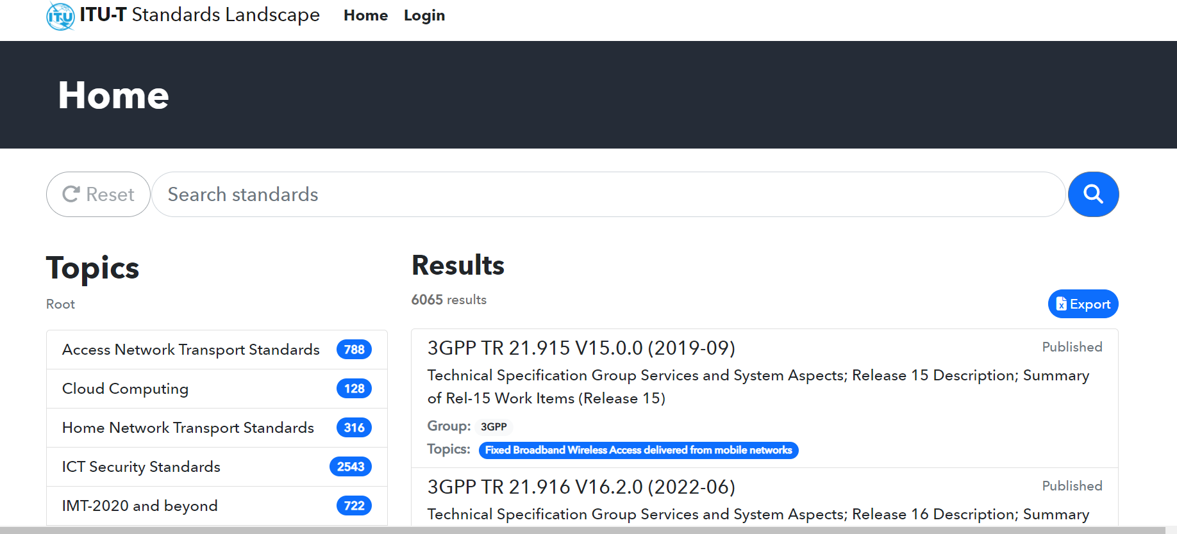

**Click on**

**Step 2** – or starting from [ITU-T landscape for ICT standards - ANT](https://www.itu.int/itu-t/landscape/?topic=0.105&group=g&search_text=)

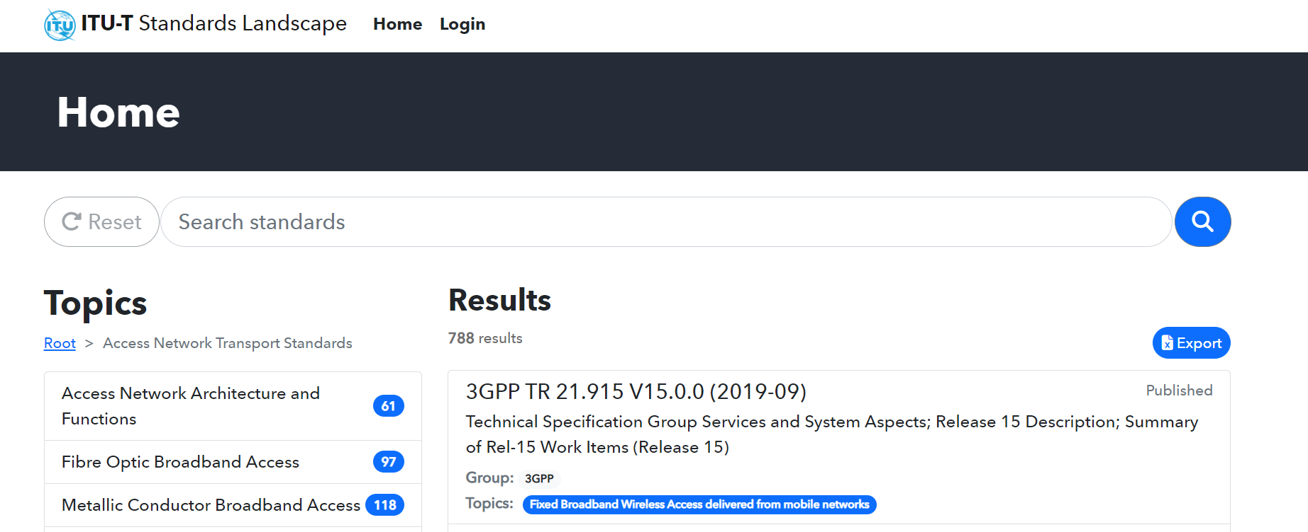

**Click on**

**Step 3**

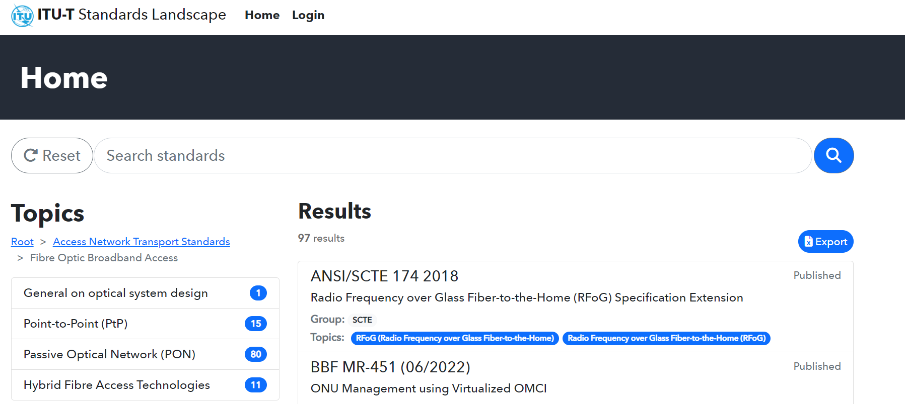

**Click on**

**Step 4**

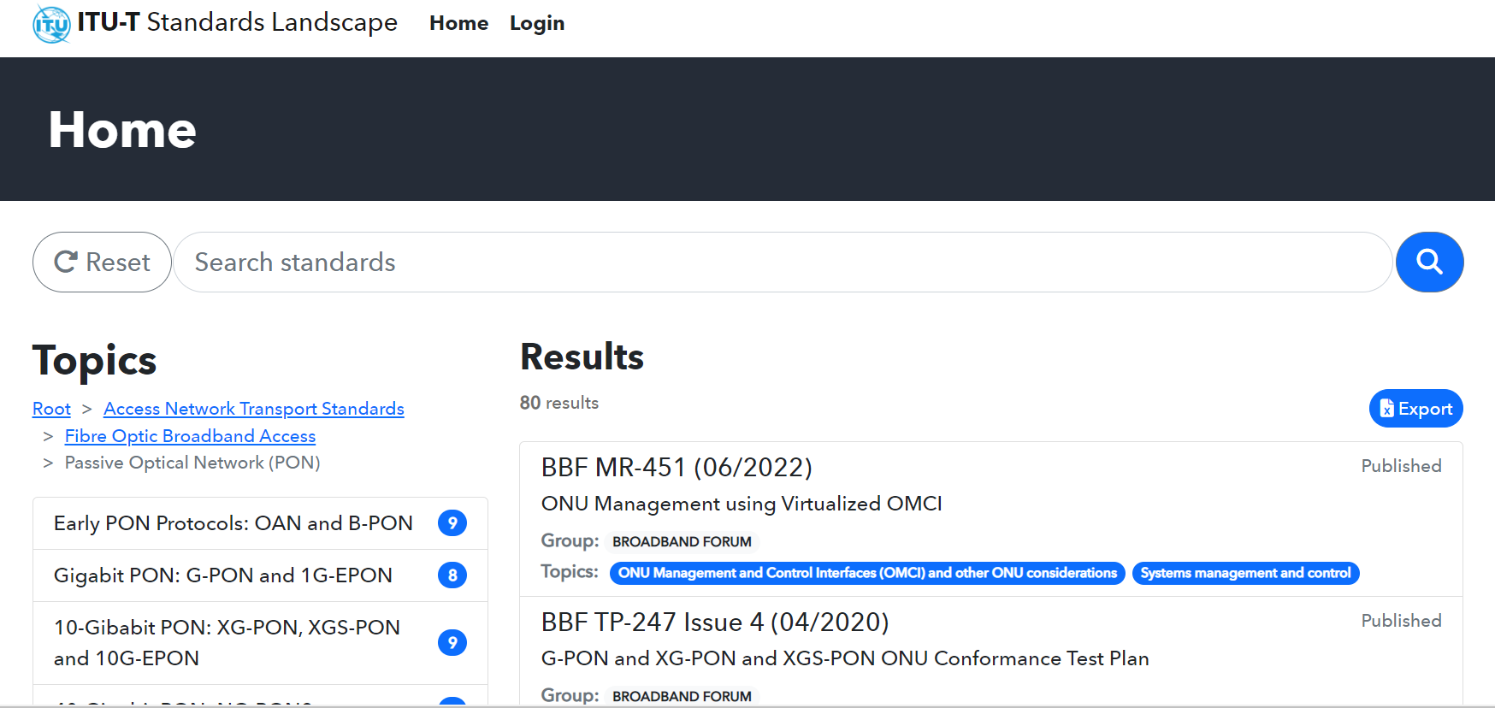

**Click on**

**Step 5**

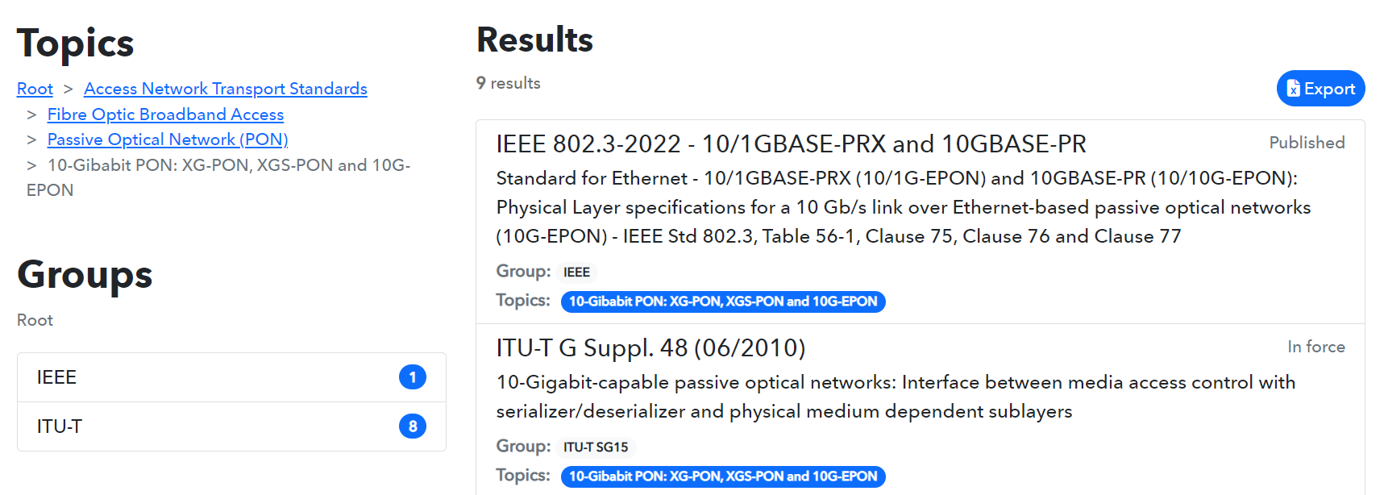

**Click on**

**Step 6**

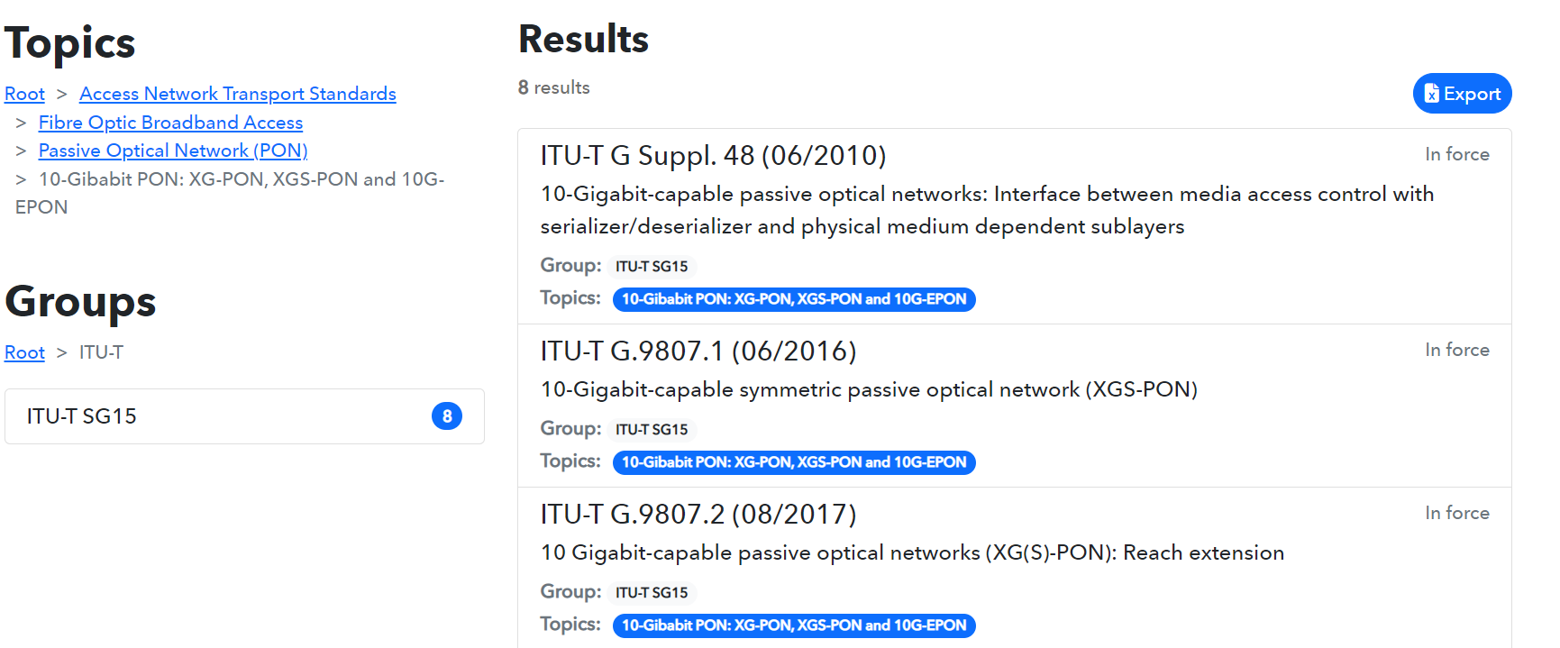

**Click on**

**Step 7**

The list of all ITU-T SG15 Recommendations, including Supplements related to 10G PON is displayed. The list can be exported on an excel table.

**Click on**

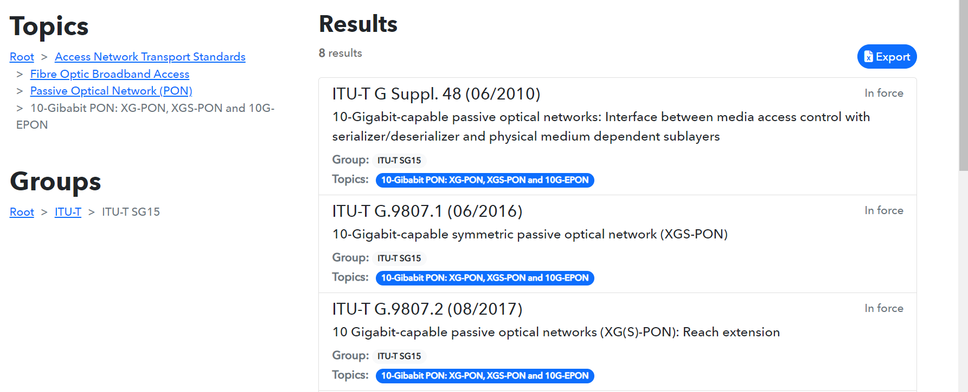

**Step 8**: “DocumentsExport xlsx” is ready for download, the list of all ITU-T SG15 Recommendations on 10G PON can be displayed in excel.

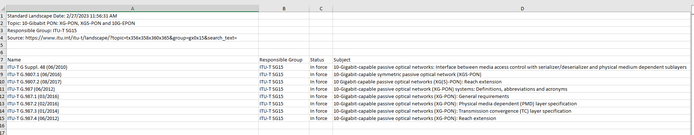

##### Search of a selected standard using the Topics structure: for example, search Recommendation ITU-T G.9807.1

**Proceed with steps 1 to 6 as in above search example 1**  
**Step 7**: Click on item ITU-T G.9807.1

**Click on**



**Step 8**: See the displayed information on ITU-T G.9807.1 (06/2016) and click on the link to access to the ITU-T SG15 webpage of Recommendation G.9807.1

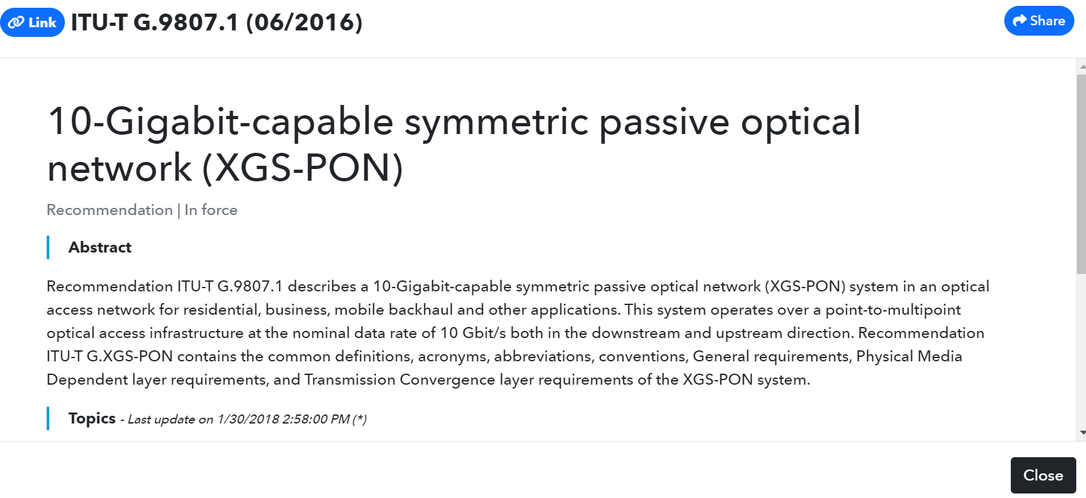

**Click on Link**

**Step 9**: The ITU-T SG15 webpage of Recommendation G.9807.1 (06/2016) including its Amendments is displayed, and the searched document can be downloaded.   
Click on “here” to download the document.

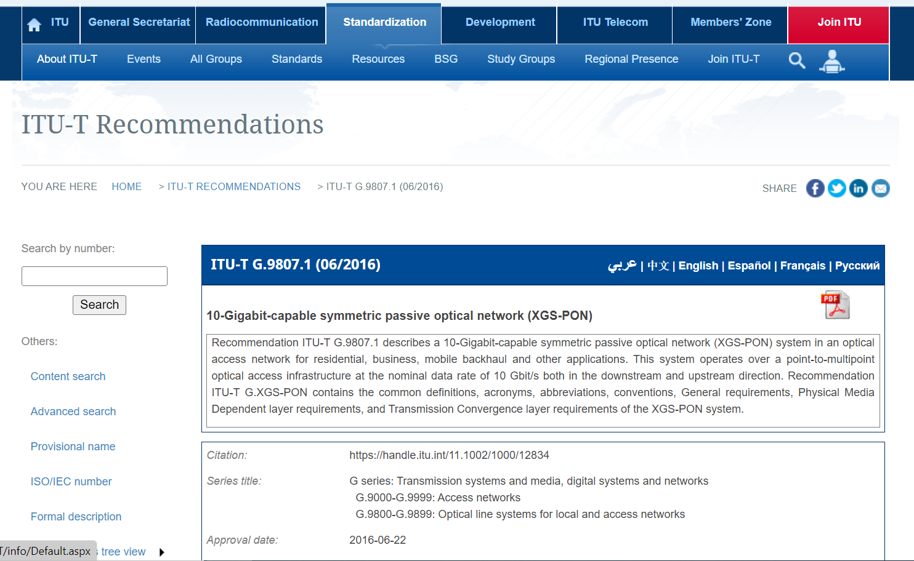

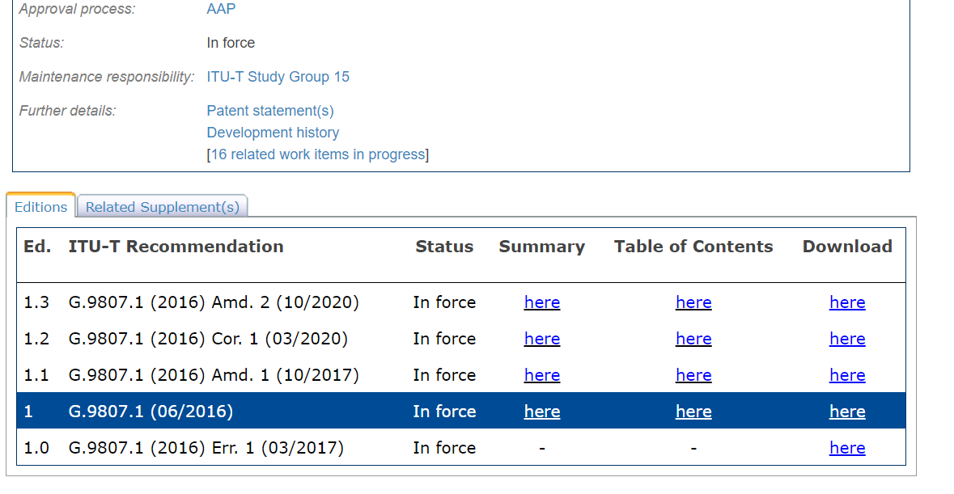

**Click on here**

**to download the document**

1. Search of a standard using the search function of the ITU-T Standards Landscape:  
   for example, search Recommendation ITU-T G.984.1

**Step 1**: Enter G.984.1 in the “Search standards” window of the ITU-T Standards Landscape  
and launch the search. The items are also searchable on title or descriptive terms.

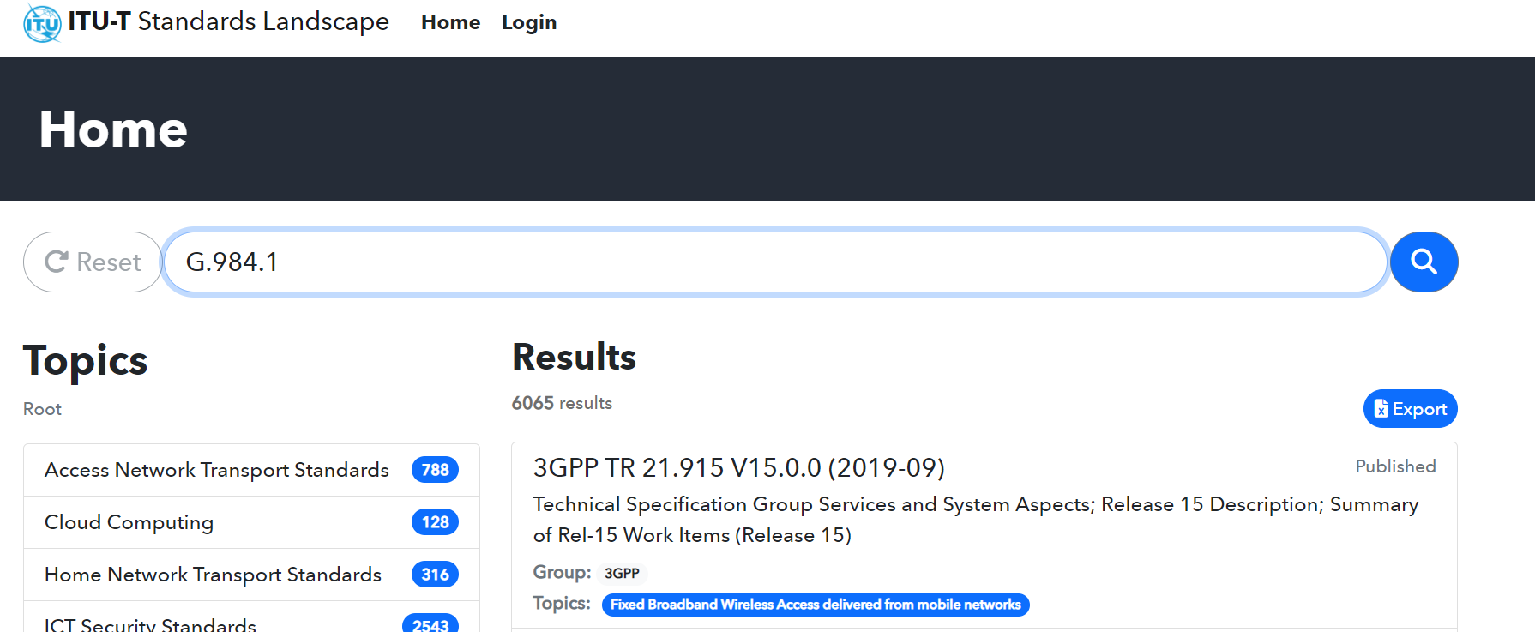

**Step 2**: See displayed Results and continue as for steps 7, 8 and 9 in above search example 2.

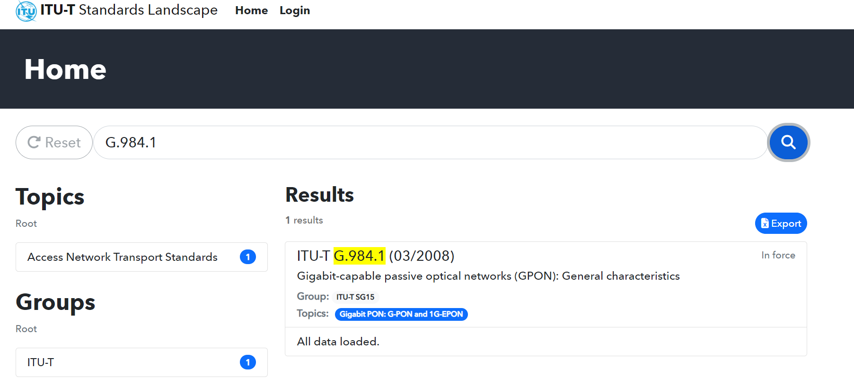

**Click on**

1. Search of a list of standards using the Groups structure:  
   for example, search the list of all ITU-T SG15 Recommendations related to PtP solutions in the fibre access

**Proceed with steps 1 to 2 as above in section 1  
Step 3**

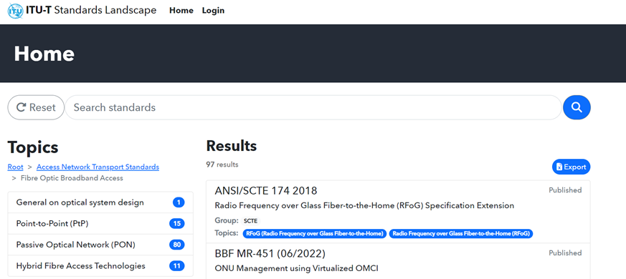  
  
**Step 4**: click on the Groups ITU-T

**Click on**

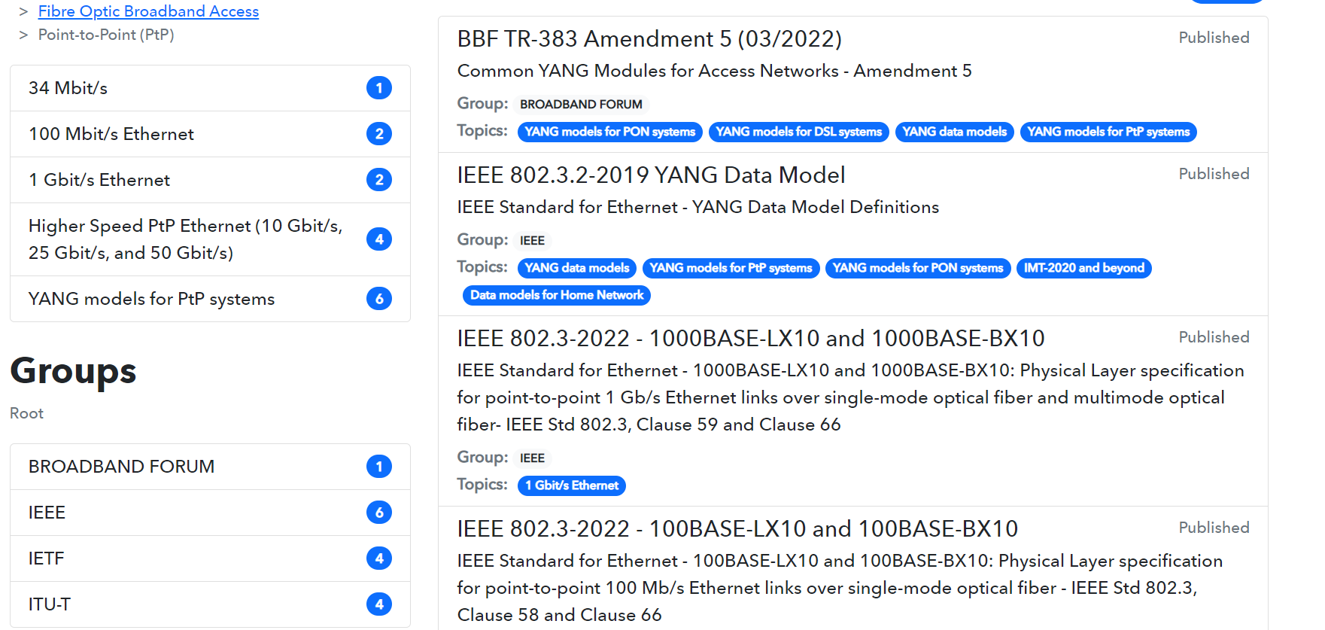

**Click on**

**Step 5**

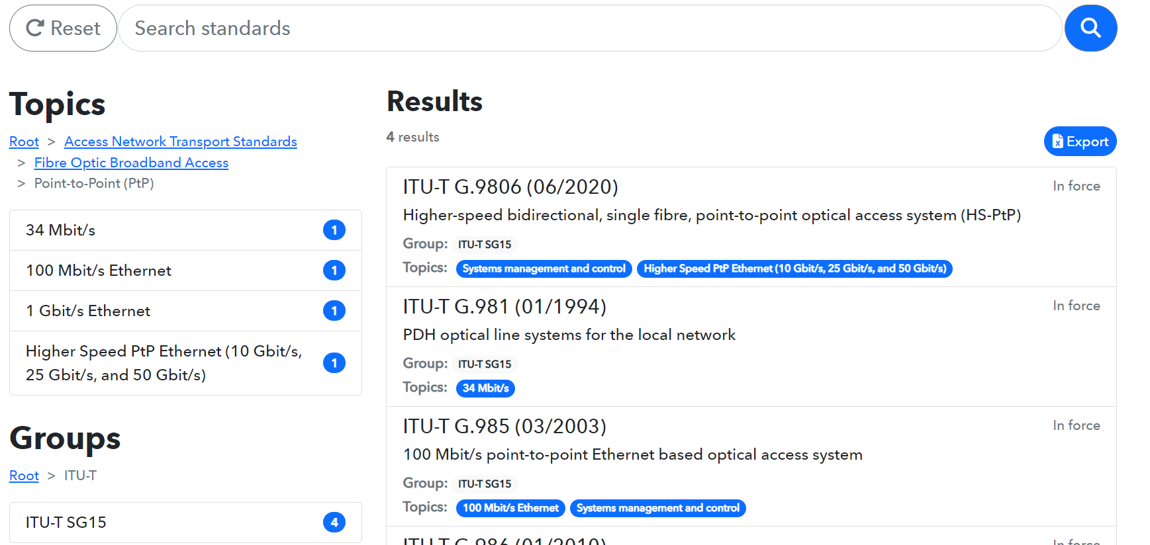

**Click on**

**Step 6**: The list of all ITU-T SG15 Recommendations related to PtP solutions in the fibre access is displayed. The list can be downloaded and exported on an excel table.

Proceed as for steps 7 and 8 in above search example 1 to download the list in excel.  


