

ITU-T Q26-27-28/13 Rapporteur and ITU-T/ISO Collaborative Team Meetings

Document Type: Logistical information for Meeting

Title: Logistical information for the ITU-T Q26-27-28/13 Rapporteur and ITU-T/ISO Collaborative Team (CT) Meetings, October 15th – 20th, 2012 in Redmond, Washington

Status: For information

Date of Document: July 26, 2012

Source: Microsoft

Expected action: Information

Email of secretary:

Committee URL:

LOGISTICAL INFORMATION

Welcome to the ITU-T Q26-27-28/13 and ISO Collaborative Team Meetings in Redmond, Washington, October 15th – 20th, 2012.

Meeting place: Microsoft Main Campus
Building 37 (Conference Rooms 1701-1701)
16071 NE 36th Way
Redmond, Washington 98052

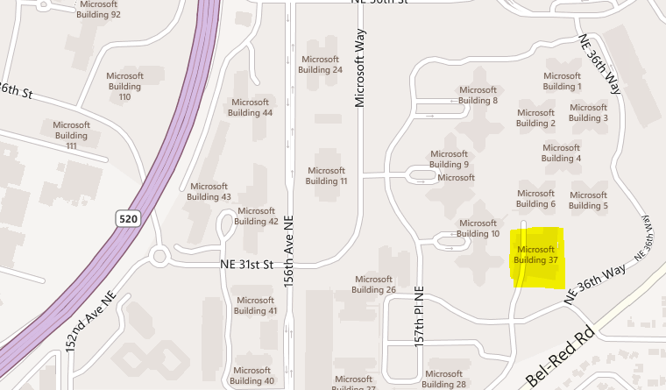

Accommodations:

All accommodations are to be booked and paid by the individual delegates, directly with the hotel. Please find recommended hotels situated close to the conference center listed below.

Hotels in Redmond: (approximately a 10 minute drive to Microsoft Redmond Main Campus)

Redmond Marriott Town Center
7401 164th Avenue NE
Redmond, WA 98052
Tel: 425-498-4000

Marriott Residence Inn
7575 164th Avenue NE
Redmond, WA 98052
Tel: 425-497-9226

Hyatt House Redmond
15785 Bear Creek Parkway NE
Redmond, WA 98052
Tel: 425-497-2000

Hotels in Bellevue: (approximately a 20 minute drive to Microsoft Redmond Main Campus)

Westin Hotel
600 Bellevue Way NE
Bellevue, WA 98004
Tel: 425-638-1000

Hyatt Regency Bellevue
900 Bellevue Way NE
Bellevue, WA 98004
Tel: 425-462-1234

Sheraton – Bellevue
100 112th Avenue NE
Bellevue, WA 98004
Tel: 425-455-3330

Hilton – Bellevue
300 112th Avenue SE
Bellevue, WA 98004
Tel: 425-455-1300

Red Lion Bellevue Inn
11211 Main Street
Bellevue, WA 98004
Tel: 425-455-5240

Embassy Suites
3225 158th Avenue SE
Bellevue, WA 98004
425-644-2500

Courtyard by Marriott
111010 NE 8th Street
Bellevue, WA 98004
Tel: 425-454-5888

TRAVEL

Visa
Visitors VISA’s are required and you can find information at Travel. State. Gov. http://travel.state.gov/visa/temp/types/types_1262.html

Currency and Credit Cards
The United States Dollar, is denoted by the international currency symbol USD.
Major credit cards such as VISA, MasterCard, Diners Club and American Express are widely accepted but always check before purchasing.
ATM’s are very commonplace throughout the United States and generally accept a wide range of cards.

Insurance
The host and organizer cannot accept any responsibility for accidents. Losses and/or damages that may occur. Delegates are advised to obtain travel, medical, personal accident and luggage insurance in their home countries prior to departure.

From airport to Redmond
Leaving the Airport:
- Follow signs to Freeways, this will put you on SR 518 eastbound, merge carefully.
- Follow signs to I-5 and I-405
- Take I-405 North-Renton (center lane)
- Continue on North I-405 thru Renton and Bellevue, approx. 14 miles
- Take SR-520 East exit toward Redmond
- Follow directions below depending on desired destination

For Main Campus
- Exit SR-520 at NE 40th St exit
- Turn Right at exit onto NE 40th St
- Turn right at light onto 156th Ave NE
- Turn left at 2nd light, NE 36th St, enter campus.

PRACTICAL INFORMATION

Bank and Post Offices
Banks are generally open from Monday to Friday, between 10:00a and 6:00p with limited hours on Saturday.

Electricity
Voltage: 110-120 Volts
Three prong plug
Adapter for Type B NEMA 5-15 (Grounded, Non-Polarized)

Emergency
In case of emergency, dial 911 to contact police, fire department or medical services.

Telephones
United States international code is +1, area code for Redmond and Bellevue is 425.

Time Zone
UTC – 8 Pacific Time Zone

MICROSOFT MAIN CAMPUS MAP
