|  |  |
| --- | --- |
| **International Telecommunication Union** |  |
|  |  |

15 August 2011

|  |  |
| --- | --- |
| Subject: | **Announcement of Joint Rapporteurs Group meeting of Q.3, 4, 5, 7, 8, and 10/9, Lawrenceville, Georgia, USA, 21-23 September 2011** |

Dear Sir/Madam,

1. On behalf of Rapporteurs for Q.3, 4, 5, 7, 8, and 10 of Study Group 9, I should like to inform you that these Questions will have the Joint Rapporteurs Group meeting in Lawrenceville, Georgia, United States of America, 21-23 September 2011, at the kind invitation of Cisco Systems Inc., in accordance with the meeting declarations at the last Study Group 9 meeting (14-18 March 2011).

The meeting will open at 9:00 a.m. Participant registration will begin at 8:30 a.m.

Detailed information concerning the precise venue of the meeting along with the list of hotels and practical information is contained in **Annex 2** of this announcement.

2. The discussions will be held in English only.

3. The meeting will be paperless.

4. The draft work programme for the meetings is set out in **Annex 1** hereto.

5. The audio teleconference may be prepared upon request. If any participant is willing to use it, please notify to relevant rapporteurs prior to the meeting.

6. Contributions should be received by the following informal iFTP site not later than **16** **September.** Also, participants are able to submit contributions by electronic mail to the relevant Rapporteur.

Informal ITU-T iFTP site:

● Q3/9 contribution site: [http://ifa.itu.int/t/2009/sg9/exchange/q3/](http://www.holidayinn.com/hotels/us/en/duluth/atldu/hoteldetail)Sep2011-Atlanta/

● Q4/9 contribution site: [http://ifa.itu.int/t/2009/sg9/exchange/q4/](http://hamptoninn.hilton.com/en/hp/hotels/index.jhtml)Sep2011-Atlanta/

● Q5/9 contribution site: [http://ifa.itu.int/t/2009/sg9/exchange/q5/](http://hiltongardeninn.hilton.com/en/gi/hotels/index.jhtml)Sep2011-Atlanta/

● Q7/9 contribution site: <http://ifa.itu.int/t/2009/sg9/exchange/q7/>Sep2011-Atlanta/

● Q8/9 contribution site: [http://ifa.itu.int/t/2009/sg9/exchange/q8/](http://ifa.itu.int/t/2009/sg9/exchange/q3/)Sep2011-Atlanta/

● Q10/9 contribution site: [http://ifa.itu.int/t/2009/sg9/exchange/q10/](http://hamptoninn.hilton.com/en/hp/hotels/index.jhtml)Sep2011-Atlanta/

We would strongly encourage you to use the set of templates that has been created to harmonize the appearance of ITU-T documents while making their production easier and hence more efficient. The templates are accessible from each ITU-T study group web page, under “Delegate resources” (<http://www.itu.int/ITU-T/studygroups/templates/index.html>).

With a view to settling any questions that might arise concerning contributions, the name, fax, telephone number and e-mail address of the person to be contacted should be indicated on contributions. Accordingly, please include those details on the cover page of all documents.

7. In order to enable hosting company to make the necessary arrangements concerning the documentation for, and organization of, the meetings, I should be grateful if you would send Mr. Gale Lightfoot, by e-mail (lightfg@cisco.com), as soon as possible but **not later than 9 September 2011.**

8. We would like to remind you that citizens of some countries are required to obtain a visa in order to enter and spend any time in the United States of America. **The visa must be requested at least four (4) weeks before the date of beginning of the meeting** and obtained from the office (embassy or consulate) representing the USA in your country or, if there is no such office in your country, from the one that is closest to the country of departure.

Yours faithfully,

Satoshi Miyaji  
Vice-Chairman of Study Group 9, ITU-T

**Attachment:**

Annex A: Draft work programme for the Joint Rapporteurs Group meeting

Annex B: Practical information

Appendix I: Map showing route to Cisco Systems Lawrenceville campus and vicinity

from Atlanta’s Hartsfield-Jackson International Airport.

Appendix II: Hotels

**ANNEX A**

**Draft work programme for the Joint Rapporteurs Group meeting**

**(Lawrenceville, Georgia, USA, 21-23 September 2011)**

|  |  |  |  |  |  |  |  |  |  |  |  |  |
| --- | --- | --- | --- | --- | --- | --- | --- | --- | --- | --- | --- | --- |
|  | 21 September Wednesday | | | | 22 September Thursday | | | | 23 September Friday | | | |
|  | A.M. | | P.M. | | A.M. | | P.M. | | A.M. | | P.M. | |
| Q.3 |  |  |  | X |  |  |  |  | X |  | X |  |
| Q.4 |  |  |  | Y | Y | X*2 | Y |  | Y |  | X |  |
| Q.5 | X | X |  |  |  | X*2 |  | X*3 |  | X | X |  |
| Q.7 |  |  |  | X |  |  |  |  | X |  | X |  |
| Q. 8 |  |  | X |  | X*1 |  |  | X*3 |  |  | X |  |
| Q.10 |  |  |  |  | X*1 |  | X |  |  | X | X |  |
| SG 9 management team |  |  |  | X*4 |  |  |  |  |  |  |  |  |

X: Room X

Y: Room Y

*1: Joint session of Questions 8 and 10.

*2: Joint session of Questions 4 and 5.

*3: Joint session of Questions 5 and 8.

*4: Night session

**ANNEX B**

Practical information

***(Lawrenceville, Georgia, USA, 21-23 September 2011)***

1. **Venue**

Cisco Systems, Inc.

5030 Sugarloaf Parkway

Lawrenceville, GA  30044

Tel.: +1 770 236 7000

1. **Transportation to the Cisco Systems Lawrenceville campus and hotels nearby:**

Hartsfield-Jackson International Airport is located in south Atlanta, inside the I-285 interstate perimeter highway.

Vehicles are available at the airport [rental car center](http://ifa.itu.int/t/2009/sg9/exchange/q8/) for your trip to the Cisco Systems Lawrenceville campus and nearby hotels. For access to the rental car center, follow the Ground Transportation signs in the airport. Public transportation is not available for the trip to the campus. Refer to the map (Appendix 1) for driving directions to the Cisco Systems Lawrenceville campus and nearby hotels.   
Rental cars are reasonable in Atlanta and directions are very easy.

Northeast of Atlanta Taxi fares:

Airport to Cisco at 5030 Sugarloaf Parkway, Lawrenceville, GA 30042 is approximately $75.00 one-way.

Taxi Fee Structure – Atlanta Business District

Flat Rate Zone from/to the Airport   
Downtown $ 30   
Buckhead $ 40   
Midtown $ 32   
*$2 charge for each additional person.

The hotels in the area have shuttle services to Cisco Systems Lawrenceville campus at your ask. Taxis are readily available also.

**3. Passports and Visas**

All foreign visitors entering the United States (US) must have a valid passport. Visitors from countries **whose citizens require a visa should at the earliest time and well in advance of travel apply for a visa at a US Embassy or consulate.** The following provides information relating to entry into the U.S.

**US ENTRY FOR NONIMMIGRANTS**

The US State department issued a detailed update of the current Visa Policy. Click on the link below for complete information.

[US State Dept. Visa Policy Update](http://ifa.itu.int/t/2009/sg9/exchange/q10/)

**For assistance with your visa, visit the following websites:**

International Visitors Office site: [http://www.nationalacademies.org/visas](http://ifa.itu.int/t/2009/sg9/exchange/q4/)

Official information on the visa application process: [http://travel.state.gov/visa](http://ifa.itu.int/t/2009/sg9/exchange/q5/)

**4. Climate**

Monthly Average values of the temperature and precipitation in Atlanta are given in the table.

|  |  |
| --- | --- |
|  | September |
| Average Max Temperature | 83°F/28°C |
| Average Minimum Temperature | 63°F/17°C |
| Average Precipitation | 11.9cm |

**5. Electrical Appliances**

Throughout the U.S. electrical appliances operate from 120V, 60Hz. power supplies with plugs as shown below. It is suggested guests bring their own power converters and wall plug adapters to allow use of international appliances. Hotels typically provide irons, ironing boards and hair dryers in the hotel rooms, so there is no need to bring these items with you.

[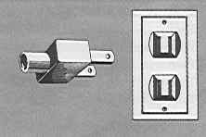](http://www.kropla.com/!ab.htm) [](http://travel.state.gov/visa/laws/telegrams/telegrams_1446.html#plug_b)

**6. Contact Point**

Any questions about the meeting arrangements, please contact:

Mr. Gale Lightfoot; email [lightfg@cisco.com](http://www.atlanta-airport.com/RentalCarCenter/) or telephone +1 770 236 7886

**Appendix I**

**Map showing route to Cisco Systems Lawrenceville campus and vicinity**

**from Atlanta’s Hartsfield-Jackson International Airport.**

(Hotels near Cisco Systems indicated on map)

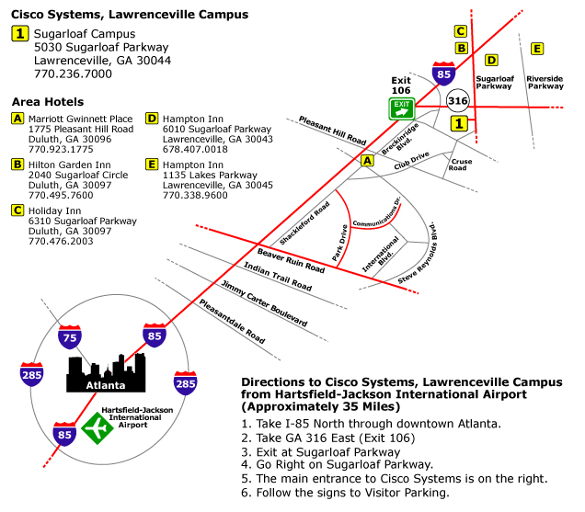

**Appendix II**

**Hotels**

**[Distance (kilometers/miles) one-way from hotel to Cisco Systems in brackets]**

**Lawrenceville, GA:** Many of the hotels in the Lawrenceville areaare not-full service hotels. They typically offer breakfast and limited room service.

|  |  |
| --- | --- |
| [**Marriott Gwinnet Place**](http://www.nationalacademies.org/visas)  1775 Pleasant Hill Road  Duluth, GA 30096  +1 770.923.1775  [9.7 km/6 miles ]  [http://www.marriott.com/hotels/travel/atlgp-atlanta-marriott-gwinnett-place/](http://travel.state.gov/visa)  [**Hilton Garden Inn**](http://hiltongardeninn.hilton.com/en/gi/hotels/index.jhtml?ctyhocn=ATLGSGI)  2040 Sugarloaf Circle  Duluth, GA 30097  +1.770495.7600  [6.4 km/4 miles]  [http://hiltongardeninn.hilton.com/en/gi/hotels/index.jhtml?ctyhocn=ATLGSGI](mailto:lightfg@cisco.com?ctyhocn=ATLGSGI)  [**Holiday Inn**](http://www.kropla.com/!ab.htm?siclientid=1952&pcCrdtd=true)  6310 Sugarloaf Parkway  Duluth, GA 30097  +1.770.476.2003  [4.8 km/3 miles] |  |
| [http://www.holidayinn.com/hotels/us/en/duluth/atldu/hoteldetail?siclientid=1952&pcCrdtd=true](http://www.marriott.com/hotels/travel/atlgp-atlanta-marriott-gwinnett-place/?siclientid=1952&pcCrdtd=true)  [**Hampton Inn**](http://www.marriott.com/hotels/travel/atlgp-atlanta-marriott-gwinnett-place/?ctyhocn=ATLDMHX)  6010 Sugarloaf Parkway  Lawrenceville, GA 30043  +1.678.407.0018  [4.8 km/3 miles]  <http://hamptoninn.hilton.com/en/hp/hotels/index.jhtml?ctyhocn=ATLDMHX>  [**Hampton Inn**](http://www.holidayinn.com/hotels/us/en/duluth/atldu/hoteldetail?ctyhocn=ATLLVHX)  1135 Lakes Parkway  Lawrenceville, GA 30045  +1.770.338.9600  [4.8 km/3 miles]  <http://hamptoninn.hilton.com/en/hp/hotels/index.jhtml?ctyhocn=ATLLVHX> |  |
|  |  |

_________