|  |  |
| --- | --- |
| **International Telecommunication Union** |  |
|  |  |

29 October 2012

|  |  |
| --- | --- |
| Subject: | **Meeting announcement: Rapporteurs’ meetings of Q1/9 and Q7/9**  **TTA, Seongnam, Korea (Rep. of), 3-4 December 2012** |

Dear Sir/Madam,

1. In accordance with the meeting declarations at the last Study Group 9 meeting (17-19 September 2012), I should like to inform you that Rapporteur meetings of Q1/9 and Q7/9 are to be held at TTA in Seongnam, Korea (Rep. of), 3-4 December 2012.

The meeting will open at 9:30 AM on the first day. Participant registration will begin at 9:00 AM.

Detailed information concerning the precise venue of the meeting along with the list of hotels and practical information is contained in **Annex 2** of this announcement.

2. The discussions will be held in English only.

3. The meeting will be paperless.

4. The draft work programme for the meetings is set out in **Annex 1** hereto.

5. The audio teleconference may be prepared upon request. If any participant is willing to use it, please notify to relevant rapporteurs prior to the meeting.

6. Contributions should be received by the following informal iFTP site not later than **28** **November.** Also, participants are able to submit contributions by electronic mail to the relevant Rapporteur.

Informal ITU-T iFTP site:

● Q1/9 contribution site: <http://ifa.itu.int/t/2009/sg9/exchange/q1/>2012-12_TTA_Rapporteurs_Meetings/

● Q7/9 contribution site: <http://ifa.itu.int/t/2009/sg9/exchange/q7/2012-12_TTA_Rapporteurs_Meetings/>

We would strongly encourage you to use the set of templates that has been created to harmonize the appearance of ITU-T documents while making their production easier and hence more efficient. The templates are accessible from each ITU-T study group web page, under “Delegate resources” (<http://www.itu.int/ITU-T/studygroups/templates/index.html>).

With a view to settling any questions that might arise concerning contributions, the name, fax, telephone number and e-mail address of the person to be contacted should be indicated on contributions. Accordingly, please include those details on the cover page of all documents.

7. In order to enable the hosting company to make the necessary arrangements concerning the documentation for, and organization of, the meetings, I should be grateful if you would register to the meeting by email informing Mr TaeKyoon KIM ([tkkim@etri.re.kr](mailto:tkkim@etri.re.kr)), as soon as possible but **not later than 19 November 2012.**

8. We would like to remind you that citizens of some countries are required to obtain a visa in order to enter and spend any time in Korea (Rep. of). **The visa must be requested at least four (4) weeks before the date of beginning of the meeting** and obtained from the office (embassy or consulate) representing the Korea (Rep. of) in your country or, if there is no such office in your country, from the one that is closest to the country of departure.

Yours faithfully,

Shigeyuki SAKAZAWA

Rapporteur for Q.1 of Study Group 9, ITU-T

TaeKyoon KIM

Rapporteur for Q.7 of Study Group 9, ITU-T

**Annexes: 2**

**ANNEX 1**

**Draft work programme for the Q1/9, Q7/9 Rapporteur meetings**

**(TTA, Seongnam, Korea (Rep. of), 3-4 December 2012)**

|  |  |  |  |  |  |  |  |  |
| --- | --- | --- | --- | --- | --- | --- | --- | --- |
|  | 3 December Monday | | | | 4 December Tuesday | | | |
|  | AM | | PM | | AM | | PM | |
| Q1/9 | X1,2 | X1 |  | X1 | X1 | X1 | X1 |  |
| Q7/9 | X1,2 | X1 | X | X1 | X1 | X1 | X1 | X |

**SESSION TIMES (unless otherwise noted):**

**Session 1**: 0900-1015; **Session 2**: 1045-1200; **Session 3**: 1400-1515; **Session 4**: 1545-1700; **Evening Sessions:** 1730-1845

|  |  |
| --- | --- |
| **X** | **Represents a meeting session.** |
| **Note 1** | **Joint session on J.HiNoC topic if contributions received for Q1/9&Q7/9** |
| **Note 2** | **The meeting will open at 9:30 AM on the first day** |

**ANNEX 2**

Practical information

***(*TTA*, Seongnam, Korea (Rep. of), 3-4 December 2012*)**

1. **Venue**

TTA

267-2 Seohyeon-dong, Bundang-gu

Seongnam-city, KOREA (Rep. of)

1. **Transportation to the TTA:**

Please refer to the following link.

<http://www.tta.or.kr/English/new/about/access.jsp>

See Appendix for more information including hotels.

**3. Passports and Visas**

All foreign visitors entering Korea (Rep. of) must have a valid passport. Participants from countries whose citizens require visa should, well in advance, apply for a visa to a Korean consulate or diplomatic mission in their respective country prior to departure. Participants are also advised to contact their local travel agents or carriers. Those participants who need a VISA Supporting Letter for entering Korea (Rep. of) are strongly advised to get in touch with the Contact Person by 2 November 2012, at the latest.

**4. Climate**

The climate of Seongnam in December is relatively cold. Temperature in the September 2010 was: 4.2 C / -3.4 C (Max/Min), and average precipitation is 24.9 mm.

**5. Electrical Appliances**

Korea (Rep. of) operates on 220 volts for electrical appliances. The frequency is 60 Hz.

The type of power outlet/connector used in Korea (Rep. of) is ‘C & F type’.

|  |  |
| --- | --- |
| [C type] | http://travelog.in/media/kunena/attachments/62/C%20plug.jpg |
| [F type] | http://travelog.in/media/kunena/attachments/62/F%20plug.jpg |

If your appliances operate on a different voltage, please bring your own transformers.

**6. Link to information for foreign visitors travelling Korea (Rep. of)**

The following link connects you to the web site operated by Korea (Rep. of) Tourism Organization situation.

<http://www.visitkorea.or.kr/intro.html>

**7. Contact Point**

Any questions about the meeting arrangements, please contact:

Mr. TaeKyoon KIM

ETRI

218 Gajeongno, Yuseong-gu, Daejeon, 305-700, KOREA

email [tkkim@etri.re.kr](mailto:tkkim@etri.re.kr)

telephone +82 42 860 6917

Fax +82 42 860 6465

**Appendix**

**Detailed travel information**

# 1. Maps and overview

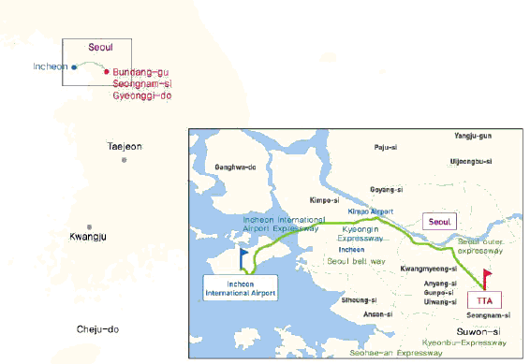

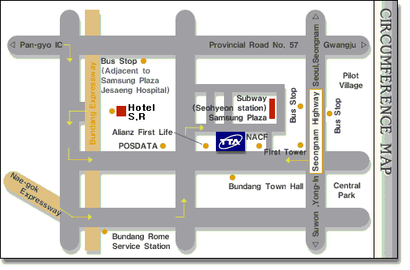

# 2. Transportation and Hotel

|  |  |  |  |  |
| --- | --- | --- | --- | --- |
| Hotel | Room | | Fare | Homepage(map) |
| SR Hotel | With breakfast  (for 1 person) | Deluxe Room | KRW 180.000 | [www.srhotel.co.kr/](http://www.srhotel.co.kr/) |
| Noblesse  Hotel | Without breakfast | Deluxe Room | KRW 80.000 | [www.hotelnoblesse.com/](http://www.hotelnoblesse.com/) |
| Gallery  Hotel | Without breakfast | Standard Room  Deluxe Room | KRW 140.000  KRW 150.000 | [www.galleryhotel.co.kr/](http://www.galleryhotel.co.kr/) |

**\* VAT is not included. (10%)**

__________________________