Practical information for the
ITU Workshop on “Trends on Quality of Service and Connectivity Assessment and Evaluation from the user's perspective” (18-19 September 2023)
and the
Meeting of ITU-T Study Group 12 (19-28 September 2023)
(20 September 2023 update: updated bus departure time)

1 Introduction
This document provides information on the meeting and guidance to the delegates for their stay in Mexico City, Mexico.

2 Meeting Venues
From 20 to 26 September 2023, the meeting will be held at:
Venue: Centro de Educación Continua Ingeniero Eugenio Méndez Docurro, Mexico City
Address: Belisario Domínguez 22, Cuauhtémoc, Mexico City, 06000.
Phone: +52 55 5729 6000

The following sessions will be held at the Barceló México Reforma​ hotel:
- ITU Workshop on “Trends on Quality of Service and Connectivity Assessment and Evaluation from the user's perspective” (18-19 September),
- ITU-T SG12 opening plenary and Working Party Opening Plenaries (19 September PM),
- Working Party Closing Plenaries (27 September), and
- ITU-T SG12 closing plenary (28 September).
Venue: Barceló Hotel (Revolución room)
Address: Paseo de la Reforma 1, Tabacalera, Cuauhtémoc, 06030, Mexico City.
Phone: +52 55 5128 5000

3 Floor Plan

Barceló hotel

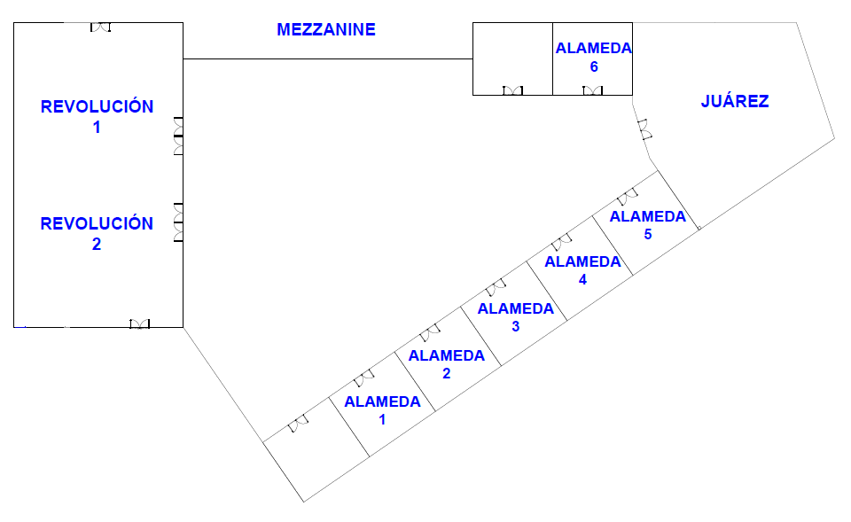
The workshop and SG12 plenary sessions will take place in Room Revolución 2.
The SG12 management team office is located in Room Alameda 2. The ITU Secretariat can be found in Room Alameda 1.

Centro de Educación Continua Ingeniero Eugenio Méndez Docurro

The Meeting (20 to 26 September 2023) will take place in

Room 1
Room 4
Room 5

Please see the room allocation on the ITU website, at https://itu.int/net4/Events/Meetings/TodayT

A Cybercafé (“Cibercafé”) for delegates is in Room 2.

The SG12 management team office is located in Room 8. The ITU Secretariat can be found in Room A.

In case delegates require a meeting room, they can request it by sending the number of participants and the day and time expected, to elias.gomez@ift.org.mx. If the space is available, they will be notified in the same way, otherwise, they will receive a proposal for an available time.

4 Registration
Badges will be issued only to individuals who have successfully undergone the pre-registration form on the Study Group 12 homepage and Workshop webpage and have been accredited. Participants will not be admitted to the venue without the badge.
Pre-Registration (badges): Monday, 18 September 2023, 0800-1200 hours.
Registration (badges): Tuesday, 19 September 2023, 0800-1800 hours.
Registration service will resume at the ITU Secretariat from 20 September.

5 Access to the meeting venue

5.1 Flights to Mexico City’s International Airport
Mexico City’s International Airport is located approximately 5 kilometers (3.1 miles) from the city center.
For more information, please see the following website: https://www.aicm.com.mx/
How to get to Mexico City’s International Airport
- By car
Accessible via Oceania Avenue about 30 minutes to and from the city center. There are several parking lots opposite the terminals: about $1.75 USD for 1 hour; less than $25 USD for 24 hours.
Several car rental companies have counters on the ground floor of Terminal 1 and 2 of the airport.
- By Metrobus
The Metrobus is a public transportation system operated by the government of Mexico City. It connects the airport with central Mexico City, as well as the capital’s points of interest, including: Paseo de la Reforma Boulevard, the Bellas Artes building and other landmarks. The Metrobus has exclusive stations so you can get on and off comfortably and safely.
Payments are made through a Metrobús smart card, which can be purchased at sales/top-up machines, located at the Terminal 1 and Terminal 2 boarding areas. The cost for the service is $30.00 pesos per person, per ride, departing from the Airport.
- Taxi
Taxi services are located at the international and domestic entrances at Terminals 1 and 2. In both cases, taxi tickets are sold at the modules located near the arrival gates and in the walkway area. Rates are posted in a visible place and are authorized by the Ministry of Infrastructure, Communications, and Transport. For your safety, we recommend you only use the taxi services authorized by this airport, which include:
Terminal 1:
- Porto Taxi, Sitio 300
- Nueva Imagen and Excelencia
Terminal 2:
- Porto Taxi, Sitio 300
- Nueva Imagen
- Excelencia
- Confort and Yellow Cab
Locate the nearest transportation service here:
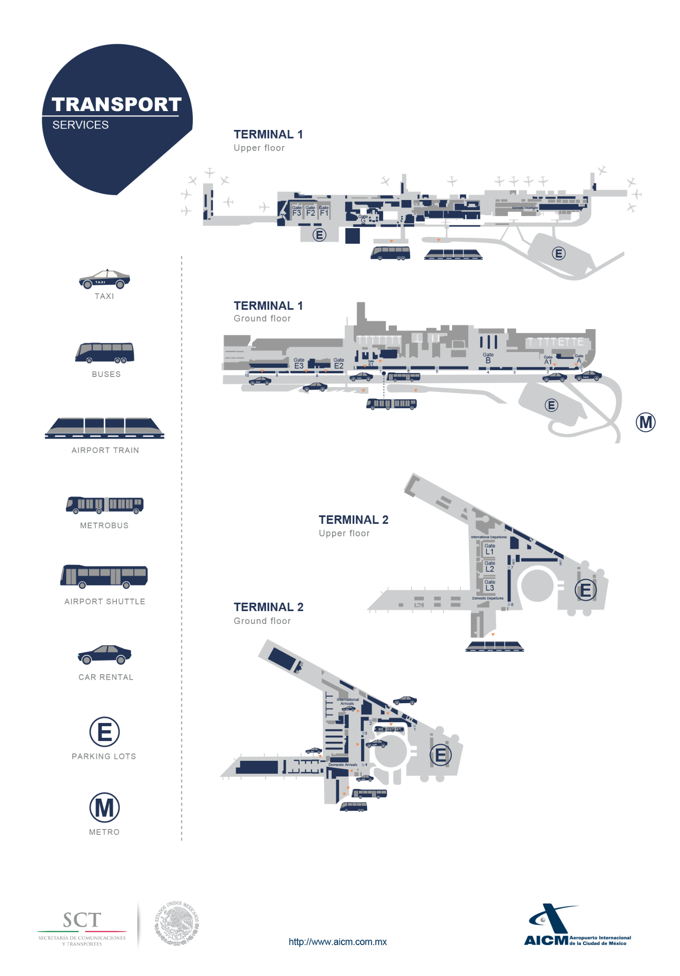

5.2 Transportation between hotels and Centro de Educación Continua
Transportation will be provided to delegates on 20, 21, 22, 25 and 26 September, according to the following schedules:

Time | Departure from | Stop in | Arrival at
08:15 hrs. | Fiesta Americana Reforma | One Alameda Centro Histórico (08:40 hrs.) | Centro de Educación Continua
08:15 hrs. | Barceló | - | Centro de Educación Continua
17:45 hrs. | Centro de Educación Continua | One Alameda Centro Histórico y Barceló | Fiesta Americana Reforma
17:45 hrs. | Centro de Educación Continua | - | Barceló
For any questions concerning transportation, please contact
Mr. Elías Gómez (IFT)
Phone: +52 55 4932 5832
Email: elias.gomez@ift.org.mx

6 Accommodation
Barceló hotel is recommended for all participants to stay during the meeting, as it will be the venue for the Workshop and the plenary sessions.

Address: Paseo de la Reforma 1, Tabacalera, Cuauhtémoc, 06030, Mexico City.
Phone: +52 55 5128 5000
URL: https://www.barcelo.com/es-mx/barcelo-mexico-reforma/
Booking at:
- By e-mail: mexicoreforma.res@barcelo.com / mexicoreforma.res2@barcelo.com
- By phone: (+52 55) 51285000
- Promotion Code: Meeting SG-12
Room Type | MX Pesos  (included taxes) | USD  Exchange rate:  $17.17 = 1 USD
Single/Double | $1,995.65 | $116.22
Single/Breakfast buffet | $2,318.30 | $135.02
Double/Breakfast buffet | $2,640.95 | $153.81
These rates apply from September 15 to October 1. If the participants would like to extend their stay, the price would vary.
Please note that the local secretariat is NOT responsible for the hotel reservation and participants are encouraged to make the reservation as early as possible.

6.1 Nearest Hotels
For your convenience, attendees are encouraged to stay in hotels near the meeting venues.
The following hotels offer a special rate for delegates:
Hotel Name | Contact (+52) | Room Type | Room Rates  USD  (taxes and fees excluded)  Exchange rate: $17.17 = 1 USD | MX Pesos | Distance to  meeting venue | Booking at
One Alameda Centro Histórico | Phone: 55 5130 0030  Address: Av. Juárez 88, Centro, Cuauhtémoc, 06040, Mexico City.  Website | Single/Double | $72.90 | $1,250.00 | 16 min walking  1.3 km | By phone:  +52 55 5326 6900  Promotion code: G1P73M@1ALA
Fiesta Inn Centro Histórico | Phone: 55 5130 2900  Address: Av. Juárez 76, Centro, Cuauhtémoc, 06010, Mexico City.  Website | Single/Double | $87.49 | $1,500.00 | 16 min walking  1.3 km | By phone:  +52 55 5326 6900  Promotion code: G1P73K@FICEN
Fiesta Americana Reforma | Phone: 55 5140 4100  Address: Paseo de la Reforma 80, Juárez, Cuauhtémoc, 06600, Mexico City.  Website | Single/Double | $87.49 | $1,500.00 | 28 min walking  2.2 km | By phone:  +52 55 5326 6900  Promotion code: G1P73J@FAR
These rates apply from September 15 to October 1. If the participants would like to extend their stay, the price would vary.
Please note that the local secretariat is NOT responsible for the hotel reservation and participants are encouraged to make the reservation as early as possible.

6.2 Other hotel suggestions
Hotel Name | Contact (+52) | Room Type | Room Rates  USD  (taxes and fees excluded)  Exchange rate: $17.17 = 1 USD | MX Pesos | Distance to  meeting venue
Hilton Mexico City Reforma | Phone: 55 5130 5300  Address: Juárez 70, Centro, 06010, Mexico City.  Website | Standard room | $253.00 | $4337.55 | 14 min. Walking  1.1 km
Hotel Plaza Revolución | Phone: 55 5234 1910  Address: Terán 35, Tabacalera, Cuauhtémoc, 06030, Mexico City.  Website | Standard room | $63.45 | $1,087.87 | 21 min. walking  1.6 km
Le Méridien | Phone: 55 5061 3000  Address: Paseo de la Reforma 69, Tabacalera, Cuauhtémoc, 06030, Mexico City.  Website | Standard room | $170.25 | $2,918.85 | 27 min. walking  2 km

7 VISA and immigration information
A visa may be necessary for participants from some countries to enter Mexico. To check the visa requirements please contact the Mexican Embassy in your country. Kindly visit: http://www.inm.gob.mx/gobmx/word/index.php/paises-requieren-visa-para-mexico/ for more details.
Participants who should require a personal Letter of Invitation for obtaining a visa are requested to contact Ms Mariana Alday Álvarez via e-mail at mariana.alday@ift.org.mx as soon as possible after confirmed registration with ITU, but no later than 19 August 2023. Your e-mail must include the following information in order to be processed:
• Complete name
• Passport Number
• Nationality.
Foreigners travelling to Mexico must have a valid Passport, issued by the competent authority. In order to meet the requirements, procedures and criteria for the attention to and resolution of visa application procedure, is recommended that participants consult the web site of the National Institute of Migration, www.gob.mx/inm.
The countries and regions that do not require a visa to travel to Mexico can be found at the following link: www.inm.gob.mx/gobmx/word/index.php/paises-no-requieren-visa-para-mexico/.
In addition, information from countries and regions that require a visa to ravel to Mexico can be found at: www.inm.gob.mx/gobmx/word/index.php/paises-requieren-visa-para-mexico/.
People are encouraged to contacting the Embassy or Consulate of Mexico in their countries, https://www.gob.mx/gobierno/mexico-en-el-mundo if they require detailed information. Participants requiring visa must obtain it before travelling to Mexico.
IMPORTANT: As of 1 April 2022, all Colombian nationals must complete a mandatory pre-registration of their trip at the following link: https://www.inm.gob.mx/spublic/portal/inmex.html

8 Network

8.1 Internet Access
In the venues, a code will be provided to access a high-speed wireless network.

8.2 Internet Lounge
The venues have a Cybercafé area where attendees can be assisted with internet access and printing documents.

9 Practical Information

9.1 Mexico City
Mexico City is known as the Cultural Capital of America. It has become the financial, cultural and political center of the country. It is one of the biggest and most populated cities in the world. To talk about Mexico City (CDMX) is to imagine one of the most populated cities in the world, where avenues, viaducts, causeways, alleys and streets become arteries where its habitants are the lifeblood of this great city. But CDMX has a characteristic that makes it very attractive for tourism: its great history, art and its beautiful colonial and contemporary architecture.
Walking through the Historic Center of Mexico City you can notice the baroque, neoclassical style and relics of our Aztec ancestors such as the same main temple next to the Metropolitan cathedral. Mexico City has an infinite number of entertainment options. There are 132 museums, 7 nearby archaeological zones and 64 theaters, not to mention nightclubs, bars, and restaurants of all kinds of Mexican and international food.
The Mexico City Government provides useful tourist information on this website, as well as recommendations for experiences while visiting Mexico City.

9.2 Health insurance
In the event of any illness or injury, delegates shall be liable for any expenses incurred when resorting to Mexican medical facilities. They must therefore consider the purchase of travel insurance before leaving for Mexico and ensure they have a suitable level of coverage during their stay in the country.

9.3 Useful addresses
Address and contact information of Embassies and Consulates in Mexico, in the following link.

9.4 Climate
Mexico City is a high-altitude location so appropriate precautions need to be taken. Weather forecasts in Mexico City generally allow for pleasant visits year-round. Rather the rainy season lasts from June through early October, when the city receives about 85% of annual precipitation. However, even during these rainiest months, rainfall is usually limited to a few hours per day and seldom for more than a few days sequentially. Expect intense downpours for parts of some days. The weather forecast for September 19 to 28 in Mexico City can be checked at the following link.
Air Quality
Although Mexico City’s high altitude and anti-cyclonic weather systems generally discourage wind, the result is that pollutants from industry and automobiles can hang in the air and affect the breathing and health of visitors alike.
For those with asthma or extra sensitivity, you may want to watch the numbers above, and reduce your activities when indicators indicate extra pollution or contaminated conditions.

9.5 Electricity and Voltage
In Mexico the electric current is 110 -120 volts (identical to U.S.A. and Canada). Please bear in mind the following recommendations:
- Multi-voltage devices (laptops, etc.): plug adapter.
- Household appliances 220—240V: plug adapter + step-up transformer.
- Japanese household appliances of 100V: step-down transformer from Japan to the United States.
For your convenience, please bring a multi-voltage travel adapter.

9.6 Language
Official Language is Spanish. Nevertheless, as Mexico City is a very big destination city, most people at touristic places and hotels speak English.

9.7 Time Zone
Central Standard Time UTC/GMT-6 hours

9.8 Banks and Currency
The Mexican peso is the official currency of Mexico. To see the updated Exchange rate, you can enter the Bank of Mexico site: www.banxico.org.mx. Exchange rate (26 June 2023):
$17.17 = 1 USD.
Banks are open from 0900 to 1600 hours from Monday to Friday.

9.9 Mobile Phone Rental Service
Participants can buy a cheap phone for around $30 in any convenient stores such as “OXXO” or “7Eleven” and they are used on a pay as you go plan. Mobile operators countrywide are AT&T, Movistar and Telcel.

9.10 Helpful Numbers
Area Code: 55
In the event of any emergency, dial 911. 911 is Mexico’s national emergency number and will give you the fastest response.
Emergency contact numbers:
- The national 911 service is answered and attended to locally, and operators will automatically receive your location.
- LOCATEL is Mexico City’s information and help line. Operators are prepared to address any non-emergency, and non-life-threatening situation - 55 5658 1111:
- The Tourist Assistance Hotline may also be able to help you with issues specific to your trip, communications with your embassy, or other issues related to your visa, airport transport, or similar problems - 5552867097 or 5552869077 ext 2104 or 2309 (Monday through Friday 9 a.m. to 6 p.m.).

9.11 Tipping
Like in the United States, leaving a tip, called “propina”, is expected in Mexico. In bars and restaurants, it is customary to tip between 10 and 15 percent. However, before leaving a tip, check the bill to make sure that a gratuity or service charge is not already included.

9.12 Safety
Mexico City is geologically characterized by its high seismic activity, so we share some measures that delegates should consider during their stay in case of an earthquake.
What to do during seismic warning?
- When the seismic alert sounds, stay calm and if you are on a low floor and it is possible, evacuate the building and follow the previously established evacuation routes.
- If you are on a high floor and you do not have time to leave, move to the lowest risk zone previously established.
- Follow the protocols of the Civil Protection Program of the place where you are and follow the instructions of the brigade members.
- Do not run, many accidents occur during a chaotic evacuation.
- Do not shout, you may spread panic and chaos during the evacuation.
- Do not push, you may injure or hurt people who are evacuating, give them time to leave.
What to do during the earthquake?
- If you did not evacuate in time, retreat to the nearest low-risk area.
- Move away from windows, furniture, mirrors, plants, or other heavy objects that could fall.
- If there are infants, seniors or people with disabilities, help them to retreat or stand in the lowest risk area.
- During the earthquake, do not use stairs or elevators.
- Evacuate the building until the earthquake has ended if the evacuation route makes it possible.
What to do after the earthquake?
- If you have retreated to low-risk areas during the earthquake, evacuate the building to the meeting point.
- Stay calm and follow the instructions of brigade members, rescue corps and civil protection authorities.
- Use cell phones only for emergencies or as little as possible.
- Use social networks to let people know that you are okay.

10 Social events
Welcome cocktail party hosted by MedUX, an ITU-T SG12 Associate.
- When: 18 September 2023
- Time: 18:00 to 21:00 hrs.
- Where: Salón Juárez, hotel Barceló, located in Paseo de la Reforma 1, Tabacalera, Cuauhtémoc, 06030, Mexico City.

Welcome dinner hosted by the IFT
- When: 19 September 2023
- Time: 18:30 to 20:30 hrs.
- Where: Salón Revolución, hotel Barceló, located in Paseo de la Reforma 1, Tabacalera, Cuauhtémoc, 06030, Mexico City.

