# Meeting Announcement Q5/9 Rapporteurs’ meetings

***Beijing, China, 30 Nov 2017***

## Rapporteur meeting for Question 5/9 in Beijing, China

**A Meeting venue and registration**

In agreement with SG9 Chairman the following SG9 Rapporteur meetings will be organized at the kind invitation of SARFT.

* Q5/9 meeting.

The venue address is:

**The Merchantel Hotel,**

**No.2 Xibianmenwai Street, Xicheng District, Beijing, China.**

To enable the host to make the necessary arrangements concerning the organization of the Rapporteurs meetings, please register via the [on-line form](http://itu.int/reg/tmisc/3001033), as soon as possible, but not later than **20 Nov** **2017**. Please note that pre-registration of participants to the meeting is carried out exclusively online **at the following address:**

<http://itu.int/reg/tmisc/3001033>

To easily provide you with any updates concerning the meeting planning, please fill in the registration form with a valid e-mail address.

**B Meeting terms of reference**:

The Q5/9 meeting has been agreed at the last SG9 meeting in Hangzhou, China (24-31 May 2017). The meeting aims at progressing the new work item ITU-T [J.stvos-spec](http://www.itu.int/ITU-T/workprog/wp_item.aspx?isn=14183) “Specification for the architecture and functional requirement of smart TV operating system” and to consider any other contributions.

In order to progress [J.stvos-spec](http://www.itu.int/ITU-T/workprog/wp_item.aspx?isn=14183) it is suggested to adopt the following session schedule:

– ***Session 1:*** Architecture of Smart TV operation system

– ***Session 2:*** Components of Smart TV operation system

– ***Session 3:*** Security architecture of Smart TV operation system

– ***Session 4:*** it will be used if and as needed

A draft meeting plan is provided in ANNEX 3 for the meeting participants’ convenience.

**C Visa to enter China**

To enter China for the meeting indicated above, you may need a letter of invitation from the host (SARFT), which you will need to present to the Chinese Embassy/Consulate in your area in order to obtain your visa **(see** **ANNEX 2** **for the Invitation letter)**. The visa must be requested and obtained from the office (embassy or consulate) representing China in your country or, if there is no such office in your country, from the one that is closest to the country of departure. Please be aware that visa approval might take time so kindly make your visa request as soon as possible.

The SG9 Rapporteurs meetings will open at 0930 hours on the day (30 Nov 2017). Participant registration will begin at 0830 hours. Detailed information concerning the meeting rooms will be available onsite and provided to you at the registration desk.

**D How to contribute**

To contribute to the Rapporteurs meetings, please send your Contribution to the responsible Rapporteur, preferably by **23 Nov 2017**, or submit the Contributions directly to the document repository at the related SharePoint site, which will be made available from the Q5/9 rapporteur meeting webpage: <https://www.itu.int/net/itu-t/lists/rgmdetails.aspx?id=8962&Group=9>

|  |  |  |
| --- | --- | --- |
| **Question** | **Rapporteur** | **Associate** |
| Q5/9 | Heming Wang ( [hermit.wangheming@hisilicon.com](mailto:hermit.wangheming@hisilicon.com) ) | Shinya Takeuchi  ( [takeuchi.s-js@nhk.or.jp](mailto:takeuchi.s-js@nhk.or.jp) ) |

Please use the provided **template** to prepare your contribution:

<https://extranet.itu.int/meetings/ITU-T/MTG%20Template/RGM_mtgdoc_template.docx>

The name, fax and telephone numbers and e-mail address of the person to be contacted about the contribution should be indicated on the cover page of all documents.

**E Other useful information**

The meeting will be run paperless and the discussions will be held in English only.

The audio teleconference may be prepared upon request. If any participant is willing to use it, please notify the Rapporteur as soon as possible.

Additional practical information is to be found in ANNEX 1.

Yours faithfully,

Heming Wang (Q5/9 Rapporteur)

***Annexes: 3***

* *ANNEX 1* *–PRACTICAL INFORMATION*
* *ANNEX 2* *– INVITATION LETTER REQUEST FORM*
* *ANNEX 3* *– DRAFT MEETING PLAN*

# ANNEX 1 –PRACTICAL INFORMATION

## Meeting Venue

**Merchantel Hotel,**

**No.2 Xibianmen Outer Street, Xicheng District, Beijing, China.**

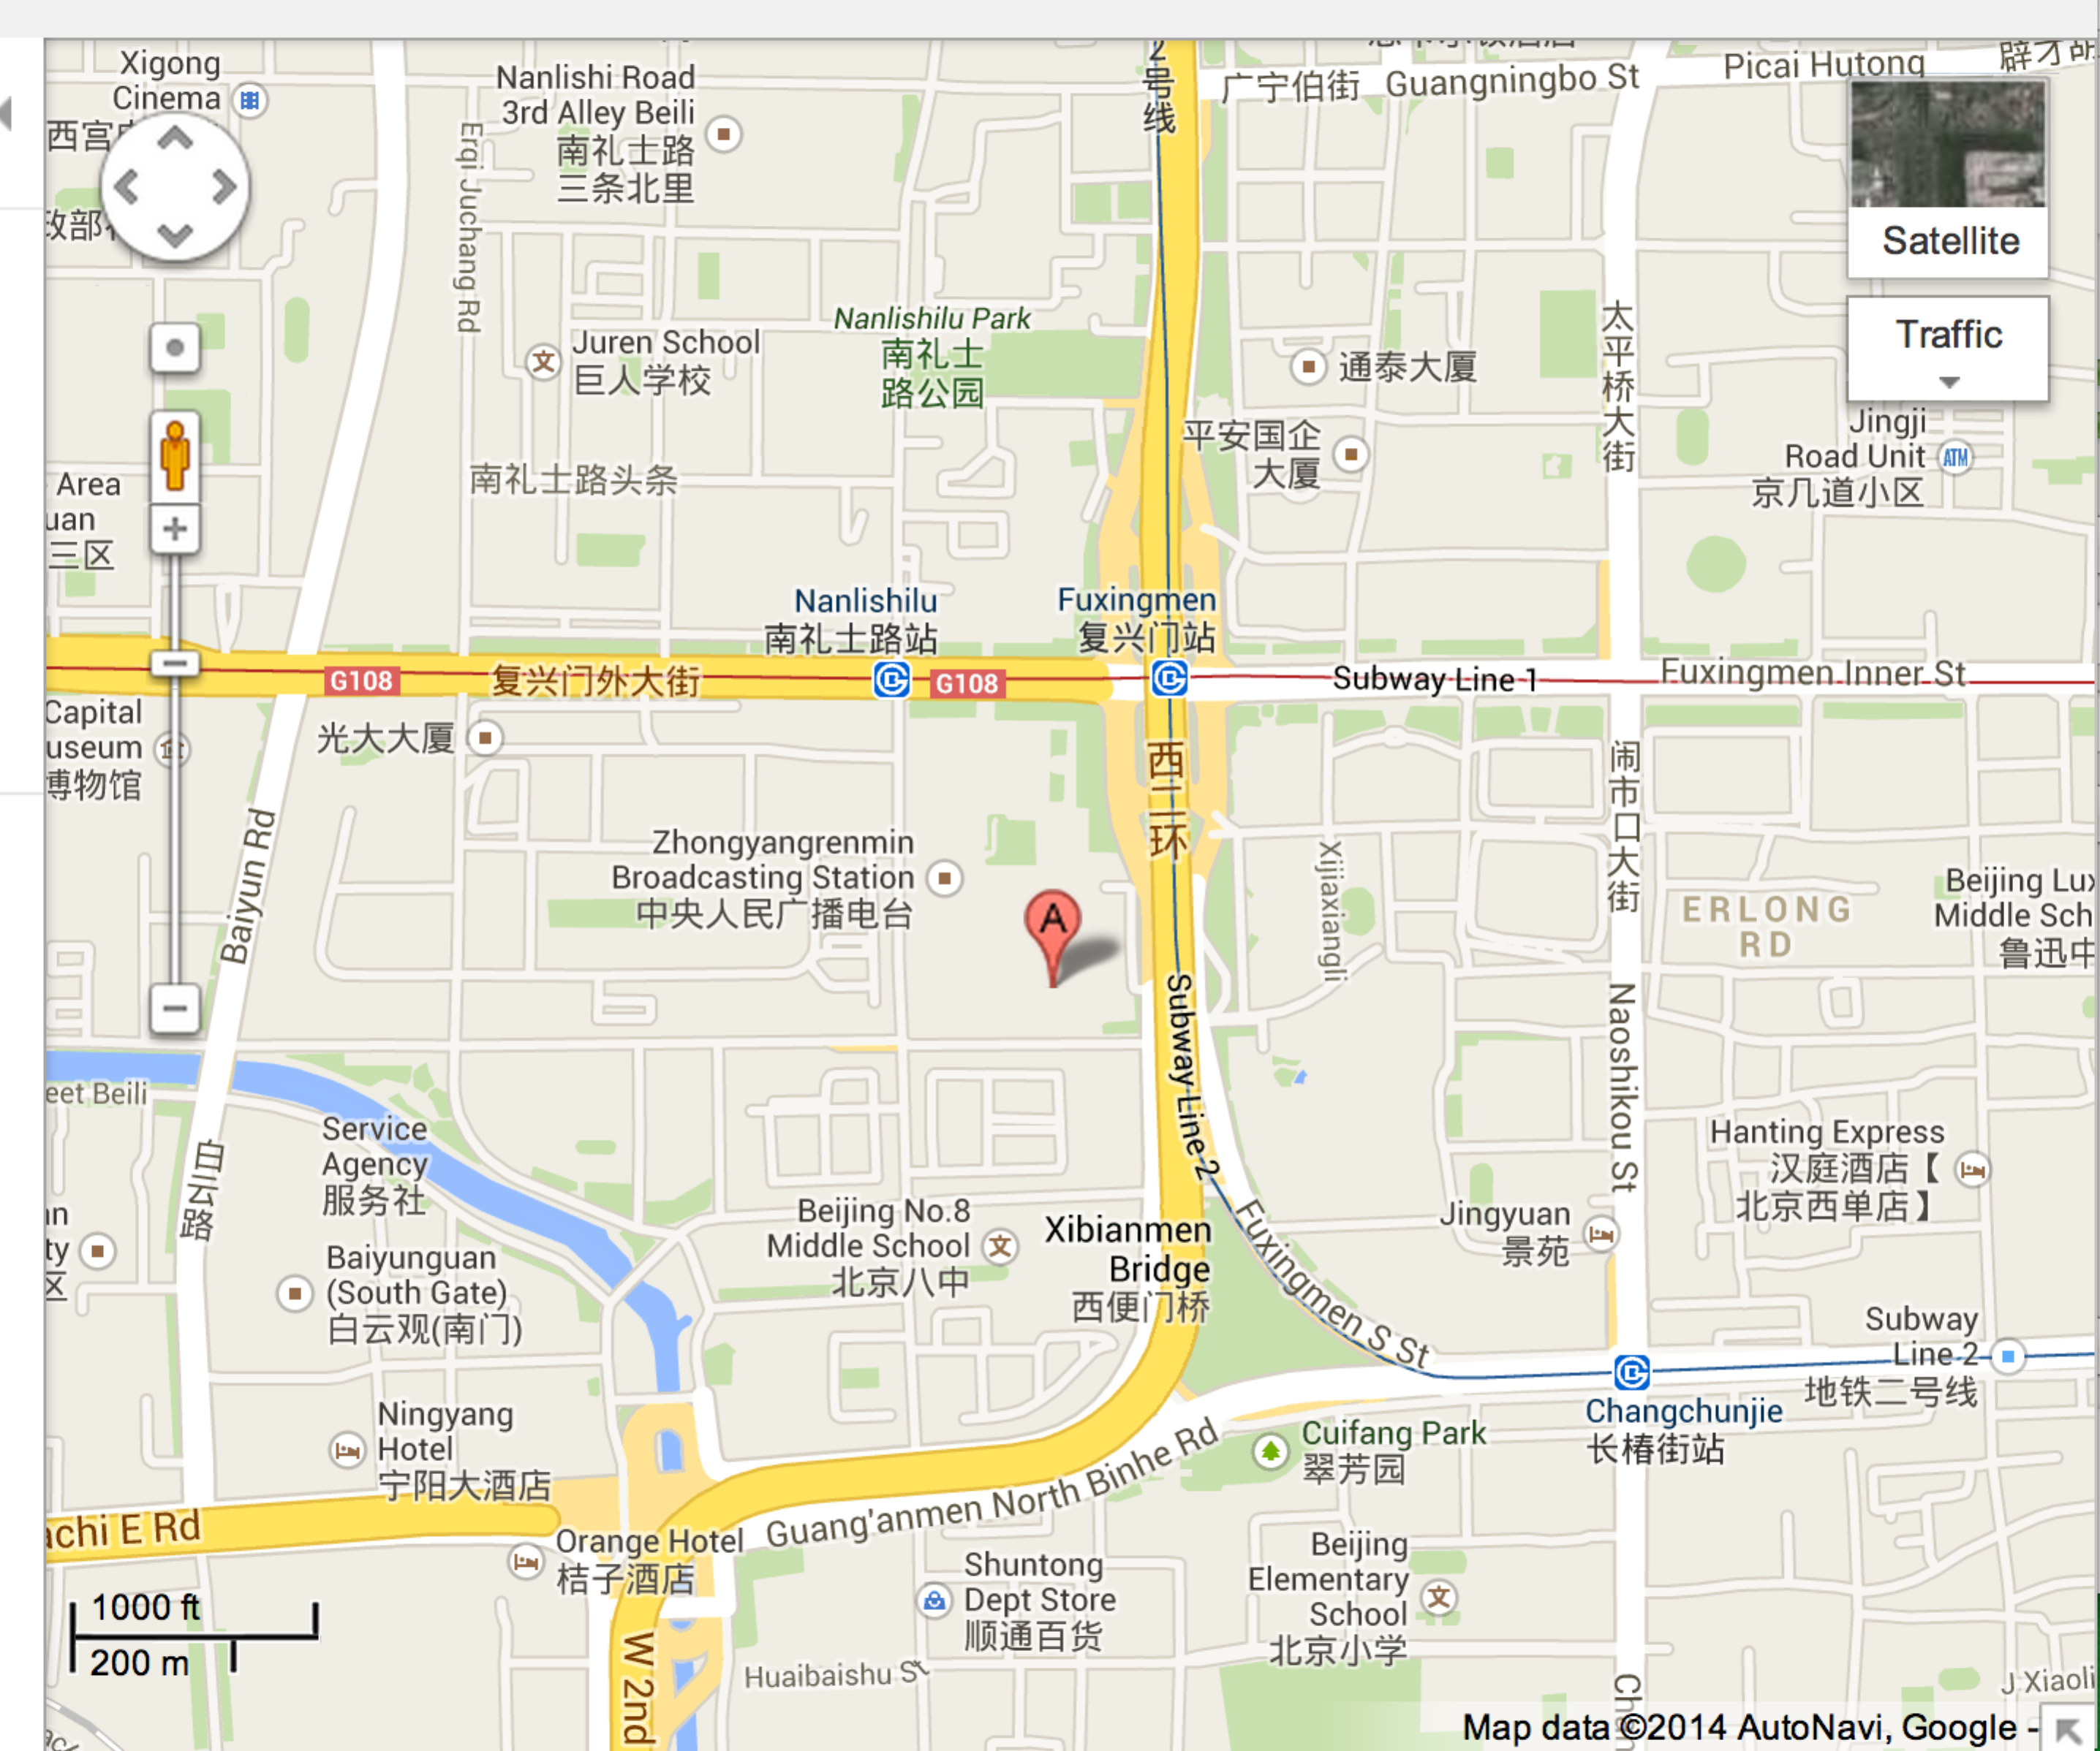

## Transportation and site information

**Transportation:**

About 34.2KM from Beijing Capital International Airport , Beijing.

Taxi about 150RMB.

## Passports and Visas

All foreign visitors entering China must have a valid passport. Visitors from countries whose citizens require a visa should at the earliest time and well in advance of travel apply for a visa at a Chinese Embassy or consulate. The following provides information relating to entry into China.

For an invitation letter, please see Annex 2.

## Climate – during Nov

Monthly Average values of the temperature and precipitation in Beijing, China are given in the table below:

|  |  |
| --- | --- |
|  | Nov |
| Average Max Temperature | 50°F/10°C |
| Average Minimum Temperature | 32°F/0°C |
| Average Precipitation | 3mm |

<http://en.weather.com.cn/weather/101010100.shtml>

## Hotels

The Merchantel Hotel, No.2 Xibianmen Outer Street, Xicheng District, Beijing

http://english.ctrip.com/hotels/beijing-hotel-detail-431614/the-merchantel/

InterContinental Beijing Financial Street Hotel, No.11 Financial Street, Xicheng District, Beijing

<http://www.starwoodhotels.com/westin/index.html>

China People Palace, No.1 Zhenwumiao Street, Xicheng District, Beijing

http://english.ctrip.com/hotels/beijing-hotel-detail-447703

## Internet access and wireless coverage

All meeting rooms will have a wireless network with access to the Internet. Every guest room offers a high-speed Internet access for free. The access to Internet will be granted using the LAN technologies listed below:

* Wireless via WiFi: IEEE 802.11a/n on 5.2 GHz and 802.11g/n on 2.4 GHz.

## Technical assistance

In case you have any technical problem at the venue (e.g. connecting to internet, finding meeting rooms etc.) please contact for help:

Dong Chen, +86-13651131862，tvos_wg@163.com

Feng Ouyang, +86-13511029034, [ouyangfeng@abs.ac.cn](mailto:ouyangfeng@abs.ac.cn)

Liyue Zhu, +86-13681246461, [zhuliyue@abs.ac.cn](mailto:zhuliyue@abs.ac.cn)

## Electricity

The electricity in China is generally 220V, 50HZ

Chinese standard

Such a socket is common in China, Australia, New Zealand and many other countries.

## Useful information

*Currency exchange*

# The currency in China is the yuan; please check the currency exchange rate in the local bank system or use the following link as a reference: <http://www.xe.com/>

## Additional information

****General Information for stay in Beijing****

**Mobile phone:** GSM and CDMA services provided by China Mobile, China Unicom and China Telecom.

**Currency:** local currency RMB Yuan(￥), the exchange rate of US$ and RMB is around 6.2.

**Tipping:** Tipping is not necessary.

**Time Zone**: GMT+8:00.

**Voltage:** 220 Volts50Hz. Please make sure you have the proper adapter.

The following is the picture for outlet type.

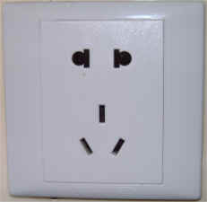

**Emergency Number:** In case of emergency please dial 110.

**Sight Seeing:**

Tiananmen Square, etc.

For more information see: <http://english.visitbeijing.com.cn>

## Contact persons

Heming Wang ([hermit.wangheming@hisilicon.com](mailto:hermit.wangheming@hisilicon.com))

Haifeng Yan(yanhaifeng@hisilicon.com)

Feng Ouyang ([ouyangfeng@abs.ac.cn](mailto:ouyangfeng@abs.ac.cn))

# ANNEX 2 – INVITATION LETTER REQUEST FORM

All foreign visitors entering China must have a valid passport. Visitors from countries **whose citizens require a visa should at the earliest time and well in advance of travel apply for a visa at a Chinese Embassy or consulate.** You may need a letter of invitation from the Chinese host, which you will need to present to the Chinese Embassy/Consulate in your area in order to obtain your visa. The visa must be requested at least four (4) weeks before the start date of the meeting and obtained from the office (embassy or consulate) representing China in your country or, if there is no such office in your country, from the one that is closest to the country of departure. In order to obtain the invitation letter, please:

1. Fill out the form below
2. Provide the electronic copy of foreigner's passport (the name, date of birth, nationality, passport number, valid date of passport, etc. must be seen clearly);
3. Provide the electronic copy of previous Chinese visa and records (if foreigners have been to China before);
4. Send the info in a), b) and c) as email attachments to: Qimeng Rong [Rongqimeng@hisilicon.com](mailto:Rongqimeng@hisilicon.com)   
   [please mark as reference in the subject **“Invitation letter request for ITU-T Q5/9 Rapporteur meeting”**:

(It is recommended to scan your passport page and email it to us so that it is discernible and can be used).

|  |  |  |  |  |  |
| --- | --- | --- | --- | --- | --- |
| **Company and Title** |  | | | | |
| **Applicant Information** |  | | | **❒Mr ❒Miss ❒Ms ❒Mrs** | |
|  | | | **Date of birth :** | |
|  | | | **Place of Issue:** | |
| **Date of Issue:** | | | **Date of Expiry:** | |
| **Marital Status:** | | |  | |
| **If the country in which you'll obtain your visa is different from your nationality, please indicate it here:** | | | | |
| **Address** | **Telephone Number:**  **Fax Number:**  **E-mail:** | | | | |
| **Note** |  | | | | |
| **Date of arrive at China** | |  | **Date of departure from China** | |  |

*(Please do not forget to attach a copy of your passport photograph page before sending.)*

***In order to receive an invitation letter, your information should be provided to the host before 10 Nov 2017.***

# ANNEX 3 – Draft meeting plan Draft timetable of Q5/9 Rapporteurs meeting (China, 30 Nov 2017)

|  |  |  |  |  |
| --- | --- | --- | --- | --- |
| **Meeting** | **Day 1 – 30/11/2017** | | | |
| **AM1** | **AM2** | **PM1** | **PM2** |
| Q5/9 | X | X | X | X |

**SESSION TIMES (unless otherwise noted):**

**Session 1**: 0930-1045; **Session 2**: 1115-1230; **Session 3**: 1430-1545; **Session 4**: 1615-1730; **Evening:** 1800-1915

|  |  |
| --- | --- |
| **X** | Represents a meeting session. |

________________