Additional Information on FG SmartCable and SG 9 Rapporteurs’ meetings

# Registration and getting to the meeting rooms (please read carefully)

The meeting rooms are located on the 34th floor of the venue “[**Shibuya Hikarie**](https://www.jreast.co.jp/e/info/map_a4ol.pdf)” or “**渋谷ヒカリエ**” [[Google Map](http://www.tokyo-skytree.jp/en/?q=Shibuya+Hikarie&ll=35.66006,139.703221)]. However, there are security gates on the 11th floor of the venue. Thus, a registration desk will be prepared at 9:00 am – 9:30 am on Thursday 26 September 2013 on the 11th floor of the venue. There are three ways to get to the 11th floor of the building as follows.

## Getting to the 11th floor of the venue

1. From Shibuya Excel Hotel Tokyu, JR-Shibuya station or Keio-Shibuya station

The walkway from the Shibuya “**渋谷**” station is connected to the 2nd floor of the venue. If you see the sign “**ヒカリエ** (Hikarie) →” in the walkway, please follow it. At the end of the walkway, you will continuously enter the venue on the 2nd floor. If you walk 50 meters more, you will find elevators on the left hand side. Please take an elevator to climb up to the 11th floor.

1. From other hotels, or for all those who will walk on the road to the venue

You will see elevators at the right hand side of the entrance of the venue on the ground floor. Please take an elevator to go up to the 11th floor.

1. From Tokyo Metro-Shibuya station (Tokyo Metro Hanzomon line, Tokyo Metro Fukutoshin line and Tokyu Toyoko line)

You can take an elevator on the B3 floor near the exit #15 of the Tokyo Metro-Shibuya station.

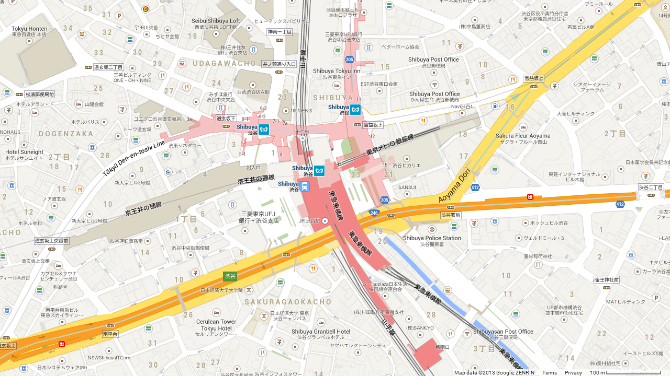  
Detailed map of Shibuya

**Route 3) B3 level**

**Route 1) 2nd floor**

**Route 2) ground level**

**Meeting Venue  
(Shibuya Hikarie)**

**Shibuya Station**

**Hotel Mets Shibuya**

**Cerulean Tower Tokyu Hotel**

**Shibuya Excel Hotel Tokyu**

**Shibuya Tokyu Inn**

## Getting the badge and entering the security gate

### The first day when you come to the venue

At 9:00 am (– 9:30 am) on Thursday 26 September, please get your ITU-T badge at the registration desk on the 11th floor. The registration desk is temporarily prepared only on 26 September, and it is separately placed from the general receptionist. **Please note the ITU-T badge is only available at the registration desk and the general receptionist will NOT provide the ITU-T badge.** If you arrive lately or if you cannot find the registration desk on the 11th floor of the venue, please call Mr Tomohiko Takahashi (+81 80 5943 9830).

After getting the badge, please present your ITU-T badge to the security guard to go through the security gate, then take an elevator to go up to the 34th floor, where the meeting rooms are located.

### The second day and after

**Next morning, please show your ITU-T badge** to the guard to go through the security gate, then take an elevator to go up to the 34th floor, where the meeting rooms are located.

If you firstly arrive after the second day (or you missed the opportunity to get your ITU-T badge on the first day), you need to get your ITU-T badge first and please call Mr Tomohiko Takahashi (+81 80 5943 9830).

# Detailed meeting plan with room assignments and Polycom availability

See Annex A of this document.

# Reception on Thursday 26 September

A reception hosted by KDDI will be held at 1900 on Thursday 26 September.

The name of the restaurant: Cruise Cruise Shinjuku (tel: 03 5485 3900)

Reserved by: Tomohiko Takahashi

Location: 8th/9th Floor, 3-5-4 Shinjuku, Shinjuku-ku, Tokyo 160-0022, Japan [[Google Map](http://www.e-akihabara.jp/en/map.htm?ll=35.691367,139.705643&spn=0.001634,0.002747&q=Cruise%20Cruise%20Shinjuku)]

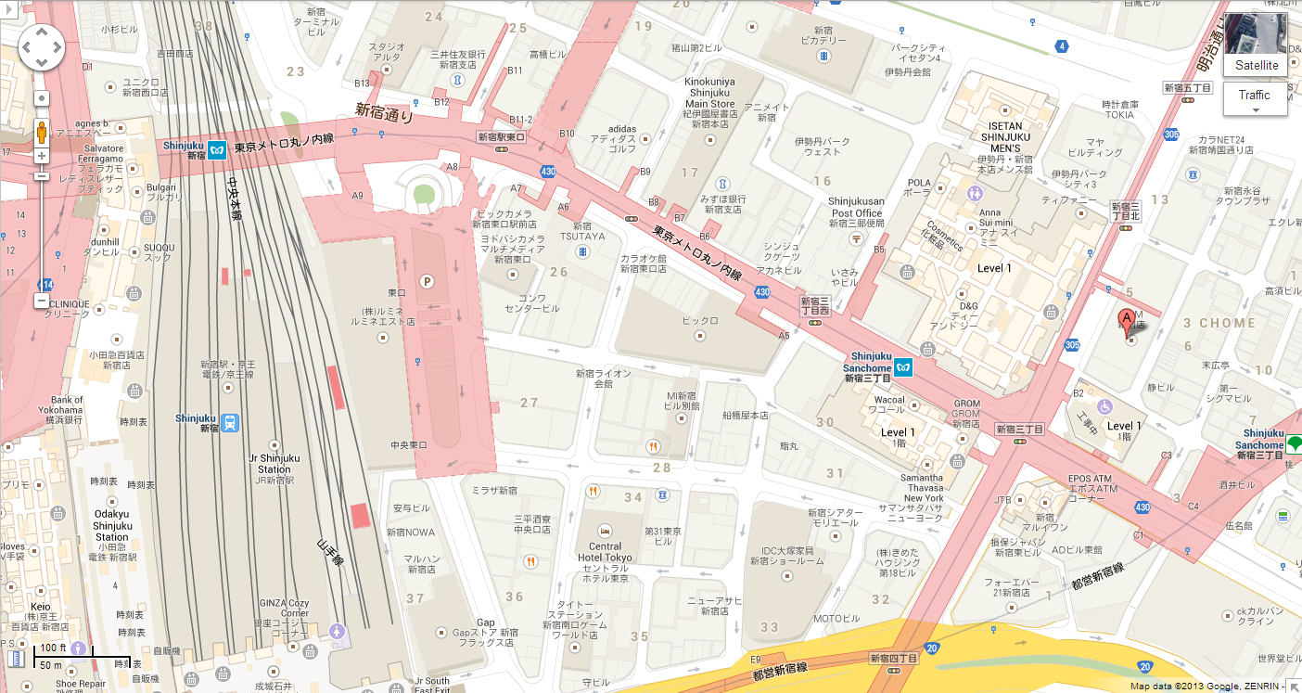

**Shinjuku Sanchome Station**

to Shibuya

**Here**

Shinjuku Station

Direction: Exit the meeting venue from the B3 floor. Walk to the Shibuya “**渋谷**” station (F16) platform #5 or #6, and take the Tokyo-Metro-Fukutoshin line. Get off at the Shinjuku-Sanchome (F13) “**新宿三丁目**” station. It will be an approx 5 minutes train ride. After getting off at Shinjuku-Sanchome, take an exit #E4, which is the basement of the building. Take an elevator to 8th or 9th floor (the floor will be determined on 26 Sep). For your reference, the ground floor of the building is H&M department store.

Tokyo Subway map is available [here](http://sankan.kunaicho.go.jp/english/guide/koukyo.html).

# Useful information for weekend

First of all, for all those who wish to explore Tokyo by train including subway, **it is strongly recommended to get a train fare card named “SUICA” or “PASMO.”** SUICA is sold by JR (Japan Railway Company) and PASMO is sold by other railway companies. These are fully compatible to each other, and you don’t need to get two of them. These fare cards are available on ticket vending machines at any stations.

For details, please visit the following URLs:  
[http://www.jreast.co.jp/e/pass/suica.html](http://highway-buses.jp/fuji/) for SUICA  
<http://www.pasmo.co.jp/en/> for PASMO

Senso-ji Temple

## Within the central Tokyo (up to 40 minutes trip from Shibuya)

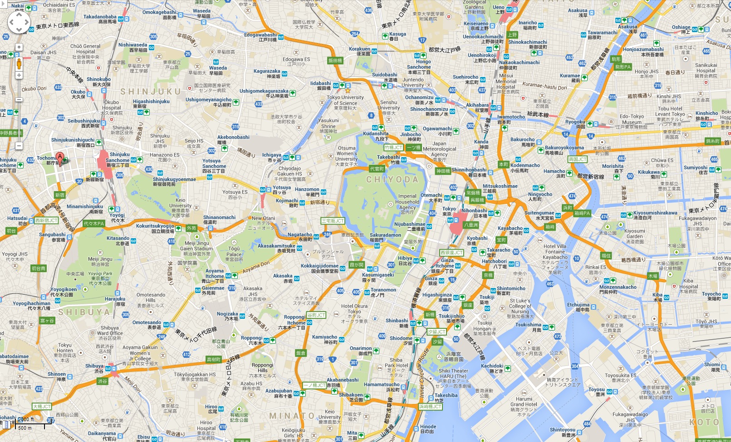

Tokyo Skytree (new TV tower, height of 634 metres)

Tsukiji (fish market)

Hamarikyu Garden

Akihabara area

Imperial Palace

**Hikarie**

KDDI HQ

Asakusa sta

Roppongi area

Tokyo Tower

Meiji-Jingu Shrine

Ueno sta

Ginza area

Tokyo sta

Shibuya sta

Shinjuku sta

The above map shows the locations of some selected train stations and some popular destinations to visit.

Tokyo Subway map is available [here](http://www.tokyometro.jp/station/common/pdf/rosen_eng.pdf).  
JR Train network is available [here](https://maps.google.com/maps).

The most convenient way to get around some of those places is to take bus tours available in the following URL:  
Half day tours: [http://www.hatobus.com/en/course/halfday.html](http://www.kunaicho.go.jp/e-event/higashigyoen02.html)  
Full day tours: <http://www.hatobus.com/en/course/fullday.html>

### Places you can enjoy in the evening

You will be able to enjoy some places such as [Tokyo Tower](http://www.hakonenavi.jp/english/), [Tokyo Sky Tree](http://www.hatobus.com/en/course/halfday.html), [Ginza area](http://www.japan-guide.com/e/e3005.html), [Roppongi area](http://www.japan-guide.com/e/e5201.html), even in the evening after the meeting.

### Places you can enjoy in early morning

[Meiji-Jingu](http://www.meijijingu.or.jp/english/index.html) Shrine opens at 5:20 am and closes at 5:20 pm in September, and opens at 5:40 am and close at 4:40 pm in October. Meiji-Jingu Shrine is located near JR Harajuku station, just one station from Shibuya or 10 minutes by taxi from Shibuya.

[Asakusa Senso-ji](http://www.hikarie.jp/en/) Temple oepns at 6:30 in the morning. However, it takes 35 minutes train ride from Shibuya station to Asakusa station. The morning train rush hour also should be taken into account (duration is almost the same, but the train will be crowded in weekday morning).

### Akihabara area

The nearest station is JR-Akihabara station, and you can also get off at Kanda (G 13) or Suehiro-cho (G 14) station of Tokyo Metro Ginza line (departing at Shibuya (G 01) station). It will take approx. 30 min from Shibuya to Akihabara. For more information,  
[http://wikitravel.org/en/Tokyo/Akihabara](http://www.odakyu.jp/english/romancecar/)  
<http://www.japan-guide.com/e/e3003.html>  
Akihabara Map: [http://www.e-akihabara.jp/en/map.htm](http://www.tokyometro.jp/station/common/pdf/rosen_eng.pdf)  
etc.

Akihabara is a very sprawling town, and it is recommended to make detailed research in advance of your visit particularly if you have something special to obtain. Even for Japanese residents, it is sometimes difficult to find right items which he or she wants to get.

**Your Japanese colleagues would welcome any consultation on how to get what you want in Akihabara.**

### Imperial Palace

If you wish to visit inside the Palace, you need to make a reservation through the web site.

Information: [http://sankan.kunaicho.go.jp/english/guide/koukyo.html](http://wikitravel.org/en/Tokyo/Akihabara)  
Visiting Application: <http://sankan.kunaicho.go.jp/english/about/koukyo.html>

In addition, the Imperial Palace East Gardens is opened to public. No reservation is required.  
[http://www.kunaicho.go.jp/e-event/higashigyoen02.html](http://www.japanican.com/tours/index.aspx)  
<http://www.japan-guide.com/e/e3018.html>

## Short excursion (a full-day trip from Tokyo)

Many travel guide books or web sites will suggest nice trips to the vicinity of Tokyo, but the following map shows our recommendation to visit.

Shibuya stn

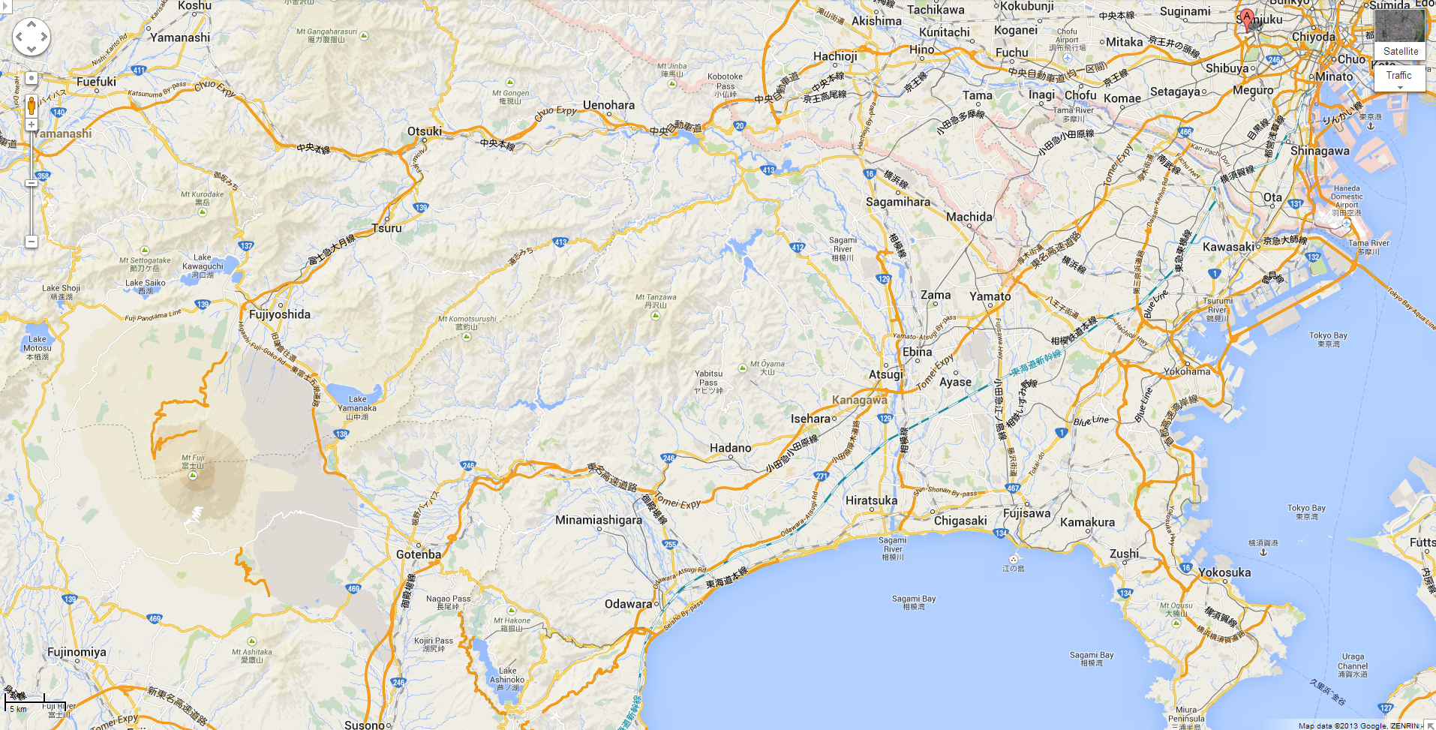

**Kamakura**

**Hakone**

Mt. Fuji

**Fuji Five Lakes area**

Taking bus tours is an efficient way to get to beautiful destinations particularly if this is your first time to visit Tokyo or Japan.  
Hakone: [http://www.hatobus.com/en/course/fuji.html](http://www.jreast.co.jp/e/pass/suica.html)  
Hakone: <http://www.japanican.com/tours/list.aspx?kw=fh1all>  
Kamakura: [http://www.japanican.com/tours/list.aspx?destcd=15&so=c](https://maps.google.com/maps?destcd=15&so=c)  
Generic: <http://www.japanican.com/tours/index.aspx?aff=EXJ>

### Kamakura

Kamakura is a historic town built in 1192, where you can see the Great Buddha and you can visit many temples. Some of JR train “Shonan-Shinjuku line” runs directly between Shibuya station and Kamakura station, and it will take approx. 50 minutes.  
<http://www.japan-guide.com/e/e2166.html>

### Hakone

Hakone is one of the most attractive destinations in Japan. You can take the fast train “[Odakyu Romancecar](http://www.japanican.com/tours/list.aspx)” departing at Shinjuku station to Hakone-Yumoto station. It will take approx. 90 minutes. Then, you can take a mountain train “[Hakone Tozan Railway](http://www.japan-guide.com/e/e5202.html)” to Gora station. If you prefer, you can further take a cable car (funicular) and a ropeway (an aerial tram) to get to the beautiful “[Lake-Ashinoko](http://www.tokyotower.co.jp/eng/)” where you can enjoy a sightseeing cruise on the lake.  
[http://www.hakonenavi.jp/english/](http://www.hatobus.com/en/course/fuji.html)  
<http://www.japan-guide.com/e/e5200.html>

### Fuji Five Lakes

Fuji Five Lakes is a recreation area closest to Mt. Fuji. [Highway buses](http://www.japan-guide.com/e/e3031.html) run from Shinjuku station to Lake Kawaguchiko, which is one of the five lakes around Mt. Fuji.  
<http://www.japan-guide.com/e/e6900.html>

## Two or three days trip from Tokyo

If you have sufficient time, you can enjoy a long trip to, for example, Kyoto, Hokkaido, Okinawa. The following URL is one of useful web sites.  
[http://www.japanican.com/tours/index.aspx?aff=EXJ](http://www.senso-ji.jp/about/index_e.html?aff=EXJ)

______________________

# ANNEX A – Draft meeting plan

Draft timetable of FG Smart Cable & SG9 Interim Rapporteurs meeting (Tokyo, Japan, 26 September – 2 October 2013)

|  | **Thu 26 September** | | | | | **Fri 27 September** | | | | | **Mon 30 September** | | | | | **Tue 1 October** | | | | | **Wed 2 October** | | | |
| --- | --- | --- | --- | --- | --- | --- | --- | --- | --- | --- | --- | --- | --- | --- | --- | --- | --- | --- | --- | --- | --- | --- | --- | --- |
|  | **AM** | | **PM** | | **E** | **AM** | | **PM** | | **E** | **AM** | | **PM** | | **E** | **AM*1** | | **PM** | | **E** | **AM** | | **PM** | |
| **FG SmartCable** | **MW** | **MW** | **MW** | **MW** | **R*2** | **MW** | **MW** | **MW** | **MW** |  |  |  |  |  |  |  |  |  |  |  |  |  |  |  |
| **Q1/9** |  |  |  |  |  |  |  |  |  |  | **AL** |  |  |  |  |  |  |  |  |  | **AL** |  |  |  |
| **Q3/9** |  |  |  |  |  |  |  |  |  |  |  |  | **VE** | **VE** |  |  |  |  | **AL** |  |  |  |  |  |
| **Q4/9** |  |  |  |  |  |  |  |  |  |  | **PO** | **PO** | **PO** | **PO** |  | **PO** | **PO** | **PO** | **PO** |  | **PO** | **PO** | **PO** | **PO** |
| **Q5/9** |  |  |  |  |  |  |  |  |  |  |  |  | **AL** |  |  |  |  |  |  |  |  | **AL** |  |  |
| **Q7/9** |  |  |  |  |  |  |  |  |  |  |  | **AL** |  |  |  |  | **AL** |  |  |  |  |  |  |  |
| **Q8/9** |  |  |  |  |  |  |  |  |  |  |  | **MW** |  |  |  |  |  | **MW** |  |  |  |  |  |  |
| **Q9/9** |  |  |  |  |  |  |  |  |  |  | **MW** |  |  |  |  |  |  |  |  |  |  |  |  | **MW** |
| **Q10/9** |  |  |  |  |  |  |  |  |  |  |  |  |  | **AL** |  |  |  | **AL** |  |  | **MW** | **MW** |  |  |
| **Joint Q1, 7/9** |  |  |  |  |  |  |  |  |  |  |  |  | **MW** | **MW** |  |  |  |  | **MW** |  |  |  | **MW** |  |
| **Joint Q5, 8, 9/9** |  |  |  |  |  |  |  |  |  |  |  |  |  |  |  | **MW** | **MW** |  |  |  |  |  |  |  |

SESSION TIMES (unless otherwise noted):

Session 1: 0930-1045; Session 2: 1115-1230; Session 3: 1430-1545; Session 4: 1615-1730; Evening Sessions: 1800-1915

|  |  |
| --- | --- |
| **E** | Represents an evening session (starts at 1800) |

Note 1: AM1 starts at 1015 only on Tuesday 1 October due to host facility reason.

Note 2: Reception is planned. See Section 3 for details.

MW (MILKY WAY), max 24 persons, Polycom (mobile phone) available

PO (POLARIS), max 12 persons, Polycom (fixed phone line) available

AL (ALTAIR), max 8 persons

VE (VEGA), max 8 persons