|  |  |  |
| --- | --- | --- |
| INTERNATIONAL TELECOMMUNICATION UNION | | **Joint Coordination Activity On Identity Management** |
| **TELECOMMUNICATION STANDARDIZATION SECTOR**  STUDY PERIOD 2013-2016 | | **DOC 129 Rev.1** |
| **English only**  **Original: English** |
|  | | Geneva, 17 April 2013 |
| **DOCUMENT** | | |
| **Source:** | TSB | |
| **Title:** | Practical facilities available for the conduct of the work of JCA-IdM | |

This document provides information on

Electronic facilities:

* TIES account and guest account
* Internet access and WIFI access
* GotoToMeeting, Cavoon, Audio Bridge, and Adobe Connect dial-in facilities
* Printers
* Mailing list
* JCA-IdM Documents
* Useful ITU-T related URLs.

Appendix 1 – Rooms and facilities

* Normal working hours

# 1 Electronic facilities:

## 1.1 TIES account and guest account

1. TIES account: ITU-T members are eligible to create a TIES account at <http://www.itu.int/cgi-bin/htsh/mm/scripts/reg.screen1.html>
2. Guest account: non ITU-T members (such as invited experts with authorization) can create a guest account at: <https://www.itu.int/net/iwm/public/frmUserRegistration.aspx>

See also: [http://www.itu.int/ITU-T/services/](http://www.itu.int/ITU-T/services)

## 2 Internet access and WIFI access

Wireless LAN facilities are available for use by delegates in the ITU main conference room areas.

To connect to ITUwifi:

1. Click the WiFi icon in the notification tray. This will show a list of available WiFi networks.
2. Choose "ITUwifi" and click the Connect button.
3. Enter the security code: "itu@GVA1211".

Detailed information is available on the ITU-T website (<http://www.itu.int/ITU-T/edh/faqs-support.html>).

In order to connect to the ITU Delegate LAN via WiFi, the new SSID **ITUwifi** is available. It should be configured with **WEP/security off; Infrastructure mode**. This SSID requires authentication using a web browser. Type a valid URL in the browser, and you will be redirected to the ITUwifi authentication page (https://wifi.itu.int/...). Credentials for delegates can be either:

* using your TIES or guest account username and password; or
* using the username and password printed on the side of delegate's badges (see figure)

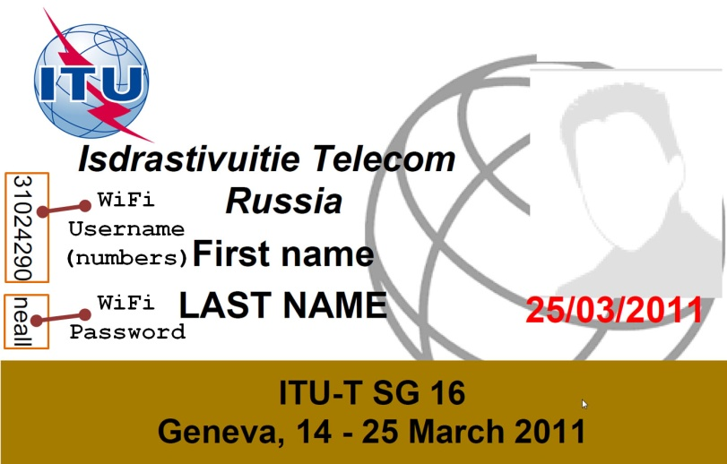

Once authenticated, the credentials will be valid for 24 hours after your last disconnection. Therefore, in principle, you should be requested to authenticate only once during a week of meetings.

The **wired LAN** access continues to be available as before in the meeting rooms of the Montbrillant building as well as in the Cyber Café areas. More details on the EDH facilities (including instructions on how to set-up the wireless LAN adapter) can be found in the Web page for TSB EDH at: <http://itu.int/ITU-T/edh/faqs-support.html>. Instructions for setting up the wireless LAN facilities can be found at: <http://itu.int/ITU-T/edh/files/InfoWirelessLAN.pdf>.

### 3 GotoToMeeting and Audio Bridge dial-in facilities, room reservation requests

Rapporteurs/editors/chairmen please send please your room reservation requests or GotoMeeting requests or audio bridge requests by email to [martin.euchner@itu.int](mailto:martin.euchner@itu.int) and indicate

* For room requests: which day and session quarter the meeting should occur; which text should be displayed on the screens; estimated number of participants of the meeting;
* For GotoMeeting requests: when the electronic meeting is to take place; if VoIP and/or PSTN audio bridge is required;
* For PSTN audio bridge requests: in which room (and when) the electronic meeting is to take place;

Announcements will be made on the TV screens then.

***Rapporteurs needing extra-session, in particular after-hours, should make a request to TSB as soon as possible but no later than 16:30 of the day affected.***

[GoToMeeting](http://www.gotomeeting.com/fec/online_meeting) and [GoToWebinar](http://www.gotomeeting.com/fec/webinar) are teleconference tools used by TSB to support virtual meetings and to allow remote participation of physical meetings. The audio component allows participants to speak and listen to others, and the "whiteboard" function allows individuals to share their screen's display with others.

Designated organizers can set up meetings, invite participants, and control the sound and video.

### Differences between GoToMeeting and GoToWebinar

GoToMeeting supports collaboration between small groups (26 participants maximum, including TSB support staff). GoToMeeting is a free service and TSB can run up to 6 simultaneous meetings (unless GoToWebinar sessions are also being run*); however, this number is reduced if the Electronic Document Handling (EDH) service is required to run the meetings.

GoToWebinar supports collaboration between larger groups (up to 1000 participants), and also allows Question and Answer (Q&A) sessions, polls and surveys. GoToWebinar is a paid-for service, and requires EDH support in all cases - TSB is therefore limited to up to 4 simultaneous meetings (unless GoToMeeting sessions are also being run*).

*GoToMeeting and GoToWebinar use the same accounts, and no more than 6 meetings of either type can be run simultaneously.

## Audio bridges

Participants can join a teleconference by dialing into a special telephone number that connects to an "audio bridge". The audio bridge allows participants to speak or listen to a teleconference using a conventional telephone. Such audio bridges can be used alone to run an audio-only.

Companies commonly use a specialized service provider who maintains the conference bridge, or who provides the phone numbers and PIN codes that participants dial to access the meeting or conference call.

When arranging a GoToMeeting using a separate audio bridge, include the necessary information in the GoToMeeting details - this will avoid having to add this information later.

## Integrated toll-free (ITF) GotoMeeting

The integrated toll-free GotoMeeting (currently a trial) allow delegates to either dial-in to an audio telephony bridge (several toll-free numbers are provided), or delegates choose to use the integrated VoIP feature of GotoMeeting.

**Join the conference call:**

1. **Join using PSTN:**
   1. Dial the toll-free number provided. You can also choose from the list of Toll-Free numbers by country.
   2. Put in the Access Code
   3. Input the PIN provided by GotoMeeting to get recognized by the system. (this allows for the participants to see who is currently speaking.)

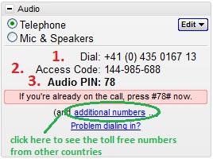

1. **Join using VoIP:**

You will be connected to audio using your computer's microphone and speakers (VoIP). A headset is recommended.

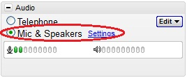

**List of Toll-Free numbers by country:**

Argentina (toll-free): 0 800 266 1382

Australia (toll-free): 1 800 193 385

Austria (toll-free): 0 800 202148

Bahrain (toll-free): 800 81 111

Belarus (toll-free): 8 820 0011 0214

Belgium (toll-free): 0 800 26116

Brazil (toll-free): 0 800 047 4906

Canada (toll-free): 1 888 455 1389

China (toll-free): 4008 811084

Czech Republic (toll-free): 800 500448

Denmark (toll-free): 8090 1924

Finland (toll-free): 80094507

France (toll-free): 0 805 541 047

Germany (toll-free): 0 800 723 5270

Hong Kong (toll-free): 30713169

Iceland (toll-free): 800 9869

India (toll-free): 000 800 100 7855

Indonesia (toll-free): 007 803 011 0395

Ireland (toll-free): 1 800 946 538

Israel (toll-free): 1 809 212 875

Italy (toll-free): 800 906959

Japan (toll-free): 00 120 663 800

Korea, Republic of (toll-free): 806150880

Luxembourg (toll-free): 800 22104

Malaysia (toll-free): 1 800 81 5373

Mexico (toll-free): 01 800 925 0372

Netherlands (toll-free): 0 800 265 8469

New Zealand (toll-free): 0 800 45 2202

Norway (toll-free): 800 30 257

Panama (toll-free): 00 800 226 8832

Peru (toll-free): 0 800 54682

Philippines (toll-free): 1 800 1651 0716

Poland (toll-free): 00 800 1213979

Portugal (toll-free): 800 784 461

Russian Federation (toll-free): 810 800 29674011

Singapore (toll-free): 800 120 5615

South Africa (toll-free): 0 800 983 867

Spain (toll-free): 0 800 900 582

Sweden (toll-free): 020 980 772

Switzerland (toll-free): 0 800 740 393

Thailand (toll-free): 001 800 658 131

Ukraine (toll-free): 0 800 50 0641

United Kingdom (toll-free): 0 808 168 0229

United States (toll-free): 1 877 309 2073

Uruguay (toll-free): 000 413 598 4110

Viet Nam (toll-free): 120 65 157

## Cavoon

During the conference:

Upon pressing * plays the voice menu "Press 1 to mute/unmute yourself, 2 to lock/unlock this conference".

* 1 - mute/unmute

* 2 - lock/unlock conference

* 3 - eject last user who joined conference

* 4 - Decrease Volume of Conference with each 4 you press - end with 8

* 6 - Increase Volume of Conference with each 6 you press - end with 8

* 7 - Decrease your volume - end with 8

* 9 - Increase your volume - end with 8

When using a Cavoon bridge, include the following text in the GoToMeeting[?](http://foswiki.itu.int/foswiki/bin/edit/TSB/GoToMeeting?topicparent=TSB.GoToMeetingAndGoToWebinar) invitation:

|  |
| --- |
| **Audio conference call options:**  **Option 1:** Participants will dial in and will pay for the call to the Swiss telephone number provided. You will be asked to enter the conference pin number, provide your name and then you are connected to the audio conference.  **Option 2:** Participants dial in and then request the system to call them. You will be asked to enter the conference pin number, provide your name and then you are connected to the audio conference. Participants will pay for the short initial call to a Swiss telephone number and ITU will pay for the rest.  **Very Important!** For Option 2, participants should provide a direct telephone line or a local number in case they are calling from a trunk line. The participant should also provide the full telephone numbers including the country code preceded by “**00**”. For example, **0081** for a telephone number in Japan.  Note: For more information, please read the following: <http://www.itu.int/ITU-T/edh/faqs-gotomeeting.html> |

**3.1 Adobe Connect**

Adobe Connect is a new TSB service to support teleconferencing from ITU meeting rooms. Adobe Connect is deemed of better quality than GotoMeeting.

|  |  |
| --- | --- |
| **Logging in the Room:** | |
| Open your browser and enter the name of the meeting room with “**xx**” as the specific room:  **http://itu.adobeconnect.com/xx/**  When prompted, please put in your login information so the host can easily identify you. example: John Smith (ITU). |  |
| **Inside Adobe Connect:** | |
| There are three options to join this meeting:   * Option 1: Listen through computer speakers (listen mode only) * Option 2: Participate using headset with microphone through VoIP * Option 3: Dial-in or dial-out to yourself over the phone.   **Option 1:**    By choosing this option, you can only listen to the conference. You won’t be able to speak.  A chat box is available if you wish to make some comments.  **Option 2:**  ***Only use this if you have good Internet connection.***  Choose the same option as option 1 to listen through computer speakers.  Once that is done, click on the icon as shown below to connect your headset.    **Option 3:**     * Click on “**Call My Phone**” * Select the country * Type in your number   The system will then call you on the specified number. To mute/unmute yourself, press *6. | |

### 4 Printers

New high yield HP printers that are now available to delegates. The printers are:

| Printer name* | Location |
| --- | --- |
| \\delprint\hpdelg1 | Varembé rooms G1/G2 (3rd floor) |
| \\delprint\hpdel2ss_gr | CyberCafé in 2nd basement of the Tower (Note: two printers on same queue) |
| \\delprint\hpdelm2_ps | CyberCafé in 2nd floor of the Montbrillant building |
| \\delprint\hpdelm1 | 1st floor of the Montbrillant building, near meeting rooms |
| \\delprint\hpdelt1 | 1st floor of the Tower (near T.101 and T.103 rooms) |

* Please note these are A4 printers. If you try to printer a document of another size (e.g. Letter), make sure the WinWord option “resize A4/Letter” is enabled.

Annex A hereinafter shows how you can install printers on a Windows computer. (Detailed screenshots are provided for Windows 7)

This information is also available online in the Delegate Resources page (<http://www.itu.int/ITU-T/info/dresources.html>), under Tools / “High-volume printers available in delegate areas”.

Please report any problems or maintenance issues to the IS Service Desk at extension 6666 (or by email to [servicedesk@itu.int](mailto:servicedesk@itu.int)), mentioning the printer name, location and a description of the problem.

See the online guide in the Delegate Resources page (<http://itu.int/ITU-T/info/dresources.html>), under Tools / “[High-volume printers available in delegate areas](http://www.itu.int/dms_pub/itu-t/oth/37/02/T37020000010002MSWE.doc)”.

**Connecting to Delegate printers:**

All printers in the delegate areas are labeled with the *print server name, print queue name* and *IP address*. To connect to the printer:

Option 1:

Do Start > Run; enter \\delprint

A list of available print queues are displayed, select the printer name that matches the *print queue name* labeled on the printer, e.g. HPDELM1

If you are prompted for authentication, use the same as for WiFi connection

Option 2:

Install a local printer using the IP address

Do Start > Devices and Printers > Add a printer

Select “Add a local printer”

Select “Create a new port” > “Standard TCP/IP Port” > Next

Enter the IP address marked on the printer

Please report all problems and issues (e.g. printer not responding, paper jam, no paper, lack of toner, etc.) to Service Desk, Room V29, Email: [servicedesk@itu.int](mailto:servicedesk@itu.int), Phone 6666

Hours: 09:00-12:30, 13:30-17:00 Mon-Fri

**Printing via email (Trial mode at present):**

In a trial, it is now also possible to print a document by sending it as an email attachment to one of the printers below. This avoids installing and configuring printer drivers on the PC/laptop.

ITU Information Services (IS) department has made available various high-volume printers in the delegate network and located near the various meeting rooms and delegate spaces. One can find the name of the available printers queues in the \\delprint.itu.int server (accessible only within the ITU network).

In addition to the "traditional" print method using printer queues that need to be installed on the user's computer or device, a new feature has been introduced in October 2011 that allows printing documents via e-mail ("e-print"). The procedure is simply to attach the documents to be printed to an email that is sent to the desired printer email address, as listed in Table 1. No driver installation is required.

E-print is well-suited for smartphones and tablets, but can be used from any computer equipped with an Internet connection. E-print is not convenient for some customized print jobs – for example, to print a few pages of a document, particular views of an excel spreadsheet, or files types that not recognized by the e-print server. In these cases, the "traditional" printing method using print queues is normally more convenient (as an alternative to generating a PDF of the desired customized printing).

Please report any problems or maintenance issues to the IS Service Desk at extension 6666 (or by email to [servicedesk@itu.int](mailto:servicedesk@itu.int)), mentioning the printer name, location and a description of the problem. If you need to *cancel* an e-print job, please also contact the IS Service Desk.

A submitted printing request is first confirmed via email:

## Processing your message...

Your message reached HP ePrint and it is currently being processed.

Date: 13.09.2011 14:45:36  
Printer: hpdelm1  
Sender: Euchner, Martin  
Subject: print 1 doc

And once the printer has completed its task, another email is returned:

## Message printed!

A message you sent, and all supported included attachments was printed.

Date: 13.09.2011 14:45:36  
Printer: hpdelm1  
Sender: Euchner, Martin  
Subject: print 1 doc

**This is still a trial and TSB is interested to hear your experiences.**

**Known caveats:**

* Printers are not configured uniformly: some print single sided, some print double sided. This cannot be controlled via email.
* Printers running out of paper, having a paper jam or facing other service outages do not indicate this in any email. The print task may be discarded silently.
* Some printers can print multiple attachments in an email, but in other instances, may choke on multiple attachments.

Table 1 – ITU printers available for e-print by delegates

| Printer name*,** | Email address | Location |
| --- | --- | --- |
| \\delprint.itu.int\hpdel2ss | hpdel2ss@eprint.itu.int | Cybercafé in 2nd basement of the Tower (Note: two printers on same queue) |
| \\delprint.itu.int\hpdelg1 | hpdelg1@eprint.itu.int | Outside Varembé rooms G1/G2 (3rd floor) |
| \\delprint.itu.int\hpdelg3 | hpdelg3@eprint.itu.int | Outside Varembé room G3 (3rd floor) |
| \\delprint.itu.int\hpdelm1 | hpdelm1@eprint.itu.int | 1st floor of the Montbrillant building, near meeting rooms |
| \\delprint.itu.int\hpdelm0 | hpdelm0@eprint.itu.int | Delegate Lounge in ground floor of the Montbrillant building (Note: ex hpdelm2) |
| \\delprint.itu.int\hpdelt01 | hpdelt01@eprint.itu.int | 1st floor of the Tower (outside offices T.101 and T.103 rooms) |
| \\delprint.itu.int\hpdelt072 | hpdelt072@eprint.itu.int | Tower building office T072 |
| \\delprint.itu.int\hpdelt079 | hpdelt079@eprint.itu.int | Tower building office T079 |
| \\delprint.itu.int\hpdelv450 | hpdelv450@eprint.itu.int | Near Varembé room V450 (4th floor) |
| \\delprint\hpdelroome | hpdelroome@eprint.itu.int | Near Varembé room E (Note: ex \\delprint\HPsalleE) |
| \\europa\hpdelv444 | hpdelv444@eprint.itu.int | Near Varembé room V444 (4th floor) |

* * Please note these are A4 printers. If you try to printer a document of another size (e.g. Letter), make sure the WinWord option "resize A4/Letter" is enabled.
* ** The printer names listed are an update of earlier lists. Please always check \\delprint.itu.int\ for the latest printer names

NOTE – For "traditional" printing to the printers above, please see the online guide in the Delegate Resources page (<http://itu.int/ITU-T/info/dresources.html>), under Tools / "[High-volume printers available in delegate areas](http://www.itu.int/oth/T3702000001)", for details on how to connect to them.

### 5 Mailing list

[*http://www.itu.int/ITU-T/studygroups/com17/edh/ifa-structure.html*](http://www.itu.int/ITU-T/studygroups/com17/edh/ifa-structure.html)

The JCA-IdM mailing list has been migrated to the new system (called “Sympa”), which requires re-subscription using either a TIES account or a “[Guest account](http://www.itu.int/ITU-T/edh/faqs-guest.html)”. The temporary measure that was put in place to ease the migration to the new email system has now been discontinued.

Subscription to the new mailing list can be done using the new mailing subscription interface at: <http://www.itu.int/tiesutils/asp/home.asp>. Delegates should note that service subscription is **automated** for **TIES** account holders with the necessary rights, but requires a *special request for Guest accounts*.

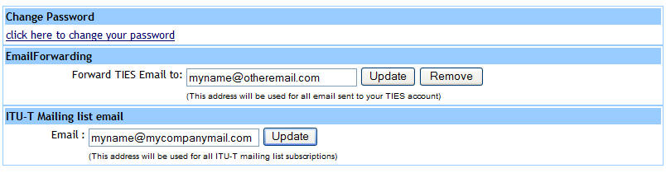

The new “**ITU-T Mailing list email**” field can be configured at the TIES account web page, whose direct link is <http://www.itu.int/tiesutils/asp/account.asp> (a login screen will intervene before accessing this page). Additional details can be found in the EDH FAQ page for mailing lists, <http://www.itu.int/ITU-T/edh/faqs-email.html>, item “**With what e-mail address am I subscribed to the mailing list?**”

**Subscription to JCA-IdM mailing list:**

Please subscribe via

<https://www.itu.int/net/iwm/private/frmMyServices.aspx>

or via

<https://www.itu.int/net4/iwm/?p0=0&p11=ITU&p12=ITU-SEP-ITU-T-SEP-Other%20Groups-SEP-jca-idm&p21=&p22>=

### 6 JCA-IdM Documents

The JCA-IdM web page is available at: [http://www.itu.int/en/ITU-T/jca/idm](http://www.itu.int/en/ITU-T/jca/idm/)

JCA-IdM documents are available at:  
<http://www.itu.int/en/ITU-T/jca/idm/Pages/docs-1316.aspx>

7 Useful ITU-T related URLs

|  |
| --- |
| *– JCA-IdM web page:*  [http://www.itu.int/en/ITU-T/jca/idm](http://www.itu.int/en/ITU-T/jca/idm/) |
| *– EDH FAQ:*  <http://itu.int/ITU-T/edh/edh-faqs.html> |
| *– ITU-T Electronic Working Methods (EWM)* <http://www.itu.int/ITU-T/edh/index.html>  *– Templates* <http://www.itu.int/ITU-T/studygroups/templates/index.html> |
| *– ITU-T Recommendations:*  <http://itu.int/rec/T-REC> |
| *– ITU-T Seminars & Workshops*  <http://itu.int/ITU-T/worksem> |
| *– Meeting room allocation (real-time database, same as ITU monitors)*  <http://itu.int/events/ExtWebDailyagenda.asp?sector=ITU-T> |
| *– Subscription to ITU-hosted emailing lists (Sympa)*  [http://itu.int/ITU-T/services/](http://www.itu.int/ITU-T/services) |
| *– Updating TIES profile*  <http://www.itu.int/tiesutils/asp/account.asp> |
| *– TIES Access*  [*http://www.itu.int/TIES/*](http://www.itu.int/TIES) |
| *– Electronic Meetings*  *Electronic Forum Service:* <http://forum.itu.int/jive/index.jspa?categoryID=2>  *Procedures*: <http://itu.int/ITU-T/edh/files/emeeting-guide.pdf> |
| *– Meeting documents in tree view*  <http://itu.int/ITU-T/meetingdocs/> |
| *– ITU Delegate LAN configuration instructions for wireless access*  <http://www.itu.int/ITU-T/edh/files/InfoWirelessLAN.pdf> |

# Appendix 1 - Rooms and facilities

Address of ITU-T in Geneva:

International Telecommunication Union (ITU)  
Place des Nations   
CH-1211 Geneva 20   
Switzerland

The ITU-T buildings can be entered via

* Montrillant building (at the corner of the Rue Varembé); featuring front desk for registration
* Varembé building (requires badge)
* Tower.

Note - Only the Tower entrance is open on weekends.

**A.1 Lockers**

Lockers are available in the Montbrillant building. Please use the corresponding input terminal in the row of your locker.

**To occupy a locker:**

1. Select an empty locker
2. Place your belongings inside it
3. On the input terminal, enter the locker number and press the validation key
4. Present your ID badge in front of the card reader
5. Await confirmation of occupancy
6. Close your locker

**To release your locker:**

1. Present your ID badge in front of the card reader
2. Your locker will open automatically
3. Remove your belongings

Once you have finished with a locker, please leave it open, ready for use by another participant. **Please note that your locker is available to you only for the period of the meeting you are attending. After that period, your ID badge will no longer open the locker, so please ensure that you emptied your locker before the end of the meeting.**

**If you have a problem with opening your locker, please contact the Security Staff at the building entrance.**

The work plan with the room allocations to sessions during the forthcoming and/or current SG17 meeting is regularly updated on the SG17 web page at: [Work plan](http://www.itu.int/en/ITU-T/studygroups/com17/Documents/info/meetings/20120220/workplan-20120220.docx)

A daily snapshot of the TV screens and the scheduled sessions with room allocation can be obtained from: <http://itu.int/events/ExtWebDailyagenda.asp?sector=ITU-T>

### A.2 Desk panel in room Popov (Room B)

Channel up/down for language selection  
(press once to  
turn on audio)

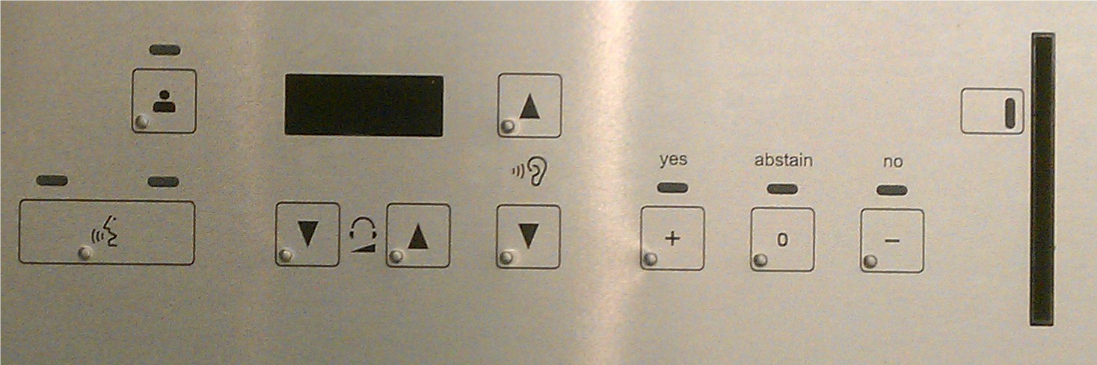

Point of order

(not used in this meeting)

Card reader

(not used in this meeting)

Volume down/up

Voting buttons

(not used in this meeting)

Microphone on/off

(take the floor)

### A.3 Working Hours

Normal working hours will be 9:30‑10:45 (1Q); 11:15‑12:30 (2Q); 14:30‑15:45 (3Q); and 16:15‑17:30 (4Q).

Consequently, coffee breaks should be held *10:45 to 11:15* in the *mornings* and *15:45 to 16:15* in the *afternoons*.

Lunch break is 12:30‑14:30.

Evening sessions normally start at 18:00 (5Q). Operation outside regular operating hours should be avoided.

___________