INTERNATIONAL TELECOMMUNICATION UNION |  | Joint Coordination Activity  On Accessibility and Human Factors
TELECOMMUNICATION  STANDARDIZATION SECTOR  STUDY PERIOD 2013-2016 |  | Doc 24
English only
Original: English
Source: | JCA-AHF Co-convener
Title: | Subtitle survey 2012
Subtitle survey 2012
Introduction
Subtitles are vital to deaf people’s understanding of television programmes.
“They have transformed my leisure time making it possible to watch/hear/understand TV programmes which I just couldn't do without subtitles.” Survey respondent
Positively, the amount of programmes with subtitles has steadily increased over the past few decades as a result of both legislation and a commitment from broadcasters. However, we regularly receive complaints about the quality of subtitles from our members and supporters. Ofcom (the communications regulator) agreed to look into this issue and we therefore decided to undertake a survey of people’s experience of subtitles to ensure that we had up to date research to inform Ofcom’s review.
We opened the online survey at the end of July and received 580 responses by early September. As people watched TV, we asked them to note down any problems with subtitles, the name of the programme, the time and date, and channel. The survey provided space for 3 different programmes, although there was nothing to stop someone from filling it in again.
Findings
We asked respondents what television service they use. Two fifths of respondents use Freeview and over one fifth have Sky. The others use a variety of different services including Freesat and Virgin Media. Some who selected other watch television through the internet.

Table 1: Which of the following TV services do you have?
TV service | Number of responses | Percentage
Freeview | 261 | 43
Sky | 139 | 23
Virgin Media | 73 | 12
Other /no answer | 68 | 11
Freesat | 44 | 7
BT Vision | 16 | 3
Total | 601 | 100%

The biggest number of complaints were directed towards BBC1, 39% of complaints in total. This high figure is possibly due to a number of reasons including; BBC 1’s relatively high audience share, and it is one of the few broadcasters to subtitle 100% of programmes and therefore people with hearing loss will disproportionately watch BBC1.
The highest percentage of complaints about subtitles were in relation to news programmes, with nearly half of respondents experiencing a problem. Entertainment programmes received 18% of complaints and drama programmes received 16%. Around one eighth of respondents complained about subtitles during a sports programme. A high proportion of these programmes are likely to have at least some live subtitling.
Table 2: Complaints received by genre
Programme type | Number of complaints | % complaints
News | 217 | 46
Entertainment | 83 | 18
Drama | 76 | 16
Sports | 58 | 12
Factual | 24 | 5
Comedy | 7 | 1
Music | 3 | Less than 1
Learning | 1 | Less than 1
Total | 469
We asked respondents to describe the problems they experienced with the subtitles on each of the programmes they reported in the survey. Below is a word cloud; the higher the frequency that a word appeared in the feedback from respondents, the larger the word appears. As you can see, ‘delay’ was by far the most regularly mentioned word by respondents in relation to problems with subtitles.
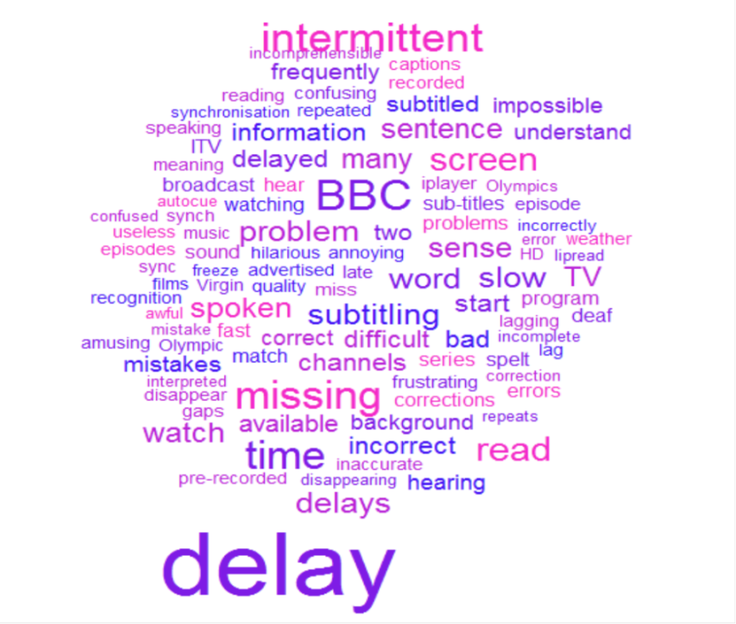
We analysed the problems experienced with subtitles by breaking them down into categories. These can be seen in the table below. Respondents often described several problems with the subtitles and hence the percentages do not add up to 100.
Table 3: Problems experienced with subtitles on each of the programmes watched
Problem experienced with subtitles | Number of times the problem was experienced | %
Delay between speech and subtitles | 361 | 62
Poor accuracy of subtitles | 263 | 45
No subtitles | 209 | 36
Intermittent subtitles | 130 | 22
Too slow | 39 | 7
Covers information or faces | 32 | 6
Too fast | 31 | 5
Scrolling | 4 | Less than 1
No subtitles on links or adverts | 4 | Less than 1
Total number of responses | 580
Looking at Table 3 above, three fifths (62%) of problems experienced with subtitles were due to delays. Subtitle delays are most likely to occur on programmes with live subtitling as the subtitler struggles to keep up with the speed at which people speak.
Without a delay, people can use a combination of hearing (if they have some), lipreading and subtitles to follow the programme. A delay however, can spoil the enjoyment of a programme, for example by telling a joke long after the sketch on screen has finished or by providing the answer to a quiz at the same time as the question, as the quote below describes. As the delay increases, it becomes increasingly difficult to follow what is happening on screen and some people talked about giving up on watching a programme because they were unable to understand it.
“Quiz programmes - sometimes the answers are displayed in the subtitles at the same time as the questions which spoils the programme!” Survey respondent
Problems with accuracy were the second most common issue with subtitles, with 45% of respondents citing this as a problem. The issues described ranged from incorrect spelling, words missing, to sentences cut in half and complete ‘mumbo jumbo’ as one respondent described it. The spelling mistakes can be funny and some examples from respondents included ‘sex lists’ for ‘cyclists’, ‘Brit Nominee’ for ‘Mitt Romney’ and ‘eddie shah’ for heavy showers. However, these mistakes can also mean that people are not able to understand what is being said and therefore can miss vital information. Attempts to correct words also further leads to delays in subtitles.
Over one third of respondents complained about a complete lack of subtitles on the programme they were watching. Issues included a programme that had previously been shown with subtitles on another channel, was then shown without subtitles on a different channel. This happened even when channels were within the same broadcaster.
“There have been a few occasions where I've missed one or two episodes of a series altogether because of subtitles not being shown, despite being advertised with them.”
Respondents expressed their concern about the lack of apology if subtitles were not available despite the programme being advertised as having subtitles.
Over one fifth of respondents reported problems with subtitles being intermittent. They stop and then may start again after a short break, or they may not return for the rest of the programme. People also reported subtitles freezing and therefore they missed out on a lot of information.
Other comments received included subtitles covering up important information such as guest names on news programmes, the auction price on Bargain Hunt or even people’s faces which prevents lipreading.
“They sometimes obscure the picture – a particular problem of wildlife programmes of which I am especially fond.” Survey respondent
Some respondents raised the issue about a lack of subtitles on catch up and video on demand services and some expressed a dislike of scrolling subtitles which they found difficult to read.
Some respondents also mentioned problems they experienced when complaining to a broadcaster about these issues. They generally did not feel their complaint was taken seriously, or that the broadcaster was unlikely to do anything about it.
We asked people to select their top 3 problems with subtitles. Again, delays came up as the biggest problem, with nearly one quarter of respondents selecting this option. Just over one fifth of respondents said that poor accuracy of subtitles was one of the biggest problems with subtitles and 16% selected intermittent subtitles as a problem.

Table 3: What do you think are the biggest problems with subtitles? Respondents could select 3 options.
Biggest problem with subtitles | Number of respondents | %
Delay between speech and subtitles | 380 | 24
Poor accuracy of subtitles | 356 | 22
Intermittent subtitles | 250 | 16
General lack of subtitles | 197 | 12
Subtitles not available when programme was advertised as having subtitles | 143 | 9
Other* | 147 | 9
Subtitles too fast | 68 | 4
Subtitles shown scrolling rather than a text box | 58 | 4
Total | 1599 | 100

Conclusion
Delays were the biggest problem for people using subtitles on television followed by inaccurate subtitles. These problems will be most likely to occur on programmes broadcast with live subtitling. We therefore believe that broadcasters and subtitling companies must invest in their live subtitling technology to ensure that the best results are obtained. We would also strongly urge broadcasters to ensure that live subtitling methods are only used on truly live programmes. Pre-recorded programmes must always have subtitles produced in advance. We would also like to see broadcasters take a more proactive role in monitoring their subtitles to ensure that any problems with the subtitles can be resolved quickly. Finally, where there are problems with subtitles, we would expect an apology and an explanation to be issued.
Recommendations
- Live subtitling methods should not be used to subtitle pre-recorded programmes.
- Broadcasters must monitor the quality of subtitles they produce and take action if there are ongoing problems.
- Develop the technology to reduce the delay and improve accuracy of live subtitling methods.
- Broadcasters improve the information available to subtitle users, including providing apologies and explanations when problems occur, as well as clear complaints procedures.
We believe that if these recommendations are followed then we would be much closer to achieving our ideal vision, where subtitles are available on all programmes and are consistently accurate and synchronised, regardless of whether the programme is live or pre-recorded.

The total number of responses is larger than the total number of respondents as some respondents stated that they use more than one television service.
According to BARB audience viewing figures from the summer of 2012, BBC1 had over one fifth of the share of the audience. http://www.barb.co.uk/report/monthly-viewing?_s=3

