INTERNATIONAL TELECOMMUNICATION UNION |  | Joint Coordination Activity  On Accessibility and Human Factors
TELECOMMUNICATION  STANDARDIZATION SECTOR  STUDY PERIOD 2013-2016 |  | Doc 16
English only
Original: English
Source: | JCA-AHF Convener
Title: | “A word with Heidi Thomas, broadcast captioner at WTSA”
This article was posted on 21 November 2012, during WTSA-12.
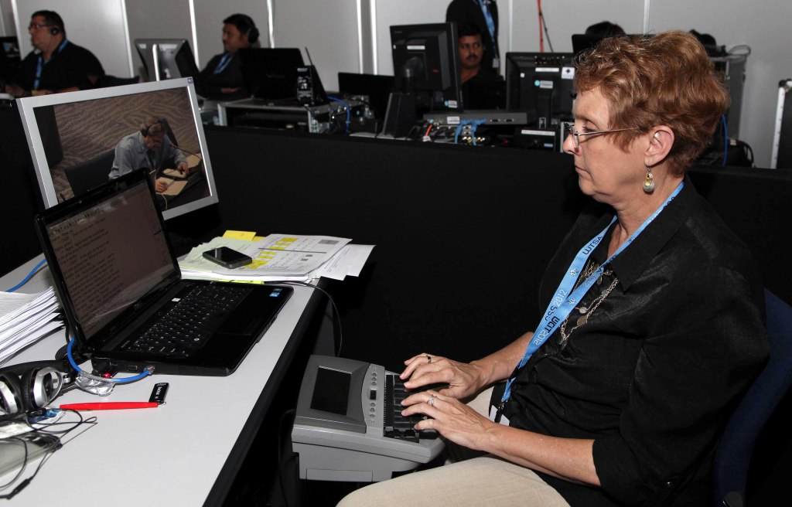

(photo) Heidi Thomas, broadcast captioner at WTSA-12
Behind the scenes, The Assembly met with Heidi Thomas. Heidi works for Caption First, a captioning service provider.
A realtime text stream from WTSA-12 is available at http://www.streamtext.net/player?event=CFI-WTSA.
The Assembly: Equal access is at the core of ITU’s mission. Can you briefly explain to our readers what captioning is, and how captioning services contribute to making conferences such as WTSA more accessible?
Heidi Thomas: Stenocaptioners are highly trained individuals who use a stenotype machine with a phonetic keyboard (as used by court reporters) to create captions. This machine enables them to type at speeds of up to 225 words a minute. The average person usually speaks 160 to 180 words a minute. The stenograph machines have a syllable-based system of 24 keys that spells words phonetically, the way they sound, rather than how they are actually spelled. Stenocaptioners use a keyboard with only 25 keys (there are about 100 on a standard computer keyboard) that account for just 13 consonants and 4 vowels.
The quality of these captions depends on the skill level of the stenocaptioner and the time they have been given to prepare for their task. Part of this preparation involves entering into their software’s ‘dictionary’ any unusual names or words which are likely to appear in the dialogue they will be captioning, so that these will be spelled correctly in the captions as they appear. They can also create ‘shortforms’ of certain phrases which are likely to be used, so several words can be created with a couple of keystrokes.
The display of the realtime captions is projected onto large screens for the benefit of the entire audience. Oftentimes in large venues it is difficult to hear the speakers clearly and there may be a lot of audience and ambient room distractions. For a person with a hearing loss or for a person whose native language is not English, these distractions present a barrier to communication. Having a large display screen with the flowing text allows audience members to focus on the message rather than straining to hear and comprehend. It may also be streamed to the web simultaneously for remote participants.
The Assembly: What are the challenges faced by a realtime captioner and how do you address them in practice?
Heidi Thomas: Realtime captioners face challenges with unfamiliar/unusual terminology, acronyms, English speakers of other languages and rapid speech. Realtime captioners do large amounts of detailed research and building of databases (dictionaries) for the highest quality translation possible.
The Assembly: Heidi, thank you very much for this interesting insight, and for your contribution to making WTSA-12 accessible to all.
______________

