INTERNATIONAL TELECOMMUNICATION UNION |  | Focus Group on  Smart Grid
TELECOMMUNICATION  STANDARDIZATION SECTOR  STUDY PERIOD 2009-2012 |  | Smart-I-175
English only
Original: English
WG(s): | All | Jeju, Korea 8-15 June 2011
DOCUMENT
Source: | TSB
Title: | Seventh meeting of the Focus Group on Smart Grid (FG Smart)  Jeju, Korea 8-15 June 2011

This document provides information on the seventh meeting of the Focus Group on Smart Grid (FG Smart).
1 The seventh meeting of the FG Smart is scheduled to take place in Jeju Island, Korea, 8-15 June 2011 inclusive by the kind invitation of TTA. The International Workshop for Smart Grid starts at 9:30 on 8 June 2011. The FG Smart meeting starts at 9:30 on 9 June 2011. Practical information is provided in Annexes.
2 The FG Smart is open to ITU Member States, Sector Members and Associates. It is also open to any individual from a country which is a member of ITU and who is willing to contribute to the work. This includes individuals who are also members or representatives of interested standards development organizations.
3 The items for discussion at the meeting will be made available on the Focus Group web page:
http://www.itu.int/ITU-T/focusgroups/smart/. Information related to the meeting as well as the contributions received will also be made available on the Focus Group web page.
The discussions will be held in English only.
The documents will be made publicly available. In preparing documents, please use the basic template for the FG documents available from the Focus Group web page. Participants shall submit input documents to FG Smart in electronic format to TSB as follows:
- contact TSB at tsbfgsmart@itu.int to receive a number (nnnn) for each document
- prepare documents with a file name as follows: FG-Smart-I-nnnn (with the appropriate file extension)
- using an FTP client, upload the document to the document drop folder in the FG Smart FTP area, namely:
Host name: ifa.itu.int
Path: /t/fg/smart/docs/incoming
Note: contents of the document drop box can be read with a web browser at: http://ifa.itu.int/t/fg/smart/docs/incoming/.
Documents will be processed by TSB and moved to the relevant read only folder: http://ifa.itu.int/t/fg/smart/docs/1106-jej/in/
Please note that this is a paperless meeting.
4 To enable TSB to make the necessary arrangements concerning the organization of the Focus Group meeting, please register via the on-line form at http://www.itu.int/ITU-T/focusgroups/smart/ , as soon as possible, but not later than 25 May 2011. Please note that pre-registration of participants to the meeting is carried out exclusively online. To easily provide you with any updates concerning the meeting planning, please fill in your valid e-mail address on your registration form.
5 We would like to remind you that citizens of some countries are required to obtain a visa in order to enter and spend any time in Jeju Island of Korea. The visa must be requested at least four (4) weeks before the date of beginning of the meeting and obtained from the office (embassy or consulate) representing Korea in your country or, if there is no such office in your country, from the one that is closest to the country of departure.
An invitation letter for VISA application should be requested to the host.

Annex A
Practical information

Meeting Schedule
Date | Time | Meeting
June 8 (Wed) | 9:30 ~ 17:00 | International Workshop for Smart Grid | Sponsored by KSGA & KATS  See Annex B.
June 9 (Thu) | 9:30 ~ 17:00 | Day 1 : FG Smart Meeting
June 10 (Fri) | 9:30 ~ 13:00 | Day 2 : FG Smart Meeting | 14:00 ~ : Bus Tour for Jeju SG Field Trial  See Annex C.
June 13 (Mon) | 9:30 ~ 17:00 | Day 3 : FG Smart Meeting
June 14 (Tue) | 9:30 ~ 17:00 | Day 4 : FG Smart Meeting
June 15 (Wed) | 9:30 ~ 17:00 | Day 5 : FG Smart Meeting
- 1 ~ 2 dinners will be served by Korean Firms

Meeting Place
URL : http://www.phoenixisland.co.kr (Korean, English, Japanese, Chinese versions)
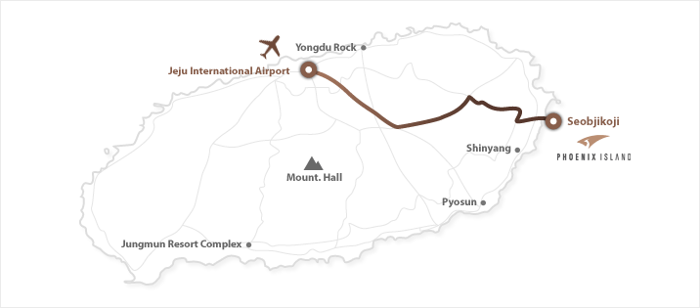

Flights to Jeju International Airport (Jeju Island is VISA free) ; more than 100 flights/day
- Domestic flights through 10 more cities, including;
Incheon International Airport ; http://www.airport.kr/eng/
and Gimpo International airport ; http://www.airport.co.kr/doc/gimpo_eng/
- International flights (http://www.airport.co.kr/doc/jeju_eng/) from Japan, China, etc.

Direction from Jeju International Airport : 50 ~ 60 minutes
- Tax : around 30 USD
- Free Shuttle Bus : Airport Parking No.7 area
 | Pheonixisland -> Airport | Airport |  | Airport -> Phoenexisland | Arrival
 | Pheonixisland -> Airport | Arrival | Waiting | Airport -> Phoenexisland | Arrival
1 | - | - | - | 10:00 | 11:00
2 | 10:30 | 11:30 | 30 Min | 12:00 | 13:00
3 | 12:30 | 13:30 | 30 Min | 14:00 | 15:00
4 | 14:30 | 15:30 | 30 Min | 16:00 | 17:00
5 | 17:30 | 18:45 | 30 Min | 19:00 | 20:00

Overview of meeting venue
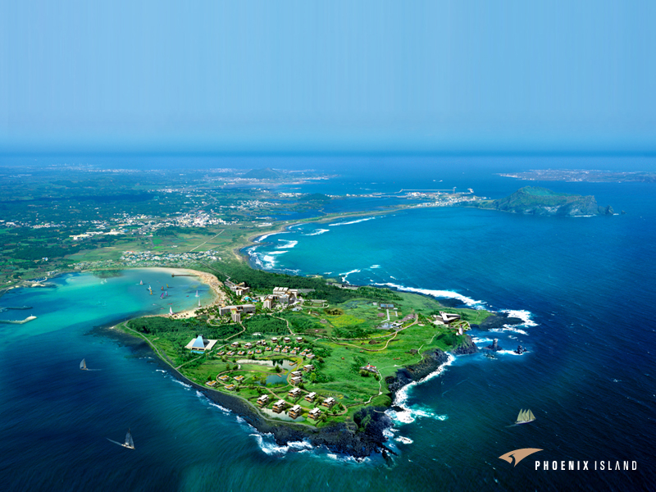

Meeting Reservation : see the annex D.

Further details will be announced soon through ITU web-page and e-mail (fgsmart@itu.int)

Annex B

International Workshop on Smart Grid
Date: June, 8, 2011
Place: Phoenixisland (co-location with ITU-T FG-SMART meeting)
Moderator : Hyung-soo (Hans) Kim : hans9@kt.com

Schedule (Tentative)

(09:30~09:35) Opening remark : Chairman of KSGA
(09:35~09:50) Keynote speech : Korean SG standard activity (KATS)
(09:50~10:10) Keynote speech : Telecom Sector’s vision on SG (KT)

(10:10-11:20) Introduction of Smart Grid status
- Status and vision of China on Smart Grid (Participant from China) – 15min
- Status and vision of EU on Smart Grid (Participant from EU)-15min
- Status and vision of Japan on Smart Grid (Participant from Japan)-15min
- Status and vision of USA on Smart Grid (David Su)-15min
- Q&A – 10min

(11:20~11:40) Break

(11:40~12:00) Keynote speech : ITU & Smart Grid (Hiroshi Ota)

(12:00~12:50) Introduction of Smart Grid activities (ITU-T FG on SG)
- Overview of FG on Smart Grid : Les Brown – 10min
- WG 1, Use Cases (Chairman of WG1)-10min
- WG2, Requirements (Chairman of WG2)-10min
- WG2, Architecture (Chairman of WG3)-10min
- Q&A-10min

(12:50-14:00) Lunch Break

(14:00~14:20) Keynote speech : Smart Grid R&D in Korea (ETRI)

(14:20~16:30) Industrial Perspective
- Energy Gateway (Bernard, Freescale) – 30min
- ETSI M2M – 30min
- G.99xx (Les, Lantiq) – 30min
- WisLeed (Fujitsu) – 30min
- Q&A-10min

(19:00-21:00) Reception

Annex C

Bus Tour for Jeju Smart Grid Field Trial

(14:00 ~ 18:00 , 10th of JUNE)

Brief overview : http://www.smartgrid.or.kr/Ebook/JejuTestBed.pdf

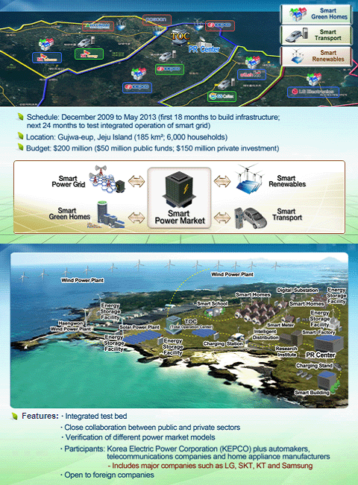
- There are 10 Consortia in Gujwa-eup, but only KT and KEPCO sites will be visited.
Annex D

Registration Form
PHOENIX ISLAND Resort, Jeju Island, Korea

Please complete the details and send this form to ‘Jun Kim’, till 22nd of April

kj@k-smartgrid.org
VENUE: PHOENIX ISLAND http://www.phoenixisland.co.kr/

Meeting and Event REGISTRATION:
DATES | MEETING | NOTES | Yes | No
June 8(Wed) | Workshop | English only
June 9(Thu) | Day 1 (09:30-17:00) FG-SMART
June 10(Fri) | Day 2 (09:30-13:00) FG-SMART
June 10(Fri) | Bus Tour for Jeju SG Testbed | 14:00 ~ 18:00
June 11(Sat) | Social Event : Tracking on Olle Trail | 10:00 ~ 16:00 (Annex D.)
June 13(Mon) | Day 3 (09:30-17:00) FG-SMART
June 14(Tue) | Day 4 (09:30-17:00) FG-SMART
June 15(Wed) | Day 5 (09:30-17:00) FG-SAMRT
*Registration for ITU-T FG SMART Jeju Meeting 2011 is completed via this form.
No registration fee is required for the participation.

YOUR CONTACT INFORMATION:

Name:

Company/Affiliation:

Address Line 1 :

Address Line 2 :
City: | State/Prov:
Zip/Postal: | Country:
Phone: | E-mail:
Notice: This registration is required in addition to on-line registration by ITU-T HP
For making your stay easy and convenient, PHOENIX ISLAND Resort is highly recommended.

Hotel Reservation Form

◆ Your Information
First Name: Last Name:
(Dr. Prof. Mr. Ms.)
Company/Affiliation:
Address:
Zip Code: Country:
Tel: Fax:
Email:

◆ Hotel Accommodations
Please check the applicable box and fill out the date of Check-In and Check-Out together with the nights you wish to stay.
Room Type | Room Rate  (per night) | Preference | Date/Period
Room Type | Room Rate  (per night) | Preference | Check-In | Check-Out | Night(s)
Royal (2 bed rooms, 1 living room and 2 bath rooms) | $135  (KRW143,000)
Special Requests: Please make a note of any requests for a room, special dietary (including vegetarian), allergies, or handicaps that we should be aware of.
- Breakfast (Buffet style breakfast) Rate: $16 (KRW17,600) VAT included
- Service charge and government tax are included in the hotel rate.
- The Hotel requires that the reservations for ITU-T FG Smart Meeting be received in a rooming list by the cut-off date of April 22, 2011. After the cut-off date, reservations will be acceptable only upon a space availability and room rate may change.
- For the cancellation made after the cut-off date, the hotel cancellation policy will be applied as follows:
- 15 days in advance: free-of-charge
- 7 days in advance: 10% of special event rate for the entire stay
- 3 days in advance: 30% of special event rate for the entire stay
- 2 days in advance: 50% of special event rate for the entire stay
- 1 days in advance & Same day: 100% of special event rate for the entire stay
- No show: 100% of special event rate for the entire stay

Annex E

Jeju Olle Trail
http://www.visitkorea.or.kr/enu/SI/SI_EN_3_4_12_13.jsp


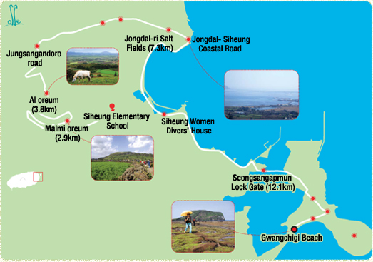
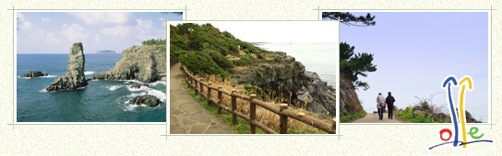
Annex F
Overview of places for events in Jeju

Jeju SG Field Trial Sites
Olle Trail

_______________

