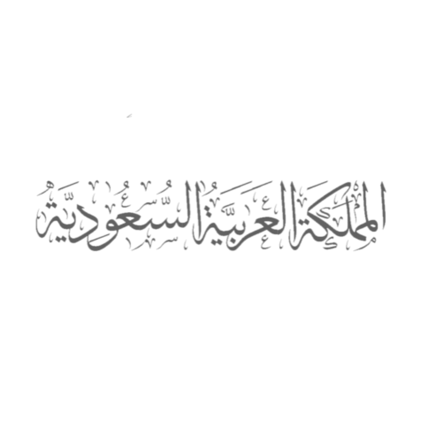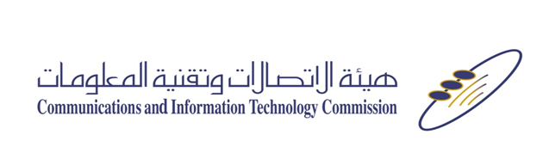

**(Practical Information)**

**Meeting:** ITU-T Focus Group on Quantum Information Technology for Networks (FG-QIT4N) Workshop and Meeting

**Host of the Meeting:** Kingdom of Saudi Arabia

**Place:** Riyadh, Saudi Arabia

**Period:** 17-20 February 2020

**1. Location and Access**

Situated in the center of the Arabian Peninsula on a large plateau, Riyadh lies in the central corridor of Saudi Arabia. It is the capital city of Saudi Arabia and is both a modern metropolis and a historical and cultural treasure. Its characteristics are diverse, that range from the shimmering golden sand dunes, to modern shopping malls, distinctive heritage and cultural sites to urban construction panaches. Such diversity makes Riyadh city the core of life and vitality in the Kingdom.

**1.1 King Khaled International Airport (RUH or KKIA)**

Riyadh is served by King Khaled International Airport, which is located about 35 km north of the city. Flights to Riyadh King Khalid International Airport come in from all over the world, including cities in Europe, Asia and the Middle East. King Khalid International Airport has three main passenger terminals. Terminal 1 and terminal 2 operates the arrivals/departures of international flights and terminal 5 the arrivals/departures of demotic flights.

**1.2 Transportation**

Modern and safe transportation network is available in Riyadh. Visitors can use modern ride-hailing apps to move around Riyadh. Taxis (limousines) are also a significant form of transportation in Riyadh. Prices are determined by meter, or by negotiating with the driver before boarding the taxi.

**2. Venue**

The meetings will be held at the Communications and Information Technology Commission. Its address is:

Communications and Information Technology Commission (CITC)

P.O Box 75606 – Riyadh 11588

Kingdom of Saudi Arabia

Phone: 00966114618000

Fax: 00966114618120

​Alnakheel Quarter - At the corner of Prince Turki Bin Abdulaziz Road and Imam Saud Bin Abdulaziz Bin Mohammed Road

(<https://goo.gl/maps/joTwsKmWZYD2>)

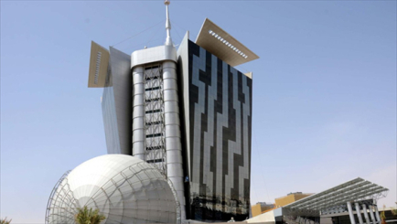

**CITC Premises**

**3. Hotels**

The list of recommended hotels situated nearby the meeting venue is presented in Annex 1. Please consult your travel agent **for other options.**

**4. Registration**

Pre-registration is mandatory and carried out exclusively online at <https://www.itu.int/net4/CRM/xreg/web/Registration.aspx?Event=C-00007312>.

A registration and information desk will be onsite to receive participants, distribute badges and register participants. Onsite registration may involve a longer accreditation process; therefore, advance registration is strongly encourage.

**5. Visa application process**

International visitors from eligible countries can apply for an eVisa through the Saudi eVisa Portal (<https://visa.visitsaudi.com>). However, if their country is not listed in the Saudi eVisa Portal. They are requested to fill the visa form attached, along with a copy of their passport biographical data page to the email address ([intaff@citc.gov.sa](mailto:intaff@citc.gov.sa)).

**6. Additional information**

**6.1 Currency**

Saudi Riyal (SR). The SR is always fixed to the US dollar ($); $1 equals to 3.75 SR.

**6.2 Climate**

Below is a figure that shows the high, low temperatures in °C and the precipitations year around for Riyadh city.

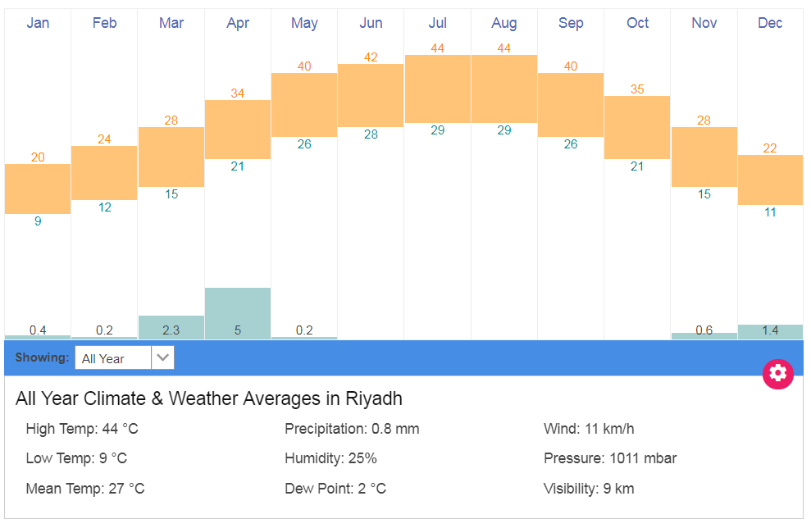

**6.3 Electricity**

220V, plug type is as shown in the figures below.

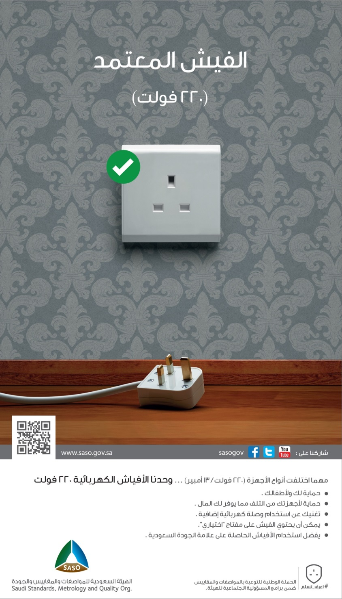

**6.4 Time zone**

GMT +3 hours

**6.5 Language**

Arabic is the official of Saudi Arabia, however English language is used widely in Riyadh.

**6.6 Credit Cards:**

Many merchants in Riyadh accept credit cards.

**6.7 ATMs:**

ATMs are available and work on international networks. Foreign travelers can use their credit cards to obtain cash through the cash advance or use debit cards to withdraw cash from their bank account. Currency exchangers are available in airports and many locations in the city.

**6.8 Tourism and Entertainment**

Please visit:

* Visit Saudi Arabia (<https://www.visitsaudi.com/en>)
* Cinema (<https://www.amccinemas.net/>) (<https://ksa.voxcinemas.com/en>)
* Enjoy Saudi (Roznamah) (<https://roznamah.sa/en/>)

**Host country contact:**

International Affairs

Communications and Information Technology Commission (CITC), Riyadh, Saudi Arabia

Tel: +966 11 4619777

email: intaff@citc.gov.sa

____________

Annex 1

Recommended Hotels

|  |  |  |  |
| --- | --- | --- | --- |
| **Contact** | **Distance to Venue (CITC)** | **Star Raring** | **Hotel** |
| * Tel. :+966 11 813 1313 Ext/1099 * Fax. :+966 11 813 1300 * [reservations.cprdc@ihg.com](mailto:reservations.cprdc@ihg.com) * [Website](https://www.ihg.com/crowneplaza/hotels/ae/ar/riyadh/ruhit/hoteldetail) | 50 m  1min/walking | 5 Stars | **Crowne Plaza Riyadh RDC and Convention Center Hotel** |
| * Mob: +966 55 362 1430 * Tel :+966 11 455 5599 * Fax :+966 11 400 3222 * [Sales4@executives-hotel.com](mailto:Sales4@executives-hotel.com) * [Website](http://www.executives-hotel.com/hotel.php?hotelid=3) | 8.9 km 9mins/car | 4 Stars | **Executives Hotel / KAFD** |
| * Tel :+966 1 288 2323 Ext/5444 * Fax :+966 1288 2424 * [H6532-RE@accor.com](mailto:H6532-RE@accor.com) * [Website](https://www.accorhotels.com/gb/hotel-6532-novotel-riyadh-al-anoud/index.shtml?utm_term=nom&utm_campaign=ppc-nov-nom-goo-me-en-sa-exa-sear-bp&utm_medium=cpc&utm_content=me-en-SA-V4965&utm_source=google) | 8.9km 9mins/car | 4 Stars | **Novotel Al Anoud Hotel** |
| * Mob: +966 59 759 9717 * Tel :+966 11 294 6392 * Tel :+966 92 000 0777 * Fax :+966 11 2946391 * info@narcissusriyadh.com * [Website](http://www.narcissusriyadh.com/ar/default.html) | 10.4km  11mins/car | 5 Star | **Narcissus Hotel and SPA** |
| * Tel :+966 11 802 8888 * Fax :+966 11 802 8777 * Reservation.Riyadh@ritzcarlton.com * [Website](http://www.ritzcarlton.com/en/hotels/saudi-arabia/riyadh) | 12.8km 15mins/car | 5 Stars | **The Ritz-Carlton** |
| * Tel :+966 11 447 9888 Ext/3144 * Fax :+966 11 447 9801 * [hamad.alowaid@rotana.com](mailto:hamad.alowaid@rotana.com) * [Website](https://www.rotana.com/rayhaanhotelandresorts/kingdomofsaudiarabia/riyadh/roshrayhaanbyrotana) | 14.5km 15mins/car | 5 Stars | **Rosh Rayhaan by Rotana** |
| * Tel :+966 11 477 9300 Ext/7171 * Fax :+966 11 479 2432 * Riyadhres@marriotthotels.com * [Website](https://www.marriott.com/hotels/travel/ruhab-courtyard-riyadh-diplomatic-quarter/) | 15km 16mins/car | 4 Stars | **Courtyard Riyadh by Marriott Diplomatic Quarter** |