Use case and requirements template

X.n. Use case title
- Title to represent the proposed use case
- Provide background or necessity of the proposed use case

X.n.1. Description
- Describe the descriptions of the proposed use case
- Depict the concept of use case using functional diagrams

X.n.2. Assumptions
- Describe assumptions for the proposed use case

X.n.3. Service scenario
- Add a sequential diagram for the proposed use case
- Describe service flows step-by-step

X.n.4. High-level service requirements (Optional, if it is needed)
- Identify relevant service entities to specify requirements for the use case
- Describe high-level service requirements related to service entities
- The requirements only apply to the proposed use case. However, these requirements can be used to derive more sophisticated requirements for functional requirements or services that will be created in the future.
- Conventions
  - "is required to" for a requirement that must be strictly followed
  - "is recommended" for a requirement that is recommended but which is not absolutely required.
  - "can optionally" for an optional requirement that is permissible, without implying any sense of being recommended.

X.n.5. Related standards/specifications (Optional, if it is needed)
- Describe the existing standards (including those under development) that can be leveraged for the proposed use case
- Describe the items for the further standardization

Attachment: An example use case for the template
Attachment: An example use case for the template

X.1. MetaSearch: Seamless discovery and mashup of content across distributed metaverse platforms
A discovery service in the metaverse is a platform or tool that helps users find and access various virtual experiences, content, or services within the metaverse. This service acts as a directory or marketplace for the metaverse, showcasing various offerings from different creators, providers, or businesses. It is also possible to create mashup services or content by combining content from different distributed metaverse platforms.

X.1.1. Description
The contents and service discovery for the metaverse should allow users to search for specific content or services based on keywords, categories, or other criteria and filter results based on factors such as popularity, price, or creator. Furthermore, it is needed to support multimodal inputs from the users. Users are able to preview content or experience before purchasing it and read reviews from other users to make informed decisions. Social recommendations based on the user's social connections, interests, or past experiences in the metaverse should also be available.
As is, a discovery service in the metaverse aims to make it easier for users to find, access, and engage with the vast array of offerings.
Through the discovery service, users can search for services provided by other metaverse platforms. It's important to identify which services are interoperable and which are not, as the distributed metaverse platform will offer independently operated services. Platform service providers can enhance competitiveness by linking with various metaverse platforms to support interoperability. In addition, users can create their own content or services by combining the metaverse content that has been searched and deploy them on their own metaverse platforms.
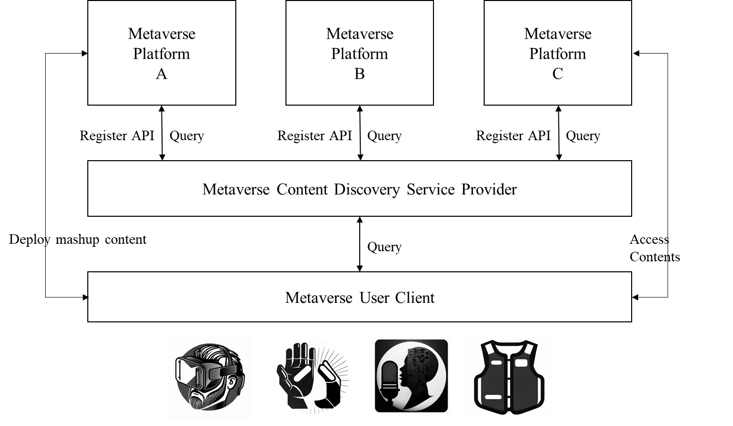
Figure X-1 – Concept of the metaverse contents discovery use case

Nevertheless, in the scenario of numerous dispersed and independent metaverses, it can become challenging for users to discover content that matches their interests. In this case, it may be beneficial to have a dedicated MCDSP (Metaverse Content Discovery Service Provider) to provide an enhanced user experience. An MCDSP can help users navigate the various platforms and find the content and services that meet their needs and be a central hub for users to find information about different metaverse platforms and their content. This can include information about virtual real estate, gaming experiences, social networks, virtual events, virtual education, and virtual tourist destinations.
The MCDSP can also provide users with relevant information about the platforms, such as the types of experiences and activities available, the number of users, and the quality of the user experience.

X.1.2. Assumptions
The assumptions related to this use case include the following;
- It is assumed that there are various distributed metaverses working independently.
- It is assumed that a user has multimodal input devices, such as a haptic glove, HMD, etc., and uses them to search the content from MCDSP.
- It is assumed that a user interacts with MCDSP and metaverse platform metaverse user client.
- It is assumed that users can create their own mashup content or service using multiple distributed content and deploy it onto a specific metaverse platform using the metaverse user client.

X.1.3. Service scenario
This clause describes the service flow for metaverse contents and service discovery service.
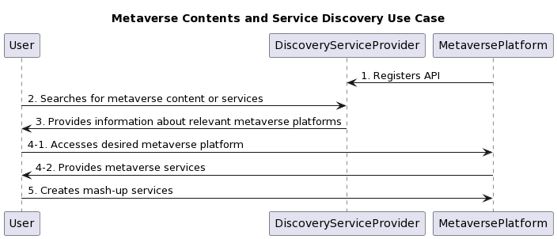
Figure X-2 – Service flows for the metaverse contents and service discovery use case

- The metaverse platform registers its API with the metaverse discovery service provider. The platform operates a server and offers its own metaverse service with a public API. This API is registered with the discovery service provider to enable users to find information about the platform's offerings.
- The user searches for metaverse content or services using the discovery service. Using the discovery service's user-friendly interface, the user searches for specific content, experiences, or services based on keywords, categories, or other criteria. They can also preview the content or experience before accessing it, and read reviews from other users to help them make informed decisions.
- The discovery service provides information about relevant metaverse platforms. Based on the user's search criteria, the discovery service returns information about the relevant metaverse platforms, including hardware requirements for access, billing information, etc.
- Once the desired metaverse platform is found, the user accesses and uses its services.
- Optionally, the user can create mash-up services by utilizing the interfaces of other metaverse platforms, and locate them into a particular metaverse platform. This user metaverse content also can be searched through the discovery service, and can be used for creating a new service by other users.

X.1.4. High-level service requirements
This section describes the service level requirements for each service entity for the metaverse content and service discovery service.
a) Metaverse Platform
– It is required to register the interface with the metaverse discovery service provider.
  - It is recommended to provide enough information for experiencing the contents, such as hardware requirements, the format of contents, the interface to access the contents, etc.
  - It is recommended to grant access from sources other than the metaverse discovery service provider with appropriate authentication and authorization methods.
  - It is recommended to support the deployment of user-created metaverse content by use of content from the distributed metaverse platforms.
b) Metaverse Content Discovery Service Provider
  - It is recommended to support various multimodal inputs, such as gestures, voice, texts, etc, from users.
  - It is recommended to provide a user-friendly interface for the user on searching for specific content, experiences, or services based on keywords, categories, or other criteria
  - It is recommended to allow users to preview the content or experience using their devices and read reviews from other users to assist with informed decisions.
c) Metaverse User Client
  - It is recommended to be capable of creating mashup services by utilizing the interfaces of other metaverse platforms registered with the discovery service.
  - It is required to be capable of rendering the contents using the user’s devices.
  - It is recommended to be capable of sending multimodal input from the user’s devices.
  - It is recommended to be capable of giving an immersive experience on metaverse content by use of a user’s device, such as VR, AR, haptic devices, etc.

X.1.5. Related standards/specifications
For the metaverse discovery service to be interoperable, various standards need to be adopted and followed by the different metaverse platforms. This clause focuses on service-level standards specifically related to the use case and does not delve into low-level standards in great depth.
NOTE - Some standards may be outdated and require revision to meet the needs. As the concept of the metaverse continues to evolve, it is likely that new standards will need to be developed, and existing standards may need to be updated or revised to ensure they remain relevant and effective.

X.1.5.1 Existing and under-development standards
- Multimodal Inputs: multimodal standards are important for ensuring interoperability and compatibility between different systems, enabling a more unified and effective approach to multimodal search.
Table X. Standards related to multimodal inputs
SDO | No. & Title | Year | Remarks
W3C | EMMA (Extensible MultiModal Annotation) | 2008
W3C | MMI (Multimodal Interaction) | 2002
W3C | VoiceXML (Voice Extensible Markup Language) | 2000
W3C | SCXML (State Chart XML) | 2008
W3C | SSML (Speech Synthesis Markup Language) | 2004
… | … | … | …

- Metaverse Content Format: A common data interchange format for exchanging information between the discovery service and the various metaverse platforms would be needed to ensure consistent and accurate data exchange.

Table X. Standards related to metaverse content format
SDO | No. & Title | Year | Remarks
ISO | ISO/IEC 12113:2022, glTF 2.0 | 2022
- | USD (Universal Scene Description)* | 2023 | Release 23.02
Khronous Group | OpenXR 1.0 | 2019
ISO | ISO/IEC 19775-1:2013, COLLADA (Collaborative Design Activity) | 2013
ISO | ISO/IEC 23005-1:2019, MPEG-V | 2019
W3C | WebXR Device API | 2023 | Candidate Recommendation
… | … | … | …
NOTE – USD is not an official standard, but it has become a de facto standard for representing 3D scenes and is widely used in the entertainment industry.

- Metaverse Platform API: The APIs used by the metaverse platforms to interface with the discovery service need to adhere to a common set of standards to ensure compatibility and interoperability.
Table X. Standards related to metaverse platform API
SDO | No. & Title | Year | Remarks
W3C | LDP (Linked Data Protocol) | 2015
IETF | RFC 7230-7235, Representational State Transfer | 2014
OpenAPI | OpenAPI Specification | 2021
W3C | Simple Object Access Protocol (SOAP) | 2007
… | … | … | …

X.1.5.2 Items for the further standardization
The clause outlines the items that are to be standardized for this use case.

Table X. Items for the further standardization
Items | Descriptions
… | …

____________

