PRACTICAL INFORMATION

Second meeting of the ITU-T Focus Group on metaverse (FG-MV)
and
Second ITU Forum on Creating a metaverse for all through international standards

(Shanghai, China, 4-7 July 2023)

MEETING VENUE
The second meeting of the ITU-T Focus Group on metaverse (FG MV) and second ITU Forum on Creating a metaverse for all through international standards will take place from 4-7 July 2023 at Zhangjiang Science Hall 张江科学会堂, Shanghai, China.
Address of the Venue: 上海市 浦东新区 36-1-29 正西方向70米 邮政编码: 201203
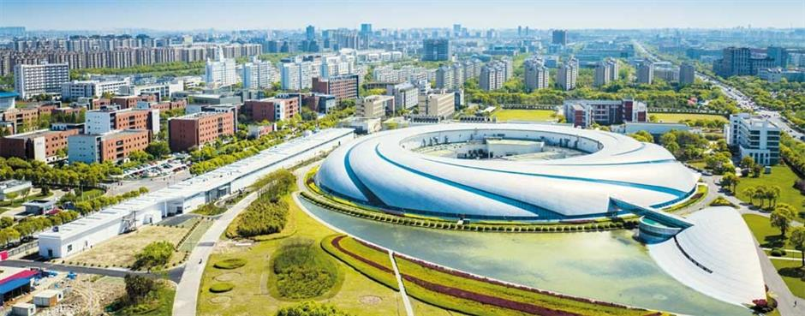

TRANSPORTATION AND SITE INFORMATION
Zhangjiang Science Hall is 26 kilometer away from Pudong international airport and 54 Kilometers from Hongqiao Airport.
It takes 28 minutes by driving from Pudong Airport and 54 Minutes from Hongqiao Airport.
You can also travel with public transport:
- From Pudong International Airport
  - Option1: take Maglev (long yang Road) -transfer to Metro Line 16 (Huaxia Zhong Road) – and then change to line 13 (Xuelin Road) - 45 Minutes
  - Option2: take Metro Line 2 (long yang Road) – Line 16 (Huaxia Zhong Road)- Line 13 (Xuelin Road) - 75 Minutes
- From Hongqiao Airport
  - Take Metro Line 2 (West Nanjing Road) – Line 13 (Xuelin Road)

PASSPORTS, VISAS AND INVITATION LETTER
The information for applying for a Visa can be found on the official website: https://www.visaforchina.cn/BUH2_EN/index.shtml
You can find general information and finish the application following the guidance step-by-step instructions.
A proper invitation letter will include:
- Invitee's personal information: name, gender, date of birth, passport number etc.;
- Invitee's visit information: visit purpose, arrival date, departure date, place of visit, relationship between inviting company/individual and invitee, means of financial support, etc.;
Please submit the visa request form (found in Annex A) to Jiajun YAO, jiajun.yao@sh-aia.com, by 20 June 2023, at the latest.

CLIMATE – DURING JULY
The average temperature in Shanghai in July is 25℃ - 32℃.
During the daytime average of 32℃, it is recommended to wear cool and breathable clothes such as clothes made of light cotton fabrics.
At night, the average temperature is 25°C. Cool and breathable clothes such as shirts made of cotton and linen fabrics, are recommended.

HOTELS
There are many different types of hotels located around Zhangjiang Science Hall for domestic and foreign businessmen to choose from. From luxury hotels to comfort hotels to meet the different needs of guests.
Please see below a list of recommended hotels
No. | Hotel | Information
1 | The Yangtze Boutique Shanghai  No. 740 Hankou Road, Shanghai, China | - Located in the city center  - Around shopping areas and restaurants  - Close to East Nanjing Road pedestrian street.
2 | Grand Central Hotel  No. 505 Jiujiang Road, Shanghai, China | - Good location  - Close to the Old Town
3 | Shanghai Blue Mountain  6F, No350, South Shanxi Road, Shanghai, China | - Minutes away from many shopping and entertainment areas  - Close to Nanjing Road
4 | Campanile Shanghai  No. 33 Fujian South Road Huangpu District, Shanghai, China | - Affordable  - Good location

INTERNET ACCESS AND WIRELESS COVERAGE
The Zhangjiang Science Hall has free WIFI coverage throughout the hall, and you can also book wired and dedicated networks of various bandwidths according to your own needs.

TECHNICAL ASSISTANCE
Please refer to Zhangjiang Science Hall on-site service quotation and other related documents.

ELECTRICITY
The standard voltage in Shanghai, China is 220V/50Hz. For China there are three associated plug types, types A, C and I (see sample below).

CURRENCY
The official currency of China is the Renminbi (RMB).
Currency exchange
1 US Dollar = 6.91 RMB

Online exchange rates are shown at: http://www.xe.com/

ADDITIONAL INFORMATION
With the official opening of Zhangjiang Science Hall, it will integrate international summits, industry roadshows, science and innovation exchanges, cultural and artistic activities, exhibitions and other functions, becoming an open and integrated science and innovation energy exchange platform for global science and innovation forces. At the same time, as a large public building, Zhangjiang Science Hall will continue to enhance the "Zhangjiang temperature" of friendliness and humanity by allowing users to expand and discover functions and to experience and integrate into the scene.
Time Zone:
UTC+08:00
Emergency Number:
In case of emergency please dial.
Fire alarm：119
Police：110
Ambulance：120

FOCAL POINTS
ITU  Secretariat of ITU-T FG-MV  tsbfgmv@itu.int | HOST – VISA support letter  CAICT  Name: Jiajun YAO  Tel: +86-17820120355，+86-13301883210  E-mail: jiajun.yao@sh-aia.com

ANNEX 1
LETTER OF INVITATION FOR VISA REQUEST
For the third ITU-T FG-MV meeting and related ITU Forum
(Deadline for sending is 20 June 2023)
[Note: Visa approval might take time. Please send your request as soon as possible]
Please use CAPITAL letters.
Surname & first name(s):
Gender:
Position:
Organization:
Address:
Telephone:
Fax:
Nationality:
Passport number:
Date of issue:
Place of issue:
Date of expiry:
Country & city where you will obtain the visa:
Date of birth:
Place of birth:
Date of arrival:
Date of departure:
All requests for letter of invitation for visa purposes must be addressed to Jiajun YAO (e-mail: jiajun.yao@sh-aia.com) with copy to ITU: ​tsbfgmv@itu.int, bearing the words “Letter of support for visa” as subject and should be sent by 20 June 2023 at the latest.
Note: the email should also include as attachments the present form duly completed specifying the name as written in the passport, date of birth, passport number, dates of issue and expiry of the passport of the individual(s) for whom the visa(s) is/are requested, scanned copy of the passport and a copy of the notification of confirmation of registration for the FG-MV meeting.

