INTERNATIONAL TELECOMMUNICATION UNION |  | Focus Group on  Disaster Relief Systems, Network Resilience and Recovery
TELECOMMUNICATION  STANDARDIZATION SECTOR  STUDY PERIOD 2013-2016 |  | DR&NRR-I-56
English only
Original: English
WG(s): | All | Tokyo, Japan 5-8 February 2013
DOCUMENT
Source: | TSB
Title: | Fourth meeting of the Focus Group on Disaster Relief Systems, Network Resiliency and Recovery (FG-DR&NRR), Tokyo, Japan 5-8 February 2013

This document provides information on the fourth meeting of the Focus Group on Disaster Relief Systems, Network Resiliency and Recovery (FG-DR&NRR).
1 The fourth meeting of the FG-DR&NRR is scheduled to take place in Tokyo, Japan 5-8 February 2013 inclusive by kind invitation by the Ministry of Internal affairs and Communications (MIC) of the Government of Japan and National Institute of Information and Communications Technology (NICT).
Joint ITU-D/ITU-T workshop on e-Health will be held from 4th to 5th February 2013 at the same venue. The participants of FG-DR&NRR are encouraged to take part in the afternoon sessions on 5th February of this workshop since these sessions will provide useful e-Health applications related to disaster relief systems.
One-day Technical Tour to Sendai City is planned on 8th February 2013.
General information including the meeting venue details, hotels, transportation, the technical tour and other practical information is given in the Annex.
2 The FG-DR&NRR is open to ITU Member States, Sector Members and Associates. It is also open to any individual from a country which is a member of ITU and who is willing to contribute to the work. This includes individuals who are also members or representatives of interested standards development organizations.
3 Remote participation will be available for the meeting. More information about remote participation will be available on the Focus Group web page: http://itu.int/en/ITU-T/focusgroups/drnrr/.
4 The items for discussion at the meeting will be made available on the Focus Group web page:
http://www.itu.int/en/ITU-T/focusgroups/drnrr/Pages/default.aspx. Information related to the meeting as well as the contributions received will also be made available on the Focus Group web page.
The technical discussion of FG-DR&NRR meeting will open at 0930 hours on 6 February 2013. Participant registration will begin at 0800 hours on 5 February 2013. No registration fee is required for participating in this meeting.
The discussions will be held in English only.
The documents will be made publicly available. In preparing documents, please use the template for the FG documents available from the Focus Group web page. Participants shall submit input documents to FG-DR&NRR in electronic format to TSB by sending them to tsbfgdrnrr@itu.int by e-mail.
The deadline for document submission for this meeting is 30 January 2013. Please note that this is a paperless meeting.
5 To enable TSB to make the necessary arrangements concerning the organization of the Focus Group meeting, please register via the on-line form at http://www.itu.int/ITU-T/focusgroups/drnrr/ , as soon as possible, but not later than 23 January 2013. Please note that pre-registration of participants to the meeting is carried out exclusively online. To easily provide you with any updates concerning the meeting planning, please fill in your valid e-mail address on your registration form.
6 We would remind you that citizens of some countries are required to obtain a visa in order to enter and spend any time in Japan. The visa must be requested as soon as possible, preferably four (4) weeks before the date of beginning of the meeting and obtained from the office (embassy or consulate) representing Japan in your country or, if there is no such office in your country, from the one that is closest to the country of departure.

An invitation letter for VISA application should be requested to the host using the “Application Form for Visa Supporting documents” given in Attachment 3 of the Annex.

ITU-T FG-DR&NRR
Tokyo, Japan, 5-8 February 2013
ANNEX
GENERAL INFORMATION

Fourth meeting of the Focus Group on Disaster Relief Systems, Network Resiliency and Recovery (FG-DR&NRR) will be held from 5th to 8th February 2013 in Tokyo, Japan. The meeting is organized by ITU-T and hosted by the Ministry of Internal affairs and Communications (MIC) of the Government of Japan and National Institute of Information and Communications Technology (NICT).
Joint ITU-D/ITU-T workshop on e-Health will be held from 4th to 5th February 2013 at the same venue. The participants of FG-DR&NRR will be expected to take part in this workshop on the afternoon sessions on 5th February, because these sessions will provide useful e-Health applications related to disaster relief systems. The usual Focus Group meeting from 6th to 7th February 2013 follows this workshop. One-day Technical Tour to Sendai City is planned on 8th February 2013.

This annex provides General Information that participants need to know about the meeting.

- VENUE
Keio Plaza Hotel Tokyo
Address: 2-2-1 Nishi-Shinjuku, Sinjuku-ku, Tokyo 160-8330 , Japan
Tel: +81 3 3344 0111
Fax: +81 3 3345 8269
Website: http://www.keioplaza.com/
The area map nearby the Keio Plaza Hotel Tokyo is referred to Figure 1 in ATTACHMENT 1.

- CONFERENCE FACILITIES AND REGISTRATION
For Participants of FG-DR&NRR who take part in the workshop on e-Health, registration services will be available from 08:00 hours Tuesday 5th February 2013 at the foyer of the OHGI room in which the workshop is held. For participants who take part in the usual Focus Group meeting only, registration will start from 08:30 hours Wednesday 6th February 2013 in front of the ARIA room (Secretariat’s room) on the 44th floor. The meeting will open at 09:30 hours at the HARMONY room next door to the ARIA room.

- ACCESS TO The Keio Plaza Hotel Tokyo
Participants from foreign countries will enter Japan through Narita Airport (New Tokyo International Airport) or Haneda Airport (Tokyo International Airport)
Narita Airport: http://www.narita-airport.jp/en/index.html
Haneda Airport: http://www.haneda-airport.jp/inter/en/
The recommended transportation options from either airport to the venue are described in following below.

  - From Narita Airport to the Keio Plaza Hotel Tokyo
- Narita Airport limousine
There is a direct limousine bus from Narita Airport to the Keio Plaza Hotel Tokyo.
Airport ticket counters are located in the arrival lobbies of terminal 1 and 2 at the Narita Airport. The Airport limousine bound for the Keio Plaza Hotel Tokyo leaves every 30 to 40 min and takes about 120 min. For more detailed information, please see the following Web site:
Airport limousine: http://www.limousinebus.co.jp/en/platform_searches/index/2/18

- JR Narita Express train
The JR Narita Express (N’EX) bound for Sinjuku Station (or Ikebukuro Station) leaves every 30 to 60 min and takes about 90 min. It takes 5 min by walking from West Exit, Shinjuku Station to the Keio Plaza Hotel Tokyo. For more detailed information, please see the following Web site:
JR Narita Express (N’EX) train:
http://www.narita-airport.jp/en/access/train/index.html
http://jreast-shinkansen-reservation.eki-net.com/pc/english/common/timetable/e_nex_u/index.html

  - From Haneda Airport to the Keio Plaza Hotel Tokyo
- Haneda Airport limousine
There is a direct limousine bus from Haneda Airport to the Keio Plaza Hotel Tokyo.
The Airport limousine bound for the Keio Plaza Hotel Tokyo leaves every 60 min and take about 75 min. For more detailed information, please see the following Web site:
Airport limousine: http://www.limousinebus.co.jp/en/platform_searches/index/4/18

ATTACHMENT 1 shows the several ways and details to access to the venue from Narita Airport or Haneda Airport.

- HOTELS
  - Keio Plaza Hotel Tokyo
The Keio Plaza Hotel Tokyo has blocked for the participants of FG-DR&NRR at the following preferential rates.
Room Rate (JPY)
(including breakfast)
Single use | 15,000
Twin use | 18,000
All reservation requests must be made no later than 20th of January 2013. Availability and room rates are not guaranteed after this date. Participants are requested to book directly to the hotel by sending e-mail using the Reservation Form of ATTACHMENT 2. The reservation will be valid upon receipt for confirmation from the Keio Plaza Hotel Tokyo by fax or e-mail.
Room cancellation policies as follows:
- Cancellation made 3 or more days in advance of check in date : no charge
- Cancellation made 2 days before check in date : 20% charge
- Cancellation made on a previous day : 50% charge
- Cancellation made on the check in date : 80% charge
- Cancellation made without any contact : 100% charge

  - Other Hotels in Shinjuku area
The following hotels are recommended in Shinjuku area. Participants are requested to book their hotel room by contacting directly to the hotel. Rooms of below three hotels are not blocked for participants of FG-DR&NRR, therefore, it is advised that participants from foreign countries are requested to book their hotel rooms as early as possible.

 |  | Room Rate (JPY) |  | Remark
Shinjuku Washington Hotel |  | Single use | 12,400 - 13,400 | 6 minute walk to the venue
Shinjuku Washington Hotel |  | Twin use | 16,000 – 18,000 | 6 minute walk to the venue
Shinjuku Washington Hotel | URL | http://shinjuku.washington-hotels.jp/ |  | 6 minute walk to the venue
Kadoya Hotel |  | Single use | 7,560 - 9,870 | 2 minute walk to the venue
Kadoya Hotel |  | Twin use | 13,650 - 15,750 | 2 minute walk to the venue
Kadoya Hotel | URL | http://www.kadoya-hotel.co.jp/eng/ |  | 2 minute walk to the venue
Keio Presso Inn Shinjuku |  | Single use | 8,400 | 8 minute walk to the venue
Keio Presso Inn Shinjuku |  | Twin use | 11,500 | 8 minute walk to the venue
Keio Presso Inn Shinjuku | URL | http://www.presso-inn.com/en/hotel/shinjuku.html |  | 8 minute walk to the venue

The locations of these three hotels are referred to Figure 1 in ATTACHMENT 1.

- VISA AND IMMIGRATION INFORMATION:
Participants needing a visa should apply at a Japanese consulate or a diplomatic mission in their respective country well in advance of their departure.
Participants are also advised to contact their local travel agents or carriers. The Embassy may take at least two weeks for visa processing.
For more information, please visit the website of the Ministry of Foreign Affairs of Japan at:
http://www.mofa.go.jp/j_info/visit/visa/

Participants needing an invitation letter and/or visa supporting documents for entering Japan shall fill out all items in the Application Form of ATTACHMENT 3, then fax or email the form to the following contact point together with a copy of the photograph page of their passport no later than 10th of January 2013.

Hideki Suganami (Mr.) / Junkichi Fujisawa (Mr.)
The ITU Association of Japan
Phone: +81 3 5357 7625/+81 3 5357 7626
Fax: +81-3-3356-8170
E-mail: dr-visa@ituaj.jp (Email is the preferable communication means.)

- TECHNICAL TOUR TO SENDAI CITY
One-day Technical Tour to Sendai City, Miyagi Prefecture, is planned on Friday, 8th February. The tour departs for Sendai City early morning and arrives at Tokyo late evening. The tour group visits the Resilient ICT Research Center operated by National Institute of Information and Communications Technology (NICT). NICT is conducting research on robust network technologies against disasters, cooperating with Tohoku University. The tour group also visits the coast disaster area damaged by the 3.11 earthquake. Location map of Sendai City is referred to Figure 5 in ATTACHMENT 1. The tour is complimentary for the participants from foreign countries.
Participants who intend to attend the Technical Tour fill out the Application Form of ATTACHMENT 4, and e-mail or fax to the local contact point in Section 8 no later than 18th of January 2013.
If the number of applicants from foreign countries is less than five, the Technical Tour will be canceled. In that case, the applicants will be informed it by the contact point in advance.

- PRACTICAL INFORMATION
  - About Tokyo:
Tokyo, the capital of Japan, is one of the largest cities of the world with a population of 13-million.
http://www.metro.tokyo.jp/ENGLISH/
  - Weather:
The temperature in Tokyo during February ranges from 2 to 10 degrees centigrade. Average rainfall in February is about 60 mm in Tokyo.
  - Time Zone: GMT + 9 hours.
  - Banks & Currency:
The Japanese currency unit is Japanese Yen (JPY). There are four kinds of bills (10,000 yen, 5,000 yen, 2,000 yen and 1,000 yen) and six kinds of coins (500 yen, 100 yen, 50 yen, 10 yen, 5 yen and 1 yen) used. Only Japanese Yen (JPY) is accepted at stores and restaurants. Major foreign currencies may be exchanged to JPY at foreign exchange banks at the International Airports on presentation of your passport. Japanese banks are usually open Monday to Friday from 9:00 to 15:00. The exchange rate as of 20th November 2012 is 81.22 Japanese Yen to 1 US Dollar. Major credit cards are accepted by most hotels, restaurants, department stores, but not local small shops.
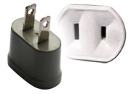
  - Tipping: Tipping is not customary in Japan.
  - Electricity: The standard power supply in Japan is 100 volts.
The frequency is 50 Hz in eastern Japan including
Tokyo. The type of power outlet/connector used in Japan is
A type which is a two-parallel-pronged type.

- LOCAL CONTACT POINT:
For any additional information, please contact:

Hideki Suganami (Mr.) / Junkichi Fujisawa (Mr.)
The ITU Association of Japan
Phone: +81 3 5357 7625/+81 3 5357 7626
Fax: +81-3-3356-8170
E-mail: dr-local@ituaj.jp (Email is the preferable communication means)
ATTACHMENT 1
Transportation from Narita or Haneda Airport to the Venue

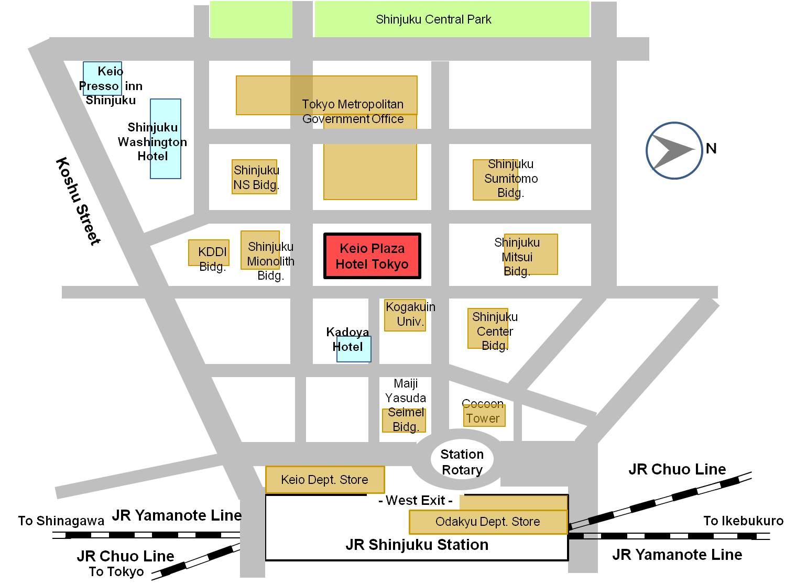

Figure 1 Area Map nearby Keio Plaza Hotel Tokyo

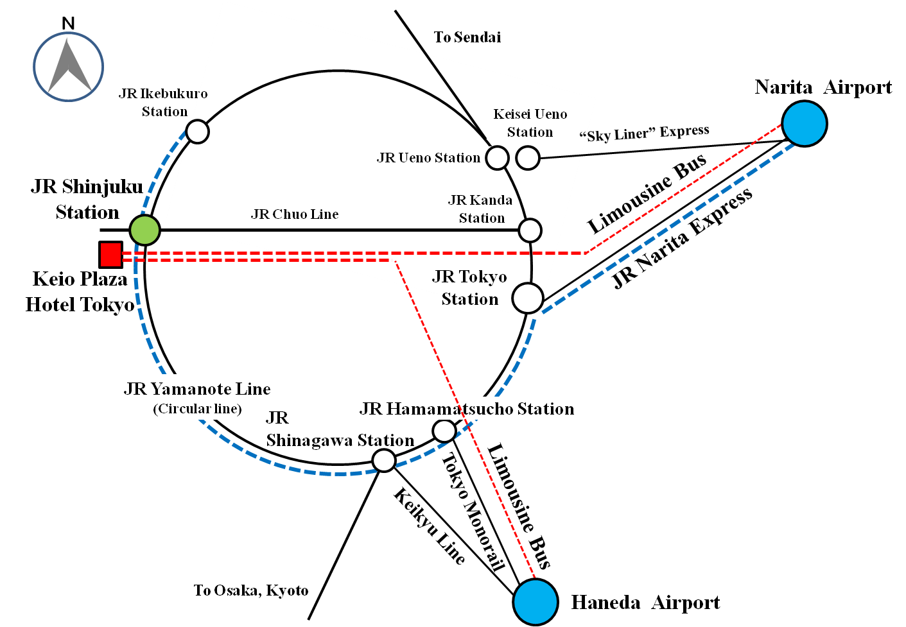

Figure 2 Transportation Map from Narita Airport or Haneda Airport

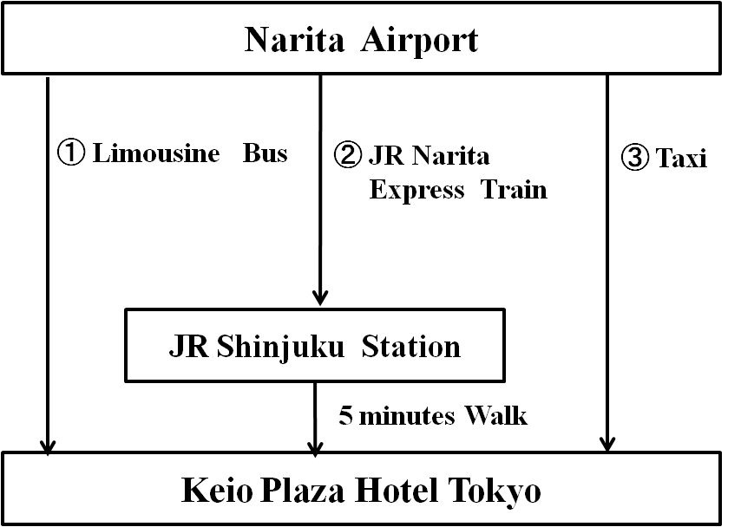

Figure 3 Transportation from Narita Airport to the Venue

Table 1 Time required and Vehicle Fee of Transportation from Narita Airport to the Venue
(Numbers in row correspond to numbers in Figure 3)
No. | Vehicle | Approx. Time Required (minutes) | Vehicle Fee  (JPY) | Remarks
1 | Limousine bus | 120 | 3,000
2 | JR Narita Express Train | 90 | 2,940
3 | Taxi | 100 | approx. 24,000 | not including expressway fare

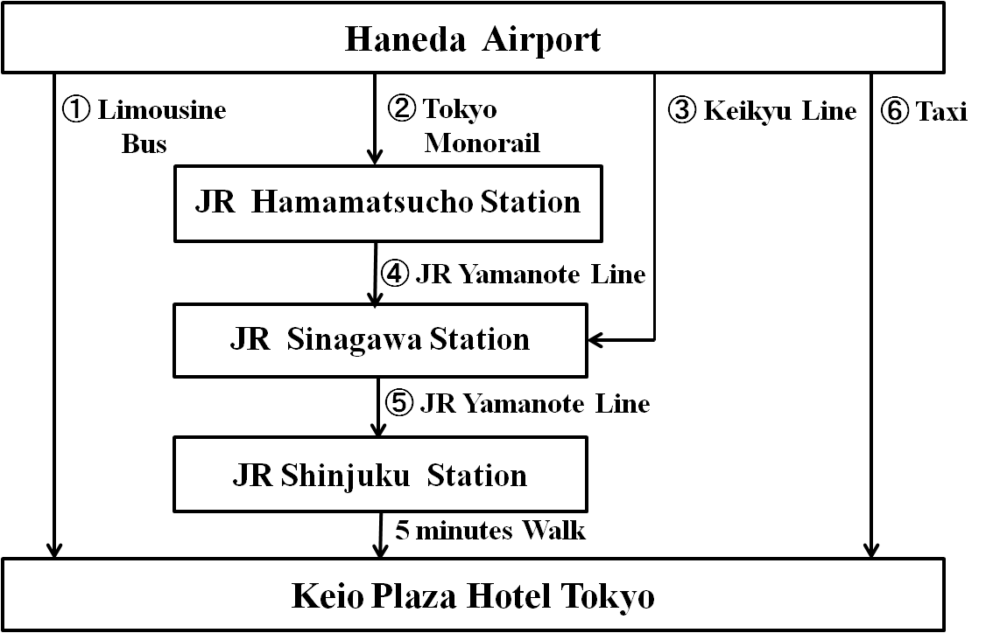

Figure 4 Transportation from Haneda Airport to the Venue

Table 2 Time required and Vehicle Fee of Transportation from Haneda Airport to the Venue
(Numbers in row correspond to numbers in Figure 4)
No. | Vehicle | Approx. Time Required (minutes) | Vehicle Fee  (JPY) | Remarks
1 | Limousine bus | 75 | 1,200
2 | Tokyo Monorail | 20 | 470
3 | Keikyu Line | 20 | 400
4 | JR Yamanote Line | 6 | 190
5 | JR Yamanote Line | 19 | 190
6 | Taxi | 50 | approx.8,600 | not including expressway fare

Figure 5 Location Map of Sendai City

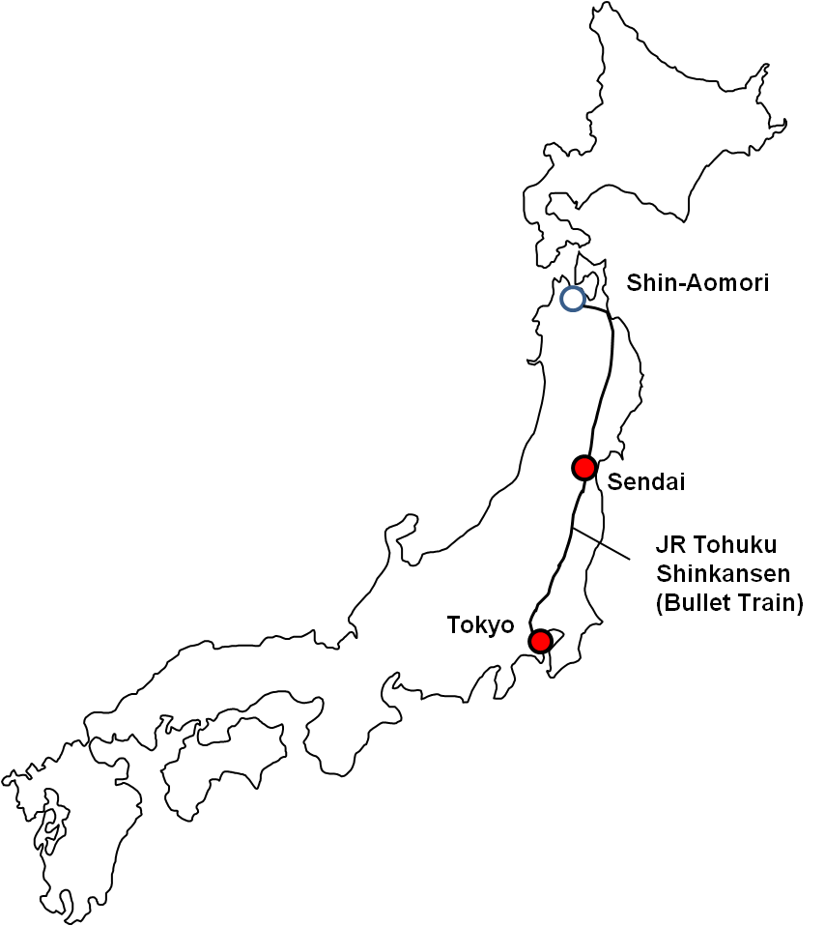
ATTACHMENT 2 Hotel Reservation Form
ITU-T FG-DR&NRR
Tokyo, Japan, 5-8 February 2013
TO: KEIO PLAZA HOTEL TOKYO
Please complete and return this form by e-mail to:
Hotel reservation counter (e-mail address: rooms-sales@keioplaza.co.jp )
Deadline of submission : 20th of January 2013

Name:

(Mr. Ms. Dr.)
 | Family Name |  | Middle Name |  | Given Name
Organization: _
Full Address: ( Office Home)

Country: _

Address: _

Phone No. Fax No. E-mail _

Name of Accompanying Person(s), if any

(Mr. Ms. Dr.)
 | Family Name |  | Middle Name |  | Given Name

PASSPORT INFORMATION:

Passport No. : Expiry Date: / / (DD/MM/YYYY)

Nationality: _

Room Type :
Single use (15,000 JPY) Twin use (18,000 JPY)
Check-in and Check-out Date:
Check in date: / / (DD/MM/YYYY) Check out date: / / (DD/MM/YYYY)
Smoking or Non Smoking
Smoking Room Non Smoking Room
Payment Method
Credit Card Cash
Conformation Reply from Hotel:
Fax Your Fax No. _
E-mail Your E-mail Address _
Date: Signature:
ATTACHMENT 3 Application Form for Visa Supporting Documents
ITU-T FG-DR&NRR
Tokyo, Japan, 5-8 February 2013
Application Form for Visa Supporting Documents

Name

(Mr. Ms. Dr.)
 | Family Name |  | Middle Name |  | Given Name
Your full name in Chinese characters(*): _
*If you are a Chinese participant, please write your name in Chinese characters.

Official Title _

Department: _

Organization _
(**): _
**If you are a Chinese participant, please write your organization in Chinese characters as well.

Country (where you live) _

Address (*1): _
(*1) VISA supporting documents will be sent to the address above by courier service.

Phone No. Fax No. E-mail _

PASSPORT INFORMATION:

Passport No. : Date of Issue: / / (DD/MM/YYYY)

Expiry Date : / / (DD/MM/YYYY)

Place of Birth: Date of Birth: / / (DD/MM/YYYY)

Nationality: _
FLIGHT INFORMATION(*2) :
Arrival in Tokyo (Haneda / Narita) from city Date / / Flight No. Time _
Departure from Tokyo(Haneda/Narita) to city Date / / Flight No. Time _
(*2) For VISA supporting documents, a planned flight s chedule is available as well.
HOTEL ACCOMMODATION
This information is NOT for hotel reservation order sheet, but NEEDED for staying schedule for visa supporting documents.

Hotel name : _
Check in date: / / (DD/MM/YYYY) Check out date: / / (DD/MM/YYYY)

If making your own accommodation arrangement other than recommended hotels in Tokyo, please indicate your contact address and phone number:

Hotel Address _
Hotel phone No. _

Date: Signature:
Deadline of Submission: 10th of January 2013 for all visa related documents
Please Return this form To:
Hideki Suganami (Mr.) / Junkichi Fujisawa (Mr.)
The ITU Association of Japan
Phone: +81 3 5357 7625/+81 3 5357 7626 Fax: +81-3-3356-8170
E-mail: dr-visa@ituaj.jp (Email is the preferable communication means)
ATTACHMENT 4 Application Form to Technical Tour
ITU-T FG-DR&NRR
Tokyo, Japan, 5-8 February 2013
Application to Technical Tour to Sendai City on 8th February 2013

Name:

(Mr. Ms. Dr.)
 | Family Name |  | Middle Name |  | Given Name

Organization: _
Full Address: (Office Home)

Country: _

Address: _

Phone No. Fax No. E-mail _

Your Contact Address, if the Technical Tour has been canceled.
Fax Your Fax No. _
E-mail Your E-mail Address _
Date:

Deadline of Submission: 18th of January 2013
Please Return this form To:
Hideki Suganami (Mr.) / Junkichi Fujisawa (Mr.)
The ITU Association of Japan
Phone: +81 3 5357 7625/+81 3 5357 7626 Fax: +81-3-3356-8170
E-mail: dr-local@ituaj.jp (Email is the preferable communication means)

_______________

