How to subscribe to the FG-DPM mailing lists
To subscribe to the FG-DPM mailing lists, you will first need ITU user account.
On the FG-DPM homepage, click on “Sign up here” to go to the FG-DPM subscription webpage.
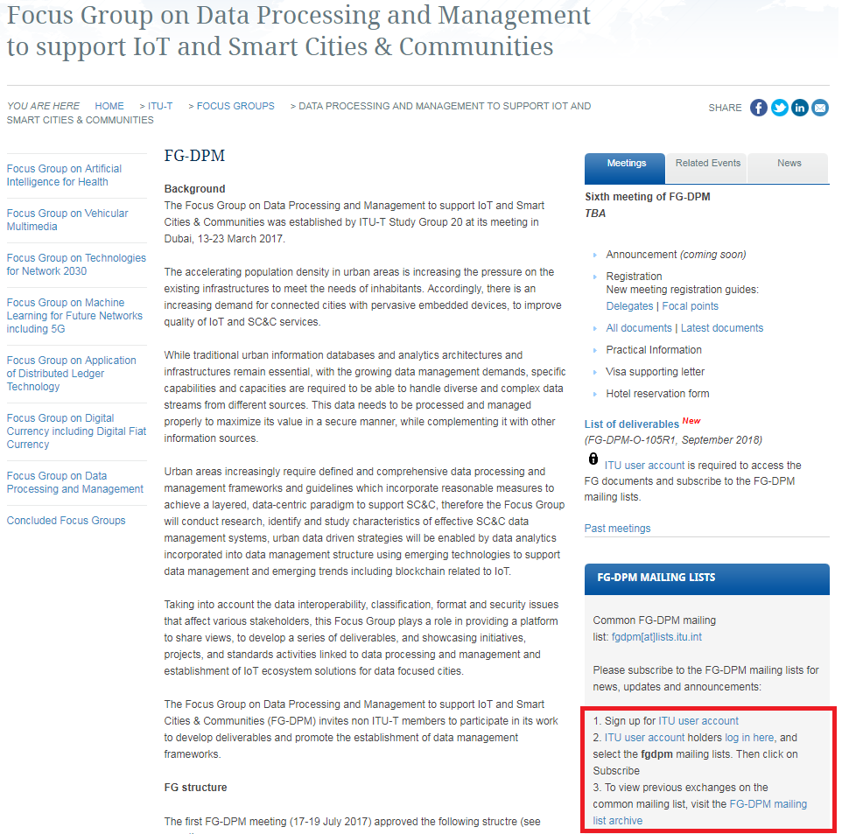

On the subscription page, click the check box to select the list to which you wish to subscribe. Then click “Subscribe / request subscription”. Once the ITU Secretariat has validated your request, you will receive an email confirming your subscription.
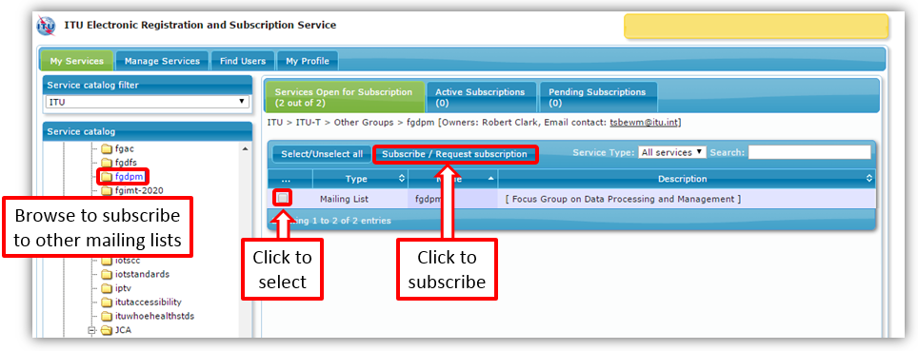
You may now send emails to all subscribers at: fgdpm@lists.itu.int; fgdpmwg1@lists.itu.int; fgdpmwg2@lists.itu.int; fgdpmwg3@lists.itu.int; fgdpmwg4@lists.itu.int; fgdpmwg5@lists.itu.int.
Any emails sent to this mailing list by other subscribers will be forwarded to you. To see previous email exchanges on this list, you may review the entire mailing list archive at: http://www.itu.int/ml/lists/arc/fgdpm.
You may unsubscribe at any time by navigating to the subscription page and selecting “Unsubscribe” from the Active Subscriptions tab.

