General Meeting Information

Meetings and Dates:
ITU-T FG Cloud Computing #4 Meeting January 10-13, 2011

Location:
Nanjing, Jiangsu Province, P.R.China

Meeting Venue:
Sheraton Nanjing Kingsley Hotel & Towers
No. 169 Hanzhong Road, Nanjing, P.R.China
Tel: +86-25-8666 8888
Fax: +86-25-8666 9999
Website: http://www.sheraton.com/nanjing

Room Rate:
Deluxe Room King/ Twin: ￥720 RMB per night
(Daily buffet breakfast, internet, tax, and surcharge included)

Cut-off Date: December 28, 2010
Please make your reservations before the cut off date to ensure the reduced group rate. Rates may be significantly higher after the cut-off date.

Reservations:
Please fill out the ROOM RESERVATION FORM in Appendix A and send the completed form via fax or email to the hotel.

To ensure that your confirmation is sent promptly, please type your information into the form. Handwritten faxes can be difficult to read.

If you have not received a faxed or emailed confirmation within 48 hours of sending the form, please call Reservation at +86-25-86668888 ext 7125/7126 or email reservation.nanjing@sheraton.com

Cancellation:
Any cancellation within 5 days or less before the meeting or NO SHOW, one night room rate will be charged from your credit card.

Please Note:
Please contact the Sheraton Nanjing Kingsley Hotel directly to make any changes.

Internet:

Hotel is complimentary to guests with access to internet in guest rooms.
Meeting room will be equipped with wireless LAN access to internet.

Airport Transportation

Sheraton Nanjing Kingsley Hotel is at a distance about 42 KM from the Airport. Taxis are always available. The fare will be approximately ￥150 RMB.

The alternative way is to take the airport bus with the ticket of ￥30 RMB to Hanzhong Inter-city Bus Station, and then walk to the hotel in 5 minutes.

For your convenience, we would recommend you to print out the attached map. It would help you during your stay in Nanjing.

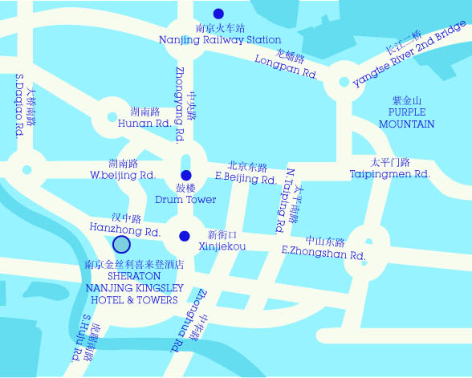

Visa Requirements:
If you require an invitation letter for obtaining your Chinese visa, please fill-in the INVITATION LETTER REQUEST FORM in Appendix B and email it with the subject of “ITU-T FG Meeting-Invitation letter request” to the host. The invitation letter will be dispatched within one week after receiving the email request.

Information of Nanjing:

You could find more information about Nanjing on the website: http://www.chinahighlights.com/nanjing/

Mobile Network:
GSM, TD-SCDMA, WCDMA, CDMA and CDMA2000 coverage in China

Currency:
Local currency is RMB ¥ (CNY). The bank and hotel can provide multi-currency service. Online spot exchange rates are shown at:
http://www.safe.gov.cn/model_safe_en/index.jsp?id=6

Tipping:
Tipping is not necessary.

Time Zone:
GMT+08:00

Electricity: 220V

See picture below for outlet type.


Emergency Number:
In case of emergency please dial 110.

Contact of the Host:
Ms. LIU Qiong
ZTE Corporation
Tel: +86 755 26775537
Fax: +86 755 26776620
Email: liu.qiong@zte.com.cn

Appendix A
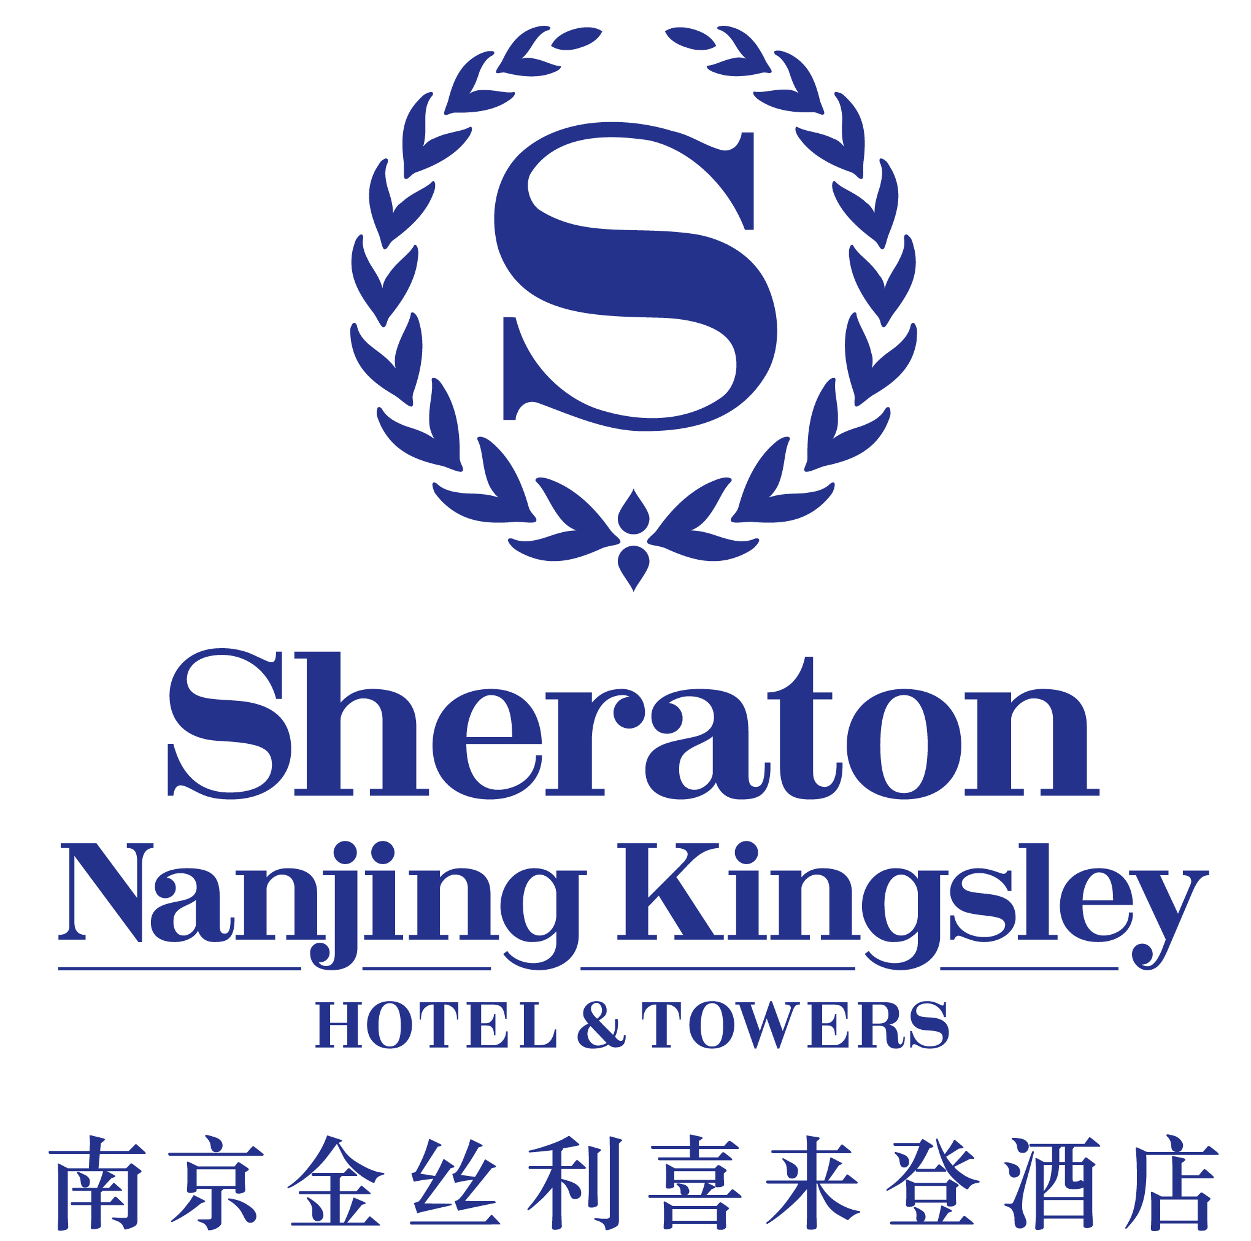
Kindly send your reservation form directly to the hotel in latest by Dec 28, 2010
Fax: +86-25-86504293 Email: reservation.nanjing@sheraton.com
Group Name: ITU Meeting
Room Reservation Form
Name:
Nationality:
Address:
Telephone: |  |  | Fax: |  |  | Email:
Date of Arrival: |  |  |  |  | Flt/ ETA:
Date of Departure: |  |  |  |  | Flt/ ETD
Please reserve _____ room(s) under name:
Rates will be valid between 7 Jan to 16 2011 |  | Airport Transfer, Please indicate transfer requirement:  ◻ Hotel Car: RMB500 per Buick / way Airport  ◻ Hotel Car: RMB750 per Toyota Coaster / way Airport  □ Airport Taxi: Own arrangement.
Deluxe Room RMB 720
□ King ◻ Twin
◻ Smoking ◻ Non-smoking
The rates are per room per night rates, including breakfast, and free Internet access in rooms.
Other special requests
(incl. Dietary requirements):
Starwood Preferred Guest (SPG) No:
To guarantee the room(s), details of my credit/charge card are as follows:
◻ Visa |  | □ Master |  |  | ◻ Diners | ◻ Amex |  |  | ◻ JCB
Name of Card Holder:
Card Number: |  |  |  |  |  |  | Expiry Date:
Signature:

IMPORTANT INFORMATION:
1. Any cancellation within 5 days or less before the meeting or NO SHOW, one night room rate will be charged from your credit card.
2. Copied both side of your credit card with your signature to guarantee your booking.
3. Please inform us of any changes or cancellation of your reservation in writing.
4. If you have not received a faxed or emailed confirmation within 48 hours of sending the form, please call Reservation at: 86 28 86668888 ext 7125/7126.

Appendix B

ITU-T FG Cloud Computing #4 Meeting (January 10-13, 2011)
Nanjing, China

INVITATION LETTER REQUEST FORM

To enter China for the meetings indicated above, you may need a letter of invitation from the Chinese host, which you will need to present to the Chinese Embassy/Consulate in your area in order to obtain your visa. In order to obtain the invitation letter, please fill out the form below and send it to:

- Ms. Liu Qiong of ZTE Corporation
Email: liu.qiong@zte.com.cn

With the email subject:

ITU-T FG Cloud Computing #4 Meeting – Invitation Letter Request

Company
Applicant Information | [ Click and Type in your full name ] |  |  | rMr rMs rMrs
Applicant Information | [ Nationality ] |  |  | [ Passport No.]
Applicant Information | Date of birth : [ Year ] [ Month] [ Day ] |  |  | [ Job Title ]
Applicant Information | If the country in which you'll obtain your visa is different from your nationality, please indicate it here:  [ Country to obtain your visa]
Address | [Click and Type in your address and ZIP code]  Telephone Number: [Click and Type in phone number]  Fax Number: [Click and Type in fax number]  E-mail: [Click and Type in email]
Places to visit after entry | (In this case, it is Nanjing by default; if you want to visit other places than Nanjing, please indicate here.)
Date of arrival at China |  |  | Date of departure from China

A scanned copy of the invitation letter is typically accepted by local Chinese Embassies / Consulates for processing visa requests. Therefore, without a special request for original invitation letter, ZTE will provide by default a scanned copy of the invitation letter. Please confirm whether your local Chinese Embassy / Consulate requires the original invitation letter for processing your visa request and let us know if it is needed.

