INTERNATIONAL TELECOMMUNICATION UNION |  | Focus Group On  Audiovisual Media Accessibility
TELECOMMUNICATION
STANDARDIZATION SECTOR
STUDY PERIOD 2009-2012
English only
Original: English
WG(s): | ALL | Barcelona, 19 January 2012
DOCUMENT
Source: | TSB
Title: | Third FG AVA meeting: 19 January 2012, Barcelona, Spain
This document provides information on the third meeting of the Focus Group on Audiovisual Media Accessibility (FG AVA).
1 As proposed at its first meeting in Geneva, Switzerland, 26 May 2011, the third meeting of the FG AVA is scheduled to take place at the Universitat Autònoma de Barcelona , Barcelona, Spain, 19 January 2012.
2 The FG AVA is open to ITU Member States, Sector Members, Associates and Academia. It is also open to any individual from a country which is a member of ITU and who is willing to contribute to the work. This includes individuals who are also members or representatives of SDOs as well as other interested stakeholders.
3 The items for discussion at the meeting and any contributions received will be made available on the Focus Group web page at http://itu.int/en/ITU-T/focusgroups/ava. Additional information related to the meeting will also be made available on the ITU-T FG AVA web page.
4 The meeting will open at 0900 hours on 19 January 2012. Participant registration will begin at 0830 hours at the following address: Sala d’actes, Rectorat, UAB. No registration fee is required for participating in this meeting.
5 The discussions will be held in English only.
6 General Information for the 3rd FG-AVA Meeting can be found in Annex A. Updated information relating to this event, including remote participation arrangements, will be made available on the ITU-T FG AVA web page.
7 To enable the organizers and TSB to make the necessary arrangements concerning the organization of the Focus Group meeting, please pre-register via the on-line form at the Focus Group web page as soon as possible but before 19 December 2011. Please note that pre-registration of participants to the meeting is carried out exclusively online. To easily provide you with any updates concerning the meeting planning, please fill in your valid e-mail address on your registration form. Any special accommodations must be requested as soon as possible but before 19 November 2011 by email to tsbfgava@itu.int with the subject heading "FG AVA Accommodation request". Kindly note that remote participation will be available at the meeting.

8 The deadline for document submission for this meeting is 6 January 2012. Please note that this is a paperless meeting.

The documents will be made publicly available for this meeting and accessible via web browser from the ITU-T FG web page.

If you intend to submit a document please send it to the FG AVA secretariat at tsbfgava@itu.int

Documents will be processed by TSB and moved to the read-only folder for the meeting: http://ifa.itu.int/t/fg/ava/docs/1201-barcelona/.

9 For any queries regarding FG AVA activities, please contact the TSB Focus Group secretariat at tsbfgava@itu.int.

10 We would remind you that citizens of some countries are required to obtain a visa in order to enter and spend any time in Spain. The visa must be requested and obtained from the office (embassy or consulate) representing Spain in your country or, if there is no such office in your country, from the one that is closest to the country of departure. Please be aware that visa approval might take time so kindly make your visa application as soon as possible.

Participants who require an invitation letter and/or a visa supporting letter for entering Spain are advised to get in touch with the contact person in this country whose detailed information is as follows using the form in Annex B:

Dr Pilar Orero (CAIAC-UAB)
Tel: +34 622 751958
Fax: +34 93 5812762
Email: pilar.orero@uab.cat

11 For any queries regarding FG AVA activities, please contact the TSB Focus Group secretariat at tsbfgava@itu.int.

Annex A
ITU FG AVA Meeting #3: General Meeting Information

Meetings and Dates:
ITU FG AVA Meeting #3: 19 January 2012

Location:
Barcelona, Spain

Meeting Venue:
Universitat Autònoma de Barcelona
Sala d’actes
Edifici Rectorat
Campus Bellaterra
08193 Bellaterra, Spain
Tel: +34-93-5811246
Fax: +34-93-581 2762
Website: http://www.uab.cat/servlet/Satellite/home-1273127135994.html
Contact persons:
Prof. Jordi Carrabina (CAIAC Director)
mail: Jordi.Carrabina@uab.cat
Prof. Pilar Orero (CAIAC Research Coordinator)
mail: pilar.orero@uab.cat
Dr. Manel Ebri (UAB Accessibility Administrator)
mail: manel.ebri@uab.cat
Office details
Centre d'Accessibilitat i Intelligència Ambiental de Catalunya
Edifici Q - Campus UAB
08193 Cerdanyola del Vallés
Barcelona
Telèfon: +34 93 581 30 82
Fax: +34 93 581 30 33
CaiaC@uab.cat

About the host organization: Universitat Autònoma de Barcelona
Universitat Autònoma de Barcelona (UAB, www.uab.cat) plays a leading role in scientific research in Spain and it was selected in the top 5 universities to receive the categorisation of Campus of International Excellence by the Spanish government. The wide range of disciplines all integrated into one university helps to promote a multidisciplinary approach to research, and at the same time its campus integrates many external research institutes, scientific installations and spin-off farms. UAB participates in FG AVA meeting via the Centre for Ambient Intelligence and Accessibility of Catalonia (CaiaC) from the Engineering School and Translation Studies Department. CAIAC (Centre for Ambient Intelligence and Accessibility of Catalonia) is a Research Centre at UAB, with approximately 60 members. CAIAC includes experienced and young researchers from eight different departments with multimedia content, accessibility and technology the common meeting point producing, among others, multiplatform interactive channels with advanced multilingual capabilities.

The University is located some 30 km away from Barcelona downtown, hence we recommend to stay in Barcelona city centre, and travel to the university in the morning.

In this case, and looking at competitive prices, we recommend the Researchers Hotel, detail are as following.

Room Rate:
VAT and breakfast are included in the price

Single room:
Mon-Friday: 70.50€
Sat& Sunday: 53.50€

Double room
Mon-Fri: 98€
Sat & Sunday: 75€

Residència d’Investigadors
C/ Hospital, 64
08001 Barcelona
Tel. +34 934 438 610
Fax +34 934 428 202
http://www.resa.es/esl/residencias/investigadors/(reservas)/Curso
investigadors@resa.es
www.resa.es

If you would like to stay away from Barcelona city centre and close to the venue, please use Hotel Campus

Single/Double room: 79 Euro with breakfast included.

http://www.hotelcampusuab.com/en/index.php?lg=en

Reservations:
Please go to the webpage where there is an online reservation application.

Visa Requirements:
If you require an invitation letter for obtaining your Spanish visa, please fill-in the INVITATION LETTER REQUEST FORM in Annex B and email it with the subject of “ITU FG AVA Meeting: Invitation letter request” to the host (Dr. Pilar Orero, pilar.orero@uab.cat) by
10 December 2011. The invitation letter will be dispatched within one week after receiving the email request.

Information of Barcelona:

You could find more information about Barcelona on the website:
- Barcelona tourism: http://www.barcelonaturisme.com/English/_3Ngb8YjSpL2a3y4pka50kmRE9iFJMC0YdWvWz1LskxvjXgtYwe2iRMDNBCBmV7uVn5EmcyFngZeKVOgw3J0_UWiZuK2vy68VQnxy2sW8XyQ
- Accessible Barcelona http://www.barcelonaturisme.com/Accessible-Barcelona/_3Ngb8YjSpL1b3hR3517b23ATCyja6WydXav7GvT128TJlJb_mRg9rg
- Barcelona city http://www.bcn.cat/en/ihome.htm

Airport Transportation

Public transportation – Barcelona has a bus, train and underground.

Currency & Exchange
Currency: The Spanish currency is the Euro. The present exchange rate is approximately 1 euro to 1.3 dollar (currency converter http://www.xe.com/ucc/). . Bank notes are Euro 5, 10, 20, 50, 100 and 500.

Weather

The Weather in September is usually hot. The average temperature is 15~24°C (59~75.2°F). For more detailed climate information, please contact the Barcelona City Hall web http://www.bcn.cat/en/ihome.htm

Telephone Calls
To make an international call, first dial the international dialling code (00), then the country code, area code, and the local telephone number. Telephone codes- Spain is +34 and Barcelona 93. When dialling from within the country, one has to dial 00 when dialling a landline from a mobile and no code if dialling from another landline number. In case one has to call a local STD mobile number, one has to prefix the number with 00.

Electricity
The standard supply is 230 volts.
The two following outlets are compatible with those available in Spain
- It is popularly known as the europlug which is described in CEE 7/16
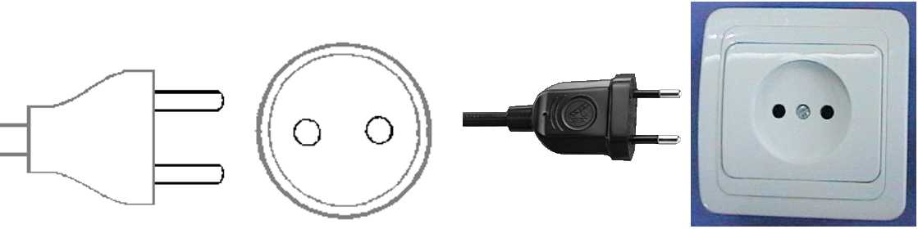
b) This plug is similar to the above except that it is round and has the addition of two grounding clips on the side of the plug
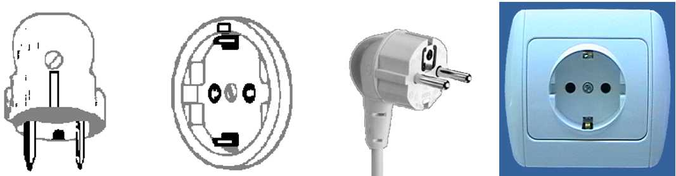

Emergencies
Police 112
Fire Department 080
Medical Emergencies 061
Other emergency no.
http://w3.bcn.es/XMLServeis/XMLHomeLinkPl/0,4022,429370260_433159994_3,00.html

Business Hours
Government offices are open from Monday to Friday between the hours of 09:00 and 15:00.
Most private businesses open at anywhere from 09:00 to 10:00, and close in the evening. Banks are a major exception. Their business hours are from 08:00 to 14:00 on weekdays. They are closed Saturdays and Sundays.
Foreign diplomatic missions in Barcelona generally maintain strict business hours including lunch. They are usually open from 09:00 to 17:00 on weekdays and are closed on Saturdays and Sundays.
Major department stores are usually open from 10:00 to 21:00, not on Sundays, but smaller shops tend to be open earlier and close later every day of the week

Automated Teller Machines (ATM) for Foreign Travelers
Travellers who carry internationally recognized credit cards can get a cash advance in Euro at Automated Teller Machines (ATMs) installed at airports, major hotels, department stores, subway stations and tourist attractions.

Tax
Value-added tax (VAT) is levied on most goods and services at a standard rate of 16% and is included in the retail price. In tourist hotels, this 16% tax applies to meals and other services and is added into the bill.

Local time
GMT + 1 hours

Computer Networking
Each meeting room will be equipped with wireless access (Wireless LAN, supporting IEEE802.11b, 2.4GHz band) to the Internet. Those who wish to use the wireless access must be equipped with the necessary hardware and correctly configured PC.

Contact of the Host (including VISA):
Dr PiIar Orero
CAIAC-UAB
Tel: +34 622 751958
Fax: +34 93 581 2762
Email: pilar.orero@uab.cat

Other accommodations
Hotels (****)
- Gran Hotel Barcino
Jaume I, 6
Tel. (+34) 93 302 20 12
- Hotel Colón
Av. Catedral, 7
Tel. (+34) 93 301 14 04
- Hotel Citadines
Ramblas 122
Tel. (+34) 93 412 77 66
- Hotel Gótico
Jaume I, 14
Tel. (+34) 93 315 22 11
Hotels (* * *)
- Hotel Campus
Vila Universitaria (campus UAB)
Tel. (+34) 93 580 89 78
- Hotel Splendid
Muntaner 2
Tel. (+34) 93 451 21 42
- Hotel Suizo
Plaza del Angel 12
Tel. (+34) 93 310 61 08
- Hotel Catalunya Plaza
Plaza Catalunya 7
Tel. (+34) 93 317 71 71
- Hotel Gravina
Gravina 12
Tel. (+34) 93 301 68 68
- Hotel NH Duc de la Victòria
Duc de la Victòria, 15
Tel. (+34) 93 270 34 10
- Hotel Turín
Pintor Fortuny, 9
Tel. (+34) 93 302 48 12
- Hotel Park Hotel
Av. Marquès de l'Argentera, 11
Tel. (+34) 93 319 60 00
- Hotel Balmes
Mallorca, 216
Tel. (+34) 93 451 19 14
Hotels (* *)
- Hotel Cuatro Naciones
Ramblas 40
Tel. (+34) 93 317 36 24
- Hotel Sant Pau
Sant Antoni Maria Claret 173
Tel. (+34) 93 433 51 51

Annex B
ITU FG AVA Meeting: Invitation letter request

ITU-T FG AVA Meeting #3, Barcelona, Spain

If needed, please return this form, no later than 10 December 2011 for the processing of formal invitation letter.

Family Name
Given Name
Date of Birth(yyyy/mm/dd)
Gender
Company(Individual Member)
Nationality
Passport Number
Mailing Address
(With postal code)
Expected entry date
Expected departure date
Tel.
Fax.
E-mail

If there is no special request for the original invitation letter, a scanned copy it will be provided by default. Also, the invitation letter can be delivered with grouping of your company.

______________________

