ITU-T FG AVA meeting: 13 March 2012
HOW TO PARTICIPATE REMOTELY
Revision 1

Meeting Details
Date: Tuesday, March 13th, 2012.
Time: 09:30 to 17:00 (IST); 04:00 to 11:30 (GMT).

Live Webcast
The meeting will be webcast using GoToWebinar with captions (live text transcript). All you need is a web browser with JavaScript and Java enabled.
GoToWebinar shows the presenters’ slides and documents that are being discussed. It also provides a two-way audio feed, live text chat and allows remote participants to ‘raise their hands’ to indicate when they want to make a contribution.
You must register in advance to use GoToWebinar.
Register at: https://www1.gotomeeting.com/register/303990128. You will receive an email giving full instructions for how to join the meeting.
Access the live video feed at: http://www.24framesdigital.com/cis/webcast/avma/.
Access live captions at: http://www.streamtext.net/text.aspx?event=ITU.
To hear the presentations and make spoken contributions, GoToWebinar provides built-in VOIP which uses your computer’s speakers and microphone. Best results can be achieved by attaching a dedicated headset.
Before speaking, you should indicate that you want to make a contribution by clicking the ‘Raise hand’ button on the GoToWebinar control panel, as shown in the following screenshot. The Chair will then invite you to speak.
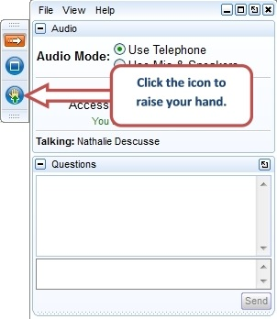

Troubleshooting
If you have lost the email link for GoToWebinar, go to www.joinwebinar.com and enter the meeting ID: 303-990-128.
If you have problems during the meeting, use the text chat tool within GoToWebinar to send messages to the meeting organisers or technical support.

