ITU Workshop and 9th Meeting of the ITU Focus Group on Artificial Intelligence Native for Telecommunication Networks (FG-AINN)

Beijing, China
21-23, September 2026

PRACTICAL INFORMATION

MEETING VENUE
Economic Development Zone National Innovation Park (Xinchuangyuan), Beijing
Address: Kegu 1st Street, Beijing Economic-Technological Development Area (BDA)

TRANSPORTATION
From Beijing Capital International Airport (PEK) to city center
Note: The conference center is not located in the city center and the following information relates to reaching the meeting venue.
- Subway: (Recommended for Convenience & Affordability)
- Best suited for: Cost-conscious travellers with light luggage who want to avoid traffic congestion
- Route (from Capital Airport - PEK):
  - Take Airport Express from Capital Airport to Sanyuanqiao (1 stop)
  - Transfer to Line 10 inner loop to Shilihe (10 stops)
  - Transfer to Line 17 to Ciqu (5 stops)
  - Take a taxi.
- Time: Approx 1.5 hour.
- Cost: 25–30 CNY total.
- Note: Subways operate from 6:00 AM to 11:00 PM. English signage is provided
- Airport Shuttle: No direct shuttles
- Uber/Taxi:
- Best suited for: Groups, heavy luggage, or late-night arrivals.
- Apps: While Uber is not widely used in China, the DiDi Chuxing app (available in English) is the most reliable ride-hailing service. Alternatively, you can hail a taxi at designated stands outside the terminals.
- Route: The drive takes approximately 45–70 minutes, but traffic in Beijing during peak hours (8:00–9:30 AM and 5:00–7:00 PM) is typically heavy.
- Cost: 90–130 CNY (taxi) or similar via DiDi.
- Tip: It is recommended to have your hotel address written in Chinese to show the driver.
- Bus: Not recommended

From Beijing Daxing International Airport
- Airport Shuttle:
- Route: Take Daxing Airport Shuttle Bus (Yizhuang Route) to Kechuang 11 Street
(the terminal stop)
- Time: About 40 - 50 minutes
- Cost: 40 CNY
- Note: The shuttles operate from 8:30 AM to 5:35 PM, every 1 hour.

- Uber/Taxi:
- Best suited for: Groups, with heavy luggage, or late-night arrivals.
- Apps: While Uber is not widely used in China, the DiDi Chuxing app (available in English) is the most reliable ride-hailing service. Alternatively, you can hail a taxi at designated stands outside the terminals.
- Route: The drive takes approximately 40–50 minutes, but traffic in Beijing during peak hours (8:00–9:30 AM and 5:00–7:00 PM) is typically heavy.
- Cost: 80 – 120 CNY (taxi) or similar via DiDi.
- Tip: It is recommended to have your hotel address written in Chinese to show the driver.
VISA REQUIREMENTS

Participants are strongly advised to check all entry and visa requirements here: website.
- The following countries need a visa to travel to China: website
- Additional information is available here: website
- Visa support letters can be requested from: Liya Yuan, (yuan.liya@zte.com.cn)
The host can assist by providing visa support letter, but granting of the visa is entirely at the discretion of the consulate or embassy.
HOTEL – Recommended Hotel near the campus
For convenience, the host recommends staying in the Beijing Economic-Technological Development Area (BDA, also known as Beijing E-town).

Hotels | Website
Holiday Inn Express Beijing Yizhuang Tongminghu | https://beijing-tongminghu-express.ihghotels.cn/en
Atour Hotel  (Beijing Yizhuang Yidong Guigu) | https://atourbeijingyizhuangyidongguigu.hotelatour.cn/en
Coffetel Fan Hotel  (Beijing Yizhuang Jingdong Headquarters Jinghai Road Subway Station) | https://www.trip.com/hotels/beijing-hotel-detail-79098334/james-joyce-coffetel/?locale=en_xx
General information

Internet access
The venue has free WIFI coverage for participants during the workshop and meeting.
Nearby cafeterias for lunch:
- Lunch
    - Wagas
    - Ziguangyuan Restaurant (Halal)
    - Panda Fan
    - Xiangjianhaowan Restaurant (Hunan Cuisine)
    - Zhang Lala Noodle
- Mall
    - Xincheng Mall
    - Zhongfu Mall
    - Baifa Mall
The weather in September is typically warm and sunny, temperature ranging from 18°C to 28°C (64°F – 82°F).
Tourist Information
- The Forbidden City (Palace Museum)
- Highlight: The world’s largest imperial palace complex, home to the emperors of the Ming and Qing dynasties.
- Distance: -20 km from the meeting venue.
- Tip: Book tickets weeks in advance as they sell out quickly.
  - The Summer Palace
- Highlight: A vast imperial garden featuring Kunming Lake and Longevity Hill, perfect for a relaxing afternoon walk.
- Distance: 33 km from the meeting venue.
- Tip: Great for photography, especially in the golden light of September.
  - Universal Beijing Resort
- Highlight: Asia’s large-scale Universal Park with a one-of-a-kind Kung Fu Panda zone.
- Distance: 11 km from the meeting venue
- Tip: Book tickets for Universal Beijing Resort online in advance to skip long queues, especially on weekends and holidays

- Electricity
The power plug sockets are of type A and C. See pictures below:
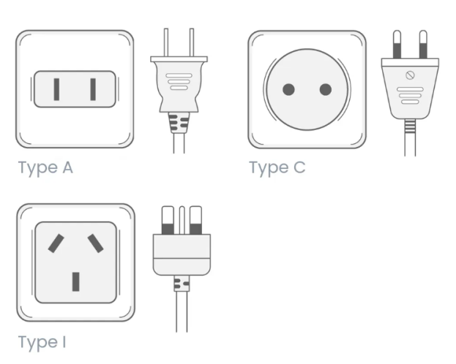
- Currency
Chinese Yuan (CNY) is the official currency. For daily current exchange rates please visit
http://www.xe.com/.
Digital Payment: It is highly recommended to set up Alipay or WeChat Pay linked to your international credit card before arrival, as cash is rarely used and card terminals are less common.
- Time Zone: (UTC+8)
- Emergency: 110
- Fire: 119
- Opening hours: Banks, shops and etc. 09:00 am
- Tipping: No.
FOCAL POINTS

- ITU FG-AINN Secretariat: tsbfgainn@itu.int
- Host - Yuan Liya: yuan.liya@zte.com.cn

________________

