PRACTICAL INFORMATION

Second meeting of ITU-T Focus Group on AI for Smart Sustainable Cities and Communities (FG-AI4SSC), and associated forum

Manchester, United Kingdom, 8 – 10, December 2026

1. Meeting Venue
- Primary Venue: Manchester Metropolitan University (All Saints Campus)

- Address: Business School, Oxford Road, Manchester, M15 6BH, United Kingdom

- Specific Building / Rooms: Business School

2. Transportation and Site Information
Manchester Metropolitan University's All Saints Campus is located centrally along the Oxford Road Corridor, with straightforward connections from major air and rail hubs.

Arriving by Air
- Manchester Airport (MAN): Approximately 9 miles (14 km) south of the campus.

  - By Train: Trains run 24 hours a day directly from the Airport Rail Station to Manchester Oxford Road Station or Manchester Piccadilly Station. Travel time is 15–20 minutes, with tickets costing roughly £4–£7.

  - By Taxi / Rideshare: Official Hackney Carriages (Black Cabs) and rideshare apps (Uber, Bolt) operate from designated ranks outside every terminal. The ride to Manchester Met University takes 25–40 minutes depending on peak traffic, costing £25–£40.

Arriving by Rail
- Manchester Oxford Road Station: The closest rail station, located a 7- to 10-minute walk (approx. 600m) directly south down Oxford Road to the MMU All Saints Campus.
- Manchester Piccadilly Station (Principal Intercity Hub): Located approximately a 15-minute walk or a 5-minute taxi/bus ride from the campus.

Local Public Transport
- Buses: Oxford Road is one of Europe's busiest bus corridors. Routes 41, 42, 43, 142, and 143 arrive every 2 to 3 minutes directly outside the university (stops at "All Saints Park" or "Grosvenor Street"). You do not need a ticket in advance- simply tap in with any contactless bank card or digital wallet (Apple Pay / Google Pay).

- Metrolink (Tram): The nearest tram stop is St Peter’s Square, a 10-minute walk north of campus.

3. Passports, Visas and Invitation Letter
All international delegates entering the UK must verify their entry requirements before traveling.

- UK Electronic Travel Authorisation (ETA): If you hold a passport from a visa-exempt country (including the USA, Canada, EU/EEA member states, Australia, Japan, etc.), you are required to hold an approved digital UK ETA prior to travel. Applications are completed via the official UK ETA mobile app or online at GOV.UK (£16 fee; valid for two years).

- Standard Visitor Visa: Delegates from visa-national countries require a formal UK Standard Visitor Visa. Processing generally takes 3 to 7 weeks; we strongly advise submitting your visa application several weeks before departure.

- Official Invitation Letter:

  - Information Required: Kindly complete the form provided in Annex I and submit it to the following email address: Mr Bamidele Adebisi (B.Adebisi@mmu.ac.uk)

  - Deadline for Visa Support Requests: 15 November 2026 (requests submitted after this date cannot guarantee sufficient processing time from UK Visas and Immigration).

4. Climate – December
December marks early winter in North West England. Weather is typically cold, damp, and crisp:

- Temperatures: Daily highs average 7°C (45°F); overnight lows average 2°C to 4°C (36°F–39°F), with occasional frost.

- Daylight: Short winter days; sunrise is approximately 08:15 and sunset is around 15:50.

- What to Wear: A warm, water-resistant winter coat, scarf, gloves, an umbrella, and sturdy walking shoes. MMU conference buildings and lecture theatres are fully heated indoors.

5. Hotels
A wide range of accommodations surrounds the MMU campus, all within a 2- to 10-minute walk:

Hotel | Category | Distance to MMU | Details
Hyatt Regency / Hyatt House Manchester | 4-Star | 350 m (4 min walk) | 55 Booth St W; directly adjacent to the university campus
Kimpton Clocktower Hotel | 5-Star | 600 m (7 min walk) | Landmark Victorian hotel right next to Oxford Road Station
Holiday Inn Express Manchester CC - Oxford Rd | 3-Star | 500 m (6 min walk) | Practical, modern; includes complimentary breakfast
Maldron Hotel Manchester Cathedral / Charles St | 4-Star | 400 m (5 min walk) | Charles Street; quiet, close to campus
ibis Manchester Centre Princess Street | Budget / 3-Star | 600 m (7 min walk) | Central, functional, budget-friendly accommodation
Note: December coincides with the city's Christmas shopping and market season. Booking your hotel well in advance is essential.

6. Internet Access and Wireless Coverage
- Eduroam: Available across the entire Manchester Metropolitan University campus. Delegates affiliated with participating academic institutions can connect seamlessly using their home university credentials.

- Guest Wi-Fi: Complimentary high-speed campus guest network:
Network (SSID): MMU-Guest

  - Login Method: Open a browser, register your name and email, and accept terms.

- Mobile Networks: Full 4G and 5G coverage throughout the campus and central Manchester across all major UK networks (EE, Vodafone, O2, Three). International eSIMs (e.g., Airalo, Nomad) connect automatically.

7. Electricity and Plug Sockets
- Voltage & Frequency: 230V AC, 50 Hz.

- Socket Standard: Type G (the standard British 3-pin rectangular plug, grounded and fitted with a local safety switch).

- Adaptors: Visitors traveling from outside the UK and Ireland will require a Type G plug adaptor. Please bring your own, as loaner adaptors are not provided on site.

Type G Socket (UK)

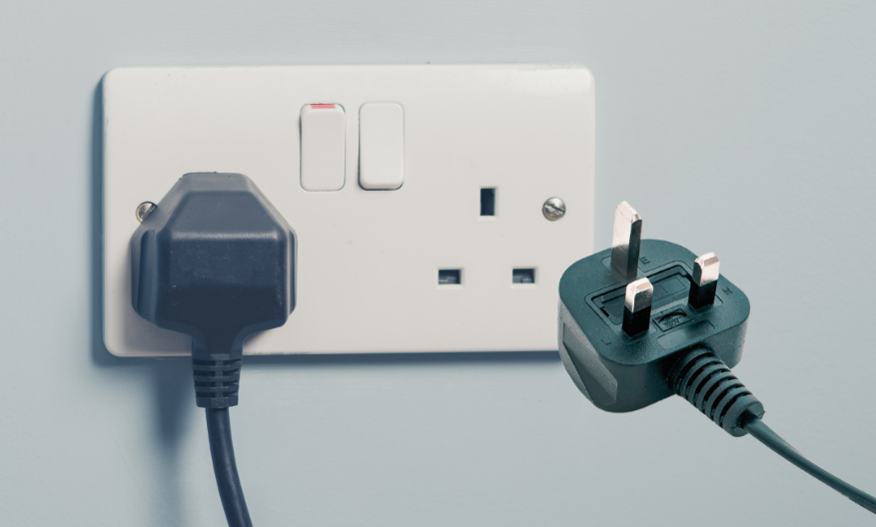
9. Useful Financial Information
- Currency: British Pound Sterling (GBP / £).

- Cashless City: Manchester is almost entirely cashless. Credit and debit cards (Visa, Mastercard, American Express) and mobile contactless payments (Apple Pay, Google Pay) are accepted everywhere—including buses, taxis, cafes, and campus vendors.

- Currency Exchange: Travelex desks at Manchester Airport; High Street bank branches and Post Offices located in Manchester city centre.

- Live Exchange Rates: Current official exchange rates can be viewed at: http://www.xe.com/

- ATMs: Multiple cashpoints are available right along Oxford Road, directly outside the All Saints building.

10. Additional Information
- Time Zone: Greenwich Mean Time (GMT / UTC+0).

- Emergency Number: In case of emergency (Police, Fire, Ambulance), dial 999 (or 112 from mobile phones). For non-emergency medical advice, dial 111 (NHS 111).

- Tipping:

  - Restaurants: 10%–12.5% is customary for table service (often added automatically as an optional "service charge"- check your bill first).

  - Taxis: Rounding up to the nearest £1–£2 is standard.

  - Bars / Pubs: Not expected when buying drinks at the counter.

- Tap Water: Fully potable and safe to drink throughout the UK. Water refilling stations are located across MMU campus buildings.

- Smoking / Vaping: Banned by UK law inside all public buildings, public transport, and hotel rooms. MMU operates a smoke-free campus policy.

- About Manchester: Known historically as the cradle of the Industrial Revolution and computing, Manchester is a global cultural, academic, and sporting center. During your visit, the annual Manchester Christmas Markets will be running across Albert Square, St Ann's Square, and Exchange Square.

City guides and event details: https://www.visitmanchester.com/

11. Contact Persons (Host & Visa Inquiries)
Local Organizing Committee & Visa Coordination:

Host Coordinator: Prof Bamidele Adebisi

Department: School of Engineering and Environment

Institution: Manchester Metropolitan University

Office Address: Dalton Building, M1 5GD, Chester Street, Manchester, UK

Email: b.adebisi@mmu.ac.uk

ANNEX 1
LETTER OF INVITATION FOR VISA REQUEST
For the Second meeting of ITU-T Focus Group on AI for Smart Sustainable Cities and Communities (FG-AI4SSC), and associated forum (Manchester, United Kingdom, 8-10 December 2026)
(Deadline for sending is 15 November 2026)
[Note: Visa approval might take time. Please send your request as soon as possible]
Please use CAPITAL letters.
Surname & first name(s):
Gender:
Position:
Organization:
Address:
Telephone:
Fax:
Nationality:
Passport number:
Date of issue:
Place of issue:
Date of expiry:
Country & city where you will obtain the visa:
Date of birth:
Place of birth:
Date of arrival:
Date of departure:
All requests for letter of invitation for visa purposes must be addressed to Mr Bamidele Adebisi (aiforsustainablecities@mmu.ac.uk) with copy to ITU: tsbfgai4ssc@itu.int, bearing the words “Letter of support for visa” as subject and should be sent by 15 November 2026 at the latest.
Note: the email should also include as attachments the present form duly completed specifying the name as written in the passport, date of birth, passport number, dates of issue and expiry of the passport of the individual(s) for whom the visa(s) is/are requested, scanned copy of the passport and a copy of the notification of confirmation of registration for the FG-AI4SSC meeting and associated forum.

