PRACTICAL INFORMATION

Forum on AI and Citiverse: Building the Foundations for Interoperable and Scalable Urban Innovation and Meeting of ITU-T Focus Group on AI for Smart Sustainable Cities and Communities (FG-AI4SSC)

(Tampere, Finland, 9-11 September 2026)

Forum on AI and Citiverse: Building the Foundations for Interoperable and Scalable Urban Innovation and Meeting of ITU-T Focus Group on AI for Smart Sustainable Cities and Communities (FG-AI4SSC)
Tampere, Finland, 9-11 September 2026

Programme & venue
Venue of the ITU Forum and the focus-group meeting: Tampere Hall, Yliopistonkatu 55
Tampere Hall is Finland’s largest congress and cultural centre, located in the heart of Tampere.
Inside Tampere Hall, both the staff and the signs will guide you to the right room, near which you’ll also find the registration desk.
Forum Wed-Thu: Sopraano (2nd floor)
Focus group meeting Thu-Fri: Duetto 1-2 (2nd floor)
https://www.tampere-talo.fi/en/premises/?em_l=image#floor-plan
Draft programme
Wednesday, 9 September 2026
9:00-17:00 | Sopraano, Tampere Hall | Forum “AI and Citiverse: Building the Foundations for Interoperable and Scalable Urban Innovation”
Thursday, 10 September 2026
9:00 – 12:45 | Sopraano, Tampere Hall | Forum including highlights on Tampere activities
12:45 – 14:00 |  | Lunch break
14:00 – 16:00 | Duetto 1-2, Tampere Hall | Meeting of Focus Group on AI for Smart Sustainable Cities and Communities (FG-AI4SSC)
18:00 –20:00 | Old City Hall, Keskustori 10 | Cocktail Reception hosted by the city of Tampere
Friday, 11 September 2026
9:00 – 16:00 | Duetto 1-2, Tampere Hall | Meeting of Focus Group on AI for Smart Sustainable Cities and Communities (FG-AI4SSC)

Please make sure that you register and indicate whether you are attending in person in Tampere or remotely.

Coffee and Lunch
A coffee station will be available to participants free of charge during the event. Lunch at the event is at your own expense.
A restaurant Tuhto on the first floor at the venue offers an affordable well-crafted, seasonal lunch inc. soup option with a Nordic touch.
Other recommended options nearby:
- Restaurant Myllärit (Åkerlundinkatu 4) Nordic cuisine from a buffet in a traditional setting. App. 150 meters from the venue’s main entrance.
- Restaurant Telakka offers a simple, hearty lunch, and a relaxed, slightly bohemian interior with a rustic feel. (Tullikamarinaukio 3). App. 350 meters from the venue’s main entrance.
- Boulangerie Marco (Tullikatu 6) offers a light, refined lunch with fresh bakery items, in a bright and stylish, distinctly French-inspired setting. App. 400 meters from the venue’s main entrance.
- Los Pollos (Tullikatu 6) offers a casual and delicious lunch menu featuring grilled chicken and Latin-inspired dishes. App. 400 meters from the venue’s main entrance.
- Moro Sky bar (Ratapihankatu 43) For those who aren't too hungry and are happy with a lighter soup lunch, but who appreciate spectacular views while enjoying a drink. App. 350 meters from the venue’s main entrance.
There are also plenty of ethnic restaurants, cafés, and workplace cafeterias in the area easily found on current online services.

City reception
All event participants are warmly invited to an evening reception ( buffet style dinner) hosted by the City of Tampere on Thursday, 10 September 2026, beginning at 18:00.
The reception will take place at the Old City Hall, located at Keskustori 10 (Central Square).
Please note that separate registration is required to attend the reception. Access will be verified at the entrance. To assist with catering arrangements, we kindly ask that you to complete the form, which will be sent by e-mail to all registered participants.

Accommodation
All recommended hotels are located within walking distance of the meeting venue Tampere Hall.
You are kindly advised to book your accommodation as soon as possible, since there is a major sports event taking place at the same time in Tampere which will affect room availability and rates.
For those participants arriving late in the evening, we recommend that you inform your hotel and guarantee your reservation.
Hotel name | Price per night incl. breakfast | Comments & booking link
Courtyard by Marriott Tampere City  Yliopistonkatu 57  This hotel is connected to the meeting venue Tampere Hall by an internal corridor. | Lowest rate 139€/night,  Standard room for one | Please check availability and room rates directly from the hotel website.  Courtyard by Marriott Tampere City | Hotel with Modern Rooms & Flexible Workspaces
Scandic Tampere Station Ratapihankatu 37  12-minute walk to the meeting venue Tampere Hall | Lowest rate 101€/night (breakfast included)  Promotion for ITU. | To make a reservation, please click on the tailored link below. You can book the room of your choice from the options on the website.  The link is now default for one person for two nights from 7-9 September, but these can be modified during the reservation process.  Make a reservation at Scandic  The above link is valid as long as there is availability.
Scandic Tampere City Hämeenkatu 1  15-minute walk to the meeting venue Tampere Hall | Lowest rate 104€/night (breakfast included)  Promotion for ITU. | To make a reservation, please click on the tailored link below. You can book the room of your choice from the options on the website.  The link is now default for one person for two nights from 7-9 September, but these can be modified during the reservation process.  Make a reservation at Scandic  The above link is valid as long as there is availability.
Scandic Postitalo  Rautatienkatu 21  16-minute walk to the meeting venue Tampere Hall | Lowest rate 92€/night (breakfast included)  Promotion for ITU. | To make a reservation, please click on the tailored link below. You can book the room of your choice from the options on the website.  The link is now default for one person for two nights from 7-9 September, but these can be modified during the reservation process.  Make a reservation at Scandic  The above link is valid as long as there is availability.
Dream Hostel and Hotel Tampere  Åkerlundinkatu 2  One minute walk to the meeting venue Tampere Hall | Lowest rate 70€/night, Double Room En Suite for one, breakfast + 10 € | Please check availability and room rates directly from the hotel website.  Dream Hostel | Affordable design hostel and hotel in Tampere, Finland

Map indicating the hotel locations
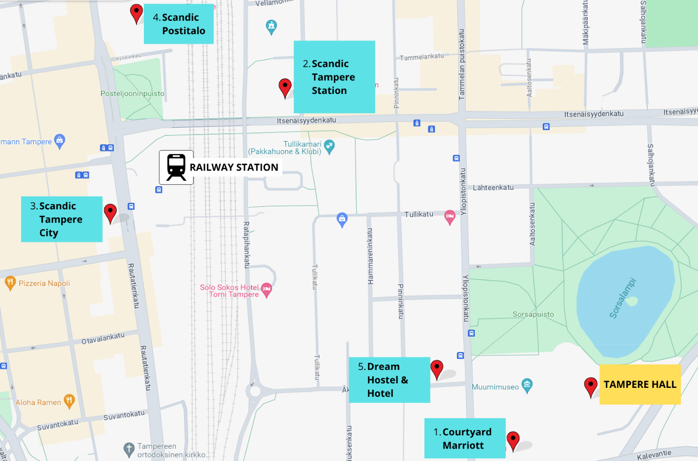

Getting to Tampere
Arrival from Helsinki Airport
We recommend flying to/from Helsinki-Vantaa airport.
There is a train connection from the airport via Tikkurila suburb station to Tampere city centre by train. The train station is located below the airport’s arrival hall, where you can also buy a train ticket from a vending machine or online at https://www.vr.fi/en.
First take the commuter train P (every 20 minutes at peak hours – subject to timetables) to Tikkurila and then change to InterCity/Pendolino train to Tampere (running approx. twice/hour). The VR App/website provides clear instructions (Helsinki airport to Tampere) and you can buy a single train ticket for the entire journey.
The journey takes approx. 2-2,5 h. The estimated cost for a one-way trip is 20-40 euro. At arrival in Tampere, all recommended hotels are a few minutes’ walk from the train station.
Are you still feeling unsure? Check out the following YouTube video:
How to Travel from Helsinki Airport to Tampere
Flying directly to Tampere
You can also fly directly to Tampere-Pirkkala Airport subject to availability of flights. Only Air Baltic is operating flights to Tampere-Pirkkala airport at the moment.
From Tampere airport, you can take a taxi (taxi stand in front of the airport). If you want to ensure a taxi is available for you or if you have special requests, you can book a taxi in advance from e.g. Taksi Tampere + 358 100 4131. The estimated cost for a taxi from Tampere Airport to downtown Tampere to is typically around 35–50 euros. The price depends on the time of day, the number of passengers, and how you book the ride (booking via an app often gives you a fixed price). The trip takes about 20–30 minutes. Uber is also available.

Departure from Tampere to Helsinki-Vantaa Airport
There is a cloakroom in Tampere Hall, so if you are staying somewhere else than Courtyard by Marriott, it could be most convenient for your departure to bring your luggage with you to the event venue. There is a cloakroom available for use at your own risk, however, there are staff present. Tampere Railway Station also has paid luggage lockers.

General practical information
Entry requirements and vaccinations
Visitors to Finland need a valid passport issued within the last 10 years and valid for at least 3 months beyond their departure date. Travelers from visa-exempt countries can stay for 90 days in any 180-day period. Non-EU/Schengen citizens must prove funds (approx. €50/day) and may need proof of accommodation. Learn more from Foreign nationals entering Finland - Ministry for Foreign Affairs
Visa requirements
Foreigners seeking to enter Finland should be in possession of a valid passport. The passport is to be presented to the Immigration Control Officer at any entry point. The passport must be presented along with a valid visa.
Information on the documents and requirements can be found on Ministry for Foreign Affairs of Finland website: https://um.fi/visa-requirement-and-travel-documents-accepted-by-finland
Where and how to apply for visa / Representation agreements in visa matters: https://um.fi/visa-representation-agreements
Online application: https://finlandvisa.fi/
Please submit the visa request form (found in Annex A) to Elias Reinikainen (e-mail: elias.reinikainen@tampere.fi) and Minna Merikoski (minna.merikoski@tampere.fi), by 1 August 2026, at the latest.
Airport taxes and Duty Free
Finland doesn’t collect additional fees or taxes for entering or exiting Finland. Tax-free shopping in Finland means that travellers from outside the EU and Norway can get a refund of the value-added tax (VAT) on their purchases when they take the goods with them outside the EU. The refund generally applies to purchases over 40 euros. The refund is requested from the seller at the time of purchase and verified by customs upon departure from the country. Learn more at Global Blue Tax Refunds | Finavia.
Currency
Finland uses Euro €. Credit cards and contactless payment methods are widely accepted, also for small amounts. Cash is also widely used, however some establishments don’t accept cash payments anymore. Money exchange is possible at Forex at the airport and at Stockmann Department Store in Tampere city centre.
Services and Retail Working Hours
- Office/Government: Typically 8:00–16:00, Mon-Fri.
- Banks: Usually open 10:00–16:30, Mon-Fri.
- Shops: Often open 07:00–21:00 or 22:00/23:00, Mon-Sun (shorter hours on Sundays). Some grocery stores are open 24 h.
Weather
September in Tampere brings typical temperatures with highs around 15°C and lows of 8°C. The difference between afternoon and evening temperatures is usually noticeable. At 8°C overnight, it gets properly cold after dark. Learn more at Tampere, Pirkanmaa, Finland Monthly Weather | AccuWeather.
Getting around in Tampere
Tampere is a compact and easy-to-navigate city where most attractions, hotels, and venues are within walking distance. The city offers efficient public transport, including buses and a modern light rail (tram), making it simple to move between key areas. Taxis, ride-hailing services and rentable electronic scooters
are widely available, and cycling is a popular option with well-maintained routes throughout the city.
Tampere public transport

Enjoy and learn more
We recommend checking the Visit Tampere webpage, to explore what else the city has to offer.
We also recommend downloading the Tampere, Finland App with maps, bus routes and timetables, the Tampere Pass discount application and more.
You are welcome to come and meet Tampere’s organisation team at the registration desk for tips!

Contact information
For questions related to the ITU Forum and Focus Group meeting, please contact the ITU secretariat at: virtualworlds@itu.int.
For questions related to invitation letters, logistics or accommodation, please contact:
]Minna Merikoski: minna.merikoski@tampere.fi, +358 40 841 6917
Jessica Stortz: jessica.stortz@tampere.fi, +358 40 628 0275

Don’t forget to register

ANNEX 1
LETTER OF INVITATION FOR VISA REQUEST
For the Forum and FG-AI4SSC meeting
(Deadline for sending is 1 August 2026)
[Note: Visa approval might take time. Please send your request as soon as possible]
Please use CAPITAL letters.
Surname & first name(s):
Gender:
Position:
Organization:
Address:
Telephone:
Fax:
Nationality:
Passport number:
Date of issue:
Place of issue:
Date of expiry:
Country & city where you will obtain the visa:
Date of birth:
Place of birth:
Date of arrival:
Date of departure:
All requests for letter of invitation for visa purposes must be addressed to Elias Reinikainen (e-mail: elias.reinikainen@tampere.fi) and Minna Merikoski (minna.merikoski@tampere.fi) with copy to ITU: tsbfgai4ssc@itu.int, bearing the words “Letter of support for visa” as subject and should be sent by 1 August 2026 at the latest.
Note: the email should also include as attachments the present form duly completed specifying the name as written in the passport, date of birth, passport number, dates of issue and expiry of the passport of the individual(s) for whom the visa(s) is/are requested, scanned copy of the passport and a copy of the notification of confirmation of registration for the FG-AI4SSC meeting.

