|  |  |  |  |  |  |
| --- | --- | --- | --- | --- | --- |
| ITU Logo | INTERNATIONAL TELECOMMUNICATION UNION  **TELECOMMUNICATION STANDARDIZATION SECTOR**  STUDY PERIOD 2017-2020 | | | FG-AI4H-N-056 | |
| **ITU-T Focus Group on AI for Health** | |
| **Original: English** | |
| **WG(s):** | | WG-O | | E-meeting, 15-17 February 2022 | |
| **DOCUMENT** | | | | | |
| **Source:** | | FG-AI4H | | | |
| **Title:** | | LS/r on the invitation to review Artificial Intelligence Standardization Roadmap and provide missing or updated information ([SG13-LS234](https://www.itu.int/net/ITU-T/ls/ls.aspx?isn=28079)) [to ITU-T SG13] | | | |
| **LIAISON STATEMENT** | | | | | |
| **For action to:** | | | ITU-T SG13 | | |
| **For comment to:** | | | – | | |
| **For information to:** | | | – | | |
| **Approval:** | | | FG-AI4H management meeting (Online, 2 March 2022) | | |
| **Deadline:** | | | 31 August 2022 | | |
| **Contact:** | | Thomas Wiegand Chair, FG-AI4H | | | E-mail: [thomas.wiegand@hhi.fraunhofer.de](mailto:thomas.wiegand@hhi.fraunhofer.de) |
| **Contact:** | | Eva Weicken and Markus Wenzel Co-chairs, WGO | | | E-mail: [eva.weicken@hhi.fraunhofer.de](mailto:eva.weicken@hhi.fraunhofer.de),  [markus.wenzel@hhi.fraunhofer.de](mailto:markus.wenzel@hhi.fraunhofer.de) |
| **Contact:** | | Shan Xu FG-AI4H vice-chair, Editor DEL00 | | | E-mail: [xushan@caict.ac.cn](mailto:xushan@caict.ac.cn) |

|  |  |
| --- | --- |
| **Keywords:** | Artificial Intelligence Machine learning Standardization Roadmap |
| **Abstract:** | FG-AI4H provides updates relative to its planned deliverables to be included in the draft of Y.sup.aisr "Artificial Intelligence standardization roadmap". |

The ITU-T Focus Group on artificial intelligence for health (FG-AI4H) thanks ITU-T Study Group 13 for your liaison statement inviting us to provide updates to SG13's Artificial Intelligence Standardization Roadmap (your [SG13-LS234](https://www.itu.int/net/ITU-T/ls/ls.aspx?isn=28079), our [FGAI4H-N-038](https://extranet.itu.int/sites/itu-t/focusgroups/ai4h/docs/FGAI4H-N-038.docx)).

We reviewed the content in [SG13-TD834/WP2](https://www.itu.int/md/T17-SG13-211129-TD-WP2-0834/en), *Supplement on Artificial Intelligence Standardization Roadmap*, and would like to provide the updates found in the attachment to this reply.

ITU-T FG-AI4H plans to meet next in May-June 2022 and then September/October 2022 timeframe, with dates and venue to be confirmed. All updates on our activities will be made available on the FG-AI4H home page at <https://www.itu.int/go/fgai4h>. Documentation can be found on the FG-AI4H collaboration site at <https://www.itu.int/go/fgai4h/collab>.

We look forward to continued collaboration with ITU-T SG13.

Attachment  
FG-AI4H updates to ITU-T Y.sup.aisr

Excerpt of pages 49-54 of [SG13-TD834/WP2](https://www.itu.int/md/T17-SG13-211129-TD-WP2-0834/en) [FGAI4H-N-038-A01]

**I.3 ITU-T FG-AI4H**

Table I-3 lists the ITU‑T FG-AI4H deliverables and work items related to artificial intelligence and machine learning. Figure I-1 demonstrate the structure and relationship of these deliverables.

[Editor’s Note] Table I-3 is updated to reflect the LS document from ITU-T FG-AI4H in SG13 meeting in [4-15 July 2022].

**Table I-3 – ITU-T FG-AI4H deliverables and work items**

|  |  |  |  |
| --- | --- | --- | --- |
| **Study group** | **Reference** | **Title** | **Status** |
| - | [DEL0](https://extranet.itu.int/sites/itu-t/focusgroups/ai4h/Deliverables/DEL00.docx) | Overview of the FG-AI4H deliverables | - |
| - | DEL0.1 | Common unified terms in artificial intelligence for health | - |
| - | [DEL01](https://extranet.itu.int/sites/itu-t/focusgroups/ai4h/Deliverables/DEL01.docx) | AI4H ethics considerations | - |
| - | [DEL02](https://extranet.itu.int/sites/itu-t/focusgroups/ai4h/Deliverables/DEL02.docx) | AI4H regulatory best practices | - |
| - | [DEL02.1](https://extranet.itu.int/sites/itu-t/focusgroups/ai4h/Deliverables/DEL02_1.docx) | Mapping of IMDRF essential principles to AI for health software | - |
| - | [DEL02.2](https://extranet.itu.int/sites/itu-t/focusgroups/ai4h/Deliverables/DEL02_2.docx) | Good practices for health applications of machine learning: Considerations for manufacturers and regulators | - |
| - | [DEL03](https://extranet.itu.int/sites/itu-t/focusgroups/ai4h/Deliverables/DEL03.docx) | AI4H requirement specifications | - |
| - | [DEL04](https://extranet.itu.int/sites/itu-t/focusgroups/ai4h/Deliverables/DEL04.docx) | AI software life cycle specification | - |
| - | [DEL05](https://extranet.itu.int/sites/itu-t/focusgroups/ai4h/Deliverables/DEL05.docx) | Data specification | - |
| - | [DEL05.1](https://extranet.itu.int/sites/itu-t/focusgroups/ai4h/Deliverables/DEL05_1.docx) | Data requirements | - |
| - | [DEL05.2](https://extranet.itu.int/sites/itu-t/focusgroups/ai4h/Deliverables/DEL05_2.docx) | Data acquisition | - |
| - | [DEL05.3](https://extranet.itu.int/sites/itu-t/focusgroups/ai4h/Deliverables/DEL05_3.docx) | Data annotation specification | - |
| - | [DEL05.4](https://extranet.itu.int/sites/itu-t/focusgroups/ai4h/Deliverables/DEL05_4.docx) | Training and test data specification | - |
| - | [DEL05.5](https://extranet.itu.int/sites/itu-t/focusgroups/ai4h/Deliverables/DEL05_5.docx) | Data handling | - |
| - | [DEL05.6](https://extranet.itu.int/sites/itu-t/focusgroups/ai4h/Deliverables/DEL05_6.docx) | Data sharing practices | - |
| - | [DEL06](https://extranet.itu.int/sites/itu-t/focusgroups/ai4h/Deliverables/DEL06.docx) | AI training best practices specification | - |
| - | [DEL07](https://extranet.itu.int/sites/itu-t/focusgroups/ai4h/Deliverables/DEL07.docx) | AI for health evaluation considerations | - |
| - | [DEL07.1](https://extranet.itu.int/sites/itu-t/focusgroups/ai4h/Deliverables/DEL07_1.docx) | AI4H evaluation process description | - |
| - | [DEL07.2](https://extranet.itu.int/sites/itu-t/focusgroups/ai4h/Deliverables/DEL07_2.docx) | AI technical test specification | - |
| - | [DEL07.3](https://extranet.itu.int/sites/itu-t/focusgroups/ai4h/Deliverables/DEL07_3.docx) | Data and artificial intelligence assessment methods (DAISAM) reference | - |
| - | [DEL07.4](https://extranet.itu.int/sites/itu-t/focusgroups/ai4h/Deliverables/DEL07_4.docx) | Clinical evaluation of AI for health | - |
| - | [DEL07.5](https://extranet.itu.int/sites/itu-t/focusgroups/ai4h/Deliverables/DEL07_5.docx) | Assessment platform | - |
| - | [DEL09](https://extranet.itu.int/sites/itu-t/focusgroups/ai4h/Deliverables/DEL09.docx) | AI4H applications and platforms | - |
| - | [DEL09.1](https://extranet.itu.int/sites/itu-t/focusgroups/ai4h/Deliverables/DEL09_1.docx) | Mobile Applications | - |
| - | [DEL09.2](https://extranet.itu.int/sites/itu-t/focusgroups/ai4h/Deliverables/DEL09_2.docx) | Cloud-based AI applications | - |
| - | [DEL10.0](https://extranet.itu.int/sites/itu-t/focusgroups/ai4h/Deliverables/DEL10_0.docx) | AI4H use cases: Topic Description Documents |  |

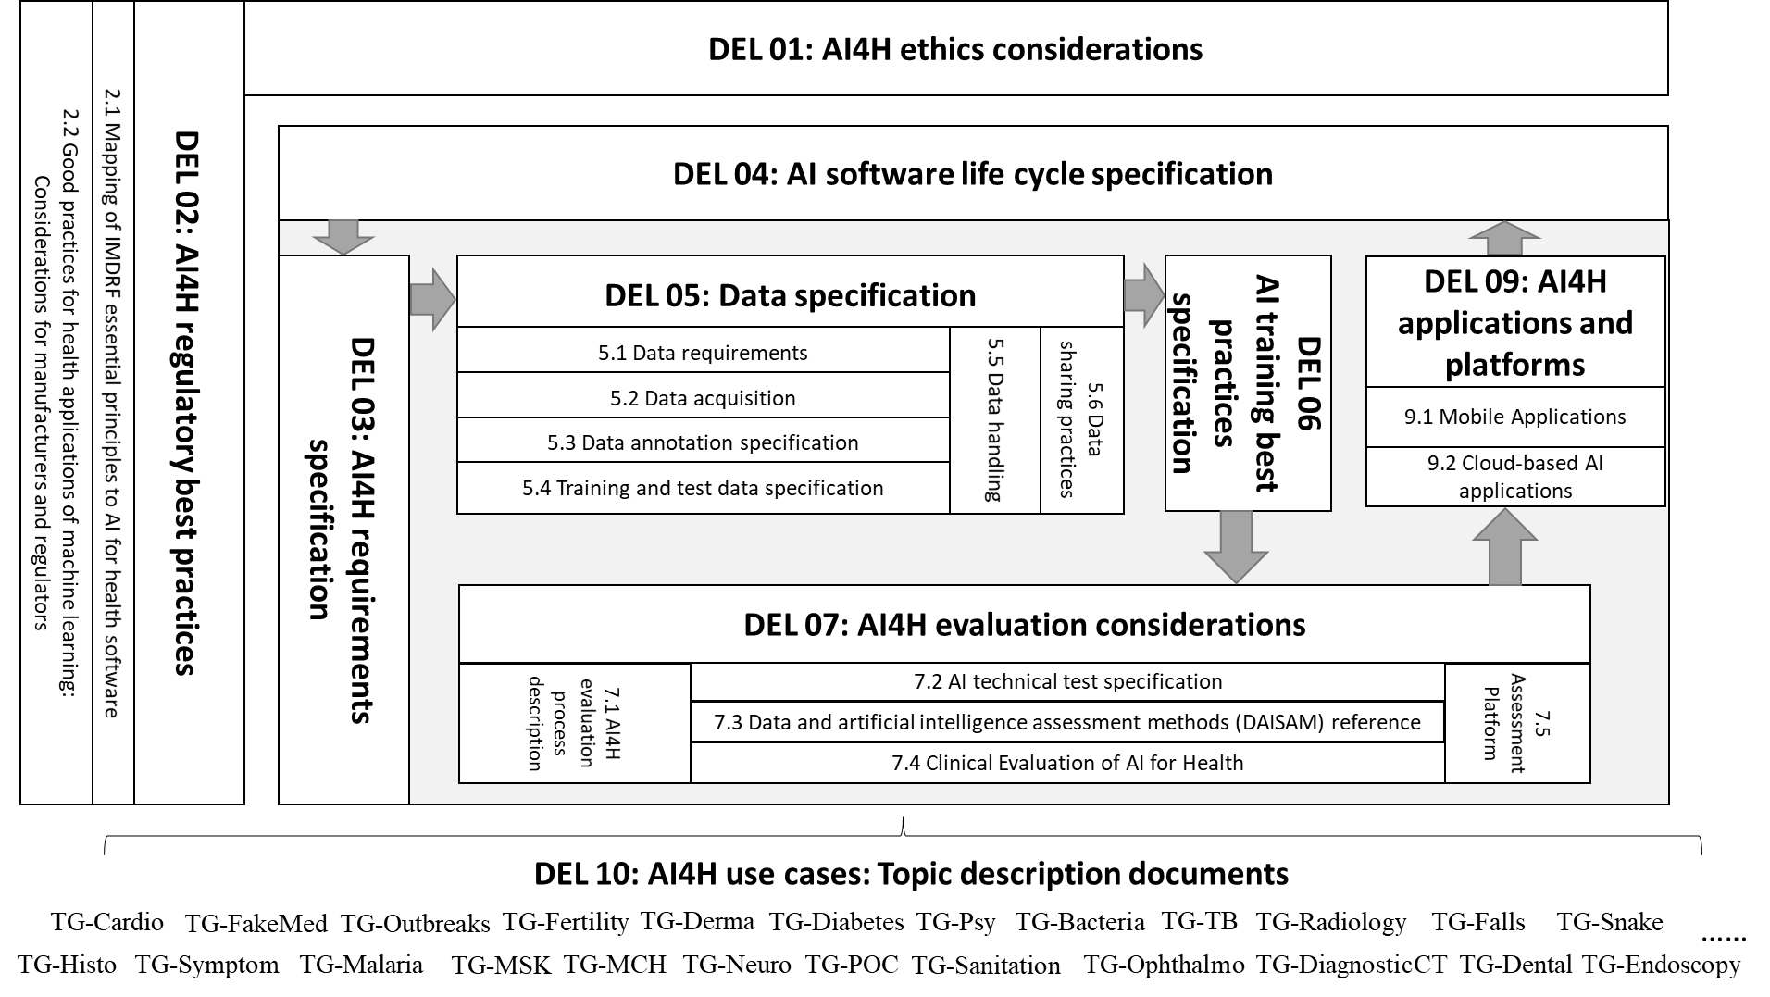

Figure I-1 – FG-A4H Deliverables structure

* **DEL0**: This deliverable provides an overview of the structure, relationship, progress, and corresponding collaborations of all FG-AI4H deliverables, including 9 generalized specifications on ethics, regulatory, requirement, data, training, evaluation, application, etc., and 20 topic description documents on specific use cases with corresponding AI/ML tasks, to establish a standardized assessment framework for the evaluation of AI-based methods for health.
* **DEL0.1:** This deliverable of the FG-AI4H contains a glossary with agreed terminology in artificial intelligence (AI) for health, in order to promote the consistent and harmonized use of important AI for health terms across the various deliverables as well as across the different disciplines involved in this cross-disciplinary field.
* **DEL01**: This document provides consideration on the ethical issues and challenges posed by AI, including ethical, legal and social concerns, e.g. regarding equitable access, privacy, appropriate uses and users, liability and bias and inclusiveness, to develop harmonised ethics guidance for the design and implementation of AI in global health.
* **DEL02**: This document is aimed as a general, high-level, and nonexclusive overview of key regulatory considerations’ topic areas delivered by the WG-RC on AI for health. It highlights some of the key regulatory principles and concepts, such as risk/benefit assessments and considerations for the evaluation and monitoring of the performance of AI solutions.
* **DEL02.1**: This document contains a mapping of the International Medical Device Regulators Forum (IMDRF) Essential Principles to related aspects of AI for health software.
* **DEL02.2**: This document defines a set of guidelines intended to serve the AI solution developers/manufacturers on how to do conduct a comprehensive requirements analysis and streamline the conformity assessment procedures to ensure regulatory compliance for the AI-based Medical Devices (AI/ML-MD).
* **DEL03**: This document defines the System Requirement Specifications (SyRS) that explains the informational, functional, behavioural and operational aspects of a generic AI for health (AI4H) system to help identify, control and track various requirements and changes to those requirements during the AI4H system development lifecycle.
* **DEL04**: This document includes the identification of all standards and best practices that are relevant for the AI for health software life cycle. b) discussion of the existing limits/gaps and need for action. c) Identification of life cycle steps that are specific/characteristic for AI for health software. d) Specification of the AI for health software life cycle and definition of best practices for the different life cycle steps.
* **DEL05**: This document combines a set of four separate deliverables as an umbrella, which address six important aspects related to data specification when used for artificial intelligence (AI) and machine learning (ML) models/methods for health purposes.
* **DEL05.1**: This document lists acceptance criteria for data submitted to the FG-AI4H and states the governing principles and rules, which will facilitate the establishment of the undisclosed test dataset as the core of the benchmarking framework for AI for health methods and make sure that the test dataset will not be made accessible to the AI developers.
* **DEL05.2**: This document presents a framework for public healthcare data acquisition and management model based on standard protocol for its easy adoption by any country or international health organizations, to bridge the gap in developing an integrated and comprehensive framework that addresses the use of EHR in a standardized way.
* **DEL05.3**: This document provides general guidance on data annotation specification, including definitions, framework, standard operating procedure(SOP), inconsistency criteria, recommended metadata, etc. to improve the data annotation quality for machine learning.
* **DEL05.4**: This document explains the best practices of data quality assurance aimed at minimizing the data error risks during the training and test data preparation phase of the machine learning process lifecycle. The training and test data requirement specifications follow the data integrity, data security and data safety norms of the AI data governance lifecycle process.
* **DEL05.5**: This document outlines how data will be handled, once they are accepted. Two major issues are discussed in the data handling policy: (a) compliance with regulations dealing with the use of personal health data; and (b) non-disclosure of the undisclosed test data held by FG-AI4H for the purpose of model evaluation.
* **DEL05.6**: This document provides guidance for existing industry best practices for the sharing of health-related data. It outlines the roles of each party with respect to the data provider, processor, and receiver while exploring traditional and novel approaches leveraging distributed and federated methods for developing privacy-preserving AI/ML models.
* **DEL06**: This document provides a review of the different aspects of the AI model training pipeline, including aspects of data pre-processing and AI model training, to facilitate maximum performance and transparency.
* **DEL07**: This document combines a set of five separate deliverables as an umbrella with considerations on the evaluation of AI for health. It provides an overview of DEL7.1-5, preliminary considerations on the evaluation process, characteristics of validation and evaluation, the concept of standardized model benchmarking, requirements for a benchmarking platform and best practices for model assessment.
* **DEL07.1**: This document includes a review of existing evaluation principles and methods, evaluation needs and solutions specific to AI4H. It also looks into ethics and risks aspects to gain insights into the direction of how the current evaluation methods evolve toward the concept of real AI.
* **DEL07.2**: This document specifies how an AI can and should be tested in silico. Best practices for test procedures known from (but not exclusively) AI challenges is reviewed, including important testing paradigms that are not exclusively related to AI applications.
* **DEL07.3**: This document is the reference collection of WG-DAISAM for assessment methods of data and artificial intelligence quality evaluation, to provide a framework for technologists that build health-related AI-based products to investigate the presence of algorithmic bias.
* **DEL07.4**: This document outlines the current best practice, the principles and outstanding issues for further considerations related to clinical evaluation of AI models for health, to promote confidence among clinicians, patients, researchers and policymakers in the safety, efficacy, and cost-effectiveness of AI solutions in health requires a more comprehensive evaluation.
* **DEL07.5**: This document collects practical experiences and lessons learned to guide the implementation of assessment platforms using AI for health. Two options to explore the implementation of an assessment platform has resulted in two code bases: (a) custom assessment platform and (b) EvalAI-based assessment platform.
* **DEL09**: This document combines a set of two separate deliverables as an umbrella with the discussion on the development of AI tools for health using mobile applications and cloud-based AI applications.
* **DEL09.1**: This document contains a draft set of rules for the development of AI tools for Health using Mobile Applications, their testing and benchmarking. It also discusses the regulatory/ethical rules for Mobile Apps with AI for Healthcare.
* **DEL09.2**: This document contains a draft set of rules for the development of Cloud-based AI applications, their testing and benchmarking. It also discusses technology, security and legal issues related to cloud-based AI tools.
* **DEL10**: This document provides an overview and template documentation for AI4H use cases as a topic description document (TDD), to facilitate topic groups to establish a procedure to benchmark AI models developed for a special task within their health topic. The TDD contains information about the structure, operations, features, and considerations of each specific health topic.

[...]

___________________