 | INTERNATIONAL TELECOMMUNICATION UNION  TELECOMMUNICATION  STANDARDIZATION SECTOR  STUDY PERIOD 2017-2020 |  | FG-AI4H-N-004
 |  |  | ITU-T Focus Group on AI for Health
 |  |  | Original: English
WG(s): |  | PLEN | Online, 15-17 February 2022
DOCUMENT
Source: |  | FG-AI4H Chairman
Title: |  | Progress report to ITU-T SG16 (17-28 January 2022) and outcomes
Purpose: |  | Information
Contact: |  | Thomas Wiegand  Fraunhofer HHI (Germany)  Germany |  | Tel: +49 (30) 31002 617  Fax: +49 (30) 392 72 00  Email: thomas.wiegand@hhi.fraunhofer.de

Abstract: | This document contains as attachment the FG-AI4H progress report to its parent group, ITU-T SG16 (Online, 17-28 January 2022), and the outcomes of the review.
The parent group of the ITU-T Focus Group on AI for Health (FG-AI4H) met online, 17-28 January 2022, and reviewed the progress report to ITU-T SG16 (17-28 January 2022). The report included a summary of results from the various FG meetings and activities in the period from April to December 2021, provided a copy of the current deliverables (Att.1) and of the reports from Meetings J to M (Atts.2 to 5). As action, the report included a request to extend the FG lifespan for two additional years.
After discussions, the following was agreed by the meeting:
1) The lifespan of the FG-AI4H is extended for an additional one year (i.e., till September 2023);
2) Identification of a collaborative platform other than a Focus Group for its continuation;
3) An action plan is requested from the FG-AI4H on how it will timely complete its work.

Attachments:
FGAI4H-N-004-A01: a zip file containing the following attachments of the original document to SG16:
2. FGAI4H-J-101, Report of Meeting J (online, 30 September – 2 October 2020)
3. FGAI4H-K-101, Report of Meeting K (online, 27-29 January 2021)
4. FGAI4H-L-101, Report of Meeting L (online, 19-21 May 2021)
5. FGAI4H-M-101, Report of Meeting M (online, 28-30 September 2021)
NOTE – Original attachment 1 with the current version of the FG-AI4H deliverables was not physically included in N-004 because of its large size (46.2 MB). It can be downloaded from:
https://www.itu.int/md/dologin_md.asp?id=T17-SG16-220117-TD-PLEN-0539!A1!ZIP-E&type=mitems.

 | INTERNATIONAL TELECOMMUNICATION UNION  TELECOMMUNICATION  STANDARDIZATION SECTOR  STUDY PERIOD 2017-2020 |  | SG16-TD539/PLEN
 |  |  | STUDY GROUP 16
 |  |  | Original: English
Question(s): |  | ALL/16 | Virtual, 17 – 28 January 2022
TD
Source: |  | FG-AI4H
Title: |  | FG-AI4H progress report (July 2020 to January 2022) and request for an extension of its lifetime
Purpose: |  | Admin
Contact: |  | Thomas Wiegand  Fraunhofer HHI, Germany |  | E-mail: thomas.wiegand@hhi.fraunhofer.de
Contact: |  | FG-AI4H Secretariat |  | E-mail: tsbfgai4h@itu.int

Keywords: | Focus Group; Artificial Intelligence for Health; Progress Report; Request for Lifetime Extension
Abstract: | The ITU/WHO Focus Group on "AI for Health" (FG-AI4H), established by ITU-T Study Group 16, is working towards international standards for trustworthy health AI technologies, with the important goal to develop an open, scalable benchmarking framework for the standardized quality assessment of these AI tools. This progress report contains an update on the status of the work since the last progress report in June 2020.  Furthermore, in view of the decent progress and momentum, FG-AI4H requests an extension of its lifetime for two more years, until September 2024, in order to be able to complete its main objectives.
Attachments:
- Current version of the FG-AI4H deliverables,
https://www.itu.int/md/dologin_md.asp?id=T17-SG16-220117-TD-PLEN-0539!A1!ZIP-E&type=mitems
- FG-AI4H-J-101, Report of Meeting J (online, 30 September – 2 October 2020), https://www.itu.int/md/dologin_md.asp?id=T17-SG16-220117-TD-PLEN-0539!A2!MSW-E&type=mitems
- FG-AI4H-K-101, Report of Meeting K (online, 27-29 January 2021), https://www.itu.int/md/dologin_md.asp?id=T17-SG16-220117-TD-PLEN-0539!A3!MSW-E&type=mitems
- FG-AI4H-L-101, Report of Meeting L (online, 19-21 May 2021), https://www.itu.int/md/dologin_md.asp?id=T17-SG16-220117-TD-PLEN-0539!A4!MSW-E&type=mitems
- FG-AI4H-M-101, Report of Meeting M (online, 28-30 September 2021), https://www.itu.int/md/dologin_md.asp?id=T17-SG16-220117-TD-PLEN-0539!A5!MSW-E&type=mitems

CONTENTS
Page
Executive summary 3
1 Introduction 4
2 Current key activities and outlook to future work 5
3 Focus group management updates 7
4 Working groups 7
4.1 Working groups on data and AI solution handling ("WG-DASH") & on data and AI solution assessment methods ("WG-DAISAM") 8
4.1.1 Open Code Initiative (OCI) 9
4.1.2 ML4H auditing 10
4.2 Working group on regulatory considerations (WG-RC) 12
4.3 Working group on ethics (WG-Ethics) 12
4.4 Working group on clinical evaluation (WG-CE) 12
4.5 Working group on collaborations and outreach (WG-CO) 13
5 Topic areas & use cases 13
6 Deliverables 15
7 Funding 18
7.1 General activities 18
7.2 WG-RC 18
8 Request for extension of lifetime 18
Appendix A: Outcomes of plenary meetings 19
1. Meeting J (online, 30 September – 2 October 2020) 19
2. Meeting K (online, 27-29 January 2021) 20
3. Meeting L (online, 19-21 May 2021) 20
4. Meeting M (online, 28-30 September 2021) 22

Executive summary
The application of Artificial Intelligence (AI) and Machine Learning (ML) for health comes with great promise and huge potential, but also with risks and challenges. Errors and biases of AI systems put individual patients at risk of harm, and subpopulations at risk of discrimination. Standardization can help to address these risks and challenges, and enable scientific rigor, due diligence, and regulatory oversight for the development of high-quality AI systems. Setting forth standards for data sourcing and labeling, and for AI model building and assessment, is key to moving forward the global research & development agenda on AI for health. AI applied to clinical and public health can then reach a similar level of progress that "low-risk" applications of AI have achieved already today, such as in the entertainment or advertisement industries that rely heavily on data-driven AI/ML models.
AI is – first – an information technology. ITU as the United Nations Specialized Agency for information and communication technologies, and the World Health Organization are the ideal partners to develop such standards/guidance, with longstanding experience in standardization and the necessary global reach to initiate an inclusive and transparent process. The ITU/WHO Focus Group on "AI for Health" (FG-AI4H) was created by ITU-T SG 16 in 2018 and has since created strong momentum in the field by activating hundreds of volunteers from academia, business, medical practice, research, and regulatory agencies in writing out standards defined by the group's deliverables. In support of the UN Sustainable Development Goal "Ensure healthy lives and promote well-being for all at all ages", emphasis is placed to developing standards that are applicable in low-resourced settings too.
A key gap identified early in the process is the lack of an independent platform to evaluate AI models. In 2020, the FG-AI4H launched the Open Code Initiative (OCI) that has since evolved into a complete assessment platform run by ITU/WHO in the cloud where the entire data and model ecosystem is integrated. In the platform prototype, which is currently being tested in a pilot phase, data can be uploaded and annotated, models can be tested, and evaluation metrics generated. This is the first not-for-profit interagency AI-model assessment platform prototype, being developed in collaboration with country-level regulatory agencies that have an interest in independent model assessments before granting approval.
A large number of FG-AI4H members are developers and scientists working on particular use-cases, such as infectious diseases (e.g., Malaria, Tuberculosis), symptom detection, radiology, histopathology, and many more (see §5, §6, and Attachment 1 to this TD). FG-AI4H has initiated a system for auditing use-case specific AI-models via the OCI described above (see §4.1). These audits will serve as blueprints for AI model approval and showcase the importance of a multidisciplinary approach to assess AI models. The audit teams thus consist of multidisciplinary teams and refer to the deliverables created by domain experts on AI/ML, regulation, ethics, technical tests, clinical evaluation, and data (see §6 and current snapshot of deliverables in Attachment 1).
The FG-AI4H has become an established member in the AI for health academic and business community, beyond developing standards documentation along the AI lifecycle, the inauguration of the first independent AI-model assessment platform prototype (by FG-AI4H's OCI), and a holistic system for AI model evaluation (AI audits). The large number of voluntary contributors (500+ subscribers to the mailing lists) as well as (3000+) views of webinars, that are hosted by the FG-AI4H on ITU's AI for Good platform, evidence this.
Over the next two years, FG-AI4H's OCI plans to continue the current proof-of-concept phase, to further test the software platform on different real use cases, to finalize the architecture in a dialogue with all stakeholders (regulation, clinical, AI algorithm developers). Subsequently, the end-to-end process will be validated and documented, the platform will be made available to users (AI developers, notified bodies, researchers, and more) and operated. Learnings will flow into standardization documentation.
In summary, setting independent standards for the use of AI in health is a complex task where the FG-AI4H has now generated the momentum, tools, and interest in the community to take on. Both WHO, ITU, and all FG-AI4H members are committed to this process.

Introduction
Artificial intelligence (AI) holds great promise for healthcare. Huge steps forward have been made recently in research and development of healthcare applications that are powered by AI and machine learning (ML). Many tasks that previously could only be performed by human specialists can now or soon be automatized, potentially mitigating the global shortfall of qualified healthcare staff. However, a lack of standards recognized by the international community, along with the lack of an independent platform for the assessment of AI tools, hinder the adoption of AI supported healthcare.
The International Telecommunication Union (ITU) has joined forces with the World Health Organization (WHO) to leverage artificial intelligence (AI) to promote well-being for all at all ages (a crucial United Nation's Sustainable Development Goal). ITU and WHO are, as UN specialized agencies, and through collaborating with stakeholders such as US FDA, Chinese NMPA, Indian CDSCO, and the European Medicines Agency, in a unique position to address this lack of standards. They are able to host a community of expert stakeholders to develop standards and regulations that the global community likely adopts. No country or organization could do this alone. Therefore, ITU-T Study Group 16 established the Focus Group on AI for Health (FG-AI4H) at its meeting in Ljubljana, Slovenia, 9-20 July 2018 in partnership with the WHO with the terms of reference found in SG16-R10 Annex F.
The two key approaches to close the lack of standards are (1) the creation of documentation and guidelines to facilitate and standardize all aspects of the data and AI solution lifecycle in collaboration with all partners, and (2), the development of an open, scalable benchmarking framework for the quality assessment of new AI for health technologies. This framework will serve as catalyst that is expected to safeguard the quality and significantly shorten the time to market of latest trustworthy AI tools.
ITU and WHO found that the creation of a benchmarking software platform for the validation of AI-technologies offers an excellent opportunity to bring health AI a large step forward towards the safe application in particular in low-resource settings. Having an UN supported benchmarking framework will enable different national bodies such as medical device regulators around the world to compare and potentially to certify AI for health technologies, based on a single standard.
FG-AI4H is a unique initiative, considering that ITU and WHO have vast experience in setting standards for information technologies and healthcare, respectively. Two collaborating UN specialized agencies are leveraging on their expertise in order to guide the development of the standards framework. The approach of FG-AI4H transcends borders and incorporates the perspectives of specialists from several fields (medicine and technology) and sectors (academia, industry, and government/regulation). FG-AI4H differs from other artificial intelligence standardization initiatives and projects because it aims to establish benchmarks that can be trusted worldwide, e.g., by national bodies and regulators to base their decisions upon.
All FG-AI4H activities are fully documented. Documentation can be accessed online on https://itu.int/go/fgai4h/collab. The progress of the FG-AI4H project is monitored in regular plenary meetings, which are open to all interested parties. During these events, all work streams within FG-AI4H provide a status update of their activities. In total, thirteen FG-AI4H meetings (some with additional workshops) were held since its foundation, exclusively online lately due to the COVID-19 pandemic (see Figure 1). Since the last progress report in June 2020, FG-AI4H held four virtual plenary meetings as well as workshops organized by the Working Group on Clinical Evaluation (WG-CE), and the Working Group on Regulatory Considerations (WG-RC).

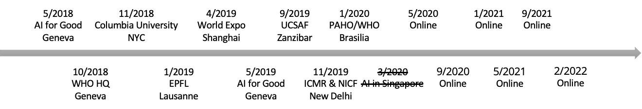
Figure 1: FG-AI4H plenary meetings from May 2018 until February 2022

This report is structured as follows:
Current key activities and an outlook to future work are presented in §2. The FG-AI4H management is introduced in §3. The progress of the working groups and the Open Code Initiative is summarized in §4. By now, FG-AI4H has in total established 24 topic groups, each of which addresses a specific health use case that benefits from AI (see §5).
A number of draft deliverables are being prepared and are subject to further refinements; see §6 and the current snapshot in SG16-TD539/Plen Attachment 1. These output documents cover topics such as data acceptance and handling as well as data and AI solution assessment. The development of these documents is conducted in close interaction with actual AI for health use cases. Through these interactions, the specifics of various modalities of AI for health technologies are considered.
Funding is reported in §7. In §8, the request to extend the FG-AI4H for a lifetime is outlined.
The main outcomes of the last four FG-AI4H meetings that the FG-AI4H held since the previous SG16 meeting in July 2020 are provided in Appendix A of this document.

Current key activities and outlook to future work
FG-AI4H's current key activities consist in:
- Creating a global community of AI and medical experts from industry, healthcare, regulation, academia, and policy to explore pathways to establish standards for health AI. FG-AI4H has taken over a particular responsibility for inclusive engagement connecting leadership from five continents.
- Developing international applicable guidelines for health AI, which cover AI and data quality aspects, the ethical and regulatory dimensions, clinical evaluation, data annotation, and more.
- Studying 24+ health use cases that benefit from AI, driven by experts from diverse backgrounds.
- An Open Code Initiative (see §4.1.1 in detail) developing the software platform for the assessment of health AIs, with 40+ people having worked on it for about two years. Thus, FG AI4H is actually producing a solution.
- Testing the applicability in repeated trial runs by FG-AI4H's ML for health auditing initiative (see §4.1.2).
In-depth information about these activities can be found in the text below, on the website (https://www.itu.int/go/fgai4h/), in onboarding material that facilitates the recruitment of new experts, the GitHub-repository of FG-AI4H (https://github.com/FG-AI4H/), and in the following publications:
- Whitepaper for the ITU/WHO Focus Group on AI for Health, FG-AI4H, 2020. https://itu.int/go/fgai4h/whitepaper
- WHO and ITU Establish Benchmarking Process for AI in Health. The Lancet, 2019. https://doi.org/10.1016/S0140-6736(19)30762-7
- Toward Global Validation Standards for Health AI. IEEE CSM, 2020. https://doi.org/10.1109/MCOMSTD.001.2000006
- ML4H Auditing: From Paper to Practice. PMLR, 2020. In Machine Learning for Health. http://proceedings.mlr.press/v136/oala20a/oala20a.pdf
- Machine Learning for Health: Algorithm Auditing & Quality Control. J Med Syst 45:105 (2021). https://doi.org/10.1007/s10916-021-01783-y
The outreach campaign of the FG-AI4H has attracted thousands of readers of these publications.
Furthermore, FG-AI4H regularly organizes webinars with international experts in the field of research on AI for health, in collaboration with Harvard Medical School's Department of Biomedical Informatics. Currently, the catalogue already spans a dozen lectures from leading experts. The aim is to offer a broad audience outside of universities and research institutions the offer to deal with AI-relevant topics. The program has received >3.000 views and included these speakers so far:
- Regina Barzilay (MIT) - 26 May 2021
- Isaac Kohane (Harvard Medical School) - 22 June 2021
- Jeremy Howard (fast.ai) - 16 July 2021
- Effy Vayena (ETH Zurich) - 15 September 2021
- David Shaywitz (Astounding HealthTech) - 22 September 2021
- Ziad Obermeyer (UC Berkeley) - 7 October 2021
- Laure Wynants (Maastricht U) & Maarten van Smeden (UMC Utrecht) - 8 Nov 2021
- Hugo Morales (Robo Laura) - 22 November 2021
- Enzo Ferrante (CONICET) - 6 December 2021
- Nigam Shah (Stanford) - 17 December 2021
- Os Keyes (University of Washington) - 13 January 2022
- Lelia Marie Hampton (Massachusetts Institute of Technology) - 19 January 2022
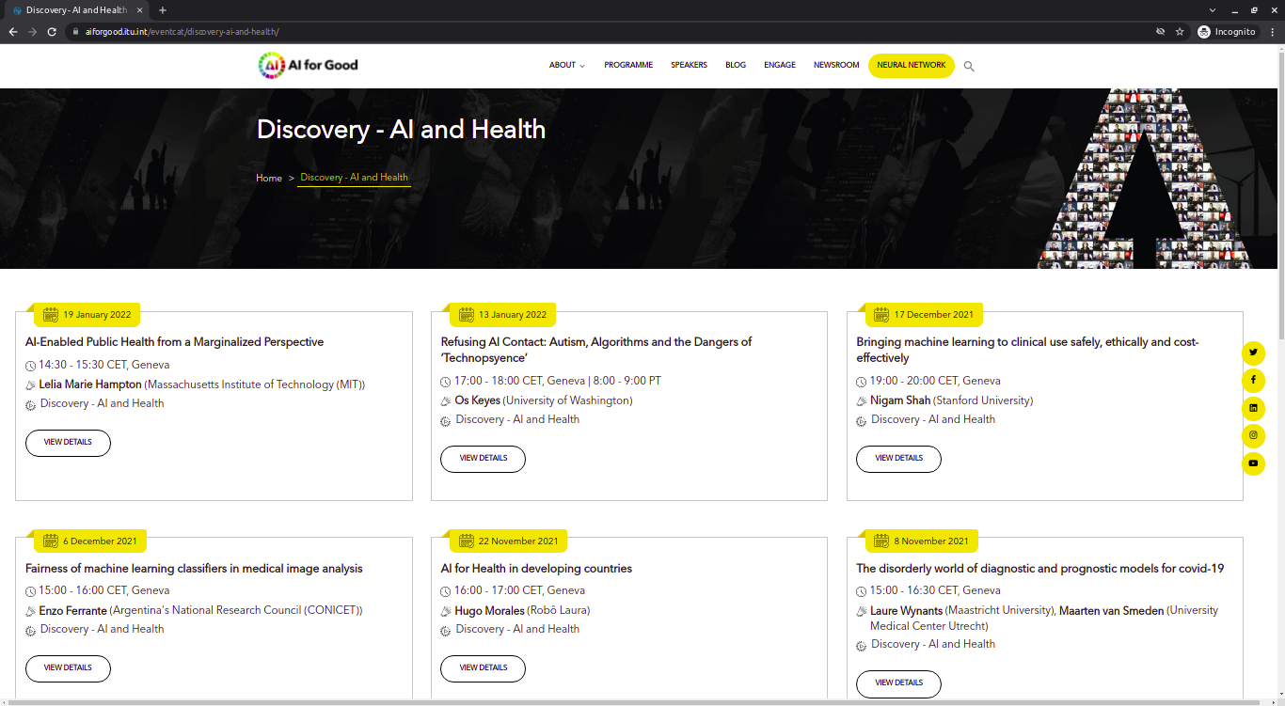Figure 2) Snapshot of the FG-AI4H webinar catalogue
Main expected outputs and outcome of FG-AI4H:
- International standards for AI for health set out by the two specialized UN agencies for information technology and health respectively along with all relevant stakeholders including partners from medicine, industry, and regulation, such as Chinese NMPA, Indian CDSCO, EMA, US FDA, and more. Several are at high maturity and will be reviewed for publication as ITU/WHO technical document in Q1/2 of 2022 (see §6 "Deliverables").
- Establishment of a standardized auditing process in collaboration with 24+ use cases where domain experts work with regulatory, clinical, ethical experts.
- Creation of an open, scalable benchmarking framework for the independent, standardized quality assessment of health AI technologies.
Future work by FG-AI4H's open code initiative is planned to be delivered over three phases:
- Phase 1 – Prototype: This phase includes the continuation of the proof-of-concept phase that is currently running. It contains the testing of the software platform on different real use cases, finalizing the overall component architecture and getting requirements from all stakeholders (regulation, clinical, AI algorithm developers).
- Phase 2 – Scale-Up: The main task of the second phase is the solution implementation with dedicated teams based on the detailed requirements refined during the course of phase 1. It also includes the validation and documentation of the end-to-end process.
- Phase 3 – Operations: After phase 2, the solution will be finalized and made available to users (AI developers, notified bodies, researchers, and more). The ongoing task will include the operation of the platform and provision of support for the users.
Planned FG-AI4H plenary meetings:
The 14th FG-AI4H plenary meeting N is scheduled for 15-17 February 2022. The group will be kept informed about the subsequent meetings (virtual meetings due to COVID-19 pandemic) through the FG-AI4H main mailing list and webpage, https://itu.int/go/fgai4h. All online activities planned are to be documented in the FG-AI4H collaboration site calendar, https://extranet.itu.int/sites/itu-t/focusgroups/ai4h/Lists/Calendar/calendar.aspx.

Focus group management updates
The FG-AI4H is a formal activity in ITU-T, created at its Study Group 16 meeting in Ljubljana, July 2018, and chaired by Mr. Thomas Wiegand (Fraunhofer HHI, Germany). As a formal activity, FG-AI4H has the commitment of the ITU-T management, which includes its Director, Mr. Chaesub Lee, and the Chief of the Study Group Department, Mr. Bilel Jamoussi. At a high level, activity is coordinated with the WHO leadership. From the World Health Organization side, there is active oversight by the Chief Scientist Soumya Swaminathan through the Digital Health Department in the Division of the Chief Scientist, as part of the WHO Digital Health Strategy. Operationally, two WHO officials, Ramesh Krishnamurthy and Sameer Pujari are active in their roles as Vice-Chairs on the Focus Group. Further vice-chairs are Stephen Ibaraki (ACM and REDDS Capital, USA), Naomi Lee (The Lancet, UK), Shan Xu (CAICT, China), and Manjula Singh (ICMR, India).
There have been no updates to the FG management since the previous meeting of SG16.

Working groups
The seven working groups (WGs) of FG-AI4H consider crosscutting subject matters that affect a specific aspect of AI-based health technologies, such as ethics, regulation, AI assessment, or data handling. The recent approval of WG-Collaborations and Outreach, led by Dr. Andrew Farlow (University of Oxford), represents the newest addition to FG-AI4H's working groups. Names and leadership of the six WGs are listed in Table 1.
Table 1 – Working Groups
Working Group | Leadership
Data and AI solution assessment methods (WG-DAISAM) | Chair: Pat Baird (Philips)  Vice-chair: Luis Oala (Fraunhofer HHI, DE)
Data and AI solution handling (WG-DASH) | Chair: Marc Lecoultre (MLlab.AI, CH)  Vice chair: Ferath Kherif (CHUV, CH)
Regulatory considerations on AI for health (WG-RC) | Chair: Naomi Lee (The Lancet, UK)  Vice-chairs:  - Paolo Alcini (European Medicines Agency, EU), observer role  - Rosemarie Purcell (FDA, USA)  - Michael Berensmann (Federal Institute for Drugs and Medical Devices, Germany)  - Robin Seidel (Federal Institute for Drugs and Medical Devices, Germany)  - Liang Hong (Center for Medical Device Evaluation, National Medical Products Administration, China)  - Chandrashekar Ranga (CDSCO, India)
Ethics (WG-Ethics) | Chair: Andreas Reis (WHO)
Clinical Evaluation (WG-CE) | Co-Chairs: Naomi Lee (The Lancet, UK), Shubhanan Upadhyay (ADA Health, Germany), Eva Weicken (Fraunhofer HHI, Germany)
Collaborations and Outreach (WG-CO) | Chair: Andrew Farlow (University of Oxford)
Operations (WG-O) | Co-Chairs: Markus Wenzel, Eva Weicken (Fraunhofer HHI, Germany)

Working groups on data and AI solution handling ("WG-DASH") & on data and AI solution assessment methods ("WG-DAISAM")
These two working groups deal with all technical aspects of the assessment of data and AI. WG-DASH focuses on the operational aspects of data processing throughout the AI lifecycle and deals with the question of how the FG-AI4H should proceed with the use of the data. WG-DAISAM deals with the identification and definition of methods for the evaluation of data and AI. The implementation of these methods is coordinated with the WG-DASH and takes place in close cooperation with FG-AI4H's topic groups and the other working groups.
The use of AI/ML tools for health in real-world applications is slow and existing approval procedures may not fully address the specific errors and risks that can come with AI/ML technology. Developers proposing new AI/ML technologies sometimes promise to achieve or even exceed the performance of existing methods, but the reality is often more complicated. Estimates of model performance are often not valid for the types of varying data distributions that can occur in real-world use. The decision heuristics that a model learns may be different from the heuristics we expect from a human, and model predictions can be accompanied by poorly calibrated confidence statements or without any estimation of uncertainty at all. Certain changes to imagery that do not affect the decision of a human expert can completely change the outcome of an image classification model. Classical ML performance evaluation cannot be automatically transferred to clinical benefit, as shown by examples from large projects on diabetic retinopathy or COVID-19 diagnosis. Reliable and integrated management of these risks remains an open scientific and practical hurdle.
In addition to the development of reference documents, these two working groups initiated the "Open Code Initiative" (OCI), in which all areas of work/activities of the FG-AI4H are united. In cooperation with other international players in this field, active work is being done on the development of software in the form of a web-based platform for the building and the standardized evaluation of AI in healthcare.
WG-DAISAM and WG-DASH reference documents can be accessed (with an ITU account) on https://extranet.itu.int/sites/itu-t/focusgroups/ai4h/SitePages/Deliverables.aspx.

Open Code Initiative (OCI)
The OCI is engaged in the development of a web-based platform (software) that will enable the benchmarking and evaluation of AI models as well as the secure collection, storage and annotation of the data (code repository: https://github.com/FG-AI4H; core platform: https://www.ai4h.net/ , assessment platform: https://health.aiaudit.org/). To design and develop the platform, we involve more than forty contributors. They are developers, regulators and medical professionals from all around the world who deliver specific requirements during regular meetings, roundtables and workshops. We split the platform into seven work packages (see Figure 3) each lead by domain specific experts. This setup allows executing our tasks in parallel and adopting the "contract-first approach", having modular components and implementing microservices. Microservices are a popular architectural style for building applications that are resilient, highly scalable, independently deployable, and able to evolve quickly.
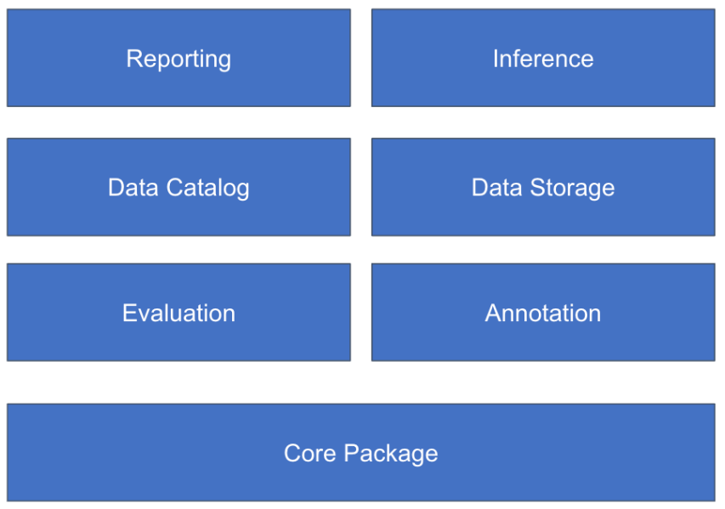
Figure 3) Work packages of FG-AI4H's Open Code Initiative
We are building a tool that is universal and can be used across borders. It is suitable for multiple stakeholders such as AI developers, notified bodies and doctors to build, assess and use AI algorithms. Some modules (e.g., annotation module) are used by developers to create software as medical devices and thus must be built in accordance with regulations. To meet these requirements, we apply standard design and implementation patterns and document our work as described in IEC62304, AMD and IEC82304-1.
To test and guarantee the right feature coverage of the platform, we cooperate with the FG-AI4H topic groups, which provide the data and procedures to test AI models for a specific medical/AI use case, all other working groups and other contributors outside the FG-AI4H.
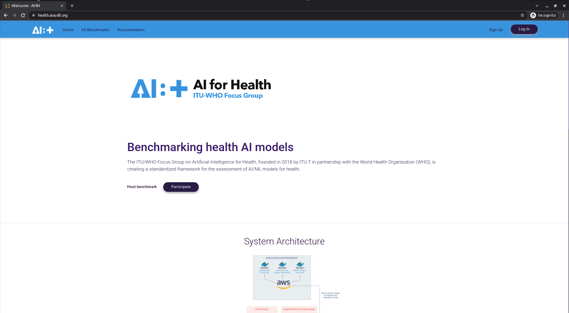
Figure 4) Frontend of the text-based evaluation pipeline that WG-DAISAM implemented and maintains as part of the FG-AI4H OCI, accessible at https://health.aiaudit.org/.

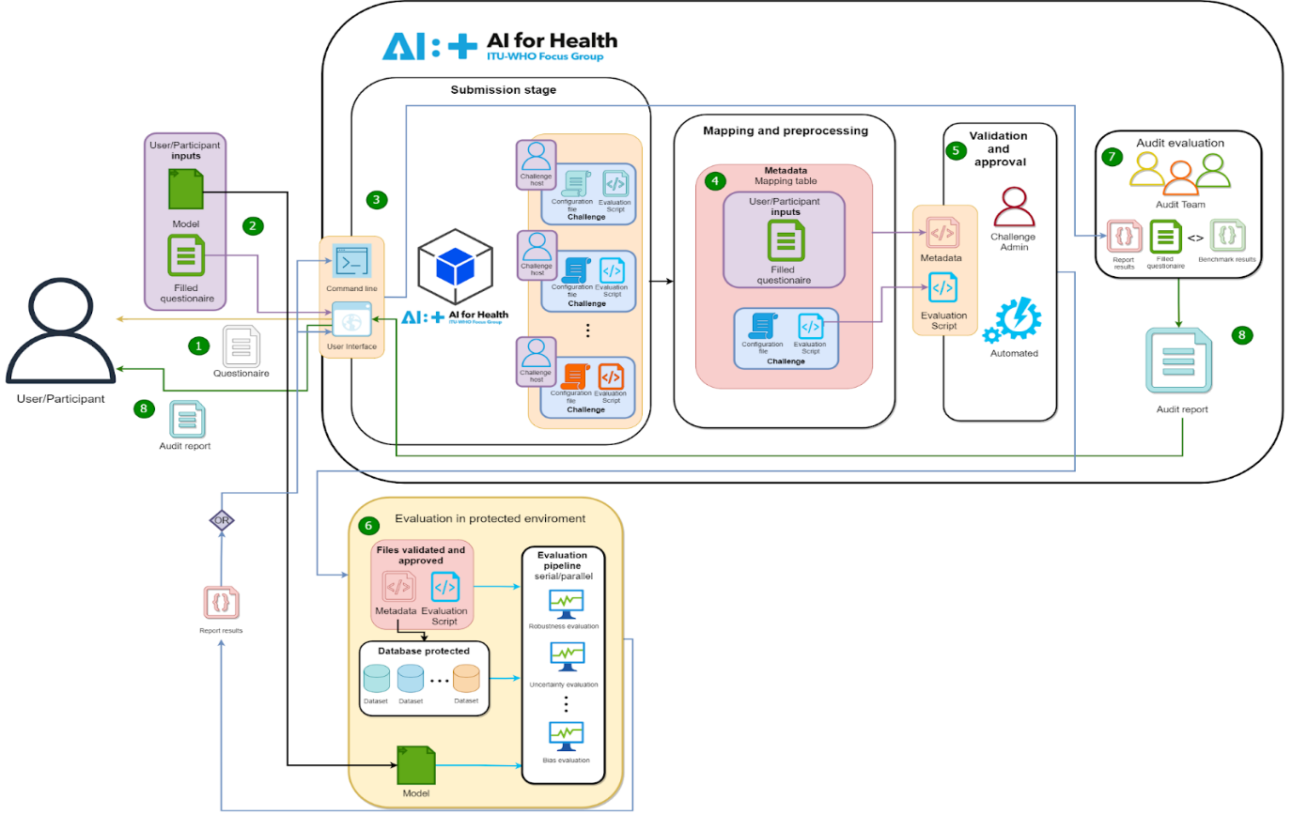
Figure 5) Architecture diagram of the text-based evaluation pipeline that WG-DAISAM implemented and maintains as part of the FG-AI4H OCI, accessible at https://health.aiaudit.org/.
Further information about the OCI can be found on the project website (https://www.itu.int/en/ITU-T/focusgroups/ai4h/Pages/opencode.aspx). The OCI also held a round table on annotation on 9 December 2021.

ML4H auditing
"ML4H auditing" is a cooperation of WG-DAISAM and WG-DASH and associated with the OCI, which develops methods, processes, and standardization methods for a trustworthy use of AI technologies in real applications at the interface between research in the field of machine learning, regulation, software development and clinical application.
Regulatory assessment is of great importance here. It includes the systematic evaluation of AI and ML tools regarding the applicable regulatory requirements in laws (MDR, IVDR, CFR, etc.), international standards (such as IEC62304, IEC 62366-1 and ISO 14971), guidelines of regulatory authorities (for example US and Chinese FDA, IMDRF) or guidelines and drafts of other organizations (for example AAMI or European Commission). Such guidelines are of practical importance for the actors in the AI-for-health ecosystem, including manufacturers (e.g., product managers, developers, data scientists, quality, and regulatory officers) and for regulatory bodies (authorities, notified bodies).
FG-AI4H has identified and critically reviewed general but fundamental regulatory requirements related to AI-for-health. This overview was transformed into specific and verifiable requirements and then published as a checklist titled "Good practices for health applications of machine learning: Considerations for manufacturers and regulators" (https://extranet.itu.int/sites/itu-t/focusgroups/ai4h/SitePages/Deliverables.aspx), covering the entire lifecycle of AI-for-health applications.

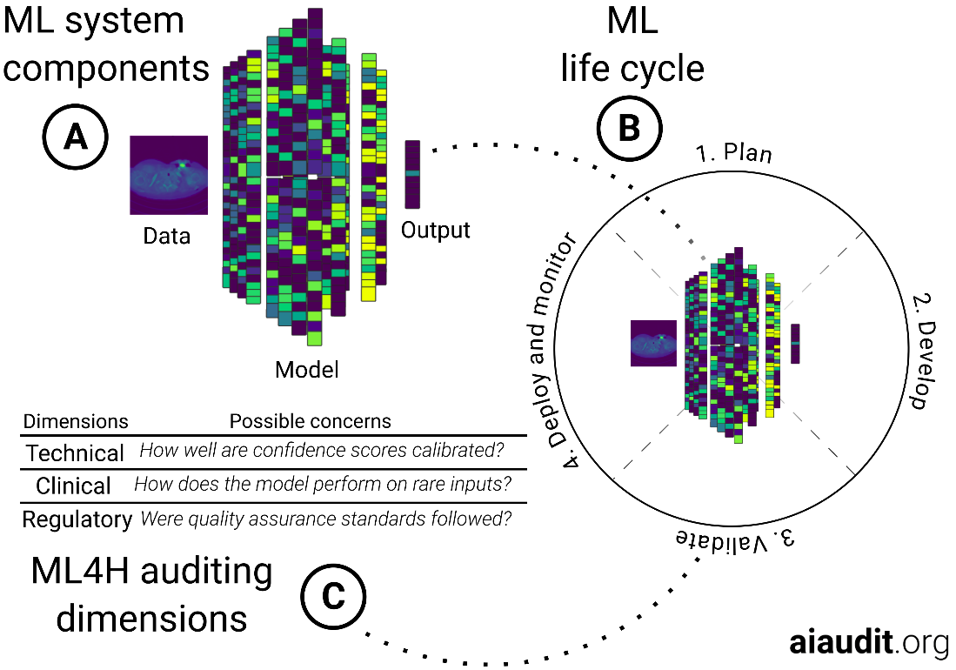
Figure 6) Process overview. (A) Most ML tools share a set of core components comprising data, a ML-model and its outputs. (B) The typical ML life cycle goes through stages of planning, development, validation and, potentially, deployment under appropriate monitoring. (C) An ML4H audit is carried out with respect to a dynamic set of technical, clinical and regulatory considerations that depend on the concrete ML technology and the intended use of the tool
The checklist contains items that can be prioritized depending on the application, given the limited time reviewers have available. Examples and comments provide users with further information. New regulatory developments, such as predetermined change control plans, lead to faster software update cycles and potentially more frequent audits. Therefore, a good tooling can become an important means to enable both effective and efficient audits. Test methods developed on paper must be put to the test to ensure that they prove themselves in audit practice. In a first iteration of trial audits, this was demonstrated in December 2020 using three medical use cases (see [ML4H Auditing: From Paper to Practice. PMLR, 2020. In Machine Learning for Health. http://proceedings.mlr.press/v136/oala20a/oala20a.pdf]). In the second iteration, these trial audits are currently being extended to more use cases. This second iteration is accompanied by an anthology "Machine Learning for Health: Algorithm Auditing & Quality Control" in the "Journal of Medical Systems" [J Med Syst 45:105 (2021). https://doi.org/10.1007/s10916-021-01783-y]. Here, practical audit examples of various AI-for-health applications are compiled as a knowledge library for users, developers, providers and auditors of AI-for-health systems.

Working group on regulatory considerations (WG-RC)
This working group deals with the regulatory requirements in the standardization process of AI in healthcare and consists of experts from international government regulatory institutions, such as CDSCO of India, Chinese FDA, US FDA, European Medicine Agency, German Federal Institute for Drugs and Medical Devices (BfArM), as well as the WHO. In cooperation with all members of this working group, a reference document is currently being developed during several workshops and meeting. The latest version of the document "Overview of Regulatory Considerations of AI for Health" can be viewed with an ITU account (see https://www.itu.int/go/fgai4h) on https://extranet.itu.int/sites/itu-t/focusgroups/ai4h/‌SitePages/‌Deliverables.aspx. Another relevant reference document prepared by members of this working group entitled 'Good practices for health applications of Machine Learning: Considerations for manufacturers and regulators' can be found at the same URL. WG-RC held its inaugural meeting on 4 May 2020 and another plenary meeting & publication review on 20 September 2021.

Working group on ethics (WG-Ethics)
A WHO expert group of leading specialists from the fields of ethics, law, digital technology, human rights and ministries of health published the report 'Ethics and Governance of AI for Health' (https://www.who.int/publications/i/item/9789240029200) in June 2021. It describes the ethical challenges and risks associated with the use of AI in healthcare and sets out six consensus principles to ensure that AI is used for the benefit of the general public in all countries worldwide. Members of this WHO Ethics Expert Group also lead the FG-AI4H Ethics Working Group and the report is considered a reference document for the FG-AI4H.
Since the publication of the report in June 2021, WG-Ethics held
- A meeting, 21 September 2021 on "Joint WHO/ITU WG-Ethics" (Agenda and summary notes can be found on the WG-Ethics collaboration site: https://extranet.itu.int/sites/itu-t/focusgroups/ai4h/wg/WGETHICS_workspace/Forms/AllItems.aspx.
- A workshop, 07 December 2021 on "WHO/Privacy International Workshop: Ethical Challenges and Opportunities with the use of AI for Health and the role of civil society"

Working group on clinical evaluation (WG-CE)
The aim of this working group is to build a community of collaboration with other stakeholders and initiatives around the clinical evaluation of AI in health. The group consists of members from various fields (clinical practice, ML/AI research, the public health system, industry, non-governmental organizations etc.) who are collaboratively developing guideline documentation based on current best practices on how AI in health should be evaluated to be used by clinicians, researchers, decision-makers, patients, civil society, and developers.
WG-CE held its inaugural workshop in October 2020 and has been meeting regularly since then. More background information about the workshop and its outcomes can be found on:
https://www.itu.int/en/ITU-T/focusgroups/ai4h/Pages/ws/2010.aspx
and on the WG-CE collaboration site:
https://extranet.itu.int/sites/itu-t/focusgroups/ai4h/wg/SitePages/WG-CE.aspx.
The latest version of the reference document of this working group can be viewed here: https://extranet.itu.int/sites/itu-t/focusgroups/ai4h/SitePages/Deliverables.aspx.

Working group on collaborations and outreach (WG-CO)
WG-CO was approved by FG-AI4H on 3 January 2022. This WG will, with other groups and stakeholders, build a global community of practice around digital and AI-for-health challenges, foster collaborations, and promote outreach. WG-CO will produce calls for setting up digital and AI-for-health challenges that include global challenges, hackathons, and other activities. These will go beyond typical technology-based hackathons to also include, as key selection criteria, implementation issues and (non-monetizable) global health impact. By creating a consortium of interested parties with expertise across the entire ecosystem of support needed, deploying scientific rigor and due diligence, it is hoped that more high-quality interventions will make it into use. WG-CO will initiate, support, and report on collaborations with other activities and groups, create outreach activities including webinars, support WHO/ITU, produce academic publication, and drive policy engagement.

Topic areas & use cases
Topic groups represent the FG-AI4H use cases and are dedicated to a specific health topic and a corresponding AI/ML task. Each topic group proposes a procedure to benchmark AI models developed for a special task within this health topic. They link the requirements for the benchmarking process defined by the working groups with actual health topics and study the specific problems that might occur with a number of AI for health tasks and data modalities. All members of a topic group create a deliverable, called "topic description document" (TDD) that contains information about the structure, operations, features, and considerations of the specific health topic. Some mature topic groups are also taking part in the open code initiative and the ML4h-auditing activities by FG-AI4H.
Table 2 provides an overview of the various topic groups including their drivers and their latest deliverables (status of January 2022).
Table 2 – Topic groups
N° | Topic group | Topic driver(s) | Document (latest version)
10_01 | Use of AI in cardiovascular disease management (TG-Cardio)  – including clinical predictions sub-topic: cardiovascular disease risk prediction | Benjamin Muthambi  (WatIF Health / IEPH, South Africa) | DEL10_01
10_02 | Dermatology (TG-Derma) | Sharad Kumar  (Nurithm Labs, India) | DEL10_2
10_03 | Diagnosis of bacterial infection and anti-microbial resistance (TG-Bacteria) | Nada Malou  (Médecins Sans Frontières, France) | DEL10_03
10_04 | Falls among the elderly (TG-Falls) | Pierpaolo Palumbo  (University of Bologna, Italy) | DEL10_04
10_05 | Histopathology (TG-Histo) | Frederick Klauschen  (Ludwig Maximilians University & Charité, Germany) | DEL10_05
10_06 | Malaria detection (TG-Malaria) | Rose Nakasi  (Makerere University, Uganda) | DEL10_06
10_07 | Maternal and Child Health (TG-MCH) | Alexandre Chiavegatto  (University of Sao Paulo, Brazil) | DEL10_07
10_08 | Neurological disorders (TG-Neuro) | Marc Lecoultre  (UNIL, CHUV, Switzerland) | DEL10_08
10_09 | Ophthalmology (TG-Ophthalmo) | Arun Shroff  (Medindia/Xtend.ai, India / USA) | DEL10_09
10_10 | Outbreak detection (TG-Outbreaks) | Stéphane Ghozzi &  Auss Abbood  (Helmholtz Center for Infectious Research & Robert Koch Institute | DEL10_10
10_11 | Psychiatry (TG-Psy) | Nicolas Langer  (ETH Zürich, Switzerland) | DEL10_11
10_12 | AI for Radiology (TG-Radiology) | Darlington Ahiale Akogo (MinoHealth AI labs, Ghana) | DEL10_12
10_13 | Snakebite and snake identification (TG-Snake) | Rafael Ruiz de Castañeda  (UniGE, Switzerland) | DEL10_13
10_14 | Symptom assessment (TG-Symptom) | Henry Hoffmann  (Ada Health, Germany) | DEL10_14
10_15 | Tuberculosis (TG-TB) | Manjula Singh  (ICMR, India) | DEL10_15
10_16 | Volumetric chest computed tomography (TG-DiagnosticCT) | Kuan Chen  (Infervision, China) | DEL10_16
10_17 | Dental diagnostics and digital dentistry (TG-Dental) | Falk Schwendicke &  Joachim Krois  (Charité, Germany) | DEL10_17
10_18 | Falsified Medicine (TG-FakeMed) | Franck Verzefé  (Trie Spec Africa, DRC) | DEL10_18
10_19 | Primary and secondary diabetes prediction (TG-Diabetes) | Andrés Valdivieso  (Anastasia.AI, Chile) | DEL10_19
10_20 | AI for endoscopy (TG-Endoscopy) | Jianrong Wu  (Tencent Healthcare, China) | DEL10_20
10_21 | Musculoskeletal Medicine (TG-MSK) | Yura Perov (Independent Contributor, UK) &  Peter Grinbergs  (EQL, UK) | DEL10_21
10_22 | AI for human reproduction and fertility (TG-Fertility) | Susanna Brandi &  Eleonora Lippolis  (Merck KGaA, Germany) | DEL10_22
10_23 | AI in sanitation for public health (TG-Sanitation). | Khahlil Louisy &  Alexander Radunsky  (Institute for Technology & Global Health, ITGH, US) | DEL10_23
10_24 | AI for point-of-care diagnostics (TG-POC) | Nina Linder  (University of Helsinki, Finland) | DEL10_24

Deliverables
The deliverables represent the main outcome of the FG-AI4H, and will be made available to the public as ITU or WHO technical documents. These deliverables are grouped into nine deliverables focusing on general aspects relevant to all areas of AI and health, including ethics, regulatory requirements, data, training, evaluation, application, while 24 deliverables are dedicated to specific medical use cases (Figure 7a).
A snapshot can be found in SG16-TD539/Plen Attachment 1 and https://extranet.itu.int/sites/itu-t/focusgroups/ai4h/SitePages/Deliverables.aspx.
Generalized specifications (DEL 1-9): focus on generalized specifications including ethics, regulatory, requirement, data, training, evaluation, application, etc. Each part is interconnected and complement each other, for a holistic view of the AI for health problem space. The arrows in Figure 7 are intended to indicate sequential connections from the perspective of software development and implementation.
Topic groups (DEL 10.1-10.24): focus on use cases in specific health domains with corresponding AI/ML tasks. Each case could be seen as an example of a whole process recommended by generalized specifications (DEL 1-9), and also adapt to some specific application scenarios.
The FG-AI4H management recently surveyed deliverable editors for completeness of their respective deliverables. Several deliverables (n = 10) are close to completion with a high estimated percentage of maturity to be published as ITU/WHO technical document. These include key deliverables such as DEL2 "Overview of regulatory considerations on AI for health", DEL3 "AI for health requirement specifications", DEL5.3 "Data annotation specification", DEL 7 "AI for health evaluation considerations", and DEL7.4 "Clinical Evaluation of AI for health". The FGAI4H management will work closely with deliverable editors to review these documents and publication until Q2 in 2022.
Figure 7. (a) Structure and relationship of the deliverables, (b) maturity for publication as technical ITU/WHO document of selected deliverables ordered by degree of completeness
During each meeting, updates on the various deliverables are presented and are stored in the FG-AI4H Deliverables collaboration site
https://extranet.itu.int/sites/itu-t/focusgroups/ai4h/SitePages/‌Deliverables.aspx.
The list with all deliverables is shown in table 3.
Table 3 – FG-AI4H Deliverables
No. | Deliverable | Updated initial draft editor
0 | Overview of the FG-AI4H deliverables | Shan Xu (CAICT, China)
1 | AI4H ethics considerations | Andreas Reis (WHO)
2 | Overview of regulatory considerations on artificial intelligence for health | Jackie Ma (Fraunhofer HHI, Germany), Rosemarie Purcell (FDA, USA) & Shada Alsalamah (WHO)
2.1 | Mapping of IMDRF essential principles to AI for health software | Luis Oala (Fraunhofer HHI, Germany), Pradeep Balachandran (Technical Consultant eHealth, India), Pat Baird (Philips, USA), Thomas Wiegand (Fraunhofer HHI, Germany)
2.2 | Good practices for health applications of machine learning: Considerations for manufacturers and regulators | Pradeep Balachandran (India) and Christian Johner (Johner Institut, Germany)
3 | AI4H requirement specifications | Pradeep Balachandran (India)
4 | AI software life cycle specification | Pat Baird (Philips, USA)
5 | Data specification | Marc Lecoultre (MLlab.AI, Switzerland)
5.1 | Data requirements | [Marc Lecoultre (MLlab.AI, Switzerland)]
5.2 | Data acquisition | Rajaraman (Giri) Subramanian (Calligo Tech, India), Vishnu Ram (India)
5.3 | Data annotation specification | Shan Xu (CAICT, China), Harpreet Singh (ICMR, India), Sebastian Bosse (Fraunhofer HHI, Germany)
5.4 | Training and test data specification | Luis Oala (Fraunhofer HHI, Germany), Pradeep Balachandran (India)
5.5 | Data handling | Marc Lecoultre (MLlab.AI, Switzerland)
5.6 | Data sharing practices | Ferath Kherif (CHUV, Switzerland), Banusri Velpandian (ICMR, India), WHO Data Team
6 | AI training best practices specification | Xin Ming Sim (AI Singapore)
7 | AI for health evaluation considerations | Markus Wenzel (Fraunhofer HHI, Germany)
7.1 | AI4H evaluation process description | Sheng Wu (WHO)
7.2 | AI technical test specification | Auss Abbood (Robert Koch Institute, Germany)
7.3 | Data and artificial intelligence assessment methods (DAISAM) reference | Luis Oala (Fraunhofer HHI, Germany)
7.4 | Clinical evaluation of AI for health | Naomi Lee (Lancet, UK), Eva Weicken (Fraunhofer HHI, Germany), Shubhanan Upadhyay (ADA Health, Germany)
8 | AI4H scale-up and adoption | Sameer Pujari (WHO), Yu ZHAO and Javier Elkin [Previously: Robyn Whittaker (New Zealand)]
9 | AI4H applications and platforms | Manjeet Chalga (ICMR, India)
9.1 | Mobile applications | Khondaker Mamun (UIU, Bangladesh), Manjeet Chalga (ICMR, India)
9.2 | Cloud-based AI applications | Khondaker Mamun (UIU, Bangladesh)
10 | AI4H use cases: Topic description documents (TDDs) | Eva Weicken (Fraunhofer HHI, Germany)
10.1-10.24 | Deliverables of the topic groups (TDDs) are listed in table 2 (in §5)

Funding

General activities
The FG-AI4H was able to secure funding from the Botnar Foundation (Switzerland), which pledged CHF 274'000 to assist with travel grants for medical and AI experts from LMIC countries, and some operational expenses. These funds became effective in July 2019 and were initially used to fund experts (and ITU staff) to travel to meetings and workshops. With the pandemic, travel stopped, and the remaining funds could be allocated to activities of the Open Code Initiative. Upon the invitation of the CEO of Fondation Botnar, FG-AI4H management has submitted a grant application for 350,000 CHF in December 2021. A decision on the application is expected in January 2022.

WG-RC
The FG-AI4H has created a Working Group on Regulatory Considerations (see §4.2) that discusses regulatory implications of AI and on developing key considerations for the regulations of AI-based health applications. The U.S. FDA has pledged USD 150,000 in total to support meetings of the working group. WG-RC held its inaugural meeting on 4th May 2020, and another plenary meeting & publication review on 20th September 2021.

Request for extension of lifetime
Overall, we are seeing a real progress towards the core objectives of the FG-AI4H, which has picked up speed and acquired substantial momentum over the past years. This momentum and engagement should be exploited in the coming years to further explore the immense potential of standardisation opportunities in the field of AI, and to leverage AI technologies for achieving UN SDG 3 ("good health and wellbeing"). Moreover, it must be considered that FG-AI4H is an inter-agency collaboration of two UN specialized agencies, that significant resources have been invested by both agencies, and that there is an expectation from the WHO side that the work will continue. Accordingly, the FG-AI4H seeks the extension of the lifetime of FG-AI4H for two additional years until September 2024.

Appendix A: Outcomes of plenary meetings

Meeting J (online, 30 September – 2 October 2020)
The 10th meeting of the FG-AI4H took place online, 30 September – 2 October 2020. Purpose included the reporting and discussion of updates to its deliverables and sub-deliverables and of progress by the (at this point in time) existing 20 topic groups as well as the creation of a new topic group.
The meeting noted with satisfaction that ITU-T SG16 extended the life of the FG-AI4H until September 2022.
Working group updates:
- Appointed three co-chairs for the WG on Clinical Evaluation: Naomi Lee (The Lancet, UK), Shubhanan Upadhyay (ADA Health, Germany), and Eva Weicken (Fraunhofer HHI, Germany).
Topic group updates:
- New TG on AI for Musculoskeletal medicine (TG-MSK) with Yura Perov (EQL, UK) as Topic Driver. The collaboration site for the new TG is https://extranet.itu.int/sites/itu-t/focusgroups/ai4h/tg/SitePages/TG-MSK.aspx. Mailing list: fgai4htgmsk@lists.itu.int (archive: https://itu.int/ml/lists/arc/fgai4htgmsk)
- The TG-Derma Driver, Maria Vasconcelos (Fraunhofer Portugal) can no longer continue. The meeting thanked Ms Vasconcelos for her efforts in progressing TG-Derma.
Deliverables' update:
- No new deliverables were agreed at this meeting. Future deliverables under consideration are:
- Reference software implementation (Editor: Marc Lecoultre). Initial elements: J-045
- Guidance on digital technologies for COVID health emergency (Editors: Shan Xu, CAICT, China), Ana Riviere-Cinnamond, PAHO). Initial draft from the AHG-DT4HE: J-035-R01.
- All available deliverables were reviewed and will be shared with SG16. The latest version of the deliverables is found in the FG-AI4H collaboration site.
It was agreed to update the following output documents, after an editing period after the meeting:
- J-102: Updated call for proposals: use cases, benchmarking, and data (to be published once the final dates of the next FG-AI4H meeting are defined)
- J-103: Updated call for topic group participation (CfTGP) template
- J-105: Updated TDD Template
- J-107: Updated FG-AI4H onboarding document
- J-200-R1: Updated list of FG-AI4H deliverables
- FG-AI4H whitepaper (J-002)
The following documents were reconfirmed:
- F-103: Updated FG-AI4H data acceptance and handling policy
- C-104: Thematic classification scheme
- F-105: ToRs for the WG-Experts and call for experts
- F-106: Guidelines on FG-AI4H online collaboration tools
The meeting had 92 participants over the various days and reviewed 55 documents (not counting attachments). There were no outgoing LSs prepared.
A list of the 12 decisions taken at the meeting is found in the meeting report:
https://extranet.itu.int/sites/itu-t/focusgroups/ai4h/docs/FGAI4H-J-101.docx

Meeting K (online, 27-29 January 2021)
The 11th meeting of the FG-AI4H took place online, 27-29 January 2021 to review updates to its 24 deliverables and sub-deliverables, and review progress by the (at this point in time) existing 21 topic groups.
The following updates in leadership of FG-AI4H working groups were endorsed:
- WG-RC: Michael Berensmann and Robin Seidel replace Wolfgang Lauer Wolfgang.Lauer@bfarm.de (Federal Institute for Drugs and Medical Devices, Germany); and Liang Hong replaces Peng Liang (National Medical Products Administration, China) as WG-RC vice-chairs
- WG-O: Eva Weicken replaces Monique Kuglitsch as WG co-chair
Topic group updates:
- No new TGs were created at this meeting
- Weihong Huang (Xiangya Hospital Central South University, China) replaces Maria Vasconcelos (Fraunhofer Portugal) as TG-Derma topic driver
- Pierpaolo Palumbo (University of Bologna, Italy) steps in as interim TG-Falls driver until Sept 2021, for Inês Sousa (Fraunhofer Portugal)
Deliverables' update:
No new deliverables were agreed at this meeting. Future deliverables considered:
- Open Code Initiative reference software implementation (Editor: Marc Lecoultre, MLlab.AI, Switzerland)
- Guidance on digital technologies for COVID health emergency (Co-editors: Shan Xu, CAICT, China; Ana Riviere-Cinnamond, PAHO)
- Risk management in AI for health (Editor: Pat Baird, Philips, USA)
- All available deliverables were reviewed, their latest version is found in the FG-AI4H collaboration site.
No new output documents were agreed. These updated output documents were agreed:
- K-102: Updated call for proposals: use cases, benchmarking, and data
- K-200: Updated list of FG-AI4H deliverables
The following documents were reconfirmed:
- F-103: Updated FG-AI4H data acceptance and handling policy
- C-104: Thematic classification scheme
- F-105: ToRs for the WG-Experts and call for experts
- F-106: Guidelines on FG-AI4H online collaboration tools
- K-107: FG-AI4H Onboarding document
- FG-AI4H Whitepaper (K-002)
- J-105: TDD Template
- J-103: CfTGP template
The meeting had 140 participants over the various days and reviewed 54 documents (not counting attachments). There were no outgoing LSs prepared.
A list of the five decisions taken at the meeting is found in the meeting report:
https://extranet.itu.int/sites/itu-t/focusgroups/ai4h/docs/FGAI4H-K-101.docx

Meeting L (online, 19-21 May 2021)
The 12th meeting of the FG-AI4H took place online, 19-21 May 2021 to review updates to its 24 deliverables and sub-deliverables, to review the progress of the existing topic groups and to consider proposals for new topic groups.
There were no updates in the FG-AI4H leadership at this meeting.
Topic group updates:
- New Topic Group on AI for human reproduction and fertility (TG-Fertility). Topic drivers: Susanna Brandi (susanna.brandi@merckgroup.com) and Eleonora Lippolis (eleonora.lippolis@merckgroup.com), Merck KGaA, Darmstadt, Germany. Collaboration site: https://extranet.itu.int/sites/itu-t/focusgroups/ai4h/tg/SitePages/TG-Fertility.aspx
- New Topic Group on AI in sanitation for public health (TG-Sanitation). Topic drivers: Khahlil Louisy (klouisy@hks.harvard.edu; Institute for Technology & Global Health, ITGH, US) and Alexander Radunsky (aradunsky@mail.harvard.edu), ITGH, US. Collaboration site: https://extranet.itu.int/sites/itu-t/focusgroups/ai4h/tg/SitePages/TG-Sanitation.aspx
- New Topic Group on AI for point-of care diagnostics (TG-POC). Topic driver: Nina Linder (nina.linder@helsinki.fi), University of Helsinki, Finland. Collaboration site: https://extranet.itu.int/sites/itu-t/focusgroups/ai4h/tg/SitePages/TG-POC.aspx
- The drivers for TG-MSK are now Peter Grinbergs (EQL, UK) and Yura Perov (UK), who can be contacted by a common e-mail address, tgmskorg@googlegroups.com.
Data annotation: The FG-AI4H agreed to support the initiative for a dataset extension and annotation website, which will initially focus on histopathology data. The leader of the activity is Frederick Klauschen, LMU Munich, Germany. Specific procedures and details will be discussed initially under TG-Histo.
Deliverables' update:
- Updates to the deliverables were reviewed, their latest version is found in the FG-AI4H collaboration site.
The following updated output documents were agreed:
- L-102: Updated call for proposals: use cases, benchmarking, and data (to be issued when the dates of the next meeting are defined)
- L-200: Updated list of FG-AI4H deliverables
- The meeting agreed to submit an updated version of the guide originally submitted in J-040 "Artificial intelligence for dental image analysis: A guide for authors and reviewers" for approval by correspondence after Meeting L.
The following documents were reconfirmed:
- F-103: Updated FG-AI4H data acceptance and handling policy
- C-104: Thematic classification scheme
- F-105: ToRs for the WG-Experts and call for experts
- F-106: Guidelines on FG-AI4H online collaboration tools
- K-107: FG-AI4H Onboarding document
- FG-AI4H Whitepaper (K-002)
- J-105: TDD Template
- J-103: CfTGP template
The meeting had 111 participants over the various days and reviewed 53 documents (not counting attachments).
Two outgoing liaison statements were prepared:
- FGAI4H-LS5: LS/r on invitation to review artificial intelligence standardization roadmap and provide missing or updated information (SG13-LS196) [to ITU-T SG13]
- FGAI4H-LS6: LS/r on invitation to provide inputs to the roadmap of AI activities for natural disaster management (FG-AI4NDM-LS001) [to FG-AI4NDM]
A list of the five decisions taken at the meeting is found in the meeting report:
https://extranet.itu.int/sites/itu-t/focusgroups/ai4h/docs/FGAI4H-L-101.docx

Meeting M (online, 28-30 September 2021)
The 13th meeting of the FG-AI4H took place online, 28-30 September 2021 to review updates to its 24 deliverables and sub-deliverables, and review progress by the existing 24 topic groups.
Concerning the FG-AI4H leadership, there were no changes in the Working Groups.
Concerning the topic groups:
- The driver for TG-Derma, Mr Weihong Huang (Xiangya Hospital Central South University, China) is unable to continue. Mr Sharad Kumar (Nurithm Labs, India) has agreed to take on the task, at the same time a co-driver with medical background is being sought.
- No new TGs were created at this meeting
Deliverables' update:
- The meeting agreed to work on a new deliverable DEL0.1 on terminology on AI for health, based on the initial draft found in M-032-R02. The initial draft was uploaded to the FG-AI4H Deliverables page.
- All available deliverables were reviewed, their latest version is found in the FG-AI4H collaboration site.
The following updated output documents were agreed:
- M-102: Updated call for proposals: use cases, benchmarking, and data (to be issued when the dates of the next meeting are defined)
- M-107: Updated FG-AI4H Onboarding document (after a two-week online consultation period)
- M-200: Updated list of FG-AI4H deliverables
The following documents were reconfirmed:
- F-103: Updated FG-AI4H data acceptance and handling policy
- C-104: Thematic classification scheme
- F-105: ToRs for the WG-Experts and call for experts
- F-106: Guidelines on FG-AI4H online collaboration tools
- FG-AI4H Whitepaper (K-002)
- J-105: TDD Template
- J-103: CfTGP template
The meeting had 127 participants over the various days and reviewed 58 documents (not counting attachments). There were no outgoing LSs prepared.
A list of the 6 decisions taken at the meeting is found in the meeting report: https://extranet.itu.int/sites/itu-t/focusgroups/ai4h/docs/FGAI4H-M-101.docx
All documentation is found per plenary meeting and as a complete collection at: https://extranet.itu.int/sites/itu-t/focusgroups/ai4h/docs.
_________________

