 | INTERNATIONAL TELECOMMUNICATION UNION  TELECOMMUNICATION  STANDARDIZATION SECTOR  STUDY PERIOD 2017-2020 |  | FG-AI4H-M-031
 |  |  | ITU-T Focus Group on AI for Health
 |  |  | Original: English
WG(s): |  | Plenary | E-meeting, 28-30 September 2021
DOCUMENT
Source: |  | Editors DEL10
Title: |  | Updated DEL10: AI4H use cases: Topic Description Documents
Purpose: |  | Discussion
Contact: |  | Eva Weicken  Fraunhofer HHI, Germany |  | Email: eva.weicken@hhi.fraunhofer.de
Contact: |  | Monique Kuglitsch  Fraunhofer HHI, Germany |  | Email: monique.kuglitsch@hhi.fraunhofer.de
Contact: |  | Markus Wenzel  Fraunhofer HHI, Germany |  | Email: markus.wenzel@hhi.fraunhofer.de

Abstract: | This document provides an overview of the ITU/WHO Focus Group on AI for Health (FG-AI4H) "AI4H use cases: Topic Description Documents". Each use case is represented by a topic group that is dedicated to a specific health topic in the context of AI. The topic group proposes a procedure to benchmark AI models developed for a special task within this health topic. All members of a topic group create a topic description document (TDD) that contains information about the structure, operations, features, and considerations of the specific health topic. This document constitutes deliverable No. 10 (DEL.10_0) and serves as an introduction to the topic groups and their topic description documents.

Call for participation
If you are interested in contributing to DEL.10_0 "AI4H use cases: Topic Description Documents" you are encouraged to contact Eva Weicken (eva.weicken@hhi.fraunhofer.de) and the FG-AI4H secretariat (tsbfgai4h@itu.int). We would appreciate if you can briefly introduce yourself and your relevant expertise.
Change Notes
This document DEL 10_0 "AI4H use cases: Topic Description Documents" provides the status of the topic groups and their TDDs. Previous versions include:
- Version 5 (DEL 10_0, E-meeting "L", 19–21 May 2021
- Version 4 (DEL 10_0, E-meeting "K", 27–29 January 2021; introduction of the updated TDD-template 'FG-AI4H J-105')
- Version 3 (DEL 10_0, E-meeting "J", 29 September–02 October 2020)
- Version 2 (DEL 10_0, E-meeting "I", 7–8 May 2020)
- Version 1 (FG-AI4H-H-210, Brasilia meeting "H", 21–24 January 2020)
- Version 0 with an initial outline (FG-AI4H-G-210, New Delhi meeting "G", 11–15 November 2019)

CONTENTS
Page
1 Scope 5
2 References 5
3 Terms and definitions 6
4 Abbreviations 6
5 Introduction 7
5.1 TDD-template update – details about development 9
6 Structure 10
7 Resources and latest document versions of all topic groups 12
7.1 Cardiovascular disease risk prediction (TG-Cardio) 12
7.2 Dermatology (TG-Derma) 12
7.3 Diagnosis of bacterial infection and anti-microbial resistance (AMR) (TG-Bacteria) 12
7.4 Falls among the elderly (TG-Falls) 12
7.5 Histopathology (TG-Histo) 13
7.6 Malaria detection (TG-Malaria) 13
7.7 Maternal and child health (TG-MCH) 13
7.8 Neurological disorders (TG-Neuro) 13
7.9 Ophthalmology (TG-Ophthalmo) 13
7.10 Outbreak detection (TG-Outbreaks) 13
7.11 Psychiatry (TG-Psy) 14
7.12 Radiology (TG-Radiology) 14
7.13 Snakebite and snake identification (TG-Snake) 14
7.14 Symptom assessment (TG-Symptom) 14
7.15 Tuberculosis (TG-TB) 14
7.16 Volumetric chest computed tomography (TG-DiagnosticCT) 14
7.17 Dental diagnostics and digital dentistry (TG-Dental) 14
7.18 AI-based detection of falsified medicine (TG-FakeMed) 15
7.19 Primary and secondary Diabetes risk prediction (TG-Diabetes) 15
7.20 AI and endoscopy (TG-Endoscopy) 15
7.21 Musculoskeletal Medicine (TG-MSK) 15
7.22 AI for human reproduction and fertility (TG-Fertility) 15
7.23 AI in sanitation for public health (TG-Sanitation) 16
7.24 AI for point-of-care diagnostics (TG-POC) 16

List of Tables
Table 1: Overview of the 21 topic groups and their corresponding deliverables 10

List of Figures
Page
Figure 1: Topic groups and the TDD/deliverables 8
Figure 2: Interaction between topic groups ('vertical') and working groups ('horizontal') 9

FG-AI4H Deliverable 10_0
AI4H use cases - Topic Description Documents
Summary
The deliverable No. 10_0 "AI4H use cases: Topic Description Documents" of the ITU/WHO Focus Group on Artificial Intelligence for Health (FG-AI4H) serves as an introduction to the 24 use cases, respectively topic groups and their deliverables. The topic groups involve stakeholders from the medical field and ML/AI domain who are dedicated to specific health topics that could benefit from AI. Under the guidance of the topic group driver, the members of each topic group develop a topic description document (TDD) that contains all requirements of the AI-related benchmarking for the respective health topic. The TDD describes the background of the health topic in the context of AI and the structure, operations, and considerations of the topic group. This document provides an overview of the various TDDs developed by FG-AI4H topic groups.
In total, 24 topic groups were established by September 2021. The topic groups represent various health topics in the context of AI including medical fields, e.g., histopathology, cardiology, neurology, and radiology. An overview of all topic groups and their TDDs, are shown in table 1.
Each topic group works on a TDD that represents the ongoing work of the benchmarking process for the specific health topic. The development of the TDD is an iterative process and updates are provided to each meeting. All topic groups use the same TDD-template which reflects the requirements for the benchmarking process defined by FG-AI4H working groups. The TDD-template was updated by meeting 'J' and is allocated as FG-AI4H-J-105.
The consistent TDD structure also facilitates an internal and external review process of the TDDs before their final approval and publication.

Scope
This document introduces the topic description documents of the ITU/WHO Focus Group on AI for Health. Further, it provides an overview of the status of the various topic groups, their TDDs and the TDD template (including updates).

References
[DEL10_01] FG-AI4H Deliverable DEL10_01, Cardiovascular disease management (TG-Cardio). Last found: including ,DEL10_01 including the subtopic: Cardiovascular disease risk prediction using AI (same as meeting H)
[DEL10_02] FG-AI4H Deliverable DEL10_02, Dermatology (TG-Derma). Last found: DEL10_02 (same as meeting E)
[DEL10_03] FG-AI4H Deliverable DEL10_03, Diagnosis of bacterial infection and anti-microbial resistance (TG-AMR). Last found: DEL10_03 (initial TDD, same as meeting J)
[DEL10_04] FG-AI4H Deliverable DEL10_04, Falls among the elderly (TG-Falls). Last found: DEL_10_04
[DEL10_05] FG-AI4H Deliverable DEL10_05, Histopathology (TG-Histo). Last found: DEL10_05 (same as meeting I)
[DEL10_06] FG-AI4H Deliverable DEL10_06, Malaria detection (TG-Malaria). Last found: DEL10_06
[DEL10_07] FG-AI4H Deliverable DEL10_07, Maternal and child health (TG-MCH). Last found: DEL10_07 (same as meeting H)
[DEL10_08] FG-AI4H Deliverable DEL10_08, Neurological disorders (TG-Neuro). Last found: DEL10_08
[DEL10_09] FG-AI4H Deliverable DEL10_09, Ophthalmology (TG-Ophthalmo). Last found: DEL10_09
[DEL10_10] FG-AI4H Deliverable DEL10_10, Outbreak detection (TG-Outbreaks).Last found: DEL10_10
[DEL10_11] FG-AI4H Deliverable DEL10_11, Psychiatry (TG-Psy). Last found: DEL10_11
[DEL10_12] FG-AI4H Deliverable DEL10_12, Radiology (TG-Radiology). Last found: DEL_10_12
[DEL10_13] FG-AI4H DEL10_13, Snakebite and snake identification (TG-Snake). Last found: DEL10_13
[DEL10_14] FG-AI4H Deliverable DEL10_14, Symptom assessment (TG-Symptom). Last found: DEL10_14
[DEL10_15] FG-AI4H Deliverable DEL10_15, Tuberculosis (TG-Tuberculosis). Last found: DEL10_15
[DEL10_16] FG-AI4H Deliverable DEL10_16, Volumetric chest computed tomography (TG-Diagnostic CT). Last found: DEL10_16
[DEL10_17] FG-AI4H Deliverable DEL10_17, Dental diagnostics and digital dentistry (TG-Dental). Last found: DEL10_17
[DEL10_18] FG-AI4H Deliverable DEL10_18, AI-based detection of falsified medicine (TG-FakeMed). Last found: DEL10_18 (same as meeting J)
[DEL10_19] FG-AI4H Deliverable DEL10_19, Primary and secondary Diabetes risk prediction (TG-Diabetes). Last found: DEL10_19
[DEL10_20] FG-AI4H Deliverable DEL10_20, AI for endoscopy (TG-Endoscopy). Last found: DEL10_20
[DEL10_21] FG-AI4H Deliverable DEL10_21, AI for Musculoskeletal medicine (TG-MSK). Last found: DEL10_21
[DEL10_22] FG-AI4H Deliverable DEL10_22, AI for human reproduction and fertility (TG-Fertility). New TG, first TDD will be submitted to meeting "M"
[DEL10_23] FG-AI4H Deliverable DEL10_23, AI in sanitation for public health (TG-Sanitation). New TG, first TDD will be submitted to meeting "M"
[DEL10_24] FG-AI4H Deliverable DEL10_24, AI for point-of-care diagnostics (TG-POC). New TG, first TDD will be submitted to meeting "M"
NOTE: Literature references are listed in the bibliography.

Terms and definitions
This document does not rely on terms defined elsewhere. It also does not define any new terms.

Abbreviations
AI | Artificial Intelligence
AI4H | Artificial Intelligence for Health
CE  CfP | Clinical evaluation  Call for Participation (to join a Topic Group)
DAISAM  DASH  FG-AI4H | Data and AI solution assessment methods  Data and AI solution handling  Focus Group on Artificial Intelligence for Health
ITU | International Telecommunication Union
MCH | Mother and child health
ML | Machine Learning
MSK  RC | Musculoskeletal  Regulatory considerations
TDD | Topic Description Document
TG | Topic Group
WG | Working Group
WHO | World Health Organization

Introduction
This draft gives an overview of the various topic description documents developed by the ITU/WHO Focus Group on AI for Health, which is a collaboration between the International Telecommunication Union (ITU) and the World Health Organization (WHO). The initiative is creating a framework for the standardized benchmarking of AI technology for health and operates at the interface of multiple fields, including AI, machine learning, medicine, public health, regulation, statistics, evaluation, and ethics.
The activities of the initiative include topic groups that take charge of specific health domains with corresponding AI/ML tasks. Under the guidance of a topic group driver each topic group develops a topic description document (TDD). Each TDD introduces the health topic being explored, explains the role of AI within this context, and proposes a procedure to benchmark AI models developed for a specific task. The topic description documents also provide information about the structure, operations, features, and considerations of the topic groups. The topic description documents are written in a collaborative effort and are iteratively improved over time by all members of a topic group. Topic group members are stakeholders from the medical field and the AI/ML domain dedicated to specific health topics that could benefit from AI.
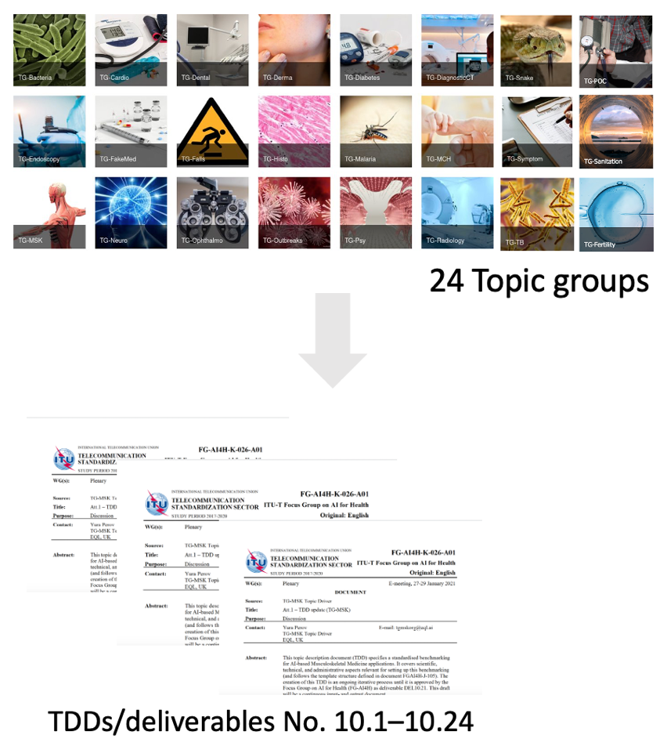
Figure 1: Topic groups and the TDD/deliverables
A generic outline of the topic description documents was proposed in the TDD-template document FGAI4H-C-105 and has been updated by meeting 'J' – FG-AI4H-J-105. The latter document serves as the current TDD-template and is applicable for all topic groups.
The TDD content can be categorized into four components:
- Topic background: What is the health topic considered? Is this of relevance (e.g., does it affect a large and diverse transect of the global population and/or represent a challenge to the healthcare community)? What is the current gold standard for addressing this health topic? Could AI provide a tangible improvement (e.g., in terms of better care, better results, and/or savings in cost and time)? Are there existing AI solutions for this health topic? Has already been worked towards the benchmarking of the aforementioned solutions?
- Topic group features: What subtopics belong to the topic group? How do members of the topic group participate and interact (e.g., via online communication, regular meetings)? What is the status update for this topic group to each meeting?
- Topic group operations: How will the benchmarking be executed (e.g., with regard to input/output data, data labelling, test dataset acquisition, scores/metrics, architecture, and data sharing policies)? How will the outcome of the benchmarking be disseminated? How will feedback be implemented? Are there existing benchmarking processes of AI systems that are of interest for the benchmarking of this topic group (e.g., publications, frameworks)? How is the retirement after benchmarking of the AI task managed?
- Topic group considerations: How are ethics and legalities addressed by the topic group? What are the regulatory considerations that apply for this topic group (e.g., what are existing regulatory frameworks? Which regulatory requirements are used for the benchmarking of the AI4H system in this topic group?)
In the end, a Declaration of Conflict of Interest by each contributor to this document is provided.
As progress is made within the topic groups, revised versions of the topic description documents are inevitable. These are submitted as input documents and are presented at each meeting by the topic group driver. The changes are discussed and integrated into the improved version.
Parallel to the topic groups, there are working groups that are dedicated to overarching themes that affect all topic groups in a specific aspect of an AI health technology, for example, the Working Group on Regulatory Considerations on AI for Health and the Working Group on Ethical Considerations on AI for Health. Working groups also develop definitions of best practices, establish processes and related policies, define ways to successfully benchmark AI for health algorithms and create reference documents. All these considerations are important for the benchmarking process of all topic groups in the context of the special health topic and are also considered in their TDD.
Figure 2 gives an overview of the interaction between FG-AI4H topic groups ('vertical') and working groups ('horizontal').
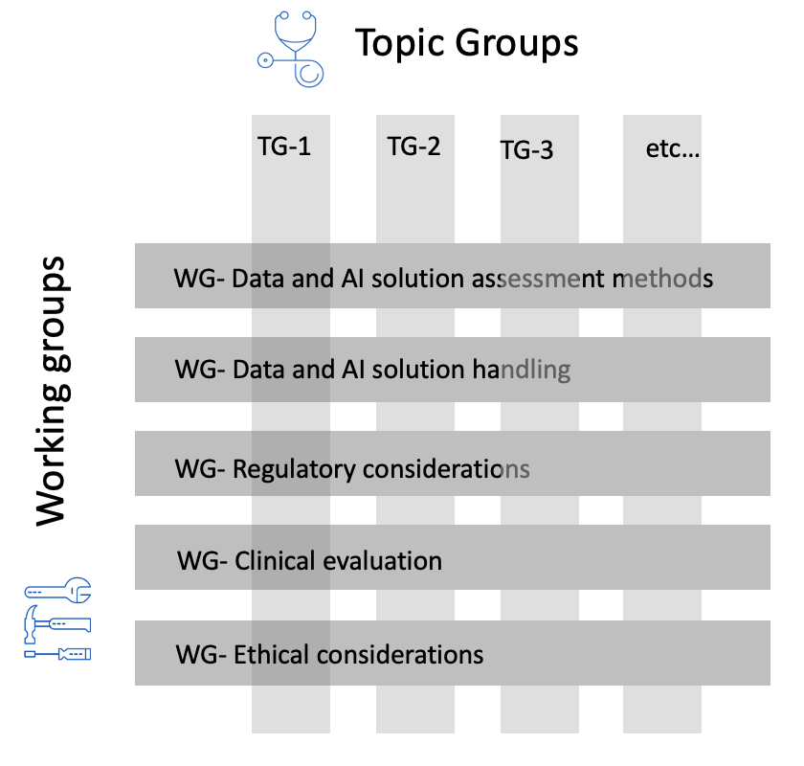
Figure 2: Interaction between topic groups ('vertical') and working groups ('horizontal')

TDD-template update – details about development
As of meeting 'H', FG-AI4H members resolved an update of the generic TDD template FGAI4H-C-105 that became obvious during the formation process of the TDD and the development and activities within FG-AI4H working groups and topic groups over time. The objective is to create a consistent structure of the TDD template that works for all topic groups and also facilitates the internal and external review process of the TDDs.
A revised version of the TDD template document was submitted as "Draft updated TDD template," allocated as FGAI4H-I-004 to meeting 'I' (E-meeting) in May 2020, including additional sections, change notes, mentioning of the contributors, restructuring of some sections, lists of figures and tables, consideration of health economics and regulation, and a list of optional sub-topics.
During this meeting, FG-AI4H members agreed on further adjustments and more detailed information about the requirements defined by the working groups and their output documents (deliverables 01 – 09) on regulatory - and ethical considerations, on clinical evaluation and on all aspects regarding data (e.g., data acquisition, handling, annotation, storing). The feedback of the deliverable editors (deliverables 01 – 09) has then been implemented in the TDD-template update and the final document has been submitted to FG-AI4H meeting 'J' (E-meeting, September 2020). After passing the FG-AI4H approval process, the updated TDD-template was finally allocated as FG-AI4H-J-105.
The four components of the TDD (TG-background, TG-features, TG-operations, TG-considerations) described before in section 5 have been complemented and updated.
Updates include:
- a new structure with more guidance
- an updated table of contents
- new sections, e.g., regulatory section
- updated sections, e.g., ethical considerations section
- new structuring of the subtopics
- new structuring and description of the benchmarking versions
- a more detailed description of the benchmarking process

Structure
This document DEL 10_0 "AI4H use cases: Topic Description Documents" serves as an introduction to a set of documents that describe several use cases of a specific health topic in the context of AI.
Table 1 gives an overview of the use cases/topic groups, their topic group drivers, and the document number. Starting topic groups might not have a TDD document number yet. As of September 2021, there were 21 draft versions of topic description documents (out of 24 topic groups in total) published on the FG-AI4H website.

Table 1: Overview of the 21 topic groups and their corresponding deliverables
N° | Topic group | Topic driver(s) | Document (latest version) | Comment
10_01 | Use of AI in cardiovascular disease management (TG-Cardio)  - including clinical predictions sub-topic: cardiovascular disease risk prediction | Benjamin Muthambi | L-006-A01 | Needs content for subtopic on cardiac image analysis.
10_02 | Dermatology (TG-Derma) | (Maria Vasconcelos)  > Weihong Huang | [same as meeting E]  L-007-A01 | Change of TG-drivers  Pending transfer to updated TDD-template
10_03 | Diagnosis of bacterial infection and anti-microbial resistance (TG-Bacteria) | Nada Malou | L-008-A01 | Pending transfer to updated TDD-template
10_04 | Falls among the elderly (TG-Falls) | (Inês Sousa)  > Pierpaolo Palumbo | L-012-A01 | Temporary change of TG-drivers
10_05 | Histopathology (TG-Histo) | Frederick Klauschen | [same as meeting I]  L-013-A01 | Pending transfer to updated TDD-template
10_06 | Malaria detection (TG-Malaria) | Rose Nakasi | L-014-A01
10_07 | Maternal and Child Health (TG-MCH) | Alexandre Chiavegatto & Filho Raghu Dharmaraju | L-015-A01 | Pending transfer to updated TDD-template
10_08 | Neurological disorders (TG-Neuro) | Marc Lecoultre | L-016-A01 | Pending transfer to updated TDD-template
10_09 | Ophthalmology (TG-Ophthalmo) | Arun Shroff | L-017-A01 | Pending transfer to updated TDD-template
10_10 | Outbreak detection (TG-Outbreaks) | Stéphane Ghozzi &  Auss Abbood | [same as meeting K]  L-018-A01
10_11 | Psychiatry (TG-Psy) | Nicolas Langer | [same as meeting K]  L-019-A01
10_12 | AI for Radiology (TG-Radiology) | Darlington Ahiale Akogo | L-023-A01 | Pending transfer to updated TDD-template
10_13 | Snakebite and snake identification (TG-Snake) | Rafael Ruiz de Castañeda | [same as meeting I]  L-020-A01 | Pending transfer to updated TDD-template
10_14 | Symptom assessment (TG-Symptom) | Henry Hoffmann | L-021-A01
10_15 | Tuberculosis (TG-TB) | Manjula Singh | [same as meeting E]  L-022-A01 | Pending transfer to updated TDD-template
10_16 | Volumetric chest computed tomography (TG-DiagnosticCT) | Kuan Chen | [same as meeting J]  L-009-A01 | Pending transfer to updated TDD-template
10_17 | Dental diagnostics and digital dentistry (TG-Dental) | Falk Schwendicke &  Joachim Krois | L-010-A01
10_18 | Falsified Medicine (TG-FakeMed) | Franck Verzefé | [same as meeting J]  L-011-A01 | Pending transfer to updated TDD-template
10_19 | Primary and secondary diabetes prediction (TG-Diabetes) | Andrés Valdivieso | [same as meeting K]  L-024-A01 | Pending transfer to updated TDD-template
10_20 | AI for endoscopy (TG-Endoscopy) | Jianrong Wu | [same as meeting K]  L-025-A01
10_21 | Musculoskeletal Medicine (TG-MSK) | Yura Perov &  Peter Grinbergs | L-026-A01
10_22 | AI for human reproduction and fertility (TG-Fertility) | Susanna Brandi &  Eleonora Lippolis |  | New TG, first TDD will be submitted to meeting "M"
10_23 | AI in sanitation for public health (TG-Sanitation). | Khahlil Louisy &  Alexander Radunsky |  | New TG, first TDD will be submitted to meeting "M"
10_24 | AI for point-of-care diagnostics (TG-POC) | Nina Linder |  | New TG, first TDD will be submitted to meeting "M"

Resources and latest document versions of all topic groups
This section contains links to the latest versions of the topic description documents, the "Call for Topic Group Participation" (CfTGP), the respective topic driver, and to the individual collaboration sites of the topic groups.

Cardiovascular disease risk prediction (TG-Cardio)
Topic description document (latest version): DEL10_01
CfP: https://www.itu.int/en/ITU-T/focusgroups/ai4h/Documents/tg/CfP-TG-Cardio.pdf
Topic driver: Benjamin Muthambi (Watif Health, South Africa, brm5@caa.columbia.edu)
Collaboration site: https://extranet.itu.int/sites/itu-t/focusgroups/ai4h/tg/SitePages/TG-Cardio.aspx

Dermatology (TG-Derma)
Topic description document (latest version): DEL10_02
CfP: https://www.itu.int/en/ITU-T/focusgroups/ai4h/Documents/tg/CfP-TG-Derma.pdf
Topic driver: Weihong Huang (Xiangya Hospital Central South University, China, whuangcn@qq.com)
Collaboration site: https://extranet.itu.int/sites/itu-t/focusgroups/ai4h/tg/SitePages/TG-Derma.aspx

Diagnosis of bacterial infection and anti-microbial resistance (AMR) (TG-Bacteria)
Topic description document (initial version): DEL10_03
Call for participation: Awaiting CfTGP
Topic driver: Nada Malou (MSF, France, nada.malou@paris.msf.org)
Collaboration site: https://extranet.itu.int/sites/itu-t/focusgroups/ai4h/tg/SitePages/TG-Bacteria.aspx

Falls among the elderly (TG-Falls)
Topic description document (latest version): DEL_10_04
CfP: https://www.itu.int/en/ITU-T/focusgroups/ai4h/Documents/tg/CfP-TG-Falls.pdf
Topic driver(s):
- Inês Sousa (Fraunhofer Portugal, Portugal, ines.sousa@fraunhofer.pt)
- Pierpaolo Palumbo (University of Bologna, Italy, pierpaolo.palumbo@unibo.it)
Collaboration site: https://extranet.itu.int/sites/itu-t/focusgroups/ai4h/tg/SitePages/TG-Falls.aspx

Histopathology (TG-Histo)
Topic description document (latest version): DEL10_05
CfP: https://www.itu.int/en/ITU-T/focusgroups/ai4h/Documents/tg/CfP-TG-Histo.pdf
Topic driver: Frederick Klauschen (Charité Berlin, Germany, frederick.klauschen@charite.de)
Collaboration site: https://extranet.itu.int/sites/itu-t/focusgroups/ai4h/tg/SitePages/TG-Histo.aspx

Malaria detection (TG-Malaria)
Topic description document (latest version): DEL10_06
CfP: https://www.itu.int/en/ITU-T/focusgroups/ai4h/Documents/tg/CfP-TG-Malaria.pdf
Topic driver: Rose Nakasi (Makerere University, Uganda, g.nakasi.rose@gmail.com)
Collaboration site: https://extranet.itu.int/sites/itu-t/focusgroups/ai4h/tg/SitePages/TG-Malaria.aspx

Maternal and child health (TG-MCH)
Topic description document (latest version): DEL10_07
CfP: https://www.itu.int/en/ITU-T/focusgroups/ai4h/Documents/tg/CfP-TG-MCH.pdf
Topic drivers:
- Raghu Dharmaraju (Wadhwani AI, India, rdharmaraju@gmail.com)
- Alexandre Chiavegatto Filho (University of Sao Paulo, Brazil, alexdiasporto@usp.br)
Collaboration site: https://extranet.itu.int/sites/itu-t/focusgroups/ai4h/tg/SitePages/TG-MCH.aspx

Neurological disorders (TG-Neuro)
Topic description document (latest version): DEL10_08
CfP: https://www.itu.int/en/ITU-T/focusgroups/ai4h/Documents/tg/CfP-TG-Neuro.pdf
Topic driver: Marc Lecoultre (ML Labs, Switzerland, ml@mllab.ai)
Collaboration site: https://extranet.itu.int/sites/itu-t/focusgroups/ai4h/tg/SitePages/TG-Neuro.aspx

Ophthalmology (TG-Ophthalmo)
Topic description document (latest version): DEL10_09
CfP: https://www.itu.int/en/ITU-T/focusgroups/ai4h/Documents/tg/CfP-TG-Ophthalmo.pdf
Topic driver: Arun Shroff (MedIndia, India/USA, arunshroff@gmail.com)
Collab. site: https://extranet.itu.int/sites/itu-t/focusgroups/ai4h/tg/SitePages/TG-Ophthalmo.aspx

Outbreak detection (TG-Outbreaks)
Topic description document (latest version): DEL10_10
CfP: https://www.itu.int/en/ITU-T/focusgroups/ai4h/Documents/tg/CfP-TG-Outbreaks.pdf
Topic driver:
- Stéphane Ghozzi (Helmholtz Centre for Infection Research (HZI), Germany, stephane.ghozzi@helmholtz-hzi.de)
- Auss Abbood (Robert Koch Institute (RKI), Germany, AbboodA@rki.de)
Collab. site: https://extranet.itu.int/sites/itu-t/focusgroups/ai4h/tg/SitePages/TG-Outbreaks.aspx

Psychiatry (TG-Psy)
Topic description document (latest version): DEL10_11
CfP: https://www.itu.int/en/ITU-T/focusgroups/ai4h/Documents/tg/CfP-TG-Psy.pdf
Topic driver: Nicolas Langer (ETH Zurich, Switzerland, n.langer@psychologie.uzh.ch)
Collaboration site: https://extranet.itu.int/sites/itu-t/focusgroups/ai4h/tg/SitePages/TG-Psy.aspx

Radiology (TG-Radiology)
Topic description document (latest version): DEL_10_12
CfP: https://www.itu.int/en/ITU-T/focusgroups/ai4h/Documents/tg/CfP-TG-Radiology.pdf
Topic driver: Darlington Ahiale Akogo (minoHealth AI Labs, Ghana, darlington@gudra-studio.com)
Collab. site: https://extranet.itu.int/sites/itu-t/focusgroups/ai4h/tg/SitePages/TG-Radiology.aspx

Snakebite and snake identification (TG-Snake)
Topic description document (latest version): DEL10_13
CfP: https://www.itu.int/en/ITU-T/focusgroups/ai4h/Documents/tg/CfP-TG-Snake.pdf
Topic driver: Rafael Ruiz de Castaneda (Université de Genève, Switzerland, Rafael.RuizDeCastaneda@unige.ch)
Collaboration site: https://extranet.itu.int/sites/itu-t/focusgroups/ai4h/tg/SitePages/TG-Snake.aspx

Symptom assessment (TG-Symptom)
Topic description document (latest version): DEL10_14
CfP: https://www.itu.int/en/ITU-T/focusgroups/ai4h/Documents/tg/CfP-TG-Symptom.pdf
Topic driver: Henry Hoffmann (Ada Health, Germany, henry.hoffmann@ada.com) ​
Collab. site: https://extranet.itu.int/sites/itu-t/focusgroups/ai4h/tg/SitePages/TG-Symptom.aspx

Tuberculosis (TG-TB)
Topic description document (latest version): DEL10_15
CfP: https://www.itu.int/en/ITU-T/focusgroups/ai4h/Documents/tg/CfP-TG-TB.pdf
Topic driver: Manjula Singh (ICMR, India, singhmanjula.hq@icmr.gov.in)
Collaboration site: https://extranet.itu.int/sites/itu-t/focusgroups/ai4h/tg/SitePages/TG-TB.aspx

Volumetric chest computed tomography (TG-DiagnosticCT)
Topic description document (latest version): DEL10_16 (same as meeting J)
CfP: https://www.itu.int/en/ITU-T/focusgroups/ai4h/Documents/tg/CfP-TG-DiagnosticCT.pdf
Topic driver: Kuan Chen (Infervision, China, ckuan@infervision.com)
Collab. site: https://extranet.itu.int/sites/itu-t/focusgroups/ai4h/tg/SitePages/TG-DiagnosticCT.aspx

Dental diagnostics and digital dentistry (TG-Dental)
Topic description document (latest version): DEL10_17
CfP: https://www.itu.int/en/ITU-T/focusgroups/ai4h/Documents/tg/CfP-TG-Dental.pdf
Topic drivers:
- Falk Schwendicke (Charité Berlin, Germany, falk.schwendicke@charite.de)
- Joachim Krois (Charité Berlin, Germany, joachim.krois@charite.de)
Collaboration site: https://extranet.itu.int/sites/itu-t/focusgroups/ai4h/tg/SitePages/TG-Dental.aspx

AI-based detection of falsified medicine (TG-FakeMed)
Topic description document: DEL10_18 (same as meeting J)
CfP: https://www.itu.int/en/ITU-T/focusgroups/ai4h/Documents/tg/CFP-TG-FakeMed.pdf
Topic driver: Franck Verzefé (TrueSpec-Africa, DRC, fverzefe@gmail.com)
Collab. site: https://extranet.itu.int/sites/itu-t/focusgroups/ai4h/tg/SitePages/TG-FakeMed.aspx

Primary and secondary Diabetes risk prediction (TG-Diabetes)
Topic description document (latest version): DEL10_19
CfP: https://extranet.itu.int/sites/itu-t/focusgroups/ai4h/_layouts/15/WopiFrame.aspx?sourcedoc=%7B546BB29A-191A-435D-A225-4C2878B11577%7D&file=FGAI4H-J-024.docx&action=default
Topic driver: Andrés Valdivieso (Anastasia.ai, Chile)
Collab. site: https://extranet.itu.int/sites/itu-t/focusgroups/ai4h/tg/SitePages/TG-Diabetes.aspx

AI and endoscopy (TG-Endoscopy)
Topic description document: DEL10_20
CfP: https://extranet.itu.int/sites/itu-t/focusgroups/ai4h/_layouts/15/WopiFrame.aspx?sourcedoc=%7B871510A1-2865-4F33-9B8F-B57DE7828334%7D&file=FGAI4H-J-025-A02.docx&action=default
Topic driver: Jianrong Wu (Tencent Healthcare, China)
Collab. site: https://extranet.itu.int/sites/itu-t/focusgroups/ai4h/tg/SitePages/TG-Endoscopy.aspx

Musculoskeletal Medicine (TG-MSK)
Topic description document: DEL10_21
CfP: https://www.itu.int/en/ITU-T/focusgroups/ai4h/Documents/tg/CfP-TG-MSK.pdf
Topic Co-drivers (tgmskorg@googlegroups.com):
- Peter Grinbergs (EQL, UK)
- Yura Perov (Individual Contributor, UK)
- Kate Ryan (EQL, UK)
Collab. site: https://extranet.itu.int/sites/itu-t/focusgroups/ai4h/tg/SitePages/TG-MSK.aspx

AI for human reproduction and fertility (TG-Fertility)
Topic description document: DEL10_22 coming soon
CfP: https://www.itu.int/en/ITU-T/focusgroups/ai4h/Documents/tg/CfP-TG-Fertility.pdf
Topic Co-drivers:
- Susanna Brandi (Merck KGaA, Germany, susanna.brandi@merckgroup.com)
- Eleonora Lippolis (Merck KGaA, Germany, eleonora.lippolis@merckgroup.com)
Collab. site: https://extranet.itu.int/sites/itu-t/focusgroups/ai4h/tg/SitePages/TG-Fertility.aspx

AI in sanitation for public health (TG-Sanitation)
Topic description document: DEL10_23 coming soon
CfP: coming soon
Topic Co-drivers:
- Khahlil Louisy (Institute for Technology&Global Health, ITGH, USA, klouisy@hks.harvard.edu)
- Alexander Radunsky (Institute for Technology&Global Health, ITGH, USA, aradunsky@mail.harvard.edu)
Collab. site: https://extranet.itu.int/sites/itu-t/focusgroups/ai4h/tg/SitePages/TG-Sanitation.aspx

AI for point-of-care diagnostics (TG-POC)
Topic description document: DEL10_24 coming soon
CfP: coming soon
Topic driver: Nina Linder (University of Helsinki, nina.linder@helsinki.fi)
Collab. site: https://extranet.itu.int/sites/itu-t/focusgroups/ai4h/tg/SitePages/TG-POC.aspx

____________________________

