 | INTERNATIONAL TELECOMMUNICATION UNION  TELECOMMUNICATION  STANDARDIZATION SECTOR  STUDY PERIOD 2017-2020 |  | FG-AI4H-M-030
 |  |  | ITU-T Focus Group on AI for Health
 |  |  | Original: English
WG(s): |  | WG-Operations | E-meeting, 28-30 September 2021
DOCUMENT
Source: |  | WG-Operations
Title: |  | Draft updates to the FG-AI4H onboarding document
Purpose: |  | Discussion
Contact: |  | Markus Wenzel  WG-Operations  Fraunhofer HHI, Germany |  | E-mail: markus.wenzel@hhi.fraunhofer.de
Contact: |  | Eva Weicken  WG-Operations  Fraunhofer HHI, Germany |  | E-mail: eva.weicken@hhi.fraunhofer.de
Contact: |  | Matthias Gröschel  ITU, Harvard Medical School |  | E-Mail: matthias.groeschel@itu.int
Contact: |  | FG-AI4H Secretariat |  | E-mail: tsbfgai4h@itu.int

Abstract: | This document proposes an update to the onboarding document FG-AI4H-J-107 for the ITU/WHO Focus Group on AI for Health (FG-AI4H).  The onboarding document explains how to get involved in the FG-AI4H and serves as an onboarding guide for new members and interested parties and individuals.  NOTE – This version has been updated online on 23.09.2021 to align with the reformatted PDF on the public site, without this cover page.

NOTE – A version of this document will be posted as https://itu.int/en/ITU-T/focusgroups/ai4h/‌Documents/ITU_WHO_AI4H_Onboarding.pdf.
This onboarding document will be posted as PDF on the website from page 2 onwards, skipping this header page.
Change notes:
This document updates the previous document versions FGAI4H-G-107 (originally prepared at the FG-AI4H meeting in New Delhi, 13-15 November 2019) and FG-AI4H-J-107 (virtual meeting, 30 September – 02 October 2020). Updates include new topic groups, updated figures and an introduction to the Open Code Initiative and the AI4H auditing process.

Onboarding document—ITU/WHO Focus Group on AI for Health

What is it all about?

Background and mission
Artificial intelligence (AI) and machine learning (ML) are changing the landscape of healthcare and biomedical research. AI/ML models are used to identify valuable features and insights from a diverse range of healthcare data, e.g., diagnostic imaging or laboratory data. Given that any technical flaw can affect people's health and lives, AI health technologies should be thoroughly validated to ensure their safe use in a complex clinical environment. For this purpose, international standards are needed to create trust in AI solutions that are accurate, benchmarked, non-discriminating, effective, cost-effective, useful, and trustworthy.
To meet these challenges, a collaboration between the World Health Organization (WHO) and the International Telecommunication Union (ITU) was first proposed during the "AI for Good" event in Geneva, May 2018. Here, it was acknowledged that to standardize AI for health, specialists in the standardization and implementation of both, healthcare (WHO) and information technology (ITU) need to work together. In July 2018, the two organizations officially agreed to move forward with this project: The ITU/WHO Focus Group on AI for Health (FG-AI4H) convened for the first time at the WHO headquarters in Geneva in September 2018.
FG-AI4H undertakes exploratory steps towards global evaluation standards for health AI technologies. In collaboration with various stakeholders from different fields (healthcare, regulation, ethics, research, health ministries, academia), FG-AI4H has defined two main goals:
- Creation of documentation that contains globally applicable guidelines on a standardized evaluation of AI for health technologies
- Development of an FG-AI4H benchmarking platform to allow independent quality assessment of AI-based systems for health.
Scope and process of FG-AI4H are described in the FG-AI4H white paper [1] and in the Lancet commentary [2].

Website and contact information
FG-AI4H website with up-to-date information: https://itu.int/go/fgai4h
Any questions and inquiries can be sent to the secretariat: tsbfgai4h@itu.int

Get involved and become a member – create an ITU user account
Firstly, everybody is invited to join FG-AI4H! Participation is free of charge and open to all. Here are some instructions on how to become a member (you need to create an ITU-user account).
FG-AI4H-M-107 (2021-09)
- Visit https://itu.int/en/ties-services/Pages/login.aspx
- Select "I am a new user" (next to "Logon'').
- With "Create your user Account as'', select one of the listed options.
If you don't know about the ITU status of your organization, simply select "Non-ITU-Members-Media and Other Organizations"
- Select "Create'', enter the details and complete the ITU user account registration.
Once your ITU user account is activated, you can:
- subscribe to our mailing list (see clause 4),
- register to upcoming workshops and meetings (see clause 5),
- get access to our collaboration site where you will find documents from all previous meetings, deliverables and our internal, interactive workspace (see clause 10).

Effective participation
How can you effectively participate in the FG-AI4H? It really depends on what you want to get out of it. In any case, you need to start with the instructions in §3.
You just want to know what is going on? Join the general mailing list. If you have specific interests, consider joining one of the existing work streams – topic groups (TGs), working groups (WGs), the ad hoc group on digital technology for COVID health emergency (AHG-DT4HE), or the Open Code Initiative (OCI) and AI4H auditing workstreams (find more information in clause 7b).
You want to contribute actively to an existing work stream? Get familiarized with what is going on, how the group is working. Observing and going with the flow helps to get started. Your contribution can be presented at the FG-AI4H Plenary ("all-hands") meetings or directly in the activities of the specific work stream. You do not find a good match to what you had in mind? Read next.
What you had in mind is not yet covered in the existing groups? After you checked that the existing work streams do not cover what you had in mind (even as a "sub-activity"), ask the group leaders about your idea. You can then make a proposal for a new activity at the next "all-hands" FG-AI4H meeting (usually every three months), following the guidelines below (§ 10 in particular).

Subscribe to the mailing lists
It is helpful to subscribe to our general mailing list for receiving updates and announcements, and for communication within FG-AI4H. Visit https://itu.int/go/fgai4h/lists, select the "fgai4h" mailing list and click "Subscribe". Now you can take part in the communication over fgai4h@lists.itu.int.
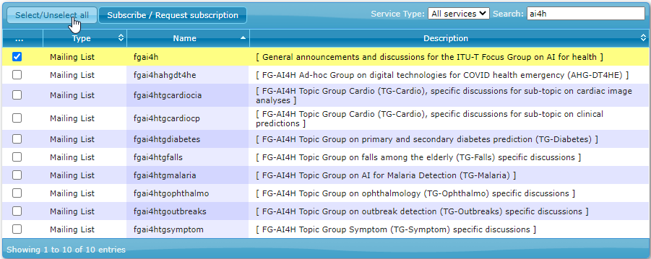
Figure 1: Subscribe to the general mailing list (and to topic group mailing lists)

Participate in our workshops/meetings
Table 1 lists all FG-AI4H meetings and workshops as of September 2021. An updated list can be found at https://itu.int/en/ITU-T/focusgroups/ai4h/Pages/all.aspx that includes links to reports, liaison statements, documentation, etc.
NOTE – It is currently uncertain to plan future physical meetings due to the COVID-19 pandemic.
Visit our website https://itu.int/go/fgai4h for up-to-date information about the upcoming workshops and "all-hands" meetings (incl. dates, locations, visa support letters and logistics). Our website has a link to the registration page for the next meeting (https://itu.int/go/fgai4h/reg).
For registration, you will need to login with your ITU user account (see above in clause 3). Participation in our workshops/meetings is free of charge and open to any interested experts. On our website, you can also find information about travel grants for priority regions and remote participation.

Organization

Management team
Chairman: Thomas Wiegand (Fraunhofer HHI, Germany)
Vice-chairmen/women:
- Stephen Ibaraki (ACM and REDDS Capital, USA)
- Ramesh Krishnamurthy (WHO)
- Naomi Lee (The Lancet, UK)
- Sameer Pujari (WHO)
- Manjula Singh (ICMR, India)
- Shan Xu (CAICT, China)
Table 1: FG-AI4H meetings and workshops, as of September 2021
A | Geneva, Switzerland, 25-27 September 2018; WHO
B | New York City, USA, 14-16 November 2018; Columbia University
C | Lausanne, Switzerland, 22-25 January 2019; EPFL
D | Shanghai, China, 2-5 April 2019; China Academy of Information and Communication Technology
E | Geneva, Switzerland, 29 May-1 June 2019; ITU
F | Zanzibar, Tanzania, 2-5 September 2019; Universal Communications Service Access Fund of Tanzania,
G | New Delhi, India, 12-15 November 2019; Indian Council of Medical Research & National Institute of Communication Finance
– | DASH/DAISAM Workshop, Berlin, Germany, 8-9 January 2020
H | Brasilia, Brazil, week of 20-24 January 2020; PAHO/WHO
– | WG-RC meeting, online 4 – 5 May 2020
I | Online, 7 – 8 May 2020
– | WG-RC orientation workshop to FGAI4H, Online, 8 July, 2020
J | Online, 30 September – 2 October 2020
– | Workshop on Clinical Evaluation of AI for health, Online, 14 October 2020
K | Online, 27 – 29 January 2021
L | Online, 19 – 21 May 2021
M | Online, 28 – 30 September
TBC | All (future) meetings are listed on the FG-AI4H website

FG-AI4H workstreams
Two types of sub-groups are generating the main output documents (deliverables): working groups (WGs) and topic groups (TGs). Both groups interact with each other. Different versions of deliverables are iteratively improved over time until they are completed to undergo an internal and external peer review process.
b.1)
Working groups (WGs) consider crosscutting subject matters that affect a specific aspect of an AI health technology, such as ethics, regulation, data handling - and assessment methods, and clinical evaluation. WG-operations is concerned with administration and logistics around FG-AI4H.
Present WGs include:
- Ethical considerations of AI for health (WG-Ethics)
- Regulatory considerations on AI for health (WG-RC)
- Data and AI solution assessment methods (WG-DAISAM)
- Data and AI solution handling (WG-DASH)
- Clinical evaluation of AI for health (WG-CE)
- Operations (WG-O)
- You find more detailed information about the background and scope of each working group in the WG’s terms of reference (ToRs): https://www.itu.int/en/ITU-T/focusgroups/ai4h/Pages/wg.aspx.
b.2)
Topic groups (TGs) take charge of specific health domains with corresponding AI/ML tasks. They are providing the connection of the WGs with actual health topics and the specific problems that might occur with a number of AI for health tasks and data modalities. In each topic group, different stakeholders, including competing companies with a common interest in the topic are working together. Present TGs (as of September 2021) include:
- Diagnosis of bacterial infection and antimicrobial resistance (TG-Bacteria)
- Cardiovascular disease risk prediction (TG-Cardio)
- Dental diagnostics (TG-Dental)
- Dermatology (TG-Derma)
- AI-based detection of falsified medicine (TG-FakeMed)
- Endoscopy (TG-Endoscopy)
- Falls among the elderly (TG-Falls)
- Histopathology (TG-Histo)
- Malaria detection (TG-Malaria)
- Maternal and child health (TG-MCH)
- AI for Musculoskeletal medicine (TG-MSK)
- Neurological disorders (TG-Neuro)
- Ophthalmology (TG-Ophthalmo)
- Outbreak detection (TG-Outbreaks)
- Primary and secondary diabetes prediction (TG-Diabetes)
- Psychiatry (TG-Psy)
- Radiology (TG-Radiology)
- Snakebite and snake identification (TG-Snake)
- Symptom assessment (TG-Symptom)
- Tuberculosis (TG-TB)
- Volumetric chest computed tomography (TG-DiagnosticCT)
- AI for human reproduction and fertility (TG-Fertility)
- AI in sanitation for public health (TG-Sanitation)
- AI for point-of care diagnostics (TG-POC)
Please note that the list might change depending on the establishment of new topic groups. The latest version is always posted on the FG-AI4H website [https://itu.int/en/ITU-T/focusgroups/ai4h/‌Pages/tg.aspx].
Figure 2 illustrates the collaboration within the FG-AI4H topic- and working groups. The TGs represent various use cases dedicated to a specific health topic. They perform the benchmarking for an AI task following the requirements defined by the WGs. The working groups play a ‘crosscutting’ role and affect all topic groups with their considerations about data and AI solution methods- and handling, ethics, regulation, and clinical evaluation of AI health technologies.

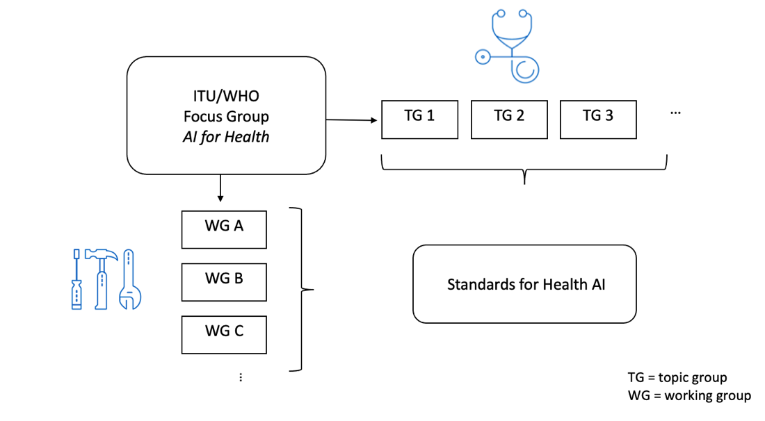
Figure 2: Interaction between working groups and topic groups
b.3)
Ad-Hoc group on digital technologies for COVID health emergencies
FG-AI4H also created an ad hoc group on digital technologies for COVID health emergency (AHG-DT4HE) that will collect effective ways and cases on AI and other digital technologies to combat COVID-19 covering the entire cycle of an epidemic emergency. Outputs are expected to evolve towards a more generalizable mechanism on the health emergency continuum, eventually applicable to other pandemics.

b.4)
FG-AI4H Open Code Initiative (OCI)
WG-DASH initiated and leads the so called “Open Code Initiative” where the activities within FG-AI4H are brought together. The OCI aims to develop a benchmarking platform (software) and associated tools that will enable the evaluation of AI models and allow a secure collection, storage, and annotation of data. This is done in collaboration with the FG-AI4H topic groups which are providing data for a specific medical/AI use case to get tested and validated on the open code platform, all other working groups, and further contributors outside of FG-AI4H. Find more information here:
- OCI development site: https://dev.azure.com/mllabai/fg-ai4h
- Terms of reference: https://www.itu.int/en/ITU-T/focusgroups/ai4h/Pages/opencode.aspx
- Demo platform: https://ai4h-audit.org/
- Code repository: https://github.com/FG-AI4H

b.5)
AI4H auditing
“AI4H auditing” is a related activity, led by WG-DAISAM which is developing processes and standardization methods for the trustworthy use of AI technologies in real-world applications. Trial procedures developed on paper need to be put to the test to ensure that they also work in practice. The auditing framework proposed by FG-AI4H follows a structured verification and validation process of technical, ethical, regulatory and clinical requirements for AI. The validation protocol was tested on three AI models (including two topic groups/use cases) in a first round of trial audits in December 2020.
By the end of September 2021, the second run of trial audits is starting. The audit teams are formed by representatives of each working group allocated to one topic group.
Find out more in the publication “ML4H Auditing: From Paper to Practice” [PMLR, 2020. In Machine Learning for Health; Link].

Deliverables [2]
The main output documents (deliverables) of FG-AI4H are produced in a joint effort by FG-AI4H members participating in the working - and topic groups. Figure 3 provides an overview of all deliverables and their relation to each other. All deliverables are also listed here: https://www.itu.int/en/ITU-T/focusgroups/ai4h/Documents/listdeliverables.pdf
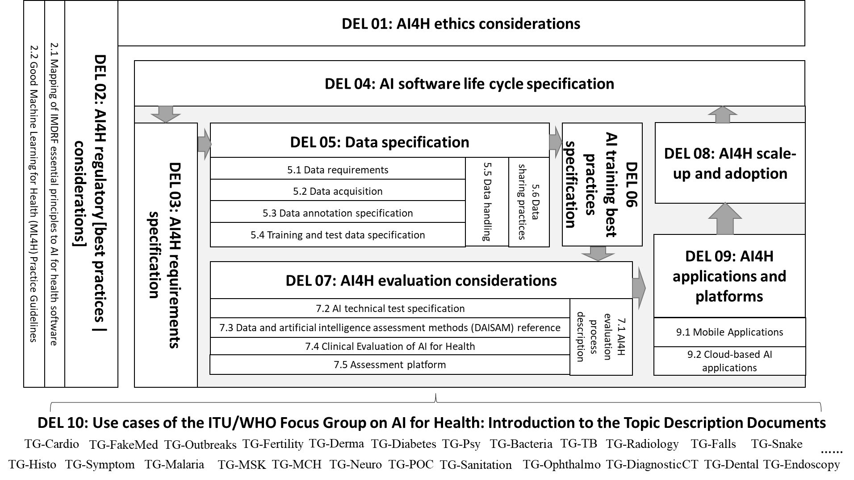
Figure 3: Overview of the structure of the deliverables and their relation to each other

Participate in a working group
You can ask the secretariat (tsbfgai4h@itu.int) for an introduction to the respective chair of the working group of your interest. Please use a descriptive email subject (e.g., "Participation in working group X"), briefly introduce yourself, describe your relevant expertise, and explain your interest in the working group.

Participate in one of the existing topic groups
Visit our website https://itu.int/go/fgai4h and select the topic group you want to join. Each topic group has its own page on our website where you find more information in a "Call for Topic Group Participation" including instructions how to get involved. Once you are a member of the topic group of your interest, you can collaborate and contribute to the work of the topic group, which is centred around the development of a ‘topic description document’ (the deliverable of each topic group). This process is moderated by a so called "topic driver". The time and effort you want to allocate can be arranged individually. Several topic groups communicate by individual mailing lists. You can subscribe to the mailing list of your choice on https://itu.int/go/fgai4h/lists.

Working method / contribute / propose a new "AI for Health" topic
The working method of FG-AI4H is centred around the production of documents. FG-AI4H members (= you) can submit "input documents" to the meetings, where the authors are expected to present the document and respond to questions raised by FG-AI4H members. The presentations can be accompanied by PowerPoint or PDF slides (optional). All documents are published on our collaboration site (see below). In this way, the work of the group is transparently documented. The group can decide to turn some documents into so called "output documents".
If you want to submit a document on any subject matter, please follow these instructions (please keep in mind the deadline published on https://itu.int/go/fgai4h):
- Use this template for your document submission: https://itu.int/en/ITU-T/focusgroups/ai4h/‌Documents/FGAI4H-Doc-template.docx
- Submit your document by E-mail to: tsbfgai4h@itu.int
- Please submit a Word file, not a PDF (additional attachments and slides are OK).
If you want to propose a new "AI for Health" topic, simply follow these instructions: https://itu.int/en/ITU-T/focusgroups/ai4h/Documents/FGAI4H-CfP_UC_Benchm_Data.pdf. Briefly, you will need to respond to eleven questions listed in the PDF, submit the document to tsbfgai4h@itu.int , give a presentation at the next meeting and answer questions in the following discussions.

Online collaboration
Our general mailing list (fgai4h@lists.itu.int) serves as the main channel for communication (subscribe to the "fgai4h" mailing list on https://itu.int/go/fgai4h/lists).
You can attend our workshops and meetings not only physically but also remotely via internet (e.g., with ITU's ‘My Meetings’-tool at https://remote.itu.int or ‘Zoom’). You can find more information on the main website https://itu.int/go/fgai4h, usually a few days prior to the event.
ITU has equipped us with several collaboration tools, centered around our collaboration site.
Collaboration site – direct link: https://itu.int/go/fgai4h/collab
Access this page with your ITU user account (see above).
You can navigate to this site also from our main webpage: https://itu.int/go/fgai4h
All documents of all meetings are stored in the collaboration site, organized by FG-AI4H meeting, see §12.
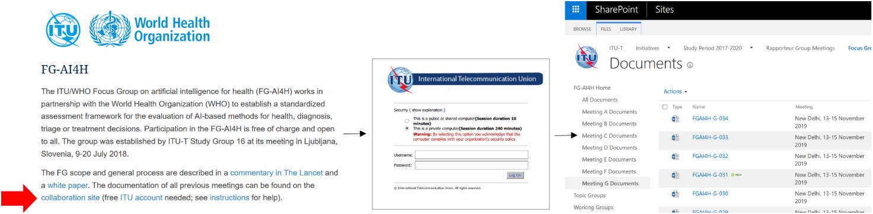
Figure 3: Access our collaboration site from the main webpage with your ITU user account

Topic/working groups can use dedicated workspaces in our collaboration site for file sharing and collaborative document editing (similar to "Google Drive/Docs"). On the left side of the collaboration site, you will find folders for "topic groups" and "working groups". Topic drivers and working group chairs can upload/create/edit the files and give other users edit rights using the "Share" button. Everyone with an ITU user account can view the files and can get granted access.
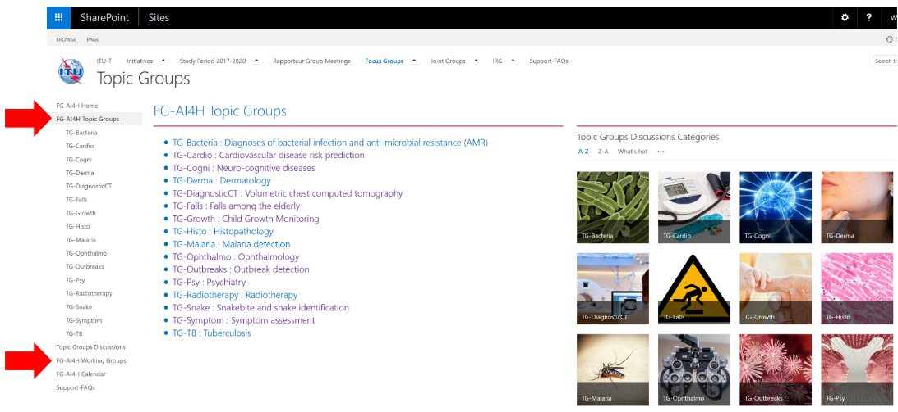
Figure 4: Workspaces for topic/working groups in the collaboration site
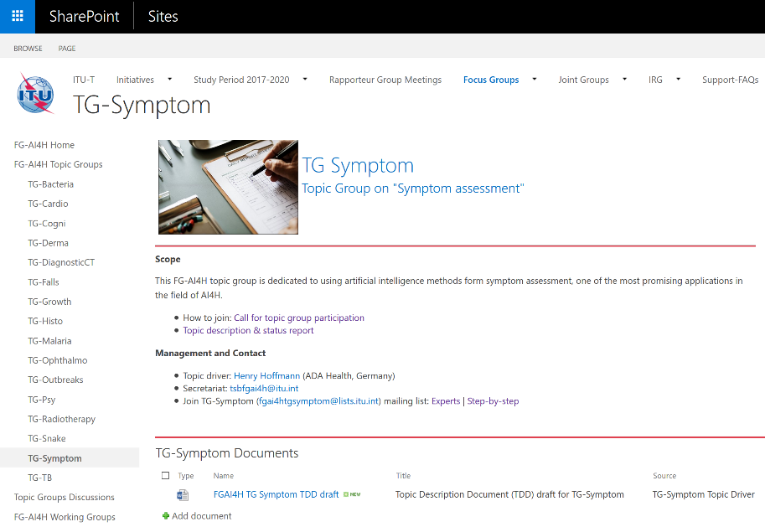
Figure 5: Workspace of one topic group as example
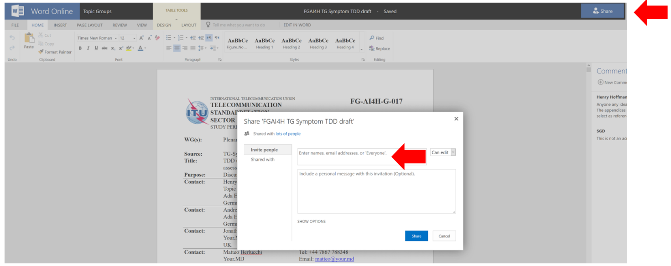
Figure 6: Word online in the workspace of one topic group on the collaboration site. Invite others with the “Share” button
Topic/working groups can use our Zoom meeting room for online meetings: https://itu.zoom.us/my/‌fgai4h. Topic drivers and Working Group chairs are responsible for booking the meeting room. Please look for a free time slot in the calendar on the collaboration site and enter your meeting directly in the calendar (with the aforementioned link as location). Time zone of the calendar is Geneva time – either Central European Time (CET) or Central European Summer Time (CEST).
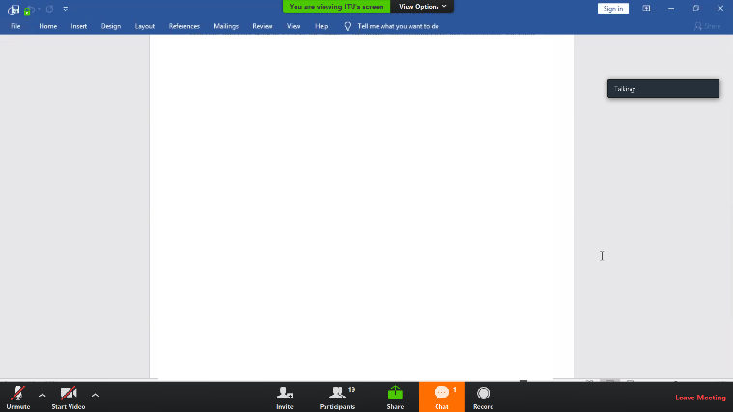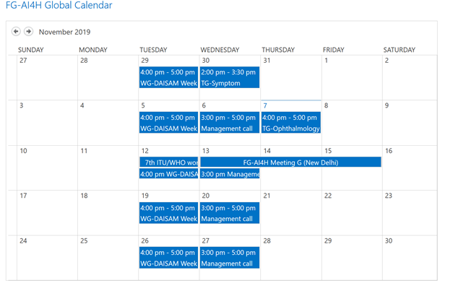
Figure 7: Zoom meeting room (left) can be booked in calendar in collaboration site (right)

Topic/working groups can create their own mailing lists. Topic drivers and working group chairs can contact the secretariat (tsbfgai4h@itu.int) to create the list. Focus group members can sign up to the list of their choice by subscribing on https://itu.int/go/fgai4h/lists with their ITU user account.

Documentation
All the documentation of FG-AI4H is stored in the collaboration area, which requires you to log in using a (free) ITU account.
Documents reviewed and produced at FG-AI4H "all-hands" meetings are organized by meeting (designated by letters – A, B, C, etc), and stored in specific folders. The right side of Figure 3 illustrates how to access these online folders.
TGs, WGs and the AHG have their own documentation and sub-pages in the FG-AI4H collaboration area. These groups have a faster pace and meet (usually online) more frequently than in the all-hands meetings only.

References
[1] Whitepaper for the ITU/WHO Focus Group on Artificial Intelligence for Health, FG-AI4H, 2020-10. https://itu.int/en/ITU-T/focusgroups/ai4h/‌Documents/FG-AI4H_Whitepaper.pdf
[2] WHO and ITU establish benchmarking process for artificial intelligence in health. The Lancet, 394(10192), 9-11. https://doi.org/10.1016/S0140-6736(19)30762-7
[3] Draft FG-AI4H Deliverables, Overview (2020).
https://extranet.itu.int/sites/itu-t/focusgroups/ai4h/Deliverables/DEL00.docx

____________________________

An archive version of the Plenary meeting documents is available externally (essentially, to enable indexing by web search engines). However, for the latest version of the documentation, always access the FG-AI4H collaboration site.

