 | INTERNATIONAL TELECOMMUNICATION UNION  TELECOMMUNICATION  STANDARDIZATION SECTOR  STUDY PERIOD 2017-2020 |  | FG-AI4H-M-018-A03
 |  |  | ITU-T Focus Group on AI for Health
 |  |  | Original: English
WG(s): |  | Plenary | E-meeting, 28-30 September 2021
DOCUMENT
Source: |  | TG-Outbreaks Topic Driver
Title: |  | Att.3 – Presentation (TG-Outbreaks)
Purpose: |  | Discussion
Contact: |  | Auss Abbood  Robert Koch Institute  Germany |  | Email: abbooda@rki.de

Abstract: | This document contains a rendering of the live presentation delivered at Meeting M on the progress of TG-Outbreaks.

TG-Outbreaks, Meeting M
In [1]:
from itertools import product

import matplotlib.pyplot as plt
import numpy as np
import pandas as pd
import seaborn as sns
from IPython.display import Image
from matplotlib.patches import Rectangle
from scipy.stats import multivariate_normal, norm
from sklearn import metrics

from scorer.scorer import EpiMetrics, Score

Problem statement
In [2]:
Image("farrington.jpeg")
Out[2]:
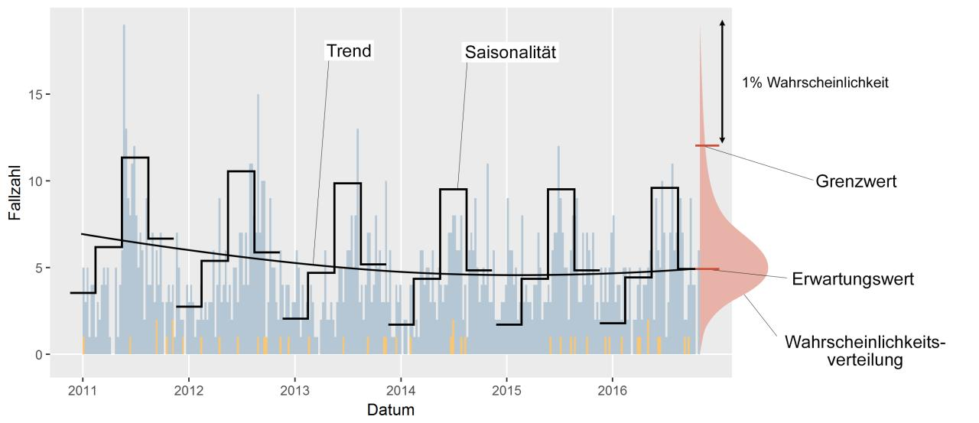
In [3]:
Image("12942_2008_Article_251_Fig4_HTML.jpg")
Out[3]:
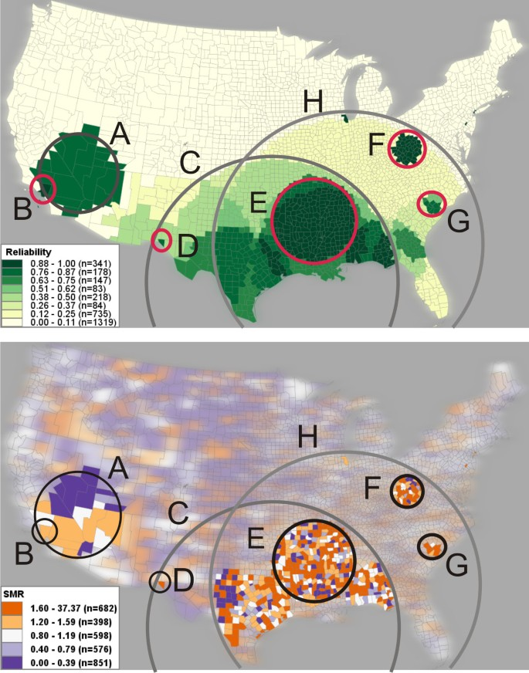

Our suggestions
$$p(d_i|x) = n(d_i,x) / \sum_{l} n(d_l,x)$$$$\hat{p}(d_i|x) = \sum_j \hat{p}(d_i|s_j,x)\, \hat{p}(s_j|x)$$

Data
In [4]:
Image("base.PNG")
Out[4]:
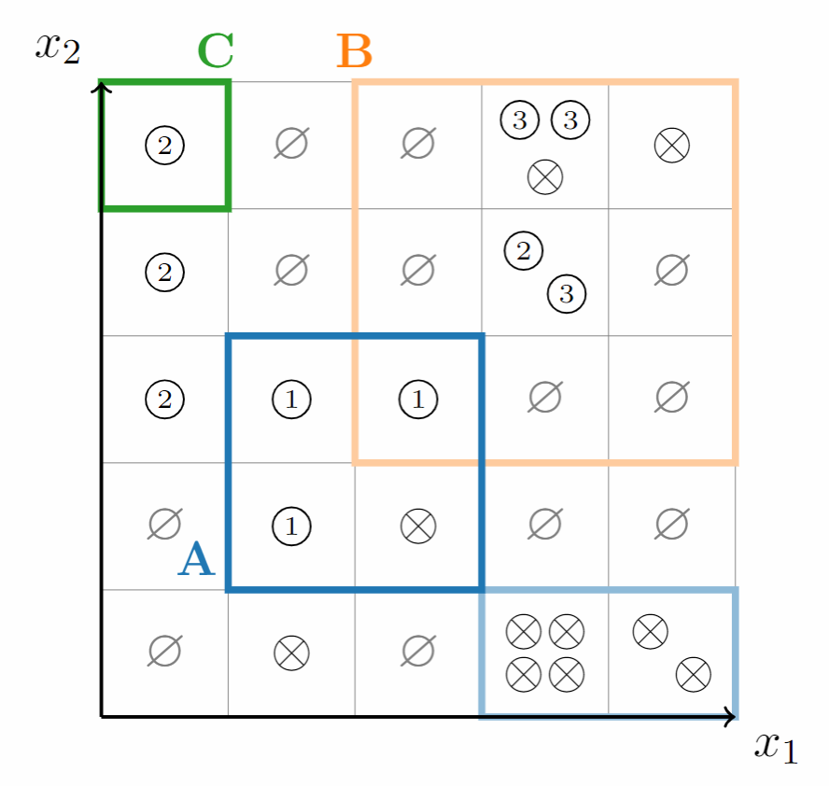
In [5]:
cases = pd.read_csv("tests/data/paper_example/cases_long.csv")
cases
Out[5]:
 | x1 | x2 | data_label | value
0 | 0.0 | 0.0 | one | 0
1 | 0.0 | 1.0 | one | 0
2 | 0.0 | 2.0 | one | 0
3 | 0.0 | 3.0 | one | 0
4 | 0.0 | 4.0 | one | 0
... | ... | ... | ... | ...
95 | 4.0 | 0.0 | endemic | 2
96 | 4.0 | 1.0 | endemic | 0
97 | 4.0 | 2.0 | endemic | 0
98 | 4.0 | 3.0 | endemic | 0
99 | 4.0 | 4.0 | endemic | 1
100 rows × 4 columns
In [6]:
signals = pd.read_csv("tests/data/paper_example/signals_long.csv")
signals
Out[6]:
 | x1 | x2 | signal_label | value
0 | 0.0 | 0.0 | w_A | 0.0
1 | 0.0 | 1.0 | w_A | 0.0
2 | 0.0 | 2.0 | w_A | 0.0
3 | 0.0 | 3.0 | w_A | 0.0
4 | 0.0 | 4.0 | w_A | 0.0
... | ... | ... | ... | ...
70 | 4.0 | 0.0 | w_C | 0.0
71 | 4.0 | 1.0 | w_C | 0.0
72 | 4.0 | 2.0 | w_C | 0.0
73 | 4.0 | 3.0 | w_C | 0.0
74 | 4.0 | 4.0 | w_C | 0.0
75 rows × 4 columns

Score
In [7]:
s = Score(cases, signals)
C:\Users\AbboodA\Documents\github\score-time_series_and_scan_statistics\scorer\scorer.py:128: UserWarning: w_endemic is missing and is being imputed.
warn("w_endemic is missing and is being imputed.")
C:\Users\AbboodA\Documents\github\score-time_series_and_scan_statistics\scorer\scorer.py:132: UserWarning: w_non_case is missing and is being imputed.
warn("w_non_case is missing and is being imputed.")
In [8]:
s._eval_df()
Out[8]:
 | x1 | x2 | d_i | p(d_i) | p^(d_i)
0 | 0.0 | 0.0 | one | 0.0 | 0.000000
1 | 0.0 | 1.0 | one | 0.0 | 0.000000
2 | 0.0 | 2.0 | one | 0.0 | 0.000000
3 | 0.0 | 3.0 | one | 0.0 | 0.000000
4 | 0.0 | 4.0 | one | 0.0 | 0.333333
... | ... | ... | ... | ... | ...
120 | 4.0 | 0.0 | non_case | 0.0 | 0.000000
121 | 4.0 | 1.0 | non_case | 1.0 | 1.000000
122 | 4.0 | 2.0 | non_case | 1.0 | 0.500000
123 | 4.0 | 3.0 | non_case | 1.0 | 0.500000
124 | 4.0 | 4.0 | non_case | 0.0 | 0.000000
125 rows × 5 columns
In [9]:
def plot_grid(series, title):
ax = sns.heatmap(
series.values.reshape(5, -1).T,
linewidth=2,
cmap="RdPu",
cbar=False,
annot=True,
)

ax.add_patch(
Rectangle(
(0, 4),
1,
1,
fill=False,
lw=4,
color="green",
)
)
ax.add_patch(
Rectangle(
(1, 1),
2,
2,
fill=False,
lw=4,
color="blue",
)
)
ax.add_patch(
Rectangle(
(3, 0),
2,
1,
fill=False,
lw=4,
color="blue",
alpha=0.5,
)
)
ax.add_patch(
Rectangle(
(2, 2),
3,
3,
fill=False,
lw=4,
color="orange",
alpha=0.5,
)
)
ax.set_title(title)
ax.set_ylim(0, 5)
ax.set_xlim(0, 5)
return ax
In [10]:
for datalabel in s._p_hat_di().d_i.unique():
plot_grid(s._p_hat_di().query("d_i==@datalabel").loc[:, ["p^(d_i)"]], datalabel)
plt.show()
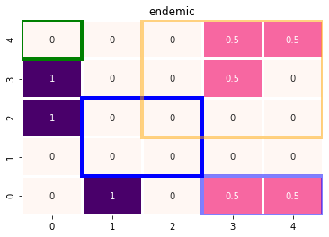
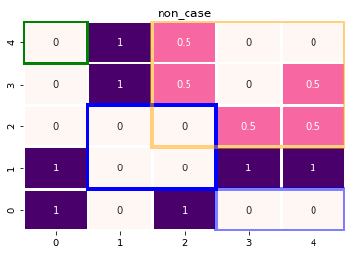
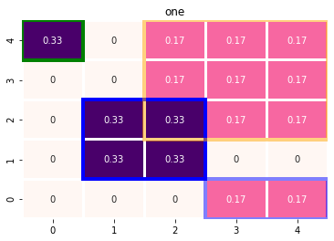
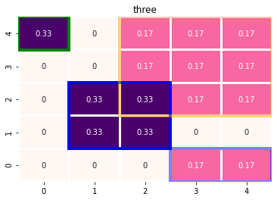
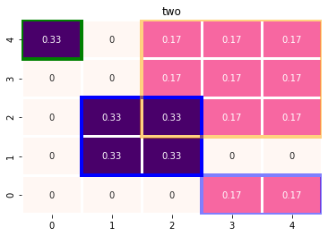
In [11]:
s.calc_score(metrics.f1_score)
Out[11]:
0.5175213675213676
In [12]:
s.calc_score(metrics.f1_score, weighted=True)
Out[12]:
0.7006081525312294
In [13]:
s.calc_score(metrics.brier_score_loss)
Out[13]:
0.168
In [14]:
conf_mats = s.class_based_conf_mat()
for k, v in conf_mats.items():
sns.heatmap(v, annot=True)
plt.title(k)
plt.show()
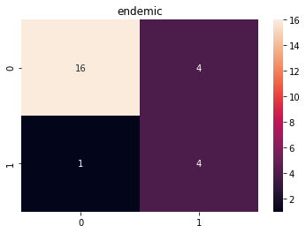
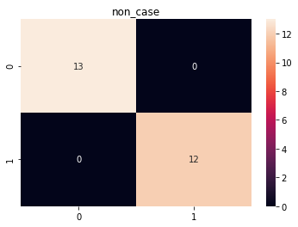
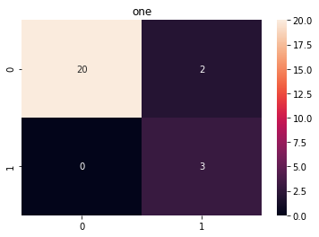
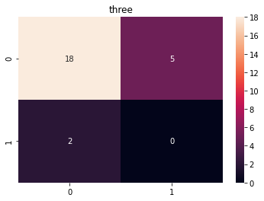
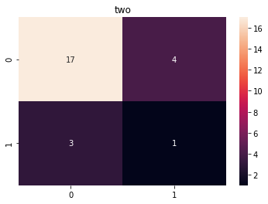
In [15]:
conf_mats = s.class_based_conf_mat(weighted=True)
for k, v in conf_mats.items():
sns.heatmap(v, annot=True)
plt.title(k)
plt.show()
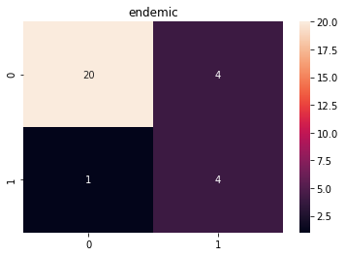
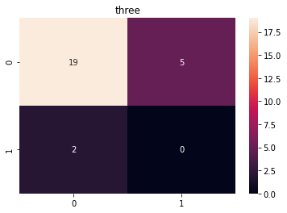

Epidemiological metrics
- Timeliness
- Large cluster over small cluster
- Spatially precises over broad determination
In [16]:
e = EpiMetrics(cases, signals)
C:\Users\AbboodA\Documents\github\score-time_series_and_scan_statistics\scorer\scorer.py:128: UserWarning: w_endemic is missing and is being imputed.
warn("w_endemic is missing and is being imputed.")
C:\Users\AbboodA\Documents\github\score-time_series_and_scan_statistics\scorer\scorer.py:132: UserWarning: w_non_case is missing and is being imputed.
warn("w_non_case is missing and is being imputed.")
In [17]:
e.timeliness("x1", 2)
Out[17]:
data_label
one 0.0
three 0.0
two 1.0
dtype: float64
In [18]:
e.timeliness("x2", 1)
Out[18]:
data_label
one 0.0
three 0.0
two 0.0
dtype: float64
In [19]:
e.gauss_weighting(["x1", "x2"])
Out[19]:
 | data_label | weight | x1 | x2
0 | endemic | 0.111419 | 0 | 0
1 | endemic | 0.081214 | 0 | 1
2 | endemic | 0.026621 | 0 | 2
3 | endemic | 0.005112 | 0 | 3
4 | endemic | 0.002094 | 0 | 4
... | ... | ... | ... | ...
120 | two | 0.001080 | 4 | 0
121 | two | 0.013104 | 4 | 1
122 | two | 0.058643 | 4 | 2
123 | two | 0.096651 | 4 | 3
124 | two | 0.058643 | 4 | 4
125 rows × 4 columns
In [20]:
two_d = multivariate_normal([2, 2], [0.5, 0.5])
x, y = np.meshgrid(np.arange(0,5, 1), np.arange(0,5, 1))

two_d2 = multivariate_normal([3, 2], [0.5, 0.5])
x2, y2 = np.meshgrid(np.arange(0,5, 1), np.arange(0,5, 1))

two_d3 = multivariate_normal([4, 4], [0.5, 0.5])
x3, y3 = np.meshgrid(np.arange(0,5, 1), np.arange(0,5, 1))

pos = np.dstack((x, y))
pos2 = np.dstack((x2, y2))
pos3 = np.dstack((x3, y3))
z = np.zeros(np.shape(two_d.pdf(pos)))
for p, pdf in zip([ pos3,pos, pos2,], [ two_d3,two_d, two_d2,]):
tmp = pdf.pdf(p)
z += tmp
z = (z - np.min(z))/np.ptp(z) # Optional
fig2 = plt.figure()
ax2 = fig2.add_subplot(111)
ax2.pcolormesh(x, y, z, shading="auto")
plt.scatter([2, 3, 4], [2, 2, 4])
plt.show()
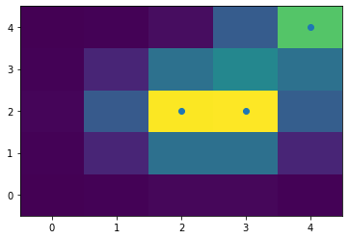
In [21]:
weights = []
for i in range(0,5):
weights.append(np.append(np.zeros(2), np.ones(3)))
fig2 = plt.figure()
ax2 = fig2.add_subplot(111)
ax2.pcolormesh(x, y, np.stack(weights, axis=0) * z, shading="auto")
plt.scatter([2, 3, 4], [2, 2, 4])
plt.show()
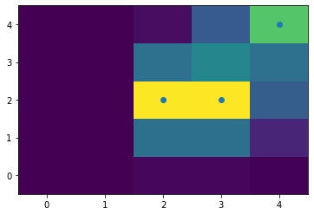
In [22]:
mean = [2, 1, 2]
cov = [[2,0, 0], [0,2,0] , [0,0,2]]
three_d = multivariate_normal(mean, cov)

mean2 = [2, 1, 3]
three_d2 = multivariate_normal(mean2, cov)

mean3 = [2, 3, 3]
three_d3 = multivariate_normal(mean3, cov)

c = [three_d.pdf(t) + three_d2.pdf(t) + three_d3.pdf(t) for t in product(range(5), repeat=3)]

x = [t[0] for t in product(range(5), repeat=3)]
y = [t[1] for t in product(range(5), repeat=3)]
z = [t[2] for t in product(range(5), repeat=3)]
ax = plt.axes(projection='3d')
ax.scatter3D(np.array(x)-0.5, np.array(y)-0.5, np.array(z)-0.5, c=c, s=40, depthshade=False)
fig = plt.gcf()
fig.set_size_inches(9, 9);
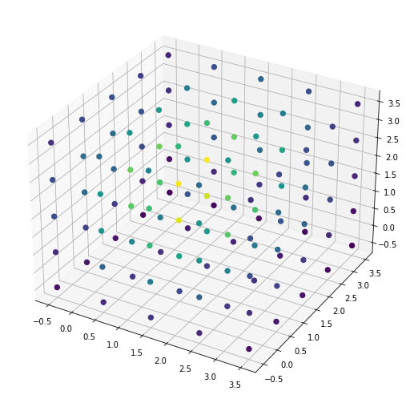
In [23]:
cond = np.array([True if t[0]>=2 else False for t in product(range(5), repeat=3) ])
c = (c - np.min(c))/np.ptp(c)
ax = plt.axes(projection='3d')
ax.scatter3D(np.array(x), np.array(y), np.array(z), c=np.where(cond, c, 0), s=40, depthshade=False)
ax.set_xlabel("x")
ax.set_ylabel("y")
ax.set_zlabel("z")
fig = plt.gcf()
fig.set_size_inches(9, 9);
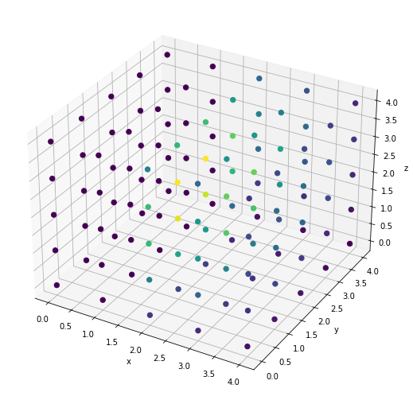
In [ ]:

