|  |  |  |  |  |
| --- | --- | --- | --- | --- |
| ITU Logo | INTERNATIONAL TELECOMMUNICATION UNION  **TELECOMMUNICATION STANDARDIZATION SECTOR**  STUDY PERIOD 2017-2020 | | FG-AI4H-K-048 | |
| **ITU-T Focus Group on AI for Health** | |
| **Original: English** | |
| **WG(s):** | | Plenary | E-meeting, 27-29 January 2021 | |
| **DOCUMENT** | | | | |
| **Source:** | | Editors | | |
| **Title:** | | Updated DEL05.3: Data annotation specification | | |
| **Purpose:** | | Discussion | | |
| **Contact:** | | Shan Xu, CAICT, China | | Email: [xushan@caict.ac.cn](mailto:xushan@caict.ac.cn) |
| **Contact:** | | Harpreet Singh, ICMR, India | | Email: [hsingh@bmi.icmr.org.in](mailto:hsingh@bmi.icmr.org.in) |
| **Contact:** | | Sebastian Bosse, Fraunhofer HHI, Germany | | Email: [sebastian.bosse@hhi.fraunhofer.de](mailto:sebastian.bosse@hhi.fraunhofer.de) |

|  |  |
| --- | --- |
| **Abstract:** | This document describes the topics to be addressed in the forthcoming Deliverable 5.3 "Data Annotation Specification". Data annotation would be one of the most dependable factors on model performance, it serves as one important aspect of data quality control on Artificial Intelligence for health. This document is addressed to give a general guideline of data annotation specification, including definition, background and goals, framework, standard operating procedure, scenario classifications and corresponding criteria, as well as recommended metadata, etc. A questionnaire is attached to seek input and collaboration with topic groups in FG-AI4H regarding data annotation. Rev.1 resolves the review questions from the secretariat. |

|  |  |  |  |  |
| --- | --- | --- | --- | --- |
|  | | **International Telecommunication Union** | | |
|  | |  | | |
| **ITU-T** | **FG-AI4H Deliverable** | |
| TELECOMMUNICATION STANDARDIZATIONSECTOR OFITU | | (draft 2020-05-04) |
|  |  | | | |
|  | FG AI4H Deliverable 5.3  Data annotation specification | | | |
|  |  | | | |

Summary

This document describes the topics to be addressed in the forthcoming deliverable "DEL05-A03: Data Annotation Specification". Data annotation is one of the most dependable factors on model performance, it serves as an important aspect of data quality control on Artificial Intelligence for health. This document is committed to give a general guideline of data annotation specification, including definition, background and goals, framework, standard operating procedure, scenario classifications and corresponding consistency criteria, as well as recommended metadata, etc. A questionnaire is attached to seek input and collaboration with topic groups in FG-AI4H regarding data annotation.

Keywords

Data Annotation, standard operating procedure, consistency criteria, metadata

|  |  |  |
| --- | --- | --- |
| **Editors:** | Shan Xu CAICT, China | Email: [xushan@caict.ac.cn](mailto:xushan@caict.ac.cn) |
|  | Harpreet Singh ICMR, India | Email: [hsingh@bmi.icmr.org.in](mailto:hsingh@bmi.icmr.org.in) |
|  | Sebastian Bosse Fraunhofer HHI, Germany | Email: [sebastian.bosse@hhi.fraunhofer.de](mailto:sebastian.bosse@hhi.fraunhofer.de) |

|  |  |  |
| --- | --- | --- |
| **Contributors:** | Yanwu Xu Intelligent Healthcare Unit, Baidu, China | Email: [xuyanwu@baidu.com](mailto:xuyanwu@baidu.com) |
|  | Nathan Guo ShuKun Techonology, China | Email: [guoning@shukun.net](mailto:guoning@shukun.net) |
|  | Jianrong Wu Tencent Healthcare (Shenzhen), China | Email: [edwinjrwu@tencent.com](mailto:edwinjrwu@tencent.com) |
|  | Yajun Zhang Tencent Technology (Shenzhen), China | Email: [yajunzhang@tencent.com](mailto:yajunzhang@tencent.com) |
|  | Chunyang Niu  Zhejiang Lab, China | Email: niucy@zhejianglab.com |
|  | Guoqiang Li  Zhejiang Lab, China | Email: gli@zhejianglab.com |
|  | Huihui Fang  Artificial Intelligence Innovation Business, Baidu, China | Email: [fanghuihui@baidu.com](mailto:fanghuihui@baidu.com) |

**CONTENTS**

| Page |
| --- |
| 1 Scope 6  2 Reference 6  3 Definitions 6  3.1 Terms defined elsewhere 6  3.2 Terms defined in this document 7  4 Abbreviations and acronyms 7  5 Background and goals 7  6 Framework 8  7 Standard operating procedure 9  7.1 Independent annotation 9  7.2 Arbitration 9  7.3 Expert Reviewing 9  7.4 Decision making box 10  7.5 Annotators training and assessment 10  7.6 Variable description 10  8 Consistency judgement 10  8.1 Input data type classification 11  8.2 Output requirement classification 12  8.3 Criteria option matrix 12  8.4 Post-processing of the annotations 17  9 Recommended metadata 17  10 Output file 17  11 File saving 17  Annex A Questionnaire on data annotation 19  Annex B Data annotation tools 25  Annex C Examples of annotation document information 27 |

**List of Tables**

| Page |
| --- |
| Table 1: Summary of common medical measurement modalities 11  Table 2: Summary of input data modalities for AI4H tasks 11  Table 3: Output requirements 12  Table 4 Criteria options in different scenarios 13  Table 5: Criteria calculation for classification 15  Table 6: Criteria calculation for Image detection and segmentation 16  Table 7 Recommended metadata 18 |

**List of Figures**

| Page |
| --- |
| Figure 1: Framework of data annotation and its external relations 8  Figure 2: Data annotation procedure 9 |

FG AI4H Deliverable 5.3

Data annotation specification

# Scope

This initial draft describes the topics to be addressed in the forthcoming deliverable "DEL05-A03: Data Annotation Specification" and help seed future content. This document is committed to give a framework of data annotation specification for different stakeholders to develop and implement AI-based tools in advancing healthcare.

# Reference

The following ITU-T Recommendations and other references contain provisions, which, through reference in this text, constitute provisions of this Recommendation. At the time of publication, the editions indicated were valid. All Recommendations and other references are subject to revision; users are therefore encouraged to investigate the possibility of applying the most recent edition of the Recommendations and other references listed below. A list of the currently valid ITU-T Recommendations is regularly published.

The reference within this document does not give it, as a stand-alone document, the status of a Recommendation.

[ISO/IEC 2382:2015] ISO/IEC 2382:2015, Information technology — Vocabulary

[IEC 62304] IEC 62304:2006 + A1:2015, "Medical device software – Software life cycle processes"

[IEC 82304] IEC 82304-1 Health software – Part 1: General requirements for product safety

[FDA] FDA's "Proposed Regulatory Framework for Modifications to Artificial Intelligence / Machine Learning (AI/ML) Based Software as Medical Device

[NMPA] Key Points for the Review and Evaluation of Deep Learning Based Software as Medical Device

# Definitions

## Terms defined elsewhere

This document uses the following terms defined elsewhere:

**3.1.1 Artificial intelligence** [ISO/IEC 2382:2015]: Branch of computer science devoted to developing data processing systems that perform functions normally associated with human intelligence, such as reasoning, learning, and self-improvement.

**3.1.2 Machine learning** [ISO/IEC 2382:2015]: Automatic learning, process by which a functional unit improves its performance by acquiring new knowledge or skills, or by reorganizing existing knowledge or skills.

**3.1.1 Medical device** [GHTF/SG1/N71:2012]: Any instrument, apparatus, implement, machine, appliance, implant, reagent for in vitro use, software, material or other similar or related article, intended by the manufacturer to be used, alone or in combination, for human beings, for one or more of the specific medical purpose(s) of: a) diagnosis, prevention, monitoring, treatment or alleviation of disease; b) diagnosis, monitoring, treatment, alleviation of or compensation for an injury; c) investigation, replacement, modification, or support of the anatomy or of a physiological process; d) supporting or sustaining life; e) control of conception, f) disinfection of medical devices; g) providing information by means of in vitro examination of specimens derived from the human body; and does not achieve its primary intended action by pharmacological, immunological or metabolic means, in or on the human body, but which may be assisted in its intended function by such means.

**3.1.4 Software as a medical device** [IMDRF/SaMD WG/N12FINAL:2014]: Software intended to be used for one or more medical purposes that perform these purposes without being part of a hardware medical device.

## Terms defined in this document

This document defines the following terms:

**3.2.1 Controlled vocabulary:** An organized arrangement of words and phrases used to index content and to retrieve content through browsing or searching.

**3.2.2 Data annotation:** Process of labelling data by humans usable for supervised machines learning.

**3.2.3 Metadata:** Data that provides information about other data.

**3.2.4 Supervised learning:** The [machine learning](https://en.wikipedia.org/wiki/Machine_learning) task of learning a function that maps an input to an output based on example input-output pairs.

**3.2.5 Unsupervised learning:** A type of machine learning that looks for previously undetected patterns in a data set with no pre-existing labels and with a minimum of human supervision.

# Abbreviations and acronyms

This document uses the following abbreviations and acronyms:

|  |  |
| --- | --- |
| AI | Artificial Intelligence |
| AI4H | Artificial Intelligence for health |
| FG-AI4H | Focus Group on Artificial Intelligence for health |
| ML | Machine Learning |
| SOP | Standard operating procedure |

# Background and goals

The great potential of digital technologies, especially Machine Learning (ML) and Artificial Intelligence (AI) are recognized to revolutionize the fields of medicine and public health in an unprecedented manner. While holding great promise, this rapidly developing field raises a number of uncertainties, for example if the model is poorly designed or the underlying training data are biased or incorrect, errors or problematic results can occur. AI technology can only be used with complete confidence if it has been quality controlled through a rigorous evaluation in a standardized way. Among all the quality controls, the data annotation would be one of the most dependable factors on model performance. In the case of mislabelled or inaccurate training instances, it is difficult for the supervised model to obtain the expected results.

Quality control on data annotation is a factor that is easily overlooked but crucial to the model performance. It is especially critical to models based on large-scale dataset. Therefore, this addresses the following:

* Assist the quality control of data annotation from standard operating procedure.
* Reduce model performance problems caused by inconsistent data annotations.
* Enable large-scale dataset projects on high diversity of data formats and multi-annotators.
* Act as a training material for non-professional annotators and improve common understandings.

# Framework

Data annotation is one of the most dependable factors on the performance of supervised machine models. If the annotation for machine learning is incorrect, the decision rules built by the machine will be biased. As a part of the entire AI4H project, data annotation works as shown in Figure 1. During the testing and evaluation of the supervised machine models, unqualified annotation may be identified, which should be relabelled or deleted from the dataset.

With the help of annotators and annotation tools, a standard operating procedure of data annotation can convert input dataset into qualified annotations for supervised machine learning. This standard operating procedure will be discussed in clause 7 in details.

The information from the data annotation process and the raw dataset can be used for training dataset for supervised machine learning and optimization, as well as testing dataset for the evaluation process. Therefore, data annotation has a very close relationship to the above core process of AI4H model, as a result, recognized as one of the most dependable factors on the model performance.



Figure 1: Framework of data annotation and its external relations

# Standard operating procedure

To establish a unified understanding and quality control mechanism, a standard operating procedure is recommended. Figure 2 illustrates a formulated process of data annotation, with much feasibility through variables and configurable threshold.

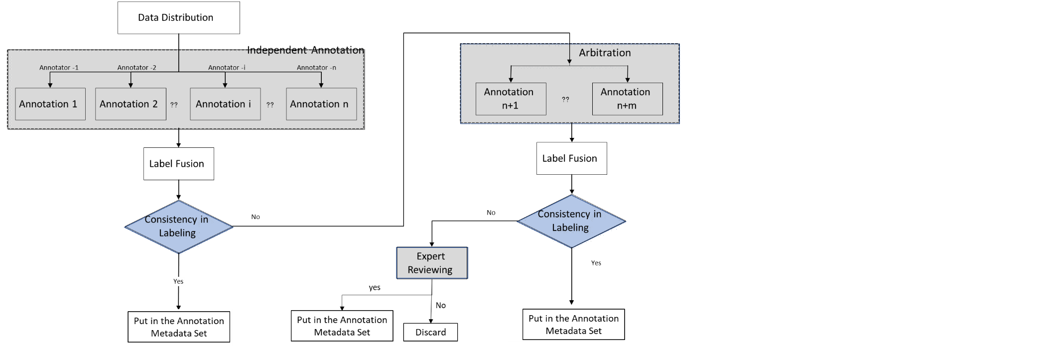

Figure 2: Data annotation procedure

## Independent annotation

The data annotation process starts with independent annotation, represented by the left grey box in Figure 2, each instance in the dataset need to be labeled by all or part of annotators independently. To avoid bias in data distribution, it is suggested that the process is carried out by grouping and crossing, and ensure the effective resolution of inconsistencies. Several annotators (represented as variable n in the figure) are invited to label the raw dataset. Certain qualifications are required on the annotators, for example doctors and trained annotators in specific case domain.

However, for cost considerations, some projects will also set up one annotator (Set n to 1) in this parallel independent annotation part, and then goes to arbitration if encounter difficulties.

## Arbitration

In the above independent annotation part, if there is an inconsistency that cannot be acceptable, or difficulties and uncertainties in single annotator setting, additional annotator with more experience should be introduced for the arbitration, represented by the upper right grey box in Figure 2. Stricter requirements on the arbitration annotator qualifications, for example, doctor with more than 3 years of experience in the case domain.

## Expert Reviewing

The expert reviewing is represented by the lower right grey box in Figure 2. This final review deals with some very tricky cases which cannot reach an agreement on the previous steps. Annotations confirmed by review experts will be marked as a final answer, and cases not approved could be considered to send back to arbitration process and arbitrated by another arbitration expert. Stricter requirements on the expert qualifications, for example, with 5 years of experience or more.

## Decision making box

Represented by the blue boxes in Figure 2, the judgment and decision making on labelling consistency cannot be avoided anywhere in the independent annotation, arbitration and expert reviewing. The simple mechanism should be: If the consistency is up to the threshold, the annotation shall be saved with confidence; if the consistency is not up to the threshold, the annotation will be discarded. Therefore, the criteria of consistency and corresponding threshold should be identified, and they are usually designed according to different scenarios, with more details in clause 8.

## Annotators training and assessment

With the continuous popularity of the AI4H model afterwards, we may expect a future with more mature and extensive mechanisms for annotators’ engagement. In addition to the experienced doctors mentioned above, candidates with no professional qualification but well-trained and quantitative assessed are also possible to be invited in the process of data annotation. This will reduce the cost and barriers of data annotation and provide more employment opportunities to the society.

The training and assessment of annotators may include the following ways:

* Gold standard materials: Data annotation made by review experts or arbitration groups can be seen as gold standards, a unified document with examples can be developed as reference to teach candidates to how to achieve the tasks.
* Training courses: In addition to paper documents, training courses is also an effective way to educate candidates and reach a common understanding on data annotation tasks, especially in large-scale dataset and numerous annotators.
* Quantitative assessment: To evaluate the performance of different annotators, examinations and certificates can be conducted. For example, set up a gold standard dataset, and let each candidate labels 20 instances randomly, and calculate the Kappa value compared with the gold standard. Only after the Kappa value reaches a certain threshold, candidate can be assigned to the annotation tasks.

## Variable description

Variables and configurable threshold in this procedure are listed here for your convenience.

* Number of independent annotators
* Number of arbitration experts
* Number of review experts
* Different options on consistency criteria (usually the same in 7.1-7.3)
* Configurable threshold on consistency criteria in the independent annotation
* Configurable threshold on consistency criteria in the arbitration
* Configurable threshold on consistency criteria in the expert reviewing

# Consistency judgement

For decision box in Figure 2, different criteria on consistency is selected according to different application scenarios. Main considerations are from two perspectives: one is input data type, elaborated in clause 8.1; the other is the output requirement for AI4H models, elaborated in clause 8.2. Under these two different classification dimensions, the options on consistency criteria will be different, elaborated in clause 8.3.

## Input data type classification

Biomedical information evolved with the medicine practice and engineering technologies at an unprecedented speed through the medical images obtained by human body imaging, high-resolution viewing of cells, and pathological specimens. Modalities covered in common measurement include X-ray, ultrasound, magnetic resonance (MR), X-ray computed tomography (CT), nuclear medicine, and high-resolution microscopy, etc. Table 1 refers to their specific information.

Table 1: Summary of common medical measurement modalities

|  | Dimensionality | Description | Anatomies |
| --- | --- | --- | --- |
| X-ray | 2D, 2D+t | Produces images by measuring the attenuation of X-ray through the body, via a detector array[1] | Most organs |
| CT | 2D, 3D, 3D+t | Creates 2D cross-sectional images of the body by using a rotating X-ray source and detector[2] | Most organs |
| Ultrasound | 2D, 2D+t, 3D, 3D+t | A transducer array emits acoustic pulses and measure he echoes from tissue scatters 1 | Most organs |
| MRI | 3D, 3D+t | Use a magnetic field to align protons; RF and gradient pulses are used to selectively excite protons in tissues and blood in order to measure their spatially encoded unclear magnetic resonance signals[3] | Most organs |
| Nuclear | 2D, 3D, 3D+t | Measures the emission of gamma rays through decay of radioisotopes introduced into the body via external detectors/Gamma cameras. 1 | All organs with radioactive tracer uptake |
| Microscopy | 2D, 3D, 3D+t | Typically uses an illumination source and lenses to magnify specimens before capturing an image1 | Primarily biopsies and surgical specimens |

Based on the above common medical measurement modalities, a classification of input data modalities for AI4H tasks are given in Table 2, with text and numbers added in specific cases of case history descriptions and blood pressure or respiratory rate, etc.

Table 2: Summary of input data modalities for AI4H tasks

| Data | Dimensionality | Description | Examples |
| --- | --- | --- | --- |
| Image | 2D | Two-dimensional medical imaging | * Fundus photos |
| 3D images | 3D | Three-dimensional spatial imaging | * Sets of CT slices |
| 4D | 4D（3D+t） | 3D space imaging changes over time | * Heart film imaging |
| Video | 2D +t | Camera or monitor recording | * Falls among the elderly |
| Audio/ signal | 1D +t | Sound or transmitted in signal form. | * Heart sound /ECG |
| Text | 1D, 2D | Structured/ unstructured description in words | * Case history, diagnosis extraction |
| Single number | 1D | Single measurement data | * Blood pressure or respiratory rate |

## Output requirement classification

When the final output requirements of models are different, even if it is the same input data format, data annotations will be different. Different output requirements include classification, detection, segmentation, localization, etc. Corresponding description and examples are given in Table 3.

Table 3: Output requirements

| Task | Description | Examples |
| --- | --- | --- |
| * Classification | * The problem of classifying instances into two or more classes. | * Identify abnormal tissue * Diabetic retinopathy grade |
| * Detection | * Identify an object, usually marked with rectangle for further processing. | * Detect the position of a coronary plaque for further processing |
| * Segmentation | * separate certain lesions, and draw the specific outline of the lesion | * Tumour segmentation |
| * Localization | * Calculate the central coordinate of the anatomical structure | * Localize the optic disc or macular fovea for further analysis of ocular fundus diseases |

## Criteria option matrix

With the above two dimensions, a matrix can be developed according to different data input format and model output requirements. This matrix can act as a reference for the selecting criteria options. Details are shown in Table 4, and other scenarios are to be added to cover all possible use cases in the FG and the AI4H industry.

Table 4 Criteria options in different scenarios

| Task  Data type | Classification | Detection | Segmentation | Localization |
| --- | --- | --- | --- | --- |
| * Image | Type 1: Classification | Type 2: Detection and segmentation for images | | Type 3: Localization |
| * 3D images | (a) slicing 3D data into different 2D  views before fusing to obtain a final detection or segmentation regions (b) exploit the 3D data by using  architectures that perform 3D convolutions and then train the network from scratch on 3D medical images[4],[5],[6],[7],[8] | | (a) slicing 3D data into 2D views to obtain the regions of the target object before calculate the final position coordinate  (b) exploit the 3D data by using architectures that perform 3D convolutions and then train the network from scratch on 3D medical images |
| * 4D | condensing the 4D data into three dimensions | | _ |
| * Video | condensing the 2D +t data into three dimensions | | _ |
| * Audio/ signal |  |  |  |
| * Text |  |  |  |
| * Single number |  |  |  |

Type 1: Classification

For this type, criteria like Cohen's kappa, weighted kappa, Fleiss' kappa and Krippendorff's alpha are recommended to use for classification tasks. The detailed calculation methods are shown in Table 5.

* Cohen's kappa: Cohen's kappa coefficient (κ) is a statistic that is used to measure inter-rater reliability for qualitative items. It is generally thought to be a more robust measure than simple percent agreement calculation, as κ considers the possibility of the agreement occurring by chance.
* Weighted kappa: Weighted kappa allows disagreements to be weighted differently, and is especially useful when codes are ordered. Three matrices are involved, the matrix of observed scores, the matrix of expected scores based on chance agreement, and the weight matrix.
* Fleiss' kappa: Fleiss' kappa is a statistical measure for assessing the reliability of agreement between a fixed numbers of raters when assigning categorical ratings to a number of items or classifying items. This contrasts with other kappas such as Cohen's kappa, which only work when assessing the agreement between not more than two raters or the interrater reliability for one appraiser versus themselves.
* Krippendorf’s alpha: Krippendorf’s alpha is an assessment of inter-rate reliability dealing with missing data, various sample sizes, categories and numbers of raters, and any type of measurement level. It can be seen as a generalization of Fleiss’ kappa (and others).

Type 2: Detection and segmentation for images

For this type, criteria like Jaccard index and Dice's coefficient are recommended to use for detection and segmentation for images. Detailed calculation methods are shown in Table 6.

* The Jaccard index: Jaccard index is also known as Intersection over Union (IoU) and the Jaccard similarity coefficient, which is a statistic used for gauging the similarity and diversity of sample sets.
* Dice's coefficient: Dice's coefficient is the quotient of similarity and ranges between 0 and 1.This coefficient is not very different in form from the [Jaccard index](https://en.wikipedia.org/wiki/Jaccard_index), and they have a connection as J=D/(2-D)，D=2J/(1+J)

**Type 3: Localization**

For this type, criteria like Euclidean Distance (ED) is recommended to use for localization. Euclidean distance is a commonly used definition of distance, which refers to the true distance between two points in the m-dimensional space.

In 2D space, $ED\left((x_{1},y_{1}),(x_{2},y_{2})\right)=\sqrt{{(x_{1}-x_{2})}^{2}+{(y_{1}-y_{2})}^{2}}$.

In 3D space, $ED\left((x_{1},y_{1},z_{1}),(x_{2},y_{2},z_{2})\right)=\sqrt{{(x_{1}-x_{2})}^{2}+{(y_{1}-y_{2})}^{2}+{(z_{1}-z_{2})}^{2}}$

Table 5: Criteria calculation for classification

| Criteria | Situation | Calculation method | Parameter explanation |
| --- | --- | --- | --- |
| Cohen's kappa | Assessing the agreement between not more than two raters or the interrater reliability for one appraiser versus themselves. | $$κ=\frac{p_{o}-p_{e}}{1-p_{e}}=1-\frac{1-p_{o}}{1-p_{e}}$$ If the raters are in complete agreement then kappa =1; If there is no agreement among the raters other than what would be expected by chance kappa =0. It is possible for the statistic to be negative which implies that there is no effective agreement between the two raters or the agreement is worse than random. | where $p_{o}$ is the relative observed agreement among raters (identical to accuracy), and $p_{e}$ is the hypothetical probability of chance agreement, using the observed data to calculate the probabilities of each observer randomly seeing each category $$p_{e}=\frac{1}{N^{2}}\sum_{k}{n_{k1}n_{k2}}$$ |
| Weighted kappa | Allows disagreements to be weighted differently, and is especially useful when codes are ordered. | $$κ=1-\frac{\sum_{i=1}^{k}{\sum_{j=1}^{k}{w_{ij}x_{ij}}}}{\sum_{i=1}^{k}{\sum_{j=1}^{k}{w_{ij}m_{ij}}}}$$ | where k is the number of codes and $w_{ij}$, $x_{ij}$, and $m_{ij}$ are elements in the weight, observed, and expected matrices, respectively. The weights in the diagonal cells are all 1 (i.e., $w_{ij}=1$ , for all i), and the weights in the off-diagonal cells range from 0 to <1 (i.e., ${0≤w}_{ij}<1$, for all $i≠j$ ). |
| Fleiss' kappa | Assessing the reliability of agreement between a fixed number of raters when assigning categorical ratings to a number of items or classifying items. | $$κ=\frac{\overline{P}-{\overline{P}}_{e}}{1-{\overline{P}}_{e}}$$ If the raters are in complete agreement, then Fleiss' kappa =1. If there is no agreement among the raters (other than what would be expected by chance) then Fleiss' kappa <0. | The factor $1-{\overline{P}}_{e}$ gives the degree of agreement that is attainable above chance, and $\overline{P}-{\overline{P}}_{e}$ gives the degree of agreement actually achieved above chance. |
| Krippendorf’s alpha | Assessment of inter-rate reliability dealing with missing data, various sample sizes, categories and numbers of raters, and any type of measurement level. Generalization of Fleiss’ kappa (and others) | $$α=1-\frac{D_{o}}{D_{e}} \\ D_{0}=\frac{1}{n}\sum_{c∈R}{\sum_{k∈R}{δ\left(c,k\right)}\sum_{u∈U}{m_{u} }\frac{n_{cku}}{P\left(m_{u},2\right)}} \\ D_{e}=\frac{1}{P\left(n,2\right)}\sum_{c∈R}{\sum_{k∈R}{δ\left(c,k\right)P_{ck} }} \\ P_{ck}=\{_{n_{c}(n_{c}-1), if c=k}^{n_{c}n_{k}, if c≠k}$$ | $D_{o}$: Disagreement observed $D_{e}$ : Disagreement expected by chance $δ:$ Metric function $n$ : Number of pairable elements $m_{u}:$ Number of items per unit/sample $n_{c,k,u}:$ Number of pairs in unit $u$ $P:$ Permutation function $P_{c,k}:$ Number of permutations in pair $\left(c,k\right)$ |

Table 6: Criteria calculation for Image detection and segmentation

| Criteria | Calculation method | Graphical representation |
| --- | --- | --- |
| Jaccard index | Numerator represents the area of overlap between two annotations; Denominator represents the area encompassed by two annotations. Dividing the area of overlap by the area of union yields our final score. | J=D/(2-D)，D=2J/(1+J) |
| Dice's coefficient | Numerator represents the double area of overlap between two annotations; Denominator represents the sum of two annotation area. Dividing the area of overlap by the sum area yields our final score. |

## Post-processing of the annotations

After the criteria calculation and consistency judgment, different post-processing methods on annotations that are acceptable as consistent will also cause different result. For example, calculate the average value of the marked results (x, y, w, h) or a maximum area with a consistency above threshold in an image is to be discussed later.

<TBD>

# Recommended metadata

Metadata is considered to be the output of the data annotation process, all necessary information for the annotation process should be included in the metadata. A metadata format is to be given in Table 7, more details will be discussed and added in the future.

# Output file

The output files include the annotation documents and the origin images. The formats of the annotation documents include but are not limited to xml，json，txt, etc. The annotation documents should include at least three items: image path, object name and object coordinates. Supporting document may be given if it’s necessary to interpret the annotation information. Annex C gives an example of the annotation document for endoscopic images.

# File saving

Both the images and the documents should be named according to the same rules for easy querying. For example, they can be named with the number of the classification of the object, and the document’s name is the same with the corresponding origin images.

Table 7 Recommended metadata

| Type | Content | | | | |
| --- | --- | --- | --- | --- | --- |
| **General information** | 1. Institution and responsible or corresponding PI; 2. Construction dates of annotation dataset; 3. Regulatory aspects (e.g. Data privacy) 4. Description of use case | | | | |
| **Annotation procedure information** | 1. Details on data annotation process (annotator number, experts group setting, tools, etc.) 2. Achieved consistency and criteria employed 3. Post- processing method employed on annotations 4. Ontology employed 5. Label list or description | | | | |
| **Data acquisition information** | 1. collection device model 2. collection frame rate/ Sampling rate | | | | |
| 1. Instance Information | 1. Instance identification code 2. patient information (age, gender) 3. diagnosis information (symptoms) | | | | |
| Annotation information | Task  Data type | Classification | Detection | Segmentation | Localization |
| * Image | class labels | * signal instance | * label per instance | * coordinate label of signal instance |
| * 3D images |
| * 4D |
| * Video |
| * Audio/ signal |
| * Text |  | Label per word, intent, or sentence | _ |
| * Single number |  |  |  |  |

Annex A  
Questionnaire on data annotation

**By Google Form:** [**https://forms.gle/3fYrm3SZSrNQu3eeA**](https://forms.gle/3fYrm3SZSrNQu3eeA)

The aim of this questionnaire is to gather insights into the current practices, the specific requirements of data annotation in the FG-AI4H topic groups and AI4H products.

Your input and suggestion will be of great value for us in forming a data annotation specification together, as one of the deliverables with the FG-AI4H. We would appreciate it if you could take the time to complete the questionnaire, or if you have further ideas, please feel free to contact us. ([xushan@caict.ac.cn](mailto:xushan@caict.ac.cn); [sebastian.bosse@hhi.fraunhofer.de](mailto:sebastian.bosse@hhi.fraunhofer.de))

1．To which topic group are you contributing?

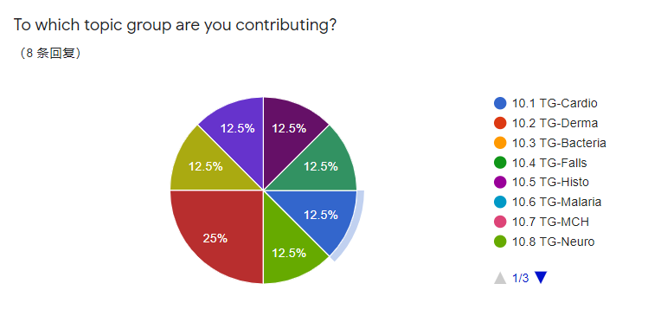

2. Which annotation task category is relevant for your project within the topic group?

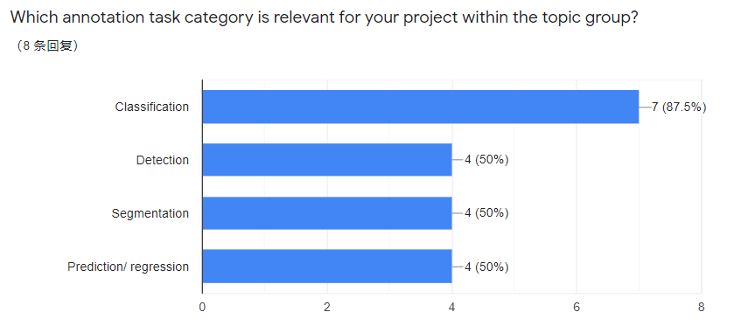

3. Is there any gold standard (or state-of-the-art task intervention method) relevant for your project within the topic group?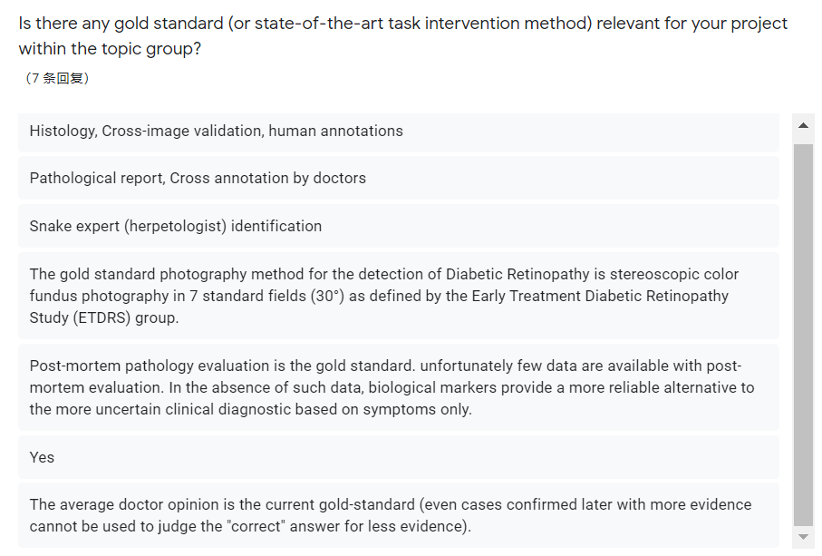

What is your data source for the training and testing dataset? (appreciated if you can give more info)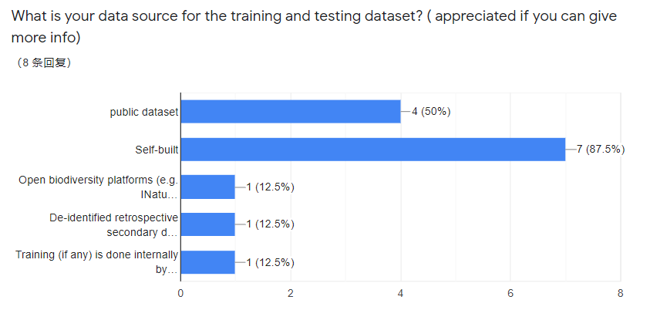

5. Which signal or data modalities are relevant for your project with the topic group?

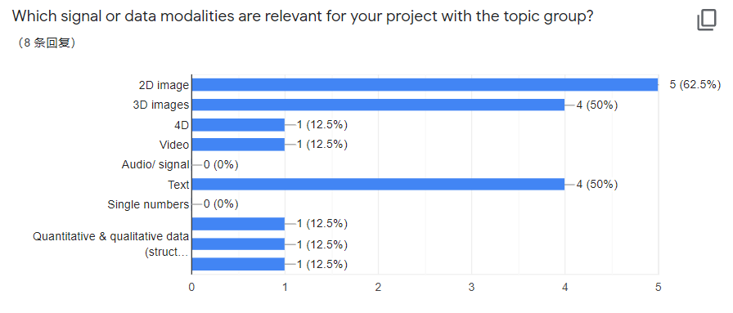

5. What is the nature of the annotation?

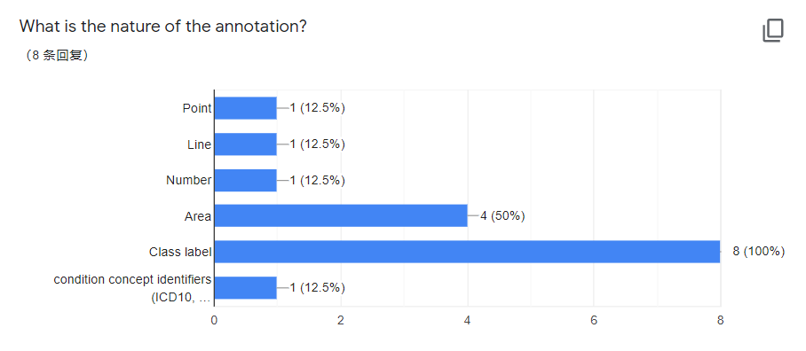

6. What kind of annotation procedure are you using? any annotation tool that you use?

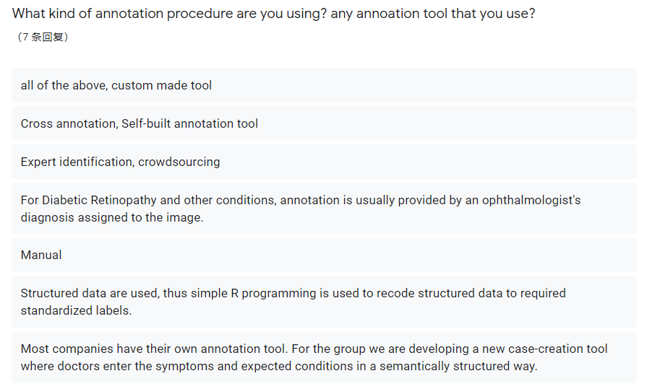

7. What annotation quality criterions are currently used in your topic group?

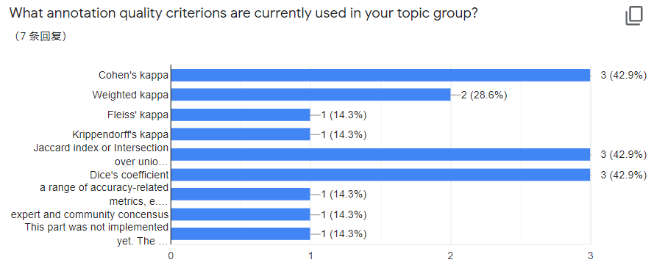

8. What kind of metadata do you consider relevant for data annotation?

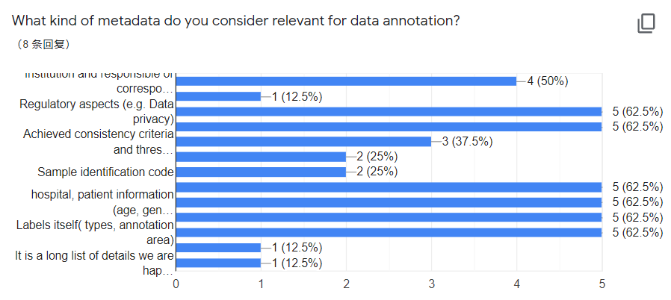

9. What type of ontology are you using? (If any)

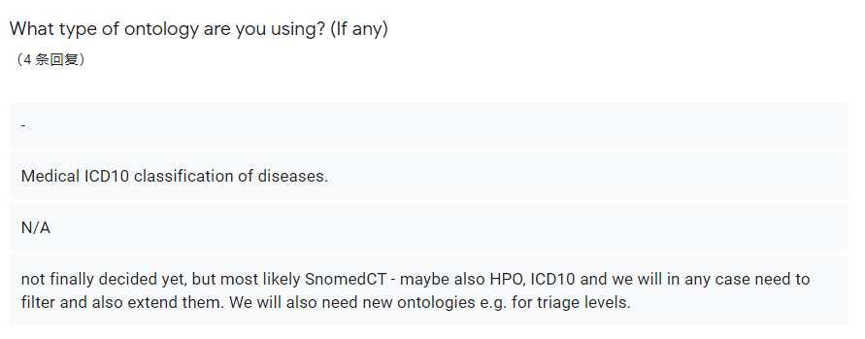

Which additional information do you need to encode the actual meaning of the annotation?

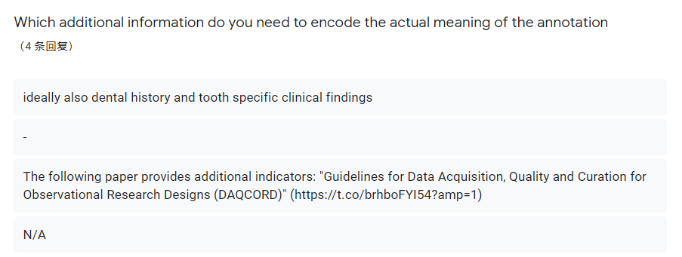

Annex B  
Data annotation tools

**Provide some data annotation tools for reference**

Sangkuhl K, Whirl-Carrillo M, Whaley R M, et al. Pharmacogenomics Clinical Annotation Tool (Pharm CAT)[J]. Clinical Pharmacology & Therapeutics, 2020, 107(1): 203-210.

Hou R, Denisenko E, Forrest A R R. scMatch: a single-cell gene expression profile annotation tool using reference datasets[J]. Bioinformatics, 2019, 35(22): 4688-4695.

Philbrick K A, Weston A D, Akkus Z, et al. RIL-Contour: a Medical Imaging Dataset Annotation Tool for and with Deep Learning[J]. Journal of digital imaging, 2019, 32(4): 571-581.

Kraljevic Z, Bean D, Mascio A, et al. MedCAT--Medical Concept Annotation Tool[J]. arXiv preprint arXiv:1912.10166, 2019.

Ramos A H, Lichtenstein L, Gupta M, et al. Oncotator: cancer variant annotation tool[J]. Human mutation, 2015, 36(4): E2423-E2429.

Iakovidis D K, Goudas T, Smailis C, et al. Ratsnake: a versatile image annotation tool with application to computer-aided diagnosis[J]. The Scientific World Journal, 2014, 2014.

Seifert S, Kelm M, Moeller M, et al. Semantic annotation of medical images[C]//Medical Imaging 2010: Advanced PACS-based Imaging Informatics and Therapeutic Applications. International Society for Optics and Photonics, 2010, 7628: 762808.

Russell B C, Torralba A, Murphy K P, et al. LabelMe: a database and web-based tool for image annotation[J]. International journal of computer vision, 2008, 77(1-3): 157-173.

Diete A, Sztyler T, Stuckenschmidt H. A smart data annotation tool for multi-sensor activity recognition[C]//2017 IEEE International Conference on Pervasive Computing and Communications Workshops (PerCom Workshops). IEEE, 2017: 111-116.

Oronoz M, Casillas A, Gojenola K, et al. Automatic annotation of medical records in Spanish with disease, drug and substance names[C]//Iberoamerican Congress on Pattern Recognition. Springer, Berlin, Heidelberg, 2013: 536-543.

Ferreira P M, Mendonça T, Rozeira J, et al. An annotation tool for dermoscopic image segmentation[C]//Proceedings of the 1st International Workshop on Visual Interfaces for Ground Truth Collection in Computer Vision Applications. 2012: 1-6.

Kim E, Huang X, Tan G. Markup SVG—An Online Content-Aware Image Abstraction and Annotation Tool[J]. IEEE Transactions on Multimedia, 2011, 13(5): 993-1006.

Rubin D L, Mongkolwat P, Kleper V, et al. Annotation and image markup: accessing and interoperating with the semantic content in medical imaging[J]. IEEE Intelligent Systems, 2009, 24(1): 57-65.

Rubin D L, Mongkolwat P, Kleper V, et al. Medical Imaging on the Semantic Web: Annotation and Image Markup[C]//AAAI Spring Symposium: semantic scientific knowledge integration. 2008: 93-98.

Karlgren K, Dahlström A, Ponzer S. Design of an annotation tool to support simulation training of medical teams[C]//European Conference on Technology Enhanced Learning. Springer, Berlin, Heidelberg, 2008: 179-184.

Karlgren K, Dahlström A, Lonka K, et al. A new educational annotation tool for supporting medical teams to improve their teamwork and communication[J]. ICEM/ILE, 2007: 20-22.

Yao B, Yang X, Zhu S C. Introduction to a large-scale general purpose ground truth database: methodology, annotation tool and benchmarks[C]//International Workshop on Energy Minimization Methods in Computer Vision and Pattern Recognition. Springer, Berlin, Heidelberg, 2007: 169-183.

Kumar A, Jawahar C V. Content-level annotation of large collection of printed document images[C]//Ninth International Conference on Document Analysis and Recognition (ICDAR 2007). IEEE, 2007, 2: 799-803.

Hollink L, Schreiber G, Wielemaker J, et al. Semantic annotation of image collections[C]//Knowledge capture. 2003, 2.

Kipp M. Anvil-a generic annotation tool for multimodal dialogue[C]//Seventh European Conference on Speech Communication and Technology. 2001.

Annex C  
Examples of annotation document information

There is an example of metadata of Endoscopic image. The annotation results include:

|  |  |
| --- | --- |
| Attributes | Examples |
| xml version | <TBD> |
| folder number | <TBD> |
| filename | <TBD> |
| file path | <TBD> |
| source | <TBD> |
| size: width/ height/depty | <TBD> |
| segmented object: name,  [coordinates](javascript:;) | <TBD> |

____________________________

1. J. T. Bushberg et al., The Essential Physics of Medical Imaging. Philadelphia, PA, USA: Lippincott Williams Wilkins, 2011.
2. J. Hsieh, Computed Tomography: Principles, Design, Artifacts, and Recent Advances.Bellingham,WA, USA: Soc. Photo-Opt. Instrum. Eng.,2009.
3. Panayides A S, Amini A, Filipovic N D, et al. AI in Medical Imaging Informatics: Current Challenges and Future Directions[J]. IEEE Journal of Biomedical and Health Informatics, 2020, 24(7): 1837-1857.
4. Q. Dou et al., “Automatic detection of cerebral microbleeds from MR images via 3D convolutional neural networks,” IEEE Trans. Med. Imag., vol. 35, no. 5, pp. 1182–1195, May 2016.
5. J. Ding, A. Li, Z. Hu, and L. Wang, “Accurate pulmonary nodule detection in computed tomography images using deep convolutional neural networks,” in Proc. Int. Conf. Med. Image Comput. Comput.-Assisted Intervention, Sep. 2017, pp. 559–567.
6. D. Nie, H. Zhang, E. Adeli, L. Liu, and D. Shen, “3D deep learning for multi-modal imaging-guided survival time prediction of brain tumor patients,” in Proc. MICCAI, 2016, pp. 212–220.
7. S. Korolev, A. Safiullin, M. Belyaev, and Y. Dodonova,. ‘‘Residual and plain convolutional neural networks for 3D brain MRI classification,” Jan. 2017. [Online]. Available: https://arxiv.org/abs/1701.06643
8. K. Simonyan and A. Zisserman, “Very deep convolutional networks for large-scale image recognition,” CoRR, vol. abs/1409.1556, 2014.