 | INTERNATIONAL TELECOMMUNICATION UNION  TELECOMMUNICATION  STANDARDIZATION SECTOR  STUDY PERIOD 2017-2020 |  | SG20–R13
 |  |  | STUDY GROUP 20
 |  |  | Original: English
Question(s): |  | 7/20 | September 2020
REPORT
Source: |  | ITU-T Study Group 20
Title: |  | Determined new Recommendation ITU-T Y.4908 (ex. Y.IoT-EH-PFE) “Performance evaluation frameworks of e-health systems in the IoT”
Purpose: |  | Admin
Contact: |  | TSB |  | Tel: +41 22 730 6301  Fax: +41 22 730 5853  Email: tsbsg20@itu.int

Keywords: | Classification of e-health services in the IoT; Performance evaluation factors; Performance evaluation framework
Abstract: | This report contains the determined draft Recommendation ITU-T Y.4908 (ex. Y.IoT-EH-PFE) “Performance evaluation frameworks of e-health systems in the IoT”.
ITU-T Study Group 20, at its plenary on 16 July 2020, DETERMINED new Recommendation ITU-T Y.4908 (ex. Y.IoT-EH-PFE) “Performance evaluation frameworks of e-health systems in the IoT”.
The DETERMINED text of this draft Recommendation is reproduced hereafter. The versions in other languages will be posted on the SG20 website as soon as they are available.

Draft Recommendation ITU-T Y.4908 (ex. Y.IoT-EH-PFE)
Performance evaluation frameworks of e-health systems in the IoT

Summary
Currently e-health systems are being implemented by governments and stakeholders to increase the effectiveness, efficiency and the quality of health care services. The Internet of things (IoT) as a relatively new technology is transforming e-health systems to further enhance health care services. However, this transformation concomitantly creates a need for effective performance evaluation frameworks of e-health systems in the IoT.
This Recommendation addresses this need for effective performance evaluation frameworks of e-health systems in the IoT and includes:
- A classification of e-health services in the IoT
- A non-exhaustive set of non-functional performance evaluation factors applicable to the e-health systems in the IoT
- Performance evaluation frameworks for e-health systems in the IoT
Keywords
Classification of e-health services in the IoT; Performance evaluation factors; Performance evaluation framework.
Table of Contents
Page
1 Scope 4
2 References 4
3 Definitions 4
3.1 Terms defined elsewhere 4
3.2 Terms defined in this Recommendation 5
4 Abbreviations and acronyms 5
5 Conventions 5
6 E-health services and systems in the IoT 5
6.1 Introduction to e-health services and systems in the IoT 5
6.2 Classification of e-health services in the IoT 6
6.3 The performance evaluation framework and its benefits for e-health services in the IoT 8
6.4 Performance evaluation framework stakeholders 8
7 Performance evaluation factors for e-health systems in the IoT 9
7.1 Interoperability 9
7.2 Usability 9
7.3 Security 10
8 Performance evaluation frameworks 10
8.1 Interoperability evaluation 10
8.1.1 Network interoperability evaluation 10
8.1.2 Data interoperability evaluation 11
8.1.3 Service interoperability evaluation 11
8.2 Usability evaluation 11
8.2.1 Usability evaluation on service 11
8.2.2 Usability evaluation on data 12
8.2.3 Usability evaluation on system 12
8.3 Security evaluation 12
8.3.1 Security evaluation 12
Bibliography 14

Draft Recommendation ITU-T Y.4908 (ex. Y.IoT-EH-PFE)
Performance evaluation frameworks of e-health systems in the IoT

1 Scope
The scope of this Recommendation includes:
- A classification of e-health services in the Internet of things (IoT)
- A non-exhaustive set of non-functional performance evaluation factors (interoperability, usability, security) applicable to e-health systems in the IoT
- A performance evaluation framework for e-health systems in the IoT
The scope of this Recommendation excludes the detailed technical requirements and capabilities of the e-health systems in general health care services.
This Recommendation does not include any regulatory requirements.
This Recommendation does not prescribe a specific evaluation methodology. It intentionally provides sufficient flexibility for the practitioner to combine one or more performance evaluation factors specified in this Recommendation.
The performance evaluation frameworks for generic e-health systems are also beyond the scope of this Recommendation.

2 References
The following ITU-T recommendations and other references contain provisions, which, through reference in this text, constitute provisions of this recommendation. At the time of publication, the editions indicated were valid. All recommendations and other references are subject to revision; all users of this recommendation are therefore encouraged to investigate the possibility of applying the most recent edition of the recommendations and other references listed below.
[ITU-T Y.4000] Recommendation ITU-T Y.4000/Y.2060 (2012), Overview of the Internet of things.
[ITU-T Y.4110] Recommendation ITU-T Y.4110/Y.2065 (2014), Service and capability requirements for e-health monitoring services.
[ITU-T Y.4113] Recommendation ITU-T Y.4113 (2016), Requirements of the network for the Internet of things.
[ITU-T Y.4408] Recommendation ITU-T Y.4408/Y.2075 (2015), Capability framework for e-health monitoring services.

3 Definitions

3.1 Terms defined elsewhere
This Recommendation uses the following terms defined elsewhere:
3.1.1 device [ITU-T Y.4000]: With regard to the Internet of things, this is a piece of equipment with the mandatory capabilities of communication and the optional capabilities of sensing, actuation, data capture, data storage and data processing.
3.1.2 Internet of things (IoT) [ITU-T Y.4000]: A global infrastructure for the information society, enabling advanced services by interconnecting (physical and virtual) things based on existing and evolving interoperable information and communication technologies.
NOTE 1 – Through the exploitation of identification, data capture, processing and communication capabilities, the IoT makes full use of things to offer services to all kinds of applications, whilst ensuring that security requirements are fulfilled.
NOTE 2 – From a broader perspective, the IoT can be perceived as a vision with technological and societal implications.

3.2 Terms defined in this Recommendation
This Recommendation defines the following terms:
3.2.1 e-health service provider: An organization, which provides organization-oriented e-health services to e-health service organization consumers and/or individual-oriented e-health services to e-health service individual consumers.
3.2.2 e-health service organization consumer: An organization, which consumes organization-oriented e-health services provided by an e-health service provider.
3.2.3 e-health service individual consumer: An individual who consumes individual-oriented e-health services provided by an e-health service provider.
3.2.4 e-health solution provider: An organization, which realizes required software and hardware for e-health service providers, e-health service organization consumers and/or e-health service individual consumers, in order to implement e-health services.

4 Abbreviations and acronyms

This Recommendation uses the following abbreviations and acronyms:
API | Application Programming Interface
ICT | Information and Communication Technology
IoT | Internet of Things
JSON | JavaScript Object Notation
QoS | Quality of Service
SSAS | Service Support and Application Support
XML | Extensible Markup Language

5 Conventions
None.

6 E-health services and systems in the IoT

6.1 Introduction to e-health services and systems in the IoT
E-health services are an expansion of traditional health services (e.g. e-health monitoring services [ITU-T Y.4110], online health management and remote consultation).
E-health systems in this Recommendation refer to a combination of applications, devices and servers, which are enabled with associated information and communication technologies (ICTs) (such as networks, data and application programming interfaces (APIs) to deliver e-health services).
There are different e-health systems. Some e-health systems support health administration, such as the systems used by health administration agencies; some e-health systems support health care, such as the systems used by a hospital or health care agencies. Personal health devices, such as smartphones with health sensor accessories, are considered as special e-health systems in this Recommendation, through which personal health management is supported.
The Internet of things (IoT) [ITU-T Y.4000] provides a global infrastructure for the information society which intends to improve the interaction of e-health systems with each other.
Compared with e-health systems without IoT enabled capabilities, e-health systems in the IoT (i.e. e-health systems with IoT enabled capabilities) can efficiently perform interconnection with each other. More specifically, the IoT infrastructure incorporates common interoperability mechanisms which result in less time consumption and less code modification.
Figure 1, on the left-hand side (Figure 1(a)), shows a typical example of the general e-health service (the e-health service without IoT), where the associated e-health systems have peer-to-peer connections among different e-health stakeholders (typically a 'Health institution', a 'Hospital' and 'Individuals' respectively). In this case, the interfaces (e.g. APIs), data formats, interaction related entities and other related aspects are required to be defined and developed on a case-by-case basis.
Figure 1, on the right-hand side (Figure 1(b)), shows an e-health service in the IoT scenario, whereby different e-health systems (from different stakeholders) are connected with each other via a centralized e-health IoT platform (which can be regarded as one of the IoT infrastructures), namely the service support and application support (SSAS) platform. In this case, the SSAS platform can handle the heterogeneity issues (e.g. the interfaces, data formats, interaction related functionalities) among different associated e-health systems.
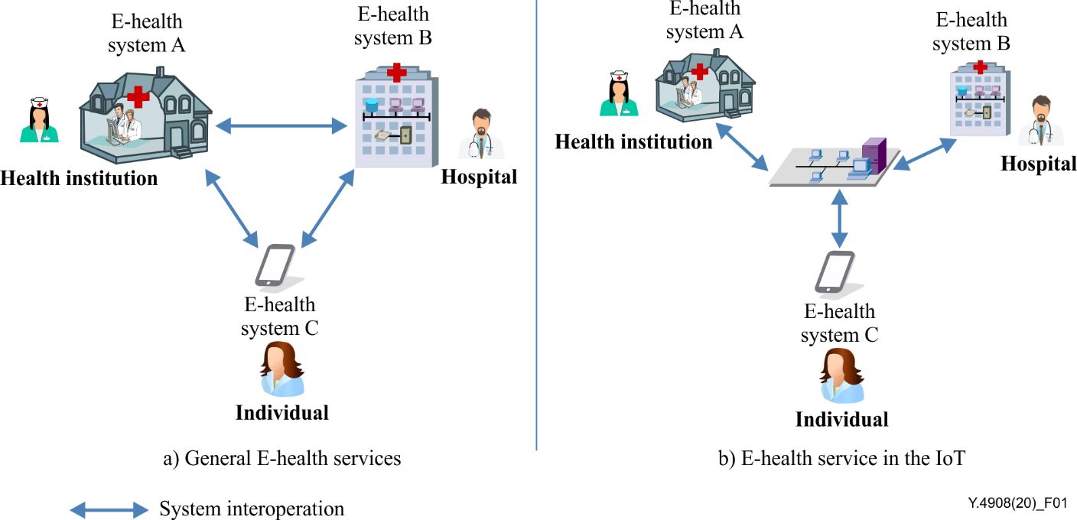
Figure 1 – Examples of general e-health services and e-health services in the IoT

6.2 Classification of e-health services in the IoT
Considering different types of users and technical facilities, three potential types of e-health services in the IoT can be identified as indicated below:
- Person-centric e-health services,
- Organization-centric e-health services; and
- Population-centric e-health services.
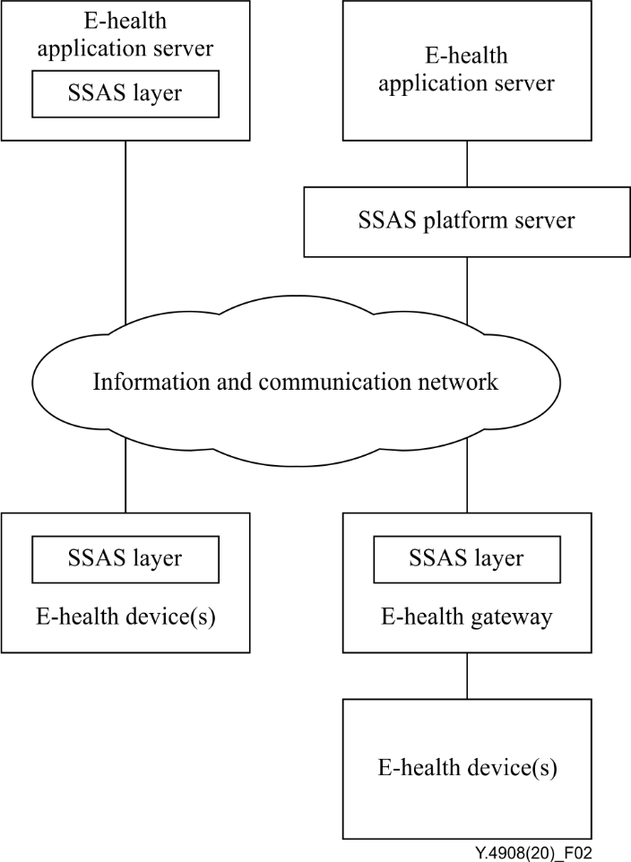
Figure 2 – System architecture of e-health services in the IoT [ITU-T Y.4113] and associated components
Person-centric e-health services: focus on individuals, who are the primary users of these kinds of e-health services. Individuals by acting as the users of person-centric e-health services, mainly focus on e-health device(s) in terms of functionality, compatibility, energy-saving, security, privacy, cost, as well as information and communication network status (e.g. coverage, QoS assurance, cost). Key components of the person centric e-health services are the e-health device(s), the e-health gateway and the information and communication network.
Organization-centric e-health services: focus on organizations, which are the primary users of these kinds of e-health services. Organizations, by acting as the users of organization-centric e-health services, mainly focus on the e-health application server in terms of functionality, scalability, security, privacy and potential others. Key component of the organization centric e-health services is the e-health application server.
Population-centric e-health services: focus on the population of a city or a country, which is the primary user of these kinds of e-health services. The city or country by acting as the user of population-centric e-health services, mainly focuses on the e-health application server and SSAS platform server, in terms of interoperability, scalability, security, privacy, and potential others. Key components of population centric e-health services are the e-health application servers and the SSAS platform servers as shown in Figure 2.

Figure 2 shows system architecture of e-health services in the IoT [ITU-T Y.4113] and associated components.

6.3 The performance evaluation framework and its benefits for e-health services in the IoT
The use of IoT infrastructure, i.e. a centralized SSAS platform, aims to make the e-health systems more effective in supporting e-health services by eliminating the need for peer-to-peer interactions required in general e-health services.
However, the centralized SSAS platform needs to address interoperability, usability, and security requirements of connected systems.
Thus, a performance evaluation framework is required by considering these factors in order to help the stakeholders of e-health services in the IoT. This performance evaluation framework will identify the requirements of the associated e-health systems and will in turn help in providing solutions.
E-health services in the IoT
E-health system A
Performance evaluation
framework
Evaluation
factors
Figure 3 – Performance evaluation framework
Utilizing a performance evaluation framework as shown in Figure 3 can benefit stakeholders of e-health services in the IoT:
- to achieve a flexible mechanism to perform interoperability evaluation when multiple e-health systems are connected together;
- to simplify the process of performing usability evaluation for the vertical integration of e-health systems (e.g. health institutions' systems, hospitals' systems) via a centralized SSAS platform;
- to efficiently perform security evaluations of disparate e-health systems (e.g. role-based access controls).

6.4 Performance evaluation framework stakeholders
This clause introduces the main e-health services stakeholders as shown in Figure 4.
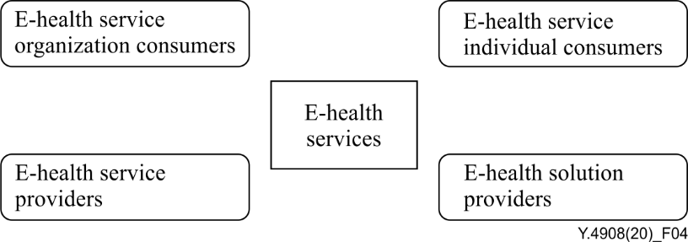
Figure 4 – E-health services stakeholders

The performance evaluation framework includes four main stakeholders, namely:
- E-health service providers,
- E-health service organization consumers,
- E-health service individual consumers, and
- E-health solution providers.

7 Performance evaluation factors for e-health systems in the IoT
This clause introduces three non-functional factors for performance evaluation of e-health systems in the IoT; namely interoperability, usability and security.

7.1 Interoperability
Basically, interoperability can be divided into network interoperability (i.e., through the IoT networks [ITU-T Y.4113]), data interoperability and service interoperability (i.e., the e-health services). Network interoperability refers to the ability of different e-health systems and devices to be interconnected at the network level via an e-health SSAS platform. Data interoperability refers to the ability to exchange data among different e-health systems and devices in the IoT. Service interoperability refers to the ability to seamlessly integrate e-health services among different e-health systems and devices in the IoT.
E-health service individual consumers and e-health service organization consumers benefit from interoperability of e-health systems because appropriate implementation of interoperability is expected to reduce their costs and to enhance their service experiences (e.g. same e-health devices can support different e-health services).
E-health service providers and e-health solution providers need to consider utilizing interoperability industry standards where applicable, as opposed to proprietary ones.

7.2 Usability
There are a large number of existing e-health systems. One of the challenges faced by most of the existing e-health systems is how to effectively meet the incessantly changing requirements of stakeholders [b-Improving Care]. More specifically, for e-health services in the IoT (SSAS is the core infrastructure), usability refers to effectively connecting the e-health systems to the SSAS platform, while meeting the stakeholders' evolving expectations effectively.
Concerning e-health service individual consumers, usability refers to conveniently sending their physiological data and healthcare-related personal information into e-health systems, and sharing the same within the e-health system in the case where the e-health service individual consumer authorizes this action.
Concerning e-health service organization consumers, usability refers to sharing e-health data with other e-health service organization consumers, to reuse e-health data, to support group-based care, and to promote care coordination.
Concerning e-health service providers, usability refers to e-health systems supporting coordinated specialty care. Such coordination among specialists can expedite e-health service providers' inputs into e-health systems design and post-implementation feedback.
Concerning the e-health solution providers, usability refers to components of the e-health systems supporting modularity and configurability to ensure the e-health solutions can meet a broad variety of deployment scenarios.

7.3 Security
Security is a major challenge faced by e-health systems including in the IoT scenario. Since the e-health systems and devices in the IoT scenario are connected via a SSAS platform and do not exchange and share data directly, e-health systems and devices are expected to implement appropriate security measures to ensure safe operation. These security measures aim to ensure confidentiality, integrity and availability of e-health data and services.

8 Performance evaluation frameworks
This clause establishes performance evaluation frameworks for e-health systems in the IoT by considering the previously defined three factors, namely interoperability, usability, and security. These three are a set of non-exhaustive and non-functional performance evaluation factors. Furthermore, one or more of these three factors can be combined to establish a specific performance evaluation framework and can be applied in a specific e-health context in the IoT.

8.1 Interoperability evaluation
In general e-health services, interactions between two e-health systems can be realized directly if they follow common technical interoperability standards (e.g., use the same interfaces, same data formats with consistent data semantics, same functionalities), common network settings, common service flows, and common administration and security rules (e.g. e-health system A can read patient's record from e-health system B).
In e-health services in the IoT, in order to resolve heterogeneity issues, each relevant e-health system can realize interoperability through a service support and application support (SSAS) layer identified by [ITU-T Y.4000], whereby data formats and service flows are compatible and so can realize service-level interoperability. In addition, the network layer also enables network interoperability, while e-health devices are connected to the e-health systems as per [ITU-T Y.4110] and [ITU-T Y.4408] in the IoT scenario, as shown in Figure 5.
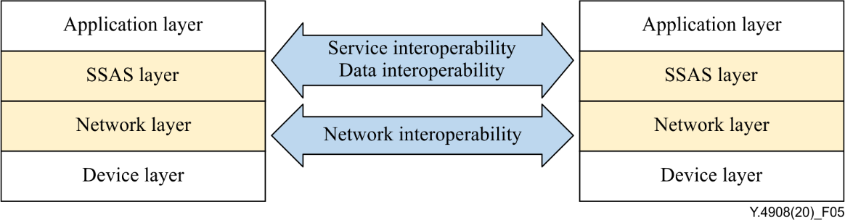
Figure 5 – Interoperability of e-health systems in the IoT through SSAS and network layers
Network, data and service interoperability as presented in this clause, are three key aspects for interoperability evaluation of e-health systems in the IoT.

8.1.1 Network interoperability evaluation
In order to provide network interoperability among e-health devices and e-health systems, the e-health devices are supposed to meet the general requirements indicated below:
- E-health devices must support all required network protocols.
- E-health devices, as an alternative, may be connected to the e-health gateway(s), whereby the implementation of network protocol conversion and interoperation are performed.
E-health devices are required to satisfy data and information caching when the network availability is limited (e.g. the network connection is temporarily interrupted) and when the network becomes available, the cached content can be synchronized with e-health systems again. As a result, the e-health devices are also supposed to meet the general requirements indicated below:
- E-health devices must support a data and information caching mechanism, to deal with a potential temporary network failure.
- E-health devices may optionally support a mechanism to deliver basic health care services while the network is temporarily unavailable.

8.1.2 Data interoperability evaluation
In the IoT scenario, interoperability is an important consideration as data sets generated by IoT devices are exchanged and shared among different types of e-health systems. In the e-health scenarios in the IoT, each of the e-health service providers/stakeholders holds a portion of personal information and the relevant data set. Therefore, e-health service providers may wish to aggregate different data sets belonging to an individual and stored in different e-health systems.
As a result, in order to provide complete e-health data analysis to e-health users, the e-health systems are supposed to meet the general requirements indicated below:
- E-health systems are expected to support all required application protocols.
- E-health systems are supposed to make interactions with other e-health systems (e.g., having disparate data sources and schemas).
Data format is another aspect that should be taken into account in data interoperability. The difficulty of data format interoperability is the protocol format mismatch. Ideally, the data format of the source e-health system can be completely accepted by the target e-health system. However, when the data format of the two sides do not match, the e-health systems are supposed to meet the general requirements indicated below:
- E-health systems are expected to support a mapping mechanism of syntax (e.g. JSON syntax, XML syntax) and semantics.
- If the data syntax of the interaction between e-health systems is inconsistent, data format needs to be transformed by tools, to ensure the consistency of data and information interaction.

8.1.3 Service interoperability evaluation
The service interoperability refers to ensuring that applications supported by two e-health systems can work collaboratively to provide health care services to end users. There are usually two ways to implement service interoperability for the e-health systems in the IoT, namely through APIs matching and through functionality porting (e.g. porting application programs).
For the APIs matching, two different approaches can be used to realize service interoperability:
- One is to adopt common standard interfaces for the relevant e-health systems; whereby both systems can interact directly;
- The other is to map interfaces into a common layer API (e.g. open API standards provided by trusted third parties) to resolve the heterogeneity.
Moreover, the common layer API should ensure downward compatibility to avoid malfunctions during upgrades and updates.
Alternatively, functionality porting is the process to move an application or its components from a source e-health system to a target e-health system and to execute it in the target e-health system.

8.2 Usability evaluation

8.2.1 Usability evaluation on service
In general, the usability of e-health services can be evaluated by establishing a set of design principles. Typically, since the e-health systems in the IoT may cover different vertical scenarios, e-health services can be deployed by following a phased approach. In this case, e-health services can be decomposed into a collection of several sub-services and each sub-service can be implemented by combining various basic functions of an e-health system.

8.2.2 Usability evaluation on data
Data usability entails e-health data to be expressed naturally in a way to anticipate end users' expectations and prior knowledge.
It is beneficial to ensure that 'terminology', 'icons', 'function consistency' and 'logical representation' enhance users' understanding of the interconnected e-health systems in the IoT scenario.

8.2.3 Usability evaluation on system
The purpose of the e-health system usability evaluation is to help e-health solution providers and e-health service providers to identify the problems regarding system functionality and reliability while accessing services across different e-health systems.
Usability will be enhanced by smooth and uniform functioning of e-health services and data across different e-health systems while providing a homogeneous user experience, especially when e-health users of a vertical system need to use one or more functions from another vertical system.

8.3 Security evaluation

8.3.1 Security evaluation
Security in this Recommendation refers to safeguarding confidentiality, integrity and availability of e-health services and data in the IoT.
The e-health data exchange in the IoT scenario is supposed to follow a data minimization principle. That is, only necessary e-health data shall be accessed to reduce the risk of data leakage during the exchange process.

- Confidentiality
In this Recommendation, confidentiality refers to safeguarding e-health data in the IoT from unauthorized access. This can be achieved through data encryption, authentication and access control, and secure communication (among others) for each vertical system and service support and application support (SSAS) platform for e-health systems in the IoT.
Confidentiality evaluation assesses the extent to which e-health systems in the IoT implement these mechanisms.

- Integrity
In this Recommendation, integrity refers to protection of e-health data in the IoT from unauthorized modification or any other alteration during data transmission, storage and processing. This can be achieved through strict data integrity verification methods and other mechanisms for e-health systems in the IoT.
Integrity evaluation assesses the extent to which e-health systems in the IoT implement these methods and mechanisms.

- Availability
In this Recommendation, availability refers to authorized users having access to required e-health services and data in the IoT as and when they need it. This can be achieved through service and data level guarantees (e.g. SLAs), restore and recovery mechanisms in the case of outages (e.g. unplanned downtimes due to disasters, threats and vulnerabilities).
Availability evaluation assesses the extent to which e-health systems in the IoT implement these mechanisms.

Bibliography

[b-Improving Care] American Medical Association (2014), Improving Care: Priorities to Improve Electronic Health Record Usability.

_______________________

