 | INTERNATIONAL TELECOMMUNICATION UNION  TELECOMMUNICATION  STANDARDIZATION SECTOR  STUDY PERIOD 2017-2020 |  | FG-AI4H-J-053
 |  |  | ITU-T Focus Group on AI for Health
 |  |  | Original: English
WG(s): |  | Plenary | E-meeting, 30 September – 2 October 2020
DOCUMENT
Source: |  | Editors
Title: |  | Updated DEL7.4: Clinical Evaluation of AI for Health
Purpose: |  | Discussion
Contact: |  | Naomi Lee  The Lancet  United Kingdom |  | E-Mail:  naomi.lee@lancet.com
Contact: |  | Shubhanan Upadhyay  Ada Health  Germany |  | E-Mail:  shubs.upadhyay@ada.com
Contact: |  | Eva Weicken  Fraunhofer Heinrich-Hertz-Institut  Germany |  | Email:  eva.weicken@hhi.fraunhofer.de
Contact: |  | Secretariat of the ITU/WHO Focus Group on AI for Health |  | Email: tsbfgai4h@itu.int

Abstract: | This document provides an overview of the current challenges of “Clinical Evaluation of AI for Health”. It is part of the deliverable-series 7.1-7.4 that are outlined by deliverable No.7 “AI for Health Evaluation considerations”.  Although the performance of AI models in health is often measured by their accuracy, establishing confidence among clinicians, patients, researchers and policy makers in the safety and efficacy of AI solutions in health requires a more comprehensive evaluation.  The purpose of the deliverable No.7.4 is to outline the current best practice, and outstanding issues for further considerations related to clinical evaluation of AI models for health. The document was submitted as J-053 at the FG-AI4H meeting J (e-meeting), 30 September – 2 October, 2020.
Call for participation
If you are interested in contributing to this deliverable “Clinical Evaluation of AI for Health”, please contact Eva Weicken (eva.weicken@hhi.fraunhofer.de) and the secretariat of the ITU/WHO Focus Group on AI for Health (tsbfgai4h@itu.int) with “AI4H – Clinical Evaluation” as email subject and a brief introduction to yourself and your relevant expertise.

Keywords
clinical evaluation, clinical validation, generalisability, bias, reporting
Change Log
This deliverable draft “Clinical Evaluation of AI for Health” will be submitted on FG-AI4H meeting ‘J’ 2020 to the secretariat of the ITU/WHO Focus Group on “AI for Health” (tsbfgai4h@itu.int) and presented by the authors.
The document is based on one earlier version:
Working draft sent as an update on 24 March 2020 to tsbfgai4h@itu.int, titled DEL7.4: “Clinical Evaluation of AI for Health

CONTENTS
Page
1 Scope 6
1.1 Specific issues to be addressed 6
2 References 7
3 Terms and definitions 8
3.1 Terms defined elsewhere 8
3.2 Terms defined here 8
4 Abbreviations 8
5 Introduction 8
6 Existing evaluation systems 9
6.1 Existing pathway for gathering evidence for traditional medical interventions 9
6.1.1 Why is this different for AI systems? 10
6.1.2 Why not just do more prospective clinical studies? 10
6.1.3 Benchmarking within a clinical study 11
6.2 Overview of existing best-practice frameworks for clinical evaluation 11
6.2.1 EQUATOR Network methodology network 20
6.2.2 SPIRIT (Standard Protocol Items: Recommendations for Interventional Trials) 20
6.2.3 CONSORT (Consolidated standards of Reporting Trials) 21
6.2.4 CONSORT-AI/SPIRIT-AI Extension (CONSORT and SPIRIT-AI Steering group) 22
6.2.5 TRIPOD (Transparent Reporting of a multivariable prediction model for Individual Prognosis or Diagnosis) 26
6.2.6 NICE (National Institute for Health and Care Excellence) – Evidence standards framework for digital health technologies (2019) 27
6.2.7 IMDRF - Software as a Medical Device Working Group (2017) 29
6.2.8 WHO-study Group 5 – Clinical evaluation 2007 31
6.2.9 Sendak, M.P., et al (2020) ‘Presenting machine learning model information to clinical end users with model facts lables’ 33
6.2.10 STARD (Standards for the Reporting of Diagnostic Accuracy Studies) 35
6.2.11 Minimum information about clinical artificial intelligence modelling: the MI-CLAIM checklist 35
7 Current best practice 35
8 Clinical evaluation across the FG-AI4H use cases 36
Annex A Cardiovascular disease management (TG-Cardio) 39
Annex B Dermatology (TG-Dermatology) 39
Annex C Diagnosis of bacterial infection and anti-microbial resistance (TG-Bacteria) 39
Annex D Falls among the elderly (TG-Falls) 39
Annex E Histopathology (TG-Histo) 39
Annex F Malaria detection (TG-Malaria) 39
Annex G Maternal and child Health (TG-MCH) 39
Annex H Neurological disorders (TG-Neuro) 39
Annex I Ophthalmology (TG-Ophthalmo) 39
Annex J Outbreak detection (TG-Outbreaks) 39
Annex K Psychiatry (TG-Psy) 39
Annex L AI for radiology (TG-Radiology) 40
Annex M Snakebite and Snake-detection (TG-snake) 40
Annex N Symptom assessment (TG-Symptom) 40
Annex O Tuberculosis (TG-TB) 40
Annex P Volumetric chest CT (TG-Diagnostic CT) 40
Annex Q Dental diagnostics and digital dentistry (TG-Dental) 40
Annex R Falsified medicine (TG-FakeMed) 40
Annex S Primary and secondary diabetes prediction (TG-Diabetes) 40
Annex T AI for endoscopy (TG-Endoscopy) 40
Bibliography 40

List of Tables
Page
Table 1: Non-comprehensive list of existing best practices for clinical evaluation 19
Table 2: Overview of FGAI4H use cases (topic groups) 38

List of Figures

Figure 1:Typical pathway for gathering evidence for traditional medical interventions 9
Figure 2[Placeholder: Illustration why "this" is different for AI systems] 10
Figure 3: Spectrum of clinical validation 11
Figure 4: The CONSORT-AI Checklist 26
Figure 5: DHTs classified by function and stratified into evidence tiers 28
Figure 6: Relation of economic impact standard components 29
Figure 7: Clinical evaluation process 30
Figure 8: Pathway for continuous learning - use of Real World SaMD Performance data in ongoing SaMD clinical Evaluation 31
Figure 9: Traditional Product Lifecycle with Proposed Digital Health Card added 32
Figure 10: Components of Digital Health Scorecard with the four domains of a digital health scorecard and their relationship to an assessment of stakeholder requirements 33
Figure 11: “Model Facts” label including relevant information about a sepsis prediction model to clinical end users 34

Summary
As growing numbers of AI models become available for use, researchers, patients, clinicians and policy makers require a framework to understand whether the models are safe, purpose-fit and cost effective, and also to compare model performance with current standards of care, and between each other. Performance measures, often used for AI models, such as accuracy often may not translate into safe interventions with clinically meaningful improvements in a complex clinical environment. While such an evidence-based medical framework exists to evaluate medical innovations such as pharmaceutical and surgical interventions, it has limitations when applied to evaluation of AI based interventions for a number of reasons.
The aim of the ITU/WHO Focus Group on AI for Health is to create a faster trusted intermediate step that can show regulators and decision-makers that ‘latest versions’ of AI systems in healthcare are of sufficient standard and appropriate for the context and use cases where they might be being planned for deployment. This requires the creation of globally representative datasets that are curated independently, secure, and provide high quality. Within the FG-AI4H each use case (presented by a topic group) is dedicated to various health topics and has its unique considerations regarding performance and utility. This work aims to broadly capture these nuances for the topic groups, but also to gain trust from the wider clinical and academic community.

Scope
This document describes current evaluation frameworks for AI models and for health interventions. It describes current best practice for clinical evaluation of AI models in health both, pre and post deployment. It also identifies gaps in the current evaluation framework for future work. Special focus is given to the various use cases (topic groups) and their unique considerations regarding performance and utility in a real-life clinical environment. Iterations of the document are produced in collaboration with the contributors of this deliverable and presented at each FG-AI4H meeting. It also serves as the main output document of the working group on clinical evaluation and is part of a series of deliverables that cover various considerations of evaluation and AI in health, listed in FGAI4H-H-200: https://itu.int/en/ITU-T/focusgroups/ai4h/Documents/listdeliverables.pdf.

Specific issues to be addressed
- Phases of evaluation
Description of possible phases of evaluation in best practice, e.g. development and internal validation, external validation, reader studies, benchmarking against current standard, use in a trial setting, repeated benchmarking/reader studies if changes occur, post market surveillance and reporting of large-scale data.

- Efficacy and comparative efficacy
How are statements of efficacy currently made? Accuracy, sensitivity and specificity. Then would need a demonstration of efficacy on a clinically meaningful endpoint in a trial setting, comparative efficacy can be demonstrated either by performance on data, or comparison in a trial. Is it reasonable to assume that if one model has a positive outcome for an endpoint, then others with similar performance on benchmarking they would have a similar effect in the real world?

- Safety
How are adverse events monitored and reported? How is safety monitored in long term post deployment settings? What are the requirements for models to demonstrate safety?

- Generalisability/Bias and Inclusiveness
The current burden of proof for generalisability is validation in an external dataset. It is currently unclear whether this is generalisable enough, and this may depend on the clinical intention of the tool (e.g., symptom checkers may be less generalisble than an AI assessing percentage of TILs in breast cancer). What would be reassuring to the community that models can be transferred?
Bias in datasets is a big issue, particular with regard to race. Is the performance of a model equal across less represented groups? How locally should models be validated before being used?

- Evaluating adaptive/learning models
Current evidence based medical framework does not facilitate rapid iterations or learning models. How could these be incorporated in

- Reporting of evaluation (following Equator)
Description of current reporting requirements, e.g., from Equator. Identify and ongoing work.

- Clinically meaningful endpoints
For different clinical use cases different endpoints may be appropriate and clinically useful. Can topic groups and experts agree a set of clinically meaningful endpoints for use in evaluation?

- Post deployment surveillance
Once tools are in use, what is the expectation on developers to continue to report performance? How can changes be made and what is expected to be reported? What longer term, high usage safety issues may become apparent.

- Specific considerations for low-and middle-income settings
Consideration for a variety of settings must be considered in each of the above heading, but what are the specific requirements in a LMIC setting? Consider ethics of research, local validation, variation in current standard of care. Also consider bar to entry of market place for local solutions, that tackle local problems.

- Collaboration and engagement
Which other groups are active in this area? How can the working group engage with experts (research and policy makers) to move the standard of evaluation forward? How can developers be encouraged to provide evaluation of efficacy? What is a reasonable burden of proof? How can stakeholder with an interest in this area support the development of this evaluation framework?

References
- Wiegand, T., Krishnamurthy, R., Kuglitsch, M., Lee, N., Pujari, S., Salathé, M., Wenzel, M. and Xu, S. (2019). WHO and ITU establish benchmarking process for artificial intelligence in health. The Lancet, 394(10192), 9-11. https://doi.org/10.1016/S0140-6736(19)30762-7
- Salathé, M., Wiegand, T., Wenzel, M. and Kishnamurthy, R. (2018). White Paper of the Focus Group on Artificial Intelligence for Health.
https://www.itu.int/en/ITU-T/focusgroups/ai4h/Documents/FG-AI4H_Whitepaper.pdf
- Mathews, S. C., McShea, M. J., Hanley, C. L., Ravitz, A., Labrique, A. B., & Cohen, A. B. (2019). Digital health: a path to validation. NPJ Digital Medicine, 2(1), 1-9.

NOTE: Additional literature references are listed in the bibliography.

Terms and definitions

Terms defined elsewhere
This document uses the following terms defined elsewhere:
3.1.1 term [reference]: definition [… add if needed]

Terms defined here
This document defines the following terms:
3.1.1 term [reference]: definition [… add if needed]

Abbreviations
AI | Artificial Intelligence
AI4H | Artificial Intelligence for Health
FG-AI4H | ITU/WHO Focus Group on Artificial Intelligence for Health
ML | Machine learning
TDD | Topic Description Document
TG  LMIC  MDR  FDR  SaMD  IMDRF  NICE  WHO  EQUATOR  CONSORT  SPIRIT  TRIPOD  STARD  MI-CLAIM  DHT | Topic Group  Low -and middle-income countries  Medical Device Regulation  Food and Drug Regulations  Software as a medical device  International Medical Device Regulators Forum  National Institute for Health and Care Excellence  World Health Organization  Enhancing the quality and transparency of health research  Consolidated Standards of Reporting Trials  Standard Protocol Items: Recommendations for interventional trials  Transparent Reporting of a multivariable prediction model for Individual Prognosis or Diagnosis  Standards for the Reporting of Diagnostic accuracy studies  Minimal information about clinical artificial intelligence modeling  Digital Health Technologies

Introduction
If AI systems are to be trusted with tasks within healthcare, decision-makers and healthcare professionals require independent evidence of effectiveness. The familiar pathway of clinical studies and randomized control trials is a good model for pharmacological or surgical interventions, but the requirements can be subtly different for AI systems that are continuously evolving with version changes.
Broadly, when assessing for the effectiveness of any intervention, three key questions need to be considered:
1) How safe is this system?
- Setting minimum safety thresholds, red flags, etc.
2) How accurate is this system?
- Addressing sensitivity and specificity, positive predictive value, etc.
3) So what?
- Aka performance does not equal utility
This question is key, and is often poorly answered – or not at all.
- depending on the use case, this will be looking at impact on:
- patient journey and patient outcomes
- clinical outcomes
- improving a certain step, or several, in a pre-clinical or clinical pathway, eg. effect on time efficiency/does it save time?
- health economics
- this step is related to another sub-question: What is the comparison to the standard of care?

Existing evaluation systems

Existing pathway for gathering evidence for traditional medical interventions
Figure 1 illustrates the evaluation process for traditional medical interventions, exemplarily shown for a pharmaceutical clinical trial. The established evaluation process includes a preclinical phase after discovery of a new drug, followed by a clinical phase 1-3 and 4 including post-market surveillance.

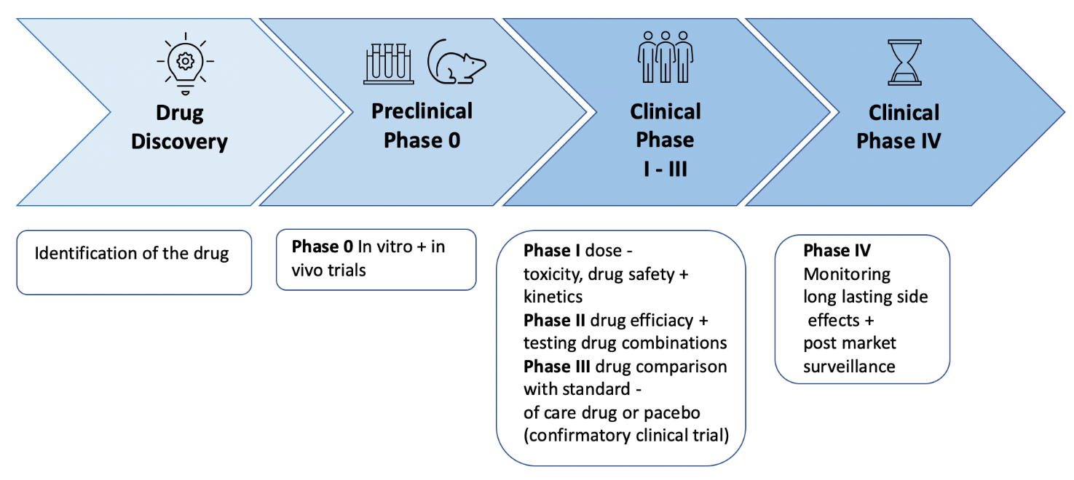
Figure 1:Typical pathway for gathering evidence for traditional medical interventions

Why is this different for AI systems?
[…] TBD Add a diagram to illustrate this

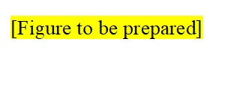
Figure 2[Placeholder: Illustration why "this" is different for AI systems]

Internal -
Test data, training data
Internal benchmarking - Verification, Validation
Quality assurance steps, etc

Release to Production > Product level testing > Post Market Surveillance > Post Market Clinical Follow Up (e.g., prospective, real world clinical studies)
Currently, regulators (e.g., MDR, FDA) require software as a medical service to show evidence of these steps. With constantly changing and evolving systems, the onus is put on AI developers to show that new versions and changes are meeting quality requirements. It is also not always fully clear at which points new clinical studies are required, aside from an expansion in the intended use.
Clinical studies require time, planning, resources, and partners, as well as ethical approvals. Therefore, providing real-world evidence in this way is powerful but slow.
The aim of the ITU/WHO Focus Group on AI for Health is to create a faster trusted intermediate step that can show regulators and decision-makers that ‘latest versions’ are of sufficient standard and appropriate for the context and use cases where they might be being planned for deployment.
This requires the creation of globally representative datasets that are curated independently, of high quality and secure (i.e. that no systems have ever seen before).
Also, the metrics used here may be wide-ranging and interactive to help answer specific contextual questions (e.g., ‘someone is planning to use this AI system on elderly people in India and would like to see metrics X, Y and Z in the India/SE Asia dataset of the same age group’).

Why not just do more prospective clinical studies?
Regulators, health systems, and governments may use the benchmarking assessment as part of their 360 assessment of an AI system before making decisions about tendering/deployment/regulatory approval. It is crucial to say here, that this is not to replace post market clinical evaluation (e.g., prospective clinical studies), and rather an important, ongoing, interim step in the “spectrum of evaluating AI systems in healthcare”.
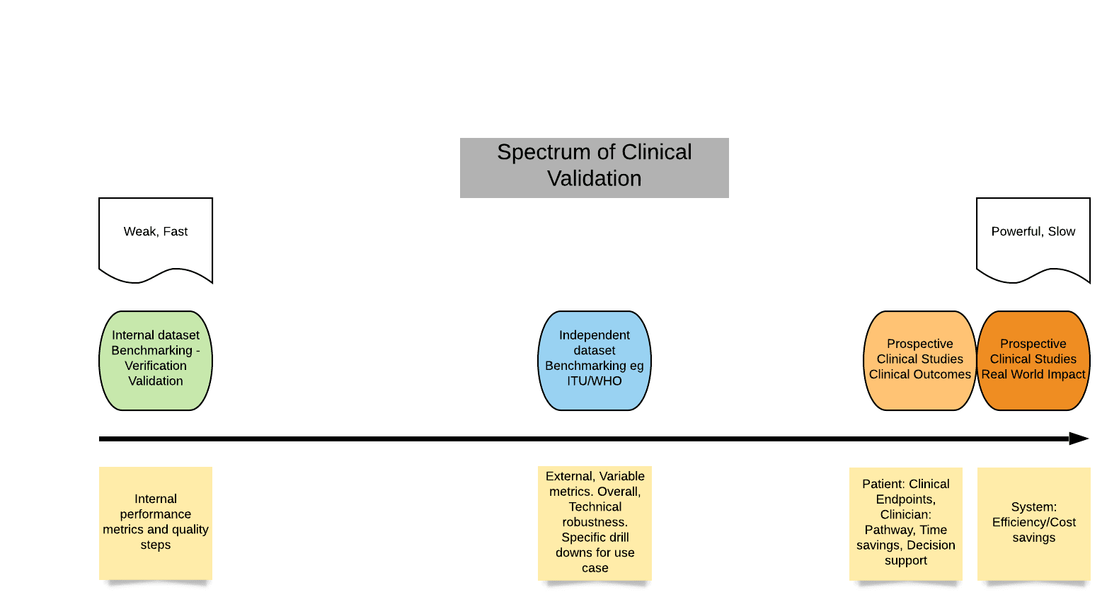
Figure 3: Spectrum of clinical validation

Benchmarking within a clinical study
We should not just be speaking about Precision, Recall, Sensitivity, PPV, etc., we should also be talking about real-world impact on:
- Patients (outcomes? Satisfaction? Better journey, faster diagnosis/referral, right care right place, etc.?)
- Clinicians and clinical workflow (time to care, etc.)
- Health system: efficiency, savings, cost benefit?
Clinical Requirements for regulators
- […] TBD
Clinical Requirements for other stakeholders – e.g., health systems, payers, governments
- important to talk about “Intended stage in the care pathway”
- […] TBD
Difficulties with “gold standards”
- […] TBD

Overview of existing best-practice frameworks for clinical evaluation
Clinical evaluation frameworks have been developed by various initiatives, collaborations and government institutions. They address relevant requirements that have to be considered for clinical evaluation of medical innovations. For the WG-CE those evaluation frameworks that include considerations on how to evaluate AI-based innovations for the application in health are of special interest. This section provides a non-comprehensive overview and a description of existing procedures and best-practices for existing clinical evaluation frameworks.
Table 1 summarizes the key facts of the publications and the respective links to the evaluation frameworks, followed by a more detailed description of the requirements and considerations, also reflecting the relevance of the frameworks for the WG-CE.

Name | Link | Key facts
Equator-Network  (Enhancing the quality and transparency of health research)  Established in 2008 | https://www.equator-network.org | “The EQUATOR Network is an ‘umbrella’ organization that brings together researchers, medical journal editors, peer reviewers, developers of reporting guidelines, research funding bodies and other collaborators with mutual interest in improving the quality of research publications and of research itself. [The EQUATOR-Network] is developing into a global initiative covering all areas of health research and all nations, and actively involving all key stakeholders. […]” [2]  Contributors:  “The EQUATOR Network is directed by an international Steering Group that brings together leading experts in health, research methodology, statistics, reporting and editorial work”. [2]
SPIRIT (2013)  (Standard Protocol Items: Recommendations for Interventional Trials) | SPIRIT statement (2013): Defining standard protocol items for clinical trials  https://www.spirit-statement.org  and  https://www.equator-network.org/reporting-guidelines/spirit-2013-statement-defining-standard-protocol-items-for-clinical-trials/  and  Chan AW, Tetzlaff JM, Altman DG, et al. SPIRIT 2013 statement: defining standard protocol items for clinical trials. Ann Intern Med. 2013;158(3):200-207. doi:10.7326/0003-4819-158-3-201302050-00583  and  http://www.spirit-statement.org/wp-content/uploads/2013/08/SPIRIT-Checklist-download-8Jan13.doc (Checklist)  and  https://www.ncbi.nlm.nih.gov/pmc/articles/PMC5114123/  (publication) | “The SPIRIT 2013 provides evidence-based recommendations for the minimum content of a clinical trial protocol. SPIRIT is widely endorsed as an international standard for trial protocols”. [3]  “The 33-item SPIRIT checklist applies to protocols for all clinical trials and focuses on content rather than format. [It] recommends a full description of what is planned; it does not prescribe how to design or conduct a trial. By providing guidance for key content, the SPIRIT recommendations aim to facilitate the drafting of high-quality protocols. Adherence to SPIRIT would also enhance the transparency and completeness of trial protocols for the benefit of investigators, trial participants, patients, sponsors, funders, research ethics committees or institutional review boards, peer reviewers, journals, trial registries, policymakers, regulators, and other key stakeholders”. [4]  Contributors:  115 key stakeholders, including trial investigators, health care professionals, methodologists, statisticians, trial coordinators, journal editors, and representatives from the research ethics community, industry and non-industry funders, and regulators agencies [3]
SPIRIT - AI  2019  2020 | https://www.equator-network.org/library/reporting-guidelines-under-development/reporting-guidelines-under-development-for-clinical-trials-protocols/  Cruz Rivera, S., Liu, X., Chan, A. et al. Guidelines for clinical trial protocols for interventions involving artificial intelligence: the SPIRIT-AI extension. Nat Med 26, 1351–1363 (2020). https://doi.org/10.1038/s41591-020-1037-7 | Protocol Guidelines for Artificial Intelligence and Machine Learning Interventions in Randomized Trials (SPIRIT-AI Extension, registered 21 June 2019); “Forthcoming journal paper. The group plans to publish the reporting guideline by March 2020, in an open-access journal) [5]  09/2020 Publication of the announced journal paper.  “The SPIRIT-AI (standard Protocol Items: Recommendations for Interventional Trials – Artificial Intelligence) extension is a new reporting guideline for clinical trial protocols evaluating interventions with an AI component. It was developed in parallel with its companion statement for trial reports: CONSORT-AI (Consolidated standards of Reporting Trials – Artificial Intelligence). Both guidelines were developed through a staged consensus process involving literature review and expert consultation to generate 26 candidate items, which were consulted upon by an international multi-stakeholder group in a two-stage Delphi survey (103 stakeholders), agreed upon in a consensus meeting (31 stakeholders) and refined through a checklist pilot (34 participants). The SPIRIT-AI extension includes 15 new items that were considered sufficiently important for clinical trial protocols of AI-interventions [and] should be routinely reported in addition to the core SPIRIT 2013 items […].” [8]
CONSORT (2010)  (Consolidated Standards of Reporting Trials) | http://www.consort-statement.org  Schulz, K.F., Altman, D.G. & Moher, D. CONSORT 2010 Statement: updated guidelines for reporting parallel group randomised trials. BMC Med 8, 18 (2010). https://doi.org/10.1186/1741-7015-8-18  (original statement of 1996 was updated 2001 and last, 2010) | “The CONSORT 2010 Statement is this paper including the 25-item checklist (for review of formal requirements, details regarding the introduction, methods, results and discussion) […]. It provides guidance for reporting all randomized controlled trials, but focuses on the most common design type-individually randomized, two group, parallel trials.” [7]  Contributors: CONSORT group members include an international and eclectic group of clinical trialists, statisticians, epidemiologists, and biomedical editors. Membership is dynamic. CONSORT Executive (KFS, DGA, DM). [7,9]
CONSORT – AI  2019  2020 | https://www.equatornetwork.org/library/reporting-guidelines-under-development/reporting-guidelines-under-development-for-clinical-trials/ - AI  Liu, X., Cruz Rivera, S., Moher, D. et al. Reporting guidelines for clinical trial reports for interventions involving artificial intelligence: the CONSORT-AI extension. Nat Med 26, 1364–1374 (2020). https://doi.org/10.1038/s41591-020-1034-x | 2019: Forthcoming journal paper.  Website: The CONSORT-AI Extension: Reporting Guidelines for Artificial Intelligence and Machine Learning Interventions in Randomized Trials (registered 8 May, 2019). [10]  09/2020 Publication of the announced journal paper.  “The CONSORT-AI (Consolidated Standards of Reporting Trials–Artificial Intelligence) extension is a new reporting guideline for clinical trials evaluating interventions with an AI component. It was developed in parallel with its companion statement for clinical trial protocols: SPIRIT-AI (Standard Protocol Items: Recommendations for Interventional Trials–Artificial Intelligence).  Both guidelines were developed through a staged consensus process involving literature review and expert consultation to generate 29 candidate items, which were assessed by an international multi-stakeholder group in a two-stage Delphi survey (103 stakeholders), agreed upon in a two-day consensus meeting (31 stakeholders) and refined through a checklist pilot (34 participants).  The CONSORT-AI extension includes 14 new items that were considered sufficiently important for AI interventions that they should be routinely reported in addition to the core CONSORT 2010 items”. [11]
CONSORT and SPIRIT AI initiative  Steering group/working group (2019): | Liu, X., Rivera, S.C., Faes, L. et al. Reporting guidelines for clinical trials evaluating artificial intelligence interventions are needed. Nat Med 25, 1467–1468 (2019). https://doi.org/10.1038/s41591-019-0603-3  (Additional publication: Liu, X., Faes, L., Calvert, M. J., & Denniston, A. K. (2019). Extension of the CONSORT and SPIRIT statements. The Lancet, 394(10205), 1225. https://doi.org/10.1016/S0140-6736(19)31819-7 ) | “[…] The CONSORT (Consolidated Standards of Reporting Trials) and SPIRIT (Standard Protocol Items: Recommendations for Interventional Trials) statements are minimum reporting guidelines for randomized controlled trials and trial protocols. […] Although this guidance has substantially improved the completeness of clinical trials reporting, there are challenges in trials involving AI interventions that are not addressed by the current guidance. […] To address these challenges, the CONSORT-AI and SPIRIT-AI Steering Group is preparing international, consensus-based, AI-specific extensions to the CONSORT and SPIRIT statement that will focus specifically on clinical trials in which the intervention includes a machine learning or other AI component, using the EQUATOR Network methodological framework for guideline development.” [12]
TRIPOD (2015)  (Transparent Reporting of a multivariable prediction model for Individual Prognosis or Diagnosis) | Collins GS, Reitsma JB, Altman DG, Moons KG. Transparent reporting of a multivariable prediction model for individual prognosis or diagnosis (TRIPOD): the TRIPOD statement. BMJ. 2015;350:g7594. Published 2015 Jan 7. https://pubmed.ncbi.nlm.nih.gov/25560730/  and  https://www.equator-network.org/reporting-guidelines/tripod-statement/ | “The TRIPOD (Transparent Reporting of a multivariable prediction model for Individual Prognosis or Diagnosis) Statement includes a 22-item checklist, which aims to improve the reporting of studies developing, validating, or updating a prediction model, whether for diagnostic or prognostic purposes. The TRIPOD Statement aims to improve the transparency of the reporting of a prediction model study regardless of the study methods used.” [13]  Contributors: International group of prediction model researchers, including statisticians, epidemiologists, health care professionals, and journal editors. [13]
TRIPOD-ML (2019)  (Transparent Reporting of a multivariable prediction model for Individual Prognosis or Diagnosis - Machine Learning) | Collins, G. S., & Moons, K. G. (2019). Reporting of artificial intelligence prediction models. The Lancet, 393(10181), 1577-1579. https://doi.org/10.1016/S0140-6736(19)30037-6  Additional:  article as PDF-File | “Although many aspects of the TRIPOD statement are applicable to prediction model studies using artificial intelligence and machine learning methods, its uptake by the artificial intelligence and machine learning communities has not been high. Possible reasons for this include subtle differences in terminology, or a perceived lack of relevance because TRIPOD focuses on regression based prediction model approaches. […] We therefore announce a new initiative to develop a version of the TRIPOD statement specific to machine learning (TRIPOD-ML). The aim of TRIPOD-ML will be to focus on the introduction of machine learning prediction algorithms, building on a long and established methodology of prediction research, while harmonizing terminology.” [14]
NICE  (National Institute for Health and Care Excellence) – Evidence standards framework for digital health technologies (2019) | https://www.nice.org.uk/Media/Default/About/what-we-do/our-programmes/evidence-standards-framework/digital-evidence-standards-framework.pdf | “The framework describes standards for the evidence that should be available, or developed, for digital health technologies (DHT) to demonstrate their value in the UK health and care system.” [15]  Contributors: “It was developed by NICE between June 2018 and February 2019 in collaboration with NHS England, Public Health England and Med City. The work was commissioned by NHS England.” [15]
IMDRF  (International Medical Device Regulators Forum) – Software as a medical device (SaMD): Clinical Evaluation (2017) | http://www.imdrf.org/docs/imdrf/final/technical/imdrf-tech-170921-samd-n41-clinical-evaluation_1.pdf | “The IMDRF seeks to establish a common and converged understanding of clinical evaluation and principles for demonstrating the safety, effectiveness and performance of SaMD.” [16]  Contributors: IMDRF SaMD Working Group
WHO-study Group 5 – Clinical evaluation 2007 | http://academy.gmp-compliance.org/guidemgr/files/GHTF-SG5-N2R8-2007-CLINICAL-EVALUATION-070501.PDF | “The primary purpose of this document is to provide manufacturers with guidance on how to conduct and document the clinical evaluation of a medical device as part of the conformity assessment procedure prior to placing a medical device on the market as well as to support its ongoing marketing. It is also intended to provide guidance to regulators and other stakeholders when assessing clinical evidence provided by manufacturers. This document provides the following guidance:  - general principles of clinical evaluation  - how to identify relevant clinical data to be used in a clinical evaluation  - how to appraise and integrate clinical data into a summary  - and how to document a clinical evaluation in a clinical evaluation report.” [17]  Contributors: The Global Harmonization Task force
Mathews, S. C et al. (2019)  ‘Digital Health: A path to validation’ | Mathews, S. C., McShea, M. J., Hanley, C. L., Ravitz, A., Labrique, A. B., & Cohen, A. B. (2019). Digital health: a path to validation. NPJ Digital Medicine, 2(1), 1-9. https://doi.org/10.1038/s41746-019-0111-3 | Digital health scorecard – “Healthcare needs a robust and transparent validation process for digital health products. All healthcare stakeholders would benefit from a more standardized, objective, rigorous, and transparent process for validation. Specifically, the validation domains would be technical validation (e.g., how accurately does the solution measure what it claims?), clinical validation (e.g., does the solution have any support for improving condition-specific outcomes?), and system validation (e.g., does the solution integrate into patients’ lives, provider workflows, and healthcare systems). A proposed pathway is outlined. A forthcoming pilot study (and publication of a detailed corresponding framework) will contain finer details of the proposed pathway.” [18]
Sendak, M.P., et al (2020)  ‘Presenting machine learning model information to clinical end users with model facts lables’ | Sendak, M.P., Gao, M., Brajer, N. et al. Presenting machine learning model information to clinical end users with model facts labels. npj Digit. Med. 3, 41 (2020). https://doi.org/10.1038/s41746-020-0253-3 | “[…] an interdisciplinary team including developers, clinicians, and regulatory experts designed the “Model Facts” label. The target audience is clinicians who make decisions supported by a machine learning model. The purpose is to collate relevant, actionable information in 1-page to ensure that front-line clinicians know how, when, how not, and when not to incorporate model output into clinical decisions.” [19]
STARD (Standards for the Reporting of Diagnostic Accuracy Studies) | https://www.equator-network.org/reporting-guidelines/stard/ | “To improve the quality of reporting of diagnostic accuracy studies, the Standards for the Reporting of Diagnostic Accuracy Studies (STARD) statement was developed. […] – an updated list of 30 essential items that should be included in every report of a diagnostic accuracy study. This update incorporates recent evidence about sources of bias and variability in diagnostic accuracy and is intended to facilitate the use of STARD. As such, STARD 2015 may help to improve completeness and transparency in reporting of diagnostic accuracy studies”. [20]
Minimum information about clinical artificial intelligence modeling: the MI-CLAIM checklist | Norgeot, B., Quer, G., Beaulieu-Jones, B.K. et al. Minimum information about clinical artificial intelligence modeling: the MI-CLAIM checklist. Nat Med 26, 1320–1324 (2020). https://doi.org/10.1038/s41591-020-1041-y | “[…] Here [the authors] propose the first steps toward a minimum set of documentation to bring similar levels of transparency and utility to the application of AI in medicine: minimum information about clinical artificial intelligence modeling (MI-CLAIM). With this work, [the authors] are targeting medical-algorithm designers, repository managers, manuscript writers and readers, journal editors, and model users. […] Validation of the exact results is generally of less interest than whether or not the results are validated in a new cohort of patients. Therefore, MI-CLAIM has two purposes: first, to enable a direct assessment of clinical impact, including fairness and bias; and second, to allow rapid replication of the technical design process of any legitimate clinical AI study.” [21]
[TBC] | […] | […]

Table 1: Non-comprehensive list of existing best practices for clinical evaluation

EQUATOR Network methodology network
Website:
Details about the EQAUTOR Network with background information and an overview of the reporting guidelines for main study types can be found here: https://www.equator-network.org; https://www.equator-network.org/about-us/

Objective: “The EQUATOR mission is to achieve accurate, complete, and transparent reporting of all health research studies to support reproducibility and usefulness. [This] increases the value of health research and helps to minimize avoidable waste of financial and human investments in health research projects. To achieve its mission the EQUATOR Network has the following major goals:
- Maintain and further develop a comprehensive collection of online resources providing up-to-date information, tools and other materials related to health research reporting
- Actively promote the use of reporting guidelines and good research reporting practices through an education and training programme
- Assist in the development, dissemination and implementation of robust reporting guidelines
- Support journals, universities and other organisations in implementing reporting guidelines through development of tools, strategies, education and other activities
- Undertake research projects enhancing the value of health-related research
- Set up a global network of local EQUATOR Centres to facilitate the improvement of health research reporting on a worldwide scale

Considerations WG-CE: The EQUATOR Network presents a valuable source of relevant reporting guidelines that have to be considered within the WG-CE. It provides a detailed and up-to-date overview of the current clinical evaluation frameworks and their extensions.
[…]

SPIRIT (Standard Protocol Items: Recommendations for Interventional Trials)
Website:
SPIRIT statement https://www.spirit-statement.org/; https://www.equator-network.org/reporting-guidelines/spirit-2013-statement-defining-standard-protocol-items-for-clinical-trials/, and (Checklist) http://www.spirit-statement.org/wp-content/uploads/2013/08/SPIRIT-Checklist-download-8Jan13.doc

Publications:
Chan AW, Tetzlaff JM, Altman DG, et al. SPIRIT 2013 statement: defining standard protocol items for clinical trials. Ann Intern Med. 2013;158(3):200-207. doi:10.7326/0003-4819-158-3-201302050-00583 https://www.ncbi.nlm.nih.gov/pmc/articles/PMC5114123/

Objective: “SPIRIT 2013 [is] a guideline for the minimum content of a clinical trial protocol. Producing evidence-based recommendations for a minimum set of items to be addressed in protocols. The 33-item SPIRIT checklist applies to protocols for all clinical trials and focuses on content rather than format. The checklist recommends a full description of what is planned; it does not prescribe how to design or conduct a trial. By providing guidance for key content, the SPIRIT recommendations aim to facilitate the drafting of high-quality protocols. […] This international project aims to improve the completeness of trial protocols by producing evidence-based recommendations for a minimum set of items to be addressed in protocols.” [3]

Scope: “The SPIRIT 2013 Statement provides guidance for minimum protocol content. […] The SPIRIT 2013 Statement primarily relates to the content of the protocol rather than its format, which is often subject to local regulations, traditions, or standard operating procedures. Finally, the intent of SPIRIT 2013 is to promote transparency and a full description of what is planned – not to prescribe how a trial should be designed or conducted. The checklist should not be used to judge trial quality […].” [3]

Relations: “The SPIRIT 2013 Statement mirrors applicable items from CONSORT 2010 (Consolidated Standards of Reporting Trials). Consistent wording and structure used for items common to both checklists will facilitate the transition from a SPIRIT-based protocol to a final report based on CONSORT.” [3]

CONSORT (Consolidated standards of Reporting Trials)
Website:
CONSORT 2010 Statement http://www.consort-statement.org, and (Checklist) http://www.consort-statement.org/download/Media/Default/Downloads/CONSORT%202010%20Checklist.doc

Publications:
Kenneth F. Schulza, *, Douglas G. Altman, David Moher for the CONSORT group. CONSORT 2010 statement: Updated guidelines for reporting parallel group randomised trials
https://www.sciencedirect.com/science/article/pii/S1743919111005620?via=ihub

Objective: “The lack of adequate reporting fueled the development of the original CONSORT (Consolidated standards of Reporting Trials) statement 1995 and its revision 5 years later. While those statements improved the reporting quality for some randomized controlled trials, many trial reports still remain inadequate. […] The CONSORT 2010 Statement is this paper including the 25-item checklist (for review of formal requirements, details regarding the introduction, methods, results and discussion) and the flow diagram […]. It provides guidance for reporting all randomized controlled trials, but focuses on the most common design type-individually randomized, two group, parallel trials. […] The Checklist contains items deemed absolutely fundamental to reporting a randomized controlled trial.” [23]

Scope: “We developed CONSORT 2010 to assist authors in writing reports of randomized controlled trials, editors and peer reviewers in reviewing manuscripts for publication and readers in critically appraising published articles. […] The explicit goal of all these initiatives is to improve reporting. The EQUATOR network will facilitate development of reporting guidelines and help disseminate the guidelines: http://www.equator-network.org provides information on all reporting guidelines in health research.” [23]

CONSORT-AI/SPIRIT-AI Extension (CONSORT and SPIRIT-AI Steering group)
Website and Publications:
Liu, X., Rivera, S.C., Faes, L. et al. Reporting guidelines for clinical trials evaluating artificial intelligence interventions are needed. Nat Med 25, 1467–1468 (2019). https://doi.org/10.1038/s41591-019-0603-3

Liu, X., Faes, L., Calvert, M. J., & Denniston, A. K. (2019). Extension of the CONSORT and SPIRIT statements. The Lancet, 394(10205), 1225. https://doi.org/10.1016/S0140-6736(19)31819-7

SPIRIT-AI: Protocol Guidelines for Artificial Intelligence and Machine Learning Interventions in Randomised Trials (SPIRIT-AI Extension, registered 21 June, 2019)

Publication 09/2020:
Cruz Rivera, S., Liu, X., Chan, A. et al. Guidelines for clinical trial protocols for interventions involving artificial intelligence: the SPIRIT-AI extension. Nat Med 26, 1351–1363 (2020). https://doi.org/10.1038/s41591-020-1037-7

“The SPIRIT-AI (standard Protocol Items: Recommendations for Interventional Trials – Artificial Intelligence) extension is a new reporting guideline for clinical trial protocols evaluating interventions with an AI component. It was developed in parallel with its companion statement for trial reports: CONSORT-AI (Consolidated standards of Reporting Trials – Artificial Intelligence). Both guidelines were developed through a staged consensus process involving literature review and expert consultation to generate 26 candidate items, which were consulted upon by an international multi-stakeholder group in a two-stage Delphi survey (103 stakeholders), agreed upon in a consensus meeting (31 stakeholders) and refined through a checklist pilot (34 participants). The SPITI-AI extension includes 15 new items that were considered sufficiently important for clinical trial protocols of AI-interventions [and] should be routinely reported in addition to the core SPIRIT 2013 items […].” [7]

The table with the SPIRIT-AI checklist can be found here:
https://www.nature.com/articles/s41591-020-1037-7/tables/2

CONSORT-AI: Reporting Guidelines for Artificial Intelligence and Machine Learning Interventions in Randomized Trials (CONSORT-AI Extension, registered 8 May, 2019).

Current situation: “Most AI interventions thus far, particularly diagnostic algorithms, have been evaluated only in the context of diagnostic accuracy. Although this initial validation stage is important, a demonstration of good diagnostic accuracy does not necessarily translate to improved patient outcomes. Yet if the ultimate goal of introducing AI into healthcare is to bring about patient benefit, then demonstration of improved patient outcome is needed. This should be done in a prospective clinical trial, in which the AI intervention is placed within its intended clinical pathway, with patient outcomes as the primary endpoint, and with an evaluation of demonstrable downstream effects in the broader management strategy. CONSORT and SPIRIT statements are minimum reporting guidelines for randomized controlled trials and trial protocols. This has improved completeness of clinical trials reporting, challenges in trials involving AI interventions remain and are not addressed by current guidance. This bears the risk that an AI intervention that might not be effective or feasible in real world could be implemented.” [11]

Objective: “Therefore SPIRIT AI and CONSORT AI steering group is preparing international, consensus based, AI specific extentions that will focus on clinical trials with ML or AI component, using EQUATOR Network methodology for guideline development. […] [The] development process includes clinicians, computer scientists, researchers, trialists, industry leaders, regulators, funders, policy makers, journal editors and patient partners with an interest in applications of machine learning in healthcare. Developed through strong stakeholder engagement and a modified Delphi consensus process, the AI extensions for CONSORT and SPIRIT guidelines will adequately reflect the concerns of the wider community. Although many voices are important in this field, [the authors] wish to particularly draw attention to the role of medical journal editors.” [11]

Relations: “This initiative will be complementary to the efforts of others working on reporting standards such as the TRIPOD-ML initiative of Collins and Moons, which seeks to improve the reporting of machine-learning-driven predictive model development and validation.” [11]

04.09.2020 Publication:
Liu, X., Cruz Rivera, S., Moher, D. et al. Reporting guidelines for clinical trial reports for interventions involving artificial intelligence: the CONSORT-AI extension. Nat Med 26, 1364–1374 (2020). https://doi.org/10.1038/s41591-020-1034-x

Objective:
“The CONSORT-AI (Consolidated Standards of Reporting Trials–Artificial Intelligence) extension is a new reporting guideline for clinical trials evaluating interventions with an AI component. It was developed in parallel with its companion statement for clinical trial protocols: SPIRIT-AI (Standard Protocol Items: Recommendations for Interventional Trials–Artificial Intelligence).
Both guidelines were developed through a staged consensus process involving literature review and expert consultation to generate 29 candidate items, which were assessed by an international multi-stakeholder group in a two-stage Delphi survey (103 stakeholders), agreed upon in a two-day consensus meeting (31 stakeholders) and refined through a checklist pilot (34 participants).
The CONSORT-AI extension includes 14 new items that were considered sufficiently important for AI interventions that they should be routinely reported in addition to the core CONSORT 2010 items”. [10]

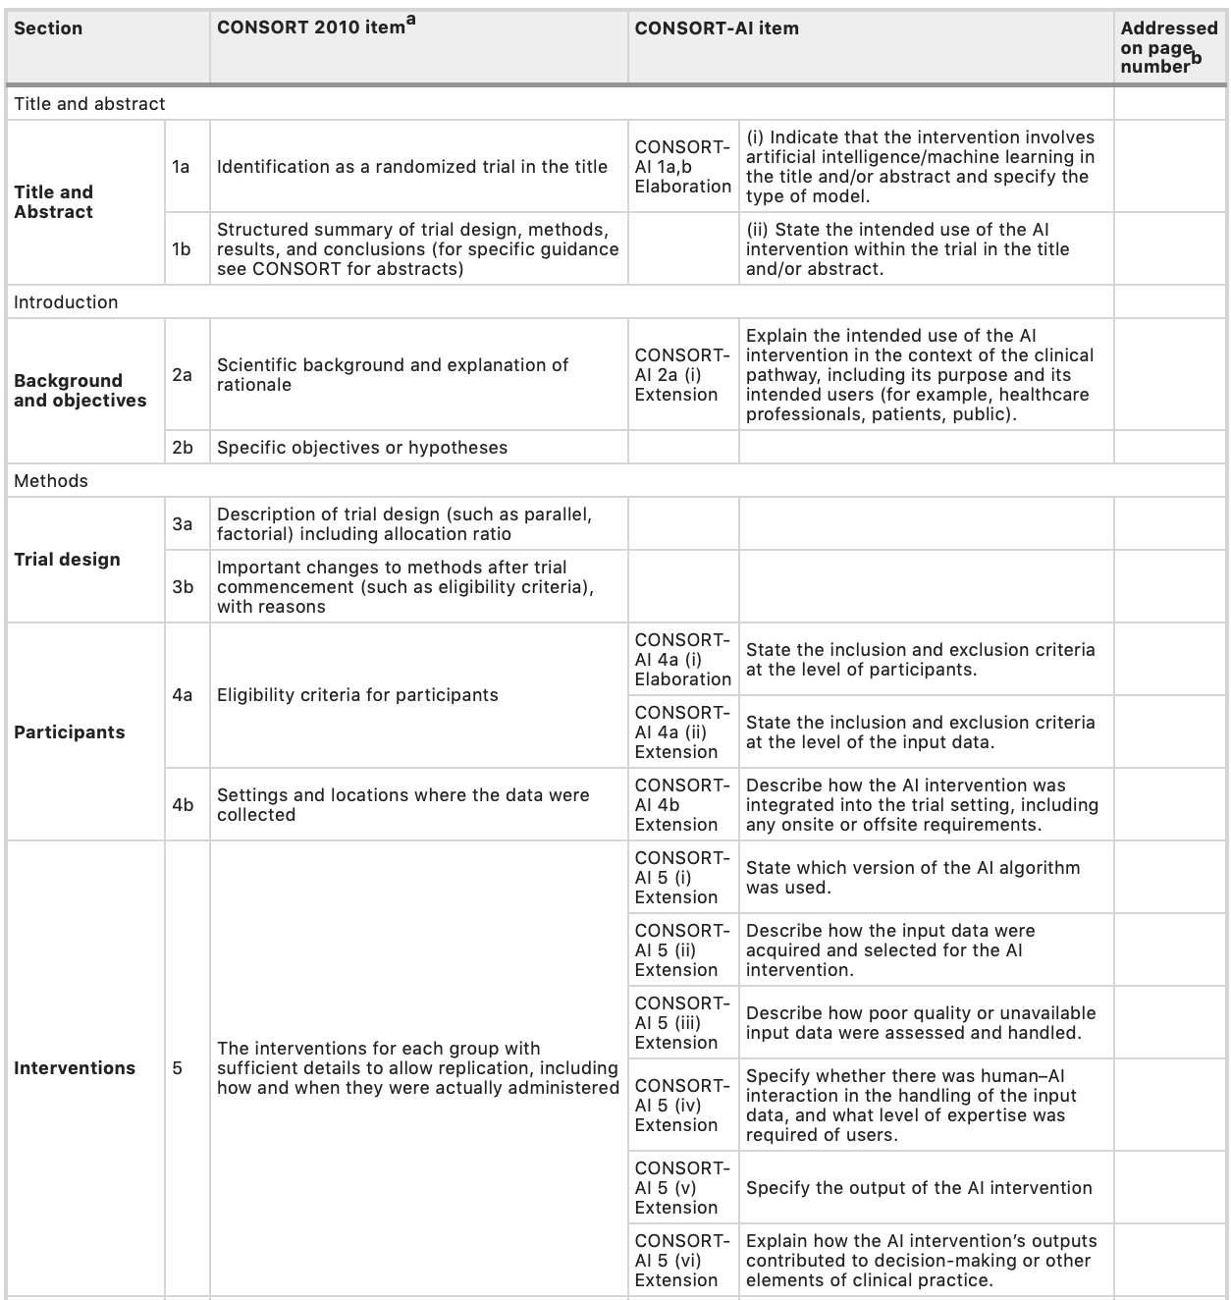
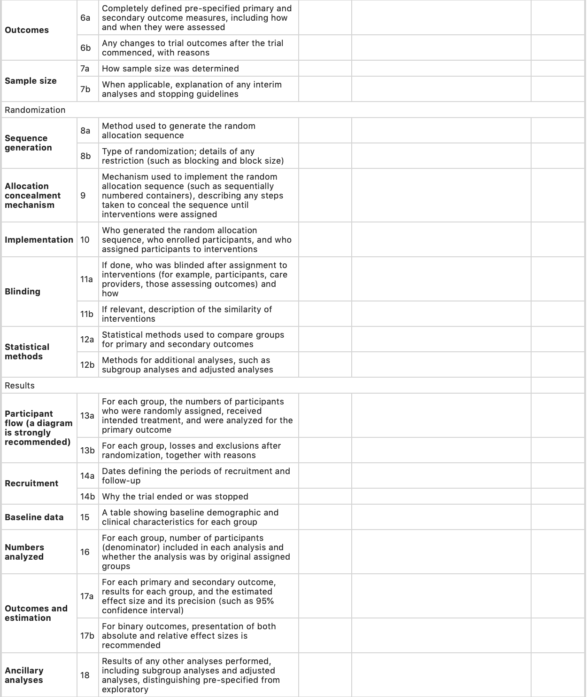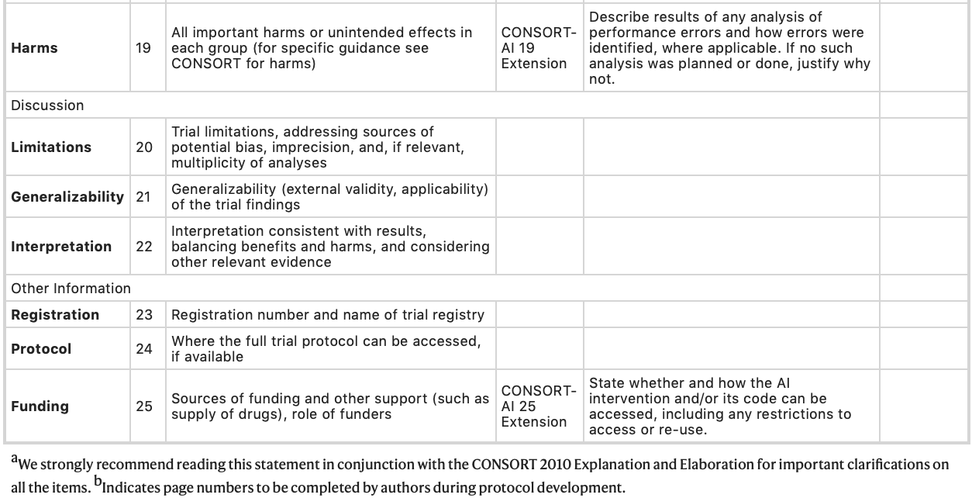
Figure 4: The CONSORT-AI Checklist

Relations: CONSORT-AI / SPIRIT AI Working group

Considerations WG-CE: The SPIRIT and CONSORT-AI extensions include valuable requirements for the evaluation of AI for health the WG-CE will follow and consider as much as possible. The guidelines address essential considerations for AI interventions and their application.

TRIPOD (Transparent Reporting of a multivariable prediction model for Individual Prognosis or Diagnosis)
Website: https://www.equator-network.org/reporting-guidelines/tripod-statement/

Publications:
Collins GS, Reitsma JB, Altman DG, Moons KG. Transparent reporting of a multivariable prediction model for individual prognosis or diagnosis (TRIPOD): The TRIPOD statement. BMJ 2015; 350: g7594. PMID: https://www.bmj.com/content/350/bmj.g7594.long

Objective: “TRIPOD developed a set of recommendations for the reporting of studies developing, validating, or updating a prediction model, whether for diagnostic or prognostic purposes. The absolute aim of this checklist is to improve the quality of reporting of published prediction model studies. The TRIPOD statement is a checklist of 22 items that we consider essential for good reporting of studies developing or validating multivariable prediction models. The recommendations within TRIPOD are guidelines only for reporting research and do NOT prescribe HOW to develop or validate a prediction model. Furthermore, the checklist is NOT a quality assessment tool to gauge the quality of a multivariable prediction model. The checklist template can be downloaded from http://www.tripod-statement.org/.” [13]

TRIPOD – ML
Publication:
Collins, G. S., & Moons, K. G. (2019). Reporting of artificial intelligence prediction models. The Lancet, 393(10181), 1577-1579. https://doi.org/10.1016/S0140-6736(19)30037-6
https://dl.uswr.ac.ir/bitstream/Hannan/80084/1/2019%20Lancet%20Volume%20393%20Issue%2010181%20April%20%2818%29.pdf

Current situation: “Methodological concerns include an often incorrect focus on classification overprediction, overfitting (whereby too many predictors or features are included for the sample size), lack of robust assessment of predictive accuracy when used with other data than those from which they were developed (validation), weak and unbiased comparison with simpler modelling approaches, and lack of transparency of the artificial intelligence and machine learning algorithm, which limits independent evaluation. There is a strong need that machine learning techniques adhere to established methodological standards already defined in prediction model research. Fair and neutral evaluations and comparisons against these existing prediction model approaches must be done. Although many aspects of the TRIPOD statement are applicable to prediction model studies using artificial intelligence and machine learning methods, its uptake by the artificial intelligence and machine learning communities has not been high. Possible reasons for this include subtle differences in terminology, or a perceived lack of relevance because TRIPOD focuses on regression based prediction model approaches. Also, TRIPOD’s explanation and elaboration document, which provides examples of good reporting to help authors, focuses on models developed using regression.”
[14]

Objective: “We therefore announce a new initiative to develop a version of the TRIPOD statement specific to machine learning (TRIPOD-ML). The aim of TRIPOD-ML will be to focus on the introduction of machine learning prediction algorithms, building on a long and established methodology of prediction research, while harmonizing terminology.” [14]

Considerations WG-CE: TRIPOD-ML addresses requirements of reporting about WG-Clinical and reference.
[…]

NICE (National Institute for Health and Care Excellence) – Evidence standards framework for digital health technologies (2019)
Publication:
https://www.nice.org.uk/Media/Default/About/what-we-do/our-programmes/evidence-standards-framework/digital-evidence-standards-framework.pdf

Objective: “The framework describes standards for the evidence that should be available, or developed, for digital health technologies (DHT) to demonstrate their value in the UK health and care system. This includes evidence of effectiveness relevant to the intended use(s) of the technology and evidence of economic impact relative to the financial risk. […] The evidence standards framework is intended to be used by technology developers to inform their evidence development plans, and by decision makers who are considering whether to commission a DHT. […]”.

Scope: “The evidence standards framework is not suitable for all DHTs. Because the framework has been designed for DHTs that are commissioned in the UK health and care system, it is less relevant to DHTs that are downloaded or purchased directly by users (such as through app stores). The framework may be used with DHTs that incorporate artificial intelligence using fixed algorithms. However, it is not designed for use with DHTs that incorporate artificial intelligence using adaptive algorithms (that is, algorithms which continually and automatically change). Separate standards (including principle 7 of the code of conduct for data-driven health and care technology) will apply to these DHTs.”
The document is split into two sections. Section A: Evidence for effectiveness standards: “Functional classification (of DHTs) is intended to be a pragmatic approach to differentiating the main functions of the types of DHTs that are expected to be most widely developed and used in the UK health and care system”. […] Classifying DHTs by function (see figure 4) allows them to be stratified into evidence tiers based on the potential risk to users. The evidence level needed for each tier is proportionate to the potential risk to users presented by the DHTs in that tier”.

Figure 5: DHTs classified by function and stratified into evidence tiers

Section B: Evidence for economic impact standards
“[…] The economic impact standards aim to promote a consistent and streamlined pathway for economic assessment of DHTs. They are designed to help developers and others understand what information is needed for an effective economic analysis, with the ultimate aim of increasing the capacity for economic analysis across the wider innovation landscape. […]
The evidence for economic impact standards is separated into 3 components:
  - Key economic information
  - Appropriate economic analysis
  - Economic analysis reporting standards

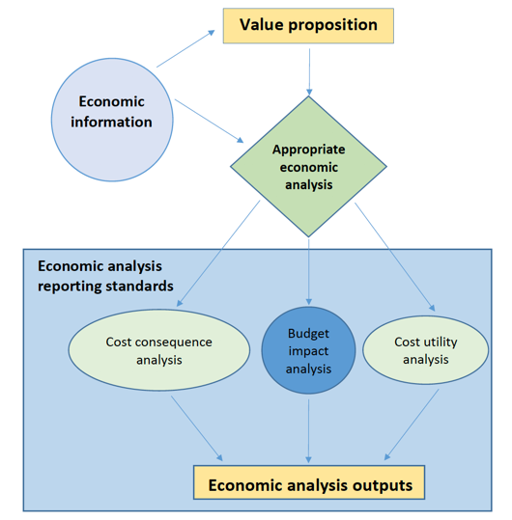
Figure 6: Relation of economic impact standard components
[23]

Considerations WG-CE: The NICE evidence standards framework is not suitable for all DHTs, especially not for artificial intelligence using adaptive algorithms.
As the WG-Clinical also considers adaptive/learning AI tools, the ‘NICE- Evidence standards framework for digital health technologies’ might have its limitations.
[TBC]

IMDRF - Software as a Medical Device Working Group (2017)
Publication:
http://www.imdrf.org/docs/imdrf/final/technical/imdrf-tech-170921-samd-n41-clinical-evaluation_1.pdf

Objective: “The International Medical Device Regulators Forum (IMDRF) seeks to establish a common and converged understanding of clinical evaluation and principles for demonstrating the safety, effectiveness and performance of SaMD. This document is […] an approach to making Software as a Medical Device (SaMD) clinically meaningful to users. This document focuses on the activities needed to clinically evaluate SaMD […]. This document describes a converged approach for planning the process for clinical evaluation of a SaMD (software with a medical purpose as defined in SaMD N10[1]2) as illustrated in [Figure 6] to establish that:
- There is a valid clinical association between the output of a SaMD and the targeted clinical condition (to include pathological process or state); and
- That the SaMD provides the expected technical and clinical data”

Figure 7: Clinical evaluation process

Scope: “This document focuses on the activities needed to clinically evaluate SaMD”

Clinical evaluation process: “Clinical evaluation should be an iterative and continuous process as part of the quality management system for medical devices […]. A SaMD manufacturer is expected to implement on-going lifecycle processes to thoroughly evaluate the product’s performance in its intended market. […] (pre-market): the manufacturer generates evidence of the product’s accuracy, specificity, sensitivity, reliability, limitations, and scope of use in the intended use environment with the intended user, and generates a SaMD definition statement. Once the product is on the market (post-market), as part of normal lifecycle management processes, the manufacturer continues to collect real world performance data (e.g., complaints, safety data), to further understand the customer’s needs to ensure the product is meeting those needs, and to monitor the product’s continued safety, effectiveness and performance in real- world use. This real world performance data allows the manufacturer to identify and correct any problems, support future expansions in functionality, meet anticipated user demands, or improve the effectiveness of the device.”

Pathway for continuous learning leveraging real world performance:
“[…] A SaMD manufacturer may have a hypothesis about future functionality and intended use of a SaMD that may be informed by continuously collecting and analyzing data on use of the SaMD in a post-market setting.
Monitoring real world performance data can help the SaMD functionality and intended use evolve after initial introduction into the market. Such data may include post-market information such as safety data, results from performance studies, on-going clinical evidence generation for medical devices, new research publications / results that support or strengthen the clinical association of the SaMD output to a clinical condition, or direct end-user feedback, that can help the SaMD manufacturer understand the real world performance of the SaMD.
This may lead to a change to the SaMD definition statement if supported by the clinical evidence generated through clinical evaluation leveraging real world performance data from the continuous monitoring as illustrated in [Figure 7].”

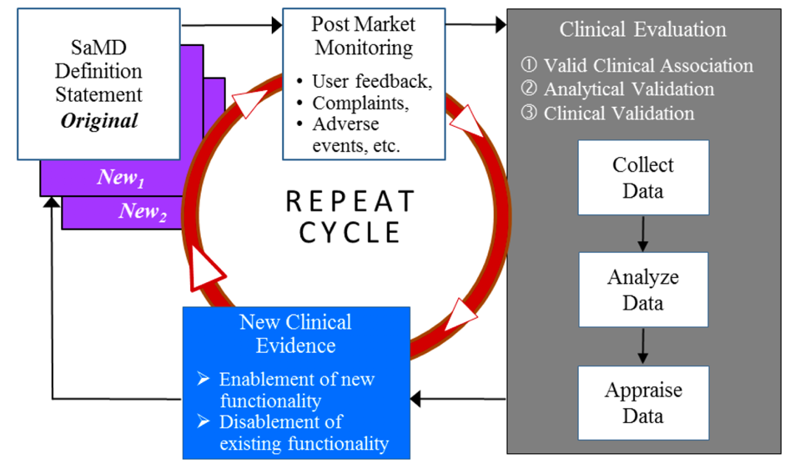
Figure 8: Pathway for continuous learning - use of Real World SaMD Performance data in ongoing SaMD clinical Evaluation
[16]

Considerations WG-Clinical: The considerations of the IMDRF Clinical Evaluation Working group addressed in this document are a valuable reference for the WG-Clinical. […]

WHO-study Group 5 – Clinical evaluation 2007
Publication:
http://academy.gmp-compliance.org/guidemgr/files/GHTF-SG5-N2R8-2007-CLINICAL-EVALUATION-070501.PDF

Objective: “The document herein was produced by the Global Task Force, which is comprised of representatives from medical device regulatory agencies and the regulatory industry. The document is intended to provide non-binding guidance for use in the regulation of medical devices, and has been subject to consultation throughout its development.”

Scope: “The primary purpose of this document is to provide manufacturers with guidance on how to conduct and document the clinical evaluation of a medical device as part of the conformity assessment procedure prior to placing a medical device on the market as well as to support its ongoing marketing. It is also intended to provide guidance to regulators and other stakeholders when assessing clinical evidence provided by manufacturers. This document provides the following guidance:
- general principles of clinical evaluation;
- how to identify relevant clinical data to be used in a clinical evaluation;
- how to appraise and integrate clinical data into a summary; and
- how to document a clinical evaluation in a clinical evaluation report.” [17]

Considerations WG-CE: [TBD]

Mathews, S. C et al. (2019) ‘Digital Health: A path to validation’
Publication:
Mathews, S. C., McShea, M. J., Hanley, C. L., Ravitz, A., Labrique, A. B., & Cohen, A. B. (2019). Digital health: a path to validation. NPJ Digital Medicine, 2(1), 1-9. https://doi.org/10.1038/s41746-019-0111-3

Objective: […] “Healthcare needs a robust and transparent validation process for digital health products. All healthcare stakeholders would benefit from a more standardized, objective, rigorous, and transparent process for validation. Specifically, the validation domains would be technical validation (e.g., how accurately does the solution measure what it claims?), clinical validation (e.g., does the solution have any support for improving condition-specific outcomes?), and system validation (e.g., does the solution integrate into patients’ lives, provider workflows, and healthcare systems). A proposed pathway is outlined. A forthcoming pilot study (and publication of a detailed corresponding framework) will contain finer details of the proposed pathway.”

Current situation/Need: “Current indications point to a future where only a fraction of digital health technologies is subject to regulatory review prior to market entry. Many other sophisticated, unproven solutions will continue to proliferate, frustrating end-users looking for a way to improve their well-being or disease self-management. Thus, the onus is shifted to the clinician and patient to identify effective and useful digital health technologies, bearing the risk of ineffective, or even potentially harmful, solutions. The need for new accessible tools to assist in informed decision-making is clear for all domains of the digital health spectrum […].
Presently, much of the digital health industry lacks this rigor, including several steps along the traditional product development cycle (figure 8 dashed boxes). The current digital health product lifecycle often focuses on high-level requirements, if at all, which limits what can be verified or validated. These fundamental elements of the product development process remain essential even in today’s world of agile development, and continuous cloud-based product deployments. We believe a Digital Health Scorecard will promote requirements-driven development to the benefit of all stakeholders.

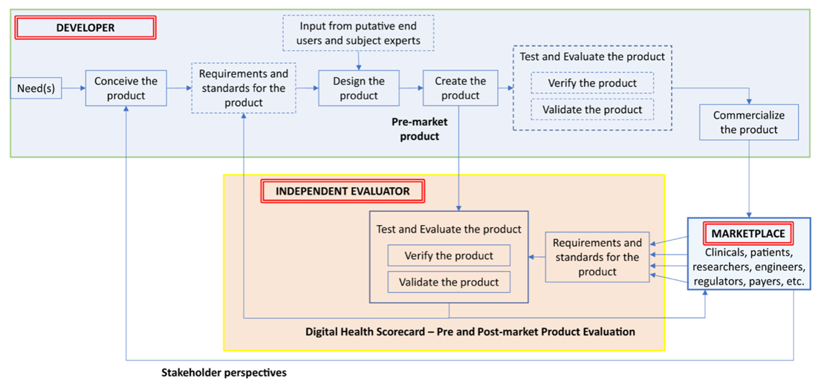
Figure 9: Traditional Product Lifecycle with Proposed Digital Health Card added

“The development of requirements will vary across types of digital health solutions based on functionality (diagnostics, monitoring, care coordination, etc.), which can also be modeled from other industry approaches. It is critical to incorporate the preferences of the clinicians and patients impacted by the digital health solution into the requirement development process. Once requirements are established, the proposed framework that could form the basis for evaluation includes the following domains: technical, clinical, usability, and cost [Fig. 9]”.

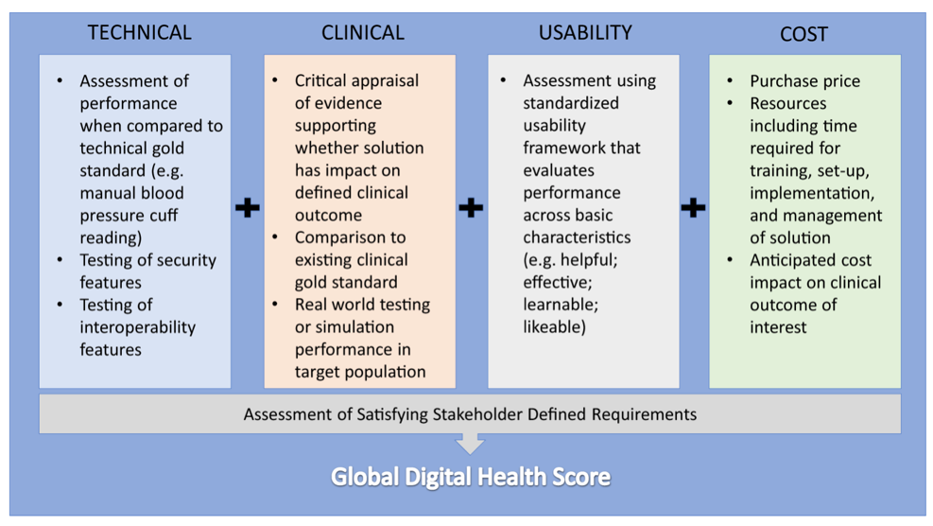

Figure 10: Components of Digital Health Scorecard with the four domains of a digital health scorecard and their relationship to an assessment of stakeholder requirements

Considerations WG-CE: The considerations raised by the authors match the ideas and addresses issues also raised by the WG-Clinical.

Sendak, M.P., et al (2020) ‘Presenting machine learning model information to clinical end users with model facts lables’
Publication:
Sendak, M.P., Gao, M., Brajer, N. et al. Presenting machine learning model information to clinical end users with model facts labels. npj Digit. Med. 3, 41 (2020). https://doi.org/10.1038/s41746-020-0253-3

Objective: “[…] This perspective presents the “Model Facts” label, a systematic effort to ensure that front-line clinicians actually know how, when, how not, and when not to incorporate model output into clinical decisions. The “Model Facts” label was designed for clinicians who make decisions supported by a machine learning model and its purpose is to collate relevant, actionable information in 1-page. Practitioners and regulators must work together to standardize presentation of machine learning model information to clinical end users in order to prevent harm to patients. Efforts to integrate a model into clinical practice should be accompanied by an effort to clearly communicate information about a machine learning model with a “Model Facts” label. […] The major sections of the “Model Facts” label include the model name, locale, and version, summary of the model, mechanism of risk score calculation, validation and performance, uses and directions, warnings, and other information”.

Scope: The “Model Facts” label specifically serves the audience of clinical end users at the implementation stage and is distributed via channels that are closely integrated with the clinical decision support.

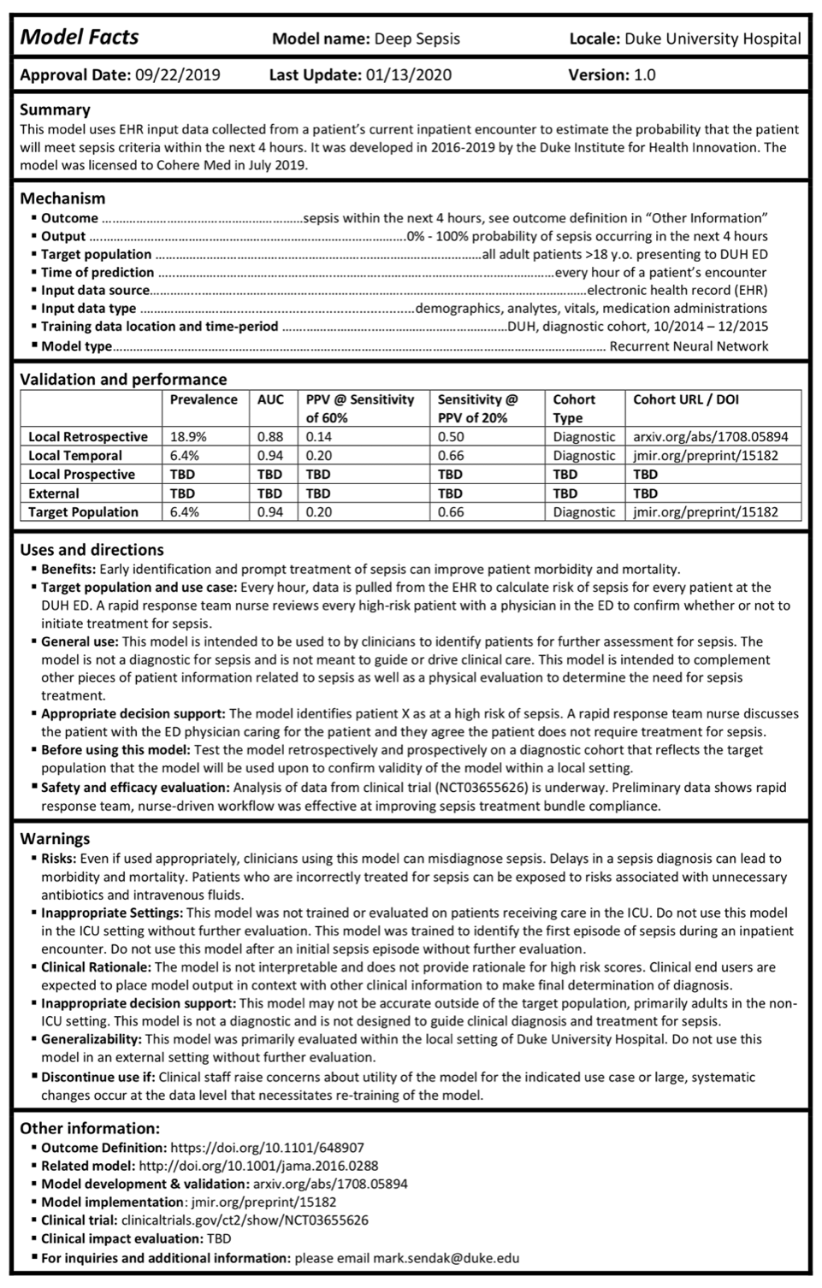
Figure 11: “Model Facts” label including relevant information about a sepsis prediction model to clinical end users

[…] “The structure of [the] “Model Facts” label presented in [Fig. 10] requires rigorous testing and evaluation. It is not meant to be immediately adopted, but to spark dialogue and to be iterated upon and critiqued by a broad group of stakeholders. Risk communication research advises against only using words in communication material and we hope that other teams implementing machine learning tools create their own versions of “Model Facts” labels”. [19]

Considerations WG-CE: Considerations of the WG-Clinical include clinical meaningful endpoints. The ‘Model facts label’ can be a valuable source for further requirements within the WG-CE and can be used as an example for the topic groups.

STARD (Standards for the Reporting of Diagnostic Accuracy Studies)

Website: https://www.equator-network.org/reporting-guidelines/stard/

Objective: “To improve the quality of reporting of diagnostic accuracy studies, the Standards for the Reporting of Diagnostic Accuracy Studies (STARD) statement was developed. […] – an updated list of 30 essential items that should be included in every report of a diagnostic accuracy study. This update incorporates recent evidence about sources of bias and variability in diagnostic accuracy and is intended to facilitate the use of STARD. As such, STARD 2015 may help to improve completeness and transparency in reporting of diagnostic accuracy studies.
[20]

Considerations for WG-CE: [TBD]

Minimum information about clinical artificial intelligence modelling: the MI-CLAIM checklist
Publication: Norgeot, B., Quer, G., Beaulieu-Jones, B.K. et al. Minimum information about clinical artificial intelligence modeling: the MI-CLAIM checklist. Nat Med 26, 1320–1324 (2020). https://doi.org/10.1038/s41591-020-1041-y

Objective: “[…] Here [the authors] propose the first steps toward a minimum set of documentation to bring similar levels of transparency and utility to the application of AI in medicine: minimum information about clinical artificial intelligence modeling (MI-CLAIM). With this work, [the authors] are targeting medical-algorithm designers, repository managers, manuscript writers and readers, journal editors, and model users.”
“[…] Validation of the exact results is generally of less interest than whether or not the results are validated in a new cohort of patients. Therefore, MI-CLAIM has two purposes: first, to enable a direct assessment of clinical impact, including fairness and bias; and second, to allow rapid replication of the technical design process of any legitimate clinical AI study.” [21]

Considerations of WG-CE: [TBD]

Current best practice
- Phases of evaluation
- Efficacy and comparative efficacy
- Safety
- Generalisability/Bias and Inclusiveness
- Evaluating adaptive/learning models
- Reporting of evaluation (following Equator)
- Clinically meaningful endpoints
- Post deployment surveillance
- Specific considerations for low- and middle-income settings

Clinical evaluation across the FG-AI4H use cases
The purpose of this document is to capture the relevance of clinical validation and evaluation across all use cases (topic groups) of the FG-AI4H. All topic groups, dedicated to a special health topic in the context of AI are performing the benchmarking process for a special AI task. They need to be concerned with assessing performance (accuracy), but also with utility and the impact of this process on a real-world clinical environment. Whilst clinical evaluation studies also do this, outputs of this work are slow. The FG-AI4H aims to enable the safe scaling up of rapidly evolving AI solutions in a trusted but reasonably quick way. The challenge is to broadly capture the unique considerations of each topic group and their modalities when it comes to performance and impact/utility (e.g. TG ‘Symptoms’ matching, triage advice, and image classification or diagnostic tests, sensitivity/specificity; impact on clinical workflow, etc.).
This document outlines the broad sections that need to be covered, and over time will bring in the relevant experts to provide the nuance and insights that can communicate this within the topic group, but also very clearly to external stakeholders.
Use cases/topic groups and their unique considerations that need to be covered regarding
- Performance
- Utility / Impact (in ‘real-world’ clinical environment)

[…]

Topic Group | Input data | More info in
Cardiovascular disease management |  | Annex A
Dermatology |  | Annex B
Diagnosis of bacterial infection and anti-microbial resistance |  | Annex C
Falls among the elderly |  | Annex D
Histopathology |  | Annex E
Malaria detection |  | Annex F
Maternal and child health |  | Annex G
Neurological disorders |  | Annex H
Ophthalmology |  | Annex I
Outbreak detection |  | Annex J
Psychiatry |  | Annex K
AI for radiology |  | Annex L
Snakebite and snake-identification |  | Annex M
Symptom assessment |  | Annex N
Tuberculosis |  | Annex O
Volumetric chest CT |  | Annex P
Dental diagnostics and digital dentistry |  | Annex Q
Falsified medicine |  | Annex R
Primary and secondary diabetes prediction |  | Annex S
AI for endoscopy |  | Annex T

Table 2: Overview of FGAI4H use cases (topic groups)

Annex A
Cardiovascular disease management (TG-Cardio)
Cardiovascular disease management (TG-Cardio) including sub-topic risk-prediction […]

Annex B
Dermatology (TG-Dermatology)
[…]

Annex C
Diagnosis of bacterial infection and anti-microbial resistance (TG-Bacteria)
[…]

Annex D
Falls among the elderly (TG-Falls)
[…]

Annex E
Histopathology (TG-Histo)
[…]

Annex F
Malaria detection (TG-Malaria)
[…]

Annex G
Maternal and child Health (TG-MCH)
[…]

Annex H
Neurological disorders (TG-Neuro)
[…]

Annex I
Ophthalmology (TG-Ophthalmo)
[…]

Annex J
Outbreak detection (TG-Outbreaks)
[…]

Annex K
Psychiatry (TG-Psy)
[…]

Annex L
AI for radiology (TG-Radiology)
[…]

Annex M
Snakebite and Snake-detection (TG-snake)
[…]

Annex N
Symptom assessment (TG-Symptom)
[…]

Annex O
Tuberculosis (TG-TB)
[…]

Annex P
Volumetric chest CT (TG-Diagnostic CT)
[…]

Annex Q
Dental diagnostics and digital dentistry (TG-Dental)
[…]

Annex R
Falsified medicine (TG-FakeMed)
[…]

Annex S
Primary and secondary diabetes prediction (TG-Diabetes)
[…]

Annex T
AI for endoscopy (TG-Endoscopy)
[…]

Bibliography

- The EQUATOR Network https://www.equator-network.org; https://www.equator-network.org/about-us/equator-network-what-we-do-and-how-we-are-organised/

- SPIRIT statement (2013): Defining standard protocol items for clinical trial https://www.equator-network.org/reporting-guidelines/spirit-2013-statement-defining-standard-protocol-items-for-clinical-trials/; http://www.spirit-statement.org/wp-content/uploads/2013/08/SPIRIT-Checklist-download-8Jan13.doc;

- Chan AW, Tetzlaff JM, Altman DG, et al. SPIRIT 2013 statement: defining standard protocol items for clinical trials. Ann Intern Med. 2013;158(3):200-207. doi:10.7326/0003-4819-158-3-201302050-00583

- Liu, X., Rivera, S.C., Faes, L. et al. Reporting guidelines for clinical trials evaluating artificial intelligence interventions are needed. Nat Med 25, 1467–1468 (2019). https://doi.org/10.1038/s41591-019-0603-3

- Cruz Rivera, S., Liu, X., Chan, A. et al. Guidelines for clinical trial protocols for interventions involving artificial intelligence: the SPIRIT-AI extension. Nat Med 26, 1351–1363 (2020). https://doi.org/10.1038/s41591-020-1037-7

- Schulz, K.F., Altman, D.G. & Moher, D. CONSORT 2010 Statement: updated guidelines for reporting parallel group randomised trials. BMC Med 8, 18 (2010). https://doi.org/10.1186/1741-7015-8-18

- Cruz Rivera, S., Liu, X., Chan, A. et al. Guidelines for clinical trial protocols for interventions involving artificial intelligence: the SPIRIT-AI extension. Nat Med 26, 1351–1363 (2020). https://doi.org/10.1038/s41591-020-1037-7

- The CONSORT statement http://www.consort-statement.org

- CONSORT AI https://www.equatornetwork.org/library/reporting-guidelines-under-development/reporting-guidelines-under-development-for-clinical-trials/ - AI

- Liu, X., Cruz Rivera, S., Moher, D. et al. Reporting guidelines for clinical trial reports for interventions involving artificial intelligence: the CONSORT-AI extension. Nat Med 26, 1364–1374 (2020). https://doi.org/10.1038/s41591-020-1034-x

- Liu, X., Rivera, S.C., Faes, L. et al. Reporting guidelines for clinical trials evaluating artificial intelligence interventions are needed. Nat Med 25, 1467–1468 (2019). https://doi.org/10.1038/s41591-019-0603-3

- Liu, X., Faes, L., Calvert, M. J., & Denniston, A. K. (2019). Extension of the CONSORT and SPIRIT statements. The Lancet, 394(10205), 1225. https://doi.org/10.1016/S0140-6736(19)31819-7 )

- Collins GS, Reitsma JB, Altman DG, Moons KG. Transparent reporting of a multivariable prediction model for individual prognosis or diagnosis (TRIPOD): the TRIPOD statement. BMJ. 2015;350:g7594. Published 2015 Jan 7. https://pubmed.ncbi.nlm.nih.gov/25560730/

- Collins, G. S., & Moons, K. G. (2019). Reporting of artificial intelligence prediction models. The Lancet, 393(10181), 1577-1579. https://doi.org/10.1016/S0140-6736(19)30037-6

- The English National Institute for Health and Care Excellence (2019). Evidence Standards Framework for Digital Health Technologies.
https://www.nice.org.uk/Media/Default/About/what-we-do/our-programmes/evidence-standards-framework/digital-evidence-standards-framework.pdf

- IMDRF (2017). Software as a medical device (SaMD): Clinical Evaluation http://www.imdrf.org/docs/imdrf/final/technical/imdrf-tech-170921-samd-n41-clinical-evaluation_1.pdf

- The WHO-study Group 5 (2007). Clinical evaluation. http://academy.gmp-compliance.org/guidemgr/files/GHTF-SG5-N2R8-2007-CLINICAL-EVALUATION-070501.PDF

- Mathews, S. C., McShea, M. J., Hanley, C. L., Ravitz, A., Labrique, A. B., & Cohen, A. B. (2019). Digital health: a path to validation. NPJ Digital Medicine, 2(1), 1-9. https://doi.org/10.1038/s41746-019-0111-3

- Sendak, M.P., Gao, M., Brajer, N. et al. Presenting machine learning model information to clinical end users with model facts labels. npj Digit. Med. 3, 41 (2020). https://doi.org/10.1038/s41746-020-0253-3

- STARD https://www.equator-network.org/wp-content/uploads/2015/03/STARD-2015-paper.pdf)

- Norgeot, B., Quer, G., Beaulieu-Jones, B.K. et al. Minimum information about clinical artificial intelligence modeling: the MI-CLAIM checklist. Nat Med 26, 1320–1324 (2020). https://doi.org/10.1038/s41591-020-1041-y

- Kenneth F. Schulza,*, Douglas G. Altmanb, David Moher for the CONSORT group. CONSORT 2010 statement: Updated guidelines for reporting parallel group randomised trials
https://www.sciencedirect.com/science/article/pii/S1743919111005620?via=ihub

- NICE (National Institute for Health and Care Excellence)
Evidence Standards framework for Digital health technologies, March 2019
https://www.nice.org.uk/Media/Default/About/what-we-do/our-programmes/evidence-standards-framework/digital-evidence-standards-framework.pdf

____________________________

