 | INTERNATIONAL TELECOMMUNICATION UNION  TELECOMMUNICATION  STANDARDIZATION SECTOR  STUDY PERIOD 2017-2020 |  |  | FG-AI4H-J-031
 |  |  |  | ITU-T Focus Group on AI for Health
 |  |  |  | Original: English
WG(s): |  | Plenary |  | Online, 30 September – 2 October 2020
DOCUMENT
Source: |  | FG-AI4H
Title: |  | Update – Onboarding document for the ITU/WHO Focus Group on AI for Health
Purpose: |  | Discussion
Contact: |  | Markus Wenzel  WG-Operations  Fraunhofer HHI, Germany | E-mail: markus.wenzel@hhi.fraunhofer.de
Contact: |  | Eva Weicken  Fraunhofer HHI, Germany | E-mail: eva.weicken@hhi.fraunhofer.de
Contact: |  | FG-AI4H Secretariat | E-mail: tsbfgai4h@itu.int

Abstract: | This document proposes an update to FG-AI4H-G-107, Onboarding document for the ITU/WHO Focus Group on AI for Health, originally prepared at the FG-AI4H meeting in New Delhi, 13-15 November 2019.  The onboarding document explains how to get involved in the ITU/WHO Focus Group on AI for Health and serves as an onboarding guide for new members and interested parties and individuals.
NOTE – A version of this document will be posted as https://itu.int/en/ITU-T/focusgroups/ai4h/‌Documents/ITU_WHO_AI4H_Onboarding.pdf.
This onboarding document will be posted as PDF on the website from page 2 onwards, skipping this header page.
Change notes:
This document updates the original document version FGAI4H-G-107 of the 7th FG-meeting ‘G’ in New Delhi, 2019. Updates include new working/topic groups, deliverables, and figures.

Onboarding document—ITU/WHO Focus Group on AI for Health

What is it all about?

Background and mission
Artificial intelligence (AI) and machine learning (ML) can contribute substantially to healthcare. However, any technical flaw can affect people's health and lives. Therefore, AI solutions for health should be thoroughly validated, e.g. by benchmarking their performance. For this purpose, international standards are needed that can create trust in AI solutions that are accurate, fair, effective, useful, and reliable.
The ITU/WHO Focus Group on AI for Health (FG-AI4H) undertakes exploratory steps towards global evaluation standards for health AI-tools. In collaboration with various stakeholders from different fields (healthcare, regulation, ethics, research, health ministries, academia) FG-AI4H defined two main goals:
- Creation of documentation that contains international applicable guidelines on a standardized evaluation of AI for health
- Development of an FG-AI4H platform and associated tools for the benchmarking of AI-based systems for health
Further objectives of the FG-AI4H include:
- To collaborate with the WHO in developing appropriate national guidance documents for establishing a policy-enabled environment to ensure the safe and appropriate use of AI in health worldwide and to facilitate a global dialogue on AI for health.
- To develop open benchmarks, targeted to become international standards, and serve as guidance for the assessment of new AI for health algorithms.
- To collaborate with stakeholders to monitor and collect feedback from the use of AI algorithms in the healthcare delivery environment, and to provide feedback to the development of improved international standards.
- To generate a transparent documentation by creating reports and specifications towards enabling external assessment of the benchmarking framework and the benchmarked AI for health methods.

Scope and process of FG-AI4H are described in the FG-AI4H white paper [1] and in the Lancet commentary [2].

The collaboration between the World Health Organization (WHO) and the International Telecommunication Union (ITU) was first proposed during the "AI for Good" event in Geneva in May 2018. Here, it was acknowledged that to standardize AI for health, specialists in the standardization and implementation of both healthcare (WHO) and of information technology (ITU) would need to work together. In July 2018, the two organizations officially agreed to move forward with this project. The FG-AI4H convened for the first time at the WHO headquarters in Geneva in September 2018.

Website and contact information
FG-AI4H website with up-to-date information: https://itu.int/go/fgai4h
Any questions and inquiries can be sent to the secretariat: tsbfgai4h@itu.int

Get involved and become a member – create an ITU user account
First of all, everybody is invited to join the FG-AI4H. Participation is free of charge and open to all. Here are some helpful instructions on how to become a member by creating an ITU-account.
- Visit https://itu.int/en/ties-services/Pages/login.aspx
- Select "I am a new user" (next to "Logon'').
- With "Create your user Account as'', select one of the listed options.
If you don't know about the ITU status of your organization, simply select "Non-ITU-Members-Media and Other Organizations"
- Select "Create'', enter the details and complete the ITU user account registration.
Once your ITU user account is activated, you can:
- subscribe to our mailing list (see clause 4),
- register to upcoming workshops and meetings (see clause 5),
- get access to our collaboration site where you will find documents from all previous meetings, deliverables and our internal, interactive workspace (see clause 10).

Effective participation
How can you effectively participate in the FG-AI4H? It really depends on what you want to get out of it. In any case, you need to start with the instructions in §3.
Just want to know what is going on? Join the general mailing list. If you have specific interests, consider joining one an existing work streams – Topic Groups (TGs), Working groups (WGs) or the Ad hoc Group (AHG) on digital technology for COVID health emergency.
Want to contribute actively to an existing work stream? First, get familiarized with what is going on, how the group is working. Observing and going with the flow helps to get started. Your contribution can be at the FG-AI4H Plenary ("all-hands") meetings or directly in the activities specific work stream. You do not find a good match to what you had in mind? Read next.
What you had in mind is not yet covered in the existing groups? After you checked that the existing work streams do not cover what you had in mind (even as a "sub-activity"), ask the group leaders about your idea. You can then make a proposal for a new activity at the next "all-hands" FG-AI4H meeting (normally every two months), following the guidelines below (§9 in particular).

Subscribe to the mailing lists
It is helpful to subscribe to our mailing list for receiving updates and announcements, and for communication within the FG-AI4H. Visit https://itu.int/go/fgai4h/lists, select the "fgai4h" mailing list and click "Subscribe". Now you can take part in the communication over fgai4h@lists.itu.int.
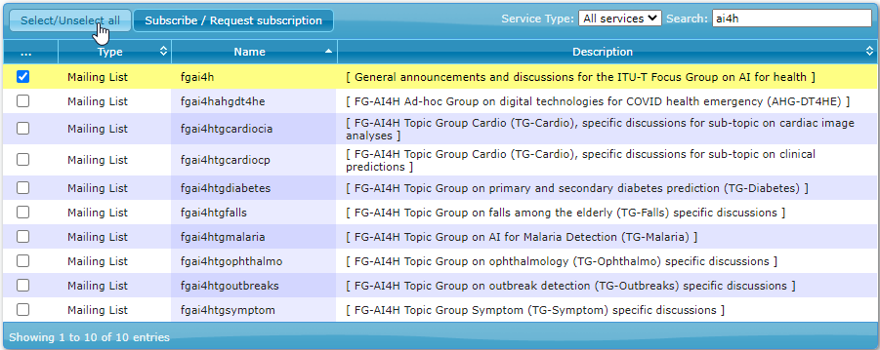
Figure 1: Subscribe to the general mailing list (and to topic group mailing lists)

Participate in our workshops/meetings
Visit our website https://itu.int/go/fgai4h for up-to-date information about the upcoming workshops and "all-hands" meetings (incl. dates, locations, visa support letters and logistics). Our website directs you to the registration page for the upcoming meeting (direct link: https://itu.int/go/fgai4h/reg). For the registration, you will need to login with your ITU user account (see above in clause 3). Participation in our workshops/meetings is free of charge and open to all. On our website, you can also find information about travel grants for priority regions and about the option to participate remotely.
Table 1: FG-AI4H meetings and workshops
A | Geneva, Switzerland, 25-27 September 2018; WHO
B | New York City, USA, 14-16 November 2018; Columbia University
C | Lausanne, Switzerland, 22-25 January 2019; EPFL
D | Shanghai, China, 2-5 April 2019; China Academy of Information and Communication Technology
E | Geneva, Switzerland, 29 May-1 June 2019; ITU
F | Zanzibar, Tanzania, 2-5 September 2019; Universal Communications Service Access Fund of Tanzania,
G | New Delhi, India, 12-15 November 2019; Indian Council of Medical Research & National Institute of Communication Finance
– | DASH/DAISAM Workshop, Berlin, Germany, 8-9 January 2020
H | Brasilia, Brazil, week of 20-24 January 2020; PAHO/WHO
– | WG-RC meeting, Online 4-5 May 2020
I | Online, 7-8 May 2020
 | WG-RC orientation workshop to FGAI4H, Online, 8 July, 2020
J | Online, 30 September – 2 October 2020
– | Workshop on Clinical Evaluation of AI for health, Online, 14 October 2020

NOTE – It is currently uncertain to plan future physical meetings due to the COVID-19 pandemic. Online events will be scheduled as needed and listed in the FG-AI4H website.

Organization

Management team
Chairman: Thomas Wiegand (Fraunhofer HHI, Germany)
Vice-Chairmen:
- Stephen Ibaraki (ACM and REDDS Capital, USA)
- Ramesh Krishnamurthy (WHO)
- Naomi Lee (The Lancet, UK)
- Sameer Pujari (WHO)
- Manjula Singh (ICMR, India)
- Shan Xu (CAICT, China)

Working groups, topic groups and ad-hoc group
Two types of sub-groups are generating the main output documents (deliverables): working groups (WGs) and topic groups (TGs). Both groups interact with each other. Different versions of deliverables are iteratively improved over time until they are completed to undergo an internal and external peer review process to be finally approved by FG-AI4H.
Working groups (WGs) consider crosscutting subject matters that affect a specific aspect of an AI health application. The deliverables of the working groups address ethical, regulatory, data handling and assessment methods, and clinical evaluation considerations in the context of AI for health.
Present WGs include:
- Clinical evaluation of AI for health (WG-CE)
- Ethical considerations of AI for health (WG-Ethics)
- Data and AI solution assessment methods (WG-DAISAM)
- Data and AI solution handling (WG-DASH)
- Operations (WG-O)
- Regulatory considerations on AI for health (WG-RC)

Topic groups (TGs) take charge of specific health domains with corresponding AI/ML tasks. They are providing the connection of the WGs with actual health topics and the specific problems involved with a number of AI for health tasks and data modalities. In each topic group, different stakeholders, including competing companies, with a common interest in the topic are working together. Present TGs include:
- Cardiovascular disease risk prediction (TG-Cardio)
- Dermatology (TG-Derma)
- Diagnosis of bacterial infection and antimicrobial resistance (TG-Bacteria)
- Falls among the elderly (TG-Falls)
- Histopathology (TG-Histo)
- Malaria detection (TG-Malaria)
- Maternal and child health (TG-MCH)
- Neurological disorders (TG-Neuro)
- Ophthalmology (TG-Ophthalmo)
- Outbreak detection (TG-Outbreaks)
- Psychiatry (TG-Psy)
- Radiology (TG-Radiology)
- Snakebite and snake identification (TG-Snake)
- Symptom assessment (TG-Symptom)
- Tuberculosis (TG-TB)
- Volumetric chest computed tomography (TG-DiagnosticCT)
- Dental diagnostics (TG-Dental)
- AI-based detection of falsified medicine (TG-FakeMed)
- Primary and secondary diabetes prediction (TG-Diabetes)
- Endoscopy (TG-Endoscopy)

Figure 2 illustrates the collaboration within the topic- and working groups of FG-AI4H. The topic groups ("vertical") represent various use cases dedicated to a special health topic. They perform the benchmarking for an AI task following the requirements defined by the working groups ("horizontal"). The working groups play a ‘crosscutting’ role and affect all topic groups with their considerations about data and AI solution methods- and handling, ethics, regulatory, and clinical evaluation.
Figure 2: Interaction between working groups (‘horizontal’) and topic groups (vertical’)
FG-AI4H also created an ad hoc group on digital technologies for COVID health emergency (AHG-DT4HE) that will collect effective ways and cases on AI and other digital technologies to combat COVID-19 covering the entire cycle of an epidemic emergency. Outputs are expected to evolve towards a more generalizable mechanism on the health emergency continuum, eventually applicable to other pandemics.

Deliverables [2]
The main output documents (deliverables) of FG-AI4H are produced in joint effort by FG-AI4H members participating in the working groups and topic groups. Figure 3 provides an overview of all deliverables and their relation to each other.
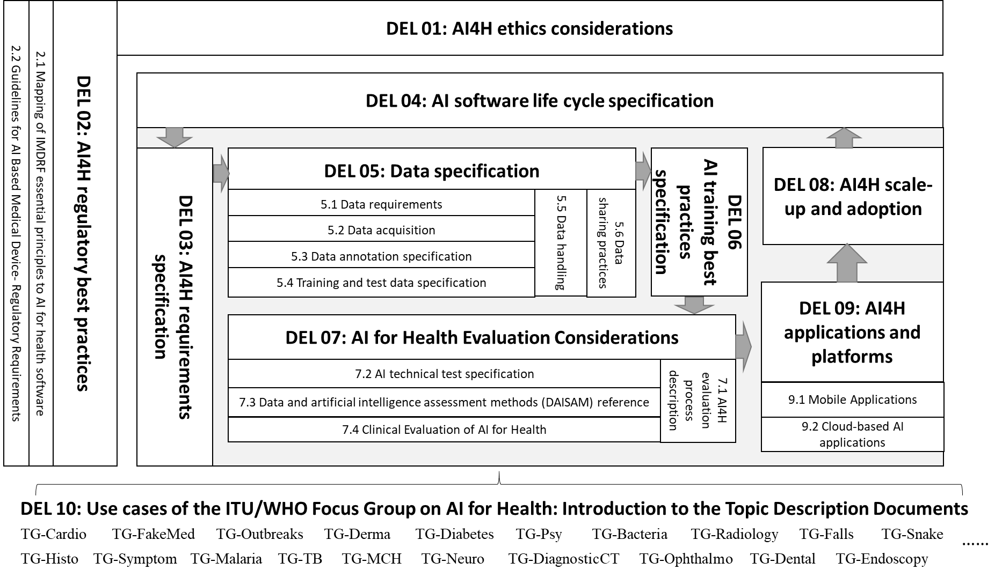
Figure 3: Overview of the structure of the deliverables and their relation to each other

Participate in a working group
You can ask the secretariat (tsbfgai4h@itu.int) for an introduction to the respective chair of the working group of your interest. Please use a descriptive email subject (e.g. "Participation in working group X"), briefly introduce yourself, describe your relevant expertise, and explain your interest in the working group.

Participate in one of the existing topic groups
Visit our website https://itu.int/go/fgai4h and select the topic group you want to join. Each topic group has its own page on our website where you find more information in a "Call for Topic Group Participation" including instructions how to "Get involved". Once you are a member of the topic group of your interest, you can contribute to the work of the topic group, which is centred around the writing of a topic description document, as main outcome and deliverable of each topic group. The process is moderated by a so called "topic driver". The time and effort you want to allocate can be arranged individually. Several topic groups communicate over separate mailing lists. You can subscribe to the mailing list of your choice on https://itu.int/go/fgai4h/lists.

Working method / contribute / propose a new "AI for Health" topic
The working method of FG-AI4H is centred around documents. FG-AI4H members (= you) can submit "input documents" to the bimonthly meetings, where the authors are expected to present the document and respond to questions raised by FG-AI4H members. The presentations can be accompanied by PowerPoint or PDF slides (optional). All documents are published in our collaboration site (see below). In this way, the work of the group is transparently documented. The group can decide to turn some documents into so called "output documents".
If you want to submit a document on any subject matter, please follow these instructions (please keep in mind the deadline published on https://itu.int/go/fgai4h):
- Use this template for your document submission: https://itu.int/en/ITU-T/focusgroups/ai4h/‌Documents/FGAI4H-Doc-template.docx
- Submit your document by e-mail to: tsbfgai4h@itu.int
- Please submit a Word file, not a PDF (additional attachments and slides are OK).
If you want to propose a new "AI for Health" topic, simply follow these instructions: https://itu.int/en/ITU-T/focusgroups/ai4h/Documents/FGAI4H-G-102-CfP_UC_Benchm_Data.pdf. Briefly, you will need to respond to eleven questions listed in the PDF, submit the document to tsbfgai4h@itu.int and give a presentation at the next meeting and answer questions.

Online collaboration tools
Our general mailing list (fgai4h@lists.itu.int) serves as the main channel for communication (subscribe to the "fgai4h" mailing list on https://itu.int/go/fgai4h/lists).
You can attend our workshops and meetings not only physically but also remotely via internet (e.g. with ITU's MyMeetings tool at https://remote.itu.int or Zoom). You can find more information on the main website https://itu.int/go/fgai4h, usually a few days prior to the event.
ITU has equipped us with several collaboration tools, centred around our collaboration site.
Collaboration site – direct link: https://www.itu.int/go/fgai4h/collab
Access this page with your ITU user account (see above).
You can navigate to this site also from our main webpage: https://itu.int/go/fgai4h
All documents of all meetings are stored in the collaboration site, organized by FG-AI4H meeting, see §11.
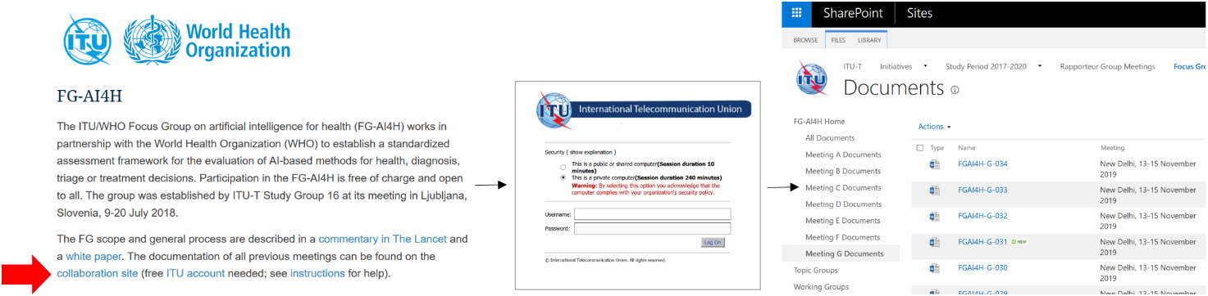
Figure 3: Access our collaboration site from the main webpage with your ITU user account

Topic/working groups can use dedicated workspaces in our collaboration site for file sharing and collaborative document editing (similar to "Google Drive/Docs"). On the left side of the collaboration site, you will find folders for "topic groups" and "working groups". Topic drivers and working group chairs can upload/create/edit the files and give other users edit rights using the "Share" button. Everyone with an ITU user account can view the files and can get granted access. The topic driver/working group chair can select the specific persons.
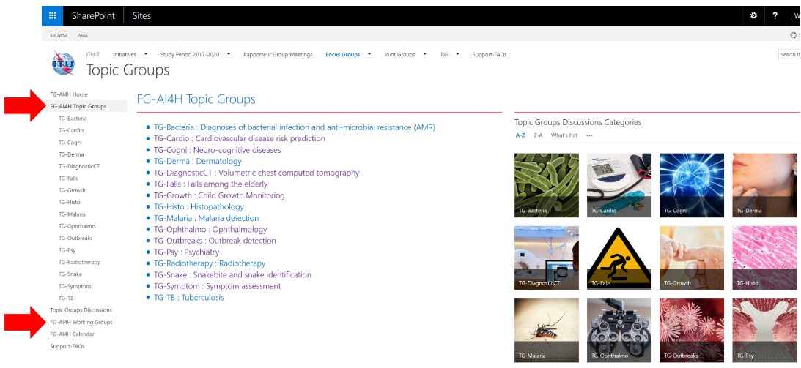
Figure 4: Workspaces for topic/working groups in the collaboration site
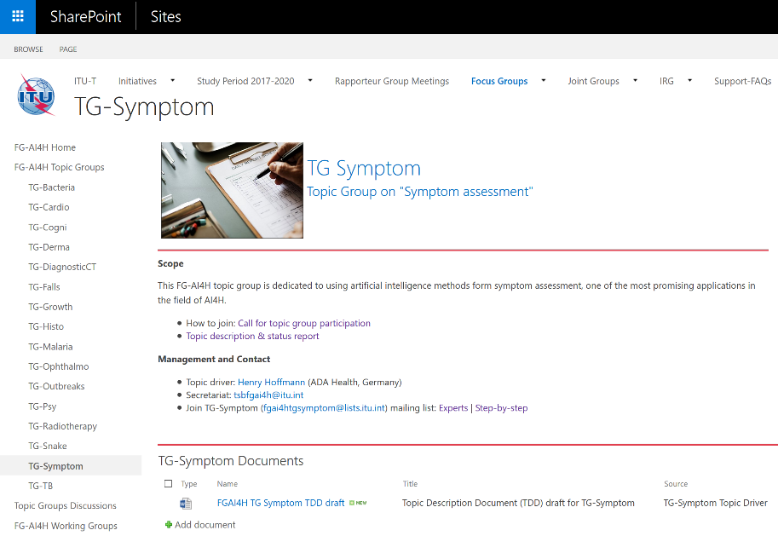
Figure 5: Workspace of one topic group as example
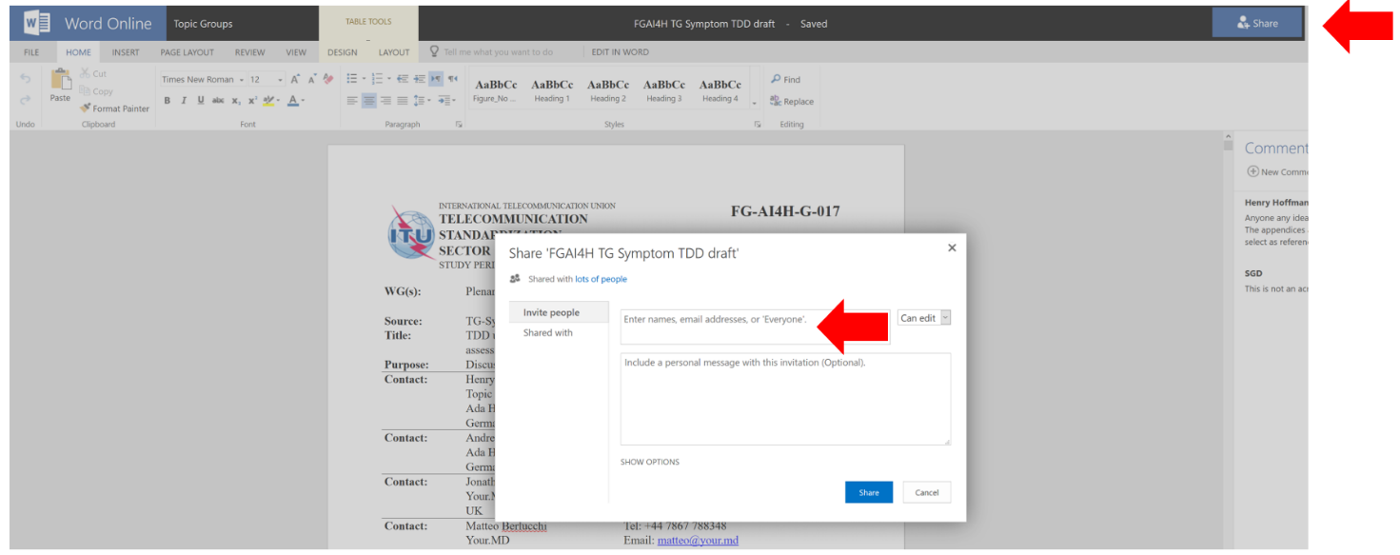
Figure 6: Word online in the workspace of one topic group on the collaboration site. Invite others with the “Share” button
Topic/working groups can use our Zoom meeting room for online meetings: https://itu.zoom.us/my/‌fgai4h. Topic drivers and Working Group chairs are responsible for booking the meeting room. Please look for a free time slot in the calendar in the collaboration site and enter your meeting directly in the calendar (with the aforementioned link as location). Time zone of the calendar is Geneva time – either Central European Time (CET) or Central European Summer Time (CEST).
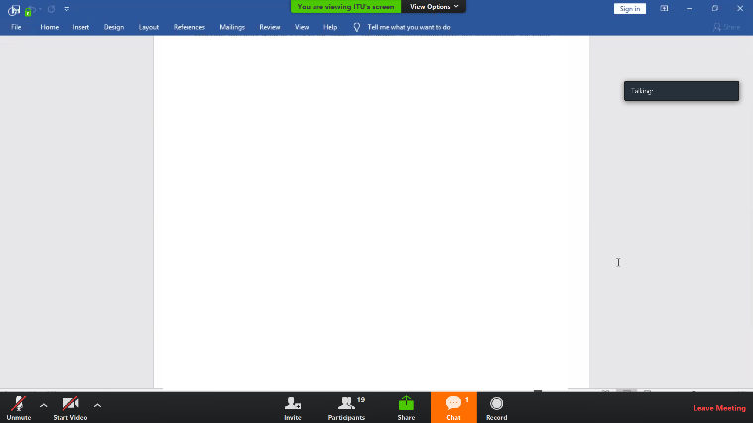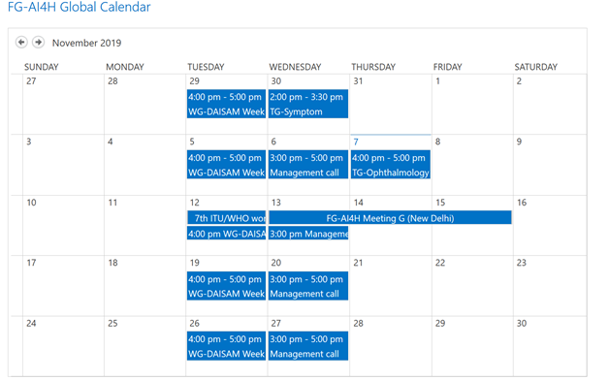
Figure 7: Zoom meeting room (left) can be booked in calendar in collaboration site (right)

Topic/working groups can create their own mailing lists. Topic drivers and working group chairs can contact the Secretariat (tsbfgai4h@itu.int) to create the list. Focus group members can sign up to the list of their choice by subscribing on https://itu.int/go/fgai4h/lists with their ITU user account.

Documentation
All the documentation of the FG-AI4H is stored in the collaboration area, which requires you to log in using a (free) ITU account.
Documents reviewed and produced at FG-AI4H "all-hands" meetings are organized by meeting (designated by letters – A, B, C, etc), and stored in specific folders. The right side of Figure 3 illustrates how to access these online folders.
TGs, WGs and the AHG have their own documentation and sub-pages in the FG-AI4H Collaboration area. These groups have a faster pace and meet (normally online) more frequently than the all-hands meetings.

References

[1] Whitepaper for the ITU/WHO Focus Group on Artificial Intelligence for Health, FG-AI4H, 2020-10. https://itu.int/en/ITU-T/focusgroups/ai4h/Documents/FG-AI4H_Whitepaper.pdf
[2] WHO and ITU establish benchmarking process for artificial intelligence in health.
The Lancet, 394(10192), 9-11. https://doi.org/10.1016/S0140-6736(19)30762-7
[3] Draft FG-AI4H Deliverables, Overview (2020).
https://extranet.itu.int/sites/itu-t/focusgroups/ai4h/Deliverables/DEL00.docx

________________________

An archive version of the Plenary meeting documents is available externally (essentially, to enable indexing by web search engines). However, for the latest version of the documentation, always access the FG-AI4H collaboration site.

