|  |  |  |  |  |
| --- | --- | --- | --- | --- |
| ITU Logo | INTERNATIONAL TELECOMMUNICATION UNION  **TELECOMMUNICATION STANDARDIZATION SECTOR**  STUDY PERIOD 2017-2020 | | FG-AI4H-I-038 | |
| **ITU-T Focus Group on AI for Health** | |
| **Original: English** | |
| **WG(s):** | | Plenary | E-meeting, 7-8 May 2020 | |
| **DOCUMENT** | | | | |
| **Source:** | | Editors | | |
| **Title:** | | DEL02: Outline describing suggested topics for the FG-AI4H Working Group on regulatory considerations (Draft: April 2020) | | |
| **Purpose:** | | Discussion | | |
| **Contact:** | | Jackie Ma Fraunhofer HHI Germany | | Email: [jackie.ma@hhi.fraunhofer.de](mailto:jackie.ma@hhi.fraunhofer.de) |
| **Contact:** | | Khair ElZarrad FDA USA | | Email: [Mohammed.ElZarrad@fda.hhs.gov](mailto:Mohammed.ElZarrad@fda.hhs.gov) |

|  |  |
| --- | --- |
| **Abstract:** | This document is the current draft of the deliverable 2 on “Regulatory considerations for AI for health”. The presented document is a high-level, educational overview of some of the key regulatory considerations that can be used as a preliminary framework that can be further developed by the WG-RC together with other stakeholders. |

|  |  |  |  |  |
| --- | --- | --- | --- | --- |
|  | | **International Telecommunication Union** | | |
|  | |  | | |
| **ITU-T** | **FG-AI4H Deliverable** | |
| TELECOMMUNICATION STANDARDIZATION SECTOR OF ITU | | (draft - 30 04 2020) |
|  |  | | | |
|  | **DEL02 Outline Describing Suggested Topics for the Regulatory Considerations on AI for Health Working Group** | | | |
|  |  | | | |

Summary

This document presents regulatory considerations that can be used as a preliminary framework for further discussion by different stakeholders. The high-level overview should further foster the dialogue between different audiences such as developers and regulators. A not fully inclusive list of topics that is presented in this document contains the following topics:

* Pre-specification, Documentation, Transparency, and Traceability as Part of a Quality System
* Risk Management
* Total Product Lifecycle Approach
* Relevance and Suitability of the Intended Use
* Data Quality
* Analytical and Clinical validation
* Ethics and Privacy
* Engagement

Keywords

Regulatory considerations

Change Log

This document is an updated version of the Deliverable 2 “AI4H regulatory best practices” approved at the ITU-T Focus Group on AI for Health (FG-AI4H) meeting held in New Delhi, 13-15 November 2019.

|  |  |  |  |  |
| --- | --- | --- | --- | --- |
| **Editor:** | Jackie Ma Fraunhofer HHI Germany | | Email:  jackie.ma@hhi.fraunhofer.de | |
|  | Khair ElZarrad FDA USA | | Email: Mohammed.ElZarrad@fda.hhs.gov | |
|  | |  | |

|  |  |  |
| --- | --- | --- |
| **Contributors:** | Naomi Lee Lancet UK | Email:  naomi.lee@lancet.com |
|  | Rose Purcell FDA USA | Email: Rosemarie.Purcell@fda.hhs.gov |
|  | Judith Van Andel WHO | Email:  jvan@who.int |
|  | Sameer Pujari WHO | Email:  pujaris@who.int |

**CONTENTS**

| Page |
| --- |
| 1 Scope 4  2 References [ADD REFERENCES] 4  3 Terms and definitions 4  3.1 Terms defined elsewhere 4  4 Abbreviations 5  5 Conventions of some regulatory considerations for AI for health 5  5.1 Scope and structure of the field of AI for health 5  5.2 Definitions in evaluation and assessment of health applications 6  6 Introduction & Purpose 6  7 Discussion: Regulatory Considerations (not fully inclusive) 7  7.1 Pre-specification, Documentation, Transparency, and Traceability as Part of a Quality System 7  7.2 Risk Management 7  7.3 Total Product Lifecycle Approach 8  7.4 Relevance and suitability of the intended use 9  7.5 Data quality 9  7.6 Analytical and clinical validation 10  7.7 Ethics and privacy 10  7.8 Engagement 10  7.9 Other 11  8 Practical implications of regulating and assessing AI for health in low-resource settings 11 |

**List of Figures**

| Page |
| --- |
| Figure 1: Spectrum of development and healthcare delivery [1] 5  Figure 2: Domains of health technology regulation, assessment and management for drugs and devices [2] 6  Figure 3: SaMD IMDRF risk categorization [3] 8  Figure 4: Overlay of FDA’s TPLC approach on AI/ML workflow [4] 9 |

**List of Tables**

| Page |
| --- |
| **No table of figures entries found.** |

ITU-T FG-AI4H Deliverable 2

Outline describing suggested topics for the regulatory considerations on AI for health working group

Summary

This document presents regulatory considerations that can be used as a preliminary framework for further discussion by different stakeholders. The high-level overview should further foster the dialogue between different audiences such as developers and regulators. A not fully inclusive list of topics that is presented in this document contains the following topics:

* Pre-specification, Documentation, Transparency, and Traceability as Part of a Quality System
* Risk Management
* Total Product Lifecycle Approach
* Relevance and Suitability of the Intended Use
* Data Quality
* Analytical and Clinical validation
* Ethics and Privacy
* Engagement

# Scope

This deliverables document has broad scope in order to be accessible for a wider audience. The non-inclusive list of topics for regulatory considerations in this document can be used as an overview of preliminary basic concepts that are key in regulatory aspects of AI in health.

# References [ADD REFERENCES]

1. WHO Document [add cite]
2. WHO Document [add cite]
3. “Software as a Medical Device”: Possible Framework for Risk Categorization and Corresponding Considerations,” <http://www.imdrf.org/docs/imdrf/final/technical/imdrf-tech-140918-samd-framework-risk-categorization-141013.pdf>
4. " FDA, Proposed Regulatory Framework for Modifications to Artificial Intelligence/Machine Learning (AI/ML)—Based Software as a Medical Device(SaMD),” <https://www.fda.gov/media/122535/download>
5. “Software as a Medical Device (SAMD): Clinical Evaluation,” <http://www.imdrf.org/docs/imdrf/final/technical/imdrf-tech-170921-samd-n41-clinical-evaluation_1.pdf>

# Terms and definitions

## Terms defined elsewhere

This document uses the following terms defined elsewhere:

**3.1.1** **Software as a Medical Device** [1]: Software intended to be used for one or more medical purposes that perform these purposes without being part of a hardware medical device Terms defined here

This document defines the following terms:

**3.2.1 AI Solution:** For the purposes of this document, “AI solutions” includes multiple technologies such as machine learning (ML), deep learning, computer vision, neural networks, and natural language processing (NLP) that, individually or in combination, add intelligence to applications.

# Abbreviations

|  |  |
| --- | --- |
| AI | Artificial intelligence |
| AI4H | Artificial intelligence for health |
| FDA | Food and Drug Administration |
| IMDRF | International Medical Device Regulators Forum |
| ITU | International Telecommunication Union |
| SaMD | Software-as-a-medical device |
| WG-RC | Working group on Regulatory considerations |
| WHO | World Health Organization |
| ML | Machine Learning |
|  |  |

# Conventions of some regulatory considerations for AI for health

## Scope and structure of the field of AI for health

Many health-related AI solutions already exist or are continuously being developed to meet a variety of stakeholders’ needs in healthcare and therapeutic development. These solutions have wide-ranging uses across the spectrum of development and healthcare delivery:

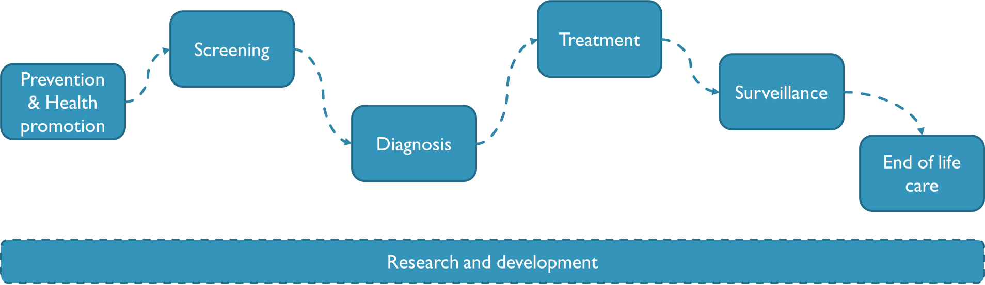

Figure 1: Spectrum of development and healthcare delivery [1]

Regulatory considerations may vary depending on a number of factors, including the context of use and the risks involved. This is mainly due to the different levels of risk to end-users and the type of assessment and evaluation that is relevant (see also discussion of these specific considerations under section III). A framework categorizing potential applications of AI solutions will be helpful in determining what regulatory considerations are applicable and how to implement such considerations. Examples of types of applications are (not fully inclusive):

* Devices and applications using AI solutions in the prevention/health promotion space. For example, AI solutions that support patients throughout the phases of the disease, such as supporting adherence to therapeutics, enhancing communication capabilities with care providers, etc.
* AI solutions that aid in early drug discovery, modelling, and prediction
* AI solutions that support therapeutic development, including supporting medical device and drug development, diagnostics, therapeutic determination, and clinical decision making, such as:
* AI solutions that facilitate clinical studies and clinical evaluations
* AI solutions that support diagnostics and disease staging efforts
* AI solutions that support the determination of appropriate therapeutics and course of therapy

*Two to three use cases can be introduced in this section that will be used to illustrate the discussed concepts throughout the document to clarify implications of the discussed considerations.*

## Definitions in evaluation and assessment of health applications

In principle, regulatory mechanisms are in place to answer the question: Do the available data (included in regulatory submission) support the conclusion that an investigational or experimental therapeutic is safe and effective to justify entry into the market and public access? This is typically determined by assessing if the use of the solution is safe (will not harm the user) and if the claims made about the performance are robust (efficacy). In this document a broader view on regulatory and assessment considerations is given, aiming to also provide a general overview of regulatory considerations.



Figure 2: Domains of health technology regulation, assessment   
and management for drugs and devices [2]

# Introduction & Purpose

Artificial Intelligence (AI)—the phenomenon of machines being able to solve problems that require human intelligence—has recently seen an enormous rise of interest due to the recognition of its great potential. With the increasing availability of healthcare data and the rapid progress of analytics techniques, AI has the potential to transform the health sector, one of the most important sectors for societies and economies worldwide. To facilitate the safe and appropriate development and use of AI solutions for health, the International Telecommunication Union (ITU) and the World Health Organization (WHO) have established a focus group on “Artificial Intelligence for Health” (FG-AI4H) that is focusing on the evaluation of health AI solutions. To support its work, FG-AI4H created several working groups, including a working group on regulatory considerations on AI for health (WG-RC).

The WG-RC consists of multiple stakeholders including representatives from regulatory agencies, academia, and industry who will explore regulatory considerations and emerging “best practices” for the development and use of AI in healthcare and therapeutic development. The WG-RC also has the dual purpose of informing the work of the FG-AI4H, as well as other stakeholders. The deliverable of the WG-RC will be a high-level, educational overview of some of the key regulatory considerations. *This draft outline is meant to provide the WG-RC with a preliminary framework for its work.*

Recognizing that a single document cannot address the specifics of the various AI solutions that can be used for therapeutic development or healthcare applications generally, the WG-RC's overview will highlight some of the key regulatory principles and concepts, such as risk/benefit assessments and considerations for the evaluation and monitoring of the performance of AI solutions.Throughout the process, the WG-RC will take into consideration different stakeholder perspectives, as well as different global and regional settings. This outline and WG-RC's final overview are not intended to be guidances, regulations, or policies. Rather, they are meant as resources that can be considered by regulators who might be in the process of identifying approaches to manage and facilitate AI solutions, developers who are exploring AI solutions, and other stakeholders.

# Discussion: Regulatory Considerations (not fully inclusive)

As mentioned previously, AI solutions may be utilized across all aspects of health care and therapeutic development. Regulators are keen not only to ensure that AI solutions used in healthcare and therapeutic development are safe and effective for intended use, but also that such promising tools reach those who need them as fast as possible. Dialogue between developers and regulators is highly advised as the community at large is continuing to establish a common understanding around the use of the AI solutions in health. The following are examples of regulatory considerations that may be relevant to all involved stakeholders.

1. Pre-specification, Documentation, Transparency, and Traceability as Part of a Quality System
2. Risk Management
3. Total Product Lifecycle Approach
4. Relevance and Suitability of the Intended Use
5. Data Quality
6. Analytical and Clinical validation
7. Ethics and Privacy
8. Engagement
9. Other

## Pre-specification, Documentation, Transparency, and Traceability as Part of a Quality System

Prespecifying and documenting the development, validation, and piloting of AI solutions are important factors that will help establish trust and confidence and guard against biases and data dredging. It is important for regulators to be able to trace back the development process and to have evidence and documentation of essential steps and decision points. For example, the selection and preprocessing of input data for AI solutions are essential decisions and documented evidence, based on scientific and practical bases, should be used to support these decisions.

It is also important to note that systems used to track and document development processes and key decision points should be designed to protect against data manipulation and adversarial attacks, and to track and record access and any changes applied.

Overall, transparency and effective documentation are essential for AI solutions and systems that may be subject to regulatory review.

## Risk Management

The controls and measures put in place to ensure that an AI solution functions as expected while minimizing any risk should be proportional to the risks that could be imposed if the AI solution were to malfunction. For example, failure of an AI solution that is designed to encourage adherence to a healthy diet is different than one that is designed to diagnose or treat certain diseases and pathologies.

Therefore, developers should consider a risk-based approach throughout all involved processes to prioritize safety. Developers need to consider the intended use of the AI solution and the clinical context, if appropriate, to evaluate the level of risk. For example, the International Medical Device Regulators Forum’s (IMDRF) risk framework identifies two major factors that contribute to the impact or risk of the Software as a Medical Device (SaMD). The first factor is the significance of the information provided by the SaMD to the healthcare decision. The significance is determined by the intended use of the information – to treat or diagnose, to drive clinical management, or to inform clinical management. The second factor is the state of the healthcare situation or condition, which is determined by the intended user, disease or condition, and the population for the SaMD – critical, serious, or non-serious healthcare situations or conditions. Taken together, these factors describing the intended use can be used to place the AI/ML-based SaMD into one of four categories from lowest (I) to highest risk (IV) to reflect the risk associated with the clinical situation and device use.

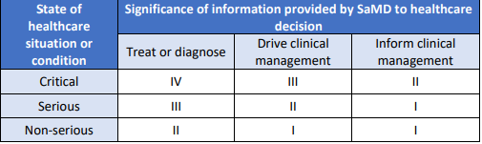

Figure 3: SaMD IMDRF risk categorization [3]

The intended use and risk classificationshould be considered when testing different models and balancing trade-offs, such as transparency and accuracy. In cases where training data sets are limited, simpler models, such as regression or decision tree models, often provide equivalent or better results than more complex models with the added benefit of more transparency and interpretability. On the other hand, in cases with larger, complex data sets, complex models, such as deep learning networks, may not lend themselves to being explainable but may provide greater accuracy than simpler models. In cases in which there is a greater risk of harm, stakeholders should consider discussing the risks and benefits of choosing a more complex model and whether there are ways to mitigate the lack of interpretability and transparency and build trust in the model through additional validation measures.

## Total Product Lifecycle Approach

AI/ ML solutions can be based on “locked” or “adaptive” algorithms. When an algorithm is locked, the algorithm provides the same result each time the same input data is applied to it and does not change or “learn” from new data. In contrast, an adaptive algorithm continuously learns from real-world experience and the output of the system for the same input data may be different before and after this learning occurs.

A lifecycle approach that involves good machine learning practices throughout the development and deployment of adaptive AI/ML solutions can facilitate continuous learning and product improvement while providing effective safeguards. This approach could potentially increase the trustworthiness and safety of the solution. For example, the U.S. Food and Drug Administration, based on IMDRF recommendations, has proposed a Total Product Lifecycle (TLPC) approach with four key components that qualify as good machine learning practices: 1) demonstration of a culture of quality and organizational excellence of the company producing the device; 2) premarket assurance of safety and effectiveness; 3) review of software as a medical device (SaMD) pre-specifications and algorithm change protocol; and 4) real-world performance monitoring.

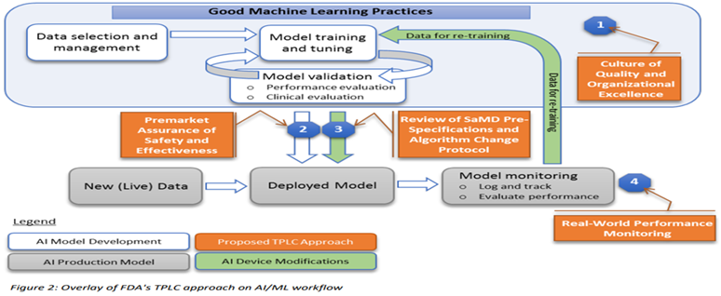

Figure 4: Overlay of FDA’s TPLC approach on AI/ML workflow [4]

## Relevance and suitability of the intended use

When developing an AI-health related tool, it is important for developers and other stakeholders to understand the complexity of the clinical and/or public health context in which the AI solution will be utilized. Developers of AI solutions should carefully consider all the facets of the problem they are attempting to address, including potential human-AI interactions. For example, they should consider the clinical context in which the AI solution is expected to be utilized, the expected interface (HCPs and/or patients), the potential for human error and the potential consequences of the error, the physiological and pathological complexity of the problem, and other potential errors and risks. Developers may want to consider addressing each aspect carefully, including outlining plans and procedures that address the context of use and ways to eliminate and/or manage potential risks.

## Data quality

High performing, robust AI models are often initially trained on carefully curated data sets. However, in many healthcare ecosystems, despite the availability of large amounts of data, access to relevant and quality data is difficult. Harmonizing data from different sources, standards, and formats into a single coherent dataset for the purpose of its comprehensive analysis is especially challenging when using healthcare data. For example, much of the data may lack interoperability and may not be in machine-readable formats. Therefore, developers should be aware of data quality limitations when attempting to curate and utilize these large-scale data sets.

Examples of factors that may affect the quality of health data include bias, missing values, outliers, and errors.Developers should consider deploying rigorous pre-release trials for AI solutions to ensure that they will not amplify biases and errors due to any issues with the training data, algorithms, or other elements of system design. If data quality issues are identified early, the resulting possible harm could potentially be ameliorated with careful design or prompt troubleshooting.

A challenge that often arises with AI solutions is that the algorithm and the data that support it are often not available or are only described by developers in a very general sense. This situation makes it difficult to assess the quality of the underlying data. Therefore, transparency and careful documentation not only for the methodology used in the collection of data, but also for the actual selection and modifications of datasets used for training, validation, and testing, are important. Such transparency and documentation would enable verification and traceability.

To mitigate the unique data quality issues that arise in healthcare data and the associated risks, stakeholders should continue to work to create data ecosystems to facilitate the sharing of good-quality data sources.

## Analytical and clinical validation

Developers can establish trust in their AI solution by performing well-documented technical and clinical validation steps throughout its lifecycle. For example, the IMDRF proposes a clinical evaluation framework that includes establishing a valid clinical association between the output and targeted clinical condition and analytical and clinical validation.

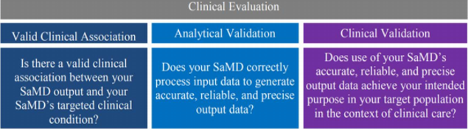

**Figure 5: IMDRF description of Clinical Evaluation components [5]**

## Ethics and privacy

The use of AI solutions and technologies for therapeutic development or healthcare applications presents considerable opportunities to advance medicine, but may also raise a number of scientific, social, and ethical challenges related to potential health risks involved, equitable access, privacy, appropriate uses and users, bias, and inclusiveness. Developers should carefully consider the potential scientific and ethical issues that may arise in the development and use of their AI solution, as well as how such systems can align with established ethical frameworks and scientific standards in medical research and clinical care.

Although the meaning of privacy varies according to context, environment, regional regulations, and society, data privacy presents a unique challenge for policymakers in any country wishing to benefit from the many opportunities of AI technologies. One of the main reasons for this is that the high dimensionality of big data could make it difficult to apply anonymization and de-identification methods. Additionally, securing large-scale data sets against unauthorized access at each stage of the development process – collection, storage and management, transport, analysis, and destruction – is an important consideration.

More than forty countries have enacted data protection regulations or information privacy laws and many other countries are in the process of enacting such laws. Therefore, when developing an AI solution for therapeutic development or healthcare applications, early in the development process developers should consider gaining an understanding of the applicable data protection regulations and privacy laws, including special regulatory provisions related to sensitive data, such as genetic data. Developers should be aware of the nuances of the different jurisdictions’ regulations and laws and consider documenting their data protection practices accordingly.

## Engagement

Stakeholder engagement, especially between regulators, developers, and health care policymakers to help establish a common understanding of the technology, its implications, and regulatory considerations will support the responsible development of AI-related health tools and enhance clarity throughout the process. Developers may want to consider engaging with regulators early in the development process to address any critical issues that may have regulatory implications and to ensure that they are accurately accounting for the complexity of the clinical and public health contexts of the AI solution’s intended use. In addition, such engagements throughout the process to address complicated questions that may arise, such as the adequacy of validation methods for less transparent models, may help provide further assurances of the safety and trustworthiness of the AI solution. These types of engagements could also potentially facilitate the approval of innovative AI solutions that could greatly benefit public health.

## Other

…

# Practical implications of regulating and assessing AI for health in low-resource settings

The utility of AI solutions holds great potential to advance health in low resource settings. Stakeholders should consider the possible challenges of the development and assessment of AI solutions in such settings. In this section, we will discuss practical implications of regulating and assessing AI for health in low-resource settings, such as:

1. Fully understanding the complexity of the healthcare needs in the specific setting.
2. Encouraging dialogue between all stakeholders to assure that the development of the AI solution is responsive to the needs and specifics of the setting.
3. Identifying and dedicating the needed resources to facilitate the development, testing, and deployment of the AI solution.
4. Determining the regulatory and governance needs to ensure that the AI solution is safe and effective.
5. Ensuring effective communication and collaboration between stakeholders to facilitate all of the processes.

Annex A  
Example of annex (important material essential to the completeness of the deliverable)

[ADD TEXT].

Appendix I  
Example of appendix (optional or informative material)

[ADD TEXT, IF ANY].

____________________________