 | INTERNATIONAL TELECOMMUNICATION UNION  TELECOMMUNICATION  STANDARDIZATION SECTOR  STUDY PERIOD 2017-2020 |  | FG-AI4H-I-037
 |  |  | ITU-T Focus Group on AI for Health
 |  |  | Original: English
WG(s): |  | DAISAM, DASH | E-meeting, 7-8 May 2020
DOCUMENT
Source: |  | WG Chairs
Title: |  | FG-AI4H assessment platform
Purpose: |  | Discussion
Contact: |  | Steffen Vogler  Bayer AG  Germany |  | Email: steffen.vogler@bayer.com
Contact: |  | Marc Lecoultre  mllab.ai  Switzerland |  | Email: ml@mllab.ai
Contact: |  | Luis Oala  Fraunhofer HHI  Germany |  | Email: luis.oala@hhi.fraunhofer.de

Abstract: | Since the DASH/DAISAM Workshop in Berlin in January 2020 we have been exploring options to implement an assessment platform that can be used to perform health AI evaluation for the different topic groups. So far, this has resulted in two code bases which we are currently working on: (a) custom assessment platform and (b) evalai-based assessment platform.

Since the DASH/DAISAM Workshop in Berlin in January 2020 we have been exploring options to implement an assessment platform that can be used to perform health AI evaluation for the different topic groups. So far, this has resulted in two code bases which we are currently working on: (a) custom assessment platform and (b) evalai-based assessment platform. Code repositories for both frameworks can be found and are maintained at:
https://dev.azure.com/mllabai/FG-AI4H%20Assessment%20Platform

(a) Custom Assessment Platform
https://dev.azure.com/mllabai/_git/FG-AI4H%20Assessment%20Platform

A basic manual for how to interact with the code can be found in the ReadMe of the repo. Currently it goes as follows:

1. Clone the repo
```shell
git clone https://gitlab.hhi.fraunhofer.de/fgai4h/assessment-platform.git
```

2. From directory run the below to build docker image
```shell
sudo docker build -t assessment-webservice .
```

3. Run the docker image
```shell
sudo docker run assessment-webservice
```

4. Run the docker image in interactive modes (for dev)
```shell
sudo docker run -it assessment-webservice /bin/bash
```

5. Get container id
```shell
sudo docker container ls
```

6. Pick container id and run the following to obtain container ip
```shell
sudo docker inspect "container id" | grep "IPAddress"
```

7. Query the running container for results (mock atm) using the container ip
```shell
curl --request POST 'http://172.17.0.2:5000/assessment_api/getResultMock' --data '{"image_path":"./testset/patch1.png"}' --header 'Content-type:application/json'
```

8. Run the full test scenario with CSV output for PDF creation
```shell
python Local_2_API.py <parentfolder-of-test-images>
```

9. Stop container
```shell
sudo docker stop $(sudo docker ps -aq)
```

10. Stop and Delete images to make space for new build
```shell
docker stop $(docker ps -aq) #Stop all running containers
docker rm $(docker ps -aq) #Remove all containers
docker rmi $(docker images -q) #Remove all images
```
Conceptually, the workflow looks as follows:
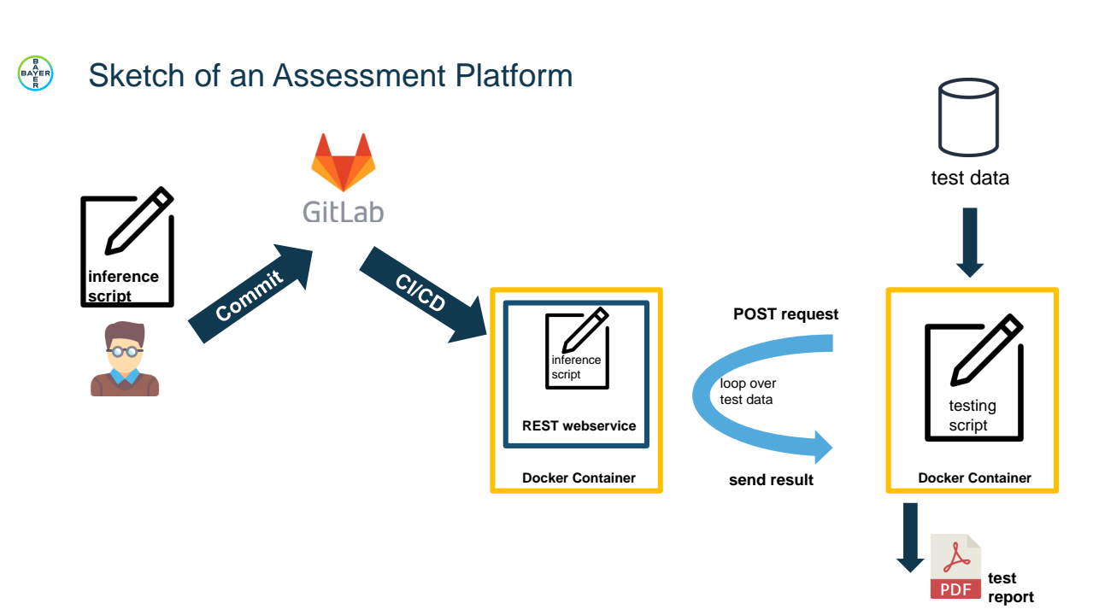
Figure 1 – Sketch of an assessment platform

(b) evalai-based Assessment Platform
https://dev.azure.com/mllabai/FG-AI4H%20Assessment%20Platform/_git/EvalAI.git
A basic manual for how to interact with the code can be found in the ReadMe of the repo. Currently it goes as follows:
- Preliminaries
  - Install Docker Install Docker Engine on Ubuntu
  - Install Docker CE https://docs.docker.com/compose/install/#install-using-pip
- Install evalai (reference: Installation — EvalAI 1.1 documentation)
  - git clone https://github.com/Cloud-CV/EvalAI.git evalai && cd evalai
  - docker-compose up –build
    - User GUI can be accessed at localhost:8888/
    - Admin GUI can be accessed at localhost:8000/admin

The platform currently knows the following user roles
Admin: someone who manages the evalai instance
Host: someone who hosts and manages a challenges on an evalai instance
User: someone who participates in a challenge and uploads preds/models to the platform

A full documentation is maintained at https://evalai.readthedocs.io/en/latest/index.html for reference.

Next Steps
We will announce our plans for the next steps at the upcoming meeting to discuss with the FG-AI4H plenary.

____________________________

