|  |  |  |  |  |
| --- | --- | --- | --- | --- |
| ITU Logo | INTERNATIONAL TELECOMMUNICATION UNION  **TELECOMMUNICATION STANDARDIZATION SECTOR**  STUDY PERIOD 2017-2020 | | | FG-AI4H-G-035-R01 |
| **ITU-T Focus Group on AI for Health** |
| **Original: English** |
| **WG(s):** | | WG-O | | New Delhi, 13-15 November 2019 |
| **DOCUMENT** | | | | |
| **Source:** | | WG-O Chair | | |
| **Title:** | | Draft: Onboarding document-ITU/WHO Focus Group on "AI for Health" | | |
| **Purpose:** | | Discussion | | |
| **Contact:** | | Markus Wenzel WG-Operations Chair Fraunhofer HHI, Germany | E-mail: [markus.wenzel@hhi.fraunhofer.de](mailto:markus.wenzel@hhi.fraunhofer.de) | |
| **Contact:** | | Eva Weicken Fraunhofer HHI, Germany | E-mail: [eva.weicken@hhi.fraunhofer.de](mailto:eva.weicken@hhi.fraunhofer.de) | |
| **Contact:** | | Elaine O. Nsoesie Boston University, USA | E-mail: [onelaine@bu.edu](mailto:onelaine@bu.edu) | |
| **Contact:** | | Clara Nordon Médecins Sans Frontières, France | E-mail: [clara.nordon@paris.msf.org](mailto:clara.nordon@paris.msf.org) | |
| **Contact:** | | Nada Malou Médecins Sans Frontière, France | E-mail: [nada.malou@paris.msf.org](mailto:nada.malou@paris.msf.org) | |
| **Contact:** | | Monique Kuglitsch Fraunhofer HHI, Germany | E-mail: [monique.kuglitsch@hhi.fraunhofer.de](mailto:monique.kuglitsch@hhi.fraunhofer.de) | |
| **Contact:** | | FG-AI4H Secretariat | E-mail: [tsbfgai4h@itu.int](mailto:tsbfgai4h@itu.int) | |

|  |  |
| --- | --- |
| **Abstract:** | This document explains how to get involved in the ITU/WHO focus group on "AI for Health" and serves as an onboarding guide for new interested parties and individuals. In this revised version R1, screenshots were added for illustration. |

[The idea is to publish this onboarding document as PDF on the website or send the PDF via mail to interested parties – *from pages 2 onwards, skipping this header page*.]

Onboarding document—ITU/WHO Focus Group "AI for Health"

# 1. What is it all about?

## Background

Healthcare can benefit considerably from artificial intelligence (AI) and machine learning (ML). However, the health domain only hesitantly adopts these powerful but complex innovations so far, because any technical fault can affect people's health, privacy, and consequently their entire lives. International standards are required for thoroughly validating AI solutions for health by benchmarking their performance. These standards might ultimately create well-founded trust in those AI solutions that have provided conclusive evidence to be accurate, fair, effective and reliable.

1. **Mission**

The mission of the ITU/WHO focus group "AI for Health" (FG-AI4H) is to undertake crucial exploratory steps towards evaluation standards for health AI tools that are applicable on a global scale. This approach offers substantial potential for synergies, because many national regulatory institutions, public health institutes, physicians, patients, developers, health insurances, licensees, hospitals, and other decision-makers around the globe can profit from a common, standardized benchmarking framework for AI and ML solutions for health. Scope and process of FG-AI4H are described in the following white paper and commentary:

White paper:[https://itu.int/en/ITU-T/focusgroups/ai4h/Documents/FG-AI4H_Whitepaper.pdf](https://www.itu.int/en/ITU-T/focusgroups/ai4h/Documents/FG-AI4H_Whitepaper.pdf)

WHO and ITU establish benchmarking process for artificial intelligence in health.   
*The Lancet*, 394(10192), 9-11. <https://doi.org/10.1016/S0140-6736(19)30762-7>

## 

## Goals

The FG-AI4H will pursue the following broad sets of goals, in order to establish a standardized assessment framework for the evaluation of AI-based methods for health:

* To be a platform to facilitate a global dialogue on AI for health.
* To collaborate with WHO in developing appropriate national guidance documents for establishing a policy-enabled environment to ensure the safe and appropriate use of AI in health.
* To identify standardization opportunities for a benchmarking framework that will enable the broad use of AI for health.
* To create a technical framework and standardization approach of AI for health algorithm assessment and validation.
* To develop open benchmarks, targeted to become international standards, and serve as guidance for the assessment of new AI for health algorithms.
* To develop, together with the WHO, an assessment framework for an evaluation and validation process of AI for health.
* To collaborate with stakeholders to monitor and collect feedback from the use of AI algorithms in the healthcare delivery environment, and to provide feedback to the development of improved international standards.
* To generate a transparent documentation by creating reports and specifications towards enabling external assessment of the benchmarking framework and the benchmarked AI for health methods.

# 2. Website and contact information

|  |
| --- |
| Our website with up-to-date information: [itu.int/go/fgai4h](http://www.itu.int/go/fgai4h)  Any questions and inquiries can be sent to the secretariat: [tsbfgai4h@itu.int](mailto:tsbfgai4h@itu.int) |

# 3. Get involved and become a member—create an ITU user account

First of all, everybody is invited to join the FG-AI4H. Participation is free of charge and open to all. Here are some helpful instructions on how to become a member by creating an ITU-account.

1. Visit [https://itu.int/en/ties-services/Pages/login.aspx](https://www.itu.int/en/ties-services/Pages/login.aspx)
2. Select "I am a new user" (next to "Logon'').
3. With "Create your user Account as'', select one of the listed options.   
   *If you don't know* about the ITU status of your organization, simply select "Non-ITU-Members-Media and Other Organizations"
4. Select "Create'', enter the details and complete the ITU user account registration.

Once your ITU user account is activated, you can:

* subscribe to our mailing list (see clause 4),
* register to upcoming workshops and meetings (see clause 5),
* get access to our collaboration site where you will find documents from all previous meetings and our internal, interactive workspace (see clause 10).

# 4. Subscribe to the mailing lists

It is helpful to subscribe to our mailing list for receiving updates and announcements, and for communication within the FGAI4H. Visit <http://itu.int/go/fgai4h-lists>, select the "fgai4h" mailing list and click "Subscribe". Now you can take part in the communication over [fgai4h@lists.itu.int](mailto:fgai4h@lists.itu.int).

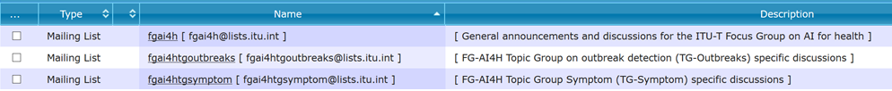

Figure 1: Subscribe to the general mailing list (and to topic group mailing lists).

# 5. Participate in our workshops/meetings

Visit our website <https://itu.int/go/fgai4h> for up-to-date information about the upcoming workshops and meetings (incl. dates, locations, visa support letters and logistics). Our website directs you to the registration page for the upcoming meeting (direct link:<https://itu.int/go/fgai4h/reg>). For the registration, you will need to login with your ITU user account (see above in clause 3). Participation in our workshops/meetings is free of charge and open to all. On our website, you can also find information about travel grants for priority regions and about the option to participate remotely via Internet.

Previous and future workshops/meetings:

1. WHO HQ, **Geneva**, Switzerland, 25-27 September 2018
2. Columbia University, **New York City**, USA, 14-16 November 2018
3. EPFL, **Lausanne**, Switzerland, 22-25 January 2019
4. China Academy of Information and Communication Technology,   
   **Shanghai**, China, 2-5 April 2019
5. Geneva Conference Center (CICG), **Geneva**, Switzerland, 29 May-1 June 2019
6. Universal Communications Service Access Fund of Tanzania, **Zanzibar**, Tanzania, 2-5 September 2019
7. Indian Council of Medical Research & National Institute of Communication Finance, **New Delhi**, India, 12-15 November 2019
8. **Brasilia**, Brazil, wee of 20-24 January 2020
9. TBD, March 2020-TBC
10. **Geneva**, Switzerland, May 2020

# 6. Organization

## Management team

Chairman: Thomas Wiegand (Fraunhofer HHI, Germany)

Vice-Chairmen:

* Stephen Ibaraki (ACM and REDDS Capital, USA)
* Ramesh Krishnamurthy (WHO)
* Naomi Lee (The Lancet, UK)
* Sameer Pujari (WHO)
* Manjula Singh (ICMR, India)
* Shan Xu (CAICT, China)

## Working groups and topic groups

Two types of sub-groups are generating the main deliverables: *working groups* (WGs) and *topic groups* (TGs).

***Working groups*** (WGs) consider crosscutting subject matters that affect a specific aspect of an AI for health application. Present WGs include:

* Data and AI solution assessment methods (WG-DAISAM)
* Data and AI solution handling (WG-DASH)
* Operations (WG-O)
* Regulatory considerations on AI for health (WG-RC)
* Health requirements (WG-HR)

***Topic groups*** (TGs) take charge of specific health domains with corresponding AI/ML tasks. They are providing the connection of the WGs with actual health topics and the specific problems involved with a number of AI for health tasks and data modalities. In each topic group, different stakeholders, including competing companies, with a common interest in the topic are working together. Present TGs include:

* Cardiovascular disease risk prediction (TG-Cardio)
* Child growth monitoring (TG-Growth)
* Diagnosis of bacterial infection and antimicrobial resistance (TG-Bacteria)
* Dermatology (TG-Derma)
* Falls among the elderly (TG-Falls)
* Histopathology (TG-Histo)
* Malaria detection (TG-Malaria)
* Neuro-cognitive diseases (TG-Cogni)
* Outbreak detection (TG-Outbreaks)
* Ophthalmology (TG-Ophthalmo)
* Psychiatry (TG-Psy)
* Radiotherapy (TG-Radiotherapy)
* Snakebite and snake identification (TG-Snake)
* Symptom assessment (TG-Symptom)
* Tuberculosis (TG-TB)
* Volumetric chest computed tomography (TG-DiagnosticCT)

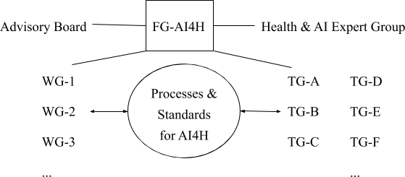

Figure 2: Organigram of the FG-AI4H with working groups (WGs) and topic groups (TGs)

# 7. Participate in a working group

You can ask our secretariat ([tsbfgai4h@itu.int](mailto:tsbfgai4h@itu.int)) for an introduction to the respective chair of the working group of your interest. Please use a descriptive e-mail subject (e.g. "Participation in working group X"), briefly introduce yourself, describe your relevant expertise, and explain your interest in the working group.

# 8. Participate in one of the existing topic groups

Visit our website <https://itu.int/go/fgai4h> and select the topic group you want to join. Each topic group has its own page on our website where you find more information in a "Call for Topic Group Participation" including instructions how to "Get involved". Once you are a member of the topic group of your interest, you can contribute to the work of the topic group, which is centered around the writing of a topic description document, as main outcome and deliverable of each topic group. The process is moderated by a so called "topic driver". The time and effort you want to allocate can be arranged individually. Several topic groups communicate over separate mailing lists. You can subscribe to the mailing list of your choice on <http://itu.int/go/fgai4h-lists>.

# 9. Working method / contribute / propose a new "AI for Health" topic

The working method of FG-AI4H is centered around documents. FG-AI4H members (= you) can submit "input documents" to the bimonthly meetings, where the *authors are expected to present* the document and respond to questions raised by FG-AI4H members. The presentations can be accompanied by PowerPoint or PDF slides (optional). All documents are published in our collaboration site (see below). In this way, the work of the group is transparently documented. The group can decide to turn some documents into so called "output documents".

If you want to submit a document on any subject matter, please follow these instructions (please keep in mind the deadline published on <https://itu.int/go/fgai4h>):

* Use this template for your document submission:  
  [https://itu.int/en/ITU-T/focusgroups/ai4h/Documents/FGAI4H-Doc-template.docx](https://www.itu.int/en/ITU-T/focusgroups/ai4h/Documents/FGAI4H-Doc-template.docx)
* Submit your document by e-mail to: [tsbfgai4h@itu.int](mailto:tsbfgai4h@itu.int)
* Please submit a Word file, *not* a PDF (additional attachments and slides are OK).

If you want to propose a new "AI for Health" topic, simply follow these instructions:  
[https://itu.int/en/ITU-T/focusgroups/ai4h/Documents/FGAI4H-F-102-CfP_UC_Benchm_Data.pdf](https://www.itu.int/en/ITU-T/focusgroups/ai4h/Documents/Archive/FGAI4H-F-102-CfP_UC_Benchm_Data.pdf). Briefly, you will need to respond to eleven questions listed in the PDF, submit the document to [tsbfgai4h@itu.int](mailto:tsbfgai4h@itu.int) and give a presentation at the next meeting and answer questions.

# 10. Online collaboration tools

Our general mailing list ([fgai4h@lists.itu.int](mailto:fgai4h@lists.itu.int)) serves as the main channel for communication (subscribe to the "fgai4h" mailing list on <http://itu.int/go/fgai4h-lists>).

You can attend our workshops and meetings not only physically but also remotely via internet (e.g. with Zoom). You can find more information on our webpage <https://itu.int/go/fgai4h>, usually a few days prior to the event.

## ITU has equipped us with several collaboration tools, centered around our collaboration site.

|  |
| --- |
| **Collaboration site**: <https://extranet.itu.int/sites/itu-t/focusgroups/ai4h/SitePages/Home.aspx>  Access this page with your ITU user account (see above).  You can navigate to this site also from our main webpage: <https://itu.int/go/fgai4h> |

All documents of all meetings are stored here.

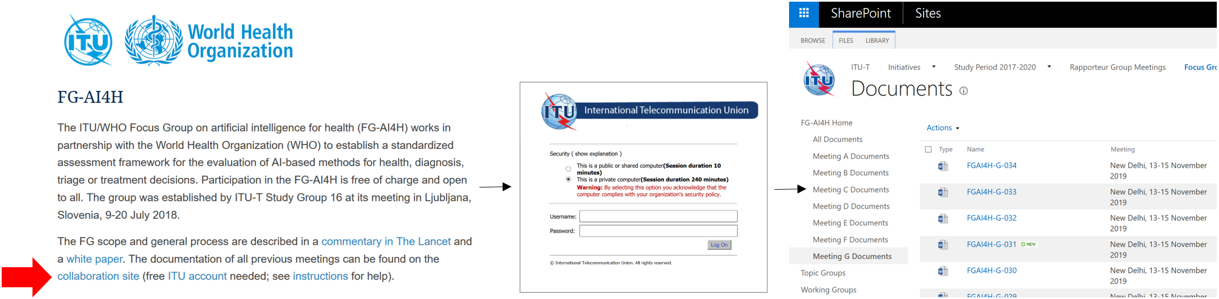

Figure 3: Access our collaboration site from [itu.int/go/fgai4h](https://itu.int/go/fgai4h) with your ITU user account.

Topic/working groups can use dedicated *workspaces in our collaboration site for file sharing and collaborative document editing* (similar to "Google Drive/Docs"). On the left side of the collaboration site, you will find folders for "topic groups" and "working groups". Topic drivers and working group chairs can upload/create/edit the files and give other users edit rights using the "Share" button. Everyone with an ITU user account can view the files and can get granted access. The topic driver/working group chair can select the specific persons.

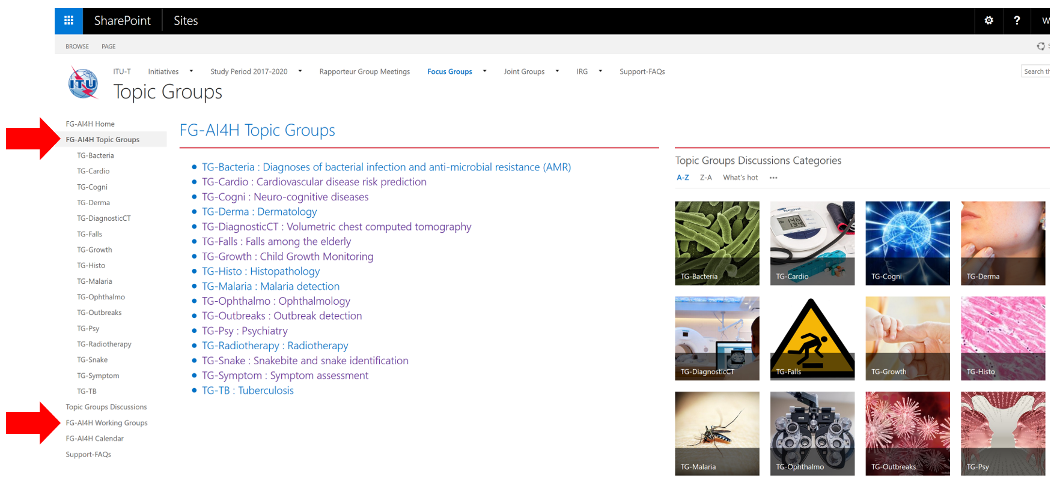

Figure 4: Workspaces for topic/working groups in the collaboration site.

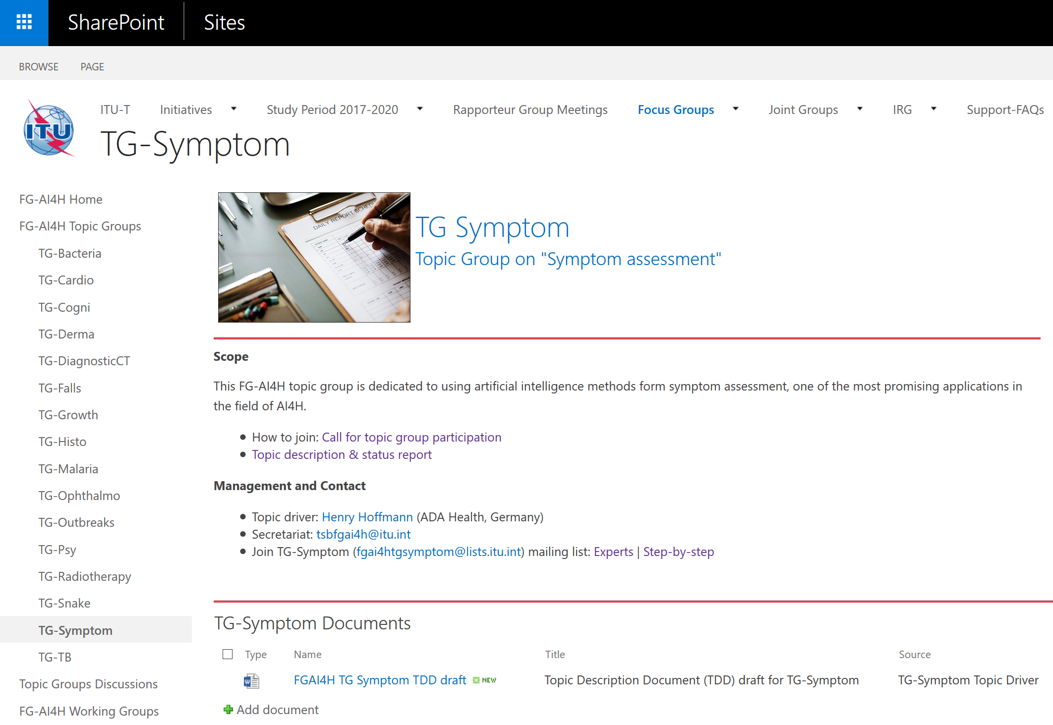

Figure 5: Workspace of one topic group as example.

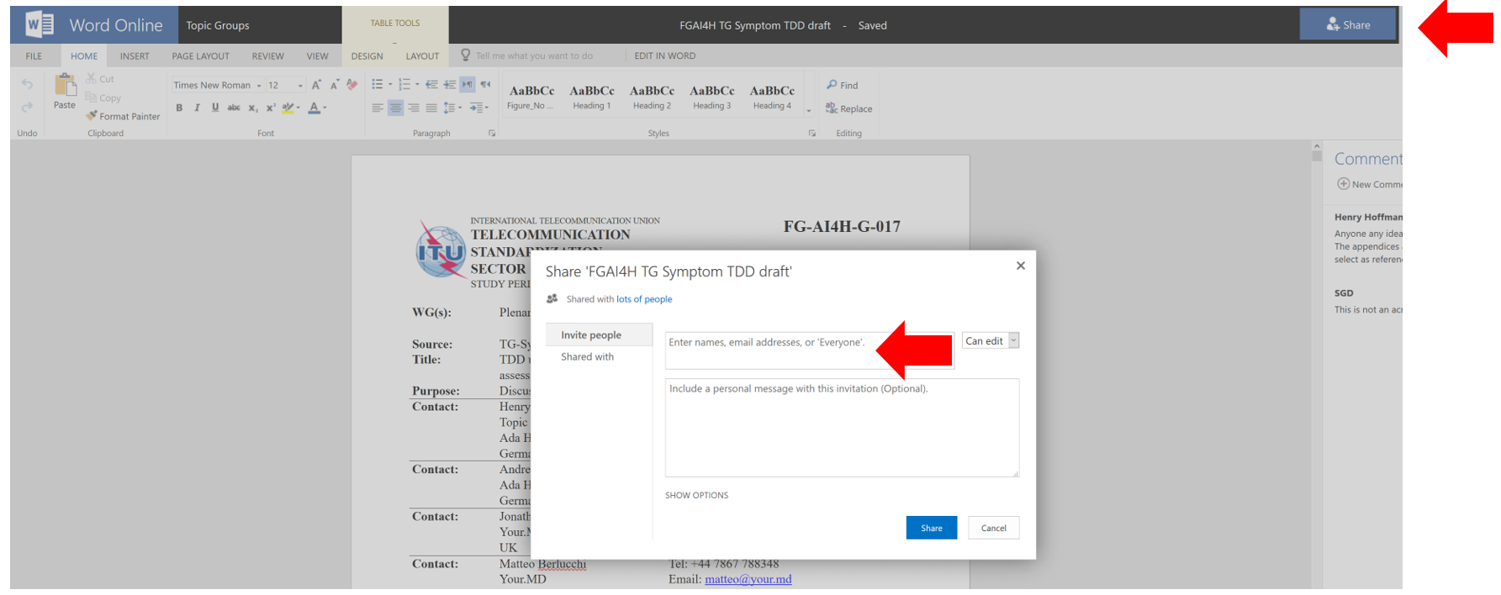

Figure 6: Word online in the workspace of one topic group on the collaboration site. Invite others with the “Share” button.

Topic/working groups can use our *Zoom meeting room for online meetings*:<https://itu.zoom.us/my/fgai4h>. Topic drivers and Working Group chairs are responsible for booking the meeting room. Please look for a free time slot in the calendar in the collaboration site and enter your meeting directly in the calendar (with the aforementioned link as location). Time zone of the calendar is Central European Time (CET).

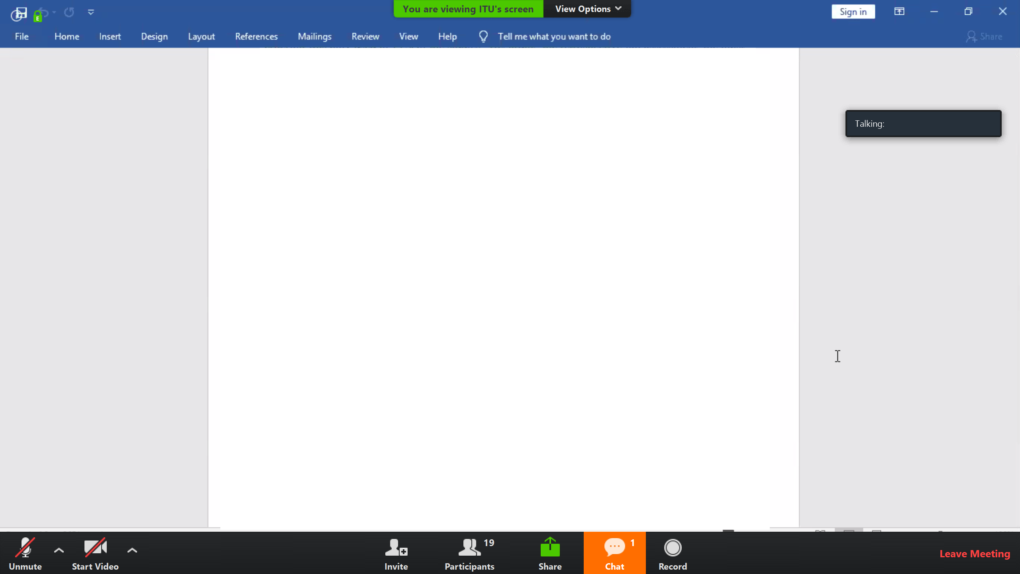 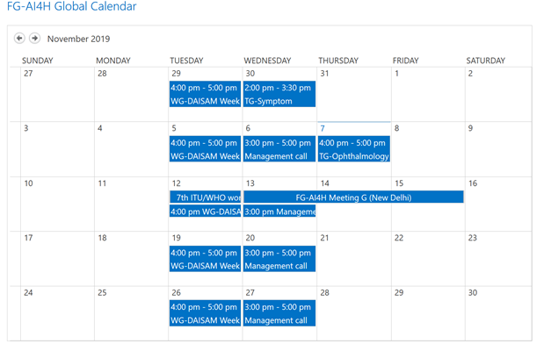

Figure 7: Zoom meeting room (*left*) can be booked in calendar in collaboration site (*right*).

Topic/working groups can create their own mailing lists. Topic drivers and working group chairs can contact the Secretariat ([tsbfgai4h@itu.int](mailto:tsbfgai4h@itu.int)) to create the list. Focus group members can sign up to the list of their choice by subscribing on<http://itu.int/go/fgai4h-lists> with their ITU user account.

Copyright note: Sections 1.a, 1.b and 6.b with the organigram originate from a conference contribution to appear in the conference proceedings or a journal. All rights remain with the authors: Wenzel, M. and Wiegand, T. (2019). Towards International Standards for the Evaluation of Artificial Intelligence for Health. *ITU Kaleidoscope Conference*. Atlanta, USA.