|  |  |  |  |  |
| --- | --- | --- | --- | --- |
| ITU Logo | INTERNATIONAL TELECOMMUNICATION UNION  **TELECOMMUNICATION STANDARDIZATION SECTOR**  STUDY PERIOD 2017-2020 | | FG-AI4H-G-029 | |
| **ITU-T Focus Group on AI for Health** | |
| **Original: English** | |
| **WG(s):** | | Plenary | New Delhi, 13-15 November 2019 | |
| **DOCUMENT** | | | | |
| **Source:** | | Ministry of Communications (India) | | |
| **Title:** | | Convergence of AI with Blockchain technology in Healthcare domain. | | |
| **Purpose:** | | Proposal | | |
| **Contact:** | | MC Sathish Kumar Ministry of Communications,  INDIA | | Tel: +91 9489917057 Email: [mc.sathish@gov.in](mailto:aminata.drame@orange-sonatel.com) |
| **Contact:** | | Kamal Kapoor Ministry of Communications INDIA | | Tel: +91 9426081947 Email: kamalkapoor13@gmail.com |

|  |  |
| --- | --- |
| **Abstract:** | This contribution proposes to explore the usage of Block chain and its associated technologies such as distributed ledger technology (DLT), smart contracts, etc in the AI applications for Health to enable the Trust, Transparency, Accountability & Security aspects. Hence, it is proposed that this Focus group may undertake a study and release a report on the convergence of AI with Blockchain technology in Healthcare sector, as a deliverable. |

**1 Introduction**

Convergence is a deep integration of knowledge, tools, and all relevant activities of human activity for a common goal, to allow society to answer new questions to change the respective physical or social ecosystem. Two of the most emerging and hotly discussed converged technologies are Artificial Intelligence and Blockchain Technology.

Artificial Intelligence is the outcome of various technologies, such as Big data analytics, machine to machine learning, 5G, IOT, getting linked together to provide an intelligent system to handle various applications.

The Blockchain technology marked the convergence of host of futuristic concepts like peer-to-peer (P2P) networks, cryptography, and shared computational power with consensus algorithms. All these concepts together enabled the Distributed Ledger Technology (DLT) which ensured trust, accountability and transparency of the chain of transactions, totally transforming the way data was handled.

Artificial intelligence and Blockchain are powerful individually, but combining the two may be the key to truly impactful big data analytics. The entire success of AI applications depends on integrity of the data behind it. Blockchain can act as the catalyst for providing a trusted data with inbuilt security. The convergence of Blockchain and AI for a better future

While AI has the potential to provide large incremental value to a wide range of sectors, adoption till date has been driven primarily from a commercial perspective. However, in critical social sectors like Healthcare, the focus should be on larger social good to provide easy access of affordable and quality healthcare instead of commercial benefits. In order to ensure a human touch in AI applications for Health sector, there is a need to build a system with Trust, Transparency, Accountability and Security. This is where Blockchain can come as a saviour.

**2 Rationale**

These two emerging technologies (AI and Blockchain) can complement each other in a potent way. Blockchain can provide the framework upon which the entire set of big data can be stored and accessed with ease without worrying much about the sanctity of the data. Similarly, AI will effectively manage the huge architecture of Blockchain in much more efficient way than Humans.

The three major challenges in the traditional healthcare setup are the Availability, Accessibility and Affordability. It is being hoped that technology will act as a huge enabler in plugging the critical gaps in the existing healthcare setup. The application of technology such as AI into healthcare will help immensely in solving these issues of Availability, Accessibility and Affordability. But in turn it may create newer issues which are related to Trust, Transparency, Accountability and Security.

For any technology to become successful it has to gain the confidence of its potential end users, it is more so in most basic and critical sectors like Health. Blockchain is one such technology which can create a structure of Trust, Transparency, Accountability and Security with the following features with which it has been built,

* **Distributed Ledger** that is shared, replicated, and synchronized in a distributed and decentralized manner. It also ensures immutability of data.
* **Consensus mechanisms** ensure convergence towards a single, immutable version of the ledger. They allow actors on the network to agree on the information recorded on the distributed ledgers, taking into consideration the fact that some actors can be untrustworthy or malicious
* **Smart contract**: program written on the distributed ledger system which encodes the rules for specific types of distributed ledger system transactions in a way that can be validated, and triggered by specific conditions. It has the feature of disintermediation.
* **Cryptography** plays a key role both in the security, as well as in the immutability of the transactions recorded on Blockchain.

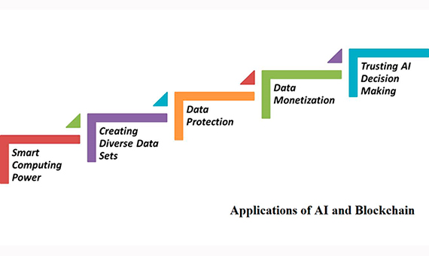

**3 Blockchain and Artificial Intelligence**

Even though AI provides our humanity with the power to manage many applications with ease and comfort, there are some fears which are creating impediments to fully adopt AI into the critical applications in real life. It is generally agreed that AI can never replace Human intelligence and the entire logic behind the working of AI applications will be based on the desired outcomes as envisaged by the creators.

Also the entire ecosystem of AI depends on the quality and quantity of the big data behind it. In order to create a usable data from the astronomical big data being generated, the data is analysed for these 5 Vs - Volume, Variety, Velocity, Variability and Veracity. However, without proper protection and security of the data underneath, the AI applications will not get much traction and always remain vulnerable to failures, which can be disastrous in domains like healthcare. This is where technology like Blockchain can help in bringing the 6th and most important V to the data - which is VALUE.

Some of the major benefits of linking Blockchain with AI are discussed below,

1. **Security of the underlying sensitive and confidential data**

As we know, Data is the oxygen for AI which keeps it running. Blockchain can protect this very oxygen from getting polluted. Blockchain is essentially a technology that allows for the encrypted storage of data on a distributed ledger. It allows for the creation of fully secured databases which can be looked into by parties who have been approved to do so. When combining blockchains with AI, we have a backup system for the sensitive and highly valuable personal data of individuals.

Medical data are too sensitive to hand over to a single company and its algorithms. Storing this data on a Blockchain, which can be accessed by an AI, but only with permission and once it has gone through the proper procedures, could give us the enormous advantages of personalized recommendations while safely storing our sensitive data.

1. **Building the Trust in AI Applications & establishing Audit trail**

However smarter the technology becomes, there is always a need to keep them under controlled mechanism so that nothing unexpected happens. Especially in the field of Healthcare, the technologies like AI can only be a facilitator rather than a decision maker. In order to establish a controlling mechanism, there is a need to setup the architecture in such a way that it is easily verifiable and auditable.

The AI algorithms may become smarter through learning from the humungous data being generated. It will become increasingly difficult for data managers to understand how these programs came to specific conclusions and decisions. Hence, there is a mandatory need to effectively audit decisions made by AI in order to ensure that the intended results are only generated.

Through the use of Blockchain technology, there are immutable records of all the data, variables, and processes used by AIs for their decision-making processes. This makes it far easier to audit the entire process. If decisions are recorded, on a datapoint-by-datapoint basis, on a Blockchain, it makes it far simpler for them to be audited, with the confidence that the record has not been tampered with between the information being recorded and the start of the audit process

The use Blockchain architecture in AI applications can thus provide the Trust which is needed by establishing a Audit trail through which the decisions made by machines can be reviewed and analysed.

1. **Use of Smart Contracts**

Smart contracts are simply computer programs that execute predefined actions when certain conditions within the system are met. They are Blockchain based protocols that facilitate the verification, enforcement, and performance of digital transactions without the need of an intermediary.

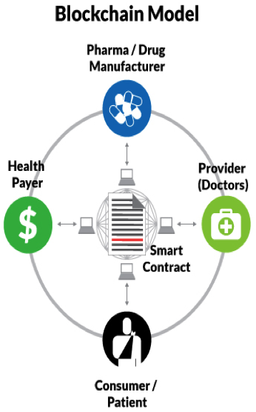

The concept of Smart contracts can have enormous applications in healthcare sector which has a complex and diverse supply chain. The agreements and transactions between various stakeholders such as Doctors, Patients, Insurance companies, Pharmacists, etc can be carried out automatically once they are onboard on the Blockchain platform.

The above examples are only a gist of the benefits which accrue when AI is linked with Blockchain technology. The AI applications in Health sector can be made democratic and trustworthy by adopting a secured and transparent platform like Blockchain to host AI applications.

Considering the humungous advantages that Blockchain offers and to address the various challenges, the ITU Telecommunication Standardization Advisory Group (TSAG) established the ITU-T Focus Group on Application of Distributed Ledger Technology (FG DLT) in May 2017. FG DLT concluded and adopted its deliverables on 1 August 2019.

Deliverables of this focus groups aim to provide material for consideration by the parent group in its standardization activities. This FG on AI4Health can take the deliverables of FG DLT as input to further explore the adoption of Blockchain in AI4Health.

AI can be incredibly revolutionary, but it must be designed with utmost precautions — Blockchain can greatly assist in this. Both serve to enhance the capabilities of the other, while also offering opportunities for better oversight and accountability

**4 Proposal**

This contribution proposes to explore the usage of Block chain and its associated technologies such as distributed ledger technology (DLT), smart contracts, etc in the AI applications for Health to enable the Trust, Transparency, Accountability & Security aspects. Hence, it is proposed that this Focus group may undertake a study and release a report on the convergence of AI with Blockchain technology in Healthcare sector, as a deliverable.

**5 References**

<https://www.bbvaopenmind.com/en/technology/artificial-intelligence/blockchain-and-ai-a-perfect-match/>

<https://www.forbes.com/sites/bernardmarr/2018/03/02/artificial-intelligence-and-blockchain-3-major-benefits-of-combining-these-two-mega-trends/#41c7336b4b44>

<https://www.prolifics.com/blog/healthcare-blockchain-how-smart-contracts-could-revolutionize-care-delivery>

____________________________