|  |  |  |  |  |
| --- | --- | --- | --- | --- |
| ITU Logo | INTERNATIONAL TELECOMMUNICATION UNION  **TELECOMMUNICATION STANDARDIZATION SECTOR**  STUDY PERIOD 2017-2020 | | | FG-AI4H-G-028 |
| **ITU-T Focus Group on AI for Health** |
| **Original: English** |
| **WG(s):** | | TG-Ophthalmo | | New Delhi, 13-15 November 2019 |
| **DOCUMENT** | | | | |
| **Source:** | | Calligo Technologies (India) | | |
| **Title:** | | TG-Ophthalmo: Input for sub-topic - Leveraging Edge analytics and Artificial Intelligence for the rapid assessment of avoidable blindness | | |
| **Purpose:** | | Discussion | | |
| **Contact:** | | Rajaraman Subramanian  Calligo Technologies  India | Tel: +919845239446 Email: [Rajaraman.subramanian@calligotech.com](mailto:Rajaraman.subramanian@calligotech.com) | |
| **Contact:** | | Sriganesh Rao  Calligo Technologies  India | Tel: +919845155800  Email: [Sriganesh.rao@calligotech.com](mailto:Sriganesh.rao@calligotech.com) | |
| **Contact:** | | Sushil Kumar  TEC, New Delhi India | Tel: +911123323471 Email: [sushil.k.123@gmail.com](mailto:sushil.k.123@gmail.com) | |

|  |  |
| --- | --- |
| **Abstract:** | *This document contains elements to be incorporated in the TDD document for the TG-Ophthalmo activity, relevant to the sub-topic on AI in diabetic retinopathy (DR).*  The most common eye problems are   * Cataract * Diabetic retinopathy * Macular degeneration * Refractive errors * Glaucoma   Diabetic Retinopathy or DR is one of the most common eye diseases and fastest growing cause of blindness in the world. Vast number of diabetic patients are there in the world and only limited number of ophthalmologists. **There is a dearth in manpower!** Prevalence of Diabetes is also increasing Year over Year. We need to have a solution which can address the needs at scale.  According to the World Health Organization (WHO), there are 422 million people with diabetes globally, of which India is home to 19%. WHO estimates that 8.7% of the country’s population between the age group of 20 to 70 years is diabetic. One of the consequences of diabetes is diabetic retinopathy, caused by high blood sugar levels damaging the back of the eye. Almost 35% of all diabetic patients have some form of diabetic retinopathy, which if left undiagnosed and untreated, can lead to blindness.  One of the biggest issues in tackling diabetic retinopathy is the lack of trained ophthalmologists in most emerging and low-income countries. In India, for instance, there are only 15,000 ophthalmologists for its population of 1.3 billion people. Another challenge is many people might not be aware that they have diabetes and early onset of diabetic retinopathy—timely detection and intervention can minimize the loss of vision as there are no solutions to reverse the condition. |

Overview

Diabetic Retinopathy is a disorder of retinal blood vessels resulting from Diabetes Mellitus. Today, Diabetic Retinopathy is rapidly evolving as a leading cause of blindness in the world.

Nearly 500,000 candidates currently have some form of Diabetic Retinopathy; with 100,000 having a vision threatening form of the disease.

Early detection of Diabetic Retinopathy can help / allow people to retain their sight and enable specialists to focus on the treatments.

Our product “Calligo Health Engine” is an Edge Analytics solution which is easy to use, industry gradable, low cost & low resource and is capable of identifying Diabetic Retinopathy using Artificial Intelligence with an accuracy **over 96%** and within **Seconds**.

Some of the key benefits of our solution

* Our automatic feature extraction uses Deep Learning techniques and iterative learning to continuously improve outcomes
* Relatively lower cost than manual methods
* Highly scalable process with a quick response time
* Solution is extensible to other eye diseases like Glaucoma, Retinopathy of Premature, Hypertensive Retinopathy, Macular Oedema etc.,
* Solution is also extensible to other common diseases, which needs attention, like Oral Cancer, Cervical Cancer etc.,

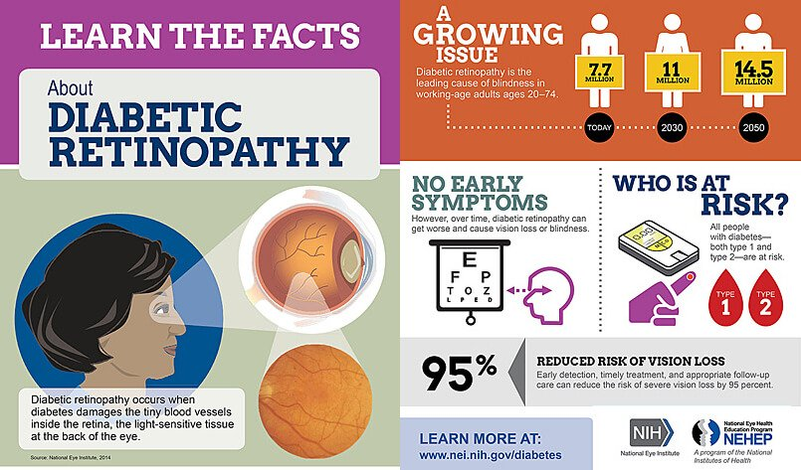

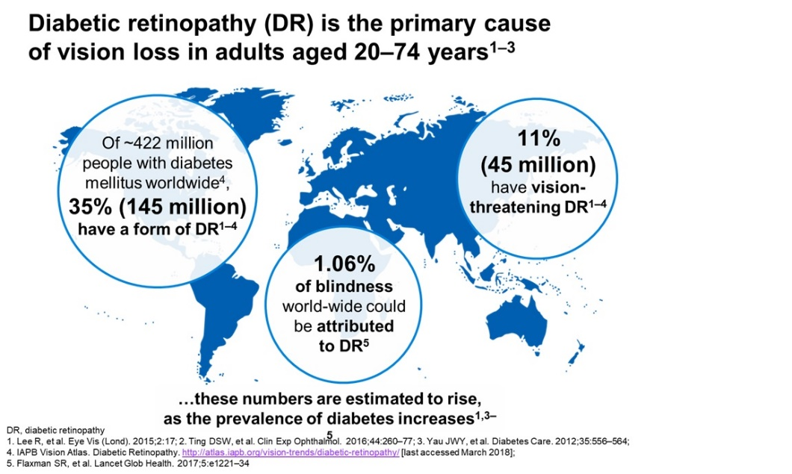

Existing Work

We have developed a screening system for early detection of Diabetic Retinopathy in low resource setting using deep Convolutional Neural Networks (CNNs). Currently the system is capable of running in different computing environments like CPU, GPU, FPGA, Dedicated DNN Hardware and also capable of working with downloadable DL models. We need to study the effects of this intervention in community clinics through field research. Need to work on back-end service for management of multiple edge computing devices in a distributed network. Need to Create Indian DR data-sets in conjunction with local DR domain experts and ophthalmology clinics. Need to extend this solution to cater for other diseases like Hypertensive Retinopathy, Macular Edema, Glaucoma, Cervical Cancer, Oral Cancer etc.,

We have already developed the product. We have created an Edge Analytical solution for Ophthalmology, which can

* Assist Ophthalmologists, Diabetologists, Diagnostics centers and Insurance companies
* Focusing on providing an Edge Analytics solution that can be used easily.

Impact

Healthcare is emerging as a prominent area for AI research and applications. And nearly every area across the industry will be impacted by the technology’s rise. Image recognition, for example, is revolutionizing diagnostics.  If data cannot be analyzed quickly enough, the value, particularly in healthcare, is reduced.

Edge Computing is a technology by which the time between data capture and [analytics](https://datafloq.com/read/descriptive-predictive-prescriptive-analytics/151?utm_source=datafloq&utm_medium=ref&utm_campaign=datafloq&utm=internal) are considerably reduced. It works by upending the system in such a manner that the devices themselves are configured to handle critical analysis on their own, and only the filtered ones will enter the user’s device.

With the advent of Edge Computing, health care industry has transformed itself considerably, while hospitals and clinics are gearing up to take better and faster care of their patients. In fact, Edge Computing has permeated the industry in such a powerful manner that clinicians and doctors heavily rely on them to treat patients. As more and more devices get connected in the health care industry, networking among them all has really become huge because the data that keeps comes in is never going to slow down.

A frequent problem in mass eyecare checkups is that the quality of images captured might not always be usable for an ophthalmologist to grade for diabetic retinopathy. In such situations, the patients are asked to come back and undergo the process again. Now with AI, the system checks the image as soon as it is clicked and prompts the technician to click another image in case it is not good enough. Now, even a minimally skilled technician can take usable images of the eye fundus.

Once usable images are captured, the system grades the images, again in real-time, and identifies if the images have diabetic retinopathy. In case a patient is found to be diabetic retinopathy positive, they are advised to consult an ophthalmologist to determine the next course of action.

Checking on patients with high risk problems and ensuring a more effective, customized treatment approach can thus be facilitated. Lack of data makes the creation of patient-centric care programs more difficult, so one can clearly understand why utilizing big data can be so highly important in the industry.

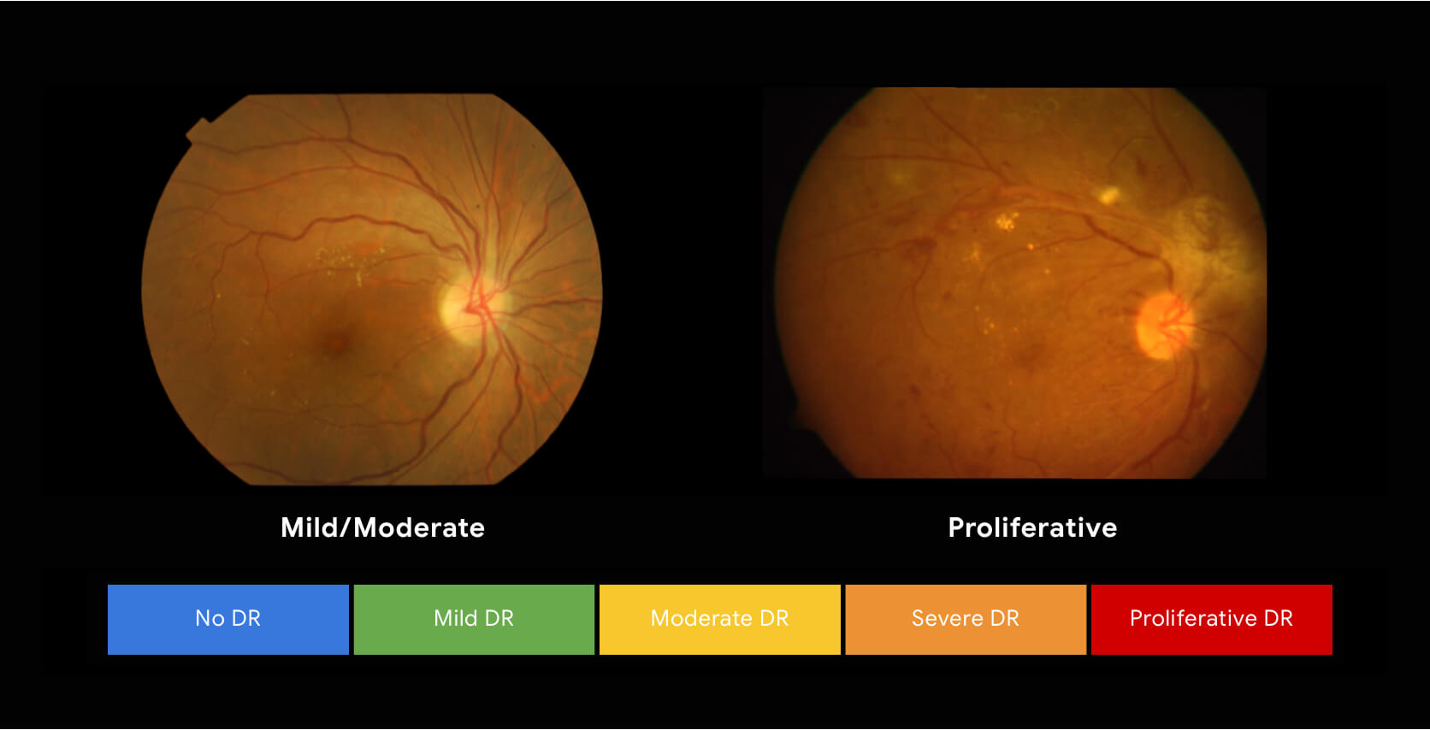

**Feasibility**

We have already developed the product. This is an assistive technology. We have tested it at limited number of hospital/ clinics and results are matching with our statistics. We need to test it out at more eye clinics, hospitals etc.

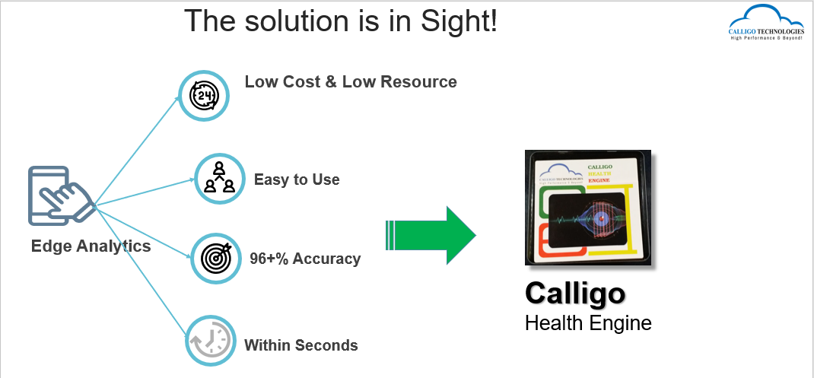

Data availability

We have used some of the datasets that are available publicly, cleaned it and used it for the development of AI models. We have also validated our models with some of the clinics’ datasets.

We have worked with clinicians and got the annotation/labelled data. This should be of high quality. As mentioned earlier, it is better for us to work with clinicians world-wide to get our model whetted and validated with their datasets.

Data Quality

The Cleaned datasets are of high quality. Any AI model is as good as the available dataset. We are interested in getting more globally available datasets to make our model more robust.

Organiser details

|  |  |
| --- | --- |
| **Organization Name** | Calligo Technologies PVT LTD, Bangalore, India |
| **Contact Name** | Rajaraman Subramanian |
| **Contact email address** | Rajaraman.subramanian@calligotech.com |
| **Contact phone number** | +919845239446 |
| **Project Title** | AI based rapid assessment of avoidable blindness |

___________________________