 | INTERNATIONAL TELECOMMUNICATION UNION  TELECOMMUNICATION  STANDARDIZATION SECTOR  STUDY PERIOD 2017-2020 |  | FG-AI4H-G-022
 |  |  | ITU-T Focus Group on AI for Health
 |  |  | Original: English
WG(s): |  | Plenary | New Delhi, 13-15 November 2019
DOCUMENT
Source: |  | TrueSpec-Africa (DRC)
Title: |  | New Topic Group : AI-based detection of falsified medicine
Purpose: |  | Discussion
Contact: |  | Franck Verzefé  TrueSpec-Africa  Democratic Republic of Congo |  | Tel: +243899833292  Email: verzefefranck@gmail.com  franck.verzefe@truespec.com

Abstract: | The presence of substandard and falsified medical products in countries and their use by patients threatens to undermine progress towards meeting the Sustainable Development Goals. Such products may be of poor quality, unsafe or ineffective, threatening the health of those that take them.  The problem of substandard and falsified medical products continues to increase, as globalized manufacturing and distribution systems grow ever more complex. That complexity heightens the risk that production errors will occur, or that medicines will degrade between factory and consumer. Increasing demand for medicines, vaccines and other medical products in almost every country, in addition to poor supply-chain management and the growth of e-commerce also creates opportunities for falsified medicines to be introduced into the supply chain.  Unfortunately, reliable information on the true public health and socioeconomic impacts of substandard and falsified medical products is sparse. A stronger evidence base is needed to help prevent, detect and respond to substandard and falsified medical products, and the public health threat they represent.  The falsified and sub-standard drugs today cause, according to the University of Edinburgh (childhood pneumonia model), the deaths of 250,000 children a year. Technological innovation, more precisely AI technology is one of the most effective means of dealing with increasingly creative counterfeiters. This topic group on AI-based detection of falsified medicine aims to develop artificial intelligence algorithms and to collect data available on falsified drugs.

Overview
250,000 children die each year from falsified or poor quality drugs (American journal of Tropical Medicine and Hygiene, 2019). Based on a 10% prevalence of substandard and falsified antibiotics, the model developed by the University of Edinburgh (childhood pneumonia model) estimates that: Up to 72 430 childhood pneumonia deaths can be attributed to the use of substandard and falsified antibiotics if there is reduced antibiotic activity and this increases up to 169 271 deaths if substandard and falsified antibiotics have no activity (1-2).
Table 1: Findings on excess deaths from severe pneumonia due to substandard and falsified antibiotics in hospital and community settings
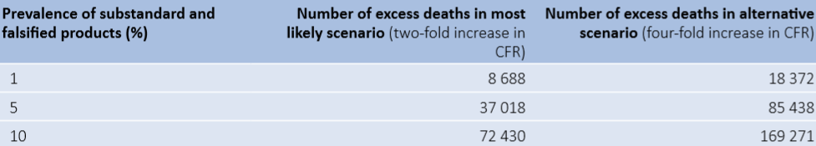

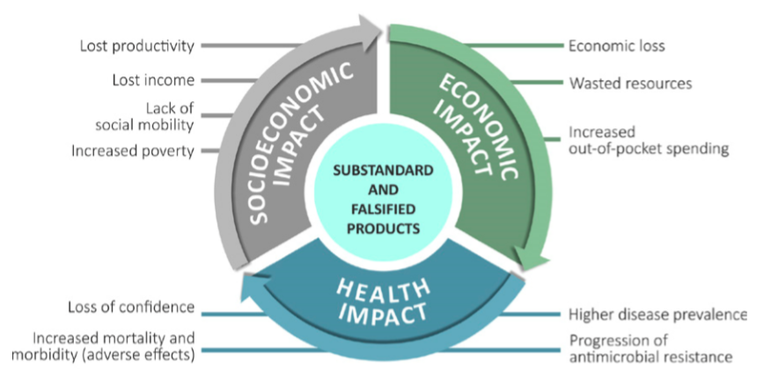
Fig.1 Impact of substandard and falsified medical product

Relevance
One of the reasons for the proliferation of falsified and substandard drugs is the lack of drug analysis equipment or simply too expensive equipment for LMICs that cannot afford a price tag of EUR 60.000 per device, many healthcare facilities and pharmaceutical depots on the continent are unable to get the technology to stop counterfeited medicine.
This lack of analytical devices leads to the lack of database that stores clean data on falsified and sub-standard drugs. Lack of high-quality data from the majority of LMICs means that first estimates will depend largely on data modelling.
AI is presented as a solution to the problem and must:
- Save life by verifying the authenticity of drugs (Customs, warehouses, pharmacies, hospitals) anywhere rapid verification is required.
- To build a database: To provide information and quantify the cost and socioeconomic impact of falsified and substandard medicines and establish the potential costs.
- To save money: An affordable solution than existing test machines on the market
- To identify the unknown chemical components: By using artificial intelligence-based technology to match collected drug data to datasets in our database stored on secure servers in the cloud.
In order to address the global challenge, the system should satisfy the following objectives:
- Visual measurement data Devices should work with an affordable smartphone
- Easy backup generation of database
- Continuous operational status follow-up measurement devices
- The system should be able to work offline and online if connection is available
- The system should allow identification and quantification of drugs
- The system should have two app, one for non-professional and the second for health professional
- The system should also provide automatic reporting (weekly, monthly, yearly)
- The system should provide simple answers and interpretation messages for non-professional

Impact
Detecting substandard and falsified medical products requires a keen awareness of the likely risk factors (including product shortages), a culture that promotes the rapid exchange of information, and the technology and trained personnel to follow up suspicion with appropriate action.
The nearly 1500 cases reported to the WHO GSMS over its first four years of operation provide many very graphic examples of how global changes contribute to the production and trade in medicines and other products that fail to meet quality standards. Although they represent only a fraction of the true number of suspect products in circulation, these cases are already increasing knowledge of the forces that underpin and facilitate the manufacture, sale and distribution of substandard and falsified medical products (WHO Global Surveillance and Monitoring System for substandard and falsified medical products, 2017)
Substandard and falsified medical products in one country can make diseases impossible to treat even in another country that has a very well-regulated medicine market. This is because substandard medicines promote antimicrobial resistance. Antibiotics and other antimicrobial medicines are manufactured and prescribed at doses designed to destroy the pathogens that are causing illness. If a treatment course contains only a fraction of the correct dose, or if it is so badly made that the active ingredients are not released properly, then it is only likely to destroy some of the pathogens, but not all of them. The ones that survive will be the ones that have mutated enough to survive low doses of the medicine. Usually, they do not reproduce very quickly. But with all the more susceptible strains killed by the weak medicines, they have room to multiply and spread to more people. There is clear evidence that resistance to the most important antimalarial medicine, artemisinin, first appeared in a part of the world where at one point between 38 and 90% of the artemisinin medicines on the market were substandard or falsified (3-4)
Improving detection technologies in the field and the laboratory Detection
Detection is difficult, in part because sophisticated laboratory equipment is expensive to acquire and run, difficult to maintain and requires trained personnel who may be in short supply. A number of field detection technologies exist, but each has advantages and disadvantages and they are not always in the hands of people who have been trained to use them effectively. (5)
It is important to develop new tools that will help front-line health care workers record and report suspect medicines – an important entry point for detection.

Database
Develop tools and systems that countries can adapt to make reporting of suspected products easier and more efficient; develop and maintain a global database relating to the discovery of substandard or falsified medicines, for use by regulatory agencies globally; analyse global data to provide evidence-based recommendations for appropriate decision-making and effective action.

Existing work
Wider use of authentication technologies while smartphone reporting technologies straddle the territories of detection and response, other technologies deal with prevention and detection. These include track and trace technologies, which allow for the seamless tracking of products through the supply chain. This sort of authentication technology allowed the Ugandan national regulatory authority to identify falsified contraceptives. Although the falsifiers had included a greyed-out area on the fake packaging that imitated a scratch-off authentication device, it was not actually scratchable. This alerted inspectors to the likelihood that the tablets were not genuine, a fact later confirmed both by the manufacturer of the original product, and by laboratory analyses, which found no active ingredient.
These devices use a barcode that are often photocopy and do not allow the user to know the chemical composition of the drugs. Existing devices to identify the chemical components of drugs are not adapted to the financial realities of the LMICs and do not allow an automatic constitution of the database.

Data availability
Anonymized data will be made available by the organizers of this Topic group.
Data available:
- Data from TrueSpec Africa
- Anonymized Drugs information

Data quality
The data from TrueSpec devices is collected in real-time. This data is structured and analysed automatically and by data scientist before being made available for further processing.

Organizer details
TrueSpec-Africa, is a start-up that has developed a portable device that allows hospitals, pharmacies, pharmaceutical laboratories and quality control centers to determine whether or not a drug is genuine in less than 10 seconds anytime and anywhere in the world using artificial intelligence technology called RAI (Real Active Ingredient).
The goal of TrueSpec-Africa is to protect people through improving the ability of national drug regulators to secure the drug supply chain. We do this by providing our platform as a service tool to drug regulators for their use in real-time drug quality checking, monitoring and reporting.

Organization Name | TrueSpec Africa
Contact Name | Franck Verzefé
Contact Email Address | franck.verzefe@truespec-africa.com
Contact Phone Number | +243 89 983 3292
Project Title | AI-based detection of falsified medicine

Bibliography
- Liu L, Oza S, Hogan D, Perin J, Rudan I, Lawn JE, et al. Global, regional, and national causes of child mortality in 200013, with projections to inform post-2015 priorities: an updated systematic analysis. Lancet. 2015;385:430–40.
- Theodoratou E, Zhang JSF, Kolcic I, Bhopal S, Nair H, Chan KY, et al. Estimating the global, regional and national burden of childhood pneumonia deaths in 2008. PLoS One. 2011;6:e25095.
- Newton P, Proux S, Green M, Smithuis F, Rozendaal J, Prakongpan S, et al. Fake artesunate in southeast Asia. Lancet. 2001;357:1948–50.
- Sengaloundeth S, Green MD, Fernández FM, Manolin O, Phommavong K, Insixiengmay V, et al. A stratified random survey of the proportion of poor quality oral artesunate sold at medicine outlets in the Lao PDR – implications for therapeutic failure and drug resistance. Malar J. 2009;8:172
- Pisani E. Antimicrobial resistance: What does medicine quality have to do with it? London: Antimicrobial Review; 2015.
____________________________

