 | INTERNATIONAL TELECOMMUNICATION UNION  TELECOMMUNICATION  STANDARDIZATION SECTOR  STUDY PERIOD 2017-2020 |  | FG-AI4H-F-034
 |  |  | ITU-T Focus Group on AI for Health
 |  |  | Original: English
WG(s): |  | Data and AI Solution Handling (DASH) | Zanzibar, 3-5 September 2019
DOCUMENT
Source: |  | WG-DASH Chair
Title: |  | Draft Process description for data and AI solution handling
Purpose: |  | Draft
Contact: |  | Marc Lecoultre  MLLab.ai  Switzerland |  | Tel: +41 79 321 09 29  Fax: +41 22 364 30 69  Email: ml@mllab.ai

Abstract: | Draft proposal for a process description of workflows for data and AI solution handling.

Data set workflow
We have identified two major workflows so far:
- Dataset submission
- AI solution benchmarking
These workflows are composed of steps or tasks that must be standardized and documented. This working group will discuss each of these steps with the appropriate experts and publish documents.
We describe below the life cycle of data set and AI solution in the context of FG-AI4H as in Figure 1.
Data set workflow | AI Solution workflow
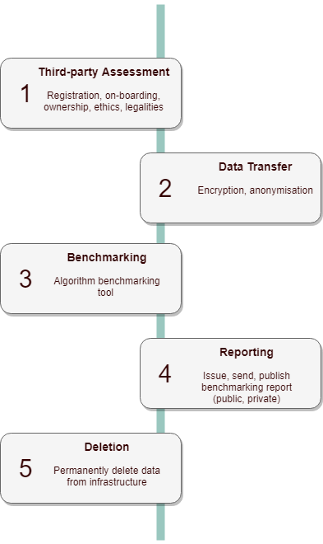 | 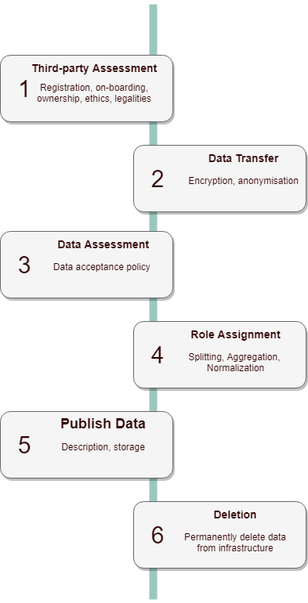
Figure 1 – Life cycle of data set and AI solution in the context of FG-AI4H
____________________________

