|  |  |  |  |  |
| --- | --- | --- | --- | --- |
| ITU Logo | INTERNATIONAL TELECOMMUNICATION UNION  **TELECOMMUNICATION STANDARDIZATION SECTOR**  STUDY PERIOD 2017-2020 | | FG-AI4H-F-033 | |
| **ITU-T Focus Group on AI for Health** | |
| **Original: English** | |
| **WG(s):** | | Plenary | Zanzibar, 3-5 September 2019 | |
| **DOCUMENT** | | | | |
| **Source:** | | Nada Malou, Médecins Sans Frontières | | |
| **Title:** | | New topic area: AI for the diagnostic of bacterial infection and antimicrobial resistance | | |
| **Purpose:** | | Discussion | | |
| **Contact:** | | Nada Malou Médecins Sans Frontières France | | Tel: +33 1 40 21 29 29 Email: [nada_malou@yahoo.fr](mailto:nada_malou@yahoo.fr)   [nada.malou@paris.msf.org](mailto:nada.malou@paris.msf.org) |

|  |  |
| --- | --- |
| Abstract: | The threat of antimicrobial resistance (AMR) is today recognized as major public health challenge and global health priority as stated by the UN General assembly in 2016. In 2014. Oneil reports estimated that 10 million deaths will be attributable to antimicrobial resistance in 2050.  Lack of access to reliable microbiology laboratories and diagnostic tools is one of the drivers of antimicrobial resistance. This is due to several factors including: the absence of essential infrastructure, the lack of laboratory supplies and equipment’s, the absence of maintenance system for equipment’s and finally the lack of trained human resources in microbiology  The lack of human resources is a key element and the response toward this issue includes the need for the development of simplified diagnostic tests both to perform and to interpret  Artificial intelligence could support the lack of trained human resources in the key steps of diagnostic of bacterial infection: from Gram staining reading and identification of bacteria based on their shape, to the identification of colony shapes on different culture media to finally interpret in accurate way results of antimicrobial susceptibility testing through the identification of resistance mechanism identified by the different shapes that can be observed on an antibiogram. |

Project Title

AI for the diagnostic of bacterial infection and antimicrobial resistance

# Overview

Antimicrobial Resistance (AMR) is a major public health concern, increasing over time: in 50 years it could become the leading cause of death globally mainly in the Asia and African continents with 10 million deaths attributable to AMR (Oneil, 2016)

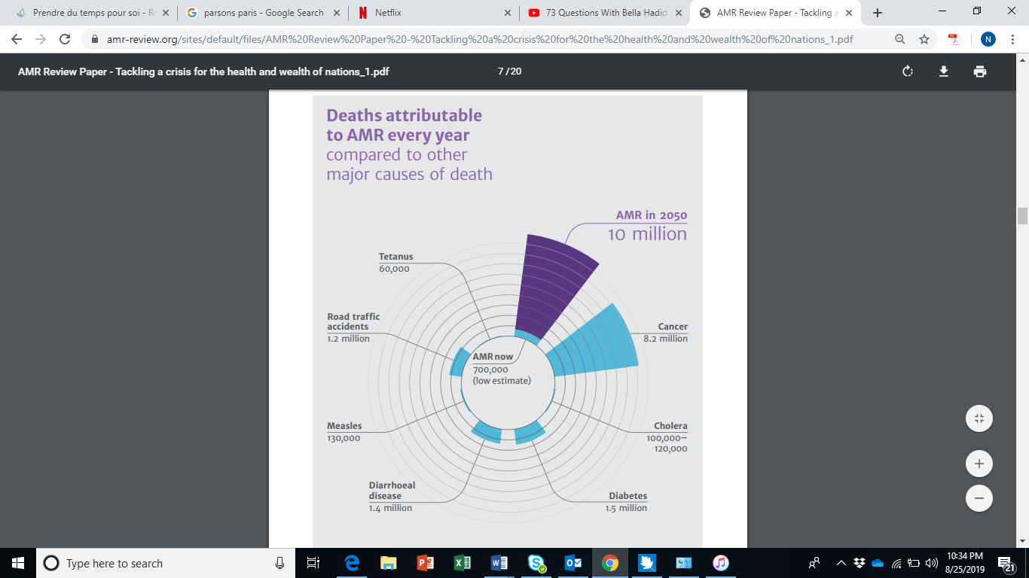

# Relevance

One of the drivers of AMR is the lack of access to microbiology diagnostic tools in order to adapt treatment to the pathogen causing infections and to its sensitivity to antibiotics. Access to microbiology laboratories can allow the rationalization of use of antibiotics and timely adaptation of treatment. The implementation of clinical laboratories in resource-limited settings is quite challenging due to the difficulties in the procurement of laboratory supplies and is compounded by a lack of skilled staff able to routinely perform but especially interpret microbiology testing, from identification of microorganisms on Gram staining and on culture media to the interpretation of the Antimicrobial Susceptibility Testing (AST) (Sien Ombelet*, 2018). Those tests are usually performed by laboratory technicians but should be interpreted and validated by clinical microbiologists. The lack of skilled human resources contributes to the lack of availability of microbiology laboratories or to an inadequate quality of results that will impact patient’s management but also the reliability and the quality of AMR surveillance data

* In order to tackle AMR, there is an urgent need for simplification of microbiology diagnostic tests both to perform and interpret. Solutions should be found today with existing tools (IACG, 2019)

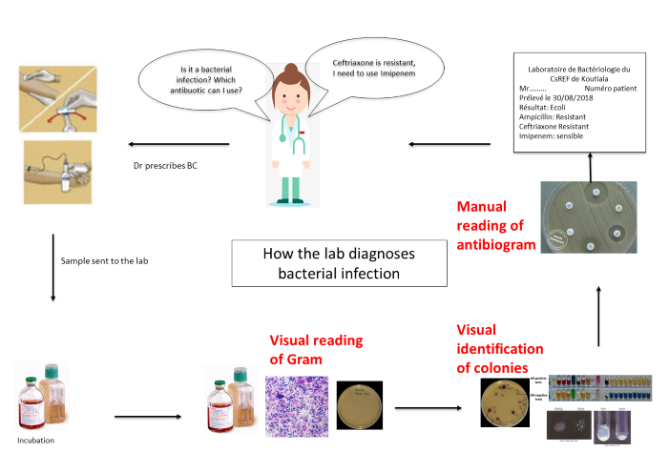

The diagnostic of bacterial infections requires several steps:

* Gram staining on positive culture and presumptive identification based on Gram staining providing a first intermediate results
* Interpretation of growth on solid media and identification of bacteria based on colonies shapes
* Reading and interpretation of antimicrobial susceptibility testing (AST)

With the different initiatives combining AI and traditional microbiology tests, it is possible to simplify the main steps of a diagnostic of a bacterial infection. We can imagine an AI based microbiology laboratory where AI can complement the technical expertise available especially for interpretations.

In order to address the global challenge, the system should satisfy the following objectives:

1. Can be implemented at any level of healthcare in order to make microbiology accessible at every level
2. Devices should work with an affordable smartphone
3. The system should be able to work offline and online if connection is available
4. The system should allow an automatic identification of bacteria based on Gram staining under microscope
5. The system should allow identification of colonies morphology for presumptive identification of bacteria on main media cultures used
6. The system should allow an automatic identification of resistance mechanisms eg: ESBL, D -zone
7. The system should provide a ready to use AST for clinicians
8. The system should provide simple interpretation messages for both lab technicians and clinicians
9. The system should also provide automatic reporting (daily, monthly, yearly) both for patient’s management and for surveillance by analysing resistance rate and producing facility based antibiograms that can be used to enrich local and global surveillance system and allowing the update of empirical treatment at facility/regional level
10. The system should allow self-training of laboratory technicians by providing explanation for each step for capacity building purposes

# Impact

The [UN](https://www.who.int/antimicrobial-resistance/interagency-coordination-group/en/) [Ad](https://www.who.int/antimicrobial-resistance/interagency-coordination-group/en/) [hoc](https://www.who.int/antimicrobial-resistance/interagency-coordination-group/en/) [Interagency](https://www.who.int/antimicrobial-resistance/interagency-coordination-group/en/) [Coordinating](https://www.who.int/antimicrobial-resistance/interagency-coordination-group/en/) [Group](https://www.who.int/antimicrobial-resistance/interagency-coordination-group/en/) [on](https://www.who.int/antimicrobial-resistance/interagency-coordination-group/en/) [Antimicrobial](https://www.who.int/antimicrobial-resistance/interagency-coordination-group/en/) [Resistance](https://www.who.int/antimicrobial-resistance/interagency-coordination-group/en/) warned that if no action is taken, drug-resistant diseases could cause 10 million deaths each year by 2050 and damage to the economy as catastrophic (IACG, 2019)

Today, at least 700,000 people die each year due to drug-resistant diseases, including 230,000 people who die from multidrug-resistant tuberculosis.

AMR is complicating the treatment of main infectious diseases including respiratory, urinary and sexually transmitted infection. simple infections that were easily treatable becomes more and more difficult to treat and today we are running out of options in term of treatments

There is an urgent need to simplify access to accurate microbiology testing in order to treat appropriately and in a timely manner infected patient, to rationale the use of broad-spectrum antibiotics but also to inform about AMR rate in blind spot areas through the implementation of accurate surveillance system (WHO, 2018)

In addition to the simplification of the microbiology tests, decreasing the turnaround time for culture results will allow a faster adaptation of treatments especially for life threatening infection like sepsis

# Existing work

Today, several initiatives are ongoing but most of them are not adapted for LMIC because based on very sophisticated methods and automates. There is a need to develop simpler methods with more affordable tools like any smartphone

## Identification of bacteria shapes on Gram staining

Ferero *et al*. describes a method for automated recognition of tuberculosis (Forero MG, 2006) whereas Ahmed *et al.* proposes a method of identification and classification of foodborne pathogens (Ahmed, 2013). Whereas previous studies described the recognition of a limited number of species, more recently Zielinski et *al* applied AI for the recognition of 33 bacteria species on Gram staining (Bartosz Zieliński, 2017)

In 2017, Smith et al used deep Convolutional Neural Network for the automatic reading of Gram staining for positive blood cultures (Kenneth P. Smith)

## Identification of colonies

Identification of Methicillin Resistant Staphylococcus Aureus (MRSA), Vancomycin Resistant Enterococcus (VRE) and Enterobacteria producing extended spectrum betalactamase (ESBL) on chromogenic media can allow a faster detection for resistance and especially for health associated infections. Copan developed WASPLab for the [aautomatic Digital Analysis of Chromogenic Media (Matthew L. Faron).](https://www.biomerieux-diagnostics.com/sites/clinic/files/automaticdigitalanalysisofchromogenicmediaforvancomycin-resistant-enterococcusscreensusingcopanwasplab.pdf)

In addition to the identification of MDR pathogens on media, initiatives towards colonies counting on different media especially for specimen like urine were developed.

## Phenotypic Colony Recognition

Copan developed in 2017 PhenoMatrix, an algorithm that uses AI to automatically count and recognize organisms, giving microbiology labs the ability to read, interpret and segregate bacterial cultures

## AST interpretation

MSF foundations launched in 2017 the ASTapp project with the objective to develop a free offline mobile application that can read and interprets AST results

# Organizer Details

*Please describe why your organization is interested in this project, and if you have run similar projects / benchmarks / challenges before.*

Médecins Sans Frontiers is an international medical humanitarian nongovernmental organization. We work in more that 70 countries where we provide care for population in need because of war, natural disasters, outbreaks, or exclusion from the health care system

Antibiotic resistance is today one of MSF priorities because we are running out of options for patients that we are seeing everyday which results in their amputation or something their death. The identification of needs and gaps in term od diagnostic is part of MSF activity. MSF foundation is the innovation arm of MSF. Based on the identification of problems in the field by MSF, the foundation supports technological innovations and operational research in order to adapt and validate solutions for the field

The MSF Foundation launched the ASTapp project in 2017 with the objective to create an offline application that will allow the reading and interpretation of antimicrobial susceptibility testing.

Through this proposal, we want to propose the addition of a new topic area but without a specific project.

# Bibliography

Ahmed, W. M. (2013). *Classification of Bacterial Contamination Using Image Processing and Distributed Computing.*

Bartosz Zieliński, A. P.-W. (2017). *Deep learning approach to bacterial colony classification.*

Forero MG, C. G. (2006). *Automatic identification of Mycobacterium tuberculosis .*

IACG. (2019). *NO TIME TO WAIT: SECURING THE FUTUR FROM DRUG RESISTANT INFECTIONS.*

Kenneth P. Smith, A. D. (n.d.). *Automated Interpretation of Blood Culture Gram Stains by Use of a Deep Convolutional Neural Network.*

Matthew L. Faron, a. B. (n.d.). *Automatic Digital Analysis of Chromogenic Media for Vancomycin-Resistant-Enterococcus Screens Using Copan WASPLab.*

Oneil. (2016). *Review on Antimicrobial resistance.*

Sien Ombelet*, J.-B. R. (2018). *Clinical bacteriology in low-resource settings: today’s.*

WHO. (2018). *Global antimicrobial resistance surveillance system (GLASS) report.*

_____________________