 | INTERNATIONAL TELECOMMUNICATION UNION  TELECOMMUNICATION  STANDARDIZATION SECTOR  STUDY PERIOD 2017-2020 |  | FG-AI4H-E-023
 |  |  | ITU-T Focus Group on AI for Health
 |  |  | Original: English
WG(s): |  | Plen | Geneva, 30 May – 1 June 2019
DOCUMENT
Source: |  | Chair WG-O and Chairman FG-AI4H
Title: |  | Proposal to create an AI for health expert group
Purpose: |  | Discussion
Contact: |  | Markus Wenzel  Fraunhofer HHI  Germany |  | Email: markus.wenzel@hhi.fraunhofer.de
Contact: |  | Thomas Wiegand  Fraunhofer HHI  Germany |  | Email: thomas.wiegand@hhi.fraunhofer.de

Abstract: | We propose the creation of a neutral and objective expert group as an important next step for FG-AI4H. Rapporteurs allocated by the expert group to the specific AI4H topics will advance the work of the topic groups by steering the discussions, providing guidance to the topic drivers, selecting independent reviewers who evaluate the respective topic description document including results, giving feedback and deliver an impartial report to the FGAI4H management.

The ITU/WHO Focus Group on Artificial Intelligence for Health (FG-AI4H) addresses a complex subject matter where several thematic fields converge (ranging from ethics, medicine, public health, AI, machine learning, statistics, and regulatory considerations, to the application “on the ground”). Within different working groups (WG), the focus group develops the general processes towards benchmarking AI4H algorithms. These processes are applied in the different topic groups (TG) to the respective AI4H topic (e.g. “AI for Dermatology”). While the focus group already gathers significant expertise in the different thematic fields and AI4H topics, experts with profound knowledge and understanding of single thematic health topics could be of considerable help.

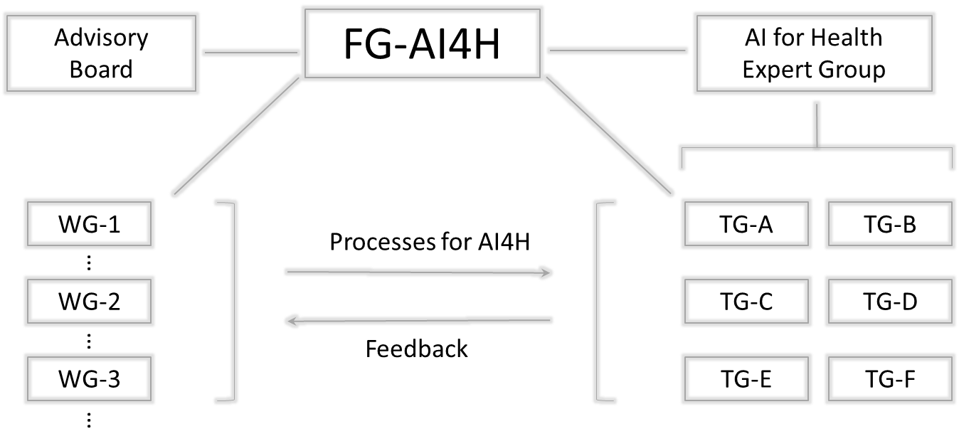
The tasks of the topic groups include solicitation of specific AI4H proposals, their ethical assessment, preparing evaluation criteria including reference data sets and metrics as well as the evaluation of the submitted AI4H solutions. Typically, the topic group members (who bring the topic forward) can be active and partial players for their own interests. Therefore, a system of checks and balances is required, and it has been proposed to nominate a rapporteur around every AI4H topic. The rapporteur should be an impartial expert potentially assisted by other impartial experts and could advance the work by steering the discussions, providing guidance to the topic drivers, selecting independent reviewers who evaluate the respective topic description document including results, giving feedback to the topic group and deliver an impartial report to the management. The overarching AI for Health Expert Group allocates a rapporteur and potentially assistant rapporteurs per topic group, which should be composed of impartial experts from the health side as well as the AI and statistics side. Please note that it would be possible to assign the same person to multiple topic groups.
If such an AI for Health Expert Group is to be created, there is a process required that FG-AI4H suggests to be conducted with the support of ITU and WHO. This includes a nomination/application procedure and forms, e.g. the declaration of interests (comparable to https://www.who.int/behealthy/digital-health/expression-of-interest and https://www.who.int/about/declaration-of-interests/en/). In order to benefit from key subject matter experts, WHO and ITU have created Experts Panels and Expert Groups in the past. These include the ITU Expert Group on Telecommunication/ICT Indicators (https://www.itu.int/net4/ITU-D/ExpertGroup/default.asp), the WTPF 2013: Informal Experts Group (https://www.itu.int/en/wtpf-13/Pages/ieg.aspx) and numerous WHO Expert Advisory Panels and Committees (https://www.who.int/about/collaborations/expert_panels/en/). Informal Expert Groups can be established quicker and with less effort by WHO in comparison to the Expert Panels. Worth mentioning is the “ePanel” as “electronic system to process nominations, extensions and terminations of membership of experts to the WHO expert advisory panels”; https://www.who.int/about/collaborations/epanel/en/).
The mechanism of establishing an expert group could prove again useful here and facilitate the inclusion of external specialists through the affiliation of expert associations. Shared interest in the subject matter, the opportunity to use the expertise for an impact on a global scale, and the honorary position could represent incentives to join a future AI for Health Expert Group.
The following open list names relevant expert associations that may serve as resources and potential partners:
- InterAcademy Partnership (“IAP is the global network of science, engineering & medical academies working together to provide independent expert advice on scientific, technological & health issues”; http://www.interacademies.org/)
- International Association of National Public Health Institutes (“IANPHI improves the world’s health by leveraging the experience and expertise of its member institutes to build robust public health systems”; http://www.ianphi.org/whoweare/index.html)
- International Hospital Federation (“IHF is an international not for profit, non-governmental membership organization”; https://www.ihf-fih.org/)
- Association for Computing Machinery (ACM “is the world's largest educational and scientific computing society, delivers resources that advance computing as a science and a profession”; https://www.acm.org/about-acm)
- International Medical Informatics Association (“plays a major global role in the application of information science and technology in the fields of healthcare and research in medical, health and bio-informatics”; https://imia-medinfo.org )
- Institute of Electrical and Electronics Engineers (“IEEE is the world’s largest technical professional organization dedicated to advancing technology for the benefit of humanity”; https://www.ieee.org/)
- American Statistical Association (“the world’s largest community of statisticians”; “advancing research and promoting sound statistical practice to inform public policy and improve human welfare”; https://www.amstat.org/ASA/about/home.aspx)
- FDA Center for Devices and Radiological Health (https://www.fda.gov/about-fda/office-medical-products-and-tobacco/about-center-devices-and-radiological-health)
- and comparable national institutions from other countries
- …
Summary
The creation of a neutral and objective expert group is an important next step for FG-AI4H. Rapporteurs allocated by the expert group to the specific AI4H topics will advance the work of the topic groups by steering the discussions, providing guidance to the topic drivers, selecting independent reviewers who evaluate the respective topic description document including results, giving feedback and deliver an impartial report to the FGAI4H management. The process should be initiated as soon as possible.
___________________

