|  |  |  |  |  |
| --- | --- | --- | --- | --- |
| ITU Logo | INTERNATIONAL TELECOMMUNICATION UNION  **TELECOMMUNICATION STANDARDIZATION SECTOR**  STUDY PERIOD 2017-2020 | | FG-AI4H-C-020-R1 | |
| **ITU-T Focus Group on AI for Health** | |
| **Original: English** | |
| **WG(s):** | | Plenary | Lausanne, 22-25 January 2019 | |
| **DOCUMENT** | | | | |
| **Source:** | | Laboratory for Research in Neuroimaging, Department of Clinical Neurosciences, Faculty of Biology and Medicine, UNIL Centre Hospitalier Universitaire Vaudois (CHUV) | | |
| **Title:** | | Status report for Alzheimer’s disease use case | | |
| **Purpose:** | | Discussion | | |
| **Contact:** | | Kherif Ferah, vice-director  LREN, CHUV Switzerland | | Tel: +41 79 556 11 06 Email: [Ferath.kherif@chuv.ch](mailto:Ferath.kherif@chuv.ch) |
| **Contact:** | | Marc Lecoultre MLLab.ai Switzerland | | Tel: +41 79 321 09 29 Fax: +41 22 364 30 69 Email: [ml@mllab.ai](mailto:ml@mllab.ai) |

|  |  |
| --- | --- |
| **Abstract:** | This document is an update of document B-013, it contains an updated use-case proposal for testing the clinical validity of machine learning-based diagnostics for Alzheimer’s disease (AD). The goal would be to find a classification algorithm able to discriminate the different types of dementias in the early stage of the disease. It also answers the questions that will help the focus group to assess if the use case it ready for the next steps. |

**Organization Name:** Laboratory for Research in Neuroimaging, Department of Clinical Neurosciences, Faculty of Biology and Medicine, UNIL Centre Hospitalier Universitaire Vaudois (CHUV) (Switzerland)

**Contact Name:** Kherif Ferah, Marc Lecoultre

**Contact Email Address:** Ferath.kherif@chuv.ch, ml@mllab.ai

**Contact Phone Number:** +41 79 556 11 06

**Project Title:** for testing the clinical validity of machine learning-based diagnostics for Alzheimer’s disease (AD).

Overview

This use case provides an empirical basis for testing the clinical validity of machine learning-based diagnostics for Alzheimer’s disease (AD) and related dementia syndromes (defined by DSM V as ‘Neurocognitive disorders’) using real world brain imaging and genetic data. With increased life expectancy in modern society, the number of individuals who will potentially become demented is growing proportionally. Current estimates count world-wide over 48 million people suffering from dementia bringing the social cost of care to 1% of world’s gross domestic product – GDP. These numbers led the World Health Organisation to classify neurocognitive disorders as a global public health priority.

Compared to visual assessment, automated diagnostic methods based on brain imaging are more reproducible and have demonstrated a high accuracy in separating AD from healthy aging, but also the clinically more challenging separations between different types of neurocognitive disorders. Similarly, although ApoE genotypes carrying higher risk for AD are easily obtainable, this information is rarely integrated in machine learning-based diagnostics for AD. Although encouraging, implementations into clinical routine have been challenging.

Relevance/Impact

The lack of strategy how to map the evolving clinical phenotypes on a multi-dimensional dynamic description of brain damage and the inconsistent use of routinely collected data across clinical entities hamper efforts for validation of machine-learning based diagnosis and prognosis in neurocognitive disorders.

Our proposal systematically addresses previous limitations by using “real-world” imaging and genetic data obtained in the clinical routine that are analysed with predictive machine learning algorithms, including benchmarking and cross-validation of the learned models. The intended integrative framework will assign a level of probability to each of several possible diagnosis to provide an output that is readily usable and interpretable by clinicians. Beyond this immediate impact on clinical decision making and patients care, our flexible strategy allows for scaling the framework by integrating further clinical variables - neuropsychological tests, imaging and CSF biomarkers, to name but a few that will lead to new areas of research developments.

The proposal is novel, has translational importance and is potentially applicable to epidemiological, pharmacological and therapeutic studies in all clinical domains seeking to explore various aspects of health Big Data and validate their accuracy as biomarkers. It will not only advance our scientific understanding of ageing-associated cognitive decline and neurocognitive disorders. It will also provide a model for infrastructure and technology for the creation of large-scale projects in different fields of research for the benefit of patients, clinical and basic science researchers.

Existing work

Our own and others’ studies on structural imaging already considered more than two diagnostic options or used probabilistic rather than categorical diagnostic labels. These pattern recognition machine-learning based approaches run on a standard PC and rely on a set of labelled training data - for example structural magnetic resonance imaging (MRI) and reliably established diagnostic label for each subject - to diagnose new cases in the absence of expert radiologists. They also permit a fully automated detection and quantification of specific pathologies (e.g. white matter hyperintensities or microbleeds.

Our expertise in building and using platform for data federation (PI Ferath Kherif) is currently used by the Medical Informatics Platform of the Human Brain Project. We provided software solution that connect patients’ data - clinical scores, neuroimaging, CSF biomarkers, to be than analysed with set of methods ranging from automated feature extraction to statistical methods and machine learning algorithms for data exploration, statistical modelling, predictive machine learning and visualisation of results.

Feasibility

We have a proven track record in applying supervised classification methods for prediction of clinical outcome and explaining the variance of the data. We previously applied support-vector machine (SVM) classification methods to anatomical data for diagnosis of different dementia subtypes. However, multivariate pattern recognition methods have been applied primarily to uni-modal data, motivating a novel methodological approach to accommodate multi-modal data. Recently, we used this methodology to build predictive models for healthy ageing and showed that the mean prediction error was significantly lower when combining all measurements.

Data Availability -

The primary data are already available and growing in volume. Data will include both real world patient’s data and data collected from research cohorts. The data will include clinical scores, diagnostic, cognitive measures and biological measures (PET, MRI, fMRI, lab results).

The data include patients on more than 6 000 patients on dementia (one of the largest patients’ cohort) different stages of the disease (subjective complains, mild impairments or demented)

**Patients Count and Diagnoses**

The table below provides details about the cohort population

|  |  |  |  |  |
| --- | --- | --- | --- | --- |
|  | Diagnostic- Labels : | | | |
| Total count | **Alzheimer's Disease** | **Mild cognitive impairment (MCI)** | **Cognitively normal (CN)** | **Other Mixed Dementia (MD)** |
| 6787 | 2082 | 1165 | 1779 | 1761 |
|  | 30.67% | 17.16% | 26.21% | 25.94% |

Demographics

Age

The graphs below provide the ages distribution on all the participants, by gender and by disease categories.

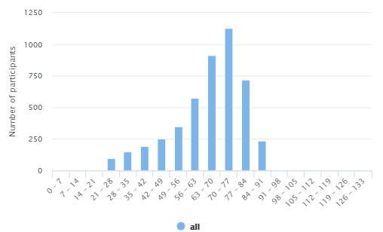

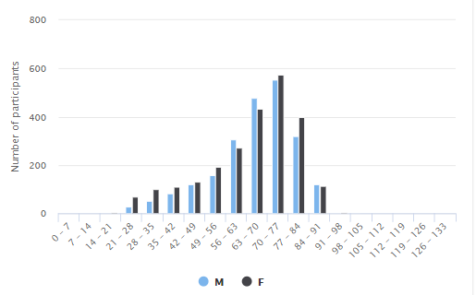

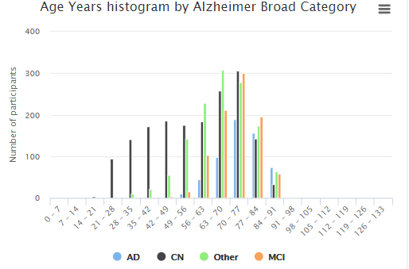

Neuroimaging Data-Brain scans

Magnetic resonance (MR) images strongly depends on the quality of the input data. Multi-centre studies and data-sharing projects need to take into account varying image properties due to different scanners, sequences and protocols

Images format requirements:

* + Must be full brain scans
  + Must be provided either in DICOM or NIFTI format
  + The images must be high-resolution (max. 1.5 mm) T1-weighted sagittal images.

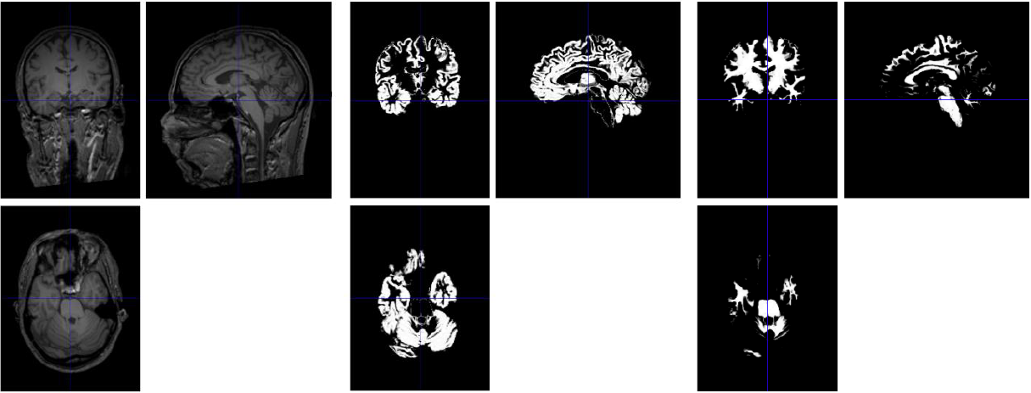

Neuroimaging-Derived Features

The Neuromorphometric Processing component (SPM12) uses NIfTI data for computational neuro-anatomical data extraction using voxel-based statistical parametric mapping of brain image data sequences:

* 1. Each T1-weighted image is normalised to MNI (Montreal Neurological Institute) space using non-linear image registration SPM12 Shoot toolbox
  2. The individual images are segmented into three different brain tissue classes (grey matter, white matter and CSF)
  3. Each grey matter voxel is labelled based on Neuromorphometrics atlas (constructed by manual segmentation for a group of subjects) and the transformation matrix obtained in the previous step. Maximum probability tissue labels were derived from the “MICCAI 2012 Grand Challenge and Workshop on Multi-Atlas Labelling”. These data were released under the Creative Commons Attribution-Non-Commercial (CC BY-NC. The MRI scans originate from the OASIS project, and the labelled data was provided by Neuromorphometrics, Inc. under an academic subscription

The full list of the features is listed in the appendix.

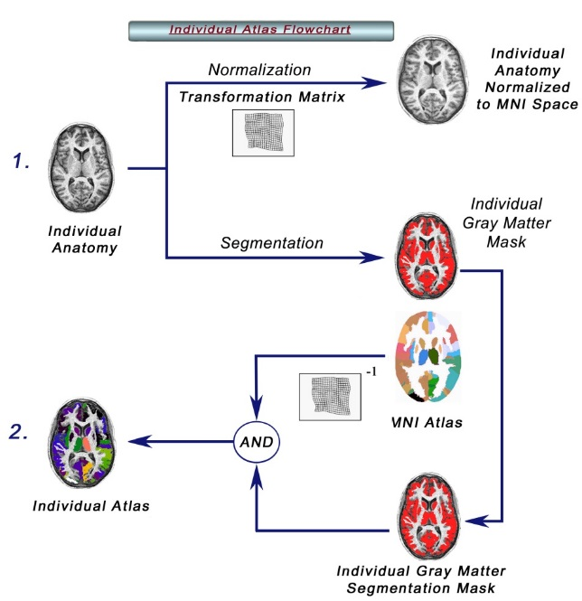

Data quality and collection process

The data have been obtained under each country ethical and regulation policies, including patient informed consents. The data have been annotated using best clinical practice and described using Common data Element and international classifications.

The Quality Check evaluates essential image parameters, such as signal-to-noise ratio, inhomogeneity and image resolution. It evaluates images for problems during the processing steps. It allows for comparing quality measures across different scans and sequences.

Benchmarking -

A large representative sample will be created and will be use for the creation of the models. The models will be then validated (see benchmarking methods below) on the real-world undisclosed patient’s data.

The benchmarking process will be based using the state-of-the-art methods for the methods used by the ML community, but also methodology recommended for clinical trial. Thus, assessment of clinical validity involves measurement of the following metrics derived from the confusion matrix:

* **Test accuracy**: F1 score
* **Clinical sensitivity**: ability to identify those who have or will get the disease = *TP/(TP+FN)*
* **Clinical specificity** ability to identify those who do not have or will not get the disease =*TN/(FP+FN)*
* **Clinical precision the probability** that the disease is present when the test is positive *=sensitivity x prevalence / (sensitivity x prevalence + (1-specificity) x (1-sensitivity) )*

In addition, we propose to integrate clinician feedback by measuring the Clinical utility. This measure assesses the impact of the automated decision in term of impact on the clinical path of the patients, impact on the treatment and also impact on the relatives …).

Organizers

CHUV-LREN has extensive expertise in collecting clinical data, curating and pre-processing these data to the highest standard. We have also developed own methods for machine learning. The PI will be available for program duration and committed in fruitful collaboration between "clinical experts", and machine learning expert and to bring high value from the data and personalised tools for disease prognoses.

Answers to focus group questions

a) In which specific form will you provide the data (which file format, how is the database structured)?

The data will be provided in a structured database which contains a features table (which contains all the measurements and the diagnostics labels) and a meta-data table (which includes the description of the data according to a standard ontology)

b) How will you provide the labels/annotations of the single samples in your data set? What output variables are possible?

Yes, we will provide the current diagnostics according to the ICD10 classification of diseases

c) Are you ready to show a few labelled samples, as actual files on your computer, in Lausanne?

Yes

d) How many labelled samples can you actually provide? (This is something the focus group needs to know.)

We can provide access to up to 6000 records.

APPENDIX 1.  
List of features.



|  |  |  |
| --- | --- | --- |
| Diagnostic | alzheimerbroadcategory | categorial |
| Demography | Age | continous |
| Gender | categorical |
| educationlevel | categorical |
| educationyears | continous |
| CSF-Biomarkers | ab1_40 | continous |
|  | ab1_42 | continous |
|  | tau | continous |
| genetic | apoe4 | categorical |
| Neuropsychology Score | adas | continous |
| MMSE | continous |
| MOCA | continous |
| Brain Features (Volumes) | leftaccumbensarea | continous |
| leftacgganteriorcingulategyrus | continous |
| leftainsanteriorinsula | continous |
| leftamygdala | continous |
| leftangangulargyrus | continous |
| leftaorganteriororbitalgyrus | continous |
| leftbasalforebrain | continous |
| leftcalccalcarinecortex | continous |
| leftcaudate | continous |
| leftcerebellumexterior | continous |
| leftcerebellumwhitematter | continous |
| leftcerebralwhitematter | continous |
| leftcocentraloperculum | continous |
| leftcuncuneus | continous |
| leftententorhinalarea | continous |
| leftfofrontaloperculum | continous |
| leftfrpfrontalpole | continous |
| leftfugfusiformgyrus | continous |
| leftgregyrusrectus | continous |
| lefthippocampus | continous |
| leftinflatvent | continous |
| leftioginferioroccipitalgyrus | continous |
| leftitginferiortemporalgyrus | continous |
| leftlateralventricle | continous |
| leftliglingualgyrus | continous |
| leftlorglateralorbitalgyrus | continous |
| leftmcggmiddlecingulategyrus | continous |
| rightmfcmedialfrontalcortex | continous |
| leftmfcmedialfrontalcortex | continous |
| leftmfgmiddlefrontalgyrus | continous |
| leftmogmiddleoccipitalgyrus | continous |
| leftmorgmedialorbitalgyrus | continous |
| leftmpogpostcentralgyrusmedialsegment | continous |
| leftmprgprecentralgyrusmedialsegment | continous |
| leftmsfgsuperiorfrontalgyrusmedialsegment | continous |
| leftmtgmiddletemporalgyrus | continous |
| leftocpoccipitalpole | continous |
| leftofugoccipitalfusiformgyrus | continous |
| leftopifgopercularpartoftheinferiorfrontalgyrus | continous |
| leftorifgorbitalpartoftheinferiorfrontalgyrus | continous |
| leftpallidum | continous |
| leftpcggposteriorcingulategyrus | continous |
| leftpcuprecuneus | continous |
| leftphgparahippocampalgyrus | continous |
| leftpinsposteriorinsula | continous |
| leftpogpostcentralgyrus | continous |
| leftpoparietaloperculum | continous |
| leftporgposteriororbitalgyrus | continous |
| leftppplanumpolare | continous |
| leftprgprecentralgyrus | continous |
| leftptplanumtemporale | continous |
| leftputamen | continous |
| leftscasubcallosalarea | continous |
| leftsfgsuperiorfrontalgyrus | continous |
| leftsmcsupplementarymotorcortex | continous |
| leftsmgsupramarginalgyrus | continous |
| leftsogsuperioroccipitalgyrus | continous |
| leftsplsuperiorparietallobule | continous |
| leftstgsuperiortemporalgyrus | continous |
| leftthalamusproper | continous |
| lefttmptemporalpole | continous |
| lefttrifgtriangularpartoftheinferiorfrontalgyrus | continous |
| leftttgtransversetemporalgyrus | continous |
| leftventraldc | continous |
| lipidemiacomorbidity | continous |
| minimentalstate | continous |
| rightaccumbensarea | continous |
| rightacgganteriorcingulategyrus | continous |
| rightainsanteriorinsula | continous |
| rightamygdala | continous |
| rightangangulargyrus | continous |
| rightaorganteriororbitalgyrus | continous |
| rightbasalforebrain | continous |
| rightcalccalcarinecortex | continous |
| rightcaudate | continous |
| rightcerebellumexterior | continous |
| rightcerebellumwhitematter | continous |
| rightcerebralwhitematter | continous |
| rightcocentraloperculum | continous |
| rightcuncuneus | continous |
| rightententorhinalarea | continous |
| rightfofrontaloperculum | continous |
| rightfrpfrontalpole | continous |
| rightfugfusiformgyrus | continous |
| rightgregyrusrectus | continous |
| righthippocampus | continous |
| rightinflatvent | continous |
| rightioginferioroccipitalgyrus | continous |
| rightitginferiortemporalgyrus | continous |
| rightlateralventricle | continous |
| rightliglingualgyrus | continous |
| rightlorglateralorbitalgyrus | continous |
| rightmcggmiddlecingulategyrus | continous |
| rightmfcmedialfrontalcortex | continous |
| rightmfgmiddlefrontalgyrus | continous |
| rightmogmiddleoccipitalgyrus | continous |
| rightmorgmedialorbitalgyrus | continous |
| rightmpogpostcentralgyrusmedialsegment | continous |
| rightmprgprecentralgyrusmedialsegment | continous |
| rightmsfgsuperiorfrontalgyrusmedialsegment | continous |
| rightmtgmiddletemporalgyrus | continous |
| rightocpoccipitalpole | continous |
| rightofugoccipitalfusiformgyrus | continous |
| rightopifgopercularpartoftheinferiorfrontalgyrus | continous |
| rightorifgorbitalpartoftheinferiorfrontalgyrus | continous |
| rightpallidum | continous |
| rightpcggposteriorcingulategyrus | continous |
| rightpcuprecuneus | continous |
| rightphgparahippocampalgyrus | continous |
| rightpinsposteriorinsula | continous |
| rightpogpostcentralgyrus | continous |
| rightpoparietaloperculum | continous |
| rightporgposteriororbitalgyrus | continous |
| rightppplanumpolare | continous |
| rightprgprecentralgyrus | continous |
| rightptplanumtemporale | continous |
| rightputamen | continous |
| rightscasubcallosalarea | continous |
| rightsfgsuperiorfrontalgyrus | continous |
| rightsmcsupplementarymotorcortex | continous |
| rightsmgsupramarginalgyrus | continous |
| rightsogsuperioroccipitalgyrus | continous |
| rightsplsuperiorparietallobule | continous |
| rightstgsuperiortemporalgyrus | continous |
| rightthalamusproper | continous |
| righttmptemporalpole | continous |
| righttrifgtriangularpartoftheinferiorfrontalgyrus | continous |
| rightttgtransversetemporalgyrus | continous |